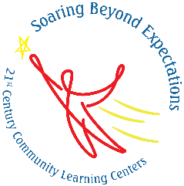
Mapleton Public Schools/Adventure Elementary
2025-26 EVALUATION SUMMARY
21st Century Community Learning Centers (CCLC) Grant

Program Overview
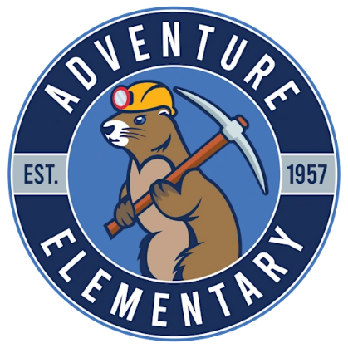
Adventure Elementary is a PreK–6 Dual Language Immersion partnership school in Mapleton Public Schools. The school values intellectual rigor, respect and inclusion for diverse abilities and cultures, biliteracy, and service to the community. In 2025–26, Adventure launched its second year as a 21st Century Community Learning Centers (CCLC) program site. The out-of-school time (OST) program provided after-school and summer opportunities to support academic growth, essential skills, biliteracy, and family engagement.
Programming included literacy activities in both Spanish and English, STEM projects, sports and active movement, life skills, and engaging clubs. Students and families responded positively, expressing enthusiasm for the opportunities available beyond the school day. Community partners such as Adams County 4-H, Sticky Fingers Cooking, Knight School, HERO Kids Sports, and Greenway Kempo Karate enriched programming by emphasizing hands-on learning, social-emotional growth, and life skills. Families participated in events like the Back to School and Resource Fair, English Adult classes, Parenting Strategies, a Healthy bilingual cooking class with the Spanish Network and Fiesta Cultural, which combined practical supports with celebrations of Adventure’s bilingual and multicultural community.

Program Vision
Adventure seeks to provide every student with a safe, supportive, and enriching out-of-school environment that complements the school day, nurtures bilingualism and biliteracy, and empowers students to thrive academically, socially, and emotionally.

Program Mission
- In partnership with families, teachers, and community organizations, Adventure Elementary’s 21st CCLC program offers engaging activities and supportive relationships that foster curiosity, resilience, and a sense of belonging. The mission is to extend learning beyond the school day and to equip students with the skills, confidence, and bilingual competencies needed for long-term success.

Program Goals and Objectives
- Academic Achievement: Provide academic enrichment opportunities to strengthen literacy and biliteracy, math, and STEM skills, supporting students in meeting state and local standards.
- Essential Skills: Offer programs and clubs that build teamwork, perseverance, creativity, and social-emotional growth.
- Commitment to School: Increase student attendance and engagement by making OST programming a fun, safe, and reliable option for families.
- Family Engagement: Host informational and celebratory events that empower families to support their children’s learning while celebrating cultural and linguistic diversity.
- Community Partnerships: Maintain and expand collaborations with local organizations to enrich student experiences and sustain the program’s impact.

Program Evaluation
Adventure’s 21st CCLC program was evaluated using a combination of quantitative data and qualitative feedback. Participation and attendance records were maintained in EZReports, which tracked student hours, average daily attendance, and family participation. Teacher surveys were administered for students who attended 75 or more hours, providing insight into changes in engagement, motivation, and classroom behavior. NWEA MAP data was used to measure academic growth in reading and math for grades 3–6. In addition, feedback from families and community partners was gathered informally during events such as the Back to School and Resource Fair, English Adult classes, Parenting Strategies, a Healthy bilingual cooking class with the Spanish Network and Fiesta Cultural, as well as regular school days. Together, these data sources give a broad picture of student participation, growth, and community impact.

Program Results
- Participation: Adventure served 118 regular attendees (grades K–6) and 236 students overall. Average daily attendance for the program was approximately 48 students during the school year. Family engagement events reached more than 90 family members.
- Academics: Of the students in grades 3–6 with available NWEA MAP data, 38% showed growth of five or more percentile points in math and 43% showed growth of five or more percentile points in reading from Fall to Winter. While this fell below the ambitious 90% target, the data provides a clear baseline for improvement in Year 3.
- Engagement: Teacher surveys indicated that most students demonstrated growth in motivation, attentiveness, and classroom participation. Overall, 100% of required teacher surveys were completed, which met the 100% expectation.
- Family Engagement: Families participated in both informational and celebratory events, including the Back to School and Resource Fair, English Adult classes, Parenting Strategies, a Healthy bilingual cooking class with the Spanish Network and Fiesta Cultural. Feedback indicated these events were well received, but additional staffing and volunteer support would help expand programming.
Family Member
“My granddaughter looks forward to after-school clubs every day. One of the clubs she loves is gardening, she gets exposure to something we unfortunately cannot have at home.”
– Adventure student grandmother
Adventure’s Teacher Survey of our regular students who participated in 75 hours or more of after school clubs. 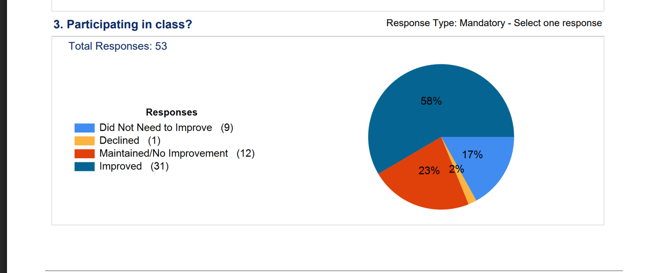 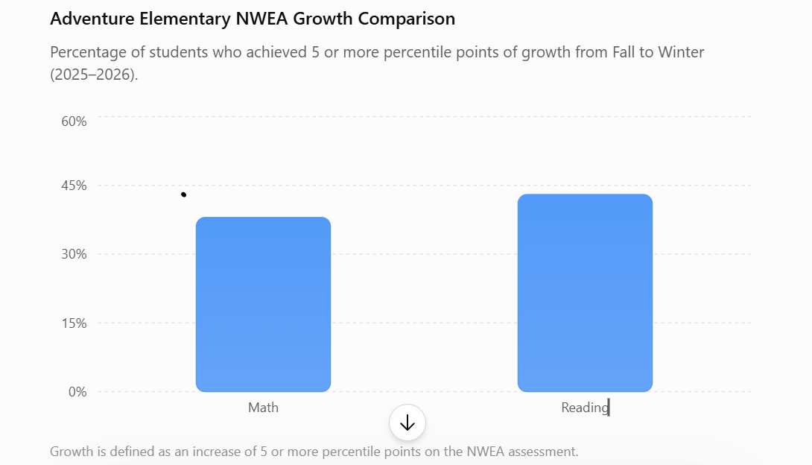

CONCLUSION
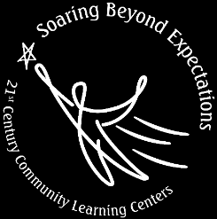
Adventure’s second year of 21st CCLC programming made a lot of growth compared to year 1 and we continue to see opportunities to do better next school year. The program successfully launched new OST opportunities, engaged hundreds of students, and continued to build our strong community. Teacher surveys show meaningful improvements in student engagement, while family participation in events keeps growing every year. At the same time, data also highlight areas for growth, particularly in helping more students achieve academic progress as measured by MAP. With continued support from Mapleton Public Schools, committed partners, and families, Adventure is well positioned to strengthen program quality and outcomes in Year 3.

- https://adventure.mapleton.us/
- Perla Flores Frescas, Adventure Elementary Site Coordinator, 303-853-1412, floresfrescasp@mapleton.us

