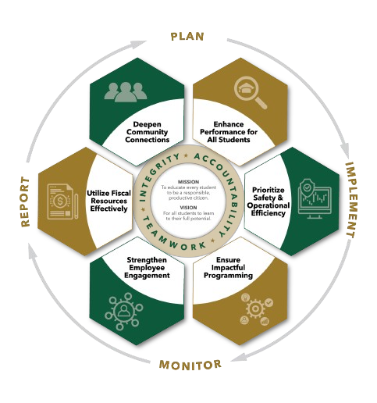


MAY Minutes
Autrey Mill Middle School Governance Council
Date | time May 11, 2026| 7:45 am | Location Room A130

SGC Members: Trey Martin, Principal | Emma Cornwall, Teacher |Maud de Groot, Teacher | Ashley Perry, School Employee | Matthew McNamara, School Employee |Kathleen Newquist, Parent | Jessica Saszi, Parent |Beth Zampieri, Parent| Korina Calbay, Community Member | Jacob Marmer, Community Member
Time | Item
7:45 am | Call to Order
7:46 am | Action Item: Approve Agenda  Motion: de Groot  Second: Newquist  All in favor
7:48 am | Action Item: Approve March Minutes  Motion: de Groot  Second: Newquist  All in favor
7:51 am | Discussion Item: Parent/Teacher SGC New Members  Members introduced themselves and new members were welcomed
7:55 am | Informational Item: Principals Update  - Wrapping up testing; expect ELA scores to come later than other testing scores due to new standards  - Thank you to PTA and parents for a great week of teacher appreciation  - Celebrations for 8th grade coming up: Chick fil A, Sky Zone, Promotion Ceremony  - May Madness  - New principal to be announced at next board meeting; official start date is July 1, 2026  - After May 22, all AMMS staff will be housed at JCHS library amid extensive renovations taking place at AMMS building  - Plans being developed for 6th grade mini camp as the building will not be available as in past years
8:00 am | Discussion Item: SGC Survey Update  All complete
8:05 am | Action Item: Meeting Adjournment  Completed survey as a Council; Council members to complete individual surveys by end of year  Motion: de Groot  Second: Jacob Marmer  All in favor

Meeting Norms
Silences Phones | Be Respectful of Others’ Opinions | Work for the Good of All Students

