August 24, 2026

Mission
Pendleton County Schools is committed to graduating every student college and/or career ready by empowering staff to deliver high quality instruction and services in a safe and trusting environment.
United in Pursuing Excellence

2025-2026 SBDM Council Members
Robert Hoover, Principal | Johnny Trenkamp, Teacher
Craig Smith, District Liaison | Elizabeth Derico, Teacher
Amanda King, Teacher | Lacy Jones, Parent
Nancy Crotty, Recording Secretary | Taylor Platt, Parent

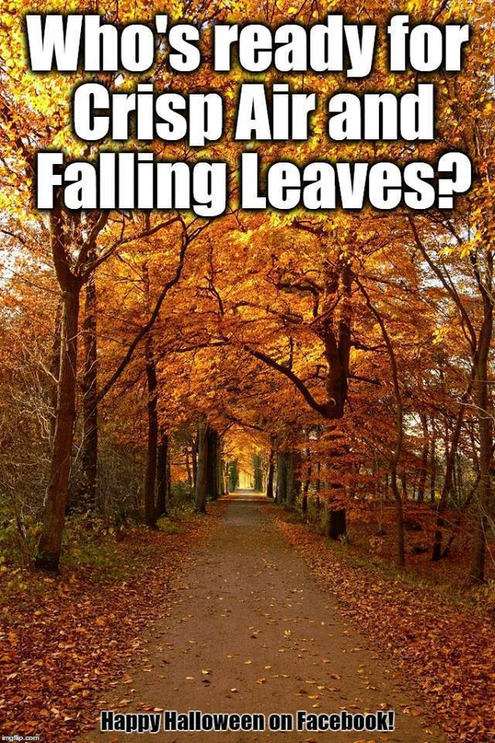

2026-2027

September 16 | Fall picture day
September 29 | Art Club 3:15-4:15
September 30 | Tech Training 3:30
October 27 | Art Club 3:15-4:15
October 29 | Tech Training 3:30
November 24 | Art Club 3:15-4:15
November 24 | Tech Training
November 30- December 4 | Book Fair
November 30-December 4 | Elf Gram Sales
December 15 | Art Club 3:15-4:15
January 26 | Art Club 3:15-4:15
January 28 | Tech Training 3:30
February 23 | Art Club 3:15-4:15
February 28 | Tech Training
March 30 | Art Club 3:15-4:15
April 12-16 | Book Fair
April 22 | Evening of the Arts
April 27 | Art Club 3:15-4:15

