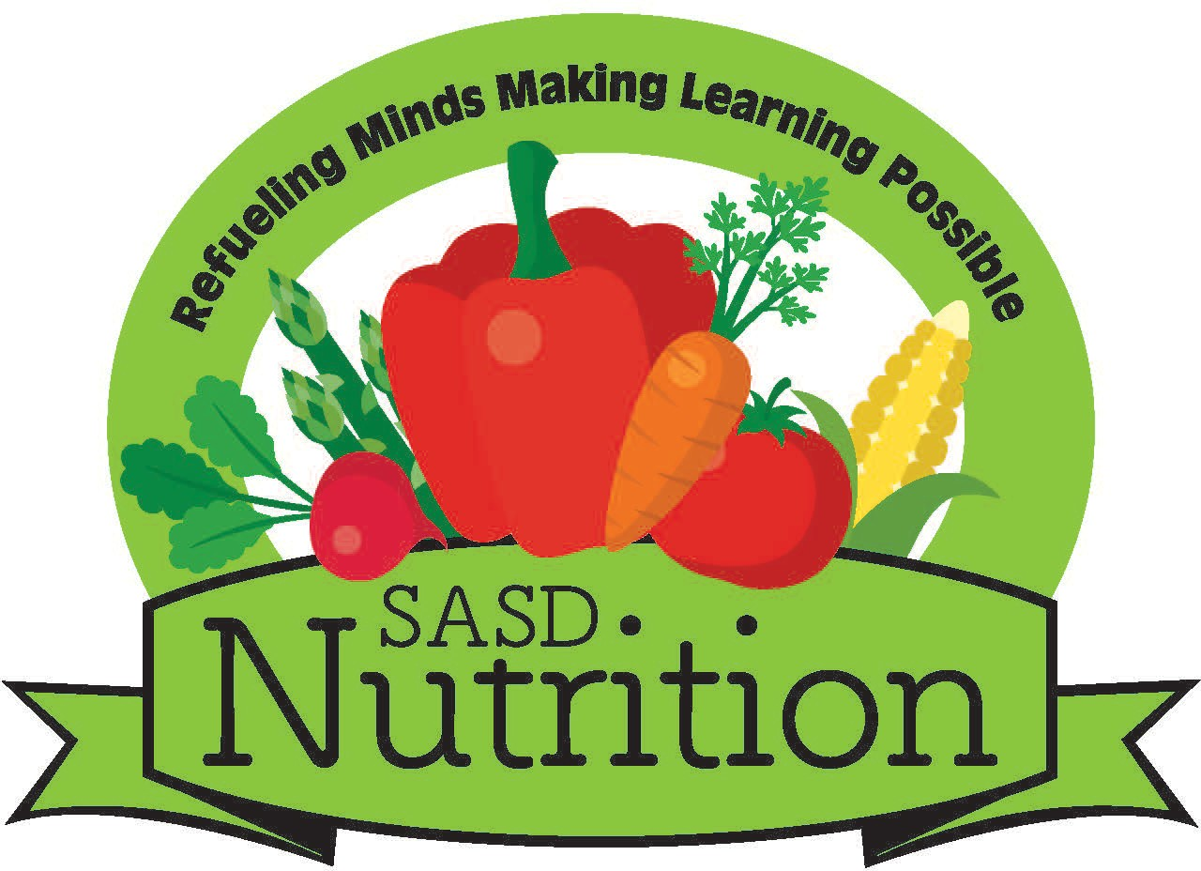
School Nutrition

830 Virginia Avenue
Sheboygan, WI 53081-4427
Phone: 920-459-3568 or
920-803-7904

MUAB COV NTAUB NTAWV TSO TAWM SIV NROG LWM COV PLHAUS NKAS PAB CUAM 26-27
**NTAWV CEEV CIA ZOO TSIS PUB LWM TUS POM ***

Nyob zoo txog Niam Txiv/Tus Neeg Saib Xyuas:
Kom tsis txhob xiam sij hawm thiab kom tsis txhob xiam dag zog, tej zaum kuj yuav muab cov ntaub ntawv/cov lus nej sau rau hauv daim ntawv thov pluas noj dawb/txo nqi los yog sis daim ntawv pom zoo (Direct Certification), tso tawm siv nrog lwm cov plhaus nkas los sis kev pab cuam yog hais koj tus me nyuam tsim nyog yuav tau txais lwm cov kev pab cuam no. Rau cov plhaus nkas pab cuam hauv qab no, peb yuav tsum tau lus tso cai los ntawm koj mas peb thiaj tso tau cov ntaub ntawv tawm rau lwm tus. Koj ua daim ntawv no xa rov tuaj los yeej tsis hloov txoj kev koj tus me nyuam tau txais pluas noj dawb los sis txo nqi.
- Tsis Kam! KUV TSIS KAM muab cov ntaub ntawv/lus sau nyob rau hauv kuv daim ntawv thov pluas noj dawb/txo nqi (Free and Reduced Price School Meals Application) tso tawm los sis siv nrog ib qhov plhaus nkas pab cuam twg.
- Kam! KUV KAM cov neeg ua num hauv tsev kawm ntawv muab cov ntaub ntawv/lus sau nyob rau hauv kuv daim ntawv thov pluas noj dawb/txo nqi (Free and Reduced Price School Meals Application) tso tawm.

Tsom iab looj qhov muag dawb
  - Txo nqi rau cov ntawv xeem hu SAT/ACT/AP
- Txo nqi rau chav kawm txuj ua si Rec Dept or Boys & Girls Club
- Txo nqi qiv Twj Paj Nruag
- Cov nqi ua daim ntawv mus kawm qib siab/CAPP

□ Kev pab cuam them kawm hauv xov huab cua (Internet Stipend)

Yog koj khij lub voj KAM rau kab lus hais los saum nov, thov ua daim ntawv hauv qab no kom tiav. Cov lus sau nyob rau hauv daim ntawv thov pluas noj dawb/ txo nqi no yuav muab khaws cia kom zoo thiab tsuas pub siv tshwj xeeb rau cov plhaus nkas pab cuam muaj npe li ntawm no xwb.
- Me NyuamNpe: Tsev KawmNtawv:

- Me NyuamNpe: Tsev KawmNtawv:

- Me NyuamNpe: Tsev KawmNtawv:

- NiamTxiv/ Tus Neeg Saib Xyuas Kos Npe: Hnub Tim:
- Sau Npe(txhobsausib cab):
- ChawNyob:

Tsev Kawm Ntawv Npe: (xa rovqabmusrau)

Tus Neeg SaibKev PabCuamNrog ThamTaulubnpe:
Xov Tooj:

(**Kuvyogtusneeg saib txog qhov kev pab cuam rau tsev kawm ntawv, kuv to taubtiascovlusntawm no yogcov lus tseem ceeb uas ceevciazootsispublawm tus paub thiabyuavmuabqhiatsistau raulwm qhov/cov plhausnkaspabcuam)

USDA Cov Lus Hais Txog Tsis Pub Cais Leej Twg (USDA Nondiscrimination Statement)

Raws li Tsoom Fwv Teb Chaws tsab cai lij choj hais txog neeg txoj cai thiab U.S. Department of Agriculture (USDA) cov cai tswj thiab cov cai qhia ua hauj lwm hais txog neeg txoj cai, lub koos haum USDA, nws cov Koom Txoos Khiav Hauj Lwm, cov chaw ua hauj lwm, thiab cov neeg ua hauj lwm, thiab cov tuamtsev ua hauj lwm uas koomrau hauv los yog muaj kev tswj fwm USDA cov kev pab caumraug txwv kom tsis pub muaj kev cais neeg tsis raws cai los ntawm haiv neeg, tsos nqaij daimtawv, keeb kwm teb chaws uas yug los, poj niam/txiv neej, muaj mob xiam oob qhab, hnub nyoog, los yog ua phemlos yog ua pauj rau ntawmqhov uas tau tawmlus tsis txaus siab txog neeg txoj cai yav dhau los hauv ib qho kev pab cuam uas tswj los yog tau nyiaj pab los ntawm USDA.

Cov neeg muaj mob xiam oob qhab uas nws thov kom muaj lwmcov hau kev los mus pab txoj kev sib cev lus kompaub txog qhov kev pab cuam(piv txwv li, muab cov ntawv pauv komsiv tes kov ces paub tias yog txhais li cas, ntaus tus ntawv komloj, muab cov lus kaw cia tau mloog, Mes Kas Kev Piav Tes Txhais Lus, thiab lwm yam), yuav tsum hu rau lub Koos Haum Khiav Hauj Lwm (hauv Xeev los yog hauv zos) nyob ntawmqhov chaw uas lawv ua ntawv thov kev pab. Cov tib neeg uas lag ntseg, hnov lus tsis zoo, los yog muaj teeb meem hais lus tsis tau yuav hu tau rau USDA los ntawm tsoom fwv txoj kev txhuas xo hu Federal Relay Service ntawm (800) 877- 8339. Ib qho ntxiv, ntawmcovxov haistxog cov kevpabcuam kuj yuav muaj txhais ua lwm homlus uas tsis yog lus As Kiv thiab.

Yog hais tias xav sau ib daimntawv tsis txaus siab txog qhov kev pab cuam, ua kom tiav daim ntawv USDA Program Discrimination Complaint Form USDA Program Discrimination Complaint Form, (AD-3027) nyob ntawm qhov vej xaij no: https://www.usda.gov/sites/default/files/documents/USDA-OASCR%20P-Complaint-
Form-0508-0002-508-11-28-17Fax2Mail.pdf , thiab nyob rauntawmUSDA ib qhovchawua hauj lwmtwg, los yog sau ib tsab ntawv xa mus rau USDA thiab qhia tas nrho cov lus komnug hauv daimntawv no tso rau hauv tsab ntawv. Yog xav thov ib daimqauvuas yog daimntawm tsis xaus siab, hu rau (866) 632-9992. Xa koj daimntawv uas muab ua tiav txhij txhua los yog tsab ntawv mus rau USDA uas yog:
(1) xa hauv tsev xa ntawv mus (mail): U.S. Department of Agriculture Office of the Assistant Secretaryfor Civil Rights
1400 Independence Avenue, SW
Washington, D.C. 20250-9410;
(2) fax: (202) 690-7442; los yog (833) 256-1665

(3) email: program.intake@usda.gov
Lubtuamtsev ua hauj lwm no yog ib qhovchawmuab kevpab cuamuas muabvaj huamsib luagrausawvdaws.

Rau Chav Ua Num Siv Xwb (Tsis txhob sau dhau kab no)
Return original form to Dawn Schutte in School Nutrition Services for confirmation of status. A copy of this form will be returned to Contact Person listed above.

Free

None

