Mollie S. Bakman Elementary School
  - 580 N. Helm Ave
  - Fresno, CA 93727

  - 559-253-6610
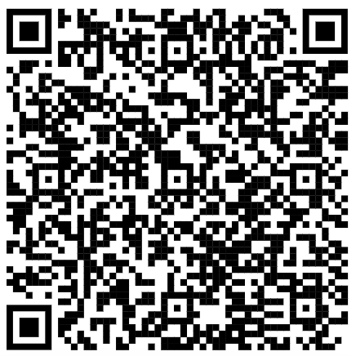

Scan the QR Code to access the digital Parent Handbook
Or visit: https://bakman.fresnounified.org/about/parent-handbook
Bakman Elementary School Mission Statement
The Bakman Elementary School community is dedicated to preparing all students for social emotional and educational success by upholding high expectations honoring diversity and building character.

  - Parent Handbook 2026-2027
  - Andrea Valdez, Principal Daniel Thomson, Vice Principal

Contents
Message from Ms. Valdez, Principal 4
2026-2027 Bell Schedule 5
Permit to Leave School 5
Breakfast/Lunch/Snack 5
Breakfast 5
Snacks 6
Birthday Celebrations 6
Arrival 6
Supervision 6
Morning Walk 6
Arrival Schedule 6
Early-Release Tuesdays 7
Schedule of School Hours 7
Bus Schedule 7
FUSD Academic Calendar 8
Student Behavior 8
Student Referral to the Office 8
Suspension 9
Notification Regarding Expulsion 9
Bakman’s Levels of Misbehavior 10
Student Dress and Appearance 10
Gang Related Apparel 11
Sun Protective Clothing 12
Sunscreen 12
Bus Rules 12
Student procedures to Follow During the School Day 13
Prohibited Items 13
Cell Phone Policy 13
Lost and Found 14
Emergency Cards (eCards) 14
Parents On Campus 15
Visitors 15
Volunteers (in Classroom) 15
Volunteers for Field Trips (Chaperones) 15
Medications 16
Illness 16
Dismissal 16
After School Recreation Program (ASES) 16
Effort Marks and Letter Grades 16
AR 5121 16
Promotion and Retention 17
Homework Policy 17
Report Card Periods 18
Study Trips (Field Trips) 18
Student Awards 19
Parent Partnership Programs 20
Uniform Complaint Policies (Eng, Sp, Hm) 21

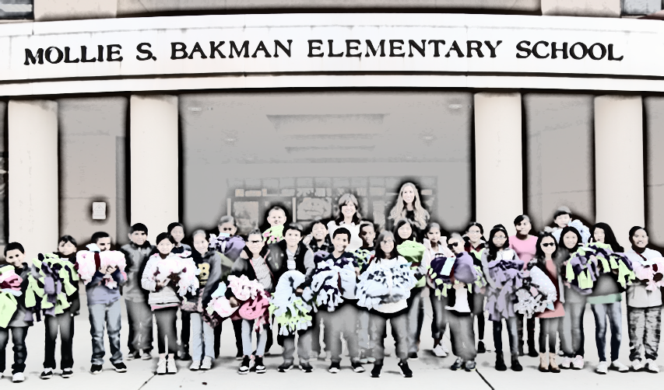

Message from Ms. Valdez, Principal
Dear Bakman Families,
Welcome to the 2026–2027 school year at Bakman Elementary School, Home of the Bruins! As we begin another exciting year together, I am filled with gratitude and optimism for all that lies ahead. Whether you are a returning family or joining our school community for the first time, we are honored to have you as part of the Bakman Bruin family.
To our returning families, thank you for your continued trust, support, and partnership. Your dedication helps make Bakman a place where students feel welcomed, challenged, and successful. To our new families, welcome! We are excited that you have chosen Bakman Elementary and look forward to building strong relationships with you throughout the year.
This year, we will continue to emphasize our Bruin GROWL Expectations, which guide our daily actions and help create the positive culture that makes Bakman special:
- G – Give it your best
- R – Respect others
- O – Observe the rules
- W – Work hard and work together
- L – Lend a hand
By living our GROWL expectations each day, our students develop responsibility, kindness, teamwork, and perseverance while helping to create a school community where everyone feels respected, supported, and empowered to succeed.

We know that student success is strongest when families and schools work together. We encourage you to stay connected, participate in school events, communicate regularly with your child's teacher, and reach out whenever you have questions, ideas, or concerns. Your partnership is invaluable, and together we can provide the best possible educational experience for every Bruin.
The 2026–2027 school year promises to be filled with opportunities for learning, growth, leadership, and celebration. I look forward to working alongside you as we support our students, celebrate their accomplishments, and continue building a school community where everyone belongs.
Once a Bruin, Always a Bruin!
Andrea Valdez
Principal
Bakman Elementary School
Home of the Bruins 🐻💙💛

2026-2027 Bell Schedule
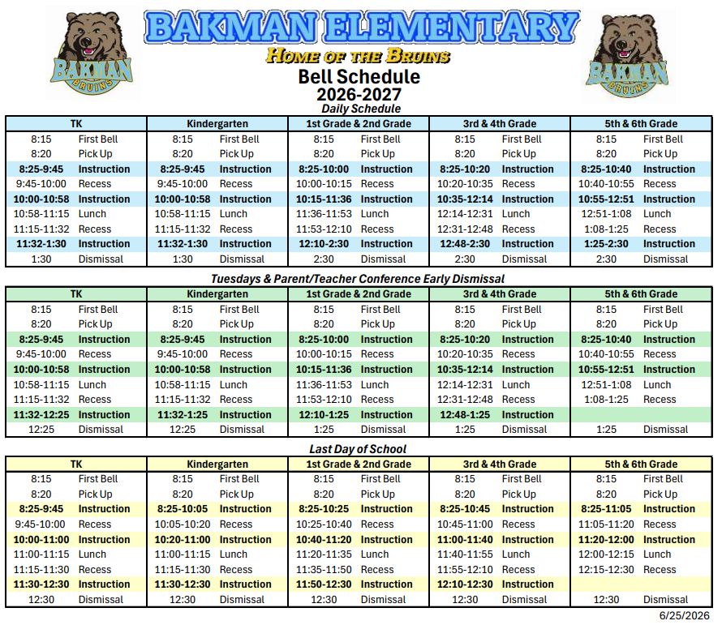

Permit to Leave School
Any child leaving school for a doctor or dentist appointment must be signed out of the office by the parent or person authorized on the emergency card. No child is to leave the school grounds during school hours unless approval has been granted by the school office.

Breakfast/Lunch/Snack

Breakfast
7:50am - 8:15 am
The cafeteria doors will close at 8:15 AM so that students will be able to get to class on time. Students who walk to school or are brought by car will not be fed after 8:15 AM. If the bus is late, bussed students only may eat breakfast after 8:15 AM.
Students eating breakfast at home should not arrive at school before 7:50 AM.

Snacks
Snacks are allowed at school under the following guidelines:
- Snacks must be healthy in nature i.e. fruit juices, water, fruit, yogurt, energy bars, raisins, etc.
- Containers, wrappers, papers, bottles, and any remaining trash must be thrown away.
- Snacks may only be eaten at morning recess in the snack area.
- NO SODAS, CANDY, GUM, OR CHIPS.

Birthday Celebrations
If parents plan on bringing cakes or celebration items, please bring them to the office at 2:00 PM. Celebrations will take place in the last 15 minutes of school as we do not interrupt class time during instruction. Helium-filled balloons will not be permitted.

Arrival

Supervision
Supervision is provided for students who do not eat breakfast beginning at 7:50 AM. The earliest a student should be at school is 7:50 AM to eat breakfast.

Morning Walk
Every morning, students will walk around the blacktop to get ready for the day of learning. Students may choose their pace (slower than a run, faster than a crawl). Exceptions include students who have written documentation from a medical professional explaining that it is not possible to walk. Also, students may choose to stay in the cafeteria, however, students must follow the cafeteria expectations or they may be asked to leave the cafeteria and join the stroll outside. Calm music will be played as well Monday-Thursday, with appropriate popular music played on Fridays.

Arrival Schedule
7:50-8:15 Walk on blacktop
8:15 Whistle, Freeze!
Whistle/Megaphone to release grade levels one at a time to WALK to their assigned spot
8:17 Bell Rings, lined up
- Hands, feet, objects to self
- Directly in line
- Leave space, but not too much space
- Stand silently
- READY TO LEARN
8:20 Teachers pick up
8:25 Instruction begins

Early-Release Tuesdays
Starting the 2024-2025 school year, school will be released early on most Tuesday afternoons to provide teachers time to plan and prepare for the students. Students will be released one hour early.
TK/Kinder: 8:25 am – 12:25 pm
1st-6th: 8:25 am – 1:25 pm

Schedule of School Hours
Pre-School | AM Session 8:00-11:00
 | PM Session 12:00-3:00
 | REGULAR SCHEDULE | EARLY RELEASE (Tuesdays)
Kindergarten & TK | 8:25 – 1:30 | 8:25 – 12:25
Grades 1-6 | 8:25 – 2:30 | 8:25 – 1:25

Bus Schedule
A detailed schedule is included in the beginning of the year packet sent home with students on the first day of school. If you would like an additional copy, please contact the office.

FUSD Academic Calendar
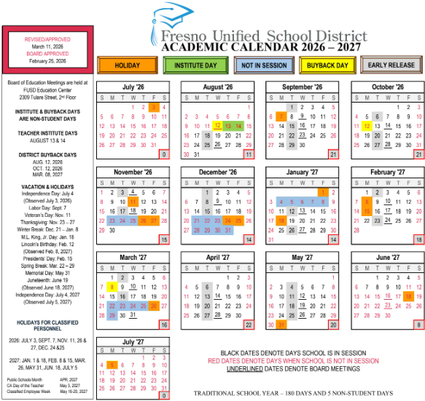

Student Behavior
Here at Bakman, we believe all our students can achieve success. As of the 2025-2026 school year, Bakman Elementary follows FUSD’s District Guidelines.

Structures and expectations are taught not only to protect our students and their property, but also to reinforce healthy social and emotional life skills. Students will be expected to follow schoolwide structures and expectations that are listed in accordance with the Fresno Unified Code of Behavior found in this packet.

Student Referral to the Office
Students will be sent to the office for Level 3 misbehavior, and in severe Level 2 cases. Incidents will be recorded in the students’ discipline log each time they are sent to the office. Consequences will be given based on Fresno Unified Behavior matrix and will align with natural consequences as much as possible.

Suspension
The purpose of suspending a student is to allow staff time to organize a more intensive intervention. Administrators will follow FUSD Discipline Guidelines to identify needs and target intervention and supports for all parties. If suspension is appropriate, parents and appropriate staff will be notified of the suspension. Upon returning to school, the student begins with a “CLEAN SLATE”. If appropriate, a re-entry circle will be held. If the teacher has not completed a Full DESSA assessment for the suspended student, the teacher will be asked to complete that to get more information about ongoing supports and prevention.

KEY POINT: ACCESS, CONSISTENCY, AND COMMUNICATION

Notification Regarding Expulsion
The Fresno Unified School District Board of Education has established policies and standards of behavior which promote learning and protect the safety and well-being of students. When these policies are violated, it may be necessary to suspend or expel a student. Board Policy 5144.1 aligns with the California education code in the approaching to serious offenses.
The following offenses will warrant a mandatory referral for expulsion:
- Brandishing of loaded or unloaded firearm
- Brandishing a knife at another student
- Unlawfully selling a controlled substance
- Sexual assault (including attempt) or sexual battery
- Possessing an explosive
The offenses listed above will not be tolerated in school buildings, school grounds, and buses, going to or coming from lunch or school or at any school-sponsored activity.
For all other violations the principle shall have the discretion to recommend expulsion of a student. If expulsion is recommended, the Board shall order the student expelled only if it makes the finding of either or both of the following:
- That other means of correction are not feasible or have repeatedly failed to bring about proper conduct;
- That due to the nature of the violation the presence of the student causes a continuing danger to the student or others.
Students who violate applicable penal codes referenced by the board policy will be referred to the appropriate law enforcement authorities.
This Board policy is publicized and each student and parent/guardian will be asked to sign a copy of the Notification Regarding Expulsion. If the letter is not returned to the school the policy still applies to all students.

Bakman’s Levels of Misbehavior
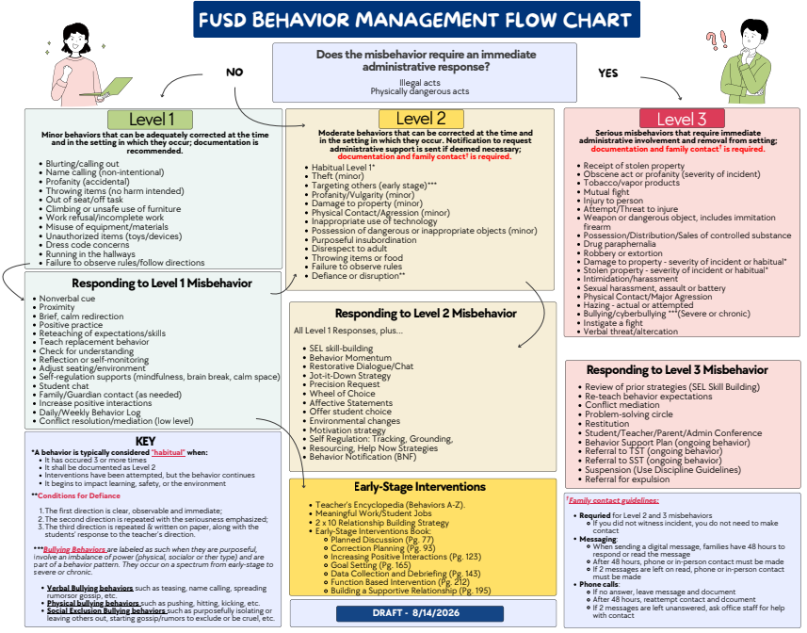

Student Dress and Appearance
The responsibility for the dress and appearance of a student rests primarily with the student and their parents or guardians. In the interest of maintaining an appropriate learning environment, the district believes in the following basic principles:
- All students are encouraged to dress in a manner that is appropriate, comfortable and conducive to an active academic school day.
- Students should be able to wear clothing without fear of or actual unnecessary discipline or body shaming.
- The student dress code should serve to support all students to develop a body-positive self-image.
- The district standard dress and appearance policy is gender neutral and applies to all students equally regardless of gender on school campuses and at school-sponsored functions and will be enforced consistently and fairly by all members of the school staff.
- Clothing and hair styles are a matter of personal choice (except for schools with uniforms). The school shall be concerned only when these impact the health and safety of students and staff.
Examples of inappropriate clothing include:
- clothing where the buttocks or torso is exposed, i.e., tube tops, half shirts, halters
- clothing that is see-through. (clothing must be opaque)
- clothing or accessories which show profanity, obscene words or pictures, sexually suggestive statements, or incites to violence
- clothing representing gang-related activities
- clothing where the entire thigh is exposed, such as micro minis or short shorts.
- bathing suits or cut-offs
- the wearing and carrying of tobacco promotional items, or items promoting controlled substances (drugs) and/or alcohol
- clothing where undergarments are exposed
- clothing that has text that is libelous, bullying, constitutes harassment or discrimination
- footwear must be worn at school and all functions
- no backless footwear for elementary students
Additionally, site leadership may establish a site-specific dress code addendum in the following circumstances:
- Times when students are engaged in extracurricular or other special school activities and where the standard dress and appearance policy would not be appropriate for the activity.
- Times when students are engaged in specific courses where modification is needed to ensure the safety of the students engaged in the class. Examples include lab sciences, CTE classes or other classes that contain potential hazards.
- Schools may set their own site-specific addendum relating to hats, caps and other head coverings. There shall be no restriction on student head coverings worn for bona fide religious purpose.
- Each school site, in accordance with the District Dress Code Review Process may develop additional guidelines stricter than the district’s minimum standard dress and appearance policy; however, these site-specific dress code addendums may not contradict the district’s dress and appearance policy outlined in this AR. Schools are responsible for following the identified district policies on notification of students and parents for their site-specific addendums.

Gang Related Apparel
Gang-related apparel is not acceptable. If individual schools that have a dress code prohibiting gang-related apparel at school or school activities, the principal, staff and parents/guardians participating in the development of the school safety plan shall define “gang-related apparel” and shall limit this definition to apparel that reasonably could be determined to threaten the health and safety of the school environment if it were worn or displayed on a school campus. (Education Code 32282)
Principals will collaborate with Law Enforcement Agencies to update changes in gang-related apparel at the beginning of each semester or as often as needed. Because gang-related symbols are constantly changing, definitions of gang related apparel shall be reviewed at least once each semester and updated whenever related information is received.

Sun Protective Clothing
Each school site shall allow for outdoor use during the school day, articles of sun-protective clothing, including, but not limited to, hats, provided that sun-protective clothing does not otherwise violate this regulation. Each school site may set a policy related to the type of sun protective clothing, including, but not limited to, hats, that students will be allowed to use outdoors, if that policy is stricter than this regulation. Specific clothing and hats determined by the school district or school site to be gang-related or inappropriate apparel may be prohibited by the school site’s dress code policy.

Sunscreen
Ed Code 35183.5 (b)
Each school site shall allow pupils the use of sunscreen during the school day without a physician's note or prescription.
Each school site may set a policy related to the use of sunscreen by pupils during the school day.

Bus Rules
Bus transportation is a service and a privilege. Students must follow all State Health Department requirements while riding the bus which can include, but not limited to wearing a mask. A school administrator, following written communication from the bus driver involved, may discipline students who are cited for the violations listed below. Further disciplinary actions for multiple violations could result in a suspended or loss of bus privileges.
- Leaving seat while bus is in motion.
- Kindergarten parents failing to pick up their child from the bus stop.
- Tampering with bus equipment.
- Obstructing the aisle with legs, feet or other objects.
- Not sitting facing the front of the bus
- Putting any part of the body out of the bus windows.
- Eating or drinking on the bus.
- Failing to cross the street in front of the bus under the driver’s supervision.
- Having dangerous objects (glass, knives, etc.) on the bus.
- Being defiant or uncooperative with the bus driver needing constant correction.,
- fighting or using body contact on the bus, or while loading or unloading.
- Damaging or defacing the bus.
- Making unnecessary noise or commotion, whistling, or calling people from the bus.
- Giving improper identification when requested by the bus driver.
- Throwing objects from the bus window or while at the bus stop.
When a student rider receives a bus citation, the following occur:
- The rider and his or her guardian will be given notice and warning.
- Upon a second offense, the rider can be denied transportation services for a period not to exceed two weeks.
- Upon a third offense, the rider may be denied transportation services for the remainder of the school year.

Student procedures to Follow During the School Day
- Maintaining our beautiful school campus by…
  - staying out of planted areas
  - not throwing balls against walls of the school building
  - picking up litter and placing it in trash cans
  - staying off grassy areas except on the playground.
- Make family arrangements in the morning about what students are to do after school. The office phones are for emergency use only and the office staff determines what qualifies as an emergency.
- In the cafeteria, students are to talk in quiet voices clean up after themselves and not take food out of the cafeteria.
- Walk at all times on the campus unless at recess or PE.
- Do not play in the restrooms or hallways.
- Before school starts, during recess, lunch, and after school, students are not allowed in the main building unless accompanied by a teacher. Students not assigned to classrooms on the 2nd floor are prohibited from going upstairs.

Prohibited Items
Toys are not to be brought to school for any reason. Bringing toys creates several problems. It takes away from the learning environment and causes problems dealing with lost and stolen toys. If toys are brought to school a teacher or administrator will take the toy away and may request that the parent pick up the toy. Toys may include laser points, spinners, game cards, and balls.

Cell Phone Policy
The Bakman Elementary Community would like to inform you about an important school policy taking place this upcoming school year. All of Bakman Elementary campus will be “cell phone free zones” as well as any cell phone accessories or communication devices. Assembly Bill No. 3216 authorizes a governing board to regulate the possession or use of electronic devices. All cell phones will be securely stowed away from arrival on campus to dismissal from campus.
Our school has agreed that a consistent school-wide policy to eliminate cell phone use will help students stay more present and engaged in their learning. Our intent is to support all our students in their academic success by removing a major temptation and distraction. We ask that parents/families use the main office when communicating messages from home or school. Students who need to make an emergency call during the day may come to the main office. If parents need to contact their child during school hours, please contact the main office. If a cell phone/ electronic device rings, vibrates, or is used for any reason without teacher permission, or is visible anytime anywhere on campus, students will be subject to consequence outlined below.
Summary of Cell Phone Policy
- Cell phones are prohibited from being used anywhere on campus from the gate to arrival to the gate at dismissal. School-issued devices will be the primary tool for instruction.
- Parents can communicate with students by calling the main office.
- ParentSquare will be used for important school updates, including emergency notifications.
Cell Phone Policy Consequences: *
- 1st Violation: The student will receive a verbal warning from the teacher. Phones will not be confiscated if students turn the phone off and put the cell phone away in their bag.
- 2nd Violation: A Level 2 behavior is documented on ATLAS, and the cell phone or mobile device is held in school office until student picks up the device at dismissal.
- 3rd Violation: A Level 3 behavior is documented on ATLAS; the cell phone or mobile device is held in school office until a parent/guardian picks it up.**
Chronic Violations: Parent Meeting will be held with an administrator. Students must check in their cell phone each day by first school bell and pick up after the last scheduled class for the rest of the school year.
*Students who do not follow teacher directives will be acting in defiance which could result in disciplinary action
**Confiscated Cell Phones will be arranged to be picked up by parents/guardians and vice principal.
It should be noted that neither the school nor any of its employees are responsible for the loss or damage to any student’s phone or electronic devices, whether in the student’s possession or confiscated by the staff. It is the responsibility of the student to adhere to this policy and to always secure his or her belongings. Classes and/or instruction will not be stopped to address or search for lost phones/devices.
Emergency Protocols: ParentSquare will be the primary source of information communicated to parents during an emergency; students can still communicate through staff-approved procedures. Parents are encouraged to use ParentSquare for immediate contact with the school rather than texting students directly during class hours.
Your Support Matters
- We recognize this is a shift and may require adjustments at home as well. This is a commitment to helping our students thrive.
- Talk to your child about the benefits of disconnecting during the school day.
- Use school communication tools like ParentSquare to stay in touch when needed.
This policy is subject to revision as necessary, and any changes will be communicated to parents accordingly.

Lost and Found
Lost and found items are kept in the cafeteria. Please remember to write your child's name in the inside of any outerwear and jackets. At the end of each semester, items that are not claimed may be donated to a charitable organization.

Emergency Cards (eCards)
Emergency cards will be completed online. Instructions will be included in the first-day packets for families. All information will then be available on ATLAS. This information is essential in case of emergencies and therefore must be completed as quickly as possible. If any parents are struggling to complete, please let Home School Liaison know so they can work for families to complete.

Parents On Campus
For the majority of students, our 1st-6th graders, parents drop off at the front gate and students will walk onto campus to either eat breakfast or go directly to the blacktop. Parents are asked to allow their students to follow this procedure independently to help maintain the security of our campus and help students acclimate to the procedures and routine of our campus. For our Kinder and TK students, parents can wait with their students in the Kinder Drop Off area. Additionally, TK and Kinder students can be dropped off to eat breakfast in the cafeteria and be walked by staff to their classrooms. Pre-School and SDC parents can sit with their students in the cafeteria and wait to be picked up.
For the first week of the school year, parents are permitted to walk with their students onto campus and wait with them. However, when students are picked up at 8:20, parents will be asked to allow teachers to move them to class so as not to interrupt instruction.

Visitors
For the safety of our students and staff, all visitors must report to the school office and go through the Raptor system before getting a visitors pass. The Raptor visitor’s pass must be turned in upon completion of the visit.

Volunteers (in Classroom)
Parents and other adults who would like to volunteer in the classroom are greatly encouraged to do so. Please contact classroom teachers to discuss availability and the nature of tasks needed to complete. When parents or other adults come to school to volunteer, they will be asked to bring a photo ID and submit it to the RAPTOR system in the office. They will be given an ID sticker, which must be worn at all times on campus. They must also sign out of the system by checking in with the office staff when they are leaving campus. This procedure ensures the safety of our students and allows school administrators and support staff to know who is on campus in case of an emergency.

Volunteers for Field Trips (Chaperones)
Parents and other adults who would like to attend class field trips are a necessary part of the experience. Parents or other adults must be 18 years old, have a valid state identification card (driver’s license), and be willing to support students to stay safe and follow safety procedures. Teachers will let parents know when there is a field trip and select a group of chaperones based on needs (some trips require a 1:10 adult to student ratio, others 1:5). Once chaperones are selected, they must be fingerprinted. District will cover the cost of fingerprinting for parents who have been selected to chaperone a specific field trip. Parents can check with the office if they have been fingerprinted in the past or for a different sibling. Once you have been fingerprinted, you do not need to be fingerprinted again as long as your student is in Fresno Unified. Chaperones, please communicate with teachers and staff about any upcoming issues as soon as possible.

Medications
Only medications or medical equipment (such as crutches, slings, soft casts, etc) prescribed by a doctor can be administered or used at school. Students cannot be sent to school with prescription medication, over the counter medicine or medical equipment without a doctor’s note. A parent or guardian must provide the Bakman Health office with a signed doctor’s note including complete instructions for medications and medical equipment. A consent form, signed by the parent or guardian and the physician, explaining the time and dosage to be given along with any special instructions is necessary. Medications will be stored in a locked cupboard in the nurse’s office.

Illness
If your child becomes sick during the school day the parent will be contacted. If the parent cannot be reached, another person on the emergency card will be contacted. Students cannot be released to walk home, be picked up by someone under the age of 18, or by someone who is not listed on the emergency card.

Dismissal
Please clarify any change to after school routines with your child before they come to school. It is not always possible that your child can receive a message during the school day.
During dismissal, please encourage proper pedestrian and traffic procedures. It is unsafe for a student to exit or enter a car in the middle of the parking lot or street.

After School Recreation Program (ASES)
The ASES Program operates daily from 1:30 AM-6:00 PM daily.

Effort Marks and Letter Grades
Kindergarten students will be given progress indicators based on standards outlined on the district kindergarten assessments. In the 1st grade effort and progress marks will be recorded. In 2nd through 6th grade, effort and achievement marks will be recorded. 2nd grade students will be given only effort marks for the first two report periods.

AR 5121
As a general practice, students working below the standards of expected student achievement for their grade level may not receive a mark higher than a "C." Exceptions to this rule require administrative approval and direct parent/guardian communication.
In order to receive an A, B, or C, students must be reading on or above grade level and doing A, B, or C work. Students at any level in any academic area can receive a lower grade than their ability level if their assignments are of poor quality or are incomplete.

Promotion and Retention
Students will be identified at the end of the first quarter if they are a “Candidate for Retention” or “At Risk of Retention.” Kindergarten students will be identified after the second reporting period. Parents will be informed at the parent teacher conference held in October. At that time, you and your child's teacher will discuss and plan interventions that will assist in your child meeting grade level requirements.
The biggest factors when discussing retention are gaps in attendance and enrollment, so the first and best intervention for students is bringing students to school every day and enrolling them as early as possible.

Homework Policy
Homework may be assigned by your student’s teacher. It is assigned by teachers for two possible purposes: to give students opportunity to practice skills; or, to elaborate on introduced material.
We recommend the following:
- Be prepared. Have all your materials or homework ready in your backpack.
- A place to do homework. If possible, you're shy your child should do his or her homework in the same place (an uncluttered quiet place to study).
- A schedule for completing homework. Set a homework schedule that fits in with each week's particular activities.
- Encouragement, motivation, and prompting. It is not a good idea to sit with your child and do homework with them. Your child needs to practice independently and to apply what he or she has learned in class.
- Understanding of the knowledge. When your child is practicing a skill ask which steps he or she finds difficult and easy and how he or she plans to improve. If your child is working on a project, ask what knowledge he or she is using to complete the work. If your child consistently cannot answer these questions. Please contact their classroom teacher.
- Reasonable time expectations. If your child seems to be spending too much time each night on homework, please contact their classroom teacher.
- Reach out to your teacher when you need help. E-mail or message your teacher when you or your student are stuck or need help we are here to help and we'll get back to you or schedule a time to work together!
Bedtime. When it is time to go to bed, please stop your child, even if he or she has not finished the homework.

Report Card Periods
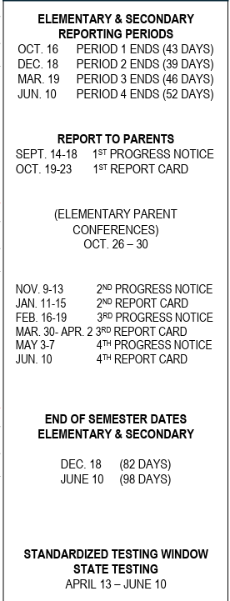

Study Trips (Field Trips)
Study trips are part of the educational experience. Students may have an opportunity to attend study trips throughout the school year. Classroom teachers will provide detailed information about the study trip they are planning. Permission slips will be sent home. Students will not be allowed to attend a study trip unless a permission slip has been signed and returned to school. We cannot accept permission to attend a study trip over the phone. There may be some cases where parents will be requested to accompany their child on a study trip due to behavior and or safety concerns. Any child who has had repeated behavior contracts or was suspended from school in the weeks prior may be excluded from any field trip away from the school site. The exclusion will be the option of the teacher and or school administrator and is based upon supervision concerns regarding the safety of your child as well as the teachers’ responsibility for every child in their care.

Student Awards
Each quarter we will hold a special awards assembly. Certificates will be given for perfect attendance, citizenship and academic accomplishment.
Assemblies will be held about three weeks after the end of the quarter.
Award templates will be sent out the week grades close. They will be due back to admin two business days after grades are due. This lead time allows time for the awards to be printed.
- Grades - Grades 2 (2nd semester), 3-6
  - Principal’s Honor Roll – GPA 4.0
  - Honor Roll – GPA 3.5 – 3.99
  - Merit List - GPA 3.0 – 3.49
- iReady (D2 & D3)
  - Charm – At least ten points of growth between diagnostics
  - Voucher – Meeting TYPICAL growth in Reading and/or Math
  - Pizza Party – Meeting STRETCH growth in Reading and/or Math
  - Donuts with Parents – Top performing students in Reading and/or Math per grade level
- SBAC
  - 4th-6th Grade students who earn meets or exceeds standard are awarded the following year at the Q1 awards assembly
- EL Reclassification
  - The English Learner Department recognizes students who achieve reclassification each year with a medal and an achievement award. This is presented to students during their Quarter Awards assembly.
- Attendance
  - Individually: Students with 95+% attendance for the quarter receive an award.
  - Class: The highest percentage attendance in the school will be rewarded weekly. Classes will be shouted out on Monday announcements and will house a trophy for the week. Every percentage point counts and ONLY the highest percentage classes will bring home the award each week!
- Citizenship/SEL/Character
  - Teacher pick one student a month that exemplifies the pillar of character that is being focused on that month. They will also be recognized at our quarterly awards assembly.
  - Character Counter Monthly Focus
- September: Trustworthiness
- October: Respect
- November/December: Responsibility
- January: Fairness
- February: Caring
- March: Citizenship
- April: Trustworthiness
- May: Respect
- June: All Pillars of Character

Parent Partnership Programs
Bakman Elementary School is committed to a Parent Partnership relationship. Research shows a positive correlation between parental engagement and academic achievement. We encourage your involvement in any of the following activities:
- Back to School Night
- Parent Teacher Conferences
- School Site Council (SSC)
- English Language Advisory Committee (ELAC)
- Parking Lot/Traffic Volunteers
- Open House
- Family Movie Night
- Sunnyside Regional Literacy Night
- Parent Coffee Hour
- Pan Dulce with Loved Ones
- Awards Assemblies
- Much, much more!!

Uniform Complaint Policies (Eng, Sp, Hm)
Fresno Unified Exhibit (E) 1312.4 (a)
Williams Uniform Complaint Procedures
Notice To Parents, Guardians, Pupils, and Teachers:
Pursuant to Education Code 35186, you are hereby notified that:
1. There should be sufficient textbooks and instructional materials. For there to be sufficient
textbooks and instructional materials, each pupil, including English learners, must have a textbook or
instructional material, or both, to use in class and to take home. Instructional Materials are:
Grades K-12 English/language arts, Mathematics, history/social science,science
Grades 7-12 Foreign Language
Grades 9-12 Laboratory science equipment
2. School facilities must be clean, safe, and maintained in good repair.
3. There should be no teacher vacancies or misassignments as defined in Education Code 35186 (i) (2)
and (3). There should be a teacher assigned to each class and not a series of substitutes or other
temporary teachers. The teacher should have the proper credential to teach the class, including the
certification required to teach English learners, if present.
Teacher Vacancy means a position to which a single designated certificated employee has not been
assigned at the beginning of the year for an entire year or, if the position is for a one-semester course, a
position to which a single designated certificated employee has not been assigned at the beginning of a
semester for an entire semester. (Education Code 35186; 5 CCR 4600)
Misassignment means that the placement of a certificated employee in a teaching or services position
for which the employee does not hold a legally recognized certificate or credential or the placement of a
certificated employee in a teaching or services position that the employee is not otherwise authorized
by statue to hold. (Education code 35186; 5 CCR 4600)
4. If you choose to file a complaint alleging that any of the above conditions is not being met, your
complaint will be addressed through the district’s Williams uniform complaint procedures as required by
law. A complaint form may be obtained at each school’s office or Constituent Services Office at 2309
Tulare, Fresno Unified, Fresno, CA 93721, or downloaded from the district’s website at
https://board.fresnounified.org/williams-case/.
You may also download a copy of the California Department of Education (CDE) complaint form from
CDE's, website when available. However, a complaint need not be filed using either the district's
complaint form or the complaint form from CDE.
Exhibit (1) FRESNO UNIFIED SCHOOL DISTICT
Approved: January 6, 2005 Fresno, California
Revised: January 24, 2008
Revised: June 2, 2011
Revised: January 5, 2012
Revised: June 21, 2016
Revised: May 23, 2022
Revised: November 13, 2023
Policy Section: 1000 Community Relations

Fresno Unified Exhibit (E) 1312.4 (a) Procedimientos de Quejas Uniformes Williams
Aviso Para los Padres, Tutores, Estudiantes y Maestros:
De Acuerdo al Codigo de Educacion 35186, por este medio usted esta siendo notificado que:
1. Debe haber suficientes libros y materiales educativos. Para que haya suficientes libros y
materiales educativos, todos los estudiantes, incluyendo los Estudiantes Aprendices de Ingles,
deben tener un libro o material educativo, o ambos, para usarlo en clase y para llevarlo a casa.
Materiales Educativos:
Grados K-12: Ingles/Artes de Lenguaje, Matematicas, Historia/Ciencias
Sociales, Ciencias
Grados 7-12: Idioma Mundial
Grados 9-12: Equipo de Laborat01io de Ciencias
2. Las instalaciones escolares deben estar limpias, seguras y mantenidas en buenas
condiciones. Un número adecuado de baños para alumnos debe estar abierto, limpio,
abastecido y completamente funcional.
3. No debe haber vacancias de maestros(as) o asignaciones equivocadas como lo es
definido en el Codigo de Educacion 35186 (i) (2) y (3). Debe haber un maestro asignado para
cada clase y no una serie de sustitutos u otros maestros temporarios. El maestro debe tener las
credenciales apropiadas para ensefiar la clase, incluyendo la certificacion requerida para
ensefiar a Estudiantes Aprendices de Ingles, si es que hay.
Vacante de Maestro significa una posicion la cual un solo empleado certificado designado
no ha sido asignado al comienzo del afio escolar por todo un afio o si la posicion es por un
curso de un semestre, una posicion en la cual un solo empleado certificado designado no
ha sido asignado al comienzo de un semestre portodo un semestre. (Codigo de Educacion
35186; 5 CCR4600)
Asignado equivocadamente significa que la colocacion de un empleado certificado en
posicion de maestro o de servicios por la cual el empleado no obtiene un certificado o
credencial reconocido legalmente o la colocacion de una posicion maestro o de servicios
que el empleado no esta de otra manera autorizado por estatus para mantenerlo
(Codigo de Educacion de 35186; 5 CCR 4600)
4. Si decide sumeter una queja alegando que no se cumplio alguna de las condiciones
anteriores, su queja sera revisada de acuerdo al proceso de quejas Uniformes Williams del distrito
según lo que exige la ley. Se puede obtener un formulario de queja en la oficina de cada escuela o,
Oficina de Servicios al Constituyente, 2309Tulare Street, Fresno, CA 93721 o puede ser bajado de
la pagina de internet del distrito https://board.fresnounified.org/williams-case/
También puede descargar una copia del formulario de queja del Departamento de Educación de
California (CDE) del sitio web del CDE cuando esté disponible. Sin embargo, no es necesario
presentar una queja utilizando el formulario de queja del distrito o el formulario de queja del CDE.
Exhibicin (1) DISTRITO ESCOLAR UNIFICADODE FRESNO
Aprobado: 6 de enero 2005 Fresno, California Revisado:
24 de enero 2008
Revisado: 2 de junio2011
Revisado: 5deenero 2012
Revisado: 21 de junio 2016
Revisasdo: 23 de mayo 2022
Revisasdo: 16 de junio 2023
Revisasdo:13 de noviembre 2023
Policy Section: 1000 Relaciones de la Comunidad

Fresno Unified Exhibit (E) 1312.4 (a)
Williams Cov Kev Tang Ua Kev Tsis Txaus Siab Raws Qauv
Ntawv Rau Cov Niam Txiv, Cov Saib Xyuas, Cov Menyuam Kawm Ntawv thiab Cov Xib Fwb:
Raws Li Kev Kawm Ntawv Txoj Cai 35186, koj tsaug qhia ntawm no tias:
1. Nws yuav tsum muaj cov phau ntawv qhia thiab cov ntaub ntawv qhia zoo. Kev ua kom muaj cov
phau ntawv qhia thiab cov ntaub ntawv qhia zoo rau txhua tus menyuam kawm ntawv,
no los yeej yog hais txog cov menyuam kawm ntawv Askiv yog horn thib ob, yuav tsum muaj
cov phau ntawv qhia los sis cov ntaub ntawv qhia coj los siv nyob rau hauv chav qhia ntawv
thiab hauv tsev. Cov ntawv qhia:
Qib K-12: Ntawv qhia Askiv, Lej, Keeb Kwm/Kev Noj Nyob, Science
Qib 7-12: Ntawv qhia txog lwm horn lus
Qib 9-12: Kawm Science muaj cov khoom siv (Laboratory Science Equipment)
2. Tsev kawm ntawv yuav tsum huv, puaj phais, thiab zoo khov kho. Cov chav dej siv yuav tsum
muaj txaus rau cov menyuam kawm ntawv kom huv siab si, khaws cia tej ntaub siv thiab siv ua
haujlwm kom tau zoo.
3. Nws yuav tsum muaj tus xib fwb qhia thiab teev kom muaj tus xib fwb qhia li hais nyob
hauv Kev Kawm Ntawv Txoj Cai 35186 (i) (2) thiab (3). Nws yuav tsum muaj ib tus xib fwb tso rau
ib chav qhia ntawv, tsis txhob cia muaj cov neeg tuaj hloov xwb los sis lwm cov xib fwb tuaj qhia
xuaj qhaus xwb. Tus xib fwb ntawm yuav tsum muaj daim ntawv qhia chav ntawv ntawm zoo li
daim ntawm qhia cov menyuam kawm ntawv uas kawm ntawv Askiv yog horn lus thibob.
Tsis muaj tus xib fwb no yog txhais tau hais tias tsis tau muab ib tus neeg ua hauj lwm
muaj daim ntawv qhia coj los tso rau chav qhia ntawv thaum lub xyoo pib rau tas nrho
lub xyoo xaus los sis yog hais tias qhov kev qhia ntawm ruas yog ib nrab xyoo xwb, los
sis yog tsis muab tus neeg muaj daim ntawv qhia ntawm tso ua ntej thaum lub nrab
xyoo pib mus txog thaum kawg. (Kev Kawm Ntawv Txoj Cai 35186; 5 CCR 4600)
Teev tsis muaj tus xib fwb no yog txhais tau hais tias muab tus neeg ua hauj lwm muaj
daim ntawv qhia ntawv tso rau ib qhov chaw qhia ntawv uas tus neeg ntawm tsis muaj
daim ntawvqhia chav ntawv ntawm los sis muab ib tus neeg ua hauj lwm muaj daim
ntawv qhia ntawv tso rau ib chav ntawv uas tsis tsaug cai (Kev Kawm Ntawv Txoj Cai
35186; 5 CCR 4600)
4. Yog tias koj xaiv ua ntawv tsis txaus siab hais tias ib qho ntawm cov xwm txheej saum toj no tsis ua
raws li, koj qhov kev tsis txaus siab yuav raug hais los ntawm koog tsev kawm ntawv Williams cov txheej
txheem tsis txaus siab raws li txoj cai. Daim ntawv tsis txaus siab tuaj yeem muab tau ntawm txhua lub tsev
kawm ntawv lub chaw ua haujlwm lossis Constituent Services Office ntawm 2309 Tulare Street, Fresno,
CA 93721, los sis yog ntawm hauv paus tsev kawm ntawv qhov website ntawm
https://board.fresnounified.org/williams-case/
Koj tuaj yeem rub tawm ib daim ntawv theej ntawm California Lub Tsev Haujlwm Saib Xyuas Kev Kawm
Ntawv (CDE) daim ntawv tsis txaus siab los ntawm CDE's, lub vev xaib thaum muaj. Txawm li cas los xij, yuav
tsum tsis txhob xa tsab ntawv tsis txaus siab uas yog siv lub hauv paus tsev kawm ntawv daim ntawv tsis
txaus siab lossis daim ntawv tsis txaus siab los ntawm CDE.
Exhibit (1) FRESNO UNIFIED SCHOOL DISTRICT Tsocaisiv:lbHlisTim6,2005 Fresno, California Kho
dua: lb Hlis Tim 24, 2008
Kho dua: Rau HliTim 2, 2011
Kho dua: lb Hlis Tim 5, 2012
Kho dua: Rau Hli Tim 21, 2016
Kho dua: Tsib Hlis Tim 23, 2022
Kho dua: Kaum Ib Hlis 13, 2023
Policy Section: 1000 Community Relations

