Altamaha Elementary School
Parent Engagement Plan for Shared Student Success
2026-2027 School Year
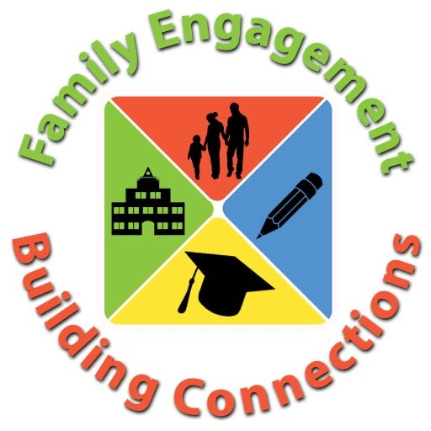
Altamaha Elementary School
Dr. Angela M. Haynes, Principal
Altamaha School Road
Baxley, GA 31513, (912)367-3713
www.appling.k12.ga.us
Revised: 6/1/2026

School Plan for Shared Student Achievement
What is it? This is a plan that describes how Altamaha Elementary will provide opportunities to improve parent engagement to support students’ learning. Altamaha Elementary values the contributions and engagement of parents in order to establish an equal partnership for the common goal of improving student achievement. This plan describes the different ways that Altamaha Elementary will support parent engagement on how parents can help plan participation in activities or events that promote students’ learning at school and at home.
How is it developed? Altamaha Elementary School welcomes parent input and comments at any time regarding the plan. All parent feedback will be used to revise the plan for next year. The plan is posted on the school website under Title I for parents to view. We also distribute an annual Title I survey to ask parents for their suggestions on the plan and the use of funds for parent engagement. Parents can also give feedback during parent meetings, Parental Advisory Council meetings, and the Title I meetings for next school year.
Who is it for? All students participating in the Title I, Part A program and their families are encouraged and invited to fully participate in the opportunities described in this plan. Altamaha Elementary will provide opportunities for the participation of parents with limited English, parents with disabilities, and parents of migratory children.
Where is it available? At the beginning of the year, the plan is copied and sent home with all students. As a reminder, we let parents know how to access the plan on the school website and in the school office. 

What is Title I?

Altamaha Elementary is identified as a Title I school as part of the Elementary and Secondary Education Act of 1965 (ESEA). Title I is designed to support state and local school reform efforts tied to challenging state academic standards in order to reinforce and enhance efforts to improve teaching and learning for students. Title I programs must be based on effective means of improving student achievement and include strategies to support parental engagement. All Title I schools must jointly develop with all parents, a written parental involvement policy.

District Goals
The Appling County School System is committed to providing a quality education that promotes maximum achievement and social responsibility.
Goal 1: The percentage of students scoring proficient or distinguished on the ELA Georgia Milestone assessment will increase by 3% by the end of the school year.
Goal 2: The percentage of students scoring proficient or distinguished on the Mathematics Georgia Milestone assessment will increase by 3% by the end of the school year.

School Goals
Altamaha Elementary’s most current achievement data and formal / informal assessments have been analyzed, and the school goals are:
Goal 1: By June 2027, students will show measurable progress in ELA as evidenced by a 3% growth as measured by Georgia Milestones Assessment in grades 3-5 and Beacon Assessment in grades 1 & 2.
Goal 2: By June 2027, students will show measurable progress in Mathematics as evidenced by a 3% growth measured by Georgia Milestones Assessment in grades 3-5 and Beacon Assessment in grades 1 & 2.

School-Parent Compacts
As part of this plan, Altamaha Elementary and our families will develop a school-parent compact, which is an agreement that parents, teachers, and students will develop together that explains how parents and teachers will work together to make sure all our students reach grade-level standards. The compacts will be reviewed and updated annually based on feedback from parents, students, and teachers during the Parental Advisory Council meeting and Annual Title I meeting. The school-parent compacts are kept with each child’s teacher if parents need a copy.

Let’s Get Together!

Altamaha Elementary will host the following events to build the capacity for strong parental engagement to support a partnership among the school, parents, and the community to improve student academic achievement.
Open House/Meet Your Teacher– Friday, July 31, 2026
Pre-K – 5th Grades 10:00 am 12:00 (Pre-K Orientation is at 10:00 am)
- Meet your child’s teacher and our friendly and helpful school staff
Parent/Family Advisory Council / School Advisory Council Meeting #1: Fri., Aug. 7, 2026 @ 8:00 am
- We invite you to provide input into Altamaha Elementary parental engagement plans, compacts, the use of 1% of parent engagement funds, school improvement plans, as well as updates.
Book Fair: September 8 – 11, 2026
Annual Title I Overview, Curriculum Plan for the Year, & PTO Meeting: Aug. 25, 2026 @ 6:00 pm
- Title I program with sharing of parent engagement plans (district & school), the school improvement plan, the school parent compact, curriculum overview (focusing on new math standards), data, & CCRPI updates.
Grandparent’s Appreciation Days at the Book Fair:
- Sept. 9, 2026 (Gr PK-KK)
- Sept. 10, 2026 (Gr 1-2)
- Sept. 11, 2026 (Gr 3-5)
Title I Family Literacy & Thanksgiving Meal: Divided up into 3 days to better accommodate parents’ participation.
- Tues., Nov. 17, 2026 – Grades: PIP, Pre-K, 1st, & 3rd
- Wed., Nov. 18, 2026 – Grades: 2nd & Kindergarten
- Thurs., Nov. 19, 2026 – Grades: 4th & 5th
- Come learn how to help your child with reading at home and school, which will take place prior to the meal.
Parental/Family Advisory Council / School Advisory Council meeting #2: Jan. 26, 2027 @ 2:00 pm
- We invite you to come and share your ideas with us.
PTO Winter Festival January 29, 2027 from 6:00-9:00 pm
Miss/Little Miss/Tiny Miss Altamaha Pageant: TBA
Book Fair Week: March 1-5, 2027
Title I Family Math Night: March 9, 2027 (6:00 pm)
- Celebrate students’ accomplishments
- We invite you to come explore ways to make math fun.
College & Career Readiness: TBD
Parental/Family Advisory Council / School Advisory Council meeting #3: March 30, 2026 @ 8:00 am
End of Year Celebration (Academics & Accomplishments) Parent/Family Summer Learning Activities
Tue., May 18, 2027 – 8:30 Kindergarten; 10:00 Pre-K 11:30 1st Grade
Wed., May 19, 2027 – 8:30 3rd Grade; 10:00 2nd Grade 11:30 4th Grade
Thur., May 20, 2027 – 10:00 5th Grade (5th Grade final walk-thru before awards @ 9:50)

Parental Engagement

Altamaha Elementary believes that parent engagement means the participation of parents and teachers in meaningful communication involving student academic learning and other school activities, including and ensuring:

- That parents play an integral role in assisting with their child’s learning;
- That parents are encouraged to be actively involved in their child’s education at school;
- That parents are full partners in their child’s education and are included, as appropriate, in decision-making by being on advisory committees to assist in the education of their child;
- The carrying out of other activities as described in this plan.

Altamaha Elementary is committed to helping our parents attend the parental activities listed in this plan. Please call or e-mail us if you need assistance with childcare in order to participate in our meetings and parent engagement workshops.
Contact at AES:
Principal: Dr. Angela M. Haynes
(912) 367-3713
Angela.Haynes@appling.k12.ga.us

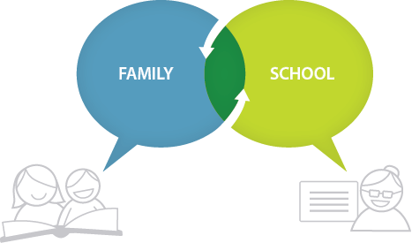

Altamaha Elementary is Branching Out!

Altamaha Elementary will take the following measures to promote and support parents as an important foundation of the school in order to strengthen the school and reach our school goals.

We will:
- Ensure that all information related to school and parent programs, meetings, and other activities is published in both English and Spanish, and posted on the school website for all parents.
- Conduct staff professional development each semester on parent engagement practices and effective strategies for staff to communicate and build partnerships with parents.
- Partner with Head Start, Migrant Head Start, local daycares, and Appling County Middle School to share school information about parent engagement activities that will help prepare parents and their child for school transition.
- Share information in English and Spanish for parents to understand the school’s academic standards and assessments as well as the ways parents can monitor their child’s progress and work with educators.
- Communicate with all families and the community on a regular basis regarding school wide events and activities such as phone messages, social media, and flyers.
- Work with our parents to develop relevant trainings and helpful presentations to educate them on the importance of parental engagement.
- Provide necessary materials for parents at conferences, meetings, and activities to help parents work with their child to improve their child’s achievement.
- Collaborate with community leaders and business groups to increase participation and awareness of the school parental engagement plan and activities.
- Offer parent classes to help further enhance their various educational backgrounds.
- Listen and respond to parents’ requests for additional support or activities.



Parent Engagement Standards

Altamaha Elementary and our parents have adopted the National PTA Standards for Family-School Partnerships as the school’s model in engaging parents, students, and the community. These standards are:
- Welcoming All Families
- Communicating Effectively
- Supporting Student Success
- Speaking Up for Every Child
- Sharing Power
- Collaborating with Community
Parental Advisory Council (PAC)
- Yes, I am excited about joining the School Parental Advisory Council.
- Yes, please contact me so I can learn more about the School PAC.
- Yes, this sounds like a great idea, please keep me posted about future meetings.
Name: _______________________________________________________
Child’s Name and Grade: ________________________________________
Address: _____________________________________________________
Phone Number: ________________________________________________
Email Address: ________________________________________________
Teacher: _____________________________________________________

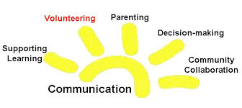
Parental Advisory Council
Altamaha Elementary invites all parents to join the Parental Advisory Council to share ideas and ways to involve other parents to build partnerships with school, families, and the community. The council will meet three times during the school year, but parents can also submit their ideas or suggestions during all the activities and meetings, as well as through our parent surveys and Title I meetings. If you would like to learn more about the Parental Advisory Council, please contact Dr. Angela M. Haynes, principal, at 912-367-3713 or complete the interest form and leave it in the Main Office.
Share Your Thoughts
We want to hear from you. If you have suggestions or if there is any part of this plan that you feel is not satisfactory with the students’ and the school’s goals for academic achievement, please provide us with your comments in the space provided and leave this form in the Main Office:
Name: (optional) _______________________________________________
- Telephone Number: (optional) _____________________________________________________________________________________________________________________________________________________________________________________________

STUDENT ACHIEVEMENT IS OUR BUSINESS!

