APPLING COUNTY SCHOOL SYSTEM
249 Blackshear Highway - Baxley, Georgia 31513 - 912-367-8600
https://www.appling.k12.ga.us/
PARENT AND FAMILY ENGAGEMENT POLICY
2026-2027
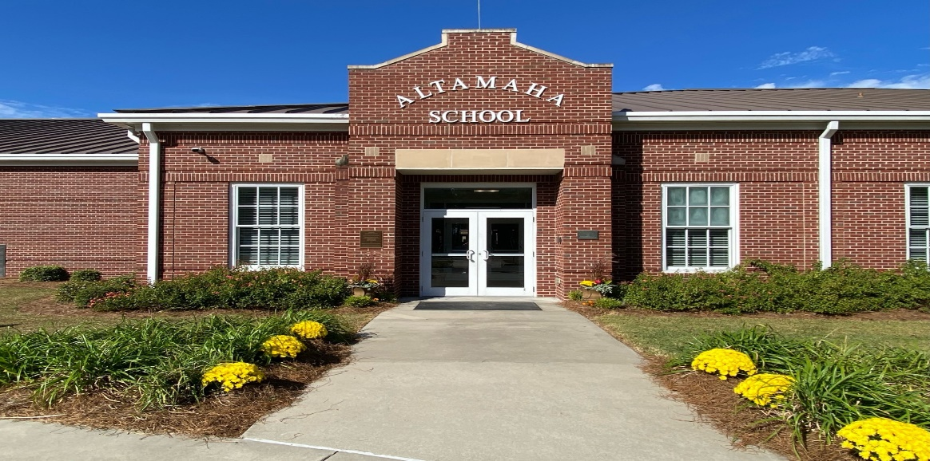
Altamaha Elementary School
What is Family Engagement?
Family Engagement means the participation of parents and family members in regular, two-way, and meaningful communication involving student academic learning and other school activities, including:
- That parents play an integral role in assisting their child’s learning.
- That parents are encouraged to be actively involved in their child’s education.
- That parents are full partners in their child’s education and are included, as appropriate, indecision-making and on advisory committees to assist in the education of their child.
- The carrying out of other activities, such as those described in Section 1116 of the Every Student Succeeds Act (ESSA).

About the Family and Parent Engagement Policy
In support of strengthening student academic achievement, the Appling County School System (ACSS) has developed this parent and family engagement policy that establishes the district’s expectations and objectives for meaningful family engagement and guides the strategies and resources that strengthen school and parent partnerships in our schools. This plan will describe ACSS’s commitment to engage families in the education of their children and to build the capacity in its schools to implement family engagement strategies and activities designed to achieve the district and student academic achievement goals.
When schools, families, and communities work together to support learning, children tend to do better in school, stay in school longer and enjoy school more. Title I, Part A provides for substantive family engagement at every level of the program, such as in the development and implementation of the district and school plan, and in carrying out the district and school improvement provisions. Section 1116 of ESSA contains the primary Title I, Part A requirements for schools and school systems to involve parents and family members in their children’s education. The ACSS will work with its schools to ensure that the required school-level parent and family engagement policies meet the requirements of federal law and each include, as a component, a school-parent compact.

Jointly Developed
During school meetings in spring 2026 and the Annual District Meeting on May 26, 2026, all parents were invited to participate and provide suggestions and ideas to improve this district parent and family engagement policy for the 2026-2027 school year. The district posted an invitation in local news media about this meeting and posted an announcement on the school district website and on school websites. During this meeting, parents also reviewed and discussed the Consolidated LEA Improvement Plan (CLIP). Additionally, each Title I school used its Parent Advisory Council to review the district parent and family engagement policy before the end of the 2025-2026 school year.
Upon final revision, the district parent and family engagement policy were incorporated into the CLIP, which was submitted to the state. Parents are welcome to submit comments and feedback regarding the policy at any time to the district family engagement coordinator (FEC) or by submitting written comments to your child’s school. All feedback received by May 2026 was considered for revisions to this policy.
The district’s plan to distribute this policy is to post it on district website and school websites, disseminate it during annual Title I school meetings in the fall and send a link to all parents via parent portal in a format and language they can understand.

Strengthening Our School
This year, the FEC will provide technical assistance and support to all Title I schools to ensure family engagement requirements are being satisfied and that family engagement strategies and activities are being implemented. Title I schools will receive notifications and resources from the district and the FEC to help them improve and strengthen family engagement. In addition to frequent communication and school visits, the FEC will hold quarterly meetings and trainings with its Title I schools’ FECs to review family engagement plans and activities. Subsequently, school FECS will train administrators and staff to improve and strengthen family engagement in their respective schools.
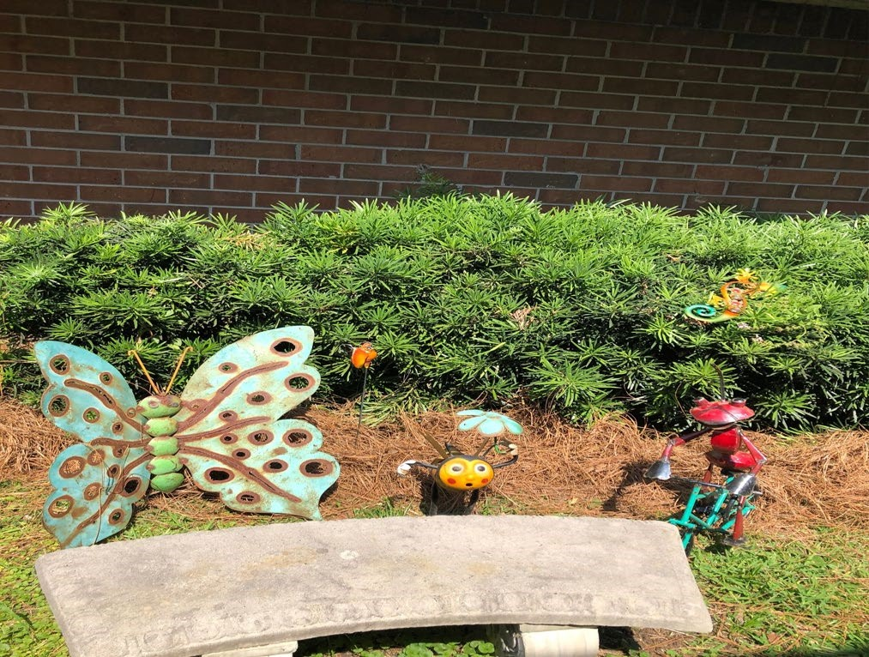
Appling County Primary School Fourth District Elementary School

Reservation of Funds
The ACSS will reserve 1 percent from the total amount of Title I funds it receives in 2026-2027 to carry out the parent and family engagement requirements listed in this policy and as described in federal law. Furthermore, the ACSS will distribute at least 90 percent of the amount reserved to our schools to support their local-level family engagement programs and activities. The district will provide clear guidance and communication to assist each school in developing an adequate family engagement budget that addresses their needs assessment and parent recommendations.
Each Title I school hosts an annual School Improvement forum in the spring for parents to provide suggestions on how these family engagement funds could be used in the upcoming year at the district and school-level. Comment cards and minutes from these meetings are reviewed by the district to determine areas of need for the upcoming school year and consider changes to the family engagement budget. If you have suggestions, please contact the FEC at the district office.

Opportunities for Meaningful Parent Consultation
Input and suggestions from parents, family members, and community partners are an essential component of the district and school improvement plans that are developed each year. All parents of students eligible to receive Title I services are invited to attend two meeting opportunities described in this section to share their ideas and suggestions to help the district, schools, and students to reach our student academic achievement goals.

District Meeting ~ May 2027
All parents are welcome to hear the latest updates from the Appling County School System, as well as, review and provide input into the district parent and family engagement policy and the Consolidated LEA Improvement Plan for the 2027-2028 school year. Notices regarding this meeting will be sent to all parents in advance of the meeting. The district will also communicate information regarding this meeting on the school district website.

School Improvement Forums~ March - May 2027
During these months, each Title I school will provide opportunities for parents and family members to participate in discussions to review the schoolwide plan, the school’s parent and family engagement policies, the district parent and family engagement policy, as well as, provide input on the family engagement budget and topics for school staff training. Each Title I school will notify parents about the date and time of these meetings through various means including, but not limited to, school phone system, Parent Portal, invitations, and social media. Parents may also provide input information via school surveys. Information regarding the School Improvement forum will also be made available on the school websites.
Input on the use of Title I funds to support family engagement programs may also be provided through the annual district survey. The survey will contain questions related to the family engagement budget and school staff training for parents to provide their comments.
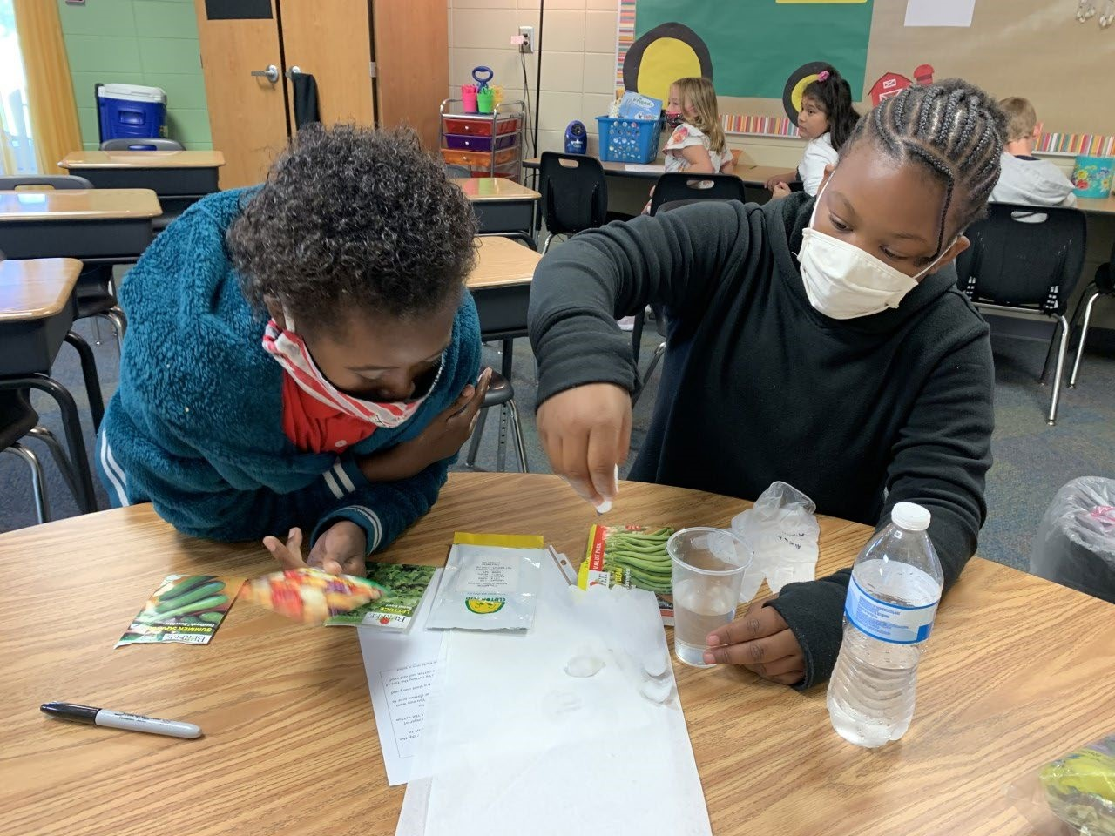
Appling County Elementary School Appling County Middle School

Building Capacity

The ACSS will build partnerships between its Title I Schools, families, and community with the goal of developing mutual support for student achievement. To develop capacity for this support, the ACSS will implement a variety of family and community engagement initiatives.

Of Parents - The ACSS including Georgia Baptist Children’s Home and Family Ministries will provide families with information about the overall Title I program and its requirements. The district works with all Title I schools to help families understand academic expectations for student learning and progress. Specific information related to the State’s challenging academic standards, and local and state assessments—including alternative assessments, will also be provided. The district also offers assistance to parents in understanding use of its online student information system and other digital resources, including the harms of copyright piracy, through its technology specialists. Notifications about these opportunities will be posted on the district website and shared through school messaging systems, newsletters, and social media postings.

In addition, the district and school websites contain resources and materials such as parent guides, study guides, practice assessments, and materials for at-home learning. Hard copies of these materials are also available at all Title I schools, including copies in Spanish.

Each school in the district has a Parent Advisor Council, made up of parent representatives from the school. Community leaders and business partners are also invited to serve on the council. The participation of all stakeholders is encouraged through video conferencing and recording options to accommodate varying schedules.

The Parent Advisory Council advises schools on all matters related to family engagement. Information related to district needs is shared with the district Family Engagement Coordinator for further review or follow up.

The ACSS will coordinate and integrate the district’s family engagement programs under this part with parent and family engagement strategies, to the extent feasible and appropriate, with other relevant Federal, State, and local laws and programs such as, the local preschool program and other federal and state funded preschool programs in the district. The district will invite faculty and staff from those programs to attend planning meetings focused on family engagement activities. In the spring, schools will host Kindergarten Transition Days, Middle and High School Transition Nights, and College and Career Fair so parents may receive information to help prepare them and their children for the next life stage.

School Staff - The ACSS will conduct four training sessions during the school year for school
Family Engagement Coordinators to learn and discuss strategies to increase family engagement, improve school-family communication, and build ties with parents and the community. These trainings will be redelivered to the faculty and staff of Title I schools.

To ensure that information related to district, school, parent programs, and activities is available to all parents, each Title I school is required to send home and post online information for parents and family members in an understandable language and uniform format. At the beginning of the year, school staff will be trained on parent notifications and resources to be sent home in parents’ preferred language, where applicable, and provide interpreters at parent events and meetings. Information posted on the district website will be translated to the extent practicable. The district will also utilize school phone call systems, Parent Portal, district and school websites, and/or social media to post information for parents.

Parent and Family Engagement Evaluation
Each year, the ACSS will conduct an evaluation of the content and effectiveness of this parent and family engagement policy and the family engagement activities to improve the academic quality of the Title I schools through an annual parent survey and the School Improvement Forums.
Beginning in January, ACSS will post a link to the annual parent survey in Parent Portal for parents to provide valuable feedback regarding the parent and family engagement activities and programs. This survey link will also be posted on the district and school websites for parents to complete. In addition to the annual survey, each Title I school will also use the School Improvement Forum to facilitate group discussions to discuss the needs of parents of children eligible to receive Title I services to design strategies for more effective family engagement.
The ACSS will use the findings from the school forums and the survey results to design strategies to improve effective family engagement, to remove possible barriers to parent participation, and to revise its parent and family engagement policies.

Accessibility
In carrying out the parent and family engagement requirements established by Section 1116 of the ESSA, the district Federal Programs Coordinator will communicate and collaborate with the Office for Student Support Services to ensure full opportunities for participation of parents with limited English proficiency, parents with disabilities, and parents of migratory children including providing information and school reports in a language parents can understand.

Adoption
This district wide parent and family engagement policy has been developed jointly and agreed upon with parents and family members of children participating in Title I, Part A programs as evidenced by the collaboration of parents, school, and district personnel at the annual State of the District meeting.
This policy was adopted by the Appling County School System on May 26, 2026, and will be in effective for the 2026-2027 academic school year. The school district will distribute this policy in multiple ways to all parents of participating Title I, Part A children before or during the first week of fall semester.

Mark Your Calendars
For Parents | For Schools
Annual Parent Survey  January 1, 2027 – January 31, 2027  School Improvement Meeting May 2027 | Family Engagement Coordinator Meetings  August 2026  October 2026  January 2027  March 2027

Ap
p

Appling County High School
Appling County High School

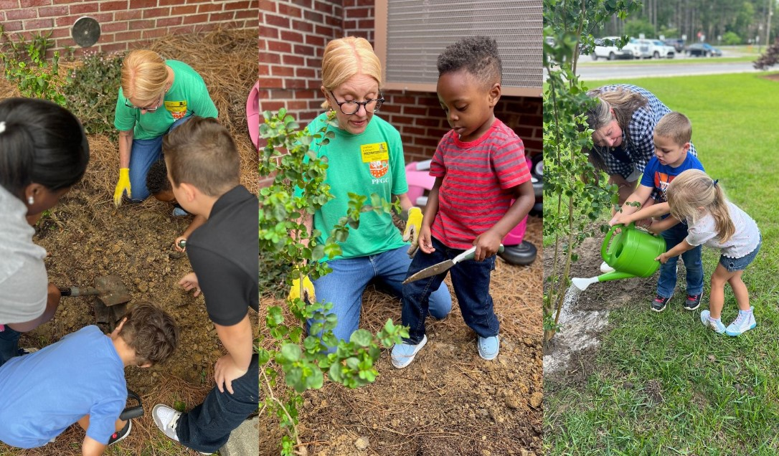
Altamaha Elementary School

