Hampton County High School Lunch/Breakfast Menus September 2025
Community Eligibility Provision (CEP)  Breakfast & Lunch is at NO COST to ALL District students.   | Served Daily  Variety of Cereal, Pop-Tarts, & Cereal Bars offered daily for Breakfast. | One Cup of Fruit Variety Offered Daily FOR BREAKFAST & LUNCH  (Canned, Fresh, Juice) | September 5 is National Cheese Pizza Day  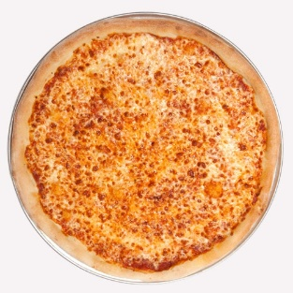 | 1% White Milk, Skim Milk and Flavored Fat-Free Milk offered daily.  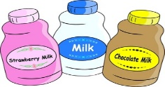  Condiments offered as needed.  Menu’s subject to change due to product availability.
1  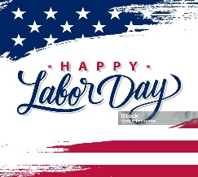 | 2  PLD | 3  BREAKFAST  Honey Bun  Fruit Variety, Juice  LUNCH  Wings w/Roll  Chef Salad  Fries, Baked Beans  Baby Carrots | 4  BREAKFAST  Pancake & Sausage on A Stick  Fruit Variety, Juice  LUNCH  Chicken Fajita  Chicken Sandwich Broccoli, Salsa  Lettuce, Cheese | 5  BREAKFAST  French Toast Sticks w/Syrup  Fruit Variety, Juice  LUNCH  Cheese Pizza  Chicken Sandwich  Green Beans, Tossed Salad  Chocolate Chip Cookie
8  BREAKFAST  Sausage Biscuit  Fruit Variety, Juice  LUNCH  LUNCH  Double Cheeseburger  Chicken Sandwich  Chef Salad  Baked Beans  Fresh Broccoli Florets w/Ranch | 9  BREAKFAST  Pancake & Sausage on A Stick  Fruit Variety, Juice  LUNCH  Mashed Potato Bowl w/Chicken & Breadstick  PB & J w/Chips Meal  Corn  Baby Carrots | 10  BREAKFAST  French Toast Sticks w/Syrup  Fruit Variety, Juice  LUNCH  Corn Dog  Chicken Sandwich  Chef Salad  French Fries, Coleslaw | 11  BREAKFAST  Honey Bun  Fruit Variety, Juice  LUNCH  Spaghetti w/Garlic Toast  PB & J w/Chips Meal  Green Beans  Tossed Salad | 12  BREAKFAST  Grits, Scrambled Eggs & Toast  Fruit Variety, Juice  LUNCH  Pizza  Chicken Sandwich  Tater Tots  Cucumber/Tomato Salad  Chocolate Chip Cookie
15  BREAKFAST  Assorted Muffins  Yogurt  Fruit Variety, Juice  Lunch  Orange Chicken w/Rice  Chef Salad  Chicken Sandwich  Steamed Broccoli  Baby Carrots | 16  BREAKFAST  Breakfast Pizza  Fruit Variety, Juice  LUNCH  Taco Tuesday  PB & J w/Chips Meal  Pinto Beans  Corn | 17  BREAKFAST  Cinnamon Roll  Fruit Variety, Juice  LUNCH  Wings w/Roll  Chicken Sandwich  Chef Salad  French Fries  Carrot &Celery Sticks | 18  BREAKFAST  Sausage Biscuit  Fruit Variety, Juice  LUNCH  Sausage, Cornbread  PB & J w/Chips Meal  Rice. Stewed Tomatoes  Celery Sticks | 19  BREAKFAST  Pancakes in a Pouch  Fruit Variety, Juice  LUNCH  Pizza  Chicken Sandwich  Glazed Carrots  Tossed Salad  Chocolate Chip Cookie
22  BREAKFAST  Sausage Biscuit  Fruit Variety, Juice  LUNCH  Double Cheeseburger  Chicken Sandwich  Chef Salad  Baked Beans  Fresh Broccoli Florets w/Ranch | 23  BREAKFAST  Assorted Muffins  Cheese Stick  Fruit Variety, Juice  LUNCH  Mashed Potato Bowl w/Chicken & Breadstick  PB & J w/Chips Meal  Corn  Baby Carrots | 24  BREAKFAST  Cinnamon Roll  Fruit Variety, Juice  LUNCH  Hot Dog  Chicken Sandwich  Chef Salad  French Fries, Baby Carrots | 25  BREAKFAST  Honey Bun  Fruit Variety, Juice  LUNCH  Turkey Ham Subs  Lettuce, Tomato  Baked Chips  PB & J w/Chips Meal  Pinto Beans  Sliced Cucumbers | 26  BREAKFAST  Pancakes in a Pouch  Fruit Variety, Juice  LUNCH  Pizza  Chicken Sandwich  Corn  Cucumber/Tomato Salad  Chocolate Chip Cookie
29  BREAKFAST  Yogurt  Graham Crackers  Fruit Variety, Juice  LUNCH  Chicken Alfredo w/Garlic Toast  Chicken Sandwich  Chef Salad  Tossed Salad  Steamed Broccoli | 30  BREAKFAST  Pancakes w SF Syrup  Fruit Variety, Juice  LUNCH  BBQ Chicken, Mac & Cheese Wheat Roll  Chef Salad  Baby Carrots  Green Beans | National Suicide Prevention Week  September 7th -13th    1-800-273-TALK (8255) |  | Hispanic Heritage Month  September 15-October 15  
“This institution is an equal opportunity provider.”

