Hampton County School District Lunch/Breakfast Menus K-8 September 2025
Community Eligibility Provision (CEP)  Breakfast & Lunch is at NO COST to ALL District students.   | Served Daily  One cup of fruit variety offered daily for BREAKFAST and LUNCH  Cereal is offered daily for breakfast. | Fruits & Veggies  More Matters Month  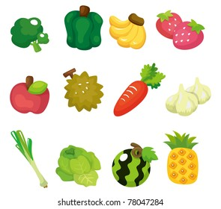 | September 5 is National Cheese Pizza Day  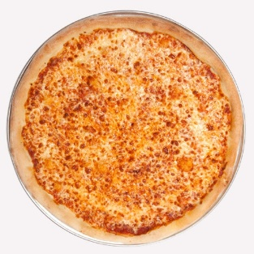 | 1% White Milk, Skim Milk and Flavored Fat-Free Milk offered daily.  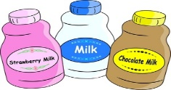  Condiments offered as needed.  Menu’s subject to change due to product availability.
1  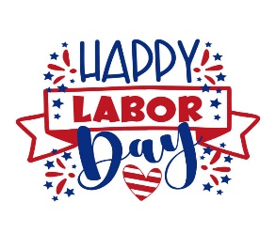 | 2  PLD | 3  BREAKFAST  Honey Bun  Fruit Variety, Juice  LUNCH  Wings w/Roll  PB&J Fun Pack*  Fries, Baked Beans  Baby Carrots | 4  BREAKFAST  French Toast Sticks w/Syrup  Fruit Variety, Juice  LUNCH  Chicken Fajita  Yogurt Fun Pack**  Broccoli, Salsa  Lettuce, Cheese | 5  BREAKFAST  Pancake & Sausage on A Stick  Fruit Variety, Juice  LUNCH  Cheese Pizza  PB&J Fun Pack*  Green Beans  Tossed Salad
8  BREAKFAST  Sausage Biscuit  Fruit Variety, Juice  LUNCH  Chicken Nuggets w/Roll  Chef Salad  Baked Beans, Fresh Broccoli Florets w/Ranch | 9  BREAKFAST  Pancake & Sausage on A Stick  Fruit Variety, Juice  LUNCH  Spaghetti w/Wheat Roll  PB&J Fun Pack*  Green Beans  Tossed Salad | 10  BREAKFAST  Honey Bun  Fruit Variety, Juice  LUNCH  Cheeseburger  Lettuce & Tomato  Chef Salad  French Fries, Coleslaw | 11  BREAKFAST  French Toast Sticks w/Syrup  Fruit Variety, Juice  LUNCH  Sausage w/Cornbread  Rice. Stewed Tomatoes  PB&J Fun Pack*  Celery Sticks | 12  BREAKFAST  Grits, Scrambled Eggs & Toast, Fruit Variety, Juice  LUNCH  Turkey Ham Subs  Lettuce, Tomato Slice  Baked Chips  Yogurt Fun Pack**  Corn, Sliced Cucumbers
15  BREAKFAST  Assorted Muffins  Yogurt  Fruit Variety, Juice  Lunch  Orange Chicken w/Rice  Chef Salad  Steamed Broccoli  Baby Carrots | 16  BREAKFAST  Breakfast Pizza  Fruit Variety, Juice  LUNCH  Taco Tuesday  PB &J Fun Pack  Pinto Beans  Salsa | 17  BREAKFAST  Cinnamon Roll  Fruit Variety, Juice  LUNCH  Corn Dog  Chef Salad  French Fries, Celery Sticks | 18  BREAKFAST  Sausage Biscuit  Fruit Variety, Juice  LUNCH  Mashed Potato Bowl w/Chicken & Breadstick  PB & J Fun Pack  Corn  Cucumber & Tomato Salad | 19  BREAKFAST  Pancakes in a Pouch  Fruit Variety, Juice  LUNCH  Pizza  Yogurt Fun Pack  California Mix  Tossed Salad
22  BREAKFAST  Sausage Biscuit  Fruit Variety, Juice  LUNCH  Chicken Nuggets w/Roll  Chef Salad  Glazed Carrots  Cucumber & Tomato Salad | 23  BREAKFAST  Assorted Muffins  Cheese Stick  Fruit Variety, Juice  LUNCH  Chicken Alfredo w/Garlic Toast  Fun Pack of Choice  Tossed Salad  Steamed Broccoli | 24  BREAKFAST  Cinnamon Roll  Fruit Variety, Juice  LUNCH  Hot Dog on WG Bun  Chef Salad  French Fries  Celery Sticks | 25  BREAKFAST  Honey Bun  Fruit Variety, Juice  LUNCH  Turkey Ham Subs  Lettuce, Tomato Slice  Baked Chips  PB & J Fun Pack  Pinto Beans  Sliced Cucumbers | 26  BREAKFAST  French Toast Sticks  Fruit Variety, Juice  LUNCH  Cheeseburger  Lettuce & Tomato  Chef Salad  French Fries, Baby Carrots
29  BREAKFAST  Yogurt  Graham Crackers  Fruit Variety, Juice  LUNCH  Chicken Strips w/Roll  Tater Tots  PB &J Fun Pack*  Baked Beans, Fresh Broccoli Florets w/Ranch | 30  BREAKFAST  Pancakes w SF Syrup  Fruit Variety, Juice  LUNCH  BBQ Chicken, Mac & Cheese Wheat Roll  Chef Salad  Baby Carrots  Green Beans | National Suicide Prevention Week  September 7th -13th  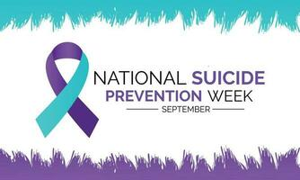  1-800-273-TALK (8255) |  | 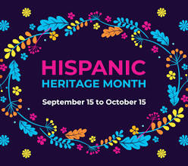
“This institution is an equal opportunity provider.”

