Hampton County School District Lunch/Breakfast Menus K-8 August 2025

Community Eligibility Provision (CEP)  Breakfast & Lunch is at NO COST to ALL District students.   | Offered Daily  One cup of fruit variety is offered daily for breakfast & lunch.  Cereal is offered daily for breakfast.  PB & J Fun Pack  Chef Salad |  |  | 1% White Milk, Skim Milk and Flavored Fat-Free Milk offered daily.  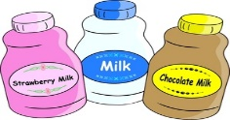  Condiments offered as needed.  Menu’s subject to change due to product availability.
*PB&J Fun Pack includes Small PB & J w/Cheese Stick & Graham Crackers  **Yogurt Fun Pack includes Yogurt, Cheese Stick &Muffin | 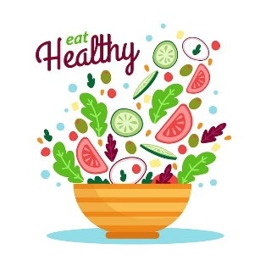 | EXERCISE DAILY  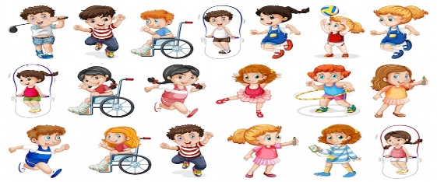 |  | 1  NO SCHOOL
4  PLD | 5  PLD | 6  PLD | 7  BREAKFAST  Sausage Biscuit  Fruit Variety, Juice  LUNCH  Chicken Strips w/Roll  Tater Tots  PB &J Fun Pack*  Baked Beans, Fresh Broccoli Florets w/Ranch | 8  BREAKFAST  French Toast Sticks w/Syrup  Fruit Variety, Juice  LUNCH  Pizza, Baked Chips  PB &J Fun Pack*  Corn, Sliced Cucumbers  Tossed Salad
11  BREAKFAST  Assorted Muffins  Cheese Stick  Fruit Variety, Juice  Lunch  Chicken Alfredo  Cornbread  PB&J Fun Pack*  Baby Carrots  Broccoli | 12  BREAKFAST  Breakfast Pizza  Fruit Variety, Juice  LUNCH  Cheeseburger  Lettuce & Tomato  Chef Salad  PB&J Fun Pack*  French Fries, Sliced Cucumbers | 13  BREAKFAST  Honey Bun  Fruit Variety, Juice  LUNCH  Wednesday Wings  Breadstick, Baked Beans  Tater Tots, Baby Carrots  Chef Salad  PB&J Fun Pack | 14  BREAKFAST  Sausage Biscuit  Fruit Variety, Juice  LUNCH  Chicken Strips w/Roll  Yellow Rice  PB &J Fun Pack  Baby Carrots  Green Beans | 15  BREAKFAST  Yogurt  Graham Crackers  Fruit Variety, Juice  LUNCH  Pizza  PB &J Fun Pack  Tater Tots  Tossed Salad
18  BREAKFAST  Sausage & Egg/Biscuit  Fruit Variety, Juice  LUNCH  Cheeseburger  Lettuce & Tomato  Chef Salad  PB&J Fun Pack  French Fries, Sliced Cucumbers | 19  BREAKFAST  Pancakes w SF Syrup  Fruit Variety, Juice  LUNCH  Taco Tuesday  PB &J Fun Pack  Black Beans  Salsa, Tortilla Chips  Shredded Cheese | 20  BREAKFAST  Cinnamon Roll  Cheese Stick  Fruit Variety, Juice  LUNCH  Corn Dog  PB &J Fun Pack  Chef Salad  Tater Tots  Celery Sticks | 21  BREAKFAST  Sausage Patty, Eggs & Toast  Fruit Variety, Juice  LUNCH  Mashed Potato Bowl w/Chicken & Breadstick  PB & J Fun Pack  Corn  Cucumber & Tomato Salad | 22  BREAKFAST  Pop Tart, Cheese Stick  Fruit Variety, Juice  LUNCH  Pizza  PB &J Fun Pack  California Mix  Tossed Salad
25  BREAKFAST  Yogurt, Graham Crackers  Fruit Variety, Juice  LUNCH  Spaghetti w/Garlic Toast  Chef Salad  PB&J Fun Pack  Green Beans  Tossed Salad | 26  BREAKFAST  Scrambled Eggs, Sausage Patty, Toast & Jelly  Fruit Variety, Juice  LUNCH  Grilled Chicken on Bun  Fries, Pinto Beans  PB &J Fun Pack  Sliced Cucumbers | 27  BREAKFAST  Honey Bun  Fruit Variety, Juice  LUNCH  Wednesday Wings  Breadstick, Broccoli  Tater Tots, Baby Carrots  Chef Salad  PB&J Fun Pack | 28  BREAKFAST  Sausage Biscuit  Fruit Variety, Juice  LUNCH  Beef Patty/Gravy  Rice, Wheat Roll  PB&J Fun Pack*  Green Beans, Baby Carrots | 29  BREAKFAST  Muffin, Cheese Stick  Fruit Variety, Juice  LUNCH  Pizza  PB &J Fun Pack  Potato Wedges  Tossed Salad  Baby Carrots
“This institution is an equal opportunity provider.”

