Kalispell Public Schools
Transportation Handbook


Revised 2026
2026 Transportation Handbook - Contents

Forward | 2 | Transportation Guidelines |  | Student Management……….. | 34-35
 |  | General Safety Statement………… | 17 | Student Expectations & Rules | 35-37
SD5 Employment Policies |  |  |  | Student Consequences……….. | 37-38
Equal Opportunity Employment | 3 | Personnel Management |  | Video Camera Guidelines……. | 38-39
Hiring ………………………………….…… | 3 | Personnel Qualification Overview | 17 | Activity & ECE Trips…………….. | 39-42
Probationary Period………………... | 3-4 | Safe Driving Record Requirement | 18 | Review & Additional Details.. | 42-44
Job Responsibilities …………………. | 4 | Point System Schedule…………….. | 18-19 | Additional Instructions - SD5.. | 44-45
Criminal Background Checks…….. | 4 | Accident/Incident Definition……. | 19
Confidentiality…………………………. | 5 | Accident/Emergency Procedures.. | 20-22 | Appendixes
Salaries & Payroll Distribution….. | 5 | Bloodborne Pathogens……………. | 22-23 | Student Injury Form A-1 | 46
 |  | Professional Appearance & Conduct | 23 | Conf Student Info Form A-2 | 47
Benefits & Leave |  | Personal Habits……………………….. | 23 | Volunteer Form A-3 | 48
Insurance…………………………………. | 5 | Attendance Expectations…….…… | 23 | Driver’s Accident Report A-4 | 49
Salary Deductions……………………. | 5 | Substitute Drivers…………….……… | 23 | Student Seating Chart A-5 | 50
Expense Reimbursement…………. | 6 | Driver Training Requirements..… | 23-24 | Rankin Loading Zone A-6 | 51
Holidays………………………………….. | 6 |  |  | Edgerton Loading Zone A-7 | 52
Leave………………………………………. | 6-7 | Driver Responsibilities |  | Elrod Loading Zone A-8 | 53
Family & Medical Leave Act…….. | 7-8 | Core Driver Responsibilities…..… | 24-25 | Hedges Loading Zone A-9 | 54
 |  | Bus Care and Maintenance……... | 25-26 | Peterson Loading Zone A-10 | 55
Personnel Management |  | Public Relations…………………..….. | 26 | Russell Loading Zone A-11 | 56
Employment & Assignment……… | 8 | Route Expectations………….…….. | 26-27 | Kalispell MS Loading Zone A-12 | 57
Employee Discipline………………… | 8-9 | Safe Bus Operation………………….. | 27-29 | Flathead HS Loading Zone A-13 | 58
Evaluations……………………………… | 9 | Loading & Unloading Procedures | 29-30 | Glacier HS Loading Zone A-14 | 59
Personnel Records…………………… | 9 | Weather & Operational Judgement | 30 | Linderman Loading Zone A-15 | 60
Meetings…………………………………. | 9 | Two-Way Radio System…………… | 30-31 | KMS Bus Loading Map A-16 | 61
Employee Conduct………………….. | 10-16 | General Transportation Policies.. | 31-32 | FHS Bus Loading Map A-17 | 62
Visitors……………………………………. | 16 | Bus Stops………………………………... | 32-33 | GHS Bus Loading Map A-18 | 63
Title IX Information…………………. | 16 | Route Schedules……………………… | 33 | Acknowledgement Form A-19 | 64

Foreword

The Transportation Handbook is designed to aid transportation personnel and school administrators in navigating transportation procedures. Its purpose is to explain the laws, regulations, and policies relevant to pupil transportation. This information is derived from Montana statutes, local ordinances, Board policies, and administrative procedures.
The Transportation Department is dedicated to providing safe, punctual, and respectful transportation services to our community. We consider ourselves an integral part of the educational environment and endeavor to greet each child in a professional manner, fostering a secure, harassment-free atmosphere conducive to learning.
Our core values of Safety, Courtesy, and Service guide our operations. It is the goal of Kalispell Public Schools to hire professionals committed to providing safe, timely, efficient transportation services to the children residing in our communities.

SD5 EMPLOYMENT POLICIES

Equal Opportunity Employment
Kalispell Public Schools (District 5) is an Equal Opportunity Employer. The District does not discriminate on the basis of race, creed, religion, color, national origin, age, physical or mental disability, marital status, genetic information, sex, or veteran status, as required by law. “Sex” includes sexual orientation and gender identity and expression. The District is required by federal law, including but not limited to the Civil Rights Act of 1964, Title IX, Section 504, and the Americans with Disabilities Act and their regulations to not discriminate against individuals in violation of these laws.

Reasonable accommodation for individuals with disabilities will be made as required by law.

If considerations of sex, age or disability have a bona fide relationship to the unique requirements of a particular job or if there are federal or state legal requirements that apply, then sex, age or disability may be taken into account as a bona fide occupational qualification, provided such consideration is consistent with governing law.

If you have questions concerning District compliance with state and federal equal opportunity employment laws, including but not limited to Title IX, contact the District’s Title IX Coordinator. For additional information, please see Policy 5010.

Inquiries may also be directed to the Assistant Secretary for the U.S. Department of Education.

Hiring
All personnel are required to sign a written contract with the District. For further information on hiring, refer to Policy 5120.

Probationary Period
All newly hired Transportation Department employees are subject to a six month probationary period beginning on the first day of employment. This probationary period applies to all positions, including drivers, student monitors, mechanics, dispatchers, and other transportation staff.

Purpose of the Probationary Period
The probationary period allows both the employee and the Transportation Department to evaluate whether the position is a good fit. During this time, supervisors assess job performance, attendance, reliability, professionalism, safety practices, communication, and the employee’s ability to meet the expectations and essential functions of the position.

Performance Expectations
Probationary employees are expected to:
- Perform assigned duties safely and effectively.
- Follow all Transportation Department policies, procedures, and directives.
- Maintain professional conduct with students, coworkers, parents, and the public.
- Demonstrate reliability, punctuality, and regular attendance.
- Meet the physical and operational requirements of the position.

Evaluation and Employment Status
Supervisors may provide feedback, coaching, or additional training during the probationary period; however, continuation of employment is not guaranteed. At any point during the six month probationary period, the District may determine that the employee is not meeting expectations or is not a good fit for the position.
If such a determination is made, employment may be ended during the probationary period in accordance with District policy and applicable law.
Successful completion of the probationary period does not alter the at-will nature of employment or create a contract of continued employment.
Because Transportation employees work directly with students and are responsible for student safety, the standards for professionalism, judgment, reliability, and student interactions are particularly important during the probationary period.

Acknowledgment
By accepting employment with the Transportation Department, employees acknowledge that they understand and agree to the terms of the six month probationary period.

Job Responsibilities
All employees receive a copy of their job description and responsibilities for review. Immediate supervisors may assign other duties as needed. Employees should ask their supervisor if they have questions regarding their assigned duties and/or responsibilities.

Criminal Background Checks
Any finalist recommended to be employed in a paid or volunteer position with the District, involving regular unsupervised access to students in schools, as determined by the Superintendent, shall submit to a criminal background investigation conducted by the appropriate law enforcement agency before consideration of the recommendation for employment or appointment. Any offer of employment or appointment will be contingent on results of the criminal background check. This policy shall also be applied to an employee of a person or firm holding a contract with the District, if the employee is working on school property, and the employee may have unsupervised access to students.

Any requirement of an applicant or employee of a contractor to submit to a fingerprint background check will be in compliance with the National Child Protection Act and applicable federal regulations. If an applicant has any prior record of arrest or conviction by any local, state, or federal law enforcement agency for an offense other than a minor traffic violation, the facts must be reviewed by the Superintendent, who will decide whether the applicant will be declared eligible for appointment or employment. Arrests resolved without conviction will not be considered in the hiring process, unless the charges are pending. The Superintendent shall keep all criminal record information confidential as required by law. For additional information, please see Policy 5122.

Confidentiality
In certain circumstances employees may receive confidential information regarding students’ or employees’ medical, discipline or court records. Employees are required to keep student and personnel information in the strictest confidence and are legally prohibited from passing confidential information along to any unauthorized individual. If employees have any questions about access to confidential information, they should speak to their Supervisor.

An official personnel file is established for each person employed by the district. A staff member’s personnel file may contain such information as applications for employment, references, records relative to compensation, payroll deductions, evaluations, complaints, and written disciplinary actions. All records containing medical-condition information, such as workers’ compensation reports and release/permission to return to work forms, will be kept confidential, in a separate file from personnel records.

All personnel records are considered confidential and not open to public inspection.

Please refer to Policies 5223 and 5231 for additional information.

Salaries and Payroll Distribution
Checks are issued according to a schedule approved annually by the Board of Directors. Salaries for Classified or Non-Union personnel are based on a salary schedule providing for 182 days of employment. Determination of and changes to Classified or Non-Union employees’ rank and experience are determined in compliance with the Master Agreement. Classified personnel may be paid on an hourly or salary basis, as determined by the Board of Directors.

BENEFITS AND LEAVE

Insurance
Kalispell Public Schools provides Unemployment insurance, Workers’ Compensation and Liability insurance for all employees. In addition, the District provides group health insurance to eligible employees. Classified or Non-Union employees are eligible for insurance benefits as stated in the current master contract. Classified employees who are regularly scheduled to work more than half time are eligible for group health benefits contributions. Classified employees who are regularly scheduled to work less than half time are not eligible for group health insurance benefits.

For more information regarding insurance benefits for employees, please see Policy 5331 or contact the Benefits Manager in HR at ext #3446.

Salary Deductions
The District makes all payroll deductions required by law or as authorized by the employee.

Expense Reimbursement
School personnel are reimbursed for travel that is required as part of their duties or for school-related activities approved by the Supervisor. The District will inform staff regarding expense reimbursement guidelines annually. For additional information, please refer to Policies 7335, 7336.

Holidays
Holidays for Classified or Non-Union staff are dictated in part by the school calendar. Temporary employees will not receive holiday pay. Part-time employees will receive holiday pay on a prorated basis. The District will observe all school holidays as required by statute. When an eligible employee is required to work any of the school holidays, another day shall be granted in lieu of such holiday, unless the employee elects to be paid for the holiday in addition to the employee’s regular pay for all time worked on the holiday.
When a school holiday falls on Sunday, the following Monday will not be a holiday. When a school holiday falls on Saturday, the preceding Friday will not be a holiday. When a holiday occurs during a period in which vacation is being taken by an employee, the holiday will not be charged against the employee’s annual leave. Please refer to Policy 5333 for additional information.

Leave
In order to provide the highest level of service, employees are expected to be at work and on time every day. However, when circumstances dictate, the District provides leave to its employees pursuant to Montana law, master contracts and individual contracts. Employees who must be absent should inform their immediate supervisor as soon as possible but no later than one hour prior to the scheduled shift. Listed below is general information regarding several types of leave available to employees. Please note that in many cases a written request, submitted for approval before leave begins, is required. Policies 5321, 5322, 5323, 5324, 5328, 5329, 5330, 5333, and 5334 contain additional information regarding the standards for different types of leave.

Sick Leave and Bereavement Leave
Classified or Non-Union employees will be granted sick leave according to terms of the master contract. Administrators and Classified employees shall be granted sick leave pursuant to Montana law governing public employees. Unless otherwise stated by contract, “sick leave” means a leave of absence, with pay, for an illness suffered by an employee or a member of the employee’s immediate family. “Immediate family” is defined as the employee’s spouse and children residing in the employee’s household.

An employee who has a death in the family is eligible for up to 5 days of paid bereavement leave, which the Director has the authority to approve. Employees seeking more than 5 days of bereavement leave must apply for that leave through the Superintendent. The Superintendent may grant additional, unpaid leave in his/her sole discretion. For the purposes of bereavement leave, “family” is defined as the employee’s spouse, child, parents/guardians, sibling, grandparents and spouse’s like relations.

Personal and Emergency Leave
Classified or Non-Union employees will be granted personal or discretionary and emergency leave according to the terms of the master contract. Administrators will be granted personal and emergency leave pursuant to the terms of their individual contracts, or at the discretion of the Board or Superintendent. Classified staff may be granted personal and emergency leave in the discretion of the Board or upon the recommendation of the Superintendent. Personal and emergency leave is without pay unless otherwise stated.

Civic Duties Leave
Employees shall be granted leave for service on a jury, in the Legislature or in response to a subpoena in accordance with state law. Each employee who is under proper summons as a juror or witness shall collect all fees and allowances payable as a result of the service and forward the fees to the appropriate accounting office. Juror and witness fees shall be applied against the amount due the employee from his employer. However, if an employee elects to charge his juror or witness time off against his annual leave, he shall not be required to remit his juror fees to his employer. In no instance is an employee required to remit to his employer any expense or mileage allowance paid him by the court.

Military Leave
Employees shall be granted leave for service in the military in accordance with state and federal law. The District will comply with all federal and state laws and regulations regarding the employee’s return to service following military leave.

Vacation Leave
Administrators will be granted vacation leave pursuant to the terms of their individual contracts and Montana law. Classified employees will be granted vacation leave pursuant to Montana law. The District, in its sole discretion, may provide cash compensation for unused vacation leave in lieu of the accumulation of vacation leave.

Maternity Leave
The District will provide maternity leave to its employees pursuant to Montana law.

Adoption Leave
The District may provide leave related to the adoption of a child pursuant to the terms of any master or individual contracts and the law.

Family & Medical Leave (FMLA)

Eligibility
Employees are eligible if they have worked for the District for at least one (1) year, and for one thousand two hundred fifty (1,250) hours over the previous twelve (12) months, and if there have been at least fifty (50) District employees within seventy-five (75) miles for each working day during twenty (20) or more workweeks in the current or preceding calendar year.

Length/Purpose of Leave
In accordance with provisions of the Family Medical Leave Act (FMLA), a leave of absence of up to twelve (12) weeks during a twelve-(12)-month period may be granted to an eligible employee for the following reasons: 1) birth of a child; 2) placement of a child for adoption or foster care; 3) a serious health condition which makes the employee unable to perform functions of the job; 4) to care for the employee’s spouse, child, or parent with a serious health condition; 5) because of a qualifying exigency (as the Secretary shall, by regulation, determine) arising out of the fact that the spouse or a son, daughter, or parent of the employee is on covered active duty as a member of the regular Armed Forces or is on covered active duty or is under a call or order to cover active duty as a Member of the National Guard or Reserves.

Servicemember Family Leave
An eligible employee who is the spouse, son, daughter, parent, or next of kin of a covered servicemember, who is a current member (or a member on the temporary disability retired list) of the Regular Armed Forces, National Guard, Reserves, or is a veteran who has incurred an injury or illness in the line of duty while on active duty, shall be entitled to a total of twenty-six (26) workweeks of leave during a twelve-(12)-month period to care for the servicemember. The leave described in this paragraph shall only be available during a single twelve-(12)-month period.

For additional information, please refer to Policy 5328.

PERSONNEL MANAGEMENT

Employment and Assignment
Each Classified or Non-Union employee will be employed under a written contract, subject to the terms and conditions of the master contract and District policies. Renewal and non-renewal will be determined by the Board after receiving a recommendation from the Superintendent and in conformance with law.

Each Classified employee will be employed under a written contract for a specified term, with a beginning and ending date. Such employees shall have no expectation of continued employment from year to year, and contracts of employment may be renewed or non-renewed each year, at the District’s sole option. The District reserves the right to change employment conditions affecting an employee’s duties, assignment, supervisor, or grade.

The Superintendent may assign, reassign, and/or transfer positions and duties of all staff, subject to any provisions contained in the master contract. The Superintendent will provide for a system of assignment, reassignment, and transfer of classified staff, including voluntary transfers and promotions. Nothing in this policy prevents reassignment of a staff member during a school year. For additional information, please see Policy 5210.

Employee Discipline
District employees who fail to fulfill their job responsibilities or to follow reasonable directions of their supervisors, or who conduct themselves on or off the job in ways that affect their effectiveness on the job, may be subject to disciplinary action up to and including termination. Behavior, conduct, or action that may call for disciplinary action or dismissal includes, but is not limited to, reasonable job-related grounds based on a failure to satisfactorily perform job duties, disruption of the District or member school district’s operation, or other legitimate reasons.

Discipline will be reasonably appropriate to the circumstance and will include, but not be limited to, a supervisor’s right to reprimand an employee and the Superintendent’s right to suspend an employee, with or without pay, or to impose other appropriate disciplinary sanctions. In accordance with Montana law, only the Board of Directors may terminate an employee or non-renew employment. Policies 5255 and 5250 contain additional information.

No public officer or public employee shall retaliate against or condone or threaten to retaliate against an individual who, in good faith, alleges waste, fraud or abuse.

Evaluations
Each non-administrative staff member’s job performance will be evaluated by the staff member’s direct supervisor. The evaluation process includes scheduled annual evaluations using forms applicable to the job classification and description, and day-to-day appraisals. Classified or Non-Union staff members shall be evaluated according to the terms stated in any master contract or pursuant to Policy 5222. Employees have a right to access to the evaluation instrument and the right to respond in writing to the completed evaluation.

The supervisor will provide a copy of the completed evaluation to the staff member and will provide an opportunity to discuss the evaluation. The original should be signed by the staff member and filed in the staff member’s personnel file. If the staff member refuses to sign the evaluation, the supervisor should note the refusal and submit the evaluation to the Superintendent. Staff members may have up to 10 working days to submit a rebuttal to the evaluation for inclusion in the file. Failure to sign an evaluation form noting receipt may subject the employee to discipline. For more information regarding evaluation of non-administrative staff, please refer to Policy 5222.

Personnel Records
The District maintains a complete personnel record for every current and former employee. The employees’ personnel records will be maintained in the District’s administrative office. Employees and their designees will be given supervised access to their personnel records in the administrative office. Copies may be given to employees and their designees, but under no circumstances may the original file leave the administrative office. In addition to the Superintendent or other designees, the Board of Directors may grant a member of the Board access to cumulative personnel files. Counsel retained by the Board of Directors will also have access to a cumulative personnel file if necessary. Personnel records will be maintained for ten (10) years after the employee has left the District’s employment.

No material derogatory to an employee’s conduct, service, character, or personality shall be placed in the file, unless the employee has had the opportunity to review the material. The employee shall be entitled to respond to the material and to have that response placed in the file, if requested in a reasonable period of time, not to exceed 10 working days.

Meetings
Staff meetings are scheduled for the purpose of organization and communication of business that typically cannot be handled through staff bulletins, departmental or committee structure. All staff are expected to attend staff meetings unless prior arrangements have been made with the Transportation Supervisor.

Employee Conduct

Absenteeism and Tardiness
Regular and timely attendance is an essential function of each position within the District. Employees are expected to report for work on time and to notify their immediate supervisor if they must be tardy or absent. Failure to provide regular and timely attendance may result in disciplinary action, up to and including termination.

Disrupting the Educational Process
Any employee who participates in or encourages activities that disrupt the educational process or the operations of the District may be subject to disciplinary action, including termination. Policy 5255.

Behavior that disrupts the educational process includes, but is not limited to:

- Conduct that threatens the health, safety or welfare of others;
- Conduct that may damage public or private property (including the property of students or staff);
- Illegal activity;
- Conduct that interferes with a student’s access to educational opportunities or programs, including ability to attend, participate in, and benefit from instructional and extracurricular activities; or
- Conduct that disrupts delivery of instructional services or interferes with the orderly administration of the District, school and school-related activities or District operations.

Contact Information
Employees are required to annually update their contact information, including phone number and physical address, at the beginning of each school. If an employee’s contact information changes at any time after the beginning of the school year, the employee is required to update his/her contact information to the current information. Contact Human Resources to update contact information.

Drug-Free/Alcohol-Free Schools
Employees must not manufacture, distribute, dispense, be under the influence of, purchase, possess, use, or attempt to obtain in the workplace or in the performance of duties, alcohol or any narcotic drug, hallucinogenic drug, amphetamine, barbiturate, marijuana (including medical marijuana) or any other controlled substance. For purposes of this regulation, a controlled substance is one that is not legally obtainable, or one that is legally obtainable and not being used as prescribed, or referenced in federal and state controlled substance acts. Any employee who violates the terms of the District’s drug-free/alcohol-free policies may be suspended, nonrenewed or terminated. Violations may result in notification of appropriate legal officials. Any employee convicted of a workplace violation of drug abuse statutes must notify his or her supervisor of the conviction within five (5) working days. For additional information, please refer to Policy 5226.

The use of any legally obtained prescription drug or other controlled substance (including medical marijuana) by any employee while performing their duties or while in a school facility is prohibited to the extent such use may affect the safety of the employee, co-workers, or members of the public, the employee's job performance, or the safe and efficient operation of school facilities. Employees are required to advise their supervisor if they are taking a legal prescription drug or other controlled substance (including medical marijuana) that may have adverse effects on their ability to perform their job safely and efficiently. The supervisor, in conjunction with administration, shall determine whether the employee poses a threat to his or her own safety, the safety of other employees, or significantly affects his or her job performance if using the legally obtained prescription drug or other controlled substance (including medical marijuana) and can continue working. The District will provide reasonable accommodations as required by law for an employee who cannot safely perform his or her job duties because of use of a legally obtained prescription drug or other controlled substance (including medical marijuana).

Weapons
Carrying, bringing, using or possessing any weapon or dangerous instrument in any District building, school building, on school grounds, in any school vehicle, or at any school-sponsored activity is prohibited. Except for authorized law enforcement officials, the District prohibits carrying concealed weapons on District property. Staff members who violate this policy are subject to disciplinary action, including termination.

Dress and Appearance
District employees are required to dress in a professional manner. No mode of attire will be considered proper if it distracts from or is disruptive of the positive learning environment of the school to which the employee is assigned or the District office.

Breastfeeding Accommodations
The District will provide reasonable accommodations for breastfeeding mothers, including access to a private area to express breast milk or breastfeed an infant child, permission to bring a breast pump and any other equipment to express breast milk, access to a power source for a breast pump or any other equipment for expressing breast milk, and access to a place to store expressed breast milk safely. Policy 5325.

Participation in Political Activities
District employees may exercise their right to participate fully in affairs of public interest on a local, county, state, and national level, on the same basis as any citizen in public or private employment and within the law. Employees may, within the limitations imposed by state and federal laws and regulations, choose any side of a particular issue and support their viewpoints as they desire, by vote, discussion, or persuading others. Such discussion and persuasion, however, may not be carried on during the performance of district duties.

Participation in Religious Activities
Employees may not encourage, discourage, persuade, dissuade, sponsor, participate in, or discriminate against a religious activity or an activity because of its religious content while in the course of performing official duties of that employee’s position(s) with the District.

Tobacco and Marijuana Products
The District maintains tobacco-free buildings and grounds. Tobacco includes but is not limited to cigarettes, cigars, snuff, pipe smoking tobacco, smokeless tobacco, vapor product, alternative nicotine product or any other tobacco or nicotine delivery innovation.
Use of tobacco or nicotine products in a public school building or on public school property is prohibited, unless used in a classroom or on other school property as part of a lecture, demonstration, or educational forum sanctioned by a school administrator or faculty member, concerning the risks associated with using tobacco products or in connection with Native American cultural activities.
For the purpose of this policy, “public school building or public school property” means:
·Public land, fixtures, buildings, or other property owned or occupied by an institution for the teaching of minor children, that is established and maintained under the laws of the state of Montana at public expense; and
·Includes playgrounds, school steps, parking lots, administration buildings, athletic facilities, gymnasiums, locker rooms, and school vehicles.
Violation of the policy by students and staff will be subject to actions outlined in District discipline policies.
Use of FDA-approved cessation devices may be permitted at school buildings and on school grounds with the approval of the building administrator. See policy 8225.

Use of School Property/Electronic Communication System/Social Networking Pages
Employees may not use any District facility, vehicle, electronic communication system, equipment, or materials to perform outside work. These items (including security codes and electronic records such as e-mail) are District property. Employees may not use a code, access a file, or retrieve any stored communication unless they have been given authorization to do so. Employees cannot expect confidentiality or privacy of the information in their e-mail accounts and should review Policy 5450 for specific information regarding use of the Internet. Authorized District personnel may monitor the use of electronic equipment from time to time, and violations of Policy 5450 may result in discipline up to and including termination.

The on-campus and off-campus conduct of employees may impact their ability to function professionally and effectively in the District. Given student and parent interest in and use of electronic media, this is especially true as related to employees' action on electronic social networking websites. Employees may not set up or update their personal electronic social networking websites using the District's computers, network or equipment. Employees who set up personal electronic social networking webpages on their home or personal computers are responsible for the content of their webpages, including but not limited to: content added by employees, their friends or members of the public who can access their webpages; or content that is linked to the employees' webpages.

Employees who set up personal websites or web pages do so at their own risk; however, employees are strongly encouraged to keep their personal web pages private and to prevent students and the parents of students from accessing their personal web pages.

Employees who drive any District-owned vehicle and who receive a traffic citation during the year must report the citation to the Superintendent immediately.

Health, Safety and Security
It is the intent of the District to provide a safe and healthful working environment for all employees. Employees should report any security hazard or conditions they believe to be unsafe to their immediate supervisor. The District may require the use of personal protective equipment, including but not limited to face masks, if necessary for the safety and welfare of staff and students. For information on the District’s Safety Plan and Bloodborne Pathogen Control Plan, contact your immediate supervisor or see the District’s Policy Manual and related procedures. Policy 8301 contains more detailed information regarding these measures.

Except for those vaccinations required by law, the District will not discriminate against an employee by denying or withholding employment opportunities based upon the employee’s vaccination status.

Assaults and Threats of Violence
Employees should immediately report any threats they receive (oral or written) to their immediate supervisor and to the appropriate District official.

Child Abuse
A District employee who knows or has reasonable cause to suspect that a student may be an abused or neglected child (which includes but is not limited to child sex trafficking and human trafficking), regardless of whether the person suspected of causing the abuse or neglect is a parent or other person responsible for the child’s welfare, shall report such a case to the Montana Department of Public Health and Human Services and notify the building administrator that a report has been made. An employee does not discharge the obligation to personally report by notifying the Superintendent or building administrator. Any District employee who fails to report a suspected case of abuse or neglect to the Department of Public Health and Human Services, or who prevents another person from doing so, may be civilly liable for damages caused by such failure or prevention and is guilty of a misdemeanor. The employee will also be subject to disciplinary action up to and including termination. In the event that a DPHHS reveals information to an employee after he or she makes a report or requests that information be shared with another employee, employees receiving such information shall keep the information confidential. Please refer to Policy 5232.

Curriculum
The curriculum established for the courses and grade levels of this district provides the flexibility necessary to meet the individual needs of students and their divergent learning rates and styles.

Deviations from established curriculum, textbooks, and instructional materials are not permitted without prior building principal approval. Teachers with questions should contact the building principal. Though teaching methodology may vary, classroom instruction is expected to reflect “best practices” consistent with research on effective instruction. The District may receive and/or provide remote, offsite, and technology delivered learning programs, as provided in Montana law and set forth in District procedures.
Parents/guardians must be given at least 48-hours notice before any “human sexuality instruction” is scheduled to occur. “Human sexuality instruction" means teaching or otherwise providing information about human sexuality, including intimate relationships, human sexual anatomy, sexual reproduction, sexually transmitted infections, sexual acts, sexual orientation, gender identity, abstinence, contraception, or reproductive rights and responsibilities. A parent/guardian may excuse a student from attending a scheduled class period, assembly, school function, or other instruction when the subject matter is related to human sexuality. Such absence is considered to be an excused absence.
Parents/guardians may also excuse their child from instruction, presentations, assemblies, guest lectures, or other educational events at the school that offend the parent’s beliefs or practices. Parents/guardians must be directed to the building administrator to discuss such excusal.

Gifts and Solicitation
Staff members are to avoid accepting anything of value offered by another for the purpose of influencing his/her professional judgment. No organization may solicit funds from staff members within the schools, nor may anyone distribute flyers or other materials related to fund drives through the school without building principal approval. The solicitation of staff by sales people, other staff, or agents during on-duty hours is prohibited without building principal approval. Any solicitation should be reported at once to the building principal.

Grievances/Communications
District employees shall use the Complaint Procedure to address complaints/concerns about District policies, procedures and directives that cannot be resolved informally. Employees covered by a master negotiated contract must use the grievance procedure in that contract to address alleged violations of that contract. Policy 1700 contains the District’s Uniform Grievance Procedure, which applies to all grievances except for those relating to complaints/concerns involving challenges to educational material, those governed by a specified procedure in state or federal law that supersedes a uniform grievance process, and those about sex discrimination and disability discrimination. A written copy of the District’s Uniform Grievance Procedure can be obtained from the Superintendent’s office.
District employees shall use the Title IX Grievance Procedure to address complaints/concerns about sex discrimination. A copy of the Title IX Grievance Procedures if available at https://www.sd5.k12.mt.us/title-ix or at any district or school office.

Harassment/Discrimination
The school district intends that employees have a safe and orderly work environment in which to do their jobs. Therefore, the District does not condone and will not tolerate harassment or bullying of employees, discrimination against employees, or any act prohibited by Board policy that disrupts the workplace and/or keeps employees from doing their jobs.

Employees are expected to be civil, respectful, and act in an orderly manner toward one another. Workplace harassment and bullying may be defined as the deliberate, hurtful, repeated mistreatment of an employee, driven by a desire to abuse or control that individual.

Common behaviors include, but are not limited to:

- Injuring, threatening, harassing or intimidating a staff member, Board member or any other person;
- Defamation of character and/or reputation;
- Yelling, shouting, and screaming; intimidating gestures toward fellow employees;
- Behind-the-back-put-downs, insulting, and unfair criticism;
- Damaging or threatening to damage another’s property;
- The deliberate sabotage and undermining of another’s work performance;
- Impeding, delaying, or otherwise interfering with the orderly conduct of the district employee program or any other activity occurring on school property;
- Operating a motor vehicle in a risky manner to scare or intimidate;
- Exclusion or social isolation; and
- Other inappropriate behavior that intimidates, offends, degrades or humiliates a co-worker, including occurrences in front of another co-worker, students, parents, contractors or visitors.

Any employee who believes that he or she, or any other employee or student, is being subjected to harassment or discrimination should bring the matter to the attention of the Supervisor and/or Building Principal. Complaints of sexual harassment should be brought to the District’s Title IX Coordinator. The District will investigate any such concerns promptly and confidentially to the extent possible. Complaints will be addressed via the applicable grievance procedure; the District’s grievance procedures can be found on the District’s website (School Board, BoardDocs, Policies, 1700) and at each District building.

No employee will be subject to any form of reprisal or retaliation for having made a good-faith complaint under this policy. For complete information concerning the District’s position prohibiting harassment/discrimination, assistance in reporting and responding to alleged incidents, and examples of prohibited behaviors, employees should refer to the District’s policies and related procedures. For additional information if an employee believes that he or she has been discriminated against or harassed on the basis of race, creed, religion, color, national origin, age, physical or mental disability, marital status, genetic information, or sex, please see Policies 5010, 5012, and 5015.

Sexual-Based Harassment
Sex-based harassment is a form of sex discrimination and means sexual harassment and other harassment on the basis of sex, including on the basis of sex stereotypes, sex characteristics, pregnancy or related conditions, sexual orientation, and gender identity, that is:
- Quid pro quo harassment. An employee, agent, or other person authorized by the recipient to provide an aid, benefit, or service under the recipient’s education program or activity explicitly or impliedly conditioning the provision of such an aid, benefit, or service on a person’s participation in unwelcome sexual conduct;
- Hostile environment harassment. Unwelcome sex-based conduct that, based on the totality of the circumstances, is subjectively and objectively offensive and is so severe or pervasive that it limits or denies a person’s ability to participate in or benefit from the recipient’s education program or activity (i.e., creates a hostile environment). Whether a hostile environment has been created is a fact-specific inquiry that includes consideration of the following:
  - The degree to which the conduct affected the complainant’s ability to access the recipient’s education program or activity;
  - The type, frequency, and duration of the conduct;
  - The parties’ age, roles within the recipient’s education program or activity, previous interactions, and other factors about each party that may be relevant to evaluating the effects of the conduct;
  - The location of the conduct and the context in which the conduct occurred; and
  - Other sex-based harassment in the recipient’s education program or activity; or
- Specific offenses.
  - Sexual assault meaning an offense classified as a forcible or nonforcible sex offense under the uniform crime reporting system of the Federal Bureau of Investigation;
  - Dating violence meaning violence committed by a person:
    - Who is or has been in a social relationship of a romantic or intimate nature with the victim; and
    - Where the existence of such a relationship shall be determined based on a consideration of the following factors:
      - The length of the relationship;
      - The type of relationship; and
      - The frequency of interaction between the persons involved in the relationship;
  - Domestic violence meaning felony misdemeanor crimes committed by a person who:
    - Is a current or former spouse or intimate partner of the victim under the family or domestic violence laws of the jurisdiction of the recipient, or a person similarly situation to a spouse of the victim;
    - Is cohabitating, or has cohabitated, with the victim as a spouse or intimate partner;
    - Shares a child in common with the victim; or
    - Commits acts against a youth or adult victim who is protected from those acts under the family or domestic violence laws of the jurisdiction; or
  - Stalking meaning engaging in a course of conduct directed at a specific person that would cause a reasonable person to:
    - Fear for the person’s safety or the safety of others; or
    - Suffer substantial emotional distress.
A determination of responsibility resulting from a formal complaint against an employee for engaging in sex-based harassment will result in appropriate disciplinary action, up to and including termination from employment.
Complaints may be submitted via the District’s Title IX Grievance Procedure. Please refer to Policies 5012 and 5015 for additional information regarding the District’s prohibition against discrimination and harassment.

Outside Employment or Activities
Employees may not perform any duties related to an outside job during their regular working hours.

Visitors
Staff members are expected to report any unauthorized person on school property to the supervisor.

Title IX Information
The Kalispell School District does not discriminate on the basis of race, religion, color, national origin, sex or disability in offering employment or in providing education services, activities, and programs, including athletic vocational programs, in accordance with the Americans with Disabilities Act, Title VI of the Civil Rights Act of 1964 as amended; Title IX of the Educational Amendments of 1972, Section 504 of the Rehabilitation Act of 1973, as amended.

TRANSPORTATION DEPARTMENT GUIDELINES

General Safety Statement

Student safety is the top priority of all transportation operations. Every procedure, decision, and expectation outlined in this handbook is designed to support that goal.
We strive to create a safe, caring, and orderly school bus environment where children feel secure and comfortable while traveling to and from school. To maintain this predictable and positive atmosphere, students are expected to follow the bus rules. Those who demonstrate good behavior should be recognized through praise, a Bus Rider of the Month Award, or positive communication with their parents.

PERSONNEL MANAGEMENT

Personnel Qualifications Overview

School Bus Driver Qualifications
Kalispell Public Schools reserves the right to establish and enforce driver qualifications and standards beyond those required by state and federal regulations in order to ensure the highest level of student safety.
All school bus drivers must meet the following minimum qualifications:
- Be at least 19 years of age with a minimum of five (5) years of licensed driving experience.
- Demonstrate good moral character.
- Hold a valid Commercial Driver’s License (CDL) with required endorsements.
- Maintain a current medical examination report approved by the U.S. Department of Transportation or the Montana Superintendent of Public Instruction.
- Maintain current certification in First Aid and CPR.
- Meet all additional qualifications established by the Montana Board of Public Education.
- Hold a valid Montana School Bus Driver Certificate (TR-35), filed with the County Superintendent.
  - A School Bus Driver Certificate remains valid until the earliest expiration of the CDL, medical certificate, or First Aid/CPR certification. Drivers are responsible for maintaining current credentials at all times.
- Meet additional physical qualifications established by Kalispell Public Schools (SD5).
- Successfully complete required federal and state criminal background checks and Driver License Record (DLR) reviews (DLR may be reviewed more than once annually).
- Comply with all federal, state, and district drug and alcohol testing requirements (see Board Policy 5228).
- Eligibility to operate district vehicles is contingent upon maintaining a satisfactory driving record, including a minimum ten-year motor vehicle history review.

Safe Driving Record Requirement
A safe driving record is required for all drivers. Employees must report any moving violations or accidents to the Supervisor immediately – whether they occur on or off duty, including those involving personal vehicles.

Driver performance is reviewed:
- At the time of hire
- Semi-annually for all drivers

Consequences for Violations
Any DLR or driver-reported violation that indicates unsafe driving habits will be reviewed with the driver, making them aware that management has noted the concern and expects improved driving behavior to protect their position as a bus driver.
Serious Violations Causing Disqualification or Termination
- Driving Under the Influence (DUI)
- Hit and run
- Vehicular homicide or manslaughter
- Reckless or careless driving
- License suspension or revocation
Consequences for Violations
The following will be cause for an administrative review. Based on the findings, the employee may be placed on an improvement plan or may be subject to termination.
- More than one moving violation within a 12-month period (within the past 36 months)
- Two or more preventable accidents within a three-year period
- Additional violations will be reviewed on a case-by-case basis.

Point System Schedule (Used for Administrative Review)

Step 1. Moving Violations During Previous 36 Months
# Violations | Points | # Violations | Points
One | 4 | Four | 12
Two | 6 | Five | 14
Three | 8 | Six | 16

Step 2. Vehicle Accidents/Incidents (Preventable) During Past 36 Months
# Accidents | Points | # Accidents | Points
One | 5 | Three | 10
Two | 7 | Four or More | 15

Step 3. Serious Violations Within Past 10 Years - (See detailed list above)
- Automatic Disqualification or Termination

Step 4. Criteria for Acceptability
Best | Average | Questionable | Needs  Attention | Undesirable
0-3 Points | 4-7 Points | 8-9 Points | 10-14 Points | 15 & over

Step 5. Recommended Action Options Based on Total Points
Points | Recommended Action
0-4 | Generally, no action
5-7 | Supervisory counseling/Improvement plan
8-9 | Heavy supervisory attention and counseling, plus required training
10-14 | Removal from driving position, ineligible for rehire until a clean driving record is established
15+ | Terminated from bus driver position, not eligible for rehire

Accident/Incident Definition (Point System)
An accident/incident is defined as:
- Any occurrence in which a school bus is involved in a collision or causes property damage and the driver is determined to be at fault, either by law enforcement or administrative review.
Not Counted Toward Points:
- Incidents where the driver is not at fault.
However, all accidents/incidents will be:
- Documented internally for safety and training purposes.
- Reported to the Transportation Director.
- Reviewed for training or safety improvements, including possible route reassignment.

Accident & Emergency Procedures

All traffic accidents, regardless of severity, must be reported immediately to the Transportation Director and the appropriate law enforcement agency. Any incident involving damage to the bus, district property, or the property of others must also be reported promptly to the District Transportation Office.

If You Are a Bus Driver Involved in an Accident
- Stop immediately
- Secure the bus
- After calling 911, contact dispatch with:
  - Location
  - Injuries
  - Number of students
- If you cannot reach dispatch or 911 with radio or cell phone:
  - Ask another motorist for help
  - Radio frequency may be changed to “Mutual Aid”
(to coordinate with emergency responders)
    - Law Enforcement, Fire, and EMS Agencies
- Provide first aid if needed
- Keep students calm and seated, (unless evacuation is necessary)
- Complete required reports
  - Seating Chart for Highway Patrol Officer (See A - 5)
  - Driver’s Accident Report Form and additional Seating Chart (See A - 4)

If You Witness an Accident
- Assist only if safe and no other help is available
- Prioritize the safety of your passengers
Drivers Not Involved in the Accident:
- Do not speculate or talk to other passengers and/or parents
- Do not go to the scene unless assigned by dispatch as relief bus
- Do not use the radio

Office Staff Responsibilities:
- Call 911 to report the accident and let them know:
  - The location of the accident
  - If there are injuries
  - Any other information that has been provided by the driver
- Alert the Transportation Supervisor
- Arrange a relief bus if needed
- Print out a roster with student phone numbers
- Call or email school office managers
  - Let them know student will be late
  - Ask them to assist calling parents if needed
  - Ask them to alert the principals to the situation
- Notify parents
  - If there are any injuries give facts, not diagnosis
    - For example, “John hit his head, we applied ice and he says he feels dizzy” verses “John has a concussion”
  - Let parents know that we are transporting students to school on a relief bus
  - Relay information back to the Transportation Supervisor
- Field calls. Do not make a statement to the press.
- If necessary call Occupational Health Services to schedule drug/alcohol test
  - Transportation Supervisor will determine if drug test is required

Transportation Supervisor Responsibilities:
- If district bus is involved or students were on board
  - Go to the scene of the accident
- If contractor bus is involved and no students were on board
    - Contractor manager will be on site
- Take as many pictures as possible.
- Make sure the driver fills out the seating chart
- Notify office staff of who was actually on the bus
- If a relief bus is needed – Alert office staff of uninjured students per the paramedics so they can ask parent permission to transport on a relief bus.
- Pass the following information on to the school principal(s) involved and the Superintendent:
  - What route?
  - Who was driving?
  - Where did the accident occur?
  - # of students on board?
  - Are there injuries?
  - Are authorities on site?
  - According to police, who was at fault?
  - As accurate information is known, continue to pass it along.
- If there is a need to talk to the press, saying something brief is better than “no comment”
- “We are currently investigating the incident”
- “There is nothing else we can share at this time.”
- Take the driver for a drug/alcohol test if required.
- Alert insurance company.
- Make sure all appropriate paperwork is completed.

Driver Return Checklist
Below is a checklist all drivers must meet prior to returning to work after an accident involving 2 of the 3 below listed criteria:
- Any vehicle had to be towed from the accident.
- The bus driver is issued a citation for the accident.
- Any person was injured and as a result of the injury, immediately receives medical treatment away from the scene of the accident.
- Drug and Alcohol tests are returned with a negative result.
- All reports are completed.
- 34 hours have passed since the accident.
- Completion of remedial training pertinent to the accident.
NOTE: A drug test is required if the accident results in a fatality, regardless of fault.

Additional Requirements:
- Alcohol testing should be completed within 2 hours (no later than 8 hours).
- Drug testing must be completed within 32 hours.
- If testing is not conducted, the employer must document the reason.
- Drivers must not consume alcohol for 8 hours following the accident or until testing is completed

Bloodborne Pathogens
The primary areas of concern for bus drivers and bus passengers would be potential contact with body fluids or contaminated needles or syringes. Buses are equipped with Blood borne Pathogens kits along with required first aid kits.
Steps for treating potential contaminated areas are as follows:
- After isolating the area, put on a pair of rubber gloves and administer medical treatment to any injured passengers;
- Remove the gloves and place them near the spill, remembering that these gloves are now contaminated;
- Put on a clean pair of rubber gloves;
- Spread the absorbent material over the spill;
- Use a whisk broom and dust pan to pick up the now gummy residue;
- Place the utensils and the residue in a plastic bag;
- Spray the area with the disinfectant liquid and wipe it up with a towel;
- Place the disinfectant and the soiled towel in the plastic bag;
- Remove one glove and place if in the plastic bag;
- Secure the top of the plastic bag;
- Place the first plastic bag, along with the second rubber glove, inside a second plastic bag;
- Secure the top of the second plastic bag;
- Dispose of the bag in a regular manner. Since the outside of the bag has not been exposed to contamination, it can be disposed of in a regular manner.

See Board Policies 3417, 5130 and 5230

Professional Appearance & Conduct
All transportation staff are expected to present a professional image.
- Must be appropriate for safe operation of a school bus
- Prohibited: sandals without back straps, barefoot, or unsafe footwear
- Cold weather gear (coat, gloves, boots, etc.) is required when applicable
- Shorts must be modest

Personal Habits
Smoking, vaping, or tobacco use is prohibited:
- While operating a bus
- On school district property

Attendance Expectations
- Drivers must notify the Transportation Office of absences as early as possible, and no later than one hour before report time.
- Preferred notification: call and leave a message before 6:00 AM.
- Drivers must communicate expected return-to-work timelines.

Substitute Drivers
Substitute drivers must meet all qualifications required of regular drivers.

Driver Training Requirements
Kalispell Public Schools provides a minimum of 15 hours of annual in-service training, as required by the Montana Office of Public Instruction.

- Pre-trip and post trip inspections
- Passenger loading/unloading
- Driving skills
- Defensive driving
- Railroad safety
- Passenger management
- Safety and emergency procedures
- Special needs sensitivity and awareness
- Student Safety
- Rules Policies and procedures affecting student transportation
Drivers unable to attend scheduled training must:
- Obtain prior approval for alternative training
- Submit written documentation of completion

DRIVER RESPONSIBILITIES

Core Driver Responsibilities
- Conduct and document daily pre-trip and post-trip inspections
- Report mechanical problems with vehicle inspection software or in writing if software is not available, so that any defects can be fixed prior to route, or a new temporary bus can be assigned
- Operate vehicles safely and follow all traffic laws
- Maintain positive relationships with students, staff, and parents
- Obey all traffic laws including wearing a seat belt while driving
- Drivers are expected to maintain established bus routes and communicate any necessary stop time updates or route changes to the Transportation Office to ensure accuracy and consistency
- For field trips, drivers should arrive to yard at least one hour before departure to complete the required pre-trip inspection, and be ready to load students 15 minutes prior to departure time
- Report discipline issues with Bus Incident Google Form promptly
- Report student accidents promptly, using the Student Injury Form (See A - 1)
- Report any type of accident where the bus has been involved immediately
- Refrain from using handheld devices while driving
- Verify camera functionality during pre-trip
- Drivers must conduct all required student checks following every route or trip and prior to exiting the school bus to ensure no student is left unattended on board.

End-of-Day Requirements
At the end of each workday, drivers must:
- Complete a post-trip inspection using software to:
  - Document vehicle condition
  - Confirm that no students remain on the bus
  - Report any concerns or damage

Bus Care and Maintenance
The Transportation Department is responsible for maintaining all school buses and district-owned vehicles. To ensure reliability and safety, we follow a scheduled preventive maintenance program. In addition, all route and activity drivers are required to complete thorough pre-trip and post-trip inspections each day. These practices help extend the life of our fleet, control costs, and—most importantly—ensure the highest level of safety for our students.

Engine Warm-up/Cool-down Procedures
- Do not drive a bus until oil pressure and air pressure gauges have reached normal operating ranges.
- Allow adequate warm-up time, typically 1–15 minutes depending on weather conditions.
- At the end of each run, drivers must allow the engine to idle briefly before shutdown to support proper cooling. A typical cool-down period is approximately one minute, depending on the assigned bus. (Do not rev the engine prior to shutdown, as this may cause damage.)
- Ensure all switches are in the “off” position before turning off the bus.
- Air brakes must be drained at the end of each day.
These procedures help protect equipment, reduce maintenance costs, and ensure safe, reliable operation.

Bus Care & Maintenance
Drivers are responsible for maintaining both cleanliness and basic care of their assigned bus.
Daily Expectations
- Sweep the bus
- Remove trash
- Clean spills
- Keep dashboard clear of loose items
- Report vandalism immediately
Weekly Expectations
- Wash exterior and undercarriage (weather permitting)
- Maintain cleanliness to prevent corrosion
Fueling
- Ensure no students/passengers are on board
- Maintain fuel and DEF at no less than ½ tank
- Turn off engine before fueling
- Never leave the pump unattended
- No smoking during fueling

Public Relations
School bus drivers are ambassadors of the Transportation Department and Kalispell Public Schools. Professional conduct at all times—toward students, staff, parents, and community members—directly reflects on the district and helps build trust and positive relationships.
School buses are to be used for district purposes only and may not be used for personal errands. During route layovers, drivers should remain with their bus whenever possible. If time does not allow a return to the bus yard, drivers must remain at a school site unless otherwise authorized by the Transportation Supervisor.
If it is necessary to leave the bus during a layover, the following safety precautions are required:
- Make sure there are no students left on the bus, by performing a student check
- Remove the key from the ignition
- Set the parking brake
- Turn the wheels appropriately if parked on a grade
Drivers are expected to respect and protect private property at or near bus stops. Any damage caused by the bus or observed student behavior must be reported promptly to the Transportation Director.
Maintaining professionalism, accountability, and respect in all interactions helps ensure a positive image and strong community confidence in our transportation system.

Route Expectations

Schedules
Each driver will be provided with a detailed route schedule that includes assigned stops, stop times, and registered students. Drivers are responsible for notifying the Transportation Office of any requested new stops needed for maintaining student safety or reasonable adjustments to the order of assigned stops.
A route binder must be maintained on each bus, including special instructions and directions for substitute or relief drivers. This information must be kept current at all times, with updates made promptly for any changes in schedules, seating assignments, or student information.
Start times vary based on route assignments and contractual agreements. All drivers are required to report to work at least 30 minutes prior to their morning departure to complete a thorough pre-trip inspection.
Drivers are expected to adhere strictly to their assigned schedules. Punctuality and consistency are essential to safe and reliable transportation service.
For Gen-Ed routes serving group stops:
- Arrive at scheduled times.
  - Under no circumstances may a driver run more than 5 minutes ahead of schedule.
- If a bus is running more than 10 minutes behind, the driver must notify dispatch
For SPED routes providing door-to-door service:
- Wait up to 2 minutes at each stop, and do not leave prior to stop time.
- If more than 10 minutes late, driver or student monitor should notify parents.
  - NOTE: If a stop is missed or bus departs early, driver will backtrack to transport the student.
- Do not drop students off earlier than their assigned time unless parents have been contacted.

Bus Stops
All bus stop locations are established with student safety as the highest priority.
- Any stop requiring students to cross a roadway must be approved by the Board of Directors..
- Stops must occur only at approved locations or as right-side pick-ups and drop-offs.
- Drivers may not deviate from their assigned route without approval.
- Bus stops will be selected to ensure clear visibility for approaching motorists, typically 300–500 feet in rural areas.
Students may only use their assigned bus stop unless permission has been granted. Parents may request an alternate stop by submitting a bus pass request through the Transportation section of the Kalispell Public Schools website.

Safe Bus Operation
Drivers are expected to operate school buses in a safe, consistent, and defensive manner at all times. All new bus drivers will be required to drive their regular assigned route at least one time before transporting students.

General Operating Expectations
- Obey all traffic laws
- Extend all courtesy to motorists
- Wear a seat belt at all times
- Use headlights whenever the bus is in motion
- Maintain safe speeds based on road and weather conditions
- Do not eat, use handheld devices, or engage in distractions while driving
- Ensure all passengers are seated before moving the bus
- Ensure students do not extend arms, heads or body parts outside of the windows
- Keep aisles on the bus clear of obstructions at all times
- Keep all doors closed while the bus is in motion
- Stop at all designated bus stops, open the door, and wait for at least 10-15 seconds
- When loading/unloading students leave enough space in front of your bus to pull out safely

First Aid Reminder
- Wear gloves provided in the first aid kid when handling open or bleeding wounds, nosebleeds, vomiting, or other body fluids (Refer to Bloodborne Pathogen subheading for detailed information)

Prohibited Actions - Drivers Must Not:
- Depart from school prior to 10 minutes after bell time
- Use a handheld mobile phone or device while driving
- Operate a bus under the influence of drugs or alcohol
- Drive straight across a 4 lane highway
- Turn left onto a 4 lane highway
- Allow unauthorized individuals to operate the bus
- Leave a bus unattended with students on board
- Allow students to operate bus equipment
- Transport unauthorized riders or family members
- End their workday before ensuring there is “no child left behind”

Backing Procedures
- Avoid backing whenever possible
- If backing is necessary (For example, on SPED Routes with door-to-door service):
  - Honk horn twice before moving
  - Use a spotter when available
  - Proceed slowly and cautiously
SPECIAL NOTE REGARDING SCHOOL ZONES:
Buses must not back up in school loading or unloading zones except in emergency situations. When done, a spotter must be used to ensure that no students are behind the bus.

Safety Checks
Drivers will perform a thorough pre-trip inspection of their assigned bus prior to operation and complete the Vehicle Inspection Report, indicating all items that were checked. If another driver has already performed an inspection, this does not negate the driver’s individual responsibility to perform their own pre-trip inspection prior to operation of each bus they drive.

Pre-trip includes but is not limited to the following:

- Check for all emergency equipment (fire extinguisher, first aid kit, reflectors)
- Start motor
- Check turn signals and amber loading lights
- Check seats on way to emergency exit. Check seats by attempting to lift the cushions
- Check red lights, turn signals, headlights and clearance lights
- Walk around and check tires, lug nuts, oil, coolant, power steering fluid and exhaust system
- Check hazard lights, high beam indicator light
- Check all switches-heater, defrosters and wipers
- Check all gauges
- Seat adjustment
- Mirror adjustment
- Check seat belt
- Check steering
- Sound horn twice before backing
- Complete air brake system check

Loading & Unloading Procedures
This is the highest-risk part of bus operation and requires full attention.

General Requirements:

Bring the bus to a complete stop
- Activate appropriate warning lights
- Check all mirrors and surroundings
- Ensure traffic has stopped before opening the door

Students Crossing the Road:
Schoolbound:
- Students wait on their side of the road
- Driver signals when safe to cross
Homebound:
- Students cross at least 10 feet in front of the bus
- Driver ensures safe crossing before moving

At School Sites:
- Stop only in designated loading zones
- Do not use red warning lights
- Ensure students are clear before moving
- Leave adequate space in front of bus to safely depart without needing to back up
- Drivers may wait outside the bus prior to loading students. However, when students arrive:
  - Enter the bus ahead of students to supervise as they load
  - Ensure the bus is running so the cameras are active and recording.
For SPED Routes with door-to-door service:
- SPED bus routes shall be planned to provide right-side pick-up and drop-off only. Students are not permitted to cross the roadway at any stop unless the stop has been formally approved by the School Board and authorized by the Transportation Office.

Weather & Operational Judgment
Drivers are expected to use professional judgment in adverse conditions.
- If bus breaks down or conditions are unsafe, contact dispatch
  - Report exact location
  - Relay the type of assistance you are requesting
- If unable to reach dispatch, drivers may:
  - Delay
  - Pull over
  - Return to base
Safety decisions made in good faith will be supported.

Two-Way Radio System
Kalispell Public Schools operates on frequency 155.205. The Transportation Office monitors the radio from 6:00 AM to 5:00 PM, Monday through Friday.
Radio Use Guidelines:
- Learn how to properly operate your radio.
- Listen before speaking—do not transmit while someone else is talking.
- Press the microphone button briefly before speaking, and hold the mic about 2 inches from your mouth.
- Speak clearly and calmly at all times.
Communication Expectations:
- Always be ready to provide your location and whether you have students on board.
- Clearly describe any mechanical issues or breakdowns.
- When reporting an accident, stay calm, give an accurate location, and indicate if emergency services are needed.
General Procedures:
- Radios are for essential communication only.
- Maintain professional, respectful communication at all times.

General Transportation Policies

Rider Eligibility
Transportation will be provided for all eligible passengers living in an area served by an approved bus route. Students will be picked up at the designated stop closest to their home and returned to that same stop. Transportation may also be available for District 5 students traveling between schools for approved school-related activities.

Students displaced from their neighborhood school because of overcrowding, will be transported from their neighborhood school to the school they have been assigned to.

Eligible passengers who live farther than 3 miles from their neighborhood school and who do not live near an approved bus route may apply for an Individual Transportation Contract (ITC). Information is available at the District Transportation Office located at 124 School Station Court.
In addition to students who are being transported to and from school or to and from school-sponsored events, the following are permitted to ride on the bus once they submit a background check to the school. Forms are available at the front office and are no cost (See Page A-3 for a copy of the form)
- Adult student monitors or chaperones.
- Family member of bus driver, with additional approval from the Transportation Director
- Driver trainees.
- NOTE: On a field trip, adult monitors or chaperones are not permitted to bring their children unless approved by the Transportation Supervisor. No child under 40 lbs will be permitted to ride unless a car-seat has been properly installed on the bus.

Special Education Students
Special education students are eligible for transportation as defined in Section 504 of Public Law 93-112 and Public Law 94-142. Parents or guardians of special education passengers are required to fill out a Confidential Student Information Form before the passenger is transported. This information will be made available to the bus driver. (See page A - 2 for a copy of the form).

All children under forty pounds or four years of age must be properly and appropriately restrained according to applicable federal motor vehicle safety standards. If the school bus is not equipped with seat belts, a factory installed CSRS (Child Safety Restraint Systems) or other federally approved restraint system must be used; Children under forty pounds or four years of age will not be granted permission to ride the bus to/from school.

Registration System
Students who ride the bus may be required to register with the District Transportation Office each year. Students who are not regular riders must have approval before riding the bus. A parent or guardian must submit a request using the bus pass form available on the Kalispell Public Schools website under the Transportation Home Page.
If approved, a temporary bus pass will be issued. Guest passes are provided only if space is available, and regularly assigned students will not be displaced.

Routing
The initial planning and administration of the school bus routes is the duty of the school District. The planning of such routes is subject to approval by the Kalispell Public Schools Board of Trustees and the Flathead County Transportation Committee. School bus routes will be established with due consideration of conditions affecting safety, condition of roads, bridges and culverts, presence of railroad tracks and hazardous crossings, extreme weather conditions, length of route, number of children and families to be served, availability of turnaround points, and the capacity of bus. Bus routes will be created and maintained to ensure safety and efficiency.

Bus Stops
Bus stops for eligible riders living in urban and suburban areas are established by school authorities prior to the opening of school.

If the driver believes a new stop is needed, he or she should notify the transportation office with the request. It should not be expected that these stops will occur at every corner, each lane, or in front of each rider’s home. The basic criteria for locating these stops will be:

- Safety factors
- Where they best serve the greatest number of riders.

Every effort will be made to minimize stopping on arterial highways and in places where visibility is such that the school bus cannot be seen from a safe distance. Once designated, they are not subject to change, and new riders will be directed to the stop nearest their home.

Riders waiting to board the bus should stand in line until the bus has come to a complete stop and the entrance doors are opened. Do not permit any student to run alongside the bus as it approaches its stop. The driver is expected to stop at the same location each day unless mud, snow, water or unforeseen problems make such action temporarily impractical. Riders are required to board and leave the bus only at their designated stop.

Bus Loading Zones are established at each school. (See pages A - 6 thru A - 15 for loading zone maps).

All changes in routes, stops, and loading areas must have prior approval of the District Transportation Office. Any permanent changes to a route requiring additional milage must have approval of the Kalispell Public Schools Board and the County Transportation Committee.

Route Schedules
Established route schedules will be followed as closely as possible. Any permanent changes must be approved by the district, and families will be notified in advance.
Temporary delays or changes due to road conditions, weather, mechanical issues, or other unexpected situations will be communicated to families by text, email, and/or recorded voice message.
School closures or late start notifications will be sent no later than 6:00 a.m. via text and email. Updates will also be available on social media and the Kalispell Public Schools website.
If a child does not arrive at home on schedule, the parent should take the following action: CALL THE TRANSPORTATION OFFICE IMMEDIATELY!

If the delay is determined to have nothing to do with a late bus or breakdown, the Principal and Transportation Office will initiate an immediate search for the missing child.

Possible causes for the delay:

- The child missed the bus.
- The bus had a breakdown, or was involved in an accident.
- The child decided to go home with another child without parental permission.
- The child decided to walk home without parental permission.
- The child was given permission to attend a birthday party, school event, etc., and the parent has forgotten that permission was granted.

Student Management
Drivers are responsible for maintaining a safe and orderly environment on the bus.
There is much to learn about understanding student behavior and maintaining a positive, orderly environment on the school bus. Managing student conduct is one of the most important—and sometimes challenging—responsibilities for drivers and bus monitors.
Transportation staff who develop skills in recognizing behavior patterns and responding appropriately are better prepared to handle situations effectively when they arise. When a driver takes the time to understand the underlying cause of a student’s behavior, it often leads to improved communication, mutual respect, and more successful outcomes for both the student and the driver.
Core Expectations
- Maintain control of students at all times
- Do not discipline while the bus is in motion
- Follow the district “No Touch” policy
- Use calm, clear, and consistent communication
Discipline Process
- Verbal warning
- Assigned seat / documentation
- Bus Incident Report submitted within 24 hours
- Administrative follow-up
Serious Situations
- Pull over in a safe location if necessary
- Contact dispatch immediately
- Call 911 in emergencies
Important Rules
- Students must never be dropped off at an alternate stop as discipline
- Drivers should learn student names and verify riders
- If a student refuses to exit the bus at their stop, drivers will contact dispatch for direction
- Unauthorized riders must be reported

Positive Student Behavior Guidelines
- Be Clear and Consistent
  - Only give instructions you intend to enforce.
  - Focus on what students should do, not what they shouldn’t.
  - Allow time for children to respond to directions.
- Explain and Encourage
  - Provide reasons for requests whenever possible.
  - Praise positive behavior and qualities.
  - Maintain a friendly, fair, and honest approach.
- Stay Calm and Professional
  - Remain sincere, composed, and never lose your temper.
  - Avoid nagging, unnecessary discipline, or public embarrassment.
  - Use humor and look for the good in every child.
- Listen and Respond
  - Pay attention to suggestions or complaints.
  - Understand that misbehavior often has underlying causes.
- Follow Through
  - Take disciplinary actions promptly when required.
  - Document incidents accurately and objectively.
- Lead by Example
  - Set a positive example with your words and actions.
  - Refrain from expressing personal biases.
  - Keep procedures clear and manageable to maintain control without confrontation.
- Be Constructive
  - Strive for solutions that teach, guide, and improve behavior.
  - Use your experience and maturity to anticipate and manage challenges effectively.

Student Expectations & Bus Rules
The bus is an extension of the classroom and passengers are expected to adhere to district rules of conduct. Failure to follow bus rules will be grounds for disciplinary action which may include the loss of bus riding privileges.
Core Bus Rules
All students are expected to follow three basic rules:
- Be Respectful
- Be Responsible
- Be Safe
These expectations apply at bus stops, while boarding, riding, and exiting the bus

Student Guidelines
At the Bus Stop:
- Arrive 5 minutes early
- Wait in an orderly manner
- Respect private property
- Stay a safe distance from the roadway
Boarding the Bus:
- Board only your assigned bus
- At bus stop, wait for the driver’s signal before approaching
- Use the handrail
- Go directly to your seat and sit down
- Note: Students may not reserve seats
While Riding:
- Follow driver directions at all times
  - This may include rules such as “no food or drink on the bus”
- Obey direction regarding seat assignments
  - Seats may be assigned at the discretion of the driver
- Remain seated and face forward
- Keep hands, feet, and objects inside the bus
- Keep aisles clear
- Keep belongings on your lap or under the seat
  - Instruments cannot displace a bus passenger
- Smoking, vaping, or tobacco use is prohibited
- Matches and cigarette lighters are not allowed on the bus
- Knives and weapons are prohibited
- Use appropriate voice levels
  - Silence is needed while the bus is stopped at a railroad crossing
Exiting the Bus:
- Remain seated until the bus stops
- Use the handrail
- Exit only at your assigned stop
- Wait for driver signal before crossing
- Never retrieve dropped items near the bus

Parent & Guardian Expectations
- Students must use their assigned stop unless prior approval is given
- Bus passes must be requested through the district system
- Students must be able to walk home independently
- Drivers are not permitted to wait for parents/guardians
PLEASE NOTE:
Passengers are not permitted to bring any item that could cause injury to others or interfere with the safe operation of the school bus. Prohibited items include, but are not limited to: animals (with or without cages), skateboards, roller blades, scooters, snowboards, ski equipment, and any other hazardous items.
Because school buses do not have interior storage space, students may be required to keep backpacks, books, musical instruments, and other school supplies on their laps.
Small personal electronic devices—such as radios, CD players, and cell phones—are permitted on the bus. However, if their use creates a distraction, safety concern, or encourages other students to leave their seats (for example, gathering to watch games or videos), the driver has the authority to restrict or prohibit their use.
If a student notices any damage to the bus, they must report it to the driver immediately. Vandalism of the bus or its equipment will not be tolerated and may result in restitution by the student’s parent or guardian.

Student Consequences
If a Student Doesn’t Comply with Bus Driver Instructions:
- First Offense –Verbal warning from driver.
  - Driver will write up a student discipline report which will be shared with the Principal of their school and their parents so that everyone is aware of the incident that occurred.
- Second Offense –
- Written warning which will be shared with the Principal of their school and their parents.
- Assigned seat
- Conference with principal (optional – principals discretion) Principal may decide to take disciplinary action.
- Third Offense –
- Written warning which will be shared with the Principal of their school and their parents.
- Assigned seat
- Conference with principal who will decide what disciplinary action to take. Normal option is suspension from the bus for period of time. When a student is removed from one bus, he or she will not be allowed to ride any other Kalispell Public School Route bus for the duration of the suspension.
- Repeat Offenses-
  - Written warning which will be shared with the Principal of their school and their parents.
  - Assigned seat
  - Conference with principal who will decide what disciplinary action to take. Longer periods of suspension with the possibility of permanent suspension. Meeting with school official, Transportation Supervisor, Parent/Guardian, Bus Driver and student in order to sign Bus Contract (last chance) may occur. Recommendations for permanent suspension from bus riding privileges will be referred to the Superintendent.
- Blatant Offenses May Result In:
  - Immediate suspension without prior warning or
  - Permanent suspension from the bus
  - Some examples of blatant offenses are:
- Fighting
- Being abusive, disrespectful, or insubordinate to the bus driver
- Being disrespectful to other passengers, chaperones, or bus aides
- Possession/or use of matches, cigarettes, lighters or flammables of any kind
- Use of tobacco (including e-cigarettes), alcohol, or drugs
- Possession of weapons
- Any behavior which jeopardizes the safety of the driver or passengers
- Vandalism to the bus - the guilty passenger or passengers will be required to pay for damages before they are allowed to ride the bus

Guidelines for the Use of Video Cameras on School Buses
District buses are equipped with video cameras and passengers are recorded while in route on district buses and while on Activity Trips.

Videos may be viewed by drivers, bus contractors or school officials at any time. Law enforcement officials may view the footage upon request. The videos may not be viewed by parents or the public due to confidentiality issues, unless allowed under the Family Educational Rights and Privacy Act* (FERPA).

Video camera footage provided by the contractor will remain the property of the contractor. The school district will reimburse the contractor for any expenses incurred if video footage is requested. The contractor will provide the district with a copy under the following circumstances:
- The parent disputes facts or appeals a decision to the Superintendent, Transportation Committee or Board of Trustees.
- Video footage contains criminal evidence.
- A parent or third party threatens legal action

*When a parent requests to review video footage documenting a significant incident involving their student, the applicable portion of the recording may be considered part of the student’s education record under FERPA. Parents have the right to inspect and review this record; however, FERPA does not require the District to provide a copy of the video. The District must also take reasonable steps to protect the privacy of other students appearing in the recording, which may include redaction, blurring, or other appropriate measures.

Activity and ECE Trips
All Transportation Requests for school-sponsored trips are made through the District Transportation Office, including Charter arrangements.
Transportation Fees
- District Buses: Fees are established by the Transportation Department. Requesting groups are charged the current rate of $2.95 per mile, which includes fuel and driver wages.
- Contracted Yellow Buses: A contractor provides both the bus and driver. The contractor bills the district directly; however, the requesting group will still be charged $2.95 per mile to cover operational costs.
- Charter Buses: A commercial carrier provides the coach and driver. All fees are determined and billed by the carrier through the Transportation Department.
- Vans: Vans are not used for student transportation, unless approved by the Superintendant.

Field Trip Assignments

Local field trips are assigned in the following order of priority:
- SD5 Route Drivers
- SD5 Trip/Substitute Drivers
- Contract Drivers
Regular route assignments always take priority over field trips if there is a bus or driver shortage.

Trip Request Process
- All trips must be submitted through the Electronic Trip Request Form
- Requests must be submitted at least one week in advance
- Principal approval is required before scheduled by Transportation Coordinator
- Late trip requests require a phone call and are subject to availability
Field trips and activity trips may be provided using:
- District school buses
- District activity buses
- Contracted buses
- Charter carriers

Service Expectations
The Transportation Department is committed to providing safe, efficient, and courteous service to all customers. Groups requesting transportation to and/or from activities or events are paying for these services and can expect them to be delivered safely, on time, and with professionalism.

During the Trip
- The driver is in charge of the vehicle and safety
- The chaperone is responsible for student behavior
- Drivers should not depart until:
  - All passengers are seated
  - All equipment or luggage inside the bus is secured
  - The aisles and exits are clear
  - The bus is within capacity limits

Capacity Guidelines
- Grades K–5 (up to 3 students per seat)
- Grades 6–8 (2–3 students per seat, based on student size and available space)
- Grades 9–12 (2 students per seat)

Drivers must be courteous, professional and:
- Perform pre-trip and post-trip inspections
- Drivers should arrive at least one hour before departure to complete the required pre-trip inspection, and be ready to begin loading students 15 minutes prior to departure time
- Ensure bus cleanliness before and after trips
- Review safety procedures and bus rules with passengers
- Confirm with chaperone that a passenger list is available for roll call
- Open/close undercarriage storage doors for group
- During cold weather, ensure bus is warm prior to loading students
- Park only in authorized areas at other schools
- Notify the Transportation Coordinator if there is a schedule change, or breakdown
- Notify the Transportation Supervisor if there is an accident or emergency

Students must have exemplary behavior and:
- Remain seated while the bus is moving
- Keep aisles clear
- Follow all school and bus rules, as outlined previously
- Eating and drinking on the bus is not encouraged
  - If necessary to eat on the bus, the chaperones will
    - Ensure garbage containers are emptied each night
    - Make sure students clean up any litter on the floor or spills
- Abstain from tobacco, vaping, drugs, and alcohol
- Not use inappropriate or abusive language
- Show good sportsmanship
- Keep noise at a safe level
- Be respectful to both the driver and the chaperones
  - When Using a Charter Bus Students Will:
    - Keep feet off seats and armrests
    - Not stand on seats to reach overhead baggage compartment
    - Wait for driver to open/close undercarriage storage doors

Chaperone Responsibilities:
- Maintain a passenger list
- Take attendance before departure and return
- Enforce student behavior expectations
- Ensure students return to the assigned bus at least 10 minutes prior to scheduled departure time
- Require a signed note from parents, if student is not returning on the bus after the event
- Abstain from the use of tobacco, and alcohol on the bus (or while in the presence of students)

Schedule Compliance
- Drivers must follow assigned itinerary schedules
- Chaperones must ensure students return on time
- Delays may impact driver hours-of-service limits

Driver Authority During Trips
Note: If behavior becomes unsafe, the driver may:
- Stop the bus until order is restored
- Contact dispatch
- Return to the point of origin if necessary
If students are in possession of or using drugs, alcohol or tobacco, isolate them near a chaperone and contact the office upon return or as soon as possible thereafter. Disciplinary action will be taken.

Luggage & Equipment
- Must be safely secured
- Must not block aisles or exits

Cleaning & Damage
- Groups are responsible for bus cleanliness throughout the trip
- Damage may result in charges to the responsible group

Field Trip Driver Qualifications
- Whenever students are transported on a District school bus or a contractor’s school bus, the driver is required to have a current Montana Bus Driver’s Certificate (TR-35).
- Qualifications for coach drivers are the responsibility of the Commercial Carrier.

Responsibilities of Principal
- Inform staff of field trip rules and chaperone responsibilities.
- Designate an accessible spot in the building where a passenger list will be available for each group that is out of town on a school-sponsored trip.

Driver Hours of Service Limitations
- Maximum 10 hours driving within a 15-hour workday
- Minimum 8 hours off between shifts
- Trips exceeding limits may require multiple drivers
Please look over itineraries carefully prior to the trip. Sometimes there is a problem if a driver is required to do a lot of shuttling after arriving at the destination. It’s possible that the home school could assist by providing a shuttle bus at these events.

Review and Additional Details

Bus Capacity
Bus seating capacity is based on manufacturer guidelines and student size. Generally, seats are designed to accommodate up to three elementary students (K–5) or two secondary students (grades 6–12) per seat. In some cases, middle school students may be required to sit three to a seat to safely and efficiently utilize available space when bus loads are high.

Daily Inspections
District drivers are required to inspect their buses at the start of each day, and to do a student check at the end of each route to ensure no student is left behind. They are also responsible to perform a post trip inspection after their final student check.

Unless it is an emergency, mechanical problems should be reported on the phone, not the CB radio.
Bus contractors are responsible for their own inspection procedures.

Drug and Alcohol Policy Training and Acknowledgment
All drivers operating district vehicles are required to comply with federal drug and alcohol testing regulations under 49 CFR Part 382. As part of this requirement, each driver will receive educational materials explaining these federal rules, along with the District’s related policies and procedures. These materials outline expectations regarding prohibited substance use, testing requirements, and reporting responsibilities for safety-sensitive employees. Drivers must review this information and sign an acknowledgment confirming they have received and understand the materials (See A - 19). This signed acknowledgment is maintained on file as part of the District’s compliance with federal transportation safety regulations. For detailed information regarding Title 49 CFR Part 382––Controlled substances and Alcohol Use and Testing, please refer to the official regulation at https://www.ecfr.gov/current/title-49/subtitle-B/chapter-III/subchapter-B/part-382.

Loading and Unloading at Bus Stops
This is the point at which most accidents occur. Remember, the student’s safety is the driver’s responsibility.
It is also the driver’s responsibility to make sure that the bus is not loaded beyond capacity. If the bus load reaches its legal capacity, contact the Transportation Office immediately so other arrangements can be made.
Until a driver knows all the students names on the route, they are required to take roll calls.
Loading and Unloading at the School
School bus zones have been provided at all schools. The bus driver should always be on time at his or her loading position and should be available to assist while the bus is being loaded or unloaded. Before departing from the school site, drivers should ensure no students or personal items have been left on the bus. The pre-warning and stop light signaling system is not used at school zones.

Loading and Unloading on the Highway – (Use of Signal Lights)
The signaling system must be used with judgment and courtesy. Its abuse causes resentment on the part of the public. If possible, the driver should allow approaching vehicles adequate time to pass or stop before actuating red overhead lights.

The drivers should make sure that traffic has stopped from both directions before opening the bus entrance door. Students must remain seated until the bus has stopped and the parking brake set.

If students must cross the road after leaving the bus, they should cross in front of the bus. Special care must be taken to teach students to watch for approaching traffic. The driver should not move the bus until he or she has made sure that the students crossing the highway have safely reached the opposite side of the street. If students have disembarked the bus and must walk on the right side of the roadway, the bus driver shall also ensure all students are a safe distance from the bus. As soon as he or she is certain that it is safe to do so, the driver shall close the entrance door, turn off the flashing red stop lights, and permit waiting motorists to pass. When safe to proceed, the driver should activate the turn signal, release the parking brake and continue on their route.

The District will adjust bus routes so that passengers do not have to cross four-lane roads to board or depart from the bus.

Passing Violations
Motorists who fail to observe the school bus stop signals should be reported to local officials. Give a description of the vehicle and its driver to your manager or the Transportation Department.

Railroad Tracks
The driver of any school bus, with or without passengers, before crossing at grade any track or tracks of a railroad, shall activate hazard lights and stop the vehicle within 50 feet but not less than 15 feet from the nearest rail of the railroad and while stopped, with the bus in neutral, will open the door and listen and look in both directions along the track for an approaching train. The bus may not proceed until able to do so safely.

Routes and Stops
All drivers, whether employed by School District #5 contractors or by the District, are expected to follow all rules and regulations set forth in Board Policy and the Kalispell Public Schools Transportation Handbook.

Schedules
It is the responsibility of the driver to adhere as closely as possible to the established schedule.

Student Evacuation
Each route driver will instruct his or her passengers in emergency evacuation procedures. Route drivers or other designated bus drivers will conduct one evacuation drill per semester and endeavor to involve all SD5 students.

Additional Instructions for SD5 Drivers
- Each person must do their part in keeping the restroom and other areas clean.
- Actual route times may fluctuate throughout the year; however, all employees are expected to fulfill their Full-Time Equivalent (FTE) hours each day. When route time is reduced, employees are expected to engage in other meaningful work, such as:
  - Completing training videos
  - Deep cleaning buses (interior and exterior)
  - Assisting with facility upkeep, including the break room, bathrooms, or wash bay
Note: Employees who choose not to perform additional assigned duties may elect to use accrued vacation time, or hours from 2 personal days received
- When driving your route, make sure your personal vehicle is parked in a designated parking spot
- All time-off requests must be submitted to and approved by your supervisor in advance. When scheduling medical appointments or other planned absences, employees should review the department calendar, as generally no more than two (2) drivers will be approved for time off on the same day. Limited exceptions may be considered when adequate coverage for the absence has been secured and operational needs can still be met.
- Employees who are absent due to illness on the scheduled workday immediately preceding or following a holiday may be required to provide medical documentation in order to use accrued sick leave. If acceptable documentation is not provided, the absence may be charged to vacation leave or unpaid leave, as applicable
- If a school bus is equipped with lap and shoulder belts for student seating in accordance with FMVSS No. 222, all students seated in those positions must properly wear and utilize the provided lap and shoulder belt restraints while the bus is in operation–See 2022 Montana School Bus Standards, p 38
- In accordance with district policy, Special Education students who are under four (4) years of age or weigh less than forty (40) pounds must be transported using an approved child safety seat or restraint system appropriate for the student’s size and needs.
- Activity trip drivers must do the following when returning from event
- Fuel the bus (including DEF)
- Empty garbages, sweep, mop spills
- Use bus wash to clean exterior and undercarriage
- Turn in trip paperwork (with mileage and hours worked) to Coordinator
- Enter hours in “Time Clock Plus”
- Upload per-diem receipts and enter budget codes, also give Coordinator correct per-diem form

SD5 Fueling Instructions (for Gas or Diesel Pump)
- Route Driver
  - Enter personal Employee ID Number (EIN) and route number.
- Trip driver
  - Cenex - Enter personal EIN and trip requisition number
  - WEX - (Enter 4 digit pin instead of EIN)

THANKS FOR YOUR COOPERATION!
KALISPELL PUBLIC SCHOOLS
TRANSPORTATION DEPARTMENT
STUDENT INCIDENT REPORT FORM
Today’s Date: _____________ Date of Incident:____________________ Bus Route: _________________
Student’s Name: _______________________ Age: _____ Gender: Male [ ] Female [ ] Grade:________
Parent’s Name: ___________________________ Address: ________________________________________
Telephone: _______________ Parent Notified: YES [ ] NO [ ] Time: __________ AM [ ] PM [ ]
Contacted: YES [ ] NO [ ] By Whom: _________________________________________________
Left Message: YES [ ] NO [ ]
Employee Name (completing form):____________________________________________________________
Student’s School: _________________ Location of Incident: _______________________________________
Type of Injury (If there was an injury):__________________________________________________________
Severity: MILD [ ] MODERATE [ ] SEVERE [ ]
Description of the Incident (Please Be Specific): ________________________________________________________________________________________________________________________________________________________________________________________________________________________________________________________________________
Immediate Action Taken: REFERRED TO DOCTOR [ ] CALLED 911 or SENT TO HOSPITAL [ ]
FIRST AID TREATMENT [ ] SENT TO SCHOOL NURSE [ ] TAKEN HOME [ ] (By Whom:________________)
Responsiveness: ALERT [ ] LETHARGIC [ ] ORIENTED [ ] PERRLA [ ]
Referred for Medical Care: YES [ ] NO [ ]
Per Parent Discretion, Student Was Transported for Medical Care:
Time: ___________ AM [ ] PM [ ] PRIVATE CAR [ ] AMBULANCE [ ]
Physician: ____________________________ Medical Facility: ______________________________
Signatures are Mandatory:
Employee Completing: ______________________________________ Phone/Cell No _________________
School Nurse (if attending):___________________________________ Phone/Cell No _________________
Transportation Director: ______________________________________ Phone/Cell No _________________
A - 1
SPECIAL ED. TRANSPORTATION: CONFIDENTIAL STUDENT INFORMATION FORM (revised May 2020)

AM_____MD_____PM YEAR______ (TRANSPORTATION OFFICE USE ONLY)

The following information must be provided by parents/guardians of students with IEPs requiring special transportation. Please complete and submit to Laura Hawkins, Transportation Supervisor.

GENERAL INFORMATION
Name of Student | Date of Birth
Case Manager | School/Program
Parent/Guardian Name | Address
Parent’s Work Phone | Parent’s Cell Phone
To School Pick-Up Location | Deliver To (school)
From School Pick-Up Location | Deliver To
Days Attending | Class Time

EMERGENCY CONTACT (2)
Name | Phone Number
Name | Phone Number

EMERGENCY MEDICAL INFORMATION
Student’s Primary Physician | Phone Number
Allergies none | Current Prescription Medication & Dosage-
Special Instructions for Attending Physician

CHECK WHICH OF THE FOLLOWING ARE APPLICABLE
__ Verbal __ Non-verbal __Ambulatory __ Non-ambulatory __ Seizure Disorder
__ Diabetic __ Asthmatic __ Severe Allergies __ Hearing Impaired __ Visually Impaired
__ Medically Fragile __ Able to Ride General Ed. Bus

SPECIAL EQUIPMENT
__Wheelchair __ Safety Vest __Car Seat __ Lap Belt __ Other
(Car seats are required for under 40 lbs. or under 4 years old)

PARENT FEEDBACK: SPECIAL INSTRUCTIONS

PARENT/GUARDIAN SIGNATURE & DATE
(case manager – please complete/sign next page)
A - 2
Dear Volunteer:

Volunteers have a long tradition in our district and have played a big role in delivering the quality education we expect in our schools.

KPS believes in common sense safety for our students. In addition to conducting FBI background searches of all employees and substitutes, we conduct tiered background checks of volunteers based on your volunteer activity level:

- Tier 1 – no background needed (limited student interaction, limited time in the school; passes out flyers, chaperones a dance, greets students, etc.
- Tier 2 – National Name Search (has more involved student interaction; volunteers in classes, overnight field trips, etc.)
- Tier 3 – FBI Background check (volunteer coach, ongoing long term responsibilities) For all volunteers who meet the Tier 3 definition. Please contact HR regarding initiating your background paperwork. 406-751-3400, Ext 3444.

Note: Name Searches are repeated annually. If you have not completed a background search for the current school year, you will be asked to complete a new form.

Volunteer Name: ______________________________________________________________
Position volunteering for: _______________________________________________________
School: ______________________________________________________________________

I, ______________________________________________authorize Kalispell Public School District to run a national name search using my social security number and date of birth. I understand the results will be confidential and the details will only be reviewed by the Principal, Superintendent, and HR Director.

Volunteer Signature: _______________________________________________ Date: _______________________

Print Full Name (including middle initial): ___________________________________________________________
Maiden Name: ____________________________________________________________________
Social Security Number: _______ /_____ /_______
Date of Birth: _____ /_____ / _____

Current Residence Address:
Address: __________________________________________________________________________
City: _____________________________________________ State: __________________________
Contact Number: ______________________________________

Please list all other States that you have lived in:
_____________________________________________________
_____________________________________________________
_____________________________________________________
_____________________________________________________

If you have questions regarding this procedure, please contact Carie Brady, HR Director, at 751-3400 ext 3435.
A - 3
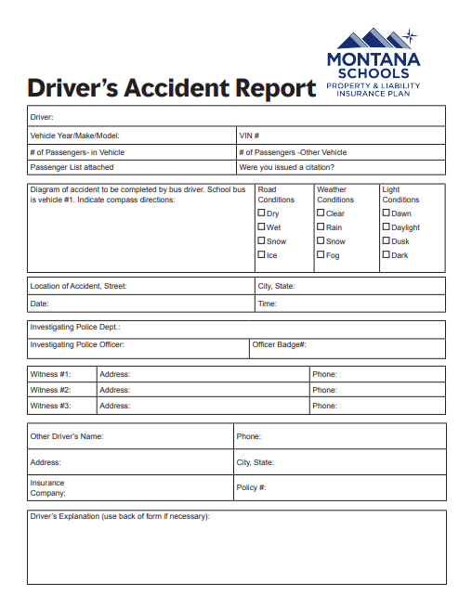
A - 4
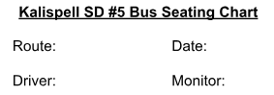

Left | Window | Center | Aisle |  |  | Center | Window | Right
1 |  |  |  |  |  |  |  | 1
2 |  |  |  |  |  |  |  | 2
3 |  |  |  |  |  |  |  | 3
4 |  |  |  |  |  |  |  | 4
5 |  |  |  |  |  |  |  | 5
6 |  |  |  |  |  |  |  | 6
7 |  |  |  |  |  |  |  | 7
8 |  |  |  |  |  |  |  | 8
9 |  |  |  |  |  |  |  | 9
10 |  |  |  |  |  |  |  | 10
11 |  |  |  |  |  |  |  | 11
12 |  |  |  |  |  |  |  | 12
13 |  |  |  |  |  |  |  | 13
14 |  |  |  |  |  |  |  | 14

A - 5

Rankin Elementary School

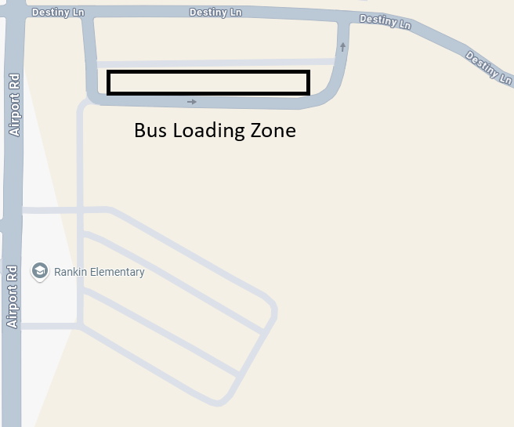

A - 6

Edgerton Elementary School

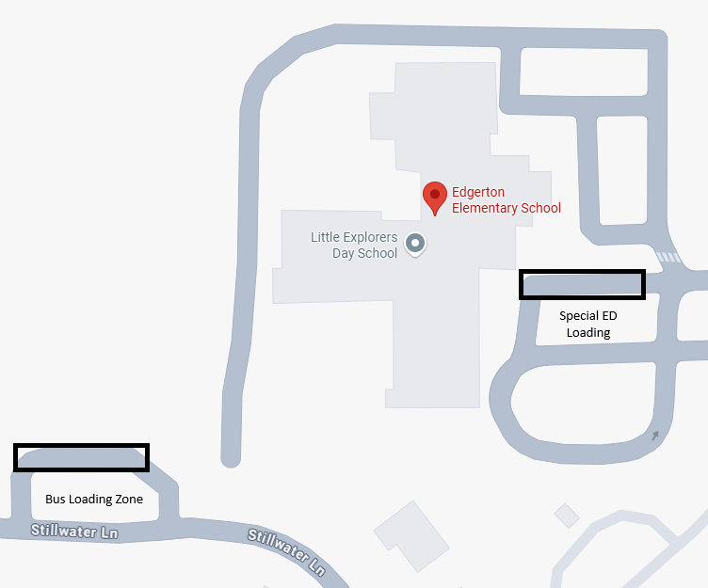

A - 7

Elrod Elementary School

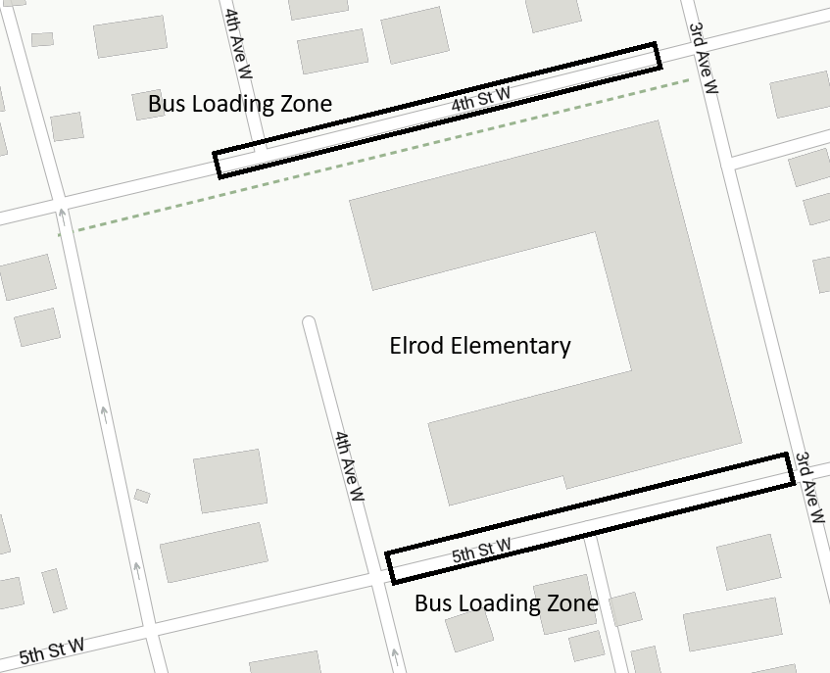

A - 8

Hedges Elementary School

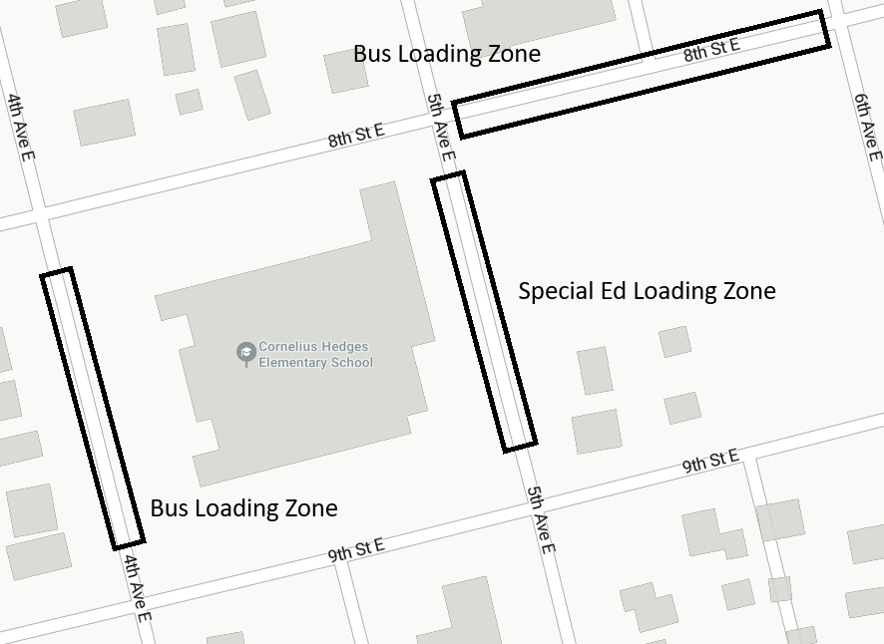

A - 9

Peterson Elementary School
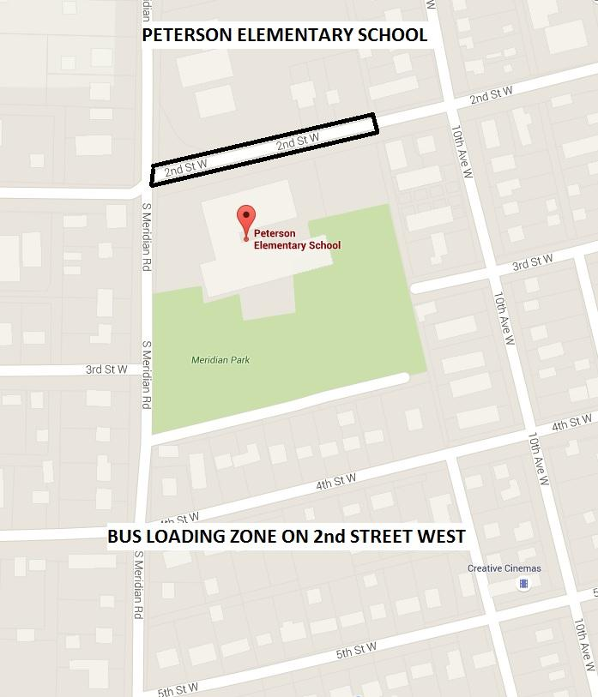

A - 10

Russell Elementary School

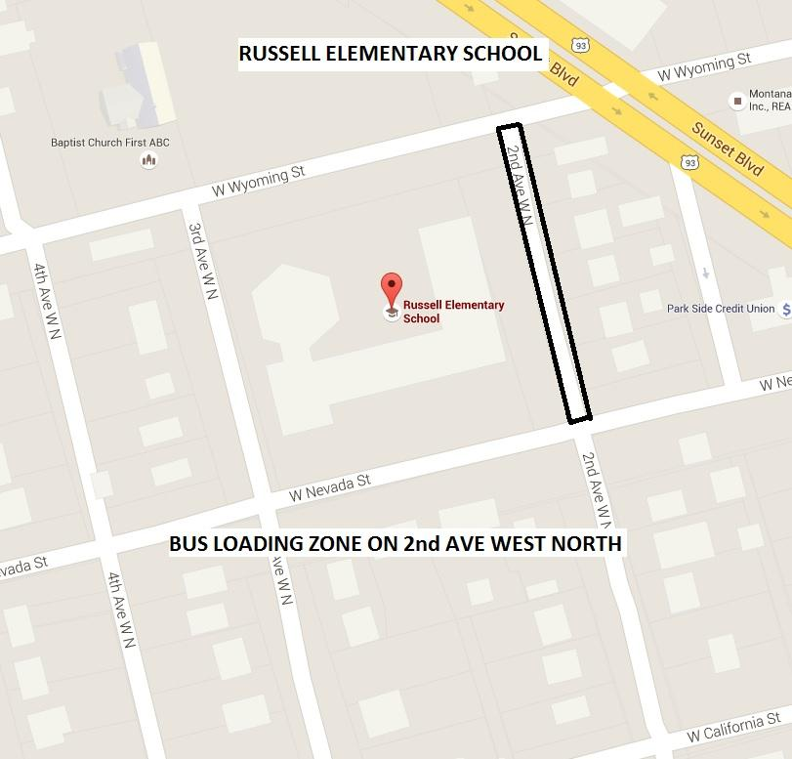

A - 11

Kalispell Middle School

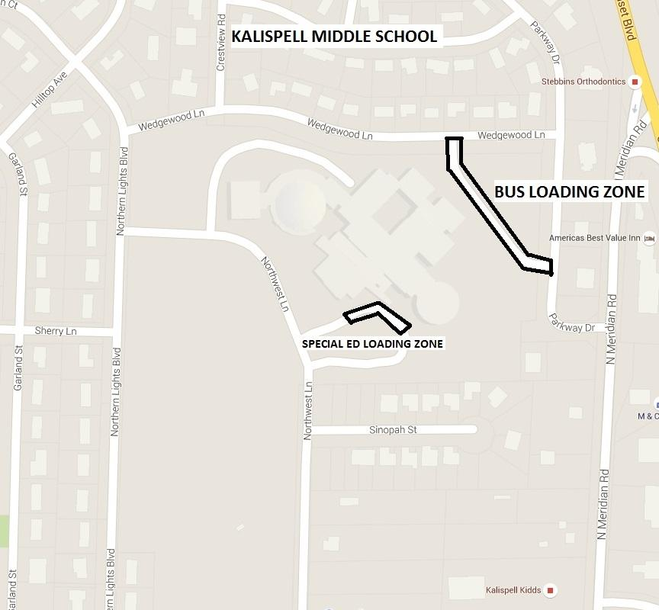

A - 12

Flathead High School

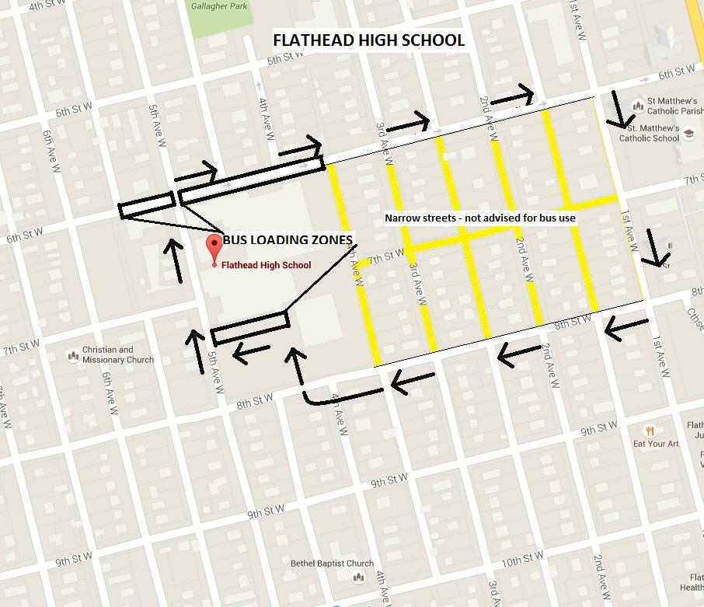

A - 13

Glacier High School

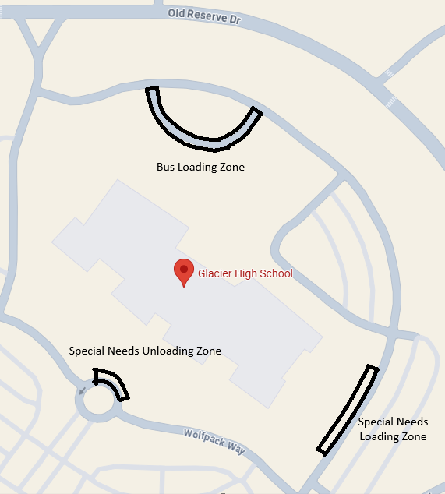

A - 14

Linderman Educational Center

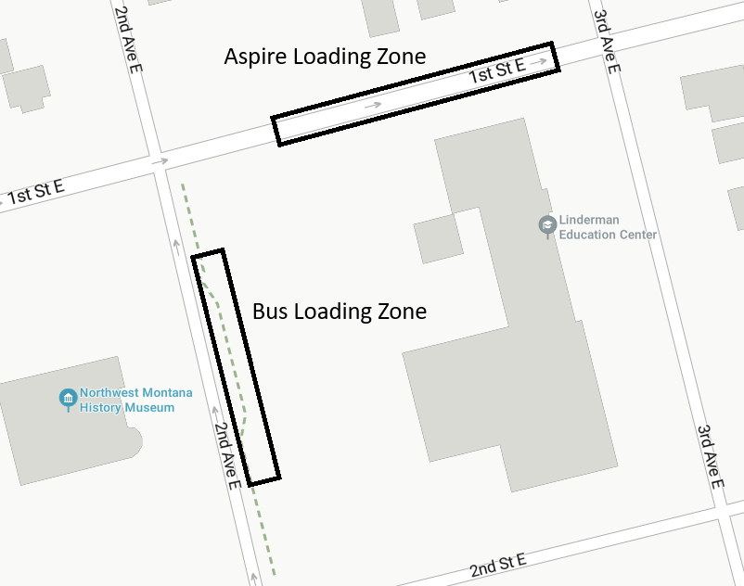

A - 15

KMS Bus Loading Map

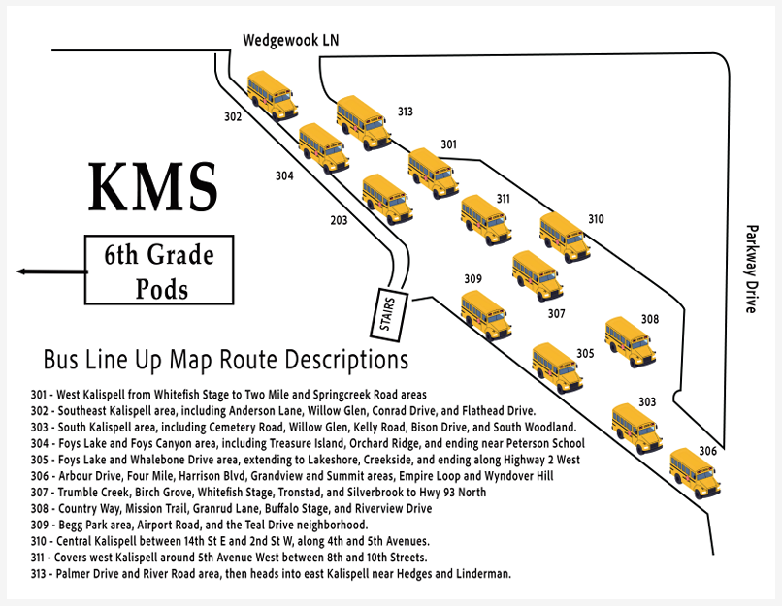

A - 16

FHS Bus Loading Map

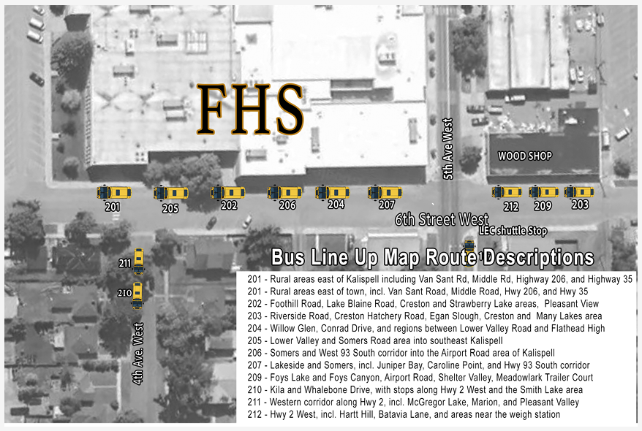

A - 17

GHS Bus Loading Map

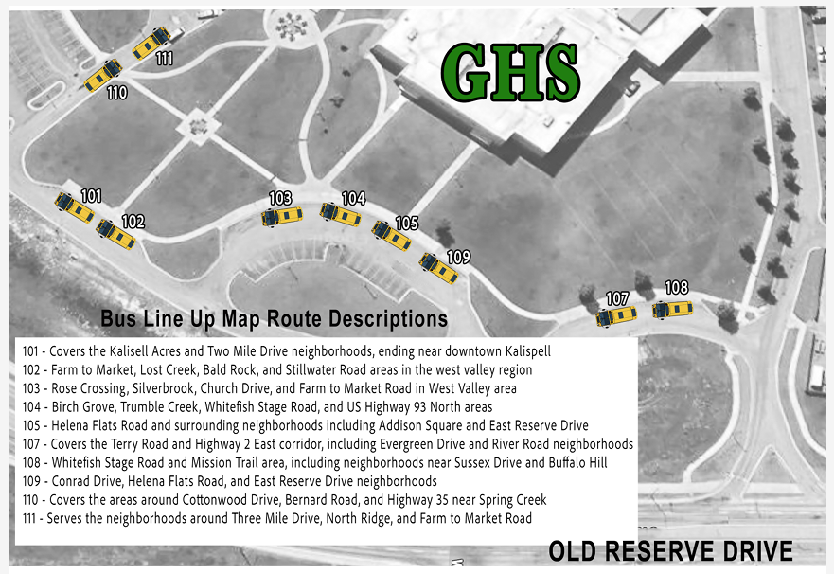

A-18

Acknowledgment Form

I, ________________________________________, have received a copy of the Transportation Handbook issued by Kalispell Public Schools, for both SD5 employees and Contracted Bus Drivers, and understand and agree that I am to review this handbook in detail and to consult District policies and procedures with my supervisor if I have any questions concerning its contents.

I understand:
- that this Handbook is intended as a general guide to District personnel policies and procedures and that it is not intended to create any sort of contract between the District and any one or all of its employees;

- that in the event there is a conflict between this Handbook and District policies and procedures, the policies and procedures will control;

3. that the District may modify any or all of these policies and procedures, in whole or in part, at any time, with or without prior notice; and

4. that in the event the District modifies any of the policies or procedures contained in this Handbook, the changes will become binding on me immediately upon issuance of the new policy or procedure by the District.

I understand that as an employee of the District I am required to review and follow the policies and procedures set forth in this Employee Handbook and I agree to do so.

__________________________________________ __________________
Signature of Employee Date

Please return this signed form to the Transportation Department.
It will be forwarded to HR in the District Office.

A - 19

