Library Nights
 Tutorials

Do you need Math or Science tutorials?
Do you need to schedule a makeup test or retest?
Come to Library Nights Tutorials!

Tuesdays and Thursdays
After School from 3:45 – 5:30 pm
GHS Library

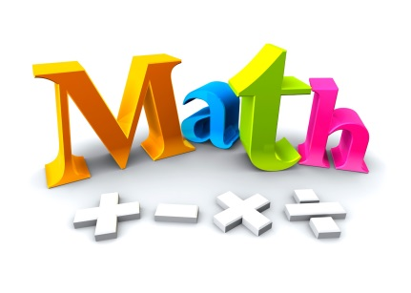

Homework Haven
Tutorials
Do you need Math tutorials?
Do you need to schedule a makeup test or retest?
Come to Homework Haven in Room 177!

Mondays and Wednesdays
After School from 3:35 – 4:20 pm
Room 177
