Hickman County School District
Professional Development Plan
2026-2027

The Hickman County School District Professional Development Plan provides a framework for aligning the written, taught, and tested curriculum. The professional development model is to create a learning organization that can realize individual and shared visions and capable of solving problems in a way that enhances the organization’s fundamental mission of teaching and learning.

A survey was given to all staff members designed to identify staff professional development needs. The following chart displays the results of the PD survey.

Results of PD Survey:
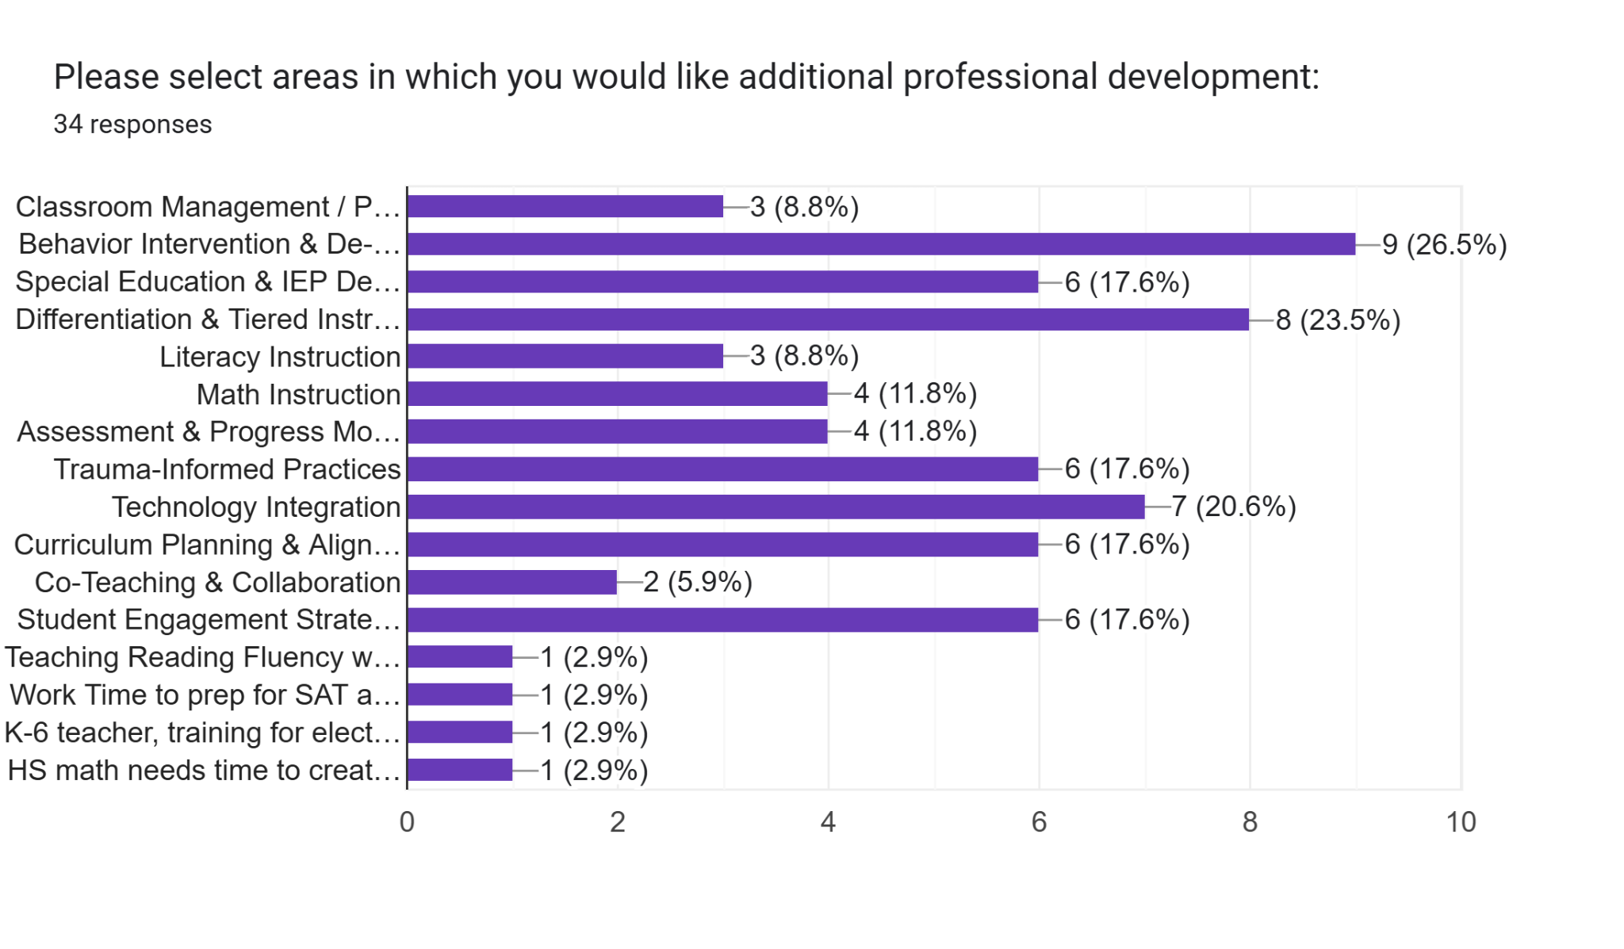

Behavior interventions, technology integration and differentiation of instruction were the top three requested professional development topics.

In alignment with our Comprehensive District Improvement Plan (CDIP), our Professional Development Plan, our Mentoring Program, and building‐level goals for academic improvement, and survey results; Hickman County School District has outlined the following professional development priorities:
• Support differentiated instruction and quality reading instructional strategies including research based tiered interventions (i.e. Science of Reading) and iReady
•Support sound instructional practices in content areas and align teaching to the KAS. Enhance the development of numeracy instruction in mathematics while investigating routines from Math In the Middle and continue our partnership with the West Kentucky Educational Cooperative to expand work, implementation of math shifts. We will continue investigating resources to support KAS in work with Mrs. Lemily to guide us in curriculum work.
• Support sound instruction, planning and teaching of the new science standards and training in PLCs and with the Co-op.
• Instruct professionals in sound pedagogical practices including cooperative learning structures.
• Enhance data analysis to inform instructional practices including professional development in data-driven instruction, running records, and analysis of KAS assessments and universal screening results. We will be working with iReady.
• Enhance the safety and security of our students, staff, and school buildings to comply with anti‐violence and safety regulations. Safety is still a top concern in our district. Staff will receive medical and safety training.
• Support sound instructional practice in Social Studies grades K‐12 with training in and curriculum work in the district and conferences out of the district.
• Utilize technology to enhance instructional practices, including Google Apps for Educators, Coding, STEAM, and expand teacher/coach knowledge in ways to create online PD opportunities
• Deepen the understanding of education laws and regulations related to 504, special education students, confidentiality, Family Education Records Privacy Act (FERPA), and evaluation and hiring practices for administrators.
• Instructional Leadership Workshops and sessions offered by the state and co-op.
• Deepen the awareness of mental health factors and disorders. Provide foundational strategies for all staff to support the mental health of students, and specialized training for counselor team in suicide awareness/prevention, anxiety and depression in youth in accordance with state toolkit. Terrace Metrics Training will continue to identify the needs of our students.

Professional Development Days
Attendance Guidelines
• All staff are required to attend professional development and adhere to the PD plan and/or the Comprehensive School Improvement Plans. (Exception: Counselors, per KDE definition, are required to receive 21 hours of EILA credit and may be assigned other duties on PD/non-instructional days.)
• The workshop must be held outside of the regularly scheduled calendar work day.
• Teachers who do not participate in required professional development per school PD plan will receive make-up/review during their planning time or at the discretion of the building principal.
• Professionals and paraprofessionals who attend a flexible professional development/workshop session must have prior administrative approval from the school administrator and the district Professional Development Coordinator.

Professional Development Activities
- Those activities which CAN be used for PD:
• Time spent in any training or meeting conducted after school hours which increases teacher knowledge to improve the academic achievement of students, for example,
- Assessment Analysis - Curriculum Development
- Student Work Analysis - Teacher Learning Teams
- Teacher Strategy Trainings - Research Based Strategy Trainings
• Any conference (not during school hours) which conducts trainings that increases teacher knowledge to improve the academic achievement of students
• Time spent after school hours as a total faculty discussion of a professional book.
- Those activities which CANNOT be used for PD:
• Time spent during or after school hours working in your classroom
• Time spent during or after school hours preparing lesson plans or presentations
• Time spent during or after school, working on IEPs, 504 plans, or GT plans
• Time spent during or after school hours taking students to competitions, athletic events, or field trips
• Time spent in graduate classes
• Time spent at a workshop or training during school hours
• Time spent during or after school hours at band formations, sports clinics or trainings
• Time spent writing grants
• Time spent after school hours for back-to-school nights, parent-teacher conferences, faculty meeting or school activities, CPR training
• Time spent with a student teacher or teacher intern
• Time spent reading a professional book after school hours
Paraprofessional Staff
Paraprofessionals may participate in professional development activities upon seeking permission from their building principal. Attendance will be assessed as voluntary attendance. Paraprofessionals must acquire prior written approval from their principal/supervisor to attend a workshop or work any additional hours. Not all paraprofessionals work the same number of days; therefore, they do not have the same school/work calendar. Your principal or supervisor will provide this information to you. Preschool instructional assistants will consult with their preschool coordinator concerning required training.

Important PD Dates to Remember 2026-27
Month of July has many PD opportunities at WKEC https://www.wkec.org/o/wkec/events
July 21 & 22, 2026- Preschool Summer Institute @ Curris Center
August 6, 2026-PD Certified Staff
August 7, 2026- PD Certified and Classified Staff
August 10, 2026-Work Day
August 11, 2026-Opening Day
November 2, 2026-Work Day for Certified Staff, if you are absent this will be considered sick or personal (certified)
February 12, 2027-Work Day for Certified Staff, if you are absent this will be considered sick or personal (certified)
March 15, 2026-Work Day
During Work Days, activities will be planned around our CDIP/CSIP needs.

Training Required for School-based Staff. Required trainings not included in PD hours.
1.School Technology Training- Required 2026-2027 by all staff
- Read Acceptable Use Policy
- Submit signed in Employee Nav.
2.Bloodborne Pathogen Training - Required 2026-27.
3.Child Abuse and Neglect Prevention Training - Required for new hires. Required for ALL 2026-27.
* Required for all school administrators, certified staff members, office staff, instructional assistants, coaches and extracurricular sponsors in 2020-21 or within 90 days of hire and every other year thereafter.
4.Review Code of Conduct for Duty to Report:
-Report Child Abuse
-Report Domestic/Dating Violence
-Report Criminal Activity, including Human Trafficking
5. MTSS/PBIS Refresh Required for ALL staff 2026-2027
6.Bullying Prevention Training - Required 2026-2027
7.FERPA/Confidentiality Training - Required 2026-2027
8. Suicide Prevention Training- Required 1 hour training for all Grades 4 - 12 school principals, guidance counselors, teachers and any other employee with job duties that require direct contact with students by September 15 annually. Required for all Grades 4 - 12 staff 2026-2027
9. Mental Health,Physical Restraint and Seclusion - Required for all staff 2026-2027
10. Emergency Management Plan Training - Required for all staff 2026-2027
11. Seizure Disorder Training- Required for new staff 2026-2027 - All principals, guidance counselors and teachers to complete a training. Submit documentation into Employee Navigation This self-study review is a one-time requirement, NOT an annual requirement.
12. Active Shooter- Required 2026-2027 This is a 1-hour training required for ALL staff annually (certified and classified) by November 1.
13. Medication Training- Required 2026-2027
14. CPR/First Aid- Training is not required for all staff. However, 702 KAR 1:160 Section 2(10)(b) states that there shall be at least one adult in the school certified in a standard first aid course including CPR for infants and children. If you drive a vehicle, you must have CPR training.
15. CPI Training for individuals deemed by administrators needing training for supervision
16. Alcohol, Tobacco, other Drugs-Required for all staff 2026-2027
17. Gifted and Talented- Required for all teachers 2026-2027
18. Title IX for all staff.
Certified staff will be required to have 24 PD hours outside of mandatory trainings. This training will be approved by principal or central office administrator and addresses their PGP.
Classified staff will be required to have 18 hours PD outside of mandatory trainings. This training will be approved by the principal or central office administration.

Professional Development Process
● For flexible professional development opportunities, the educator will submit a PD request form through the district email prior to the event.
● Professional development will be approved first by the immediate supervisor/principal and then by the District PD Coordinator.
● Once approved the educator will submit evidence of completion through a certificate, reflection or other documentation in the district platform.
● The District PD coordinator will approve submitted professional development evidence.
● Throughout the year the District PD Coordinator will submit to principals and supervisors an updated list of hours for their staff members.

