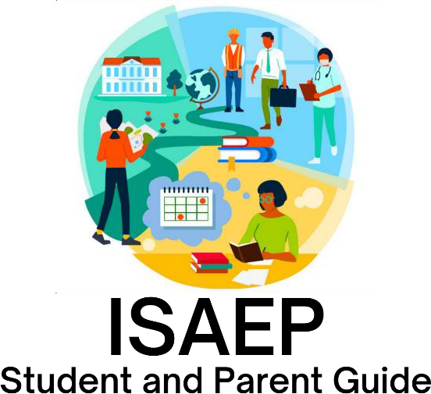

2026-2027

ISAEP/GED Guide

- ISAEP ELIGIBILITY

- APPLICATION PROCESS

- ABOUT THE PROGRAM
  - MEETING TIME
  - ATTENDANCE
  - HOMEWORK
  - WORK/VOLUNTEER HOURS
  - STAFF CONTACT INFORMATION

- PROGRAM CONTENT
  - ECONOMICS AND PERSONAL FINANCE
  - WORKPLACE READINESS SKILLS CERTIFCATION
  - CORE ACADEMIC CONTENT
  - GED TESTING

ELIGIBILITY
The Individual Student Alternative Education Plan (ISAEP) Program prepares students to take the GED test while developing career and technical educations skills. The ISAEP fulfills compulsory attendance requirements for students who are at least 16 years of age and have been found eligible by their base school counselor and administrators. Students are eligible if:
- Students are currently enrolled in a Roanoke County public high school, actively attending base school classes, and are at risk of dropping out/not graduating with their 9th grade cohort.
- Students are at least 16 years of age and at least one academic year behind their 9th grade cohort based on number of credits.
- Students will need state issued photo ID (necessary for official GED testing once enrolled in the ISAEP program).
- Students have met with high school counselor to review graduation requirements and possibility of graduating in traditional school setting.
- Students participate in initial meeting with base school principal, counselor, and parent/guardian to complete application process and review ISAEP requirements and expectations.
- Students meet academic testing entrance requirements; commit to preparing for GED test by attending class and completing weekly homework assignments; and commit to completion of 150 work or volunteer hours or online career training modules assigned by ISAEP staff.
To be eligible for the ISAEP Program, students must demonstrate a 7.5 grade level reading ability. This will be verified through a passing score on the 8th grade Reading SOL or by passing the TABE Reading assessment taken with the ISAEP coordinator. After having demonstrated a 7.5 grade level reading proficiency, students will take four GED Ready subtests in language arts, math, social studies, and science. Students must score a 140 or higher on each test to meet entrance requirements.

Application Process
The purpose of the initial base school meeting is to help students and their parents/guardians understand the following options for satisfying Virginia’s high school credentialling options and compulsory attendance requirements:
- Remain in a traditional school program
- Enroll in an alternative education program
- Enroll in an ISAEP program
At this initial meeting, students and their parents/guardians may complete the ISAEP application. The ISAEP Coordinator will contact students and parents/guardians to schedule testing once the application has been reviewed. Eligibility testing is comprised of five segments: the TABE Reading Achievement Test (waived if students have passed their 8th grade Reading SOL), the GEDReady Reasoning through Language Arts test, the GEDReady Reasoning through Math test, the GEDReady Reasoning through Social Studies test, and the GEDReady Reasoning through Science test. These tests will be administered in 4-5 sessions at BCAT/RCCTC as scheduled with the ISAEP Coordinator.

Eligibility testing takes an average of three weeks to complete, during which time students are expected to attend classes at their base schools. Failure to attend base school classes may result in a pause in entrance testing process. Students will have the opportunity to retest on entrance tests after 2 weeks of self-remediation if the 1st attempt is not passed.

Students will complete eligibility testing at BCAT/RCCTC as scheduled with Mara Pufko, ISAEP Coordinator, at 540-562-3900 ext. 29076. Parents/guardians are responsible for transportation for both eligibility testing and class attendance.

In addition to passing eligibility tests, students will need a state-issued photo ID and have an employment/community volunteer position or complete career training modules for homework once enrolled in the program. This satisfies the VDOE requirements for career development training.

Once all requirements are met, students and their parents/guardians will participate in an entrance meeting at BCAT/RCCTC to review expectations and requirements and sign the ISAEP contract. After the entrance meeting, students will attend class at BCAT/RCCTC instead of their base school.

ABOUT THE PROGRAM

Meeting Time
ISAEP classes meet every Monday and Wednesday that RCPS is in session; if RCPS has a non-student day on Monday or Wednesday, ISAEP classes do NOT meet. Class meets from 3:30 -6:00 with students entering and leaving through the main office entrance at BCAT; doors open at 3:10. Prompt pickup and departure is expected at 6:00pm. Please note that meeting location will be at RCCTC (6305 Peter’s Creek Road) after the winter break.

The ISAEP program follows the Roanoke County Schools calendar and inclement weather schedule for closings. Please refer to local media to find out if Roanoke County Schools are closed. In the event of a weather-related two-hour delay for the school system, ISAEP class will be held at the regular time. If RCPS dismisses early and/or cancels after school activities, ISAEP will NOT meet. Students (and parents/guardians if they desire) will register with the Remind App so that ISAEP staff can communicate updates regarding class meeting changes.

Attendance
Consistent attendance is vital to the success of ISAEP students. As there are only 2 in-person class meetings per week, each class meeting carries a higher value when considering learning opportunities and support. Absences of any kind must be communicated prior to class by parents/guardians. All absences must be verified by an official third party note from a doctor or court.

Class
Students in the ISAEP program work at their own pace to complete computer modules focused on completing Virginia’s Personal Finance and Workplace Readiness Skills certification requirements as well as GED modules that will prepare them to take the final GED tests in language arts, math, social studies, and science. ISAEP staff will work with students to establish a manageable yet productive pacing for classwork as well as facilitate remediation of weak skills and mastery of content. Students must bring the laptops they were issued at their base school to access these modules. In addition to academic preparation, students will have access to support to help with goal setting, employment, and independent living.

Homework
ISAEP students are required to spend a total of 15 hours each week working towards completion of the ISAEP coursework. 5 hours each week are spent in class on Mondays and Wednesdays; the remaining 10 hours are satisfied through completion of assigned homework in the Scoreboost GED prep workbooks and other assigned activities. Completion of homework hours should be approached as follows:
- ISAEP staff will assign HW at each class meeting. HW is assigned by content with an average completion time value attached.
- Homework is completed by the START of class each Monday and Wednesday. HW will be checked by ISAEP tutor during each class meeting.
- Students may work ahead and complete more HW than is assigned.
- Repeated failure to complete HW may result in removal from program.

Work/Volunteer/Career Training Requirements
In addition to hours spent working towards ISAEP certifications and GED completion, ISAEP students are required to complete 150 hours of paid/volunteer work. Students should plan on working an average of 10 -15 hours per week.
On Wednesdays, students will provide proof of a minimum of 10 hours worked through pay stubs or Verification of Hours form obtained from ISAEP staff. If a student is unable to find work experience in the community, ISAEP staff will provide career training modules to be completed at home; these modules will satisfy the VDOE career training requirement.

Staff Contact Information
ISAEP Office 540-562-3900 ext. 29076
ISAEP Coordinator/Instructor – Mara Kennedy Pufko mpufko@rcps.us
ISAEP Instructors/Tutor– Amanda Kinser

Students and parents/guardians will have the opportunity to enroll in ISAEP class text communication system through the Remind App. This will be done either at entrance meeting or first day of class.

Program Content
Economics and Personal Finance/ Workplace Readiness Certification
Students must earn a credit for both Economics and Personal Finance certification and Workplace Readiness Skills certification. If students have completed these credits at base school, the credits will transfer. The Econ/Personal Finance course is an online course structure. Additionally, ISAEP/ GED students must take and pass the Workplace Readiness Skills certification test.

Core Academic Content /GED Prep
In class, students will use the Essential Education GED prep online platform as well as in- person instruction to develop skills in language arts, math, social studies, and science to prepare for the four academic components of the GED test. In addition to in-class preparation, students will work independently at home on these academic subject skills in Scoreboost GED Prep books.
Students will only work on one subject at a time, with online modules and HW being coordinated. GED instructors will facilitate individual and small group instruction as needed.

Once academic assignments in the Scoreboost books and Essential Education platform have been completed, students will complete a GEDR practice test for that subject and earn a 145 or higher; when GEDR has been passed and the work/career training components have been met, students will be ready to take GED subject component.

GED Testing
Upon the completion of 1) at least 37.5 work/CTE training hours per academic test; 2) all the homework for at least one core subject;3) a score of 145 or higher on the GED Ready test; and 4) regular attendance, an ISAEP GED student may sit for one of the four GED tests.

GED tests are given locally at the Roanoke Higher Education Center. Students are required to arrive at the testing center 15 minutes early with a government issued photo ID. Testing is free of charge to students. If a student does not attend the test session or does not have required documentation, the student is responsible for the retest fee.

