CALLOWAY County Middle School
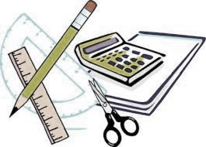
2026-2027 School Supply List

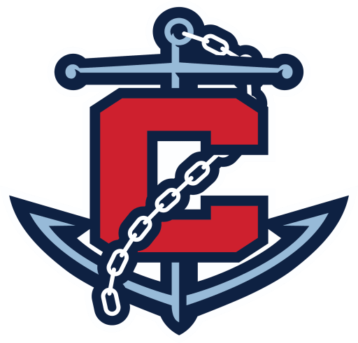
6th grade
To be carried from class to class:
-1 Binder (regular or zipper, not larger than 2”)
-6 folders (labeled 1st-6th period)
-Pencil pouch
-loose leaf paper
-At least 30 pencils
-Manual pencil sharpener
-package of colored pencils
-Highlighters
-wired earbuds
-markers
-erasers (cap & block)
-Red pens (at least 4)
-Texas Instrument TI-30XIIS calculator
-two pocket paper folder for library barcodes
To be left in classrooms:
-2 composition notebooks (Science & ELA)
-1" binder (SS)
-binder divider tabs (SS)
7th grade
To be carried from class to class:
-1 Binder (regular or zipper, not larger than 2”)
-6 folders with 3 holes (labeled 1st-6th period)
-Pencil pouch
-loose leaf paper (college ruled)
-At least 30 pencils
-Manual pencil sharpener
-package of colored pencils
-Highlighters
-two pocket paper folder for library barcodes
-Texas Instrument TI-30XIIS calculator
NOTE: if your student is a member of the CCMS band or choir, they will also need a ½” black 3-ring binder with additional
divider tabs (6-8), along with a pencil pouch (with pencils, highlighters, etc.) with it. Thank you!!!
To be left in classrooms:
-2 composition notebooks
-3 1-inch binders

Classroom Donations Welcomed
Germ-X, Kleenex/tissues, paper towels,
Clorox wipes/Baby wipes, EXPO markers
8th grade
To be carried from class to class:
-1 Binder (regular or zipper, not larger than 2”)
-6 folders with 3 holes (labeled 1st-6th period)
-Pencil pouch
-loose leaf paper (college ruled)
-At least 30 pencils
-Manual pencil sharpener
-package of colored pencils
-Highlighters
-graph paper
-red ink pens (at least four)
-erasers (cap & block)
-index cards
-wired earbuds
-two pocket paper folder for library barcodes
-Texas Instrument TI-30XIIS calculator
To be left in classrooms:
- composition notebook & folder (SS)
-1.5" binder (science)
-2 composition notebooks (ELA)

