NEW ONLINE METHOD FOR REPORTING A STUDENT ABSENCE

NEW: Absences must be reported through the PowerSchool Parent Portal in a web browser.
The Attendance Monitor is NOT available in the PowerSchool app.

STEP 1  After signing in, choose your student, then scroll to the bottom of the menu on the left side of the screen and click Attendance Monitor.  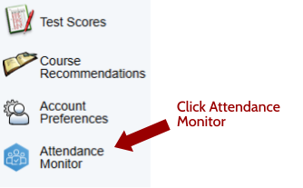 | STEP 2  On the Report Attendance tab, click Report New Attendance.  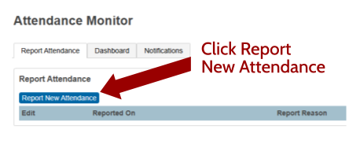
STEP 3  Choose the absence date or range of dates, indicate whether the student will miss the full day or part of the day, select the reason for the absence, and provide a brief explanation. Then click Submit.  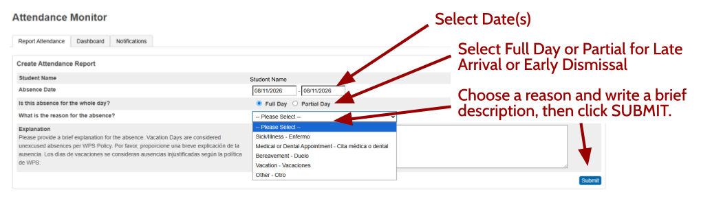 |  | HELPFUL REMINDERS  - You may report a planned absence up to 20 days in advance.  - If you forgot to notify the school, you may submit an absence for up to the previous 3 days.  - You may edit/delete a submitted attendance report until it has been processed by the school.  - WPS Attendance Policy

