FMS- Online Payment Instructions for TLS at Camp Kieve via PowerSchool Form
Updated 8-10-26

Below are instructions to submit an online payment using a credit/debit card or echeck/ACH for your 6th grade student’s participation in The Leadership School at Camp Kieve. Payment is due Tuesday 9/1/26. If you plan to pay by check, you do NOT need to fill out this form.

- Login to PowerSchool to access your student’s account.

- Click “Forms” from the left navigation menu.

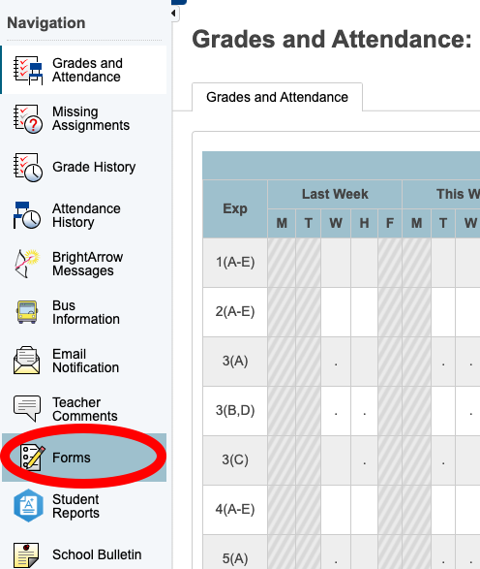

- Scroll down to access the form called “Camp Kieve - Online Payment” under the “FMS” section

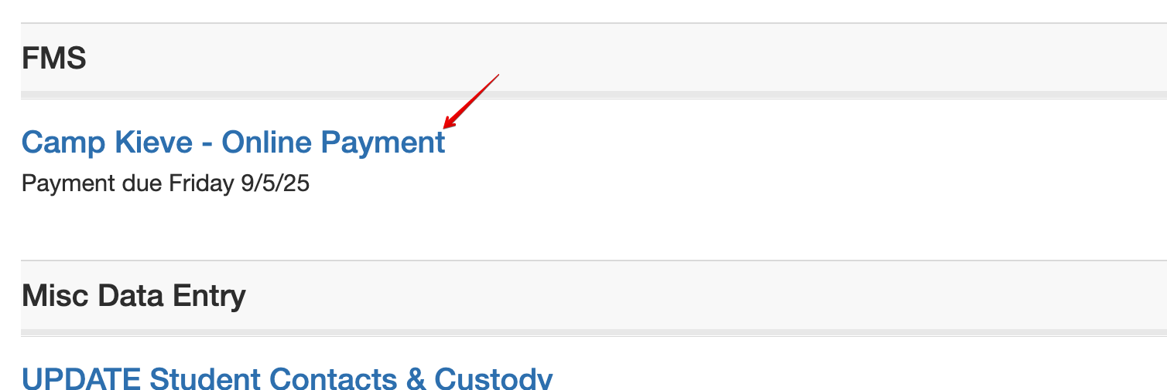

- Indicate your scholarship status, payment option, and amount, and then submit your payment as directed. Thank you. Please reach out to Angela Piveronas at apiveronas@falmouthschools.org with any questions.

