
“Setting the Standards for Excellence in Public Education”

PHILIP HAMMACK KEVIN THOMPSON
Principal Assistant Principal

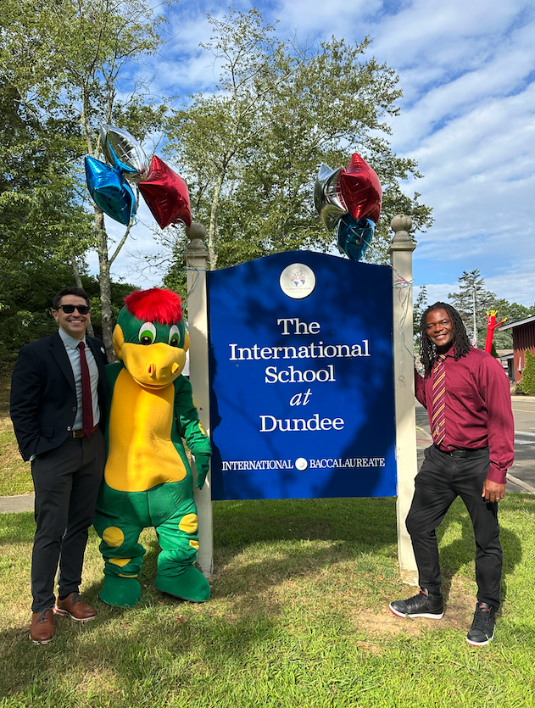
Dear Parents and Families of ISD,

We could not be more excited to welcome everyone back for another school year. Located in the beautiful Riverside section of Greenwich, ISD was the first magnet school established in Greenwich in 2000. In 2003, ISD was also the first school in New England to become an accredited International Baccalaureate Primary Years Programme (PYP) school.

Last year we celebrated the International School at Dundee’s 25th anniversary, an incredible milestone for our community. This year, we look forward to building on the successes of last year as we continue to improve upon the amazing foundation for learning at ISD.

The Primary Years Programme provides students the opportunity to engage with engaging transdisciplinary units of study. This approach to learning reinforces ISD’s vision to lead students towards becoming life-long learners and responsible citizens of the world. Teachers at ISD use the IB Learner Profile to teach students to become Inquirers, Thinkers, Communicators, Risk-Takers, Knowledgeable, Principled, Caring, Open-Minded, Balanced, and Reflective.

This unique approach to teaching and learning aligns seamlessly with the Mission of the Greenwich Public Schools to educate all students to the highest levels of academic achievement; to enable them to reach and expand their potential; and to prepare them to become productive, responsible, ethical, creative and compassionate members of society

There is so much to be excited about at the start of the school year, and we look forward to partnering with each of you in the coming months to ensure that each and every student at ISD continues to develop and grow to their fullest potential.

We are truly excited to partner with you all, and look forward to another great school year at ISD! Please don't hesitate to reach out to your classroom teacher, myself, Dr. Thompson or Sparky at any time with any questions or concerns.

See you soon!

Phil Hammack & Kevin Thompson

