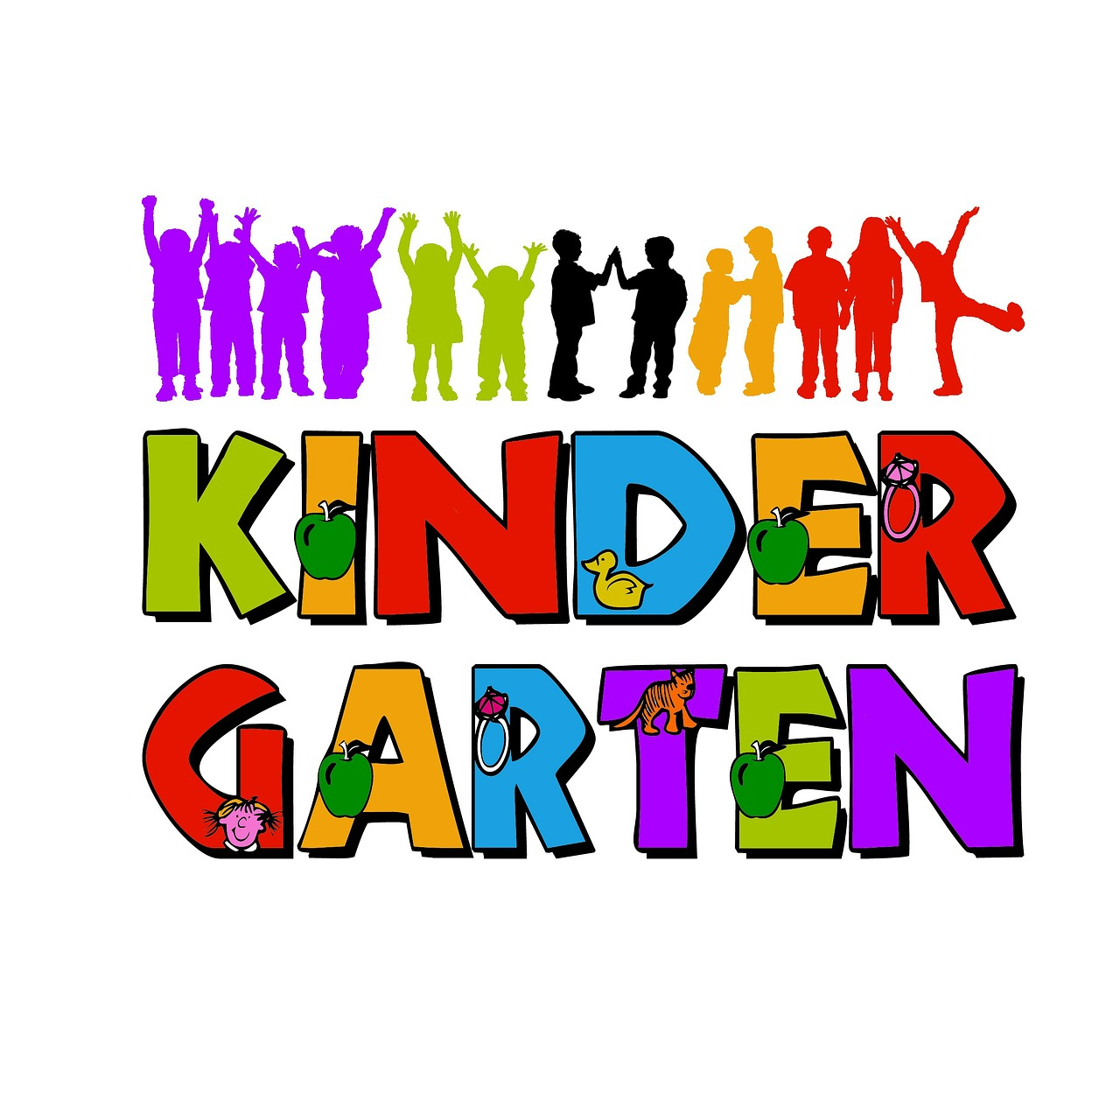
“Kinder Crew” 2026-2027
Let the “JOURNEY” begin!

BLANCHE SPRENTZ ELEMENTARY
Steve Callahan scallaha@fcusd.org
Sara Huntington shuntington@fcusd.org
Principal Nereida Cabrera ncabrera@fcusd.org
Blanche Sprentz (916)294-9110

All Day Kindergarten 8:15-2:45. Thursday is early dismissal 8:15-1:15.

Appropriate clothing:
Your child needs to wear comfortable clothes and shoes for working. Kindergarten can be messy, so no special clothes please, except on the first day and on picture day. Please put your child’s name inside any jackets, etc. that can be removed and left behind.
Backpacks:
Your child needs to have a full-sized backpack for school, large enough for papers 9 x 12. Please take out and review papers in the backpack daily. After the first few days of school, the backpack should not contain items from home such as binder, crayons, toys, etc. Students will be using supplies we have in class. No toys or other treasures from home at school, please! Backpack also need to be labeled with their names.
Water Bottle/Daily Snack/Lunch:
Students need to bring a water bottle every day. Please send a small, healthy snack each day. First recess is 10:05-10:20. For lunch, please send a healthy lunch or let students know that they are getting a school lunch (free).
Weekly Bear Folders (Monday)
This is where you will find all the school communications. Homework will be included in this folder, also, once a week only. Homework will consist of our weekly reading passage and usually a math paper. Homework can be returned in the Bear Folder or as it is finished.
Drop off/Pick up:
Students are to be dropped off and picked up outside the kindergarten playground gate. Please keep us informed of your child’s transportation to and from school and any changes.

Monthly Class Calendar:
Each month we will send a calendar home with your child. There are specific homework directions each month for the class calendar. There will be a color pattern for crossing days off the calendar and a Read Aloud page attached to record the stories you read together at home. Cross off all the days of the month (even weekends!) in the color pattern, record stories read (at least 10 each month) and then return it to school for credit. There is a reward for the children who complete these calendar assignments each month, so don’t let your child miss out!

Our School Year:
Each child in our classes will get to be “Star Student”, for 1 week of the year. We will send home a special poster at the end of the before they are the star. We will also be sending home a note of explanation prior to your child’s assigned week.

Academics:
We have an academic Kindergarten and cover all 26 letters of the alphabet, 1 letter each week. We use UFLI reading program, Benchmark Advanced reading series, and the SIPPS reading program to help your child learn about letters/reading. We will also be using the Innovamat Math series to work on skills in Counting and Cardinality, Operations and Algebraic Thinking, Numbers and Operations in Base 10, Measurement and Data, and Geometry. e. Our curriculum for Science, Amplify, covers Plants and Animals, Sunlight and Weather, as well as Pushes and Pulls. In Social Studies we talk about “Me and My World.”
There will be a formal Parent /Teacher Conference mid-year. However, please feel free to talk with us anytime!
P.E. Days: Callahan T/W Huntington M/T
Supplies:
We have attached our Blanche Sprentz Kindergarten Supply list for those who would like to help support our classes.
A “Play-Doh Parent” is needed each month to keep our classroom stocked with fresh Play-doh. We will send an email request. Please respond with the month you’d be willing to help make Play-Doh. A specific recipe will be provided.
We make many fun projects at school, and we need STUFF. Please find attached the list of purchasable or discard items we will be needing. We are also asking for a $$ donation to our classroom fund to help us with the things we need to purchase, such as ingredients for craft projects. Please help if you can.

Our Developmental Practice and Philosophy

Since play is a child's work, we try to enhance that play, but never replace it! Flexibility is built into our day so that we can capitalize on "teachable" moments. Learning how to learn and how to question are important during the kindergarten years. Kindergarteners learn by doing, playing, talking, listening, modeling others, and listening to stories. In our class we expose our young learners to all of these and more.

Lastly, know that we are in this together and we are very excited to start this wonderful year of learning together! Thank you for your support, flexibility, and patience.

Your “K” Team”

Ms. Huntington and Mr. Callahan



Just Playing
by Anita Wadley
When I'm building in the block room, please don't say I'm "Just Playing".
For you see, I'm learning as I play, about balance and shapes.
Who knows, I may be an architect someday.
When I'm getting all dressed up, setting the table, caring for the babies,
Don't get the idea I'm "Just Playing". For, you see, I'm learning as I play;
I may be a mother or a father someday.
When you see me up to my elbows in paint or standing at an easel, or molding
and shaping clay, Please don't let me hear you say, "He is Just Playing".
For, you see, I'm learning as I play. I'm expressing myself and being creative.
I may be an artist or an inventor someday.
When you see me sitting in a chair "reading" to an imaginary audience,
Please don't laugh and think I'm "Just Playing".
For, you see, I'm learning as I play.
I may be a teacher someday.
When you see me combing the bushes for bugs, or packing my pockets with choice things I find, Don't pass it off as "Just Play".
For you see, I'm learning as I play.
I may be a scientist someday.
When you see me engrossed in a puzzle or some "plaything" at my school,
Please don't feel the time is wasted in "Play".
For, you see, I'm learning as I play.
I'm learning to solve problems and concentrate.
I may be in business someday.
When you see me cooking or tasting foods,
Please don't think that because I enjoy it, it is "Just Play".
I'm learning to follow direction and see differences.
I may be a cook someday.
When you see me learning to skip, hop, run and move my body,
please don't say I'm "Just Playing".
For, you see, I'm learning as I play.
I'm learning how my body works.
I may be a doctor, nurse or athlete someday.
When you ask me what I've done at school today, and I say, "I Just Played",
Please don't misunderstand me. For you see, I'm learning as I play.
I'm learning to enjoy and be successful in my work. I'm preparing for tomorrow.
Today, I am a child and my work is play.

BLANCHE SPRENTZ SCHOOL SUPPLY LIST
KINDERGARTEN 2026-2027
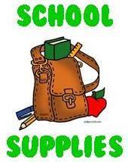
KINDERGARTEN
Please do not label with student’s name:
__ Crayola 24 Count Crayons- 2 boxes
__ pencils -Ticonderoga #2 (1 package)
__ Crayola Markers 10 pack
__ tissues (Kleenex brand if possibl)
__ 2 reams of white copier paper
__ Prang or Crayola Watercolor Paint Set
__ Zip Lock bags (snack, sandwich, and gallon)

Please DO label with student’s name:
__ backpack large enough for 9” x 12” papers
__ Personal headphones (not ear buds) in a zip top plastic bag.
Please also label all jackets, sweaters, coats, etc.

