PIRATE’S TREASURE CHEST

STUDENT HANDBOOK 2026-2027

PINECREST ELEMENTARY & MIDDLE SCHOOL
Megan Hicks, Principal
Jackie Trim, Curriculum Coordinator
3604 Hwy. 557
West Monroe, LA 71292
TABLE OF CONTENTS
A Note to Parent---------------------------------------------------- 3
Vision & Mission Statements--------------------------------------- 4
Closed Campus Policy ----------------------------------------------- 5
Parent Conferences ------------------------------------------------- 5
Google Classroom & Dojo / School Fees ------------------------------6
Accountability & Standardized Tests ----------------------------- 7
Grading Scale & Requirements for Promotion --------------------8
Student Awards ----------------------------------------------------- 9
Attendance Requirements ------------------------------------------ 10
Dress Code, Clear bags, and Waterbottles------ 11
PBIS Policy ---------------------------------------------------------- 12-19
Guidelines for Students -------------------------------------------- 20
Cafeteria Rules ----------------------------------------------------- 21
Classroom Rules/Computer Lab Rules------------------------------ 22
Library Rules -------------------------------------------------------- 23
Cell Phone Policy ----------------------------------------------------- 24
Holdback Information…………………………………………..….25
Harassment, Intimidation, and Bullying Policy ---------------- 26
Other Policies 27
Saturday Seminar. Tracking Form------------------------------------ 28
Medication in School / Guidelines for Attendance-------------29-32
Immunization Requirements ---------------------------------------- 33
Chromebook Policies ----------------------------------------------- 34-37
Web Publishing Policy/AI --------------------------------------------- 38-39
School Calendar ---------------------------------------------------- 40
Section 504 Information ------------------------------------------- 41-44
Homeless Student Info………………………………………… 45-46
Signature Page------------------------------------------------------- 47

A Note to the Parents

Your objectives as a parent and the objectives of the school in respect to your children are the same: To give him/her the very best possible guidance toward the realization of his or her capacities. To accomplish this goal, full cooperation between home and school is essential.

The faculty and staff at Pinecrest School realize that our school can be a success only with the help and support of our community. We strongly encourage you, as a parent, to be concerned with the education of your child and to participate in our school functions. We will strive to notify you of school activities and upcoming events through notes, newsletters, Google Classroom, Class Dojo, and the School Website and Facebook group. We invite you to visit often and be an active part of the Pinecrest School family. We look forward to another successful year of serving you and your child at Pinecrest.

LET’S HAVE A GREAT YEAR!!!!
GO PIRATES!!


Parish Vision Statement:

Building Bridges to the Future

Parish Mission Statement:

As a community, Ouachita Parish Schools will connect learning to 21st Century skills needed for college and career-ready students who will excel in a global society.

Beliefs:

Ouachita Parish Students will learn at high levels.
Parents, students, teachers, and community matter.
Safe schools are a top priority.
Bridges connect past and present learning to future dreams.

School Mission Statement:

Our mission is to create an atmosphere and provide a curriculum where all students can succeed academically, technologically, and socially.

CLOSED CAMPUS POLICY

It is most important for us to be aware of students arriving and leaving campus during the school day. We ask that you adhere to the following rules while on campus.

1. CHECK IN with the office UPON ARRIVAL at school for any reason.
2. Students should be CHECKED IN / OUT THROUGH THE OFFICE only!
3. Please notify the school, IN WRITING, if your child is to leave school in any way that differs from the normal procedure. This request should be given to the homeroom teacher. It will be sent to the office. This note SHOULD BE BROUGHT TO SCHOOL BY THE STUDENT! PLEASE, DO NOT WAIT until the end of the day to call in with a change in plans unless it is an emergency. Constantly changing a child’s routine is not conducive to learning. Having a routine and a feeling of security allows a student to focus on school instead of how he or she will get home or who will pick them up.
4. Parents are NOT to go past the security door without permission from the office. Every minute of class time is important. If the teacher is interrupted, learning cannot take place. Also, this is crucial to our school’s security plan.

PARENT / TEACHER CONFERENCES

A parent - teacher conference is a planned, prescheduled meeting, usually involving a teacher, the principal, and one or both parents. The time should be used to:

1. Provide an opportunity to get to know each other.
2. Obtain information about the school and its programs.
3. Confer with teachers regarding a child’s academic progress, conduct, or any other area of concern.
Google Classroom / On Course / Class Dojo
The Ouachita Parish School System offers parents an opportunity to know exactly how their child is performing in the classroom without ever having to pick up the phone or visit the school! This wonderful tool is located on the School Website page and is called On Course Connect. Access to this page will allow you to track your child’s grades, assignments, and test schedule. You can also find things like the school calendar, lunch menu, and basketball schedule, and school supply lists on our website.

All teachers will be using Google Classroom to post assignments and information. Parents should check here for any assignments missed due to student absences.Students in grades 3 and up should easily be able to access this to show you.

Teachers will also be using Class Dojo as a means of communication between the teacher and parent. Our goal is for all parents to be informed at all times regarding school related work and activities. We ask that parents keep communication to normal business hours.

School Fee/Money Policies
The school fee of $40 is due at the beginning of the 2026-27 school year. This money purchases paper, printers / printing costs, ink cartridges, toner, and includes Chromebook insurance. All payments must be made using Online School Payments. We will not accept cash or checks.

Fee breakdown:
$ 5.00 Chromebook insurance
$ 8.00 Ink/Toner
$ 5.00 Paper/Printing costs
$ 5.00 Online class materials
$10.00 Graphis arts materials
$2.00 student folders for sign/return
$5.00 awards,certificates, trophies

ACCOUNTABILITY & STANDARDIZED TESTS

Pinecrest School administers the DIBELS 8(k-3) & numeracy screener 3 times per year,as this is state mandated. The LEAP 2025 (3-8) state-mandated test in the spring of each school year. These tests are used to evaluate student progress from year to year and to determine areas of strength and weakness.
Students in grades 2 and 3, in accordance with state law and the OPSB Pupil Progression plan, may not go to the next grade level if they score “Well Below” on the end of the year Dibels. There are exceptions to this policy, as well as options to retest and/or participate in remediation.
Students who do not meet expectations on these tests will receive an IASP, as well as targeted interventions to help them make progress toward reaching grade-level goals and expectations.

You will receive a detailed schedule closer to the beginning of testing.
It is extremely important that students attend school during this time. A doctor’s excuse is required if a student misses any portion of an exam.
The faculty and staff of Pinecrest are constantly working to ensure that our students master our curriculum to the highest possible level. Your help, as a parent, is crucial. Please encourage your child to strive for maximum performance in his or her work. If we all work together, we will continue to have great success.

Ouachita Parish Grading Scale
A 90 - 100
B 80 - 89
C 70 - 79
D 60 - 69
F 59 - below
REQUIREMENTS FOR PROMOTION
Kindergarten | Must pass reading knowledge, math, and reading skills with a C average
Grade 1 | Must pass reading knowledge, math, and reading skills with a C average
Grade 2 | Must pass reading knowledge, math, and reading skills with a C average  *students must pass a literacy screener. See the district Pupil Progression Plan for details.
Grade 3 | Must pass reading, math, & 2 other major subjects  *students must pass a literacy screener. See the district Pupil Progression Plan for details.
Grades 4 & 5 | Must pass reading, math, and 2 other major subjects
Grades 6-8 | Must pass ELA, math, and 2 other major subjects or 1 major and 1 minor subject
HOLD BACK REQUESTS FROM PARENTS
For students who have passed academically but parents are considering holding students back in their current grade:
- Parents must submit in writing their request to Mrs. Hicks by the end of February each school year.
- SBLC will meet and approve / deny the request.
- Parent will be notified of the decision.

*Retention due to not meeting passing requirements is based on the district Pupil Progression Plan/SBLC, as listed above, and is not a parent decision.
STUDENT AWARDS
Our students will receive special recognition for academic achievement at the end of each nine weeks grading period and at the conclusion of the school year. Special awards will be given on Awards Day as indicated below:
PRINCIPAL’S LIST  (4.0 GPA) ALL As ALL YEAR | Gold Medal AND Certificate
A AVERAGE  (3.5 – 3.99 GPA) | Silver Medal AND Certificate
B AVERAGE  (3.00 – 3.49 GPA) | Bronze Medal AND Certificate
**Students may receive only ONE of the three awards listed above.
Students cannot have an F on their report card.
ALL A’s IN A CORE SUBJECT | ONE Certificate  (All Subjects on Same Certificate)
CITIZENSHIP  (2 per homeroom) | Medal with Red, White, & Blue Ribbon
PERFECT ATTENDANCE  (Cannot miss a whole or half day according to computer printout) | CERTIFICATE
**All students are eligible for the three awards directly above.
**Conduct and P.E. are not considered a core subject.

Honor Roll
Rewards for students who qualify for the honor roll will be given each nine weeks.

Principal’s List – All A’s
A/B Honor Roll – All A’s and B’s

Attendance Requirements
Compulsory attendance laws and the Louisiana Board of elementary and secondary Education (BESE) regulations require students to be in attendance a minimum of 60,120 minutes (equivalent to 167 six-hour days) a school year in order to be eligible to receive credit for courses taken.
The following define absences according to OPSB policy and state law:
excused absences- absences incurred due to personal illness or serious illness in the family that is documented with acceptable excuses, such as a doctor’s note or funeral announcement. A parent note explaining an illness can be used for one day (per week) for a short-term illness. The purpose of the acceptable excuse is to allow the student to be eligible to make up work and tests, receive credit for work completed, and receive credit for a course and/or school year completed. These absences are not considered for truancy purposes.
Unexcused absences- absences not meeting the requirements set forth in the excused absences and extenuating circumstances definitions (see OPSB policy). Students shall be given failing grades for those days missed and shall not be given an opportunity to make up work.
Suspensions- non-exempted absences for which a student is allowed to make up his/her work and is eligible for consideration for credit when completed satisfactorily and in a timely manner. The absence shall be considered when determining promotion, but shall not be considered for the purpose of truancy.

chrome-extension://efaidnbmnnnibpcajpcglclefindmkaj/https://doe.louisiana.gov/docs/default-source/career-and-college-readiness/attendance-guidance-one-pager-8-15-2024.pdf
Truancy
When a student has 5 unexcused absences or tardies, they are considered truant. This information will be pulled by the Child Welfare and Attendance office of OPSB, who may pursue legal action. Parents will be notified after 3 unexcused absences by letter and required to meet with the principal. Parents will be required to meet with CWA after 5 unexcused absences to determine further action of seat recovery time. RS 17:233
In accordance with state law and district policy, students who are truant and do not make up the appropriate seat time can receive an F6 and be forced to repeat a grade.

Dress Code
Pinecrest School follows the OPSB Dress Code for students. We do not require uniforms or clear backpacks for students. Please see the link below for dress code requirements. In addition, we ask that shorts be no shorter than fingertip length when standing. Leggings must be worn with a top that covers the backside.
https://files.gabbart.com/1815/jcdb-24b_1.pdf
Each year our lost and found is filled with clothing items that are lost by students and never reclaimed. Items not reclaimed are donated to a local charity. Please label all removable garments such as jackets, hoodies, sweaters, coats, etc. with a name.
OPSB Clear bag Policy for Events
https://files.gabbart.com/1815/policy_review_april_2024.pdf
Metal Detectors
Students in grades 6-8 are required to enter through the middle school hall and walk through our metal detectors. Backpacks, bags, etc that set it off will be searched by administration. Should a student set off a metal detector, they will be asked to remove anything they think set it off and try again. Should it continue to go off, the student will be checked with a metal detecting wand.Parents will be called if needed after this point.
Water Bottle Policy
Students may use a plastic refillable or disposable water bottle to refill at refilling stations. Metal water bottles are prohibited to be brought by students. All hallways have traditional water fountains students can use if they do not have a plastic bottle or for students who violate this policy. Teachers will return the metal bottle, emptied at the end of the day and parents will be notified. If this is a continual problem, the bottle will be turned into the office for a parent to come get at their convenience.
Pinecrest Pirates

PBIS Parent/Student Handbook

Respectful
Responsible
Safe

Mission Statement:
Our mission is to facilitate positive behavior change in our students and staff and to increase instructional time through the development of effective, proactive, education-oriented interventions that result in the reduction of inappropriate behaviors by students and staff.
Pirate Code of Conduct
⮚ We are Respectful to all staff and other students, including cafeteria, custodial and bus employees.
⮚ We are Responsible in all areas on the premises of Pinecrest school and on the busses.
⮚ We are safe with our actions to all staff members and other students, including on the busses.



Positive Behavior Interventions and Supports (PBIS) In our efforts to establish Pinecrest Elementary/Middle School as a safe, welcoming, and purposeful learning environment, we have implemented Positive Behavioral Interventions and Supports (PBIS). PBIS teaches behavioral expectations and recognizes students for following them. The goal is to establish a climate in which appropriate behavior is the norm. PBIS actively encourages students to achieve their academic potential while also behaving with good character. The goal is to design the most effective learning community possible with the best outcomes for all students
At Pinecrest School the focus is on teaching and encouraging expected behavior in all areas of the school, concentrating on the instruction of The Pirate Code of Conduct: Be Respectful, Be Responsible, and Be Safe. Students who are respectful, responsible, and safe act appropriately so they maximize their learning opportunities and do not detract or interfere with the learning opportunities of their classmates. Students are actively involved in learning what The Pirate Code of Conduct means and looks like in all areas of our school through activities, lessons, demonstrations, and role playing.
In addition to learning the Pirate Code of Conduct, teachers and staff will recognize and celebrate students for modeling appropriate behavior. Along with classroom based recognition, staff can issue tickets called Bounty Bucks to students that demonstrate model behavior. The Bounty Bucks can be used to purchase a variety of items from the concession stand, privileges from teachers, and access to special PBIS drawings and activities.

Token Economy System
Pinecrest Elementary/Middle School’s token economy system incorporates the following:
⮚ Makes expectations known (prevention)
⮚ Directly instructing students about acceptable behaviors (teaching)
⮚ Rewarding desired behavior (reinforcement) thru the use of "Pirate Bounty Bucks"
Pinecrest has a set of three positively stated school-wide expectations. These expectations are posted in all school settings (e.g. classroom, hallways, restrooms, cafeteria etc.). Students are directly taught in the natural setting how to follow these expectations. After direct instruction the staff actively monitors students in an effort to "catch" individuals who are following expectations or who are demonstrating appropriate behavior. These students can earn a “Pirate Bounty Buck” from school staff that can be redeemed for a variety of rewards and privileges. The Bounty Bucks are also used in a school-wide drawing each six weeks for larger prizes. All students that have an A average in conduct will be eligible for the drawing as well as bounty buck recipients.

Sample Rewards
1st Nine Weeks Skate Town Tickets
2nd Nine Weeks Movie Tickets
3rd Nine Weeks Sweet Frogs Gift Card
4th Nine Weeks Mini Golf Tickets

Other Examples:
Excalibur Tickets
Eskimos Gift Card
(End of Year)
Elementary Fun Day (Behavior/Attendance)
Junior High Technology Day (Behavior/Attendance)
*Incentives may change yearly depending on Student Survey Result

Examples of Pinecrest Bounty Bucks
Pinecrest Bounty Buck
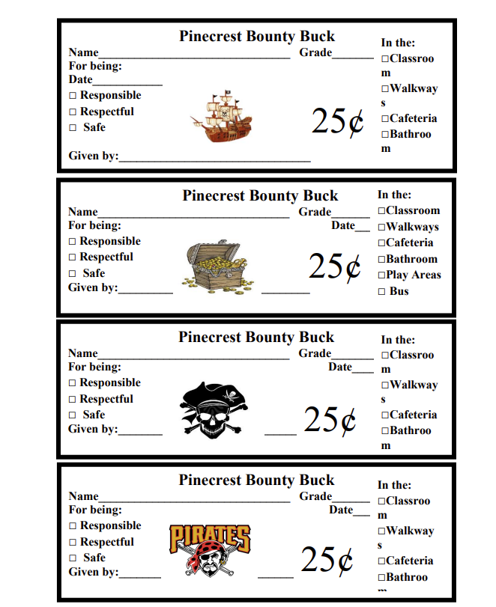

Behavior Matrix
Expectation | Cafeteria | Hallway | Bus | Restroom | Playground
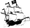 |  |  |  |  | 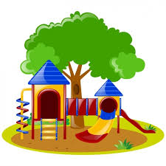
Be  Respectful | Keep voices low | Remain quiet  Keep hands, feet, and other objects to self | Listen to the bus driver | Keep restroom clean | Play  cooperatively  Throw away trash
Be  Responsible | Keep eating area clean | Be on time  Stay in line | Keep hands,  feet, and objects to self | Use only the  supplies that you need | Line up when you are  signaled to do so
Be Safe | Only touch  your own  food | Walk  Stay to the right  side | Follow Bus  Rules | Wash your hands | Use  playground  equipment  properly

Consequence System
Consistent and fair discipline procedures are crucial to a successful consequence system in all schools. It is important that we are respectful of students in our disciplinary responses. Consequences should focus on teaching, remediation, or logical consequences as much as possible (i.e. if a student breaks a window they work it off in restitution, etc.). In providing consequences we also want to be mindful of the instructional time students are missing with the goal of minimizing the amount of instructional time missed.
In order to maximize student instructional time staff are encouraged to deal with problem behavior in their classroom as much as possible. This requires that staff develop a clear discipline plan, which teaches expectations and routines, incentives for positive behavior, and clear classroom responses to problem behavior for their classroom. If teachers are experiencing pervasive problem behavior in their classroom, they are advised to seek assistance or additional consultation by contacting the principal.
It is essential that staff and administration agree on the following: ⮚ What problem behaviors should be sent to the office?
⮚ What problem behaviors are expected to be dealt with in the classroom?
⮚ What is the sequence of disciplinary responses in the school, or what alternatives are there?
⮚ What are the procedures for an office referral?
The following pages contain materials outlining the consequence system at our school:
⮚ Office Discipline Referral form
⮚ Office versus Staff Managed Behavior
⮚ Discipline Procedures Flowchart

Guidelines for Students
1. Students will go directly from the bus to the cafeteria to get his/her to-go breakfast. Kindergarten will eat in the cafeteria.
2. Students will eat the to-go breakfast in the classroom and not wander the halls.
3. All students are expected to be in class by the 7:45 bell.
4. Students arriving after 7:45 will not be able to eat breakfast unless they are tardy due to bus problems.
5. Students arriving after 7:45 are to check in with the office and cafeteria before going to class.
6. A duty teacher will be in the cafeteria. Teachers will be on duty in the halls to supervise students from 7:20 a.m. - 7:45 a.m.
7. Students are to avoid gathering in the hallways or restrooms before school.
8. Use the restrooms at proper times and avoid going during class time as much as possible. DO NOT play in the restrooms.
9. Students may use the telephone ONLY in case of emergency. TEACHER AND OFFICE PERMISSION IS REQUIRED.
10. Disaster Drill instructions should be followed closely.
11. Upper grade students are NOT allowed to visit or use the restroom facilities in the lower grade hall.
12. Matches, knives, lighters, or instruments that might inflict a wound are not to be brought to school.
13. No TOYS or electronic devices are allowed at school.
14. Smoking, vaping, chewing, or possessing tobacco is prohibited at school.
15. FIGHTING IS A SERIOUS OFFENSE and if two or more students involve themselves, they may be suspended from school.
16. No student is allowed to bring items from home to sell on campus.
17. No student is allowed to stay after school without WRITTEN permission from a parent and designated faculty member.

CAFETERIA RULES

1. Students are expected to be orderly in the cafeteria line and while eating.
2. Students who bring lunches from home must eat in the cafeteria.
3. Drinks in cans or glass bottles are not allowed in the cafeteria.
4. Lunches from home CANNOT to be kept in the cafeteria refrigerator.
5. Juice CANNOT be kept in the refrigerator unless the child has a written excuse from the doctor stating that he/she is allergic to milk.
6. Practice good table manners at all times. This includes chewing with your mouth closed and not talking with food in your mouth.
7. Students are expected to pick up their own paper items before leaving the table.
8. Students should be respectful to the cafeteria staff AT ALL TIMES.
9. No student is allowed in the cafeteria without permission except during lunch.
10. NO STUDENT IS ALLOWED IN THE KITCHEN AREA OF THE CAFETERIA AT ANY TIME.
11. Parents, please DO NOT bring fast food lunches into the cafeteria for your child. It is against federal guidelines for school lunch programs.

CLASSROOM RULES
Students are expected to follow the guidelines of the PBIS policy. Teachers may add additional rules and guidelines not outlined in this handbook.

****Poor classroom behavior / conduct grades could result in the loss of extracurricular activities such as field trips, fun days, or participation in sports.

LIBRARY RULES AND INFORMATION

The purpose of the library is to provide materials that meet the needs of students and faculty. Each class in grades Pre-K through 5 has been assigned a weekly library visit during which students are encouraged to check out books. The Library Media Specialist works in collaboration with the classroom teacher to provide reinforcement of skills taught in the classroom. The LMS, also, is responsible for the implementation of Accelerated Reader and the STAR Reading Assessment.

Library rules are as follows:

1. All students must return all library materials before or on the due date.
2. Students are NOT allowed to check out materials if they have overdue materials.
3. Junior High students will not be exempted from any final if money and/or book is due to the library.
4. Students must return all materials before transferring to a new school.
5. If a student damages or loses a book, he or she must pay for the item.
6. Students are to remain quiet and orderly while in the library. Those who choose not to behave in an appropriate manner may receive conduct marks or be asked to leave the library and return to the classroom.

Ouachita Parish Cell Phone Policy
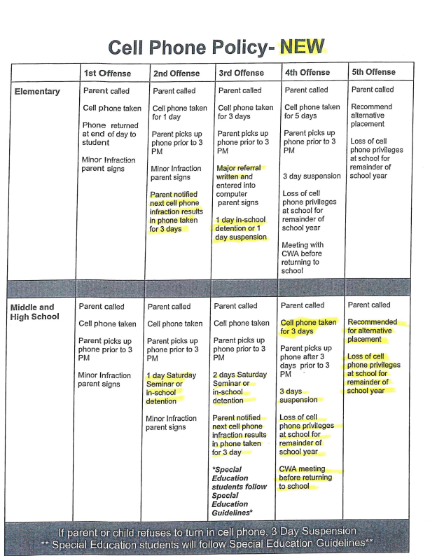
Ouachita Parish & Pinecrest School policy follows ACT 313 Guidelines, as required by law.
Hold back Information For Parents
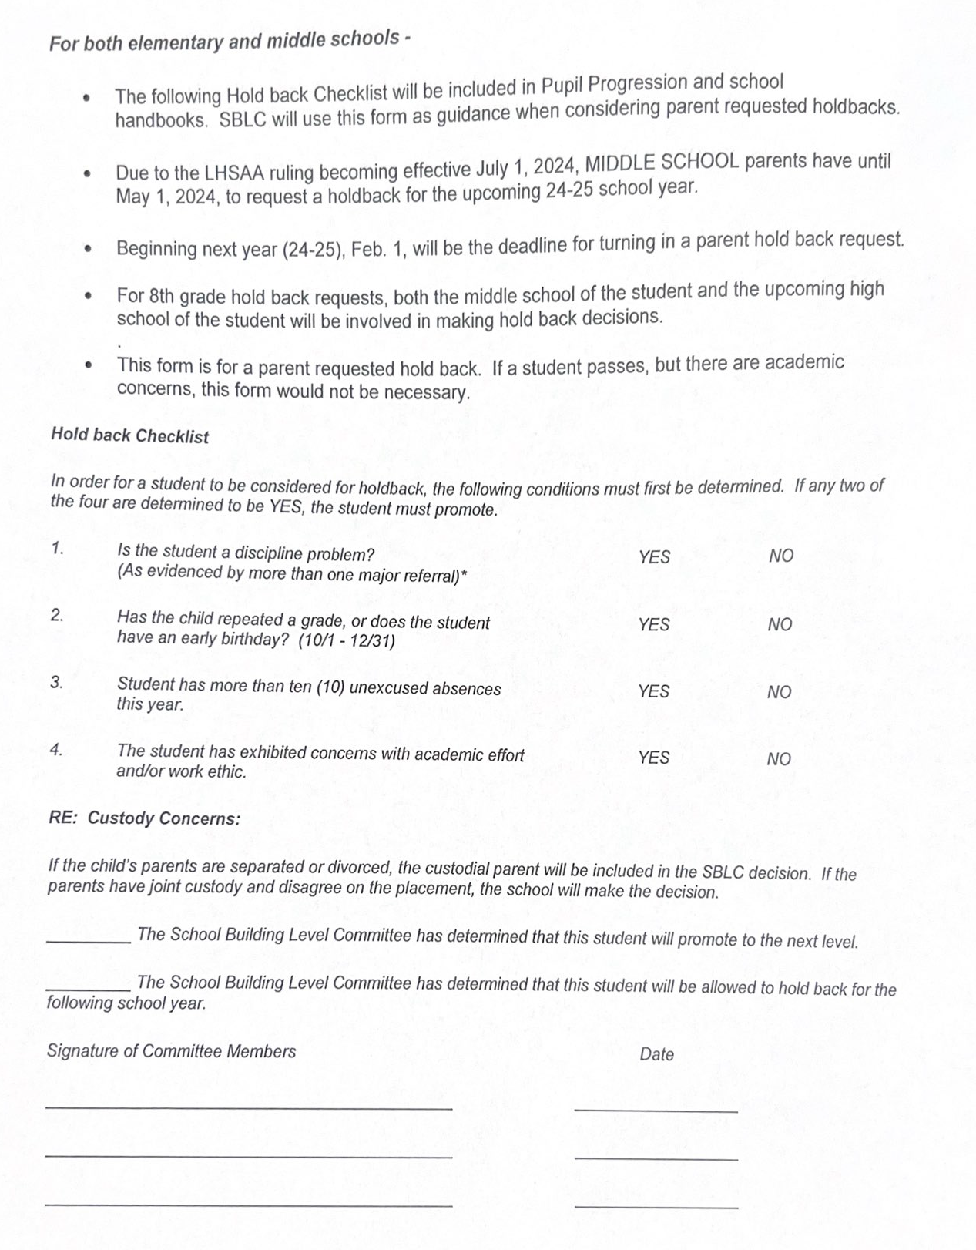

HARASSMENT, INTIMIDATION, AND BULLYING POLICY
The Ouachita Parish School Board directs students, school board employees, and school volunteers to report any incidents of harassment, intimidation, or bullying of a student by another student. For purposes of this policy, the terms “harassment”, “intimidation”, or “bullying” shall mean any intentional gesture or written, verbal, or physical act that
1. A reasonable person, under the circumstances, should know what will have the effect of harming a student or damaging his/her life of property or placing a student in reasonable fear of harm to his/her life or person or damage to his/her property; and
2. Is so severe persistent, or pervasive that is creates an intimidating, threatening, or abusive educational environment of a student.
The Ouachita Parish School System will not tolerate any harassment, intimidation, or bullying of students on school property, while riding on a school bus, or while going to or returning from school. The school administrator shall investigate any reported incident of harassment, intimidation, or bullying. Should the investigation determine that an incident has occurred, the students involved shall be disciplined in accordance with this policy. The disciplinary action may include a conference with the student(s) involved, a conference with parent/guardian, a warning, or in more serious cases, the student(s) may be suspended/expelled from school as follows:

First Offense 1-3 day suspension, counseling required

Second Offense 2 day suspension, counseling required

Three or more offenses 3 day suspension or a recommendation for expulsion

Serious cases Recommendation for change of placement and/or alternative school placement for the remainder of the school year.CWA hearing required.
LEGAL REFERENCE: Louisiana R.S. 17:416.13
REASONS FOR SUSPENSION
Including but not limited to the list below. Discipline procedures follow the district Discipline Procedure Manual.
1. Willful disobedience
2. Disrespect to a teacher, principal, superintendent, and/or member or employee of the local school board.
3. Making an unfounded charge against anyone in Number 2 above
4. Using unchaste or profane language
5. Immoral or vicious practices
6. Conduct or habits injurious to his/her associates
7. Using or possessing any controlled or dangerous substances goverened by the Uniform Controlled Dangerous Substances Law, in any form.
8. Uses or possesses tobacco, lighter or matched, electronic smoking devices/smoking. If a substances in device is identified as a controlled substance, student will be recommended for expulsion per LA law.
9. Uses or possesses alcoholic beverages
10. Disturbs the school or habitually violates any rule.
11. Cuts, defaces, or injures any part of public school property, building, or vandalism.
12. Writes profane and/or obscene language or draws obscene pictures.
13. Instigating or participating in fights while under school supervision. Videoing/posting images with any inappropriate behavior.
14. Possesses weapons as defined by Section 921 of Title 18. Possession of imitation/toy weapon.
15. Possessess firearms, knives, or other implements, which may be used as weapons.
16. Throws missiles liable to injure others
17. Leaves school premises or classroom without permission.
18. Takes another’s property or possessions without permission.
19. Bullying/harrassment
20. Commits any other serious offense
NOTE: Any student who is suspended is subject to losing his/her privileges to go on field trips.

OPSB SEARCH OF STUDENT AND SCHOOL PROPERTY
The Board is the exclusive owner of any public school building, any desk or locker in the building, or any other area that may be set aside for the personal use of students. Any administrator, school resource officer, or teacher may search any building, desk, locker, area, or grounds for weapons, illegal drugs, alcohol, stolen goods, or other materials or objects for which possession is a violation of Board policy. This includes a random search with a metal detector or a search conducted when there is a reasonable belief that the items sought will be found. Any administrator, school resource officer, or teacher may search a student or a student’s personal effects when, based on the attendant circumstances at the time of the search, there are reasonable grounds to suspect that the search will reveal evidence that the student has violated the law, Board policy, or a school rule.
Saturday Seminar
Students in grades 4-8 may be assigned Saturday Seminar as a disciplinary consequence if deemed necessary by the school administrator. These sessions are held each Saturday, from 8:00 – 11:30, at OPAL on Thomas Road. Failure to report for Saturday Seminar as assigned may result in an out-of-school suspension.

Classroom Tracking Forms
Students in Grades PK – 8 may have minor behavior issues documented over a five-step process on a disciplinary tracking form. Students, parents, and teachers will be required to communicate regarding the problem behavior and attempt to correct it on the first 4 occurrences before an official discipline referral to the office becomes necessary on the 5th occurrence.

Ivy Daniels Law Information
https://docs.google.com/document/d/16wAv22o4nQAhOWBmia_C8aMuIxPgm6GDGTNpVhb2ZsU/edit?usp=sharing
Act 619 Information
https://drive.google.com/file/d/1KGM09w1r5752jRqhVozDQGZvP9if3GLQ/view?usp=sharing
MEDICATION IN SCHOOL
The Louisiana State Legislature passed a school medication law in 1994 (R.S. 17:436.1). The Ouachita Parish School Board has established new guidelines and procedures in order to be in compliance with this law.
AS A GENERAL PRINCIPLE, MEDICATIONS WILL NOT BE GIVEN AT SCHOOL. However, when circumstances arise in which a student must take medication at school; the following will be adhered to:
1. Medications must have a proper medication order form completed by the physician detailing the name of the medicine, dosage, and exact time to be given.
2. Parents must meet with the school nurse to sign appropriate medication forms (consent, release of liability, and emergency) before any medication can be administered at school. The parent shall bring the completed proper medication form, their child, and the properly labeled medication (this includes all over-the-counter drugs). At this time, the nurse will perform a physical assessment on your child.
3. Medication must be brought to the school by a PARENT OR GUARDIAN in a current container appropriately labeled by the pharmacy. Parents/Guardians must sign a form stating that the school received the medication and how much was received. No more than 25 dosages in a tablet form can be kept at the school for each child. NO MEDICATION WILL BE ACCEPTED IN PLASTIC BAGS OR MISLABELED BOTTLES! It is recommended that all narcotics (Dexedrine, Adderall, Ritalin, methylphenidate) be dispensed in a blister pack. At this time, these packs are available at Wal-Mart (WM location only), Price Right Pharmacy (Calhoun), Eckerd’s, Rite Aid, and Mason’s. There are probably other pharmacies that will provide this service that we are not aware of, so check with your pharmacist.
4. If a medication or dosage is changed, please contact the school nurse at the number listed below or notify the school office. A new order and new pharmacy labeled bottle will be required.
If medication is found in a student’s possession, whether it be prescription or over-the-counter (THIS INCLUDES ASPIRIN, TYLENOL, COUGH DROPS, COUGH SYRUP, ANTACIDS, ETC.), the student will be subject to disciplinary action. The ONLY exceptions are inhalers for severe asthma and epi-pens for severe allergic reactions. These medications also require the above arrangements and an additional form to be completed by the doctor and parent. If a student carries an inhaler or epi-pen on their person, it is also advisable that the school office be provided with an additional dose for locked storage. In most cases of Kindergarten and 1st grade, it is recommended that the student NOT carry these medications on them. NO EYE OR EAR DROPS CAN BE GIVEN AT SCHOOL. Antibiotics should be given in a time span so they may receive them at home if at all possible. REMEMBER, A PARENT OR GUARDIAN MAY ADMINISTER MEDICATION TO THEIR CHILD AT SCHOOL WITHOUT ANY OF THE ABOVE REGULATIONS.
The school nurse needs to be notified of any changes that occur in your child’s health condition, provided updated telephone numbers and address changes readily in order to facilitate the care needs of your child. THESE HEALTH NEEDS SHOULD BE SUBMITTED IN WRITING TO YOUR SCHOOL NURSE EACH SCHOOL YEAR. The school nurse can be reached by calling the school at 325-4331 or you may call the parish office at 432-5338.

Ouachita Parish School System
~Guidelines for School Attendance~
Fever is a sign of infection. If your child has a temperature of 100 degrees or above, he/she should remain at home. Children must be FREE OF FEVER for 24 HOURS WITHOUT FEVER MEDICATION before returning to school.

Vomiting & Diarrhea is often contagious. Your child should be watched closely for dehydration and/or bloody stools. Children must be FREE OF DIARRHEA and VOMITING for 24 HOURS before returning to school.

Runny noses & Coughs are typical during the cold and allergy seasons. These should be watched carefully. You child should remain at home if he/she is too uncomfortable to benefit from instruction, has a frequent cough and/or thick, discolored nasal discharge. If these symptoms persist, a doctor should be consulted.

Ringworm is a fungal infection of the skin and may be spread from one child to another.
- Ringworm of the scalp – the student must be seen by a doctor and BE ON MEDICATION for 24 HOURS before returning to school.
- Ringworm of the skin – the student may be treated with over-the-counter medication and may return to school with the site covered.

Rashes vary widely, both in appearance and severity. Whereas a small, isolated area may not warrant keeping your child home, a rash covering a large portion of the body would. A doctor should be consulted if a rash accompanies an illness, if the rash covers a large portion of the body, if the rash is spreading, or if the child is too uncomfortable to pay attention in class.

Sores may be caused by a bacterial skin infection. These often begin around the nose and mouth but may appear at the site of a minor injury and then spread to normal skin nearby. This type of infection is contagious and may cause serious problems for the child. They should be seen by a doctor and MAY RETURN in 24 HOURS.

Staphylococcus (staph) causes a wide variety of illness in children ranging from very mild skin infections to devastating toxic shock syndrome. Most staph infections start small like a blister and can be mistaken for an ant or spider bite. The sore will be very tender around the site and will produce a thick, milky discharge. Antibiotics will be required for treatment and the area should be kept covered to prevent spreading. This is a highly contagious infection, therefore the nurse always has the right to refuse to allow a student to return to school for the safety of other students.

Pink Eye is another common condition seen in schools. It is contagious and must be treated with a medication prescribed by your doctor. Symptoms include redness, itching, swelling, drainage and excessive matter in the eye upon awakening in the morning. (Eyelids may be stuck together). Do not send your child to school with these symptoms. Students may RETURN TO SCHOOL AFTER BEING TREATED FOR 24 HOURS.

Head Lice are often a problem. Any child can get head lice, but it is treatable with time and patience. Our school system follows a “Nit Free” policy. This means a child must be clear of lice and/or eggs before returning to school. Parents are asked to bring students to school where he/she can be checked by school personnel before being admitted to class.

If you have any questions concerning these or any other conditions, please contact the school nurse. Thank you for helping us keep your child’s school a healthy learning environment.
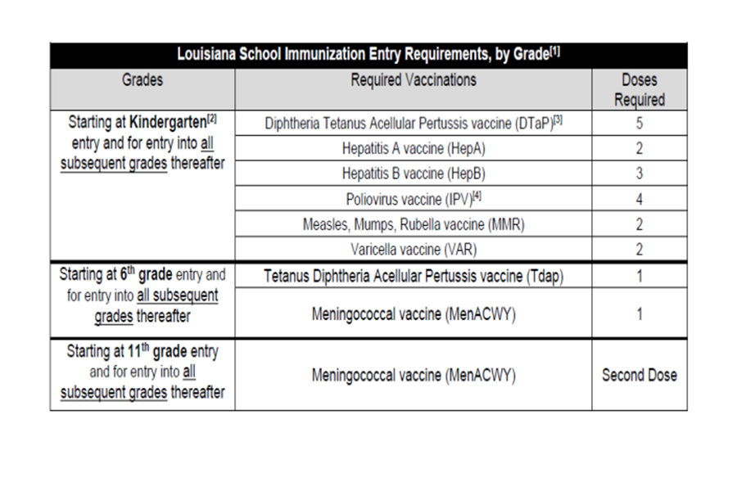

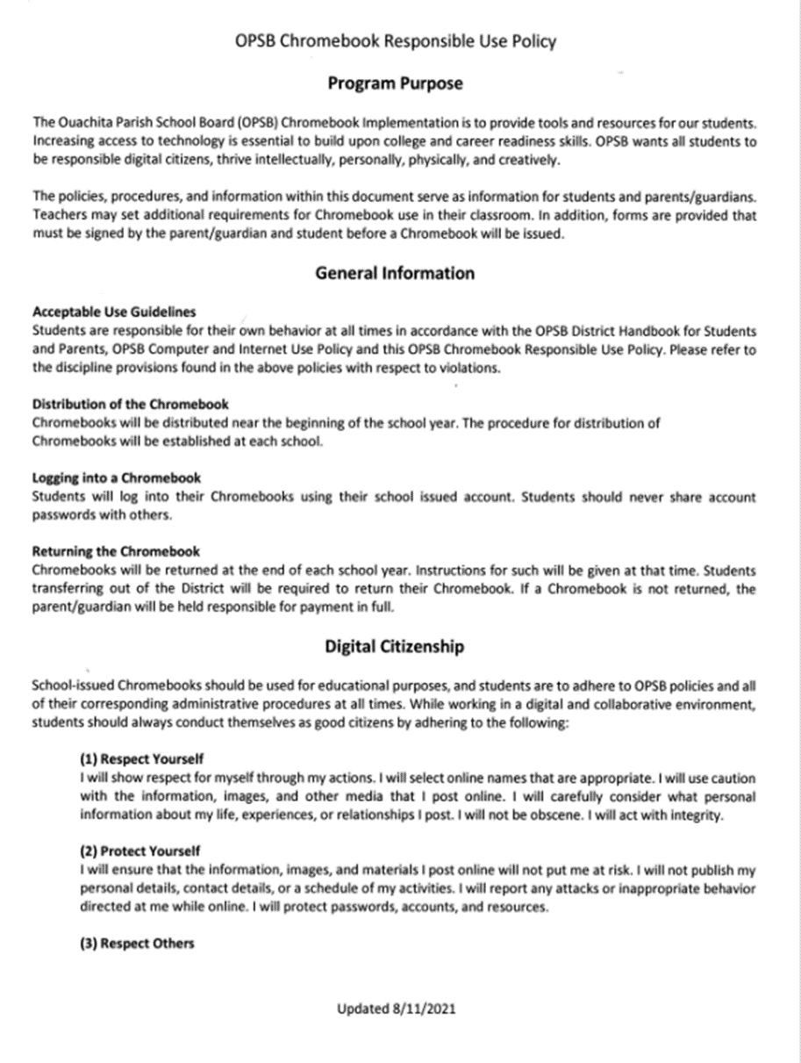
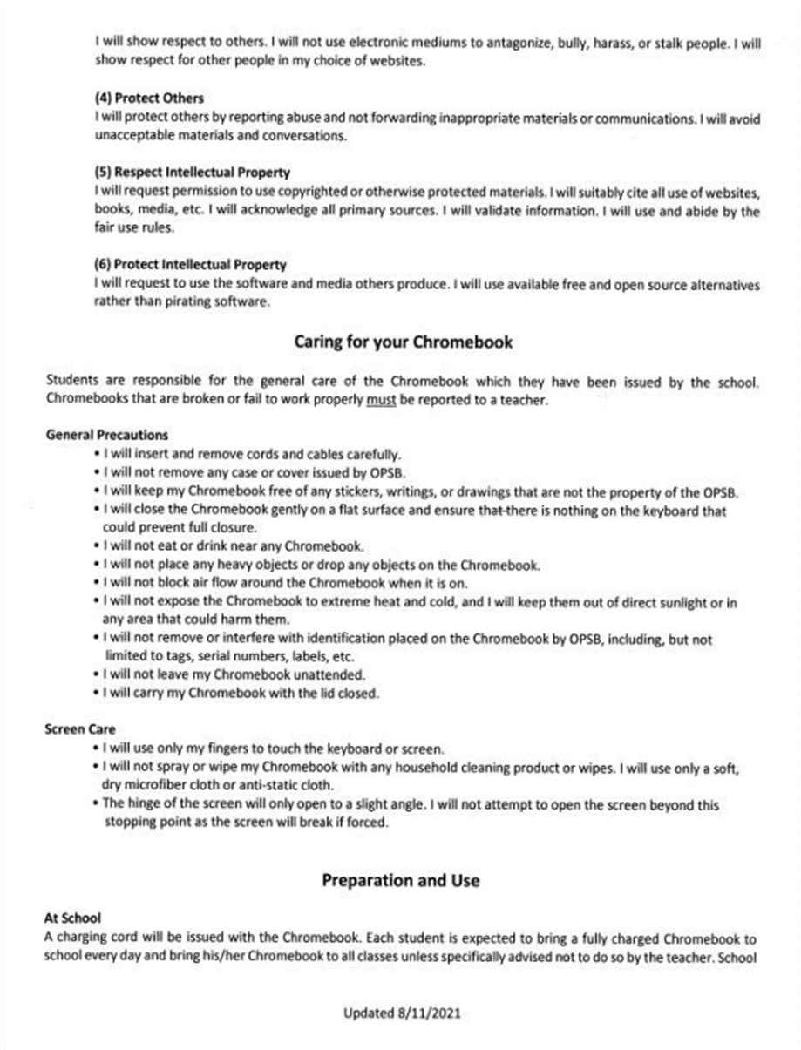

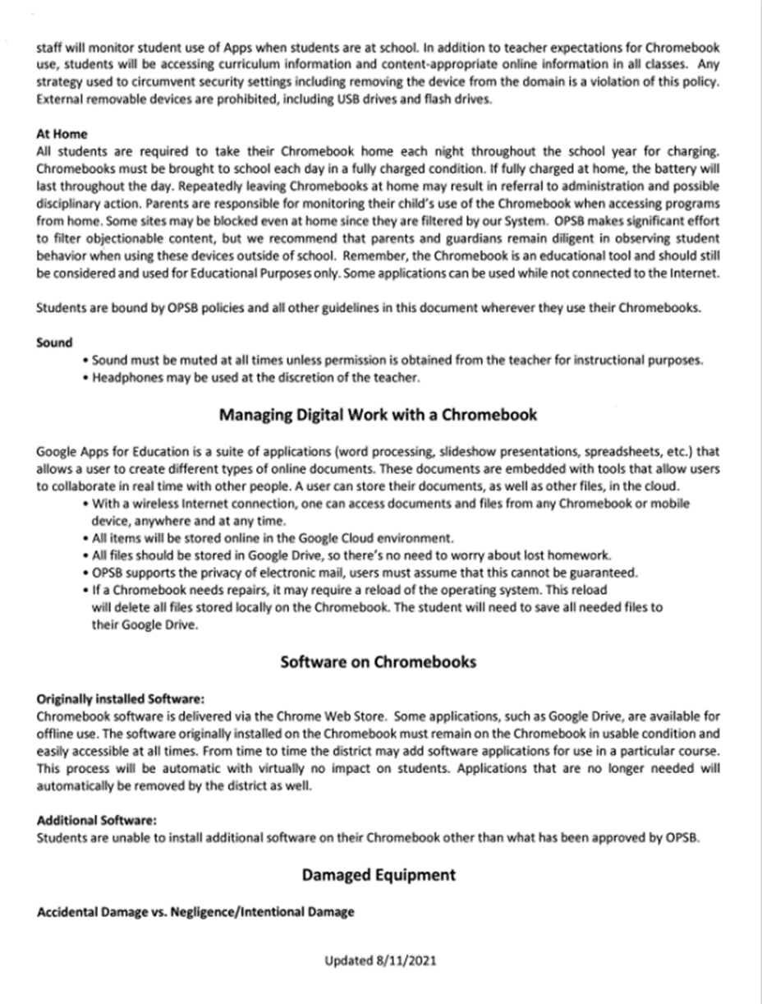
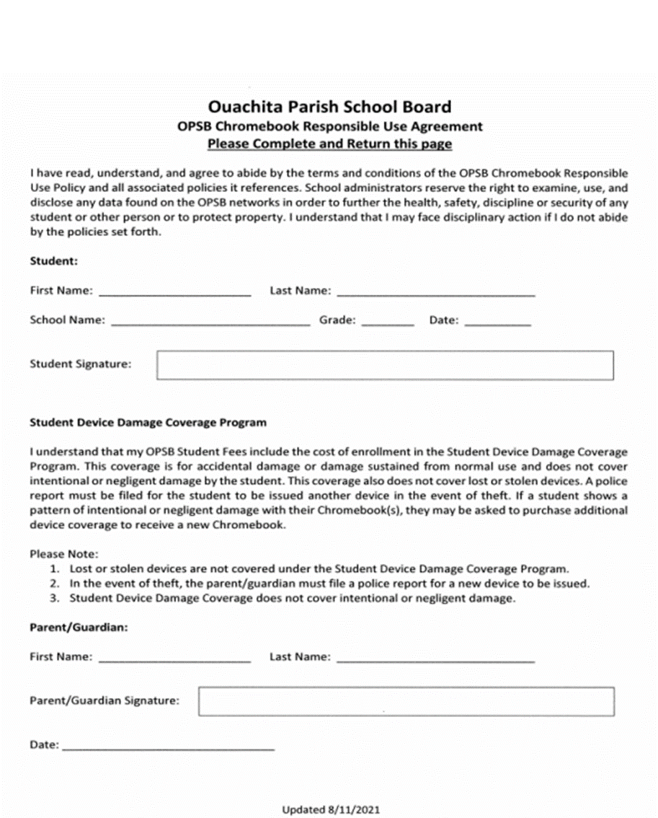

OUACHITA PARISH SCHOOL SYSTEM
OPSB.NET WEB PUBLISHING POLICY
Purpose
The purpose of the Ouachita Parish School Board (OPSB) website is to provide a means of effective communication between administrators, teachers, support staff, students, parents, and our community. All content on the OPSB website must adhere to the policies outlined in this document. Failure to follow these policies may result in a loss of publishing privileges and/or other disciplinary actions.
Organizational Responsibilities
The Website administrator is responsible for developing and maintaining the OPSB district website.
The Communications Department has the primary responsibility for the content of the OPSB website. All content for the OPSB district website must be approved by the Communications Department.
A Website Coordinator will be designated for each school in the district. Each school’s Website Coordinator will be responsible for all content posted to that school’s website. The Website Coordinator is also responsible for insuring that a release form is on file before publishing any identifiable student photos or works.
The Webmaster is the person who actually creates, publishes, and maintains the school’s website. The Webmaster may be the Website Coordinator or may be designated by the Website Coordinator. The Webmaster may be a teacher (or other school employee), parent, or other individual deemed capable of publishing the school’s website. However, the Website Coordinator is ultimately responsible for the content of the school’s website.
Content Standards
All content must adhere to all state, federal, and international laws concerning copyright and intellectual property rights.
All official school board and school web pages should reside primarily on the OPSB web server. If a school chooses to host its website with another provider, the OPSB website will provide a link to the school’s website only if the school’s website meets all other criteria maintained in this policy.
All content must be related to curriculum, instruction, or other school or school district related information.
Personal information should not be published. Any phone numbers or email addresses should be ones used within the school system.
The OPSB web server will not be used for personal or commercial financial gain or for any illegal activity. Links to retail or political sites will not be allowed.
All web pages must not link to or contain any inappropriate material. The Communications Department will have full discretion in determining appropriate content.
Student Safety
Student names may be published without a release form. However, no identifiable student photo or student works may be published unless a signed release form is on file for the current school for every associated student.
No personal information (other than the student name) should ever be published about a student.
No information that identifies the location of a student at any particular time during the school day (such as schedules) should ever be published.
Students are not allowed to have or use OPSB assigned email accounts.
Students are not allowed to publish information to the OPSB web server
Web Publishing Guidelines
All published content must reflect educational goals.
All published content should be reviewed for accuracy, correct spelling, and correct grammar.
All published content must adhere to all state, federal and international laws concerning copyright and intellectual property rights. If you are granted permission to publish copyrighted material, you must maintain documentation of this permission as long as the material is on the OPSB web server.
All published content must be kept up to date.
Do not use spaces in naming pages or directories. Use the underscore character (“_”) instead of spaces.
Graphics should be optimized to minimize page loading times and bandwidth usage.
School web sites must include
*School name
*Principal’s name
*Full address
*Telephone number
*Fax number
*A link to http://www.opsb.net

OPSB AI Policy
https://drive.google.com/file/d/1VTO9p7shhIVdtte0NUIW-8yi0oMFIIql/view?usp=sharing
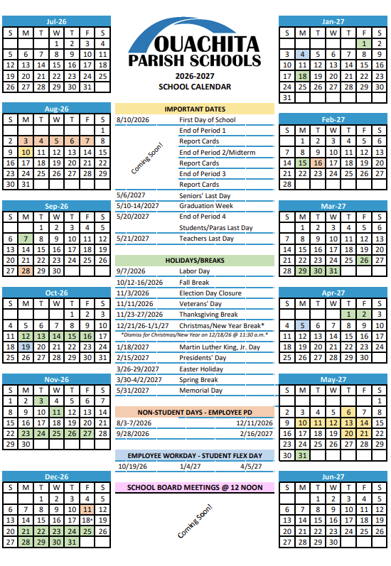



POLICY STATEMENT
Section 504 Compliance

The policy of the Ouachita Parish School System is to provide a free and appropriate public education to each student within its jurisdiction, including students with disabilities, regardless of the nature or severity of the disability.

It is the responsibility of the Ouachita Parish School System to ensure that students who are disabled within the definition of Section 504 of the Rehabilitation Act of 1973 are identified, evaluated, and provided with appropriate educational services.

Due process rights of disabled students and their parents under Section 504 will be enforced.


TITLE VI, TITLE IX, THE AMERICANS WITH DISABILITIES ACT (ADA),
AND SECTION 504 COMPLIANCE
The Title VI, Title IX, ADA, and Section 504 federal laws ensure that individuals will be free from discrimination based upon sex, race, national origin, or disabilities. To resolve problems which students, employees, or applicants for employment may believe are the result of discrimination practices, the Ouachita Parish School Board has established a grievance policy. For further information about these federal laws or the grievance process, contact:
Jason Thompson
Assistant Superintendent / Personnel Chief /
Title VI & Title IX Coordinator
Ouachita Parish School Board
100 Bry Street
Monroe, LA 71210
(318) 432-5000

Dr. Angela Westerburg
Director of Special Education
Student Support Services
800 Claiborne Street
West Monroe, LA 71291
(318) 432-5400

Barry Johnson
Section 504 Coordinator
Student Support Services
800 Claiborne Street
West Monroe, LA 71291
(318) 432-5400

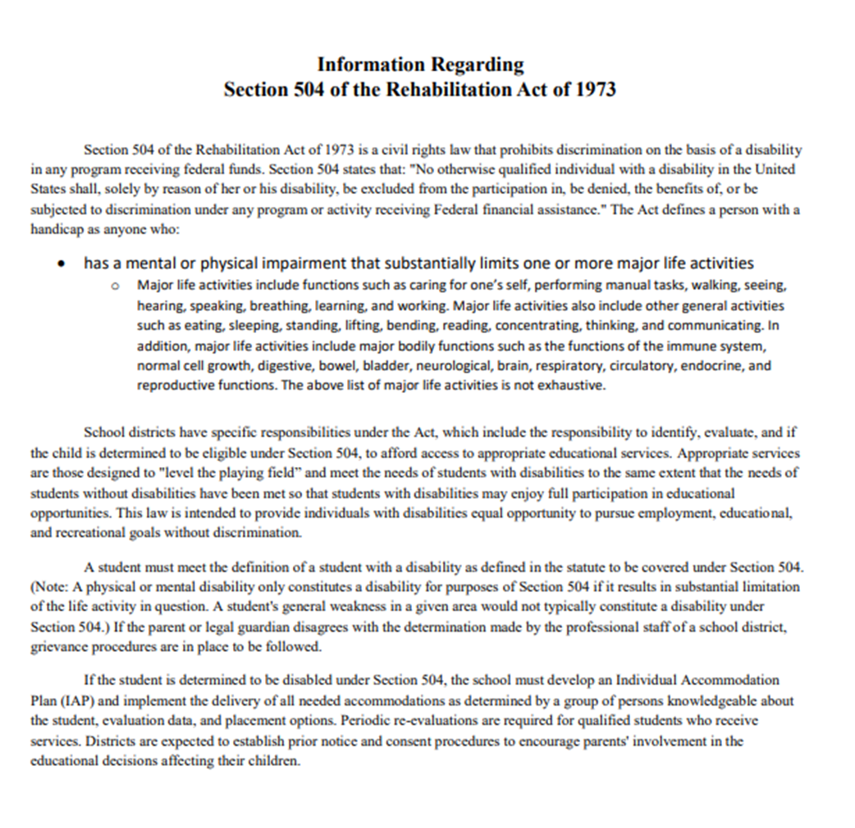

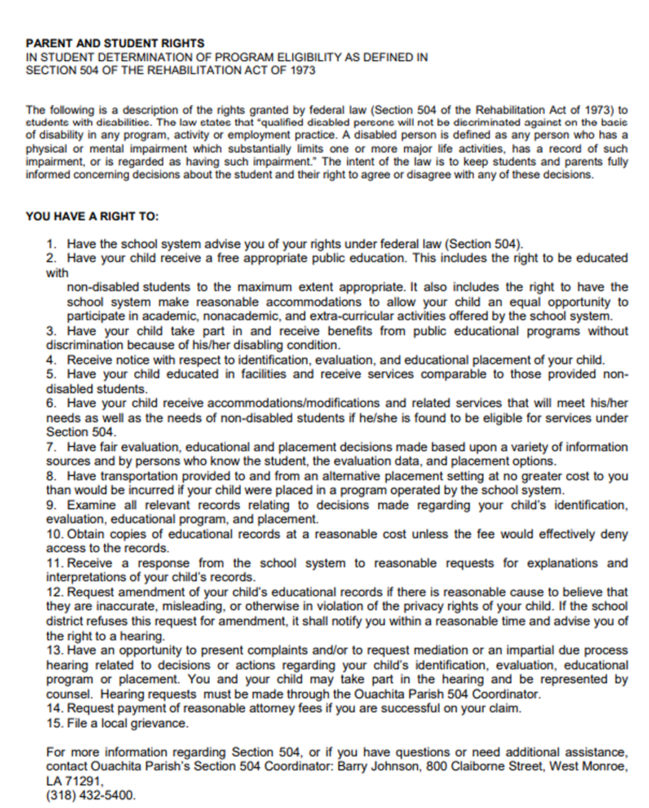
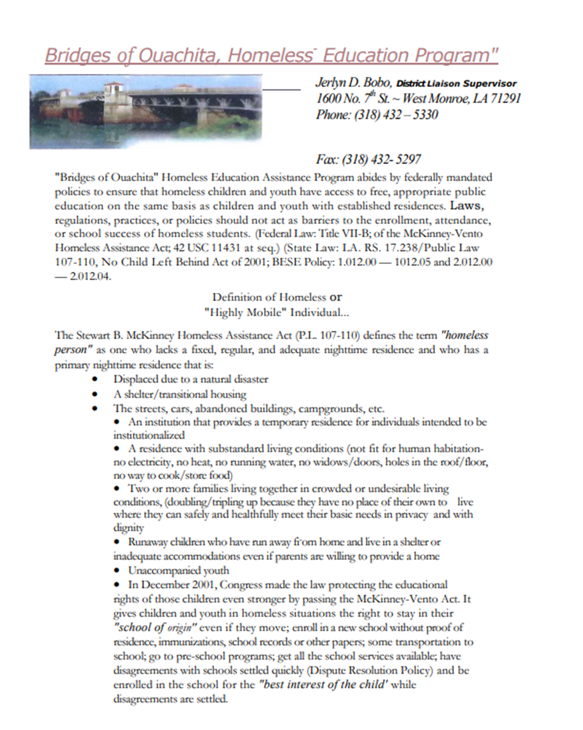
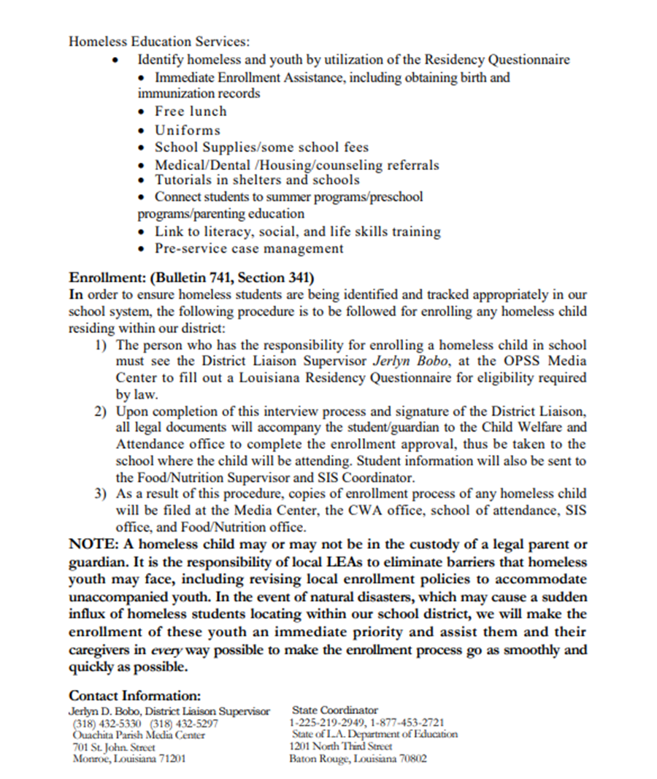

***The student handbook is located on our website:
https://pinecrest.opsb.net/parent-resources/student-handbook-pbis-discipline-plan

Parent / Student Signature Page
Student’s Name ________________________ Date ___________
Teacher’s Name ________________________ Grade __________

*Parents, please sign the following statements and return to your child’s teacher!

I have received the Pinecrest handbook and have discussed the contents with my child.

Parent / Guardian Signature ______________________ Date____________

Medication Policy

I have read the Ouachita Parish Medication Policy and the Guidelines for School Attendance in regard to illness / disease and will comply with both.

Parent / Guardian Signature ______________________ Date____________

Cell Phone Policy

I have read the Ouachita Parish Student Cell Phone Policy and understand the consequences for violating the policy.
Parent / Guardian Signature __________________Date______________

Web Publishing Policy

I give permission for the above named student’s full name, photograph, and works, (art, written papers, voice, verbal statements, etc.) to appear on the school or school district’s website. I understand that these pictures or works may or may not personally identify the student.

Parent/Legal Guardian (please print)______________________________

Signature_________________________________________________

Date_____________________________________________________

