WOW Uniforms 2026-2027
Purple |  | Heather Grey | White |  | Blue | Black
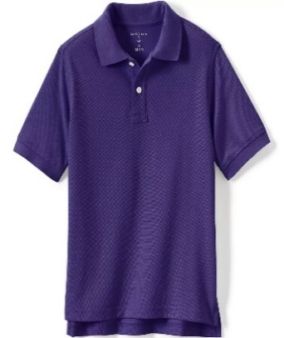 |  | 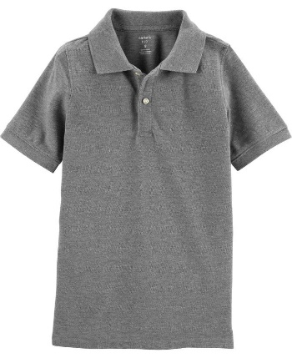 | 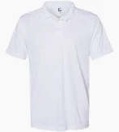 |  | 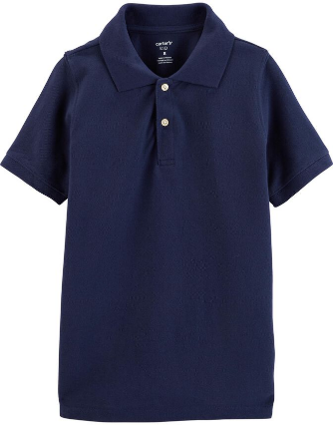 | 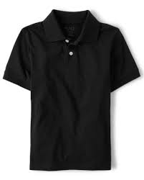
Approved Tops – must have collar
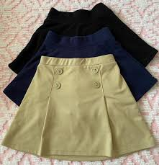  Skirts | Shorts  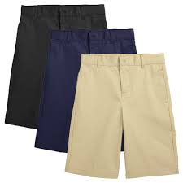 |  | 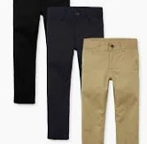  Pants | 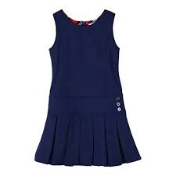  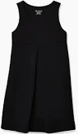  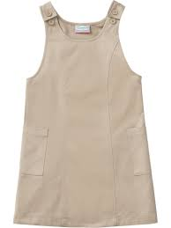  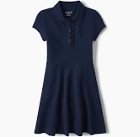  Jumper/Dress
Approved Bottoms
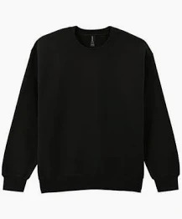  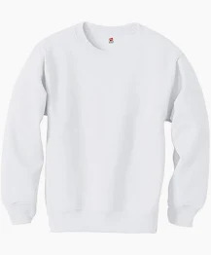  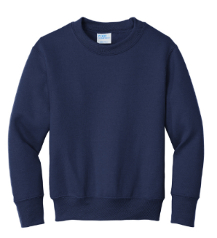  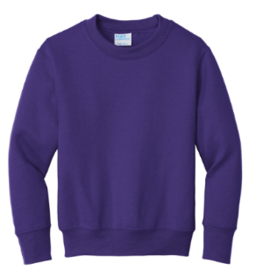  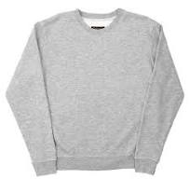 |  |  |  | 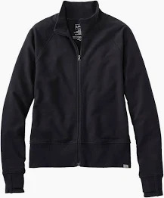  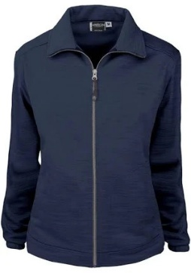  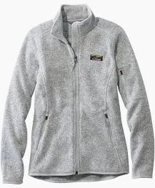  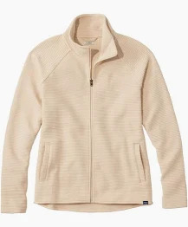
Approved Sweatshirt/Sweater Colors |  |  |  | Approved Jacket Colors

Tops:
- Color Choices: Blue, Gray, Purple, Black, White
- Types: Collared Shirts, Dresses, Jumpers, Crewneck Sweatshirts, or Walsingham Oaks PTSA Logo shirt (long or short sleeve),
- Free of Design, Letters, or Emblems

Bottoms:
- Color Choices: Blue, Black, Khaki
- Types: Shorts, Pants, Skirts, Jumpers, or Skorts
- Bottoms should fit properly and be no shorter than mid- thigh
- No jeans or tight fit shorts or pants
- Must wear shorts under dresses or skirts. Leggings are only allowed to be worn under skirts, jumpers and dresses-They are not school appropriate bottoms.

Shoes:
- All shoes must be enclosed all around the heel, toes, and sides.
- All shoes worn to school must be appropriate for physical education and recess.
- Students wearing crocs, slides, water shoes or sandals will not be able to take part in outside recess or P.E for safety reasons.

Jackets/Sweaters/Sweatshirts:
- All jackets must be zippered or buttoned with NO hoods.
- Sweatshirts cannot have hoods.
- No emblems, words or designs should be visible on the worn jacket/sweatshirt.
- Sweaters may be worn as long as they are Purple, Black, Heather Gray, White or Blue.

Please label all jackets, sweaters, sweatshirts with child’s first and last name.

