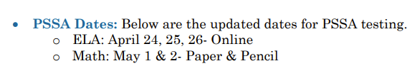
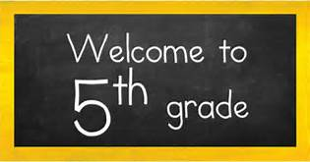

Dear Fifth Grade Parents and Students,
Looking ahead to the new year, I am so lucky to teach your children. This will be my 34th year of teaching and accomplishing my goals. Over the years, I feel I have grown up at Butler, since I started teaching after college, got married, and had children while teaching here. Through the many stages of my career, I have enjoyed teaching second, third, and fifth grade. Butler Elementary has been a great place to grow and learn!
Personally, my husband, Jim, and I have three children. Emily is 30 and is a graduate of Kutztown University. She works as a senior designer for a company specializing in college marketing called Carnegie. Emily and her husband, Neal, have a baby girl named Charlotte. Kate is 27 and is a medical speech pathologist at Geisinger Hospital in Danville, PA. She played soccer for the Huskies and loved her career at BU. Our youngest child, Jimmy, will be a senior accounting and finance major at BU. He loves to trade stocks and worked at an accounting internship this summer. In addition, we are keeping very busy with our German Shorthair named Tully! We enjoy our summers to reconnect as a family at the mountains to kayak, paddle board, and swim at the lake.
Academically, I graduated from Council Rock High School. After graduating, I attended Millersville University majoring in elementary and early childhood education. To further my education, I attended West Chester University to earn my master’s degree in education with a concentration in writing. Later, I went through the rigorous National Board process and became board certified. In addition, I navigated the process again to get re-certified. It is my goal to continue to learn and grow with my students.
Professionally, I strive to create a classroom climate where students learn to appreciate the uniqueness of others and begin to find their passions in life. I have three big questions: 1. What can I do well? 2. What do I want to become? 3. How am I going to make it happen? As we learn the fifth-grade curriculum, we will be reinforcing the ideas of “I can do it!” “I have grit!” and “How can I make a difference today?” We will have a great year learning about Weather, Energy, and Nature’s Recyclers in Science. For our Social Studies curriculum, we will read about the Revolutionary War and the Constitution. Visiting the Constitution Center and Revolutionary War Museum would make a great family trip!
I look forward to meeting everyone during our Back to School Night! In the meantime, if you need to contact me, please email me at jschlotter@cbsd.org. See you next school year!
Sincerely,
Mrs. Schlotter
Fifth Grade Teacher

