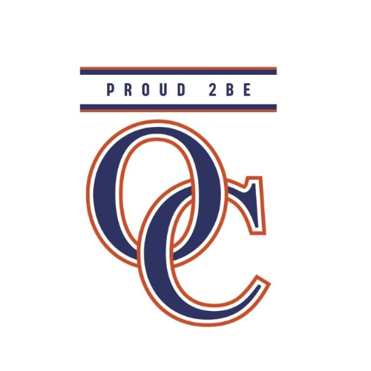
Orange County Public Schools
2026-2027
Grade Level: 2
Language Arts - Skills

Online Resources Used:
Lexia Learning System
Amplify
CKLA - Core Knowledge Language Arts
mCLASS Interventions

Marking Period 1

Skills 1 8/5-9/14; Pausing Point 9/11 and 9/14
SOL 2.FFR.2a-c, 2.FFR.3a-e, 2.DSR.a, b, 2.RV.1a, e, g, 2.RL.1a, c, d, 2.RL.3a, 2.FFW.2a-c, 2.W.1a, 2.LU.1, a, e, 2.LU.2a, c, 2.C.1 a, a.i, a.ii, 2.C.2 a, a.i, a.ii,m 2.C.2c, 2.R.1b, d, e
This unit focuses on reviewing various spellings with an emphasis on consonant sounds, one- and two-syllable words, and high-frequency Tricky Words. Students will blend, segment, and spell one and two-syllable words with short vowels. Students will edit writing samples for proper capitalization & punctuation. Students will accurately read given text with accuracy, fluency, and comprehension.

Skills 2 9/15-10/12 Pausing Point 10/8 and 10/12
SOL 2.FFR.2,a,b,c - 2.FFR.3,a,b,d,e - 2.DSR a,b,d - 2.RV.1a,b,d,e h,f,g - 2.RL.1a,b - 2.RL.3a - 2.FFW.2b,c - 2.W1a, d - 2.W.2a, a.i, a.ii, a.iii, a.iv - 2.W.3a, b - 2.LU.1a,e,h - 2.LU.2c - 2.C1a - 2.C2c - 2.R.1b,c
The focus in unit 2 is on various spellings with an emphasis on vowel sounds. Students will read one- and two-syllable words, as well as contractions. Students will practice high-frequency Tricky Words he, she, we, be, me, we, they, their, my, by, you, your. They learn about the use of quotation marks and begin instruction in the writing process, writing narratives and opinions.

October 8th end of 1st 9 weeks

Marking Period 2

Skills 3 10/13-11/19 Pausing Point 11/18, 11/19
SOL 2.FFR.2a,b,c -2.FFR.3a,b,c,d,e - 2.DSR.a, b - 2.RV.1a, d,e,h,f,g - 2.RLa, - 2.RL.3a, - 2.FFW.2a,2b2c - 2.W.1a, 1d - 2.W.3a,3b - 2.LU.1g, - 2.LU.2c - 2.C.1a, 2.C.1a.iii, 2.c.1a.iv - 2.C.2c
In unit 3, students will read and write words with vowel sounds /oo/, /oo/, /ou/, /oi/, /aw/. They will distinguish between similar vowel sounds /ue/, /oo/, /oo/, and /u/.
Students will identify and spell Tricky Words should, could, would, down, because.
They will identify and use verbs and verb tenses. Students will read the decodable Reader “Fables” to practice fluency. Students will answer comprehension questions orally and/or in writing.

December 18th end of 2nd 9 weeks

Marking Period 3

Skills 4 11/20-1/15 Pausing Point 1/14-1/15
SOL 2.FFR.2a, 2b, 2c - 2.FFR.3 - 2.DSR.a,b - 2.RV.1a,g - 2.FFW.2a, 2b, 2c - 2.W.1c - 2.W.2a - 2.W.3a,3b - 2.LU.1a,1c,1e,1f,1g,1h - 2.LU.2b,2c
Unit 4 : Students are introduced to more spelling alternatives for vowel sounds, and three tricky spellings. Students will practice persuasive writing as part of a friendly letter. In grammar, students review singular and regular plural nouns, as well as common and proper nouns. They are introduced to the formation of irregular plural nouns, action verbs, and to-be verbs.

Skills 5 1/19-3/4 Pausing Point 3/3 and 3/4
SOL 2.FFR.3b,3c,3d,3e - 2.DSR.a,b - 2.RV.1a,1b, 1c,1d,1h, 1f,1g - 2.RL.1c, 1d, - 2.RL.3a, - 2.FFW.2a - 2.W.2a - 2.W.3a, 2.W.3b - 2.LU.1e, 1f,1h - 2.LU.C.1a - 2.C.2c
In Unit 5 students will read words and write words with alternative vowel spellings. Students will alphabetize words, read and write words with /ə/ (schwa) sounds, identify the subject and predicate in sentences, and understand and use adjectives in sentences. Students will use correct capitalization, punctuation, and grammar in writing and use the writing process to write a different ending to a story from the Reader.

March 9th end of 3rd 9 weeks

Marking Period 4
Skills 6 3/5 -5/5 Pausing Point 5/4 and 5/5
SOL 2.FFR.3a,3b,3c,3e - 2.DSR.a,b - 2.RV.1a,1h,1g - 2.RI.1a, 2a,2b - 2.RI.3c - 2.FFW.2a - 2.W.1b,1c - 2.W.3a,3b - 2.LU.1e,1g,1h - 2.LU.2c - 2.C.1a - 2.C.2c
Unit 6 introduces several new spelling alternatives for vowel and consonant sounds. Students review grammar skills and learn about adverbs. They also learn to distinguish complete from incomplete sentences, as well as how to identify and correct run-on sentences. Students are introduced to expository or report writing.

May 19th end of 4th 9 weeks

