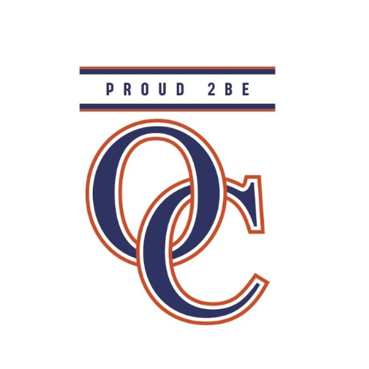

Orange County Public Schools
2026-2027
Grade Level: 2

Online Resources Used:

Five Ponds Press
Discovery Ed
Studies Weekly

First 9 Weeks:

Social Studies Unit 1: Civics & Diversity (Aug. 5th- Aug. 21)
SOL: 2.1, 2.2, 2.4, 2.12a

Science Unit 1: Habitats (Aug. 24th-Sept. 16th)
SOL: 2.1, 2.5, 2.7, 2.8

Social Studies Unit 2: History- The Beginning of America (Sept. 17- Oct. 8th) SOL: 2.8, 2.9

Social Studies: SOL 2.3 Labor Day (September 7th, 2026) and Christopher Columbus Day/Indigenous Peoples’ Day and Yorktown Victory Day (October 12, 2026)

Second 9 Weeks:

Science Unit 2: Force, Energy, & Motion (Oct. 13- Oct. 21st)
SOL: 2.1, 2.2

Social Studies Unit 3: American Indians (Oct. 22nd- Nov. 13th)
SOL: 2.5, 2.6

Science Unit 3: Weather (Nov. 16th- Dec. 4th) SOL: 2.1, 2.6, 2.7

Social Studies: SOL 2.3 Election Day (No Election), Veteran’s Day (November 11, 2026), Thanksgiving (November 26, 2026), Christmas Day (December 25, 2026)

Third 9 Weeks:

Social Studies Unit 4: History- Famous Individuals (Dec. 7th- January 29th)
SOL: 2.7, 2.10

Science Unit 4: Matter (Feb. 1st-Feb. 19th) SOL: 2.1, 2.3

Social Studies Unit 5: Economics- (Feb. 22nd- March 5th)
SOL: 2.13

Social Studies: SOL 2.3 New Year’s Day (January 1, 2027), Martin Luther King Jr. Day (January 18, 2027), George Washington Day (Presidents’ Day) (February 15th, 2027)

Fourth 9 Weeks:

Science Unit 5: Plants (March 8th- March 23rd)
SOL: 2.1, 2.4, 2.5, 2.7, 2.8

Social Studies Unit 6: Geography (April 5th-April 21st)
SOL: 2.11, 2.12b, 2.12c

Science Unit 6: Life Cycles (April 22nd-May 10th)
SOL: 2.1, 2.4, 2.7

Social Studies: SOL 2.3 Memorial Day (May 31, 2027), Juneteenth (June 19, 2027), Independence Day (July 4, 2027)

Common Assessments will be given at the end of each unit.
Projects will be assigned throughout the year.

