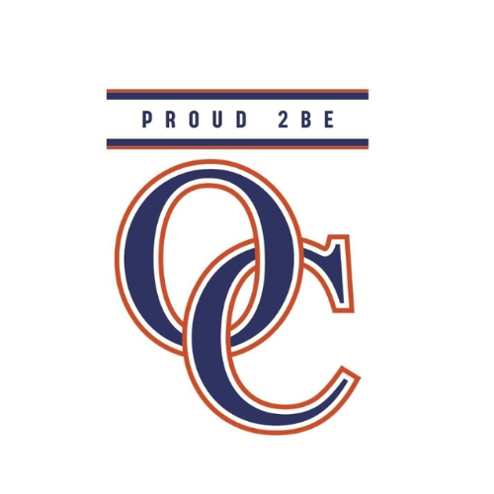

Orange County Public Schools
2026-2027
Grade Level: 1
Language Arts - Skills

Online Resources Used:
Lexia Learning System
Amplify
CKLA - Core Knowledge Language Arts
mCLASS Interventions

Skills 1
SOL 1.FFR.2a,b,c; 1.FFR.3a,b,e,f; 1.DSRa,c; 1.RV.1h; 1.RL.1a,c; 1.RL.3a,b; 1.FFW.1a,b; 1.FFW.2a,d; 1.LU.1h; 1.LU.2a,b,c; 1.C.1a,a.i,a.ii,a.iii,a.iv; 1.C.2b,d
This domain will be a review for students from Kindergarten. In this unit, students will review the 5 short vowel sounds and 25 consonant sounds. Students will read decodable stories and blend and segment words.

Skills 2
SOL 1.FFR.2a,b,c; 1.FFR.3a,b,e,f; 1.DSR.a,c; 1.RV.1a,c,h; 1.RL.1a,b,c; 1.RL.3a,b; 1.FFW.1c; 1.FFW.2d; 1.C.1a; 1.C.1a.i,ii,iv; 1.C.2b
In Unit 2, students will learn five new vowel sounds and the most common spelling for each sound: /ee/, /a_e/, /i_e/, /o_e/, /u_e/. Students will learn these as vowel digraphs and begin to see and process separated digraphs as single spelling units. Students will use marking conventions that point out the connection between the letters.

Skills 3
SOL 1.FFR.2a,b,c; 1.FFR.3a,b,e,f; 1.DSR.a,c; 1.RV.1h; 1.RL.1a,b,c; 1.RL.3a,b; 1.FFW.1c; 1.FFW.2a,c,d; 1.W.1a,c; 1.W.3a; 1.LU.1a,e; 1.LU.2a,b,c, 1.C.1a; 1.C.1a.i,ii,iv; 1.C.2b,d; 1.R.1c,d
In Unit 3, students will learn five additional vowel sounds and the most common spelling for each sound: /oo/, /oo/, /ou/, /oi/, /aw/. Students will practice sounding out the tricky spelling /oo/ - a tricky spelling is a grapheme that can be pronounced more than one way.

Skills 4
SOL 1.FFR.2a,b,c; 1.FFR.3b,c,d,e; 1.DSRa,c; 1.RV.1c,e,g,h; 1.RI.1a,c; 1.RI.2a,b; 1.FFW.2a,b; 1.W.1b; 1.W.3a; 1.LU.1d,e; 1.LU.2c; 1.C.1a,a.i,a.ii,a.iv; 1.C.2b; 1.R.1b
In Unit 4, students will learn r-controlled vowel sounds and the most common spelling for each sound: /er/, /ar/, /or/. Students will learn the concept of a syllable and practice chunking multisyllabic words into parts.

Skills 5
SOL 1.FFR.2a,b; 1.FFR.3b,c,d,e,f; 1.DSR.a,c; 1.RV.1a,c,e,h; 1.RL.1c; 1.RL.3a,b; 1.RI.1c; 1.FFW.1c; 1.FFW.2a,b,d; 1.W.1c; 1.W.3a; 1.LU.1a,b,d,f; 1.LU.2a,b,c; 1.C.1a; 1.C.1a.i,ii,iv; 1.C.2b; 1.R.1b,e
In Unit 5, students will learn spelling alternatives for consonant sounds and review single-letter or double-letter spellings. Students will be explicitly introduced to forming plural endings.

Skills 6
SOL 1.FFR.3a,b; 1.DSR.a,c; 1.RV.1a,c,e,h; 1.RL.1b,c; 1.RL.3a,b,c; 1.FFW.2a,c; 1.W.1a; 1.W.3a; 1.LU.1a,b,c,d,e,f; 1.LU.2a,c; 1.C.1a,a.i,a.ii,a.iv; 1.C.2b; 1.R.1c
In Unit 6, students will continue to learn spelling alternatives for consonant sounds and review single-letter or double-letter spellings. Students will practice identifying nouns, verb tenses and expanding sentences by adding prepositions to provide more details.

Skills 7
SOL 1.FFR.3b,c,d,e; 1.DSR.a,c; 1.RV.1c,e,h; 1.RL.1b,c; 1.RL.3a,b,c; 1.FFW.1c; 1.FFW.2a,b; 1.W.1b,c; 1.W.3a; 1.LU.1b,f; 1.LU.2a,b,c; 1.C.1a; 1.C.1a.i,ii,iv; 1.C.2b
In Unit 7, students will continue to learn spelling alternatives for vowel sounds. Students will practice opinion and instructional writing and are taught a three-stage writing process: plan, draft, edit.

