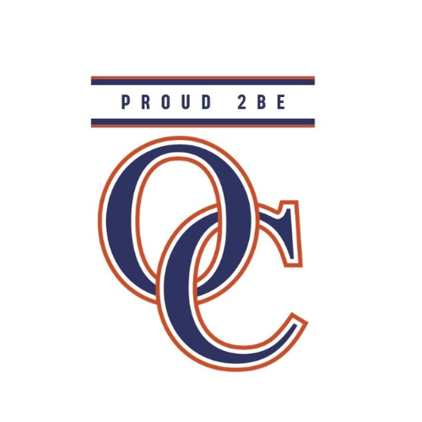

Orange County Public Schools
Kindergarten
2026-2027

Online Resources Used:

Five Ponds Press
Discovery Ed

Social Studies Five Ponds Press Online Access:
Student: https://student.efiveponds.com Username: OCPS1 Password: History

Quarter 1:

Unit 1: Civics: Citizenship in the Classroom
SOL: K, K.1
Vocabulary: community, citizen, respect, honest, self-control, kindness, rules, consequences
Unit 2: Patriotism
SOL: K, K.3
Vocabulary: American flag,Virginia flag, Pledge of Allegiance, President of the United States, leader, patriotism, Independence Day.
Quarter 2:

Unit 3: Relative Location
SOL: K, K.6
Vocabulary: near, far,over, under, above, below, behind, in front of, left, right, next to, between

Unit 4: Maps and Globes
SOL: K, K.7
Vocabulary: globe, model, map, Earth, symbol, map key/ legend, land, water, continents, mountains, deserts
Quarter 3:

Unit 5: Economics: Wants, Needs, and Choices
SOL: K, K.8
Vocabulary: choice, wants, needs, money, coins, paper bills,benefit (advantage), cost (disadvantage)

Unit 6:Past and Present: VA History
SOL: K, K. 4
Vocabulary: Indigenous People (Tribes: Algonquian, Siouan, Iroquoian, Powhatan, Pocahontas, George Washington, Thomas Jefferson, James Madison, Maggie Lena Walker, James Barbour
Unit 7: Past and Present: “Our Community”
SOL: K, K.5
Vocabulary: Community Members/Helpers, doctors (medical personnel), first responders, teachers, business leaders

Quarter 4:

Unit 8: Honoring State and National Traditions
SOL: K, K. 2
Vocabulary:Labor Day, Columbus Day (Indigenous Peoples’ Day), Election Day, Veterans Day, Thanksgiving Day, Christmas, New Year’s Day, Martin Luther King, Jr. Day, George Washington Day (Presidents’
Day), Memorial, Juneteenth (June 19th), Independence Day, Yorktown Victory Day

