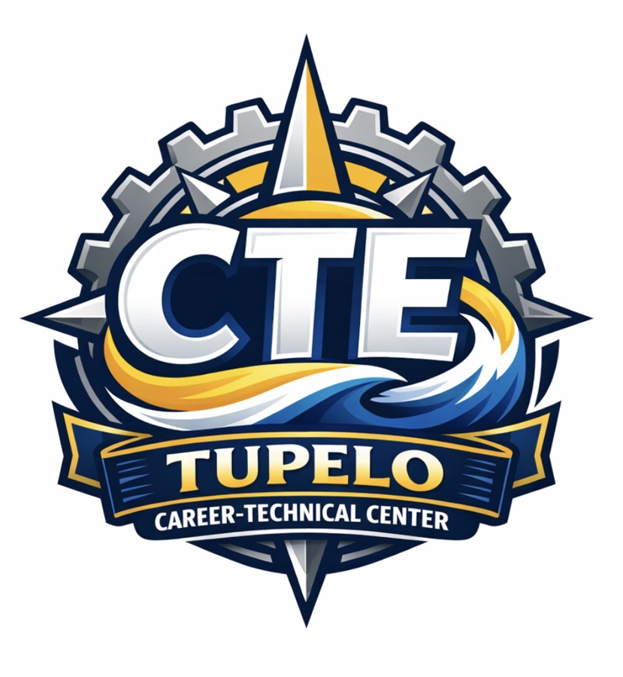

Tupelo Career-Technical Center
Career & Technical Student Organization (CTSO)
Operations Manual & Advisor Handbook
2026–2027
Real Skills • Real Experience • Real Ready

TABLE OF CONTENTS
Letter from the CTE Director .......................................................................................................... Page 3
SECTION I – FOUNDATION .........................................................................................................Page 4
SECTION II – GOVERNANCE & OPERATIONS ....................................................................... Page 11
SECTION III – MEMBERSHIP & AFFILIATION ....................................................................... Page 16
SECTION IV – CHAPTER OPERATIONS ................................................................................... Page 19
SECTION V – TRAVEL & STUDENT SUPERVISION .............................................................. Page 21
SECTION VI – FORMS & RESOURCES ..................................................................................... Page 29

A Letter from Our CTE Director

Dear Students, Parents, Advisors, and Community Partners,
Career and Technical Student Organizations represent some of the most meaningful work we do at Tupelo Career-Technical Center. Through CTSOs, students move beyond simply learning about a career field. They begin to see themselves as professionals, leaders, problem-solvers, teammates, competitors, and contributors to the community.
The classroom provides the foundation. The lab develops technical confidence. Industry partnerships connect students to the world of work. CTSOs bring all of those pieces together. When students compete, lead meetings, serve their community, travel to conferences, speak with judges, present projects, and represent Tupelo on a regional, state, or national stage, they are practicing the very skills employers and post-secondary institutions value most.
This manual has been created to bring clarity, consistency, and excellence to our student organization work. It is not meant to limit the creativity or leadership of our advisors and students. Instead, it gives each CTSO a strong foundation so every student has access to a high-quality, safe, organized, and professionally meaningful experience.
At TCTC, our goal is not only to help students become competition-ready. Our goal is to help them become career-ready, service-minded, ethically grounded, and confident enough to lead. CTSOs are one of the most powerful vehicles we have to accomplish that mission.

Sincerely,

Ryan Curry, Ed.D.
CTE Director
Tupelo Career-Technical Center

Section I – Foundation
Career and Technical Student Organizations are the leadership, service, competition, and career-readiness arm of Career and Technical Education. At Tupelo Career-Technical Center, CTSOs are not treated as optional add-ons or isolated clubs. They are part of the instructional and professional culture of the center. This section establishes the shared philosophy and purpose that will guide every CTSO operating under the TCTC umbrella.

Welcome and Purpose
This Tupelo Career-Technical Center CTSO Operations Manual & Advisor Handbook is designed to provide a common structure for all Career and Technical Student Organizations affiliated with TCTC. It exists to support advisors, students, parents, administrators, and community partners by clarifying expectations, strengthening consistency, and ensuring that all CTSO experiences reflect the mission and standards of Tupelo Career-Technical Center.
This Handbook will ultimately serve four audiences. For students, it explains expectations, opportunities, leadership pathways, and standards of conduct. For parents and guardians, it explains the value of CTSO participation, and the responsibilities associated with travel, competition, forms, and support. For advisors, it provides a practical operating guide for recruitment, affiliation, competition preparation, travel supervision, fundraising, and annual planning. For District and board leadership, it documents how TCTC aligns student organization work with state-recognized Career and Technical Education priorities.

Purpose Statement
The purpose of this Handbook is to establish a consistent, professional, and board-ready framework for the operation of all CTSOs at Tupelo Career-Technical Center while preserving the unique mission, rules, and traditions of each affiliated organization.

Career and Technical Student Organizations in Mississippi
The Mississippi Department of Education identifies student organizations as opportunities that expand and enhance students' overall educational experiences by improving social skills, building self-confidence, developing leadership skills, and helping students learn how to function effectively as members of groups and teams. At TCTC, this state-level philosophy becomes the starting point for every CTSO experience.
Mississippi's student organizations provide a structured medium for interaction among students, faculty, staff, industry, and the community. This statewide view supports TCTC's belief that CTSOs are both instructional and developmental. They help students practice leadership, professional communication, teamwork, technical skill application, and service in authentic settings.
Source Alignment: Mississippi Department of Education, Student Organizations portal; MDE identifies CTSOs including DECA, Educators Rising, FCCLA, FFA, HOSA, NTHS, SkillsUSA, and TSA as coordinated student organizations that support student development and community interaction.
Mississippi-Recognized Student Organization Landscape
Organization | Primary Career Focus | TCTC Relevance
SkillsUSA | Skilled trades, technical, health, service, and occupational areas | Core alignment for skilled trades and technical programs
TSA | STEM, engineering, technology, robotics, digital media, and computer science | Core alignment for Engineering, STEM, and computer science-related programs
HOSA | Health science, biomedical science, and healthcare professions | Core alignment for Health Sciences
DECA | Marketing, finance, hospitality, management, and entrepreneurship | Core alignment for Business, Marketing & Finance
Educators Rising | Teacher preparation and education careers | Core alignment for Educator Preparatory programs
NTHS | Recognition of excellence in Career and Technical Education | Cross-program recognition and honor society
FCCLA | Family and Consumer Sciences, hospitality, human services, education, and related pathways | Potential alignment for culinary, early childhood, and future FCS-related pathways

Why CTSOs Matter
CTSOs matter because they transform students from participants into practitioners. A student may learn technical knowledge in a classroom, but CTSOs require students to communicate, perform, present, lead, solve problems, manage pressure, receive feedback, and represent something larger than themselves.
At TCTC, CTSOs are organized around six essential student outcomes:
Outcome | What Students Gain
Leadership Development | Students learn to lead meetings, organize teams, speak publicly, serve as officers, make decisions, and model professional expectations.
Career Readiness | Students practice employability skills such as punctuality, communication, accountability, attire, teamwork, and professional conduct.
Technical Skill Development | Students apply classroom and lab learning through competitive events, projects, demonstrations, and authentic industry-aligned challenges.
Community Engagement | Students engage in service projects, awareness campaigns, local partnerships, and activities that connect CTE programs to the needs of the community.
Professional Networking | Students interact with judges, employers, post-secondary partners, alumni, community leaders, and students from other schools.
Postsecondary Preparation | Students build resumes, portfolios, presentation skills, confidence, scholarship readiness, and a clearer vision of their next step after high school.

Board-Level Rationale
A strong CTSO system supports student achievement, school culture, workforce development, community partnerships, and the District's broader goal of preparing students for college, career, and life.

CTSOs as an Extension of Classroom Instruction
The most effective CTSOs are intracurricular rather than merely extracurricular. This means they are intentionally connected to the curriculum, technical standards, employability skills, work-based learning, career exploration, and industry expectations within each CTE program.
At TCTC, advisors should view CTSO work as an instructional strategy. Competitive events can become performance tasks. Officer responsibilities can become leadership labs. Service projects can become community-based learning. Conference preparation can become professional communication practice. Fundraising can become financial literacy, entrepreneurship, and project management. Travel can become professionalism, independence, and personal responsibility.
This approach honors the unique identity of each organization while creating a common expectation: every CTSO should strengthen the student's program of study and career pathway.
Instructional Integration Examples
Instructional Area | CTSO Connection | Student Evidence
Technical Skills | Competition event preparation tied to program standards | Project, demonstration, portfolio, or judged performance
Employability Skills | Professional dress, punctuality, teamwork, and communication expectations | Advisor observation, rubric, reflection, or employer feedback
Leadership | Officer roles, committee work, meeting facilitation, and service planning | Meeting minutes, officer reports, event agendas
Work-Based Learning | Industry speakers, judges, advisory partners, and business visits | Reflection, resume update, career plan
Financial Literacy | Fundraising budgets, sponsorships, deposits, and expense tracking | Fundraiser proposal and financial summary
Public Speaking | Presentations, interviews, speeches, and competitive role-play | Mock presentation score, judge feedback, video review

Tupelo Career-Technical Center Student Organization: Mission, Vision, and Core Values
The CTSO system at TCTC should operate from a shared mission and vision that align with the broader purpose of Career and Technical Education.
Mission
The mission of the Tupelo Career-Technical Center’s Student Organization program is to develop career-ready leaders by connecting classroom instruction, technical skill development, leadership experiences, competitive events, service learning, and industry engagement.
Vision
The vision of the Tupelo Career-Technical Center’s Student Organization program is to ensure that every student has access to a high-quality organization experience that builds confidence, direction, professionalism, and opportunity.

Core Value | Operational Meaning
Integrity | We represent TCTC honestly, ethically, and responsibly.
Leadership | We step forward, serve others, and accept responsibility for results.
Excellence | We prepare with purpose and hold ourselves to high standards.
Service | We use our skills to improve our school, community, and profession.
Professionalism | We communicate, dress, travel, and compete in ways that reflect the workplace.
Innovation | We solve problems, adapt, create, and think beyond the obvious answer.

The TCTC CTSO Framework
The TCTC CTSO Framework organizes all student organization work around six repeated pillars: Leadership, Service, Competition, Career Readiness, Employability, and Technical Skills. Every chapter, regardless of organization, should be able to show evidence of student growth in these areas.
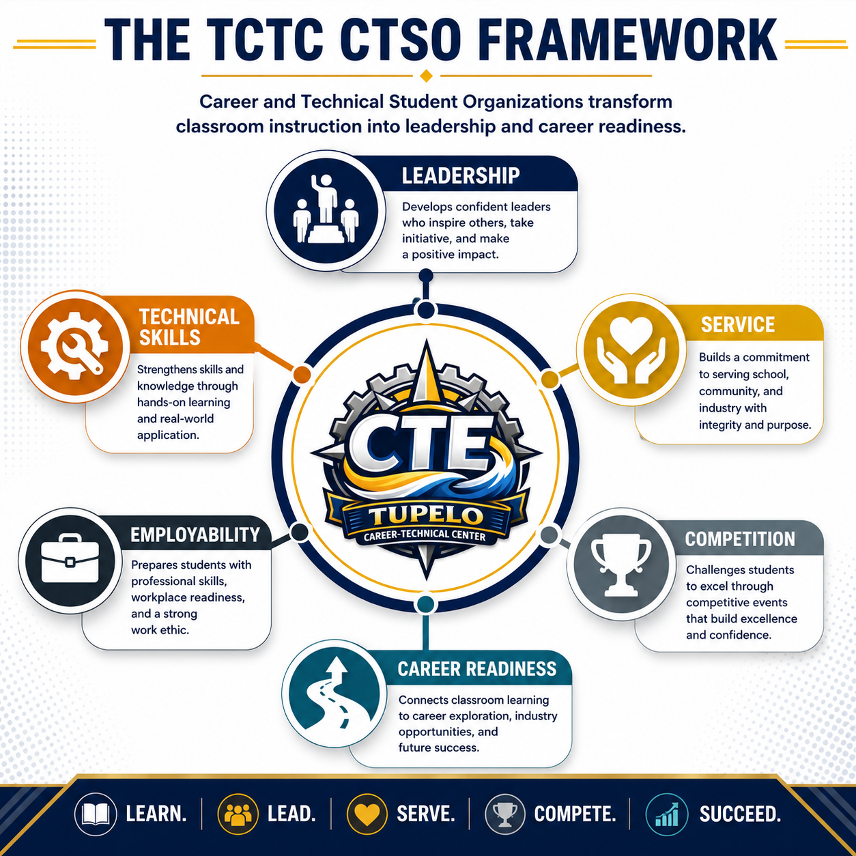

Mississippi CTSO Structure and Competitive Pathway
Students and families often see only the immediate event: a competition, a trip, a conference, a fundraiser, or an award ceremony. The broader pathway is more structured. Most CTSO experiences progress from local chapter activities to district or regional events, state conferences, and national conferences. This progression allows students to develop over time and earn opportunities through performance, leadership, and preparation.

Standard CTSO Pathway
Local Chapter | District/Regional | State | National
Recruitment, meetings, officers, service, local preparation | District events, testing, preliminary competition, leadership development | State conference, state competition, officer candidacy, recognition | National conference, national competition, advanced leadership, scholarship and networking
The Mississippi CTSO district map below is included to help advisors, students, and families understand the geographic structure of district and regional conferences.
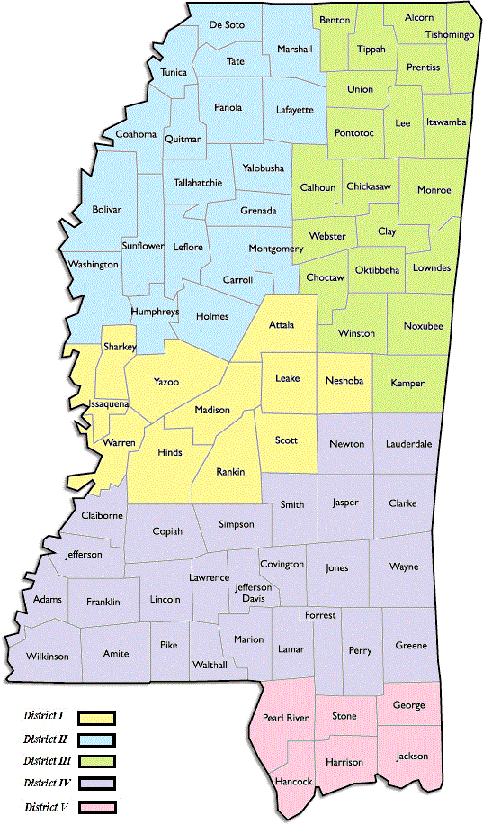

Section II – Governance and Operating Structure
A strong CTSO program requires both inspiration and systems. Students need opportunities to lead, compete, and grow; advisors need clear procedures; parents need consistent communication; administrators need accountability; and the District needs documentation that student organization work is safe, aligned, and purposeful.

Governance Philosophy
Our governance model is based on three principles: consistency, clarity, and student leadership. Consistency ensures that every CTSO follows common standards for eligibility, conduct, travel, fundraising, and communication. Clarity ensures that students, parents, advisors, and administrators understand their roles before problems occur. Student leadership ensures that CTSOs remain student-centered rather than advisor-dependent.
Each CTSO will maintain its own national and state identity, bylaws, competitive events, dress code, affiliation rules, and conference requirements. However, all CTSOs operating under TCTC will also follow the local expectations established in this Handbook and any applicable Tupelo Public School District policies.

Mississippi CTSO Alignment at TCTC
The following alignment table should be used to help advisors, counselors, administrators, parents, and students understand which CTSOs naturally connect to TCTC programs. Some organizations may serve more than one pathway, and some pathways may have students who participate in multiple organizations depending on local availability, eligibility, and student interest.
Program / Pathway | Primary CTSO | Notes
Automotive Service Technology | SkillsUSA | Skilled trades, technical skill demonstration, leadership, workplace readiness
Collision Repair Technology | SkillsUSA | Skilled trades, technical skill demonstration, leadership, safety, professionalism
Construction | SkillsUSA | Construction, carpentry, masonry, electrical, safety, project-based technical competition
Welding | SkillsUSA | Welding performance, safety, blueprint interpretation, technical skill verification
Culinary Arts | SkillsUSA / FCCLA | SkillsUSA for culinary technical events; FCCLA may also support hospitality, food service, and leadership
Health Sciences | HOSA | Health science leadership, healthcare skill events, biomedical and clinical career exploration
Engineering | TSA | STEM, engineering design, robotics, technology problem-solving, leadership
Exploring Computer Science / IT | TSA | Coding, software development, cybersecurity-related interests, technology presentations
Business, Marketing & Finance | DECA | DECA is primary for marketing, finance, entrepreneurship, hospitality, and management
Educator Preparatory | Educators Rising / FCCLA | Future teacher leadership, education career exploration, public speaking, service
All Programs | NTHS | Honor society recognition for excellence in CTE, leadership, scholarship, and character

Chain of Responsibility
Clear lines of responsibility protect students and support advisors. The chain of responsibility is not intended to create barriers; it is intended to ensure that concerns, approvals, travel decisions, financial matters, and student issues are handled through the correct professional channels.
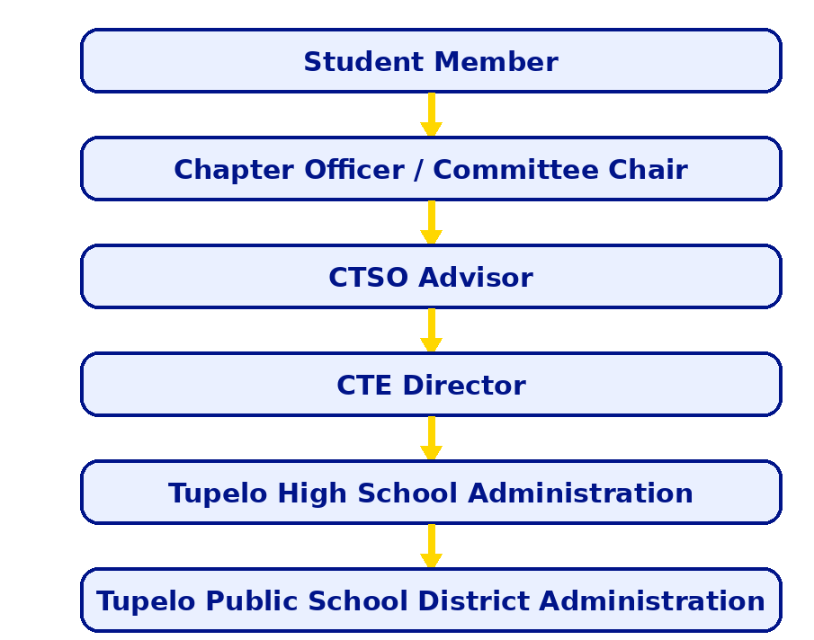

Operational Interpretation
Students are expected to communicate first with chapter officers and advisors when questions arise. Chapter officers assist with communication, organization, recruitment, and chapter accountability but do not replace adult supervision. Advisors are the first line of operational responsibility for meetings, affiliation, competition preparation, travel supervision, and parent communication. The CTE Director coordinates consistency across CTSOs and supports advisor planning, budget alignment, fundraising review, and district-level communication. School and District administration provide policy guidance, approval authority, and final oversight.

CTSO Bill of Rights and Responsibilities
The CTSO Bill of Rights and Responsibilities establishes a common understanding of what students can expect from participation and what TCTC expects from students who represent the center.
Student Rights | Student Responsibilities
- To participate in CTSO activities when eligible and in good standing.  - To seek leadership opportunities at the chapter, state, or national level.  - To compete fairly under published rules and timelines.  - To receive advisor guidance, coaching, and preparation.  - To be treated with dignity and respect by peers and adults.  - To understand expectations before travel, competitions, and conferences. | - To maintain academic, attendance, behavior, and membership eligibility.  - To follow all school, District, local, state, and national CTSO rules.  - To demonstrate professional dress, speech, and behavior.  - To respect advisors, chaperones, judges, competitors, and hotel/conference staff.  - To submit required forms and meet deadlines.  - To represent TCTC, Tupelo High School, and Tupelo Public School District with integrity.

Advisor Standards of Practice
The advisor is the adult leader who guides student ownership while ensuring that CTSO work remains safe, organized, instructional, and aligned with school and District expectations. Effective advisors do not do all the work for students; they build systems that allow students to lead responsibly.
Standard | Advisor Practice
Recruitment and Access | Advisors recruit students equitably, communicate the benefits of membership, and provide clear information about dues, deadlines, expectations, and opportunities.
Affiliation and Membership | Advisors complete affiliation requirements on time, verify rosters, maintain accurate records, and ensure that students are officially registered before conference or competition participation.
Leadership Development | Advisors establish officer structures, train student leaders, delegate responsibilities, and teach students how to plan, communicate, and follow through.
Competition Preparation | Advisors help students select appropriate events, establish practice schedules, secure materials, review rubrics, conduct mock presentations or skill checks, and verify event rules.
Student Supervision | Advisors supervise students during meetings, practices, travel, lodging, conferences, competitions, and related activities in accordance with school and District policy.
Financial Oversight | Advisors follow District procedures for fundraising (Policy DKAAA), receipting, purchasing (Policy DJE), deposits (Policy DJBA), sponsorships, student activity funds (Policy DK), and documentation.
Parent Communication | Advisors provide timely communication about dues, travel, forms, schedules, expectations, emergencies, and student conduct concerns.
Industry and Community Engagement | Advisors connect CTSO work to advisory committees, employers, guest speakers, judges, sponsors, work-based learning, and community service.
Annual Documentation | Advisors maintain records of membership, officer rosters, meeting dates, financial activity, travel forms, competition results, recognition, and end-of-year reflection.

Student, Parent, Officer, and Administrator Responsibilities
A high-functioning CTSO system depends on shared ownership. The advisor is critical, but the advisor cannot be the entire system. The responsibilities below clarify how each stakeholder contributes to the success of the program.

Student Members
- Attend meetings and practices.
- Meet eligibility requirements.
- Prepare for competitions.
- Follow conduct, dress, and travel expectations.
- Represent TCTC with professionalism.

Chapter Officers
- Lead by example.
- Assist with meetings, communication, recruitment, and service.
- Support advisor planning.
- Track chapter goals and member engagement.
- Model professionalism and accountability.

Parents/Guardians
- Review schedules, costs, forms, and expectations.
- Provide accurate medical and emergency information.
- Support student preparation and deadlines.
- Remain reachable during student travel.
- Partner with advisors when concerns arise.

CTSO Advisors
- Guide student leadership.
- Maintain records.
- Prepare students.
- Supervise activities.
- Communicate with parents and administration.

CTE Director/ District Administration
- Support consistency across CTSOs.
- Coordinate advisor resources.
- Review major travel, fundraising, and program needs.
- Align CTSO work with center goals.
- Support board-ready documentation.
- Provide policy oversight.
- Approve major activities as required.
- Support safe travel and responsible financial practice.
- Recognize student achievement.
- Ensure alignment with District expectations.

Annual CTSO Cycle
Advisors benefit from seeing the entire year at once. While each CTSO has its own specific dates, the following cycle provides a common planning cadence for TCTC.
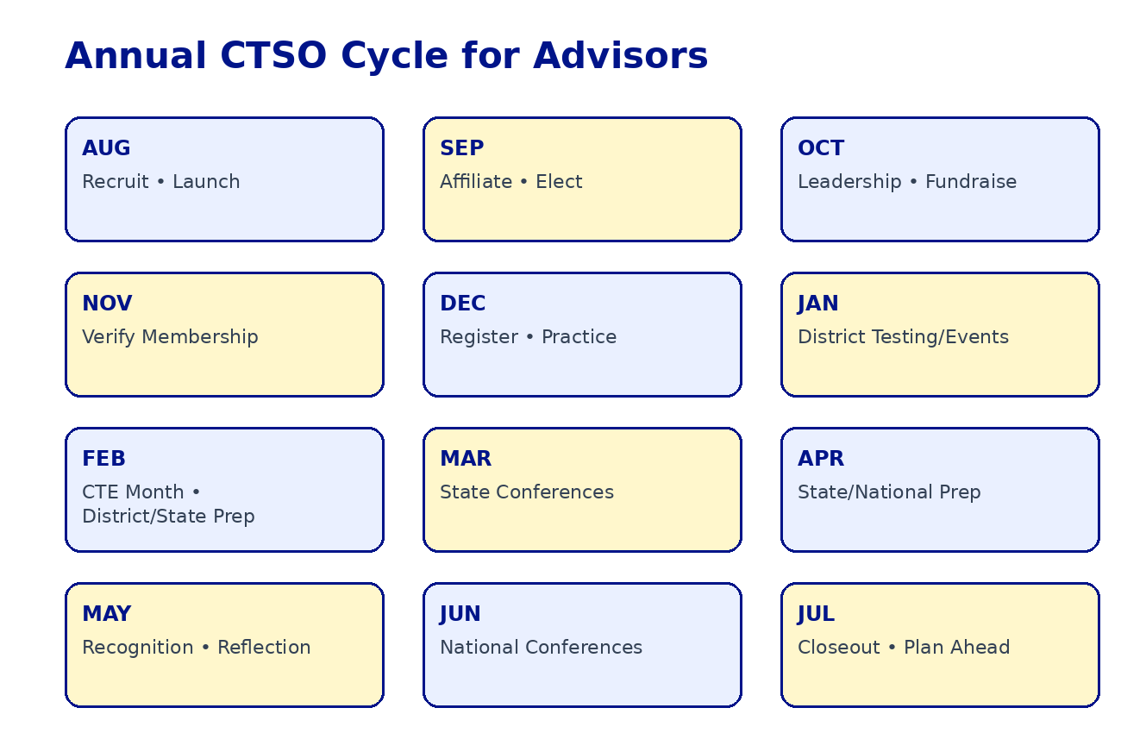

Annual Cycle Expectations
- Each advisor should begin the year with a recruitment and affiliation plan.
- Each CTSO should submit a preliminary calendar of major events, expected competitions, and fundraising activities.
- Students should receive written expectations before any travel or competitive event.
- Advisors should conduct at least one parent/guardian communication before overnight or out-of-state travel.
- Each chapter should submit end-of-year highlights, competition results, and recommendations for improvement.

Section III: Membership, Eligibility & Affiliation

Purpose
This section establishes District-wide expectations for membership, eligibility, affiliation, recruitment, retention, and member engagement across all Career and Technical Student Organizations at Tupelo Career-Technical Center.

Membership Philosophy
Career and Technical Student Organizations are the leadership development component of Career and Technical Education. Membership is more than paying dues; it is a commitment to leadership, professionalism, service, technical excellence, and career readiness. Through active participation, students strengthen communication, teamwork, problem-solving, and workplace readiness skills while applying classroom learning in authentic settings.

Membership Eligibility Standards
Students must remain in good standing academically, behaviorally, and professionally. Eligibility standards provide consistency across all CTSOs and ensure students are prepared to represent TCTC at local, state, and national events.

Membership Benefits
Students gain access to leadership opportunities, competitive events, scholarships, networking, travel, service learning, recognition programs, and career exploration experiences.

CTSO Affiliation Procedures
Each CTSO maintains national and state affiliation requirements. Advisors are responsible for ensuring students are properly affiliated before participating in conferences, competitions, and leadership activities.
Student Conduct, Professionalism & Participation Eligibility
- Maintain passing grades CTE course and satisfactory progress in the CTE pathway. Failure of a term (9 weeks) will result in Probation (1st offense); Failure of any two terms during the school year will result in dismissal (2nd Offense).
- Students who receive OSS will have their CTSO membership automatically revoked. ISS will result in Probation (1st offense) or removal (2nd offense).
- Students who miss 20% of the course each term due to absences or tardies will be placed on Probation; missing 30% will result in removal.
- Policy violations or conduct that reflect negatively on TCTC will result in Probation (1st offense) or Removal (2nd offense).
- Final eligibility decisions are made by the advisor in consultation with administration. Students or parents who wish to appeal an eligibility decision should contact the advisor and CTE Director in writing within five school days.

Advisor Checklist

Beginning of Year Membership Launch
□ Verify national and state affiliation deadlines
□ Update membership fee schedules
□ Conduct classroom recruitment presentations
□ Recruit student ambassadors
□ Schedule parent information meeting
□ Publish annual CTSO calendar
□ Establish membership tracking system
CTSO Affiliation Overview
Organization | Primary Focus | Affiliation Required | Competition Eligibility
SkillsUSA | Skilled Trades & Technical Programs | Yes | Yes
TSA | STEM & Engineering | Yes | Yes
HOSA | Health Sciences | Yes | Yes
DECA | Business & Marketing | Yes | Yes
Educators Rising | Education Pathways | Yes | Yes
NTHS | Honor Society Recognition | Membership Selection | Varies

Membership Fee Structure
Fee structures should be reviewed annually and communicated clearly to students and parents.
Membership Fee Table (May change year to year)
Organization | State Dues | National Dues | Local Dues | Total
SkillsUSA | $7.00 | $8.00 | $5.00 | $20.00
TSA | $5.00 | $10.00 | $10.00 | $25.00
HOSA | - | $10.00 | $20.00 | $30.00
DECA | $6.00 | $8.00 | $26.00 | $40.00
Educators Rising | $10.00 | $15.00 | - | $25.00
NTHS | - | $30.00 | - | $30.00

Recruitment Framework
Successful CTSO chapters recognize that recruitment is not a single event, but an ongoing process that begins long before students enter a Career and Technical Education program and continues throughout the school year. At Tupelo Career-Technical Center, advisors should utilize multiple recruitment sources to build awareness and encourage participation, including 5th Grade Career Tours, 8th Grade Pathway and Career (PAC) Visits, Open House events, Student Ambassador programs, social media campaigns, industry partner engagement, competition showcases, and parent information nights. Effective recruitment follows a progression from Awareness → Interest → Membership → Participation → Leadership, helping students move from initial exposure to active involvement within the organization. Once students join, advisors should focus on retention by providing meaningful leadership opportunities, competitive event participation, community service projects, scholarship opportunities, recognition programs, and national conference experiences. These opportunities help students develop ownership, build connections, and remain engaged throughout their CTSO journey.

Recommended recruitment sources include:
- 5th Grade Career Tours
- 8th Grade PAC Visits
- Open House Events
- Student Ambassador Program
- Social Media Campaigns
- Industry Partner Engagement
- Competition Showcases
- Parent Information Nights
- Membership Funnel Graphic Placeholder
- Awareness → Interest → Membership → Participation → Leadership
- Membership Retention Strategies
- Leadership opportunities
- Competitive event participation
- Community service projects
- Scholarship opportunities
- Recognition programs
- National conference participation

Section IV – Chapter Operations, Programs & Advisor Management

Chapter Purpose
The purpose of this chapter is to provide advisors with practical guidance for developing sustainable, high-performing CTSO chapters that consistently provide meaningful opportunities for student growth and achievement.

The Role of the CTSO Advisor
The CTSO advisor serves as the mentor, coach, facilitator, manager, advocate, and role model for the chapter. Advisors provide guidance and structure while empowering students to assume leadership responsibilities and take ownership of chapter activities. Successful advisors focus on developing student leaders rather than simply managing events, creating opportunities for students to grow in confidence, professionalism, and career readiness

CTSOs as Intracurricular Organizations
Career and Technical Student Organizations are intracurricular, meaning they are an integral part of the Career and Technical Education program rather than an extracurricular activity. CTSOs extend classroom instruction by providing students with opportunities to apply technical knowledge, leadership skills, and professionalism through competitive events, service projects, leadership activities, and career exploration experiences.

Building a Chapter Culture
A strong chapter culture promotes professionalism, leadership, service, inclusion, excellence, and accountability. Advisors and officers establish the expectations that guide member behavior and participation. When students feel valued, connected, and challenged, they are more likely to become active participants and contribute positively to the chapter's success.

Characteristics of High-Performing Chapters
High-performing CTSO chapters are characterized by strong student leadership, active membership, effective communication, meaningful opportunities for involvement, community engagement, continuous recruitment efforts, and sustainable organizational systems. These chapters create environments where students are encouraged to develop leadership skills, pursue excellence, and actively contribute to chapter goals.

Developing Student Ownership
Student ownership is developed when members are given meaningful responsibilities and opportunities to lead. Advisors should encourage students to facilitate meetings, assist with recruitment, serve on committees, prepare for competitions, and coordinate service projects. When students take ownership of chapter activities, engagement increases and leadership development becomes more meaningful.

Annual Chapter Planning
Successful chapters operate according to an annual plan that outlines goals and activities related to membership, competition, leadership development, service, fundraising, and recognition. Planning helps advisors and officers establish priorities, meet deadlines, and ensure that chapter activities align with the mission and objectives of the organization throughout the year.

Industry Partnerships
Industry partners provide valuable support by serving as mentors, competition judges, guest speakers, sponsors, and technical experts. These partnerships strengthen the connection between classroom learning and workforce expectations while providing students with authentic learning experiences, networking opportunities, and exposure to potential career pathways.

Recognition Systems
Recognition programs help reinforce positive behaviors, celebrate accomplishments, and maintain member engagement. Effective recognition may include awards, certificates, social media spotlights, scholarship opportunities, officer recognition, certification celebrations, and public acknowledgment of student achievements. Consistent recognition promotes a culture of excellence and encourages continued participation.

Advisor Checklist Guide
☐ Review chapter goals
☐ Affiliate advisor and chapter
☐ Develop annual calendar
☐ Review conference dates
☐ Establish officer team
☐ Develop recruitment plan
☐ Create communication systems
☐ Review financial status
☐ Schedule chapter meetings
☐ Plan service projects

Review Chapter Goals
Begin each school year by reviewing the chapter's mission, objectives, and priorities. Consider membership growth targets, competition goals, leadership development opportunities, community service initiatives, and fundraising needs. Establishing clear goals provides direction for the chapter and helps officers and members understand what success looks like throughout the year.

Affiliate Advisor and Chapter
Verify that all advisor memberships, chapter affiliations, and required registrations have been completed through the appropriate state and national CTSO organizations. Early affiliation ensures access to resources, communications, conference registration, competitive events, and leadership opportunities.

Develop Annual Calendar
Create a master calendar that includes chapter meetings, officer meetings, recruitment events, fundraising activities, service projects, competition deadlines, state conferences, national conferences, and recognition events. A well-developed calendar helps prevent scheduling conflicts and ensures adequate preparation time for major activities.
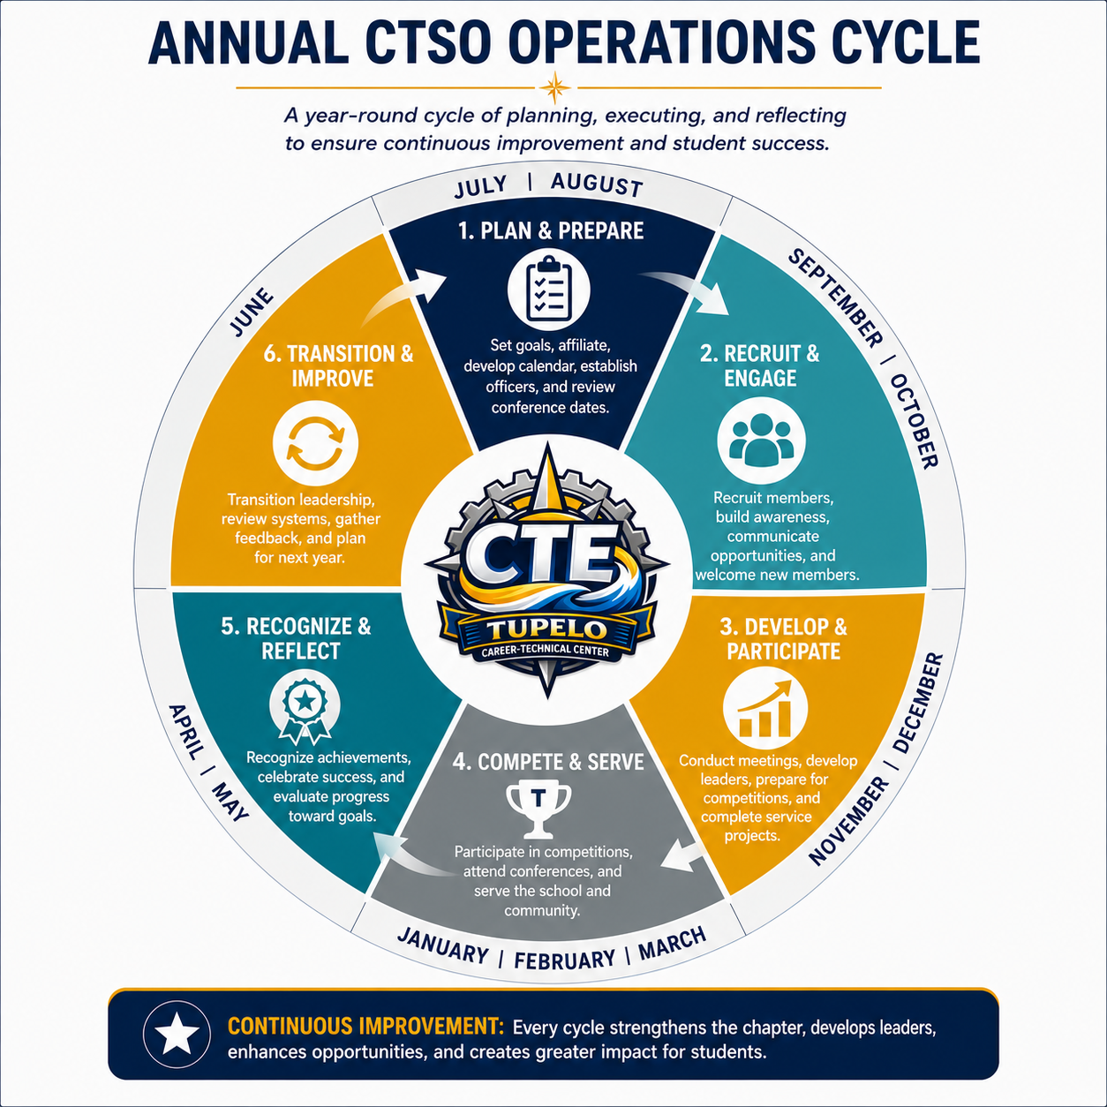

Review Conference Dates
Review all state and national conference dates, registration deadlines, hotel deadlines, and competition timelines as soon as they are released. Advisors should work backward from these dates to develop preparation schedules, fundraising plans, and travel arrangements.

Establish Officer Team
Select, appoint, or confirm chapter officers and clearly communicate their responsibilities. Conduct an officer orientation meeting to review expectations, chapter goals, meeting procedures, leadership responsibilities, and upcoming activities. Strong officers help create strong chapters.

Develop Recruitment Plan
Recruitment should be intentional and ongoing rather than limited to the beginning of the school year. Identify recruitment opportunities such as 5th Grade Career Tours, 8th Grade PAC Visits, Open House events, classroom presentations, social media campaigns, student ambassadors, competition showcases, and parent information nights. Establish membership goals and strategies for achieving them.

Create Communication Systems
Determine how information will be communicated to students, parents, administrators, and stakeholders. Communication methods may include email, Remind, Canvas, social media platforms, newsletters, school announcements, and parent meetings. Good communication improves participation & reduces confusion.

Review Financial Status
Review available chapter funds, outstanding obligations, fundraising needs, and anticipated expenses for the year. Understanding the chapter's financial position early allows advisors and officers to develop realistic budgets and fundraising goals that support planned activities.

Schedule Chapter Meetings
Establish a meeting schedule for the year and communicate it to members and parents. Consistent meeting dates improve attendance and allow students to plan accordingly. Advisors should also consider scheduling officer meetings and committee meetings as needed.

Plan Service Projects
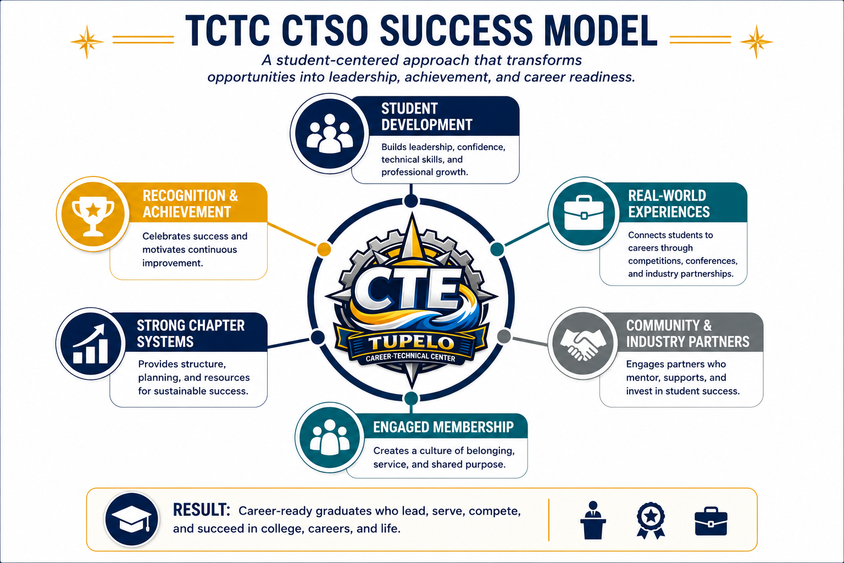
Community service is a core component of most CTSOs and provides students with opportunities to develop leadership skills while making a positive impact. Identify service projects that align with chapter goals, community needs, and CTSO initiatives. Planning early allows for greater student involvement and stronger project outcomes.

Section V – Conferences, Travel & Student Supervision

Purpose of CTSO Travel & Conferences
CTSO travel and conference participation are extensions of the Career and Technical Education experience at Tupelo Career-Technical Center. These experiences should not be viewed as recreational trips or rewards for participation. Instead, they are instructional, leadership-based, and career-connected opportunities that allow students to apply classroom learning in authentic environments.
Through CTSO travel, students may participate in competitive events, attend leadership sessions, engage with industry professionals, visit postsecondary or workforce settings, represent TCTC at state and national events, and experience professional expectations beyond the classroom. These opportunities help students develop confidence, independence, communication skills, professionalism, and career readiness.
Because CTSO travel involves student safety, supervision, public representation, transportation, finances, and District approval, every trip must be carefully planned and clearly connected to the goals of the student organization and the instructional program. Advisors are responsible for ensuring that travel is purposeful, properly approved, well communicated, financially responsible, and aligned with District procedures.
All CTSO travel should support at least one of the following purposes:
- Participation in CTSO competitive events
- Attendance at district, state, regional, or national conferences
- Leadership development
- Career exploration
- Post-secondary awareness
- Industry engagement
- Community service
- Technical skill development
- Recognition of student achievement
When planning travel, advisors should be prepared to explain how the experience supports student learning, strengthens the CTSO chapter, and advances the mission of Career and Technical Education at TCTC.

Advisor Note
Before planning any CTSO trip, advisors should ask:
“What is the instructional or organizational purpose of this experience?”
If the trip does not clearly support competition, leadership, career readiness, service, technical skill development, or CTSO participation, it may not belong in the CTSO travel plan.

Travel Planning & Approval Process
The travel planning and approval process (Policy IFCB) should begin well before the date of the proposed trip. Advisors should never assume that a conference, competition, or off-campus experience is approved simply because it appears on a CTSO calendar or has occurred in previous years. Each trip must move through the appropriate approval process and include required documentation.
The advisor is responsible for initiating the planning process, communicating with administration, preparing required forms, confirming transportation needs, identifying costs, collecting required student documentation, and ensuring that parents and guardians receive accurate information.

Step 1: Begin with the Purpose of the Trip
Every travel request should begin with a clearly stated purpose. The purpose should explain why students are traveling and how the experience supports the CTSO, the instructional program, or student career development.
Examples of appropriate CTSO travel purposes may include:
- Students will compete in the SkillsUSA State Leadership and Skills Conference.
- HOSA members will participate in leadership and competitive events connected to Health Sciences.
- TSA students will present engineering and STEM projects at a state conference.
- DECA students will participate in business, marketing, and entrepreneurship events.
- Educators Rising students will attend a conference focused on future teacher preparation.
- NTHS members will participate in a recognition or leadership event.
The purpose statement should be specific enough that administrators can clearly understand the educational value of the trip.

Step 2: Seek Tentative Administrative Approval
Before communicating final trip details to students and parents, advisors should first discuss the proposed trip with the appropriate administrator. This early conversation allows the advisor to confirm whether the trip is appropriate, whether the proposed date creates conflicts, whether transportation may be available, and whether funding is feasible.
This step is especially important for overnight travel, out-of-state travel, national conferences, or trips requiring significant fundraising or substitute coverage.

Step 3: Review Required Timelines
Advisors should work backward from the date of the trip and allow enough time for approvals, transportation arrangements, parent communication, registration, lodging, fundraising, and student preparation.
Type of Trip | Recommended Planning Timeline
Local walking trip or short off-campus excursion | Begin planning at least several weeks in advance
Trip requiring District transportation | Begin planning at least one month in advance
State conference or competition | Begin planning two to three months in advance
Overnight travel | Begin planning at least three months in advance
National conference or out-of-state travel | Begin planning as early as possible, preferably six months or more in advance
Advisors should always follow the District’s required timelines and should begin earlier whenever possible.

Step 4: Complete the Field Trip and Excursion Request Form
The Field Trip and Excursion Request Form should be completed with accurate and complete information. This form documents the basic details of the proposed trip and provides administrators with the information needed to review the request.
The form should include:
- Date of request
- School name
- Name of requesting group
- Name of teacher, advisor, or sponsor
- Purpose of trip
- Trip date or dates
- Destination
- Departure date and time
- Return date and time
- Number of students
- Number of staff chaperones (Policy IFCB -1:5 for grades Pre-K, K, 1, 2; 1:8 for grades 3, 4, 5, 6; and 1:12 for grades 7, 8, 9, 10, 11, 12. For local field trips the ratio is elementary 10:1 and secondary 20:1)
- Number of administrators, security officers, or other chaperones if applicable
- Cost per student
- Funding sources
- Transportation arrangements
- Advisor signature
- Principal approval
- Superintendent approval when required
Advisors should ensure that all information is complete before submitting the form for approval.

Step 5: Confirm Transportation Needs
Transportation should be considered early in the process. Advisors should determine whether the group will travel by District bus, charter bus, walking trip, or another approved transportation method.
Transportation planning should include:
- Number of students traveling
- Number of adults traveling
- Departure time
- Return time
- Destination address
- Multiple stops, if applicable
- Bus or vehicle needs
- Parking or drop-off information
- Special equipment or luggage needs
If District buses are needed, advisors should communicate early with the TPSD Transportation Department or administrator to determine availability. If charter transportation is needed, advisors should follow all district procedures for contracts, approvals, and purchasing.

Step 6: Develop a Preliminary Budget
Every trip should have a clear and realistic budget before final approval is requested. Advisors should identify all anticipated expenses and funding sources.
Possible expenses may include:
- Registration fees
- Transportation
- Lodging
- Meals
- Parking
- Student materials
- Competition supplies
- Advisor travel expenses
Possible funding sources may include:
- CTSO chapter funds
- Student fees
- Fundraising proceeds
- School budget
- Donations or sponsorships
- Grants or approved external funding sources
The advisor should be able to explain how costs will be covered and whether any financial barriers may affect student participation.

Step 7: Complete Travel Expense Documentation When Needed
When employee travel costs, lodging, registration, meals, airfare, mileage, or other reimbursable expenses are involved, the appropriate travel request or travel expense documentation should be completed.
Advisors should pay careful attention to:
- Budget codes
- Estimated costs
- Required signatures
- Receipts
- Registration documentation
- Lodging documentation
- Meal documentation
- Submission deadlines after travel
Travel-related financial documentation should be handled carefully and submitted promptly following the trip.

Step 8: Secure Formal Approval Before Promoting the Trip as Final
Advisors should avoid presenting a trip as finalized until all required approvals have been obtained. Students and parents may be informed that a trip is being planned or proposed, but final commitments should not be made until approval is confirmed by administration.
Once approval is granted, advisors may proceed with:
- Parent communication
- Student registration
- Transportation requests
- Lodging arrangements
- Fundraising activities
- Conference preparation
- Collection of permission forms

Step 9: Create a Travel Planning File
For each CTSO trip, advisors should maintain a travel planning file. This file may be digital, physical, or both.
The file should include:
- Approved field trip request
- Approved travel request, if applicable
- Conference information
- Student roster
- Chaperone list
- Parent permission forms
- Emergency contact information
- Medical information
- Itinerary
- Transportation details
- Hotel information
- Room assignments, if applicable
- Registration confirmation
- Budget documentation
- Receipts and expense documentation
- Post-trip reflection or evaluation
Maintaining organized records protects the advisor, supports student safety, and creates a planning reference for future trips.

Advisor Checklist: Travel Planning & Approval
☐ Identify the purpose of the trip
☐ Confirm instructional or CTSO connection
☐ Discuss proposed trip with administrator
☐ Review District timelines
☐ Complete Field Trip and Excursion Request Form
☐ Confirm transportation needs
☐ Develop preliminary budget
☐ Identify funding sources
☐ Complete travel expense documentation if needed
☐ Obtain required approvals
☐ Create parent communication plan
☐ Begin registration and lodging arrangements after approval
☐ Maintain a travel planning file

Advisory Note:
The strongest travel plans begin with the end in mind. Advisors should first identify the purpose, learning outcome, or CTSO objective of the trip, then build the logistics around that purpose. When the educational value is clear, the approval process, parent communication, and student expectations become easier to explain.

SECTION VI – Forms, Templates, and Resources

Advisor Quick Reference Checklists
- Beginning of Year Checklist
- End of Year Checklist
- Competition Readiness Checklist
- Travel Planning Checklist

Competition Resources
- Competition Travel Checklist

Travel Resources
- TPSD Field Trip Request Form
- TPSD Field Trip and Excursion Checklist
- TPSD Field Trip Parent Permission Form
- TPSD Travel Request Forms
- TPSD District Vehicle Request Form
- Room Assignment Sheet
- Conference Planning Worksheet
- Chaperone Assignment Sheet
- Emergency Contact Roster
- TPSD Policy IFCP: Field Trips and Excursions

Fundraising Resources
- Fundraiser Request Form
- TPSD Donation Form
- Live Work Order Requests: Automotive, Construction, Collision Repair, Welding

CTSO Contacts & Resources
- Student & Parent Membership and Participation Agreement
- CTSO Parent Summary
- Mississippi CTSO Contacts: MDE, SkillsUSA, HOSA, DECA, TSA, Ed Rising, NTHS, FCCLA
- National CTSO Websites: SkillsUSA, HOSA, DECA, TSA, Ed Rising, NTHS, FCCLA
- MDE CTSO Links
- Tupelo Career-Technical Center Administrative Contacts
  - Dr. Ryan Curry, Director – 662.841.8991; rwcurry@tupeloschools.com
  - Vanessa Southward, Office Manager – 662.841.8990; vrsouthward@tupeloschools.com

Tupelo Career-Technical Center
4125 Golden Wave Dr. Tupelo, MS 38801 Ph: 662-841-8990
The Tupelo Public School District does not discriminate on the basis of race, color, national origin, sex, disability, age or any other classification protected by law in its education programs, activities or employment practices. The following person has been designated to handle inquiries or reports regarding the nondiscrimination policies:
Tupelo Public School District
Title IX Coordinator
Scott Williams
445 North Church Street, Tupelo, MS 38804
sewillams@tupeloschools.com
662-841-8609
Tupelo Public School District
504 coordinator
Heather Justice
903 Fillmore Drive, Tupelo, MS 38801
hcjustice@tupeloschools.com
662-690-5006


