


PowerSchool
New School
Year Setup

Step by Step Guide

PowerSchool Support Team
powerschoolhelp@esboces.org
http://www.powerschool.esb.site.eboard.com
631 844 5723

May 2026

After the End of Year Process

After the End of Year Process has been completed, there are a number of recommended tasks to perform before starting the upcoming school year.

A thorough review of your school setup before the beginning of the upcoming school year will help ensure a successful transition into the next school year.

Below are the detailed steps required to completely set up your data for the start of the new school year.

Years and Terms
Start Page > School Management>Scheduling>Years and Terms

Years and Terms are required to be setup accurately immediately following the EOY Process so you can continue working in PS and enrolling students.

- Verify the starting and ending dates of your Years & Terms for each school, as well as your District.
  - Per NYS, they should all be 7/1/xxxx to 6/30/xxxx

- Make sure each school is defined as a Year, Semester, Quarter or Trimester School.

- In District, your Years & Terms are defined only as a Year Term using 7/1/xxxx – 6/30/xxxx

Bell Schedules
Start Page > School Management>Scheduling>Bell Schedules

The Bell Schedule is required to be setup accurately immediately following the EOY Process so you can continue working in PS and enrolling students.

- Verify that the bell schedule(s) for each school contain the correct number of periods and is associated to the correct Attendance Conversion Method.

- Verify that each period in each bell schedule has the correct start time, end time, and is set to count in (or to be excluded from) ADA calculations.

- If you use the Meeting/Daily attendance bridge, ensure that each bell schedule has one period assigned as the daily attendance bridge (Golden Period).

Note: Only one bell schedule can be used per calendar day. The bell schedule determines which attendance conversion is used on a given day.

Reminder: No period on the Bell Schedule can be less than 5 minutes in duration.

Full Time Equivalencies
School Management>Attendance>Full-Time Equivalencies

FTE’s are required to be setup accurately immediately following the EOY Process so you can continue working in PS and enrolling students.

- Verify that each Full Time Equivalency (FTE) is assigned a Default Attendance Mode and a Default Attendance Conversion.

- For NYS Reporting, if a school’s default is Daily, make sure you override the default to Meeting in District > Schools/School Info > click on school(s) name > Attendance Mode for Calculating Instructional Minutes

Configure Calendar
School Management>Scheduling>Calendar>Configure Calendar
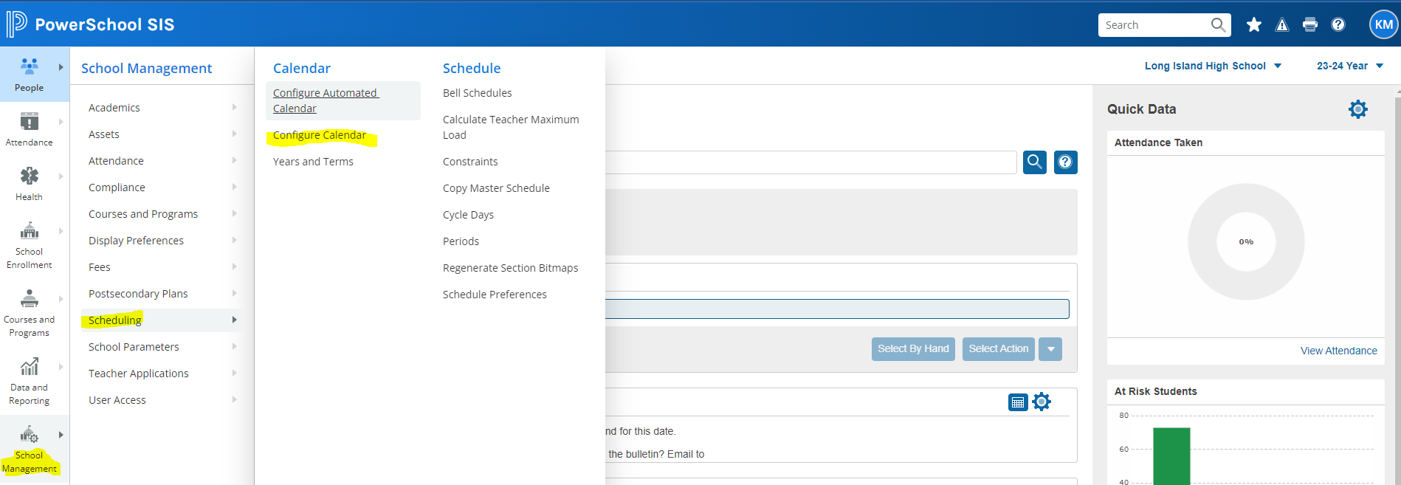

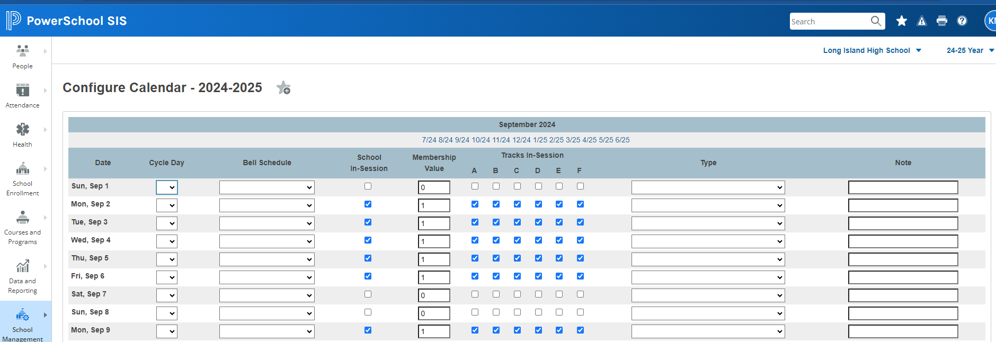

Note: If you have not already set up the School Calendar, you must set it up immediately following the EOY Process so you can continue working in PS and enrolling students.

- Ensure that each in-session school day is assigned with the appropriate membership value. This value is usually set to 1, but may differ for special school days such as half days, which may have a membership value of .5.

- Ensure that any school day with a positive membership value is assigned the correct in-session status.

- Ensure that each in-session day is assigned a bell schedule and a cycle day.

Attendance Conversions
School Management>Attendance>Attendance Conversions

- Verify that each attendance conversion is correctly and completely defined for each full-time equivalency.

- Make sure you are signed into the New Year.

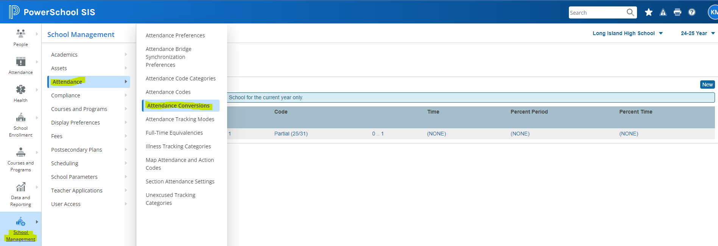

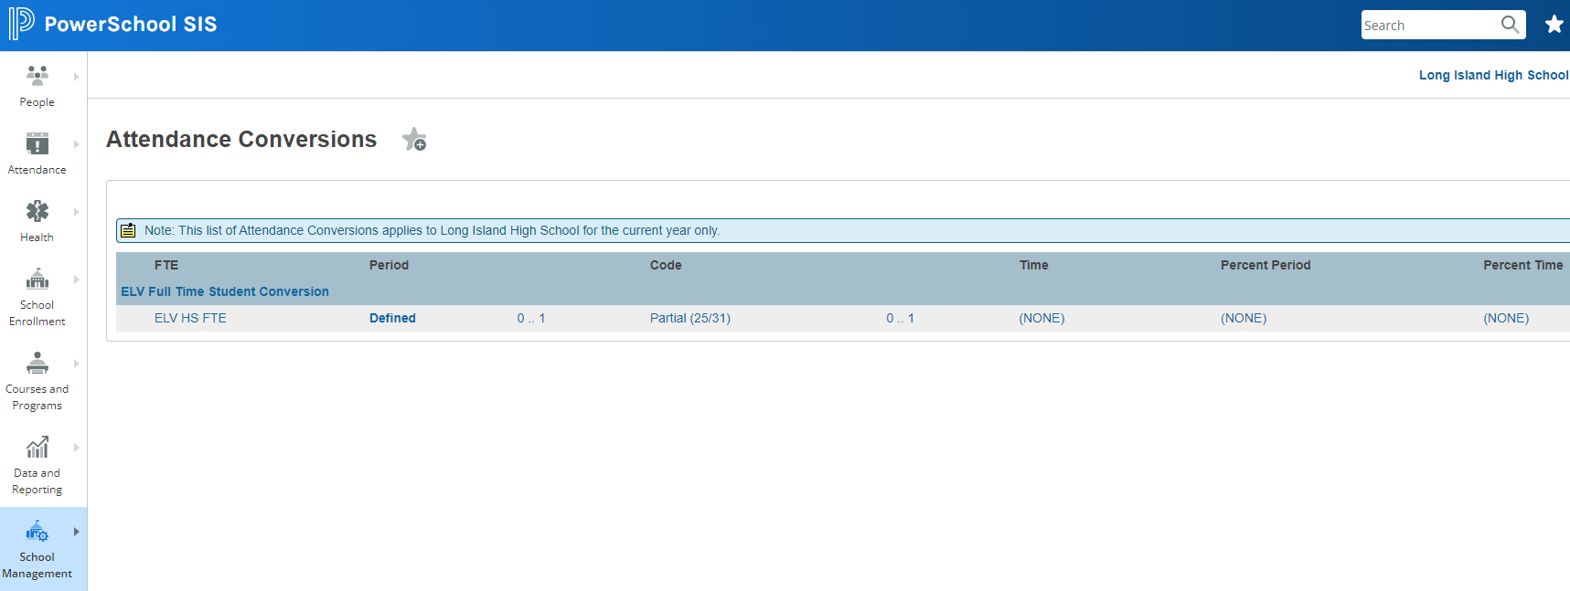

Attendance Preferences
School Management>Attendance>Attendance Preferences

Attendance preferences are copied from the previous school year upon creating the year term for a new school year. Review your attendance preferences for the following:

- Ensure that the correct attendance recording methods are set

- Set one-way or two-way synchronization for the meeting and daily attendance bridge if your school records both meeting and daily attendance

- Set the number of school days before and after the current date during which teachers can enter attendance

- Set the calculation accuracy for ADA and ADM values

- Determine whether attendance recorded at another school counts for students at the current school

- Determine whether present codes (positive attendance) or absent codes (negative attendance) are used for the period conversion

- Determine whether PowerSchool should round or truncate ADA and ADM values when calculating attendance

- Choose whether to enable or disable passing time deductions if using a daily, time-to-day conversion

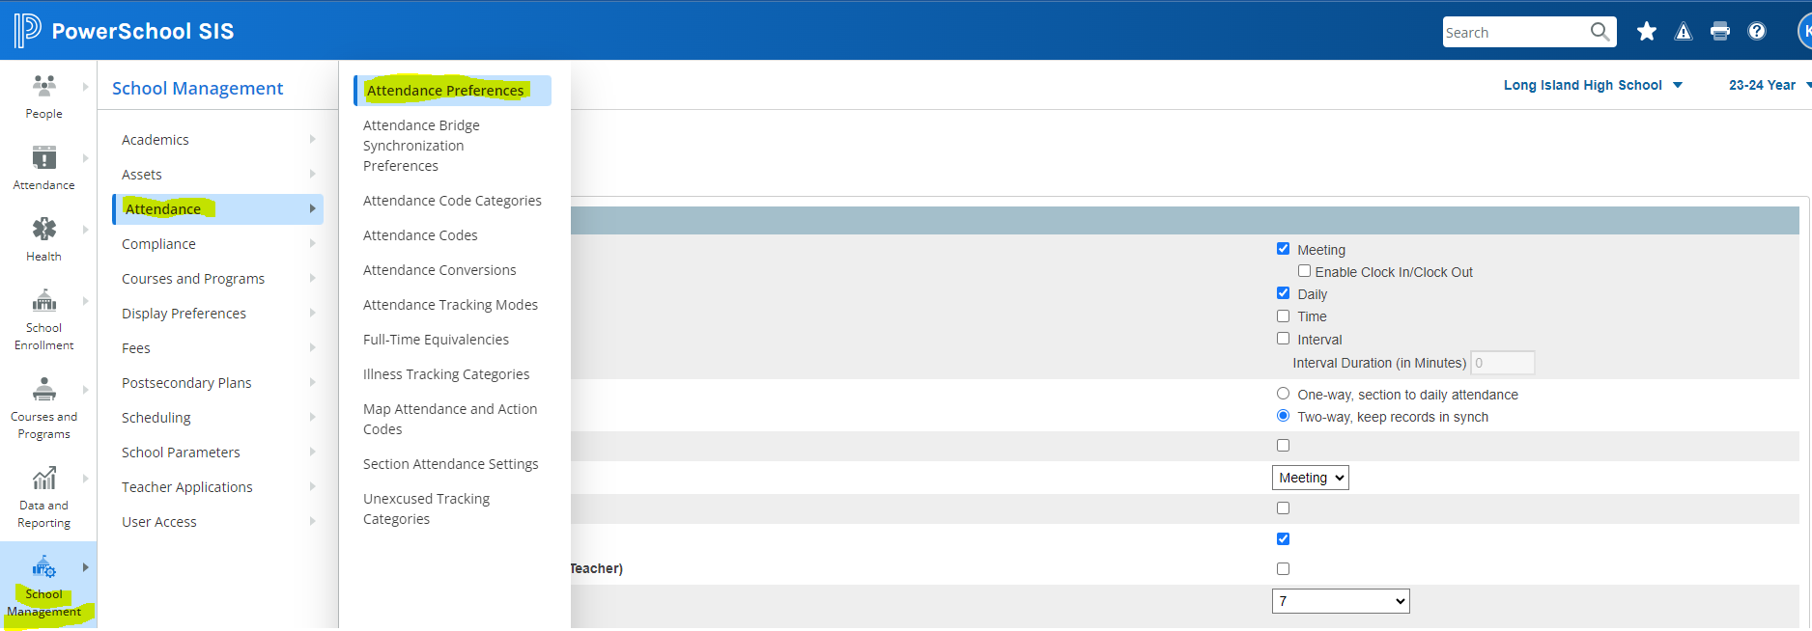

This function does not roll into the new year. The box below must be checked.

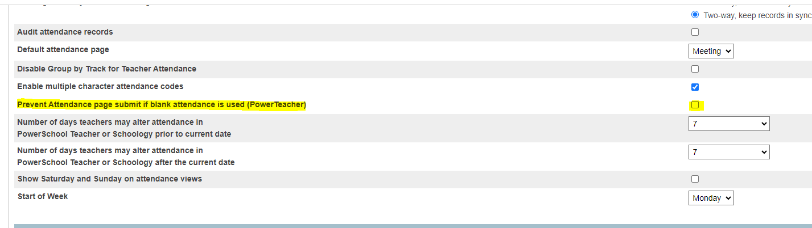
Attendance Codes
School Management>Attendance>Attendance Codes
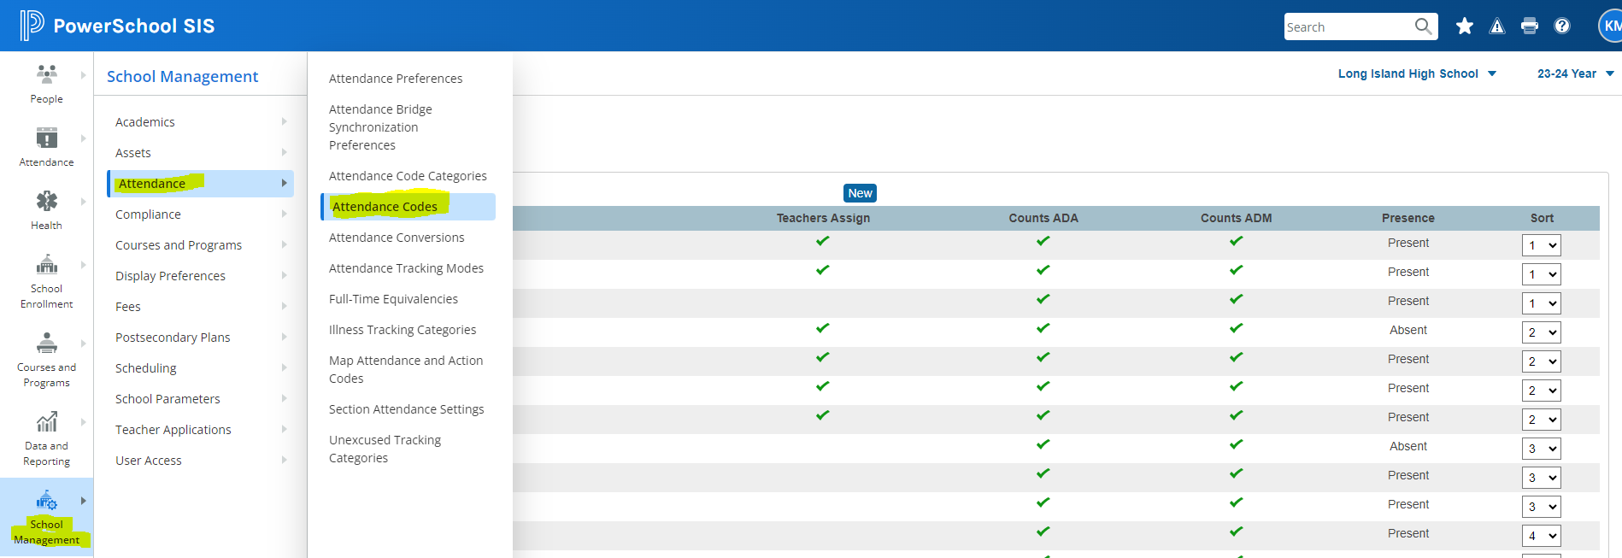

When creating the New Year term for a new school year, PowerSchool copies the attendance codes from the previous school year, eliminating the need to setup attendance codes each year from scratch.

- Verify your Attendance Codes for the upcoming school year. Ensure that the proper codes are designated as Present, Absent or Tardy and are properly counted in ADA for Daily Attendance.

- Add, delete or modify your attendance codes, if applicable before the first day of school.

- Confirm that the appropriate present codes are correctly tagged in the NY Category if they are used to subtract seat time.

Attendance Code Categories
School Management>Attendance>Attendance Code Categories

- Verify that the correct Attendance Code Categories are setup for the upcoming school year and properly tagged to the appropriate attendance codes.

- Mandatory Categories for NYS Reporting are Present, Tardy, Excused, Unexcused, ISS, and OSS. All Present and Tardy codes must be reported with modality.

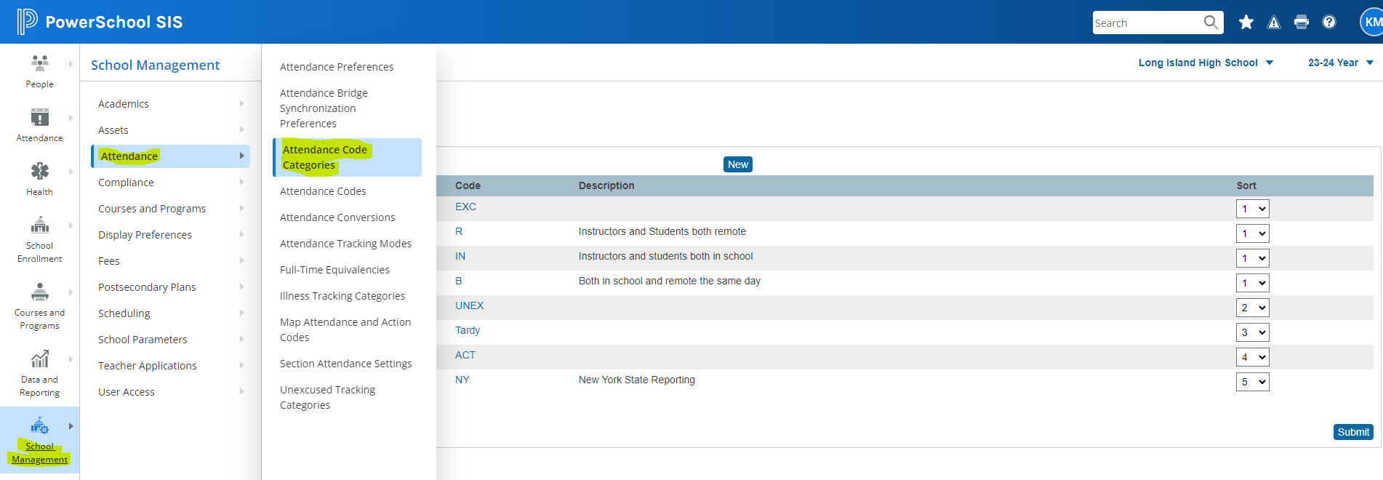

Entry Codes & Exit Codes
System Management>Data>Code Sets

- Review your district’s entry and/or exit codes at the district level for any updates from NYS. State codes are installed on the Transfer Info Page in the NY_SSE fields.

- If applicable, make sure the top portion of the Transfer Info page contains all the state codes as defined in the State Info Section on this page.

Ethnicity Codes
District Management>People>Scheduling and Reporting Ethnicity Codes

- Verify your Federal Ethnicity Codes and Race categories are updated as per NYS mandates.

- Verify your students are properly tagged

Membership Share
Data and Reporting>Exports>Direct Database Export (DDE)

Ensure that students have a valid Membership Share value in [1] MembershipShare field. Most students should have a value of 1 but half-time enrollment may have a value of .5

- Search on Membership Share Value in DDE to make sure there are no blank values.
Membershipshare = (leave blank)

NY_SSE fields
Start > Select Student(s)>School Enrollment>Transfer Info>Edit transfer info

- NY_SSE_GradeLevel and NY_SSE_Kindergarten fields under NYS information need to be reviewed and updated.

Please note:
- Information in these fields roll over to the New Year.
- Grade 1 students will still be tagged as KF or KH in the New Year and K students who attended PK will still be tagged as PK.
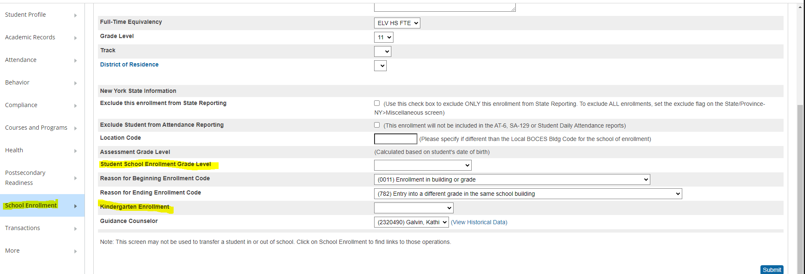
Student Location Codes

Student>School Enrollment>Enrollment History>Edit Current Enrollment
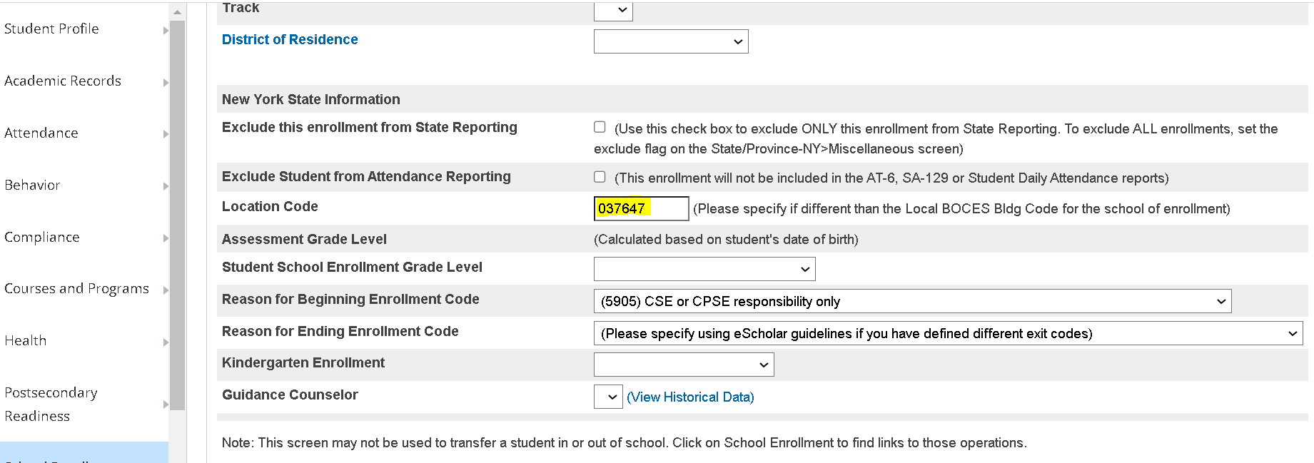

The information in the student location field rolls from year to year.

- Check and verify the Location Code on the Transfer Info Page is still accurate.

- Update your Location code table, if applicable. (Instructions available)

UPK Program Services
- Make sure your UPK students are tagged with the correct Program Services codes. State/Province-NY > Program Fact

- Update the PS Grade Level on the Transfer Info Page for all your PreK students.

Incoming Grade 9 Students
Compliance> Demographics (Student Lite)
Line 26 ”Date of Entry into Grade 9”

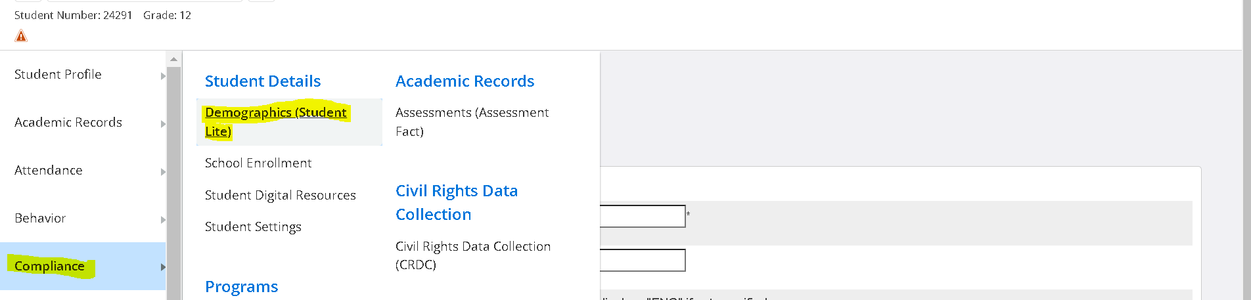

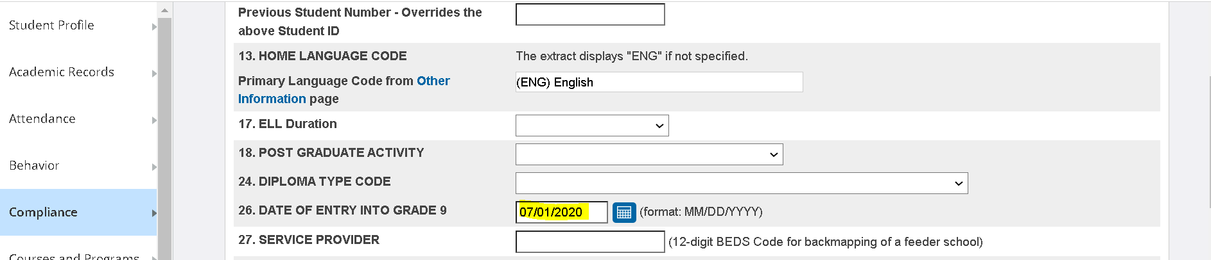

Tag your incoming grade 9 students with their cohort. You can mass change the following field: NY_dateofentrygrade9 using Student Field Value. Example
Date: 7/1/XXXX

Custom Fields / Pages

- Information in custom fields and custom pages will move with the student to the new school year. You need to clear these fields out and populate with the current year information if necessary.

Some examples of these fields and/or pages may be:
  - Homeroom
  - Homeroom Teacher
  - Counselor Name (update your counselors)

Custom & User Defined Reports

System Management>Reports>Object Reports

Object Reports, Form Letters, and Report Cards are all user-defined reports that often contain year-specific information in data access tags or in other areas such as headings and titles

Example
The ^(*gpa) data access tag can be used in a report card footer to return a student’s GPA based on a specific method. It is possible to specify a year in which to query grades for the GPA calculation. If any of your reports include the ^(*gpa) data access tag with a year parameter, update the year value accordingly on the GPA Calculation Page in District for the upcoming school year.

The following instance of the ^(*gpa) data access tag will return a GPA value using the “Simple” method and will only include grades from the 2010-2011 school year.

^(*gpa method=”simple” year=”2019”)

- Review and Update any term-specific information for the current year.

- Review your Report Card Object Reports and update the Attendance Terms to the current year.

Activities
School Management>Courses and Programs>Extracurricular Activities Setup

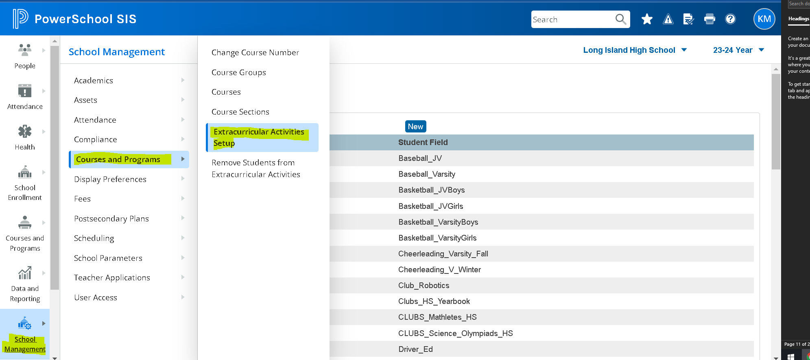

This is a field that rolls information into the New Year.

- If applicable, clear out old data before creating new data.

- Create any new activities that will be offered in the upcoming school year.

When specifying the field name of a new activity, ensure that you are using supported characters for a custom field name. PowerSchool supports letters, numbers, and the underscore (_).

Cycle Days
School management>Scheduling>Cycle Days (View Cycle days)

Verify the number of cycle days and the cycle day abbreviations for the new school year. It must match your schedule! To adjust the number of cycle days in a given school year:

1. School Management>Scheduling>Years and Terms
2. Click the link in the Year column to modify the selected year. The Edit School Year page appears.
3. Select the number of Cycle Days from the Days menu.
4. Click Submit

Periods
School Management>Scheduling>Periods

- Verify the number of periods and the period abbreviations for the new school year. It must match your schedule

To adjust the number of periods in a given school year:
1. Navigate to School Management>Years and Terms
2. Click the link in the Year column to modify the selected year. The Edit School Year page appears.
3. Select the number of Periods from the Periods menu.
4. Click Submit.

School Management>Scheduling>Schedule Preferences
Adjust the settings to display the schedule in the order you prefer.

Reporting Segments
System Management>Reports>Reporting Segments
(to setup in a School) or
Data and Reporting>Reports>Compliance Reports

Reminder! This is a field that rolls information into the New Year. Do not update your Reporting Segments until reports have been completed for the previous school year.

These reporting segments are set up to run the standard PowerSchool reports found in System Reports.
- The 10 required monthly segments MUST be sorted chronologically, by month, starting with sort order 1 for September. Do not leave gaps between the end of one segment and the start of the next.
- Segments created in addition to the 10 required monthly segments should be assigned a sort order of 11 or higher.

- **Note: NYS reports AT-6 and SA-129 no longer use these reporting segment dates. Please refer to the New York State setup section on how to setup state reporting segments.

GPA Calculations
Start Page > District Management > Academics > GPA Calculations

If your district uses GPA calculations with specific query options, ensure that your GPA calculations are updated with new parameters that pertain to the current school year.

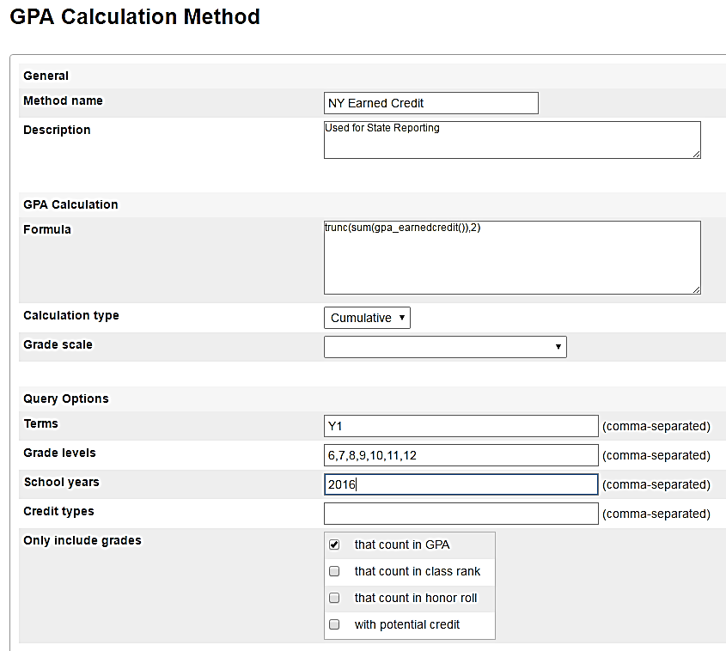

Honor Roll Methods
School Management>Academics>Honor Roll Methods

- If your school's honor roll methods use year-specific GPA calculations, ensure that the honor roll methods at each school are updated to use GPA calculations that are setup for the current school year.

Class Rank Methods
School Management>Academics>Class Rank Methods
- Review each class rank method and ensure each is associated to the correct GPA calculation method.

Final Grade Setup

School Management>Academics>Grades>Create Final Grade and Reporting Term

- Ensure that your final grade reporting terms (store codes) are correctly set up for each scheduling term in your school year.
- Ensure that your final grade reporting terms are checked to either “Suppress Letter Grade” or “Suppress Percent” (Grades will display twice in the Quick Look-up)

Notes:
- Final Grade Setup defines your marking period buckets and are visible in the teacher’s grade book.

- You can end a Final Grade Term on a Weekend (Saturday or Sunday) but never begin a Final Grade Term on a Saturday, Sunday or Holiday. The term start date should always be on an In-Session date.

- Remember to keep your Final Grade Term dates within your school’s Years and Terms.

Location Marking Periods for state reporting is setup on this page. Please see the NYS setup section for details.

Current Grade Display
School Management>Academics>Grades>Set Current Grade Display

- Update the Active Term on this “new” page.

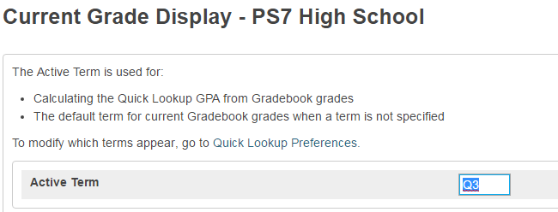

Quick Lookup Preferences

School Management>Display Preferences>Quick Lookup Display Preferences

- Update the columns to display on the Quick Lookup parent/student screen, teacher screen and/or Admin screen

- Update the Source of Data for each column so that grades are viewed from the gradebook (current grades) or grades (Historical)
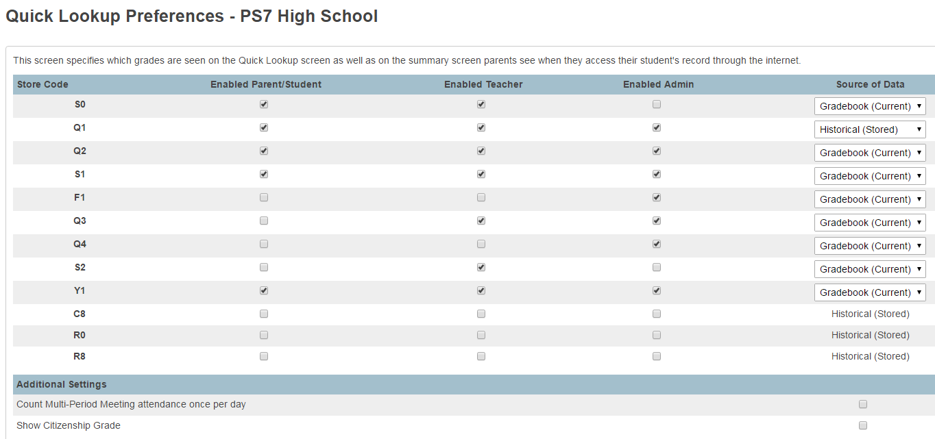

Once July 1 passes, PowerSchool automatically goes to the new school year internally
and grades from the “current” school year can no longer be viewed on the portal.

GPA Student Screens
School Management>Academics>GPA>GPA Info for Student Screens

- Update various settings at each school on the GPA Student Screens page. Select a GPA calculation method from the pop-up menu to determine the GPA displayed at the bottom of the Quick Lookup student screen.

- Update any Data Access Tags (DATs) used for the Cumulative Info student screen. Some DATs on this page may have year or term-specific parameters that need to be updated every year or every term.

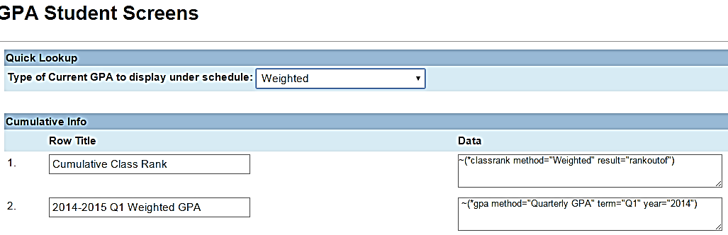

Fees
District Management>Fees>Fee Categories

- If your district uses PowerSchool’s fee system, review your district’s school enrollment fees and course enrollment fees.

Substitute Sign-In Settings
School Management>User Access>Define Substitute Password

- Set up Sign-In Information
- Set up Password as per your school’s policy

School Bulletin
The Daily Bulletin can be created at the School level by clicking on the Gear Icon right next to the Calendar Icon from the main page. It was just removed from the Special Functions menu because it was no longer needed there since the Gear Icon was already there.

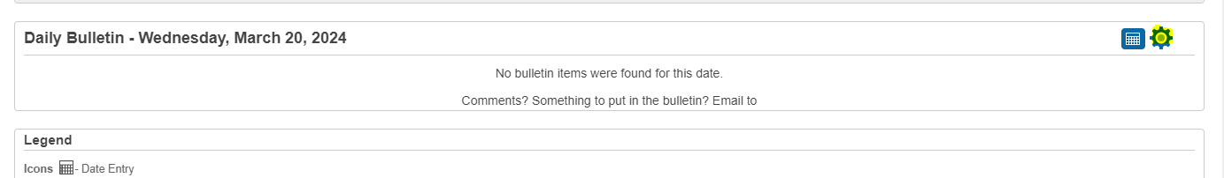
- The Daily Bulletin is cleared as part of the EOY Process.
- Setup any school bulletin items for the beginning of the school year.

Student and Parent Portals – Enable Access

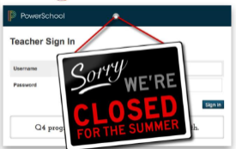
If you inactivated your portal access prior to committing the schedule and now want to activate, navigate to the appropriate pages below.

To check settings for Portal access:

Additional System Preferences
District Management>District Setup>Additional System Preferences

- Enable the Student and Parent Portals/Mobile Apps by unchecking.
(No need to erase your message. Once you uncheck, the message will no longer appear)

Parent/Student Access Page in each School

School Management>User Access>Configure Parent and Student Access

NY STATE REPORTING SETUP

Location Marking Period
School Management>Academics>Create Final Grade and Reporting Term, Click the Term Bin on the Edit Final Grade Page setup LMP under the NYS Information Section

- Final Grade Term bins must be setup first in order to set up LMP.
- To prevent two grades from appearing on the Quick Lookup screen for one course, you may need to set up a Y1 under the Semesters – use the Semester dates for Y1 (this applies if you are using Suppress Percent)

- Elementary Schools need to have the Y1 Term created for State Reporting purposes

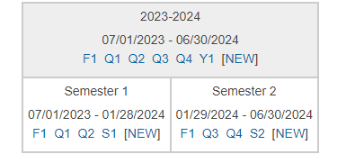

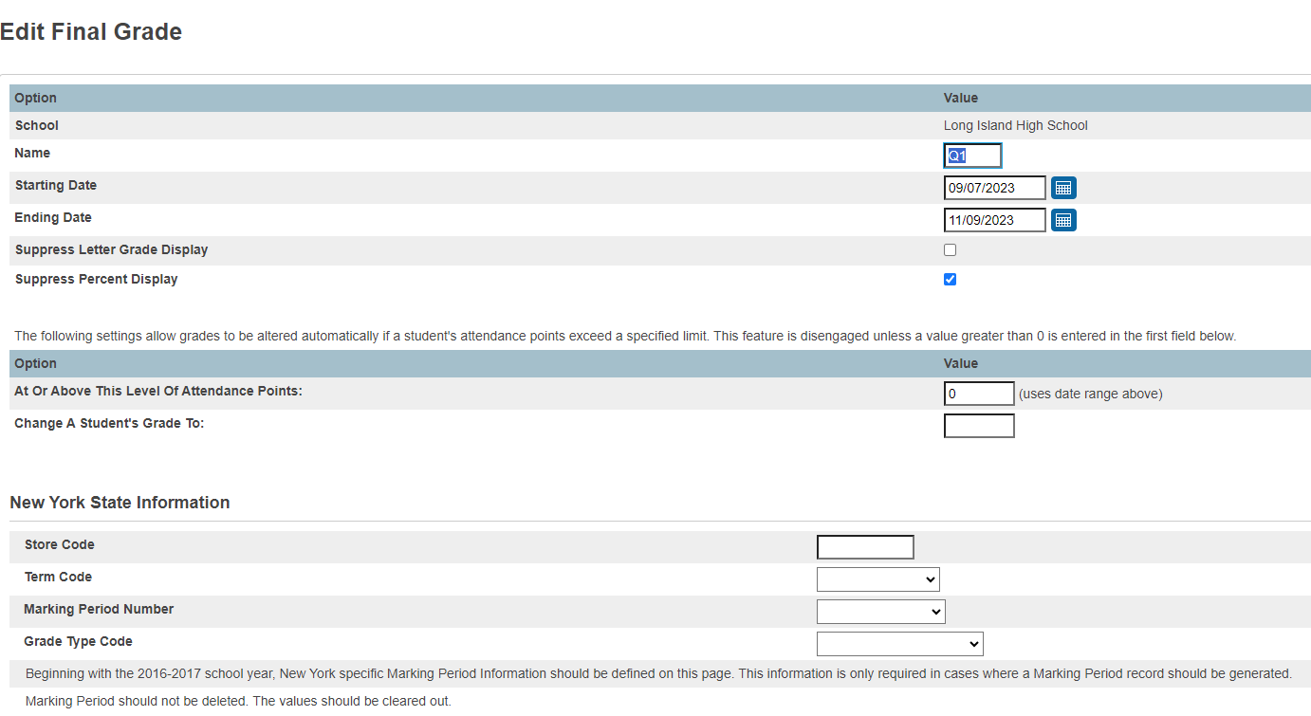

Daily Attendance Mapping
District Management>District Setup>School Info >Click on the School Name>Scroll down the Attendance

- Fill in the appropriate attendance codes for each of the categories and populate the fields that pertain to your district.

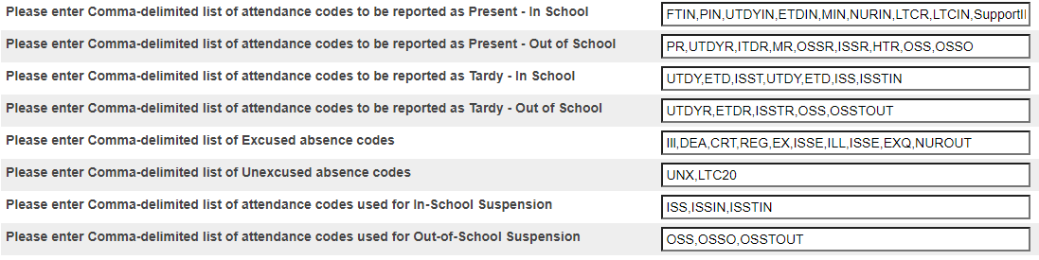

PK Students
- PreK students receiving services over the summer cannot enter Kindergarten prior to 9/1/xxxx

- Make sure you tagged your PK students on the Transfer Info Page. PowerSchool generates PK grade levels as -1 or -2, so for state reporting purposes only PKF or PKH are acceptable.

Pre-Registered Students

Optional

Pre-registered students that have a 9/1 date should be massed changed to 7/1/xxxx prior to the opening of school. This can include newly enrolled Kindergarten students who did not receive services over the summer, however, all kindergarten students can remain with a 9/1 enter date

Courses

- Make sure you properly tag all your courses for state reporting
- State Course Code ID
- Current year Assessment Dates
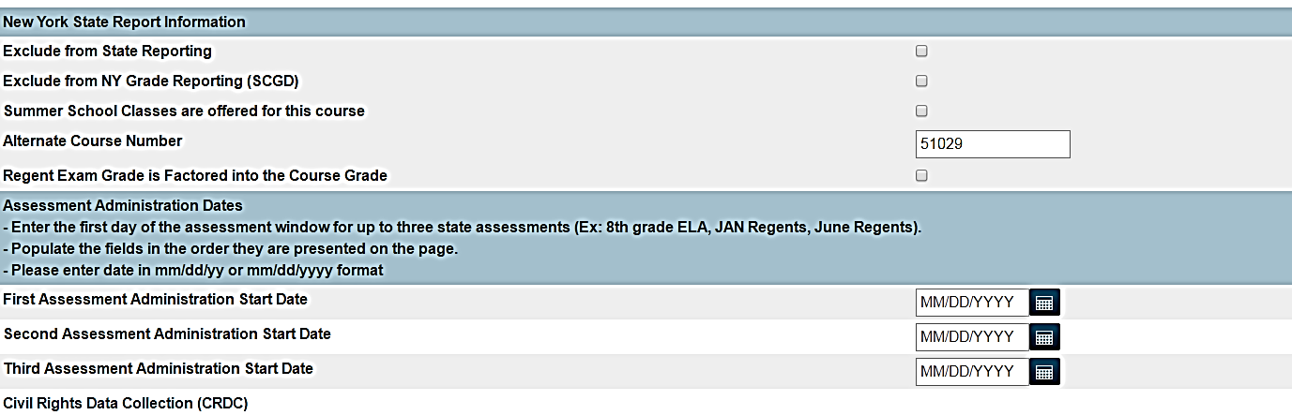

New Teachers / Staff
Make sure all your teachers are tagged with a State ID
Staff>Staff Profile>Demographics

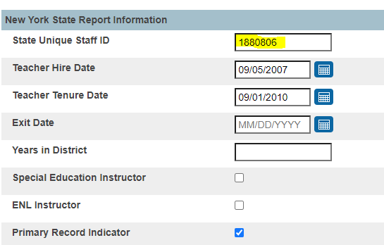

Teacher Tracking Records
School Management>Courses and Programs>Courses

Click on Section, Choose section, Edit Section

- Teacher tracking is done on the Edit Section page under Teacher-Section Lead and Teachers/Staff –Addition.
- Make sure there are no overlapping dates
- Only 1 active Lead teacher can be assigned on a section
Primary teacher and Special Ed Teacher tags are found on the Notes Page under Actions

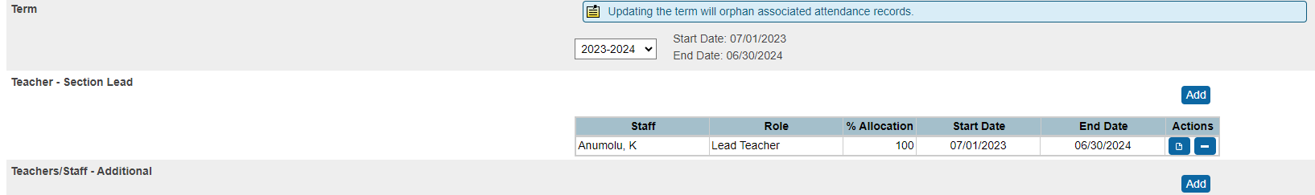

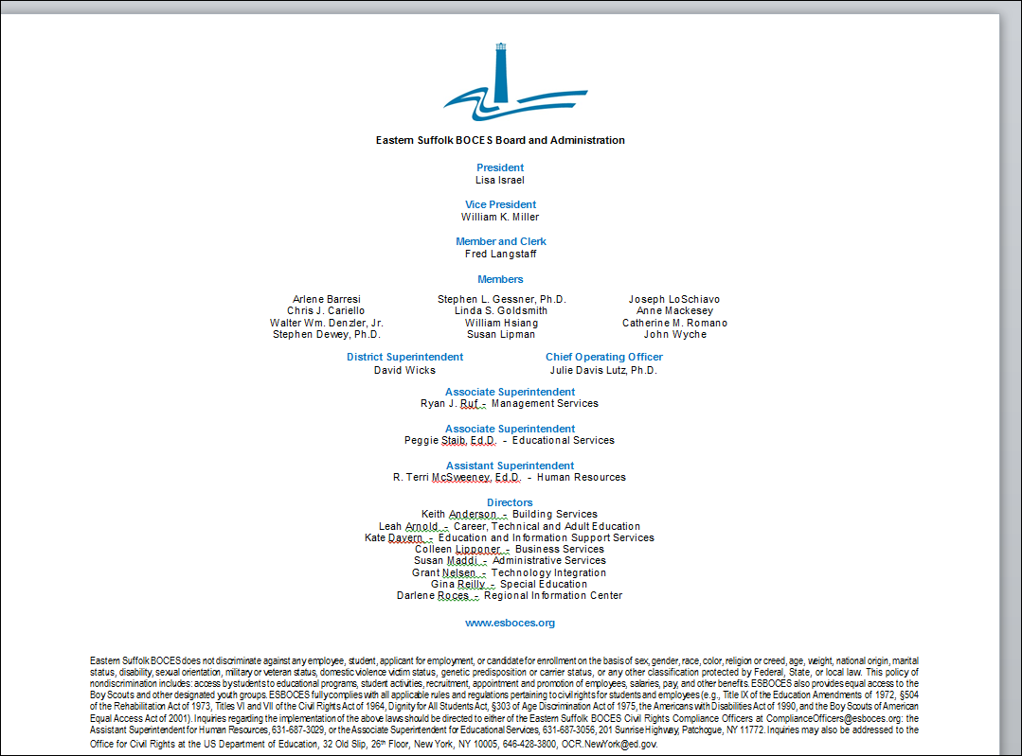

ESB POWERSCHOOL SUPPORT

John Straub
Monica Zignaigo
Kathy McKee
Doreen Kujawski

631.844-5723 powerschoolhelp@esboces.org

