CAMP HILL ATHLETICS COACHES HANDBOOK



Table of Contents

PAGE
Coaches – Expectations, Duties and Responsibilities 3
Head Coach Responsibilities 4
Procedure for Awarding Athletic Letters 5
Transportation 6
Travel Roster 7
Coach to Athlete Communication 8

School Board Policies 11

Athletic Trainer Policies and Emergency Plans
Athletic training Checklist 12
Lightning Policy 13
Asthma Medication Policy 17
Epi Pen Medication Policy 18
Heat Safety Policy 19
Head Injury Policy 22
Air Quality Policy 24
School Issued Helmet Policy 26
Cold Weather Policy 27
Emergency Action Plan 30
Coaches Policies and Procedures 46

Rank One Instructions 49

Sway Parent/Guardian Letter 52

Required Documents and Clearances for Coaches 53

Sports Medicine Points of Emphasis 57

Sports Physical Pre-Participation Information and Instructions 59

Manager Liability Waiver and Permission Form 63

COACHES

Coaches and advisors, as an extension of the academic curriculum, are charged with the responsibility of helping each student develop to his or her fullest potential through the teaching of critical life skills that often cannot be learned in the classroom. These skills include, but are not limited to, commitment, dedication, teamwork, organization, planning, leadership, followership, fairness, dignity, overcoming adversity, self-worth, and conflict resolution. Coaches and advisors are expected to model the best of these behaviors, especially when they themselves are faced with challenges. In doing so, they are expected to interact with students and their families in a manner that is mature, professional, and consistent with the highest standards of the community.

The degree to which coaches and advisors meet their responsibilities, adhere to expectations and standards, and foster the development of critical life skills are not predicated only on wins and losses, team/group recognitions, decisions regarding involvement/playing time, or competition strategy. Rather, the degree to which they do all these things is measured greatly by the personal growth of each student and how well the students can independently apply throughout their lives what has been learned on and off the playing surfaces as a member of Camp Hill Athletics.

All coaches and athletic staff are required to adhere to the Camp Hill School District Code of Conduct and all applicable district policies. Coaches are held to the same professional and ethical standards as all district employees and are expected to model appropriate behavior both on and off the field. Failure to comply with district policies may result in disciplinary action up to and including termination of employment or volunteer status.

HEAD COACH
ALL SPORTS

The varsity coach and his/her assistants should first and foremost be leaders of young men and women constantly setting a fine personal example of what it means to be an athlete. It is expected that the varsity coach and his/her assistants will be consistent and fair in all rules and regulations applied to the athletes by the coach.

One of the most important positions in education today is that of the coach. It is a position that is constantly open to the public display and with it will come criticism and praise. A coach must be a person with high moral character, a person of integrity, and a person whose first and only though is the welfare of the athletes he/she coaches.

SPECIFIC RESPONSIBILITIES
  - Responsible for all school district equipment under their jurisdiction.
  - Lead party for team discipline.
  - Assign all duties to assistant coaches under their jurisdiction.
  - Make a thorough check of locker room, showers, and equipment rooms after each practice session and game.
  - The head coach, or a member of his/her staff, should be the last to leave practice or game or locker area.
  - The varsity coach and his/her staff should cooperate closely with the Athletic Director concerning schedules, time of games, officials, transportation, dressing facilities, communication, discipline, and eligibility lists.
  - The varsity coach should determine schedules for all practice sessions and should communicate to the Athletic Director and the Athletic Trainer.
  - The varsity coach is responsible for submitting all medical reports to the team trainer following athlete injury.
  - The varsity coach should communicate to the Athletic Office equipment or resource needs prior/during the season.
  - The coaching staff shall assist the Athletic Office in the distribution of uniforms and equipment prior to the season, and the collection of uniforms and equipment at the end of the season.
  - It is the duty of the head coach to devise a set of rules governing the conduct of all squad members. It is the duty of the head coach to inform his/her staff and team that all rules should be adhered to. If any athlete refuses to adhere to any of the rules, it shall be the duty of the head coach to determine the eligibility of such player.
  - The varsity coach and assistants shall complete any additional duties assigned by the Athletic Director or the Athletic Trainer.

Procedure of Awarding Athletic Letters

The criteria for awarding a varsity letter will be an evaluation by the coach or coaches concerning the amount of game or meet time played by the athlete along with the following:
- Attitude of athlete.
- Attendance of athlete.
- Self-discipline of athlete.
- Character of athlete.
- Skill development of athlete.
- Leadership qualities of athlete.
- Loyalty qualities of athlete.

- Guidelines for evaluating game time*:
- Baseball/Softball – 40% of total innings.
- Basketball/Field Hockey/Soccer – 40% of total quarters.
- Football – 40% of total quarters
- Track & Field/Cross Country – based on averaging 1 point per meet.
- Wrestling/Golf/Tennis – participate in 40% of matches.
- Cheerleading/Managers/Trainers – recommendation of the coach.

*A varsity letter may be awarded to any student-athlete the coach feels meaningfully impacted a varsity season. At the end of the season, the coach will provide the athletic director with a list of all student-athletes who he/she feels met the requirements/standards for earning a varsity letter.

A varsity letter will be awarded for the first time an athlete meets the requirements. In succeeding years when a varsity letter is earned, a bar will be issued in lieu of a letter. Varsity letter winners will receive one chenille award per career at the conclusion of their senior year.

Any athlete that has participated in a varsity sport for three years and has never lettered shall receive a varsity letter in his/her senior year.

TRANSPORTATION

The Athletic Director shall be responsible for the transportation necessary for all away contests. He/she will take care of scheduling these trips and notifying the coaches of dismissal/departure times and the mode of transportation. Camp Hill Athletics will utilize school vans and various bus companies depending on the team and season to transport teams to away events.

Since the Camp Hill School District provides transportation for athletes to and from away contests, ALL athletes should ride the team van or bus. However, if it is necessary for a student-athlete to ride home with a parent/guardian from an away contest, the following procedure should be used:

- A parent requesting that their child ride home with them should submit such request in writing/email prior to the game to the Head Coach of that sports team. Approval from the coach should be confirmed prior to departure to the event.
- No student-athlete will be permitted to ride home with anyone other than their parent, even if they have a written request asking permission to ride with another parent.
- If a student-athlete must meet the team at the away sporting event, that request must be written, submitted to, and approved by the athletic director prior to the day of the event.
- No student-athlete shall be permitted to drive his/her own vehicle to PIAA sanctioned contests. All transportation to contests, team-affiliated events, or any other travel shall be confirmed through the athletic department.

Any other means of transportation must be approved by the Athletic Director or Camp Hill Administration.

Board Policy 810.3 - Drug Use and Alcohol Misuse Prevention - School Vehicle Drivers

ALL COACHES MUST COMPLETE AN ATTENDANCE REPORT/TRAVEL ROSTER PRIOR TO LEAVING THE SCHOOL TO GO TO THE AWAY EVENT AND PRIOR TO LEAVING THE AWAY EVENT TO RETURN TO THE SCHOOL.

*Please find an example of a travel roster report on the next page.

CAMP HILL ATHLETICS |  |   TRAVEL ROSTER
STUDENT-ATHLETE | DEPART  (X) |  | RETURN  (X) | PARENT/GUARDIAN SIGN-OUT  (if applicable)

TRAVEL ROSTER SHOULD BE SUBMITTED TO THE ATHLETIC DIRECTOR AND ATHLETIC TRAINER BOTH BEFORE LEAVING FOR AN EVENT AND AGAIN BEFORE LEAVING TO COME HOME FROM AN EVENT. FAILURE TO FILL OUT AND SUBMIT PROPERLY WILL RESULT IN A MEETING WITH THE ATHLETIC DIRECTOR. WE NEED TO HAVE ACCURATE TRAVEL ROSTERS IN CASE SOMETHING HAPPENS EN ROUTE TO OR FROM AN EVENT.

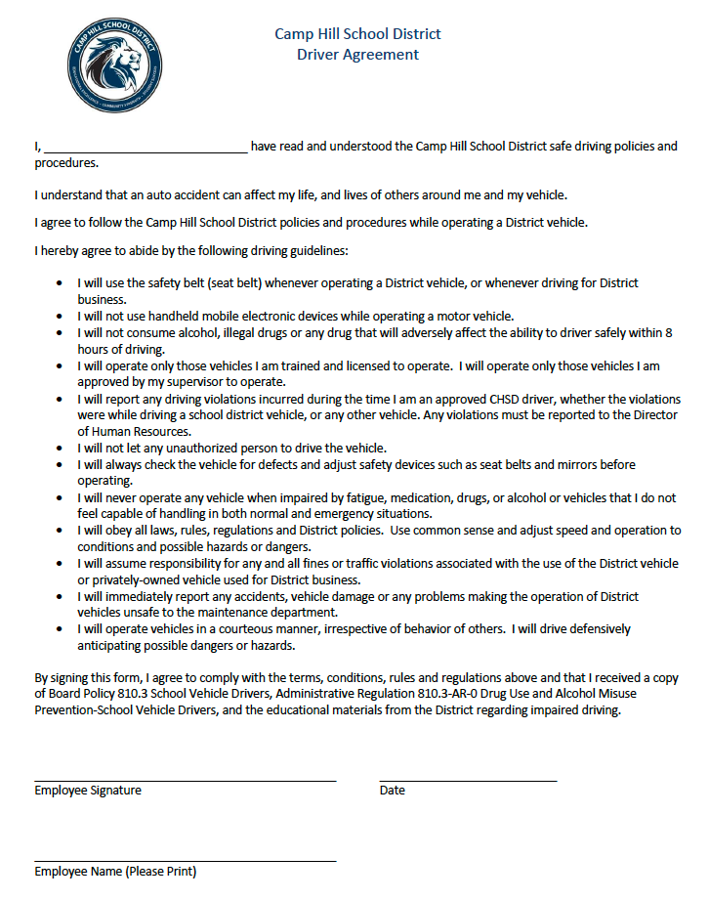

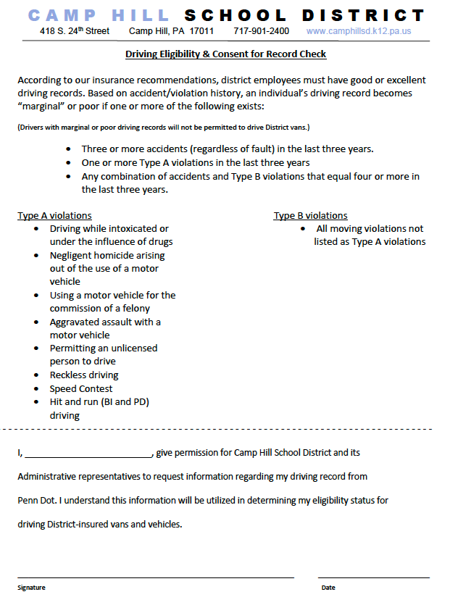

Coach to Athlete Communication Guidelines

Purpose
The following establishes guidelines for all coaches and athletic staff to ensure safe, professional, and transparent communication with student-athletes. These guidelines are designed to protect athletes, coaches, and the integrity of our programs.

Core Principles
All communications with minor athletes must be:

- Transparent
- Professional
- Safe
- Protective

Board Policy 824 - Maintaining Professional Adult/Student Boundaries

General Rules

      - Avoid One-on-One Electronic Communication
Coaches and adult program participants should avoid engaging in private electronic communication with minor athletes. This includes text messages, direct messages, private emails, phone calls, video calls, and any other electronic platform allowing private communication.

One-on-one communication between an adult and a student-athlete—especially involving personal or emotional topics—can create unnecessary risk and potential for misinterpretation. These guidelines protect both the athlete and the coach by ensuring all interactions remain professional and observable.

Communication Methods
Method 1: Include Another Adult
Example: Message the athlete and include another coach. Email the player and copy their parent.

Method 2: Team or Group Communication
Benefits: These platforms provide transparency and create a professional trail.

Method 3: In-Person Communication
Coaching instruction, feedback, and mentorship during team activities, practices, and competitions do not require a third party present, as these occur in observable, group settings.

- Coach to Athlete Communication Content
All communications should be:
- Sports-related — focused on athletic participation, performance, training, and team activities supporting athletic growth and skill development
- Developmental — approaching opportunities to help the growth of student-athletes both on and off their playing surfaces professionally and in alignment with Camp Hill School District’s vision for student success
- Professional — maintaining appropriate coach-athlete boundaries

Note: Coaches are valued mentors and role models in student-athletes’ lives providing opportunity to assist student-athlete growth in sports and in life. However, it is important to understand that personal advice on non-sports-related matters may need to be redirected to parents, guardians, the athletic director, school counselors, or other appropriate resources.

- Appropriate Hours
Except in emergencies, communications should occur between 6:00 a.m. and 9:00 p.m.

- Athlete-Initiated Contact
If a student-athlete initiates one-on-one electronic communication with a coach, the coach should:
- Not engage in private communication
- Include another adult (parent, guardian, coach, athletic director) in the response
- Document the interaction and notify athletics leadership if unusual or concerning

- Parental Communication
Parental Requests to Cease Communication -
If a parent or guardian requests that a coach cease communicating with their athlete, the coach should:
- Stop all communication immediately
- Notify the athletic director
- Document the request

Potential Exceptions to These Rules

Exception 1: Emergency Situations
A coach may have direct one-on-one contact with a student-athlete during an emergency.
Suggested actions:
- Document the emergency immediately
- Report to athletic director or school administration
- Provide details of the communication and its necessity

Exception 2: Pre-Existing or Dual Relationships
A pre-existing relationship with a student-athlete outside the sport may permit exceptions with parental consent/understanding.
Example: An assistant coach at school who also coaches the athlete's club sport
Suggested actions:
- Obtain written parental or guardian consent
- Document the nature of the pre-existing relationship
- Maintain ongoing communication with leadership regarding the relationship

These guidelines exist to protect athletes, coaches, and our sports programs. Adherence to these guidelines ensures that all interactions remain professional, safe, and in the best interest of our student-athletes.

Coaches should remain aware of their responsibility as District staff members and/or District volunteers to report student athletes’ reports that fall under Title IX Sexual Harassment as outlined in Board Policy 103 Discrimination/Title IX Sexual Harassment Affecting Students. As mandated reporters of child abuse in the state of Pennsylvania, coaches must also comply with identification and reporting requirements for suspected child abuse as outlined in Board Policy 806 Child Abuse and state law.

CAMP HILL SCHOOL DISTRICT SCHOOL BOARD POLICIES
FOR
STUDENT ATHLETES AND COACHES

https://go.boarddocs.com/pa/camp/board.nsf/public

Coaches Athletic Training Checklist
(Beginning of the season)

Emergency Action Plan
- Review Emergency Action Plan individually and with coaching staff
- Review the location of AED’s at game and practice venues with coaching staff and athletes.
- Make sure you have the correct keys to access AED’s at your specific venues. If you do not, please speak with athletic director immediately
Lightning Policy
- Review lightning policy individually and with coaching staff
- Review lightning safe structures with coaching staff and athletes
Misc.
- Send practice schedule to the athletic trainer
- Review list of athletes with asthma, epi pens, and other special conditions
- Notify athletic trainer of parents meetings
- Pick up your water cooler, injury ice chest, and med kit prior to or on the first day of practice (winter sports only need a med kit)
- Confirm that you have athletic trainers contact information stored in your phone
- Confirm that you can access Rank One for student athlete emergency forms and injury updates
- Confirm that you have access/keys to the AED location at your facility
Daily Checklist
- Med kit, injury ice, and water should be at all practices and competitions both home and away (with the exception of indoor practices)
- Athletes with inhalers or epi pens have them out and labeled in case of emergency
- Coaches phone are charged and accessible in case of an emergency or if the athletic trainer is trying to get ahold of you
- Check your emails or notifications from Rank One for injury updates through the start of your practice. Notifications will come up until 345pm.
- Notify athletic trainer immediately with any practice schedule changes
- Ensure that your team is properly equipped with safety equipment (Shin guards, helmets, etc)

Camp Hill Athletics Lightning Safety Protocol
Purpose of policy
Lightning is the most dangerous and frequently encountered thunderstorm hazard that people experience every year. The purpose of this policy is to ensure proper education and prevention protocols are in place for the health and safety of our student athletes. Lightning injuries are one of the top ten causes of sport related death. As such, it is imperative to take the proper steps to prevent catastrophic injuries from this thunderstorm hazard. The “National Athletic Trainers Association Position Statement: Lightning Safety for Athletics” outlines the best practices for lightning safety. This includes “when thunder roars, go indoors” as well as the identification of safer structures and structures for evacuation in advance. By implementing proper policies, athlete safety can be ensured when a storm with lightning approaches the playing fields.
This policy describes the best practice procedures for the prevention, monitoring, and when necessary, the treatment of lightning related injuries for students/athletes, faculty and staff of Camp Hill Athletics.

This policy will be a living, working document that is continually reviewed and updated yearly as the organization and our community changes.

This policy applies to all staff members (e.g., athletic trainers, physicians, athletic administrators, coaches, strength and conditioning staff, school administrators, advisors) of Camp Hill Athletics who are associated with activities where lightning injuries pose a risk. This policy also applies to athletic participants and spectators of organized events.

Chain of Command
The two individuals from Camp Hill High School in charge of postponing/canceling a practice or athletic event in the event of lightning are:

• Athletic Director
• Certified Athletic Trainer (Designated Weather Watcher)

The certified Athletic Trainer will use a combination of the WeatherBug Spark app, various other weather apps and sites, and eyes/ears to gather the necessary information.

In the absence of these individuals, the game officials and/or coach are to be responsible for the athletes. This would be the case when the practice or competition is held at an off-site venue.

Rules
If no apps or weather sites are available, the flash to bang method will be utilized.
Whenever thunder is heard or lightning seen, practice and/or competition must stop immediately. All coaches, athletes, officials, and fans should be directed to a safe shelter until play can resume. By the time the flash-to-bang count reaches 30, everyone should already be inside a shelter.

Flash-to-Bang = # of seconds from lightning to thunder / 5 = # of miles from site

A minimum of 30 minutes must pass between the last clap of thunder or bolt of lightning, and resuming play.

Safe Shelters
Safe shelters are considered fully enclosed buildings with running water and electrical wiring. Doors and windows to lightning safe structures must be kept closed at all times during the storm. If unable to get to a safe shelter, utilize a bus or car with a hard metal roof (DO NOT touch sides and keep windows closed). Dugouts, concession stands, and press boxes are not considered lightning safe structures!!

Unsafe structures
Generally, any structure in the open air is unsafe, such as dugouts, bleachers, golf carts, open garages, press boxes, etc. High places are also unsafe, avoid areas near trees, light poles, fences, and towers. Large bodies of water, including swimming pools, are not safe from the danger of lightning injury. Research has shown that using or being in close proximity to plumbing (sinks, showers, baths) or wiring (land-line phone, computer that is plugged in, appliances, etc.) can be unsafe from lightning danger.
Lightning Safe Structures At Each Venue
Siebert Park
- Field House Locker Rooms and Bathrooms
- Bathrooms Next To The Tennis Courts
- Car/Bus
Fiala Field/College Park
- Car/Bus
- Bathrooms Next To Little League Baseball Field On Princeton Ave (not always reliable for being open)
- Last option-students should run back to the high school or Hoover (use door 1-4 by the gym lobby) and take shelter there

Hoover (softball)
- Inside of the school. Use door 3-8 behind the third base dugout
- Car/Bus
All student athletes have the right to vacate an outdoor site or unsafe area, without fear of repercussion or penalty, in order to seek a lightning-safe location if they feel in danger from impending lightning activity.
Coaches – If you are at an away event and the opposing team does not have a
designated safe location, seek safety on the bus, or in the school if possible.

Lightning Strikes Within 10 miles or less
- The following actions will take place.
- The dugouts/field will be cleared immediately.
- An announcement will be made over the PA system (if available) alerting the spectators to the severe weather situation.
- The entire facility, including the metal bleacher areas will be cleared.
- Participants, game officials, athletics staff, and any other person desiring shelter will be relocated to the appropriate location.
- Practices and games will be delayed.

Lightning Strikes Within 15-20 Miles
The head coach and game officials will be notified of the approaching lightning.

Return to Athletic Activity
The decision to resume athletic practice or competition (after it has been suspended due to severe weather and/or lightning) will be made by the Athletic Trainer, Athletic Director, or game officials on site.
The event or practice will not resume until lightning strikes are greater than 10 miles away (per lightning detector) OR 30+ seconds have passed from the time lightning is sighted to when the clap of thunder is heard (per the flash-to-bang method) AND for no less than 30 minutes after the last lightning strike in the 10 mile radius.

Coaches: If the practice or competition is canceled or postponed due to lightning, you are responsible for making sure your athletes do not walk, ride their bikes, or skateboard home. They should either wait for the weather to clear or get a ride. Please make sure you have a working cell phone charged and available to you at all times during practices and competitions in case we need to communicate with you regarding lightning in the area.

How Do You Treat a Lightning Strike Victim?
There is no need to worry about getting an electric shock from the victim. The flow of electricity traveled through the victim and there is no charge that is stored. Cardiac arrest is the immediate cause of death for those who die, so first aid, and CPR are likely to be needed immediately.
In the event of a lightning strike the following steps should be taken to ensure your safety and to treat the appropriate people:
- Make sure the scene is safe to treat the lightning victims. You should not place yourself in harm if danger is imminent.
- Activate EMS (or have someone else activate EMS if you are the one providing care).
- Be prepared to treat people in cardiac arrest, have severe burns, shock, fractures, and other trauma.
  - Use an Automatic External Defibrillator, if one is available, as well as other basic first aid materials.
- Treat the victim that appears most severely injured first (if there is more than one victim). This victim is in the worst condition and timely care needs to be taken to maximize chances of survival.
  - The basic principle of triage, “treat the living first” should be reversed in patients struck by lightning.
- If needed and capable move the victim to a safe area for treatment

Camp Hill Sports Medicine Asthma Medication Protocol
Depending on the severity of asthma, medications can be taken on an as-needed basis (prn) regularly to prevent or decrease breathing difficulty. Most of the medications fall into two major groups: quick relief/emergency medications and long-term control medications. Asthma medication policies are as follows:
● IF AN ATHLETE WITH A PRESCRIBED INHALER DOES NOT HAVE ONE AVAILABLE AT AN ATHLETIC SESSION, THEY WILL NOT BE PERMITTED TO PARTICIPATE IN ANY PRACTICE, SCRIMMAGE, OR COMPETITION
● The inhaler must be labeled with the student's name.
● Inhalers must be kept on or around the bench area at all times. They may not be kept in the locker room, because it doesn’t allow for quick access.
● Student athletes are not allowed to share inhalers.

Camp Hill Sports Medicine EpiPen Protocol
Anaphylaxis is a severe, life-threatening allergic reaction. The most common
causes in young children are eggs, peanuts, tree nuts, dairy, bee or other insect stings,
and some medications. Depending on the severity, a student athlete may be prescribed an EpiPen.
- IF AN ATHLETE WITH A PRESCRIBED EPIPEN DOES NOT HAVE IT AVAILABLE AT AN ATHLETIC SESSION, THEY WILL NOT BE PERMITTED TO PARTICIPATE IN ANY PRACTICE, SCRIMMAGE, OR COMPETITION. In addition to not being able to participate, the athlete should not travel to any away events for safety concerns.
- The EpiPen must be labeled with the student's name.
- EpiPens must be kept on or around the bench area at all times. They may not be kept in the locker room, because it doesn’t allow for quick access.
- Student athletes are not allowed to share EpiPens.

Camp Hill Sports Medicine Heat Safety Policy

Exertional heat illness (EHI) includes exercise-associated muscle cramps, heat syncope, heat exhaustion, and exertional heat stroke (EHS). Current best practice guidelines suggest that the risk of exertional heat injuries can be minimized with heat acclimatization and diligent attention to monitoring individuals participating in activities that place them at a higher risk for these types of injuries. In the event an athlete sustains a heat illness, immediate and proper treatment is needed.

National governing bodies, such as the National Federations of High School Associations, National Collegiate Athletic Association (NCAA) and numerous state athletic/activity associations, have published guidelines for the prevention, monitoring and treatment of exertional heat illnesses. In addition, national authorities such as the National Athletic Trainers’ Association and the Korey Stringer Institute have published research to support best practices in this area. The development of the organization’s heat acclimatization guidelines will be based on the current best practice documents.

This policy applies to all staff members (e.g., athletic trainers, athletic administrators, coaches, strength and conditioning staff, school administrators, advisors) of Camp Hill who are associated with activities where heat illness poses a risk, including but not limited to, outdoor and indoor activities where high temperature and specifically high humidity environmental risks are present.

This policy describes the best practice procedures for the prevention, monitoring, and when necessary, the treatment of exertional heat illnesses for students/athletes, faculty and staff of Camp Hill Athletics. This policy will be a living, working document that is continually reviewed and updated yearly as the organization and our community changes.

*Coaches should be able to recognize the signs and symptoms of EHI*
These signs and symptoms include (but are not limited to):
Rapid pulse, low blood pressure, hyperventilation
Headache
Dehydration, dry mouth, thirst
Confusion or just look “out of it”
Decreasing performance or weakness
Disorientation or dizziness
Profuse sweating
Altered consciousness, coma
Collapse, staggering or sluggish feeling
Nausea or vomiting
Muscle cramps, loss of muscle function/balance, inability to walk
Diarrhea
Irrational behavior, irritability, emotional instability/altered mental status

Environmental Monitoring and Activity Modification/Cancellation
1. Environmental monitoring will occur utilizing a WBGT device (Kestrel).
2. Environmental monitoring will occur any time it is warm outside (i.e. over 70F).
3. Environmental monitoring and activity modifications may be necessary for certain types of indoor facilities that are not climate controlled or poorly climate controlled.
4. Modifications are meant to be fluid, meaning if the environment gets more oppressive, the modifications get stricter. However, if environmental conditions improve, the modifications will be in line with the new environmental conditions.
5. Monitoring of WBGT will occur every 30 minutes beginning at the scheduled practice time. 6.Documentation of WBGT temperatures and modifications will be kept by the athletic trainer

Treatment of EHI.
- Student-athletes that show signs of EHI (exertional heat illness) should be immediately removed from competition/practice and moved to a cool, shaded or air-conditioned area. The athletic trainer and/or 911 should be called.
- Excess clothing should be removed (shoulder pads, helmets, socks/shin guards, shirt if applicable, etc)
- The student-athlete should be cooled with ice bags, ice towels, and/or ice bath as available.
- Start fluid replacement
- Rest in supine position (on the back) and elevate legs

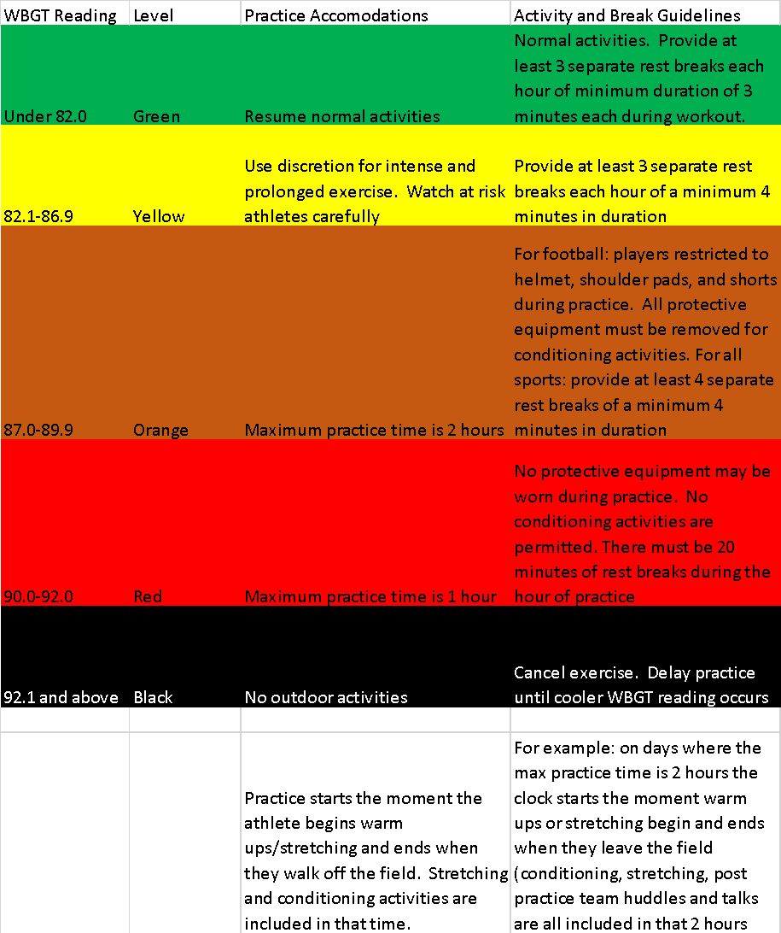

CAMP HILL SCHOOL DISTRICT HEAD INJURY PROTOCOL
In the event of a head injury and suspected concussion to a Camp Hill athlete, the athlete must be seen by a licensed physician (MD or DO ONLY) before returning to sports and activity. The Athletic Trainer can make the initial evaluation and determine if the athlete needs emergent care or can recommend that an appointment be made in the coming days with a licensed physician. The physician’s orders must be followed in regards to return to play. Regardless of physician orders, all athletes diagnosed with a concussion must complete a “Six Step Return to Play Protocol.”

Coaches cannot clear or re-enter an athlete back into practice or competition after any type of head trauma. The athlete must be cleared by the school's certified athletic trainer or physician.

Athletes officially diagnosed with a concussion must complete the head injury protocol as designed by the Camp Hill School District and Certified Athletic Trainer. Camp Hill Athletics will adhere to the following protocol when returning a concussed athlete to full participation.

STEP 1: No physical activity other than light walking, stationary biking, low risk sport specific skills (dribbling a basketball, throwing a football/baseball, shooting a field hockey ball, etc.) is permitted during the initial stages of the protocol (symptom score 10 or more). These activities are at the athletic trainers discretion.

STEP 2: Once the athlete is asymptomatic or has only minimal symptoms (0-9 on the symptom score sheet), they can begin low-impact activities such as stationary bike, elliptical, fast paced walking, light jogging, and body weight strength exercises. If symptoms increase during light activity, the student athlete should return to resting.

STEP 3: Advance to sport-specific aerobic activity (jogging, agility drills, swimming, biking, and sport specific skills)

STEP 4: Progress with non-contact training drills with the team (dribbling, batting, shooting) & may begin light resistance training in addition to conditioning drills

STEP 5: Full contact practice in team setting

STEP 6: May return to competition following final medical clearance if asymptomatic

**Step 3-Step 6 must be observed by a member of the Camp Hill coaching staff or Camp Hill Certified Athletic Trainer**
**If signs and symptoms recur, return to the previous level of activity until symptom free for 24 hours**

The athlete must be symptom free (without the use of medications) for at least 48 hours to begin step 3 and beyond. 24 hours should lapse between each stage of the progression. An athlete needs to be symptom free (without the use of medications) for at least 6 days before returning to practice and 7 days for competitions.

The athlete must receive clearance from a physician (MD or DO only) in conjunction with completing the school mandated return to play protocol to return to full activity.

Students participating in any school-sponsored sport will be required to take the SWAY baseline cognitive and balance based examination. The athlete must have no remaining significant deficits as determined by the program in order to return to play.

Concussions can have an effect on the student’s ability to perform in the classroom. Parents should advise the school counselor of the situation so that the appropriate steps can be taken to accommodate the student while they are symptomatic.

Camp Hill Sports Medicine Air Quality Policy
The Air Quality Index (AQI) is a system developed by the US Environmental Protection Agency that describes the general health effects associated with different pollution levels, as well as whatever precautionary steps may need to be taken if air pollution levels rise into an unhealthy range. During times of suspected high air pollution, the AQI should be checked prior to all practices and contests. A particular location’s AQI can be found at www.airnow.gov. The AQI takes into consideration the five major determinants of air pollution: ozone, particulate matter, carbon monoxide, nitrogen dioxide, and sulfur dioxide. The measured pollutant concentrations are then converted into a number on a scale of 0 to 500. Higher numbers correlate to a greater level of air pollution. Under the Clean Air Act, the National Ambient Air Quality Standard is 100. An AQI level greater than 100 indicates that a pollutant is in the unhealthful range.
When air quality is affected by wildfire smoke or other sources, the Athletic Director and Athletic Trainer will be responsible for monitoring the air quality at www.airnow.gov. We will be using the chart below to determine the status of outdoor activities.

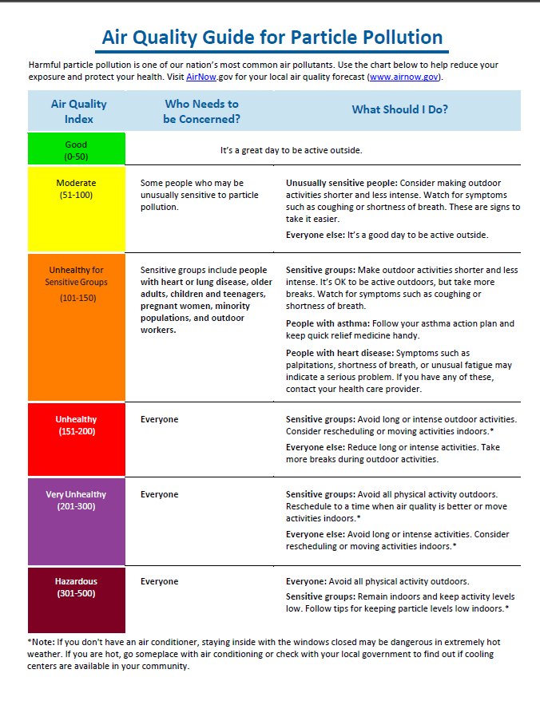

School Issued Helmet Policy

The Camp Hill Athletic Department requires student athletes to wear school issued helmets in baseball, softball, and football. Baseball and softball catcher’s masks are no longer included in this policy. Softball face guards do not fall under this policy. They are not regulated by NOCSAE and do not require reconditioning at this time. Student owned equipment is typically not recertified and checked annually and therefore presents a safety concern. Particular emphasis is directed towards reducing the risk of injury for athletic event participants. NFHS (National Federation of State High School Associations) and the PIAA rules state that each athletic equipment must meet NOCSAE standards. The athletic department cannot determine and has no record of student owned equipment being NOCSAE compliant, therefore only school purchased equipment can be used.

Camp Hill Athletics Cold Weather Policy

In accordance with the recommendations by the National Athletic Trainers’ Association and the guidelines set forth by the NCAA, the Cold Weather Policy for outdoor practices and competition has been established to protect the Camp Hill School District student-athletes and staff from cold injuries associated with decreased environmental temperatures.

Injuries associated with a decrease in environmental temperatures include hypothermia, frostbite, chilblain, and trench foot. Worst-case scenarios for all of these conditions include tissue necrosis, neurapraxia, limb loss, and death.

The CHSD Athletic Department Cold Weather Policy is designed to limit exposure to environmental cold by altering outdoor practices and competition as needed based on two factors, the wind chill temperature and precipitation. The National Weather Service has calculated the wind chill temperature by using the ambient temperature and the velocity of air speed. As an individual loses body temperature more quickly in windy conditions due to the process of convection, special consideration must be given to the wind chill temperature as opposed to ambient air temperature. Additionally, moisture increases the rate at which body temperature is lost. With a decrease in temperature and/or precipitation, student-athletes and Athletics staff should take steps to properly cloth themselves. Proper clothing includes moisture wicking fabrics, cotton layers (avoid cotton on first layer if possible), water and/or wind proof layer on top, moisture wicking socks, proper footwear, gloves, and hat.

Wind Chill Temperature Guidelines/adjustments

Wind Chill Temperature | Guidelines/Adjustments
25-30 F | -Be aware and ready for possible cold injuries  -Total exposure time: maximum of 2 hours
15-25 F | -Cover all exposed skin as possible  -Rewarm: ever 20 min for at least 10 min  -Total exposure time: maximum 60 min
0-15 F | -Considering limiting or modifying activity to limit exposure  - Rewarm: every 15 min for at least 10 min  -Total exposure time: maximum 30 minutes
< 0 F | -Cancel all practices/competitions

GAMES:

The Athletic Director, with input from the Athletic Trainer if deemed necessary, will decide whether to play or call a game due to inclement weather on game days.
- Events are recommended for rescheduling if the wind chill is less than 25 degrees
- Competition field must be clear of ice and snow at the time of the event
- Wet clothing must be changed during halftime when wind chill temperatures are less than 35 degrees.

When the temperatures drop, coaches should perform an indoor warm-up and take the team indoors at the end of practice for team meetings or discussions. Periods of inactivity should also be kept to a minimum during practices below thirty degrees. In rainy conditions, the above considerations should be considered when the temperature drops below fifty degrees. Coaches should make sure athletes are prepared for the temperature and dressed appropriately by keeping track of the forecast not only for the day but also for the following days to warn athletes what to expect.

In order to reduce the likelihood of cold-related injury, follow these strategies:

Layer clothing
Cover head
Protect hands
Stay dry
Stay hydrated
Warm up thoroughly
Never train alone

Cold Injuries

Frost Bite
Signs and Symptoms: An athlete experiencing frostbite will often have edema, tingling or burning, white/gray colored patches and the skin will become hard. The color will turn to black or purple if it isn’t properly treated. He/she will also experience poor circulation and progressive tissue necrosis
Treatment: The skin should be re-warmed at room temperature and the skin can be placed on another’s warm skin. Avoid applying friction massage and do not allow the skin to refreeze after re-warming has begun.

Hypothermia
Signs and Symptoms: The athlete’s core body temperature will usually be under 95º F. Shivering will stop when body temperature drops below 85-90º F. Athlete will experience cold extremities, shivering, lowered respiration rate and pulse, and impaired motor control.
Treatment: The treatment of mild hypothermia should begin with removing damp/wet clothing and providing athlete with blankets and a warm environment. To re-warm, the ATC should provide the athlete with heat to the trunk and other areas of heat transfer to prevent the production of after drop. The athlete should also be provided with warm fluids. Vital signs should be monitored.

The NWS Wind Chill Temperature (WCT) index uses advances in science, technology, and computer modeling to provide an accurate, understandable, and useful formula for calculating the dangers from winter winds and freezing temperatures.

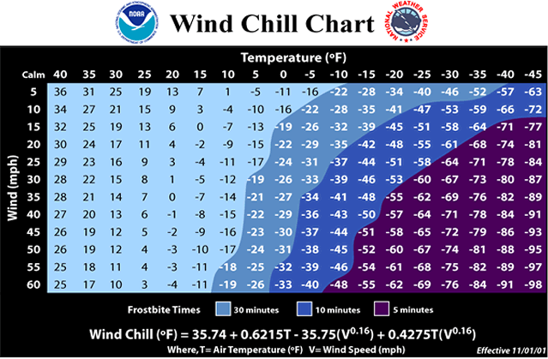



Camp Hill Sports Medicine Emergency Action Plan

EMERGENCY ACTION PLAN FOR ATHLETICS
Emergency situations may arise at any time during athletic events. Expedient action must be taken in order to provide the best possible care to the student athlete. The development and implementation of an emergency action plan will help ensure that the best care will be provided.

As emergencies may occur at any time and during any activity, all school activities personnel must be prepared. Athletic organizations have a duty to develop an emergency action plan that may be implemented immediately when necessary and provide appropriate standards of emergency care to all sports participants. This preparation involves formulation of an emergency action plan, proper coverage of events, maintenance of appropriate emergency equipment and supplies, utilization of appropriate emergency medical personnel, and continuing education in the area of emergency medicine and planning. Through careful pre-participation physical screenings, adequate medical coverage, safe practice and training techniques and other safety avenues, some potential emergencies may be averted. However, accidents and injuries are inherent with sports participation, and proper preparation on the part of the sports medicine team should enable each emergency situation to be managed appropriately and efficiently.

Components of an Emergency Action Plan
1. Emergency Personnel
2. Emergency Communication
3. Emergency Equipment
4. Roles of First Responder
5. Venue Directions with a Map

Emergency Personnel
The first responder in an emergency situation during an athletic practice or competition is typically a member of the sports medicine staff, such as a certified athletic trainer. However, the first responder may also be a coach or another member of the school personnel.

Certification in cardiopulmonary resuscitation (CPR), first aid, automated external defibrillator (AED), emergency action plan review, prevention of disease transmission, and emergency plan review is strongly recommended for all athletics personnel associated with practices, competitions, skills instructions, and strength and conditioning [including: athletic director, school nurse, certified athletic trainer, all coaches, etc.]. All coaches are required to have sudden cardiac event training and concussion management training certifications. Copies of training certificates and/or cards should be maintained with the athletic director or athletic trainer. Certification in cardiopulmonary resuscitation (CPR/AED), first aid, prevention of disease transmission, and emergency plan review is strongly recommended for all athletics personnel associated with practices, competitions, skills instruction, and strength and instruction. It is currently a requirement that at least one coach per staff has CPR/AED training. The emergency team may consist of physicians, emergency medical technicians, certified athletic trainers, coaches, managers, and possibly even bystanders. Roles of these individuals will vary depending on different factors such as team size, athletic venue, personnel present, etc.

The four basic roles within the emergency team are:

1. Establish scene safety and immediate care of the athlete:
This should be provided by the most qualified individual on the medical team
2. Activation of Emergency Medical Services:
This may be necessary in situations where emergency transportation is not already present at the sporting event. Time is the most critical factor. This may be done by anyone on the team. However, the person chosen should be someone who is calm under pressure, communicates well, and is familiar with the location and address of the sporting event
3. Equipment Retrieval
May be done by anyone on the emergency team who is familiar with the types and locations of the specific equipment needed. Assistant Coaches or team managers may be good choices for this role.
4. Direction of EMS to the Scene:
One of the members of the team should be in charge of meeting the emergency medical personnel as they arrive at the site. This person should have keys to locked gates or doors

**Formation of an emergency team and implementation of specific roles are important. You should also assign more than one person to a role in case certain members are not present during an emergency situation.

Activating Emergency Medical Services

- Call 9-1-1
- Provide Information
- Name, address, telephone number of the caller
- Nature of emergency
- Number of victims
- Condition of victim(s)
- First aid treatment initiated by the first responder
- Specific directions as needed to locate the emergency scene
- Other information requested by the dispatcher
- Do not hang up until you are told to do so!

Emergency Communication
Communication is a key to a quick, efficient emergency response. There should be a pre-established phone tree to ensure all relevant parties are notified. Access to a working telephone line or other device, either fixed or mobile, should be assured. A cellular phone is preferred if available. Please keep yours charged and available! There should also be back-up communication in effect in case there is a failure of the primary communication. At every athletic venue, home and away, it is important to know the location of a workable telephone. Back-Up communication includes another cell phone and/or landline phone. Landline phone locations: Hoover Gym, Eisenhower Gym, and High School Athletic Training Room (extension 3031).

Emergency Equipment
All necessary emergency equipment should be at the site and quickly accessible. Personnel should be familiar with the function and operation of each type of emergency equipment. The equipment should be checked on a regular basis to ensure good condition and equipment use should be rehearsed by all emergency personnel. Creating an equipment inspection log book is strongly recommended. Know how to properly care for and store all of the equipment. You should choose a clean, dry, environmentally controlled area and it should be readily available when emergency situations arise. This type of equipment could include: spine boards and straps, automated external defibrillators (AEDs), AED pads, AED batteries, splinting equipment, helmet removal equipment and their batteries, etc.

**Coaches should take note of the closest AED to their practice and game locations, and rehearse this with their student athletes and staff**

Medical Emergency Transportation
Ambulances are on site for varsity football and junior high football games. In the event that an ambulance is on site, there should be a designated location with rapid access to the site and cleared route for entering/exiting the venue. In the event that an ambulance is not on site, the medical personnel should be aware of average EMS response time for the athletic venue and distance from the venue to local hospitals. If an ambulance is not present at the event, entrance to the facility should be clearly marked and accessible
Any emergency situation where there is impairment in loss of consciousness (LOC), airway, breathing, or circulation (ABCs) or there is a neurovascular compromise should be considered a “load and go” situation and emphasis placed on rapid evaluation, treatment, and proper transportation.

Non-Medical Emergencies
For the non-medical emergencies (fire, bomb threats, violent or criminal behavior, etc.) refer to the Camp Hill safety and security quick reference.

Conclusion
The importance of being properly prepared when athletic emergencies arise cannot be stressed enough. An athlete’s survival may hinge on the training and preparation of athletic healthcare providers and the coaching staff. It is prudent to invest athletic department “ownership” in the emergency action plan by involving the athletic administration and sport coaches as well as sports medicine personnel. The emergency action plan should be reviewed at least once a year with all athletic personnel and local emergency response teams. Through development and implementation of the emergency plan Camp Hill Athletics helps ensure that the athlete will have the best care provided when an emergency situation does arise.

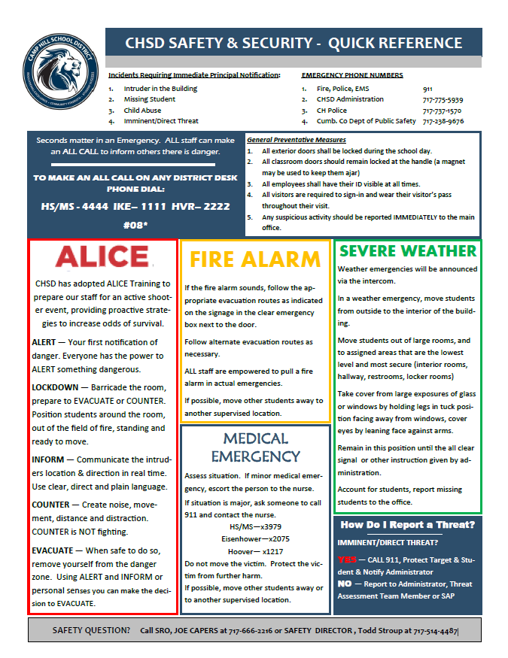

Important Contact List

Name | Title | Office Number | Cell Number
Lisa Simpson | Certified Athletic Trainer | 717-901-2400 X3031 | 717-649-2768
Jake June | Athletic Director | 717-775-5975 | 717-514-8676
Mark Ziegler | High School Principal | 717-901-2400 X3953 | 717-439-9623
Sherri McNamara | Assistant High School Principal | 717-901-2500 X3961 | N/A
Nick Snider | Middle School Principal | 717-901-2450 X3957 | N/A
Dena Higgins | School Nurse | 717-901-2400 X3979 | 717-574-5365
Minke Kooistra | Administrative Assistant | 717-901-2400 X5943 | N/A
Linda Still | High School Administrative Assistant | 717-901-2500 X3959 | N/A
Joe Capers | School Resource Officer | 717-901-2500 X3955 | N/A
Carrie Sweetland | Middle School Administrative Assistant | 717-901-2450 X3949 | N/A
Todd Stroup | Building and Grounds Director | 717-901-2500 x3074 | 717-514-4487

Off Campus Contacts | Phone Number
EMS | 911
Camp Hill Police Non-Emergency Number | 717-737-1570
Holy Spirit Hospital Main Number | 717-763-2100
Harrisburg Hospital Main Number | 717-782-3131
West Shore Hospital Main Number | 717-791-2600
Poison Control Center | 1-800-222-1222
Crisis Intervention Cumberland County | 717-763-2222
Suicide and Crisis Lifeline | 988
Child Welfare | 1-800-932-0313

Camp Hill High School
100 S 24th Street
Camp Hill PA

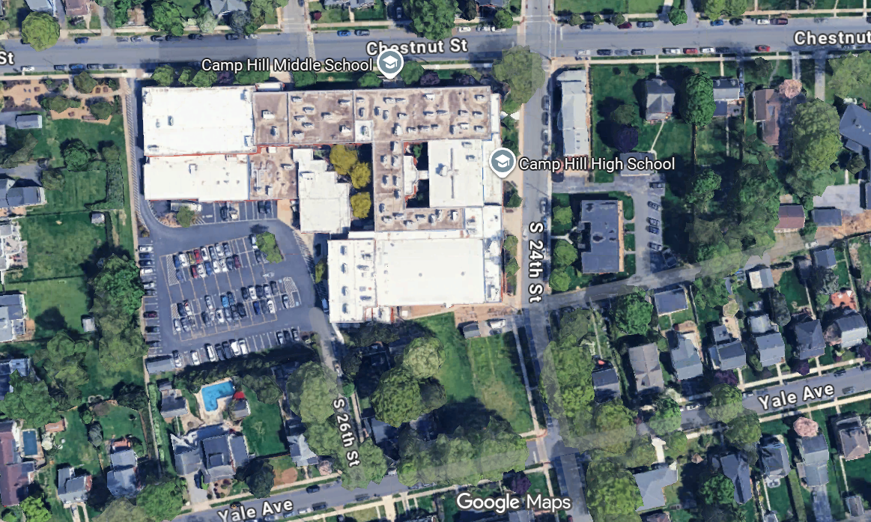

Green Arrows-Ambulance Access Points
Red Star-AED locations (Gym)
Yellow Lightning Bolt-Lightning Safe Structures
Events Held at this venue include but aren’t limited to:
High school basketball games and practices
Wrestling matches and practices
Fall and spring sports indoor practices (occasionally due to weather)
Cheerleading practices
Team weight lifting/conditioning sessions
Entrance: Use 24th street gym entrance (to the left of the Lion statue/Door 1-3) for all events except weight lifting sessions. In that case, use the back parking lot entrance (Door 3-1)
AED: Located just outside the gym on the 24th street side of the school
Lightning Safe Structure: Inside of the building

College Park
Methodist Church address
417 S 22nd Street
Camp Hill PA
OR
2020 Harvard Ave
Camp Hill PA

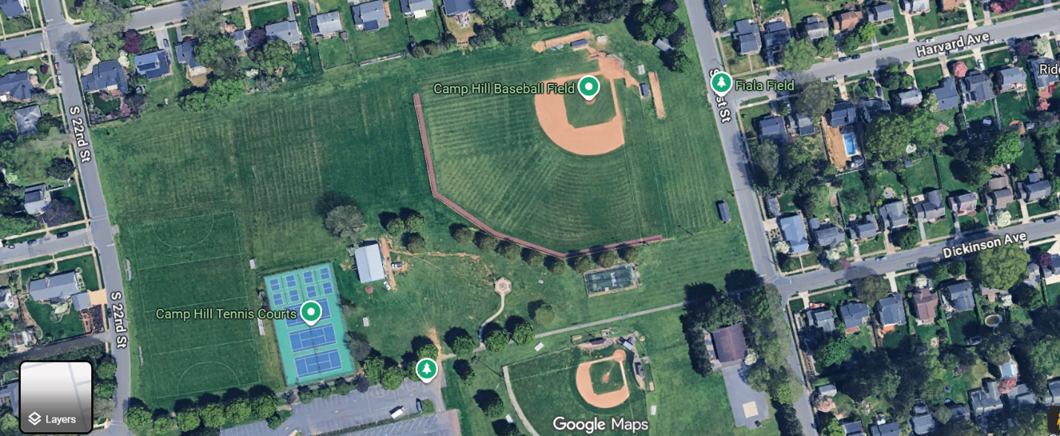
To The High School
To Fiala Fields
4
5
3
2
1
Green Arrows-Ambulance Access Points
Red Star-Fall AED location
Yellow Lightning Bolt-Lightning Safe Structures (None at this venue)
Orange Triangle-Spring AED location
Events Held At This Venue include but aren’t limited to:
Field Hockey Practices and Games (mostly middle school) (5)
High School Football Practice (1)
Middle School Football Practice (2)
Baseball Games and Practices (3)
Cross Country Start/End (meeting spot for most practices (4)
Entrance: Gate on 22nd Street for field hockey and varsity football practice.
Church parking lot for tennis, varsity football, and field hockey.
Gate on 21st street for baseball
AED: Will be with certified athletic trainer and in the shed next to the practice football field and tennis courts in the fall and in the shed behind the baseball backstop in the spring
Lightning safe structures Cars, bus, Hoover and the High School. The church is no longer an option

Eisenhower Elementary
340 North 21st Street
Camp Hill PA
OR
303 N 23rd Street
(Parking Lot by the gym)

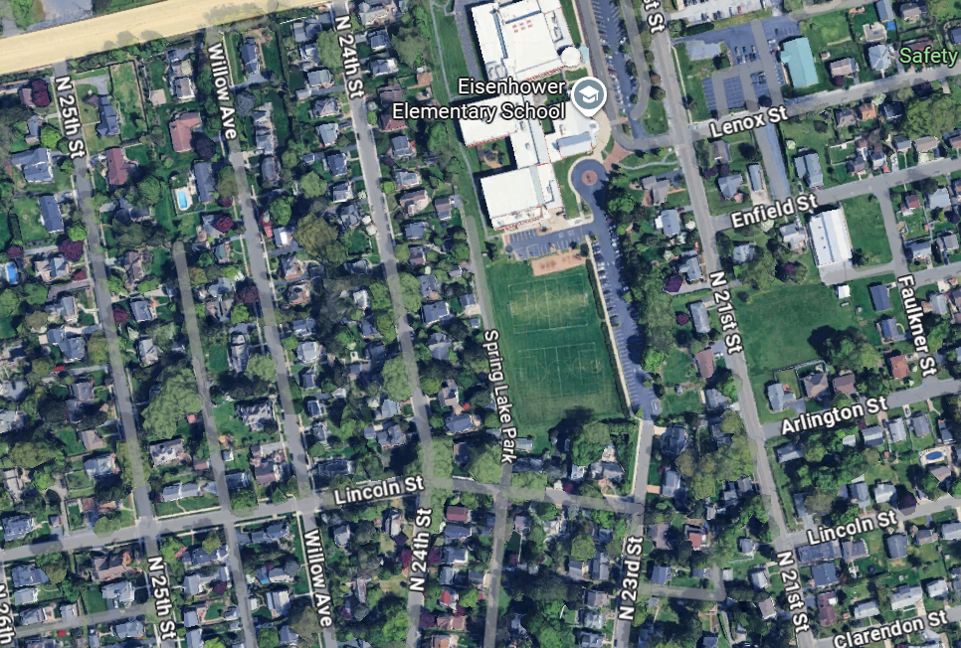
Green Arrows-Ambulance Access Points
Red Star-AED locations (Gym)
Yellow Lightning Bolt-Lightning Safe Structures
Events held at this venue include but aren’t limited to:
Middle School basketball games and practices
High school basketball practices (occasionally)
Soccer practices
Entrance: Gym doors are on the back side of the building (North 23rd Street parking lot) facing the playground (Door 2-8)
AED: Located just outside of the gym on the back side of the building

Fiala Field
Methodist Church address
417 S 22nd Street
OR
2118 Princeton Ave
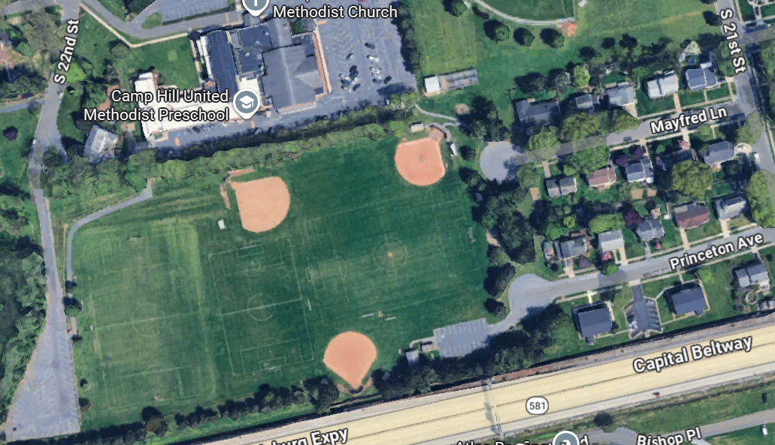
To College Park Fields
To Hoover
2
1

Green Arrows-Ambulance Access Point
Red Star-AED locations (Shed)
Yellow Lightning Bolt-Lightning Safe Structures
Events Held at This Venue include but aren’t limited to:
Middle School Soccer games and practices
High School Soccer practices
Typically, the girls’ soccer teams practice on field 1 and boys on field 2
Entrance: Church parking Lot, 22nd street parking lot, or Princeton Ave should be used for all soccer events at this venue
AED: The AED will be in the soccer equipment shed next to the bathrooms on the Princeton Ave side
Lightning safe structures: Bathrooms next to practice soccer field 2. Field 1 will need to go to Hoover or the High School. The church is no longer an option. Your swipe card will work at the gym lobby doors at Hoover (Door 1-4)

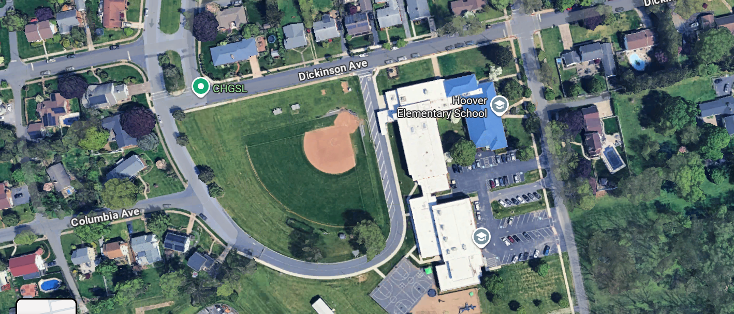

Green Arrows-Ambulance Access Points
Red Star-AED locations (Gym)
Yellow Lightning Bolt-Lightning Safe Structures
Events Held at this venue include but aren’t limited to:
Softball games
Baseball and softball (indoor) practices
Wrestling practices
Basketball practices (occasionally)
Fall sports indoor practices (occasionally due to weather)
Entrance: Softball field is on Dickinson ave side (Door 3-8 behind 3rd base dugout)
Gym is off of the parking lot on the 24th street side (Door 1-4)
AED: Located in the gym
Lightning safe structures: Inside of the school/gym

Siebert Park
2414 Cumberland Blvd.
Camp Hill, PA

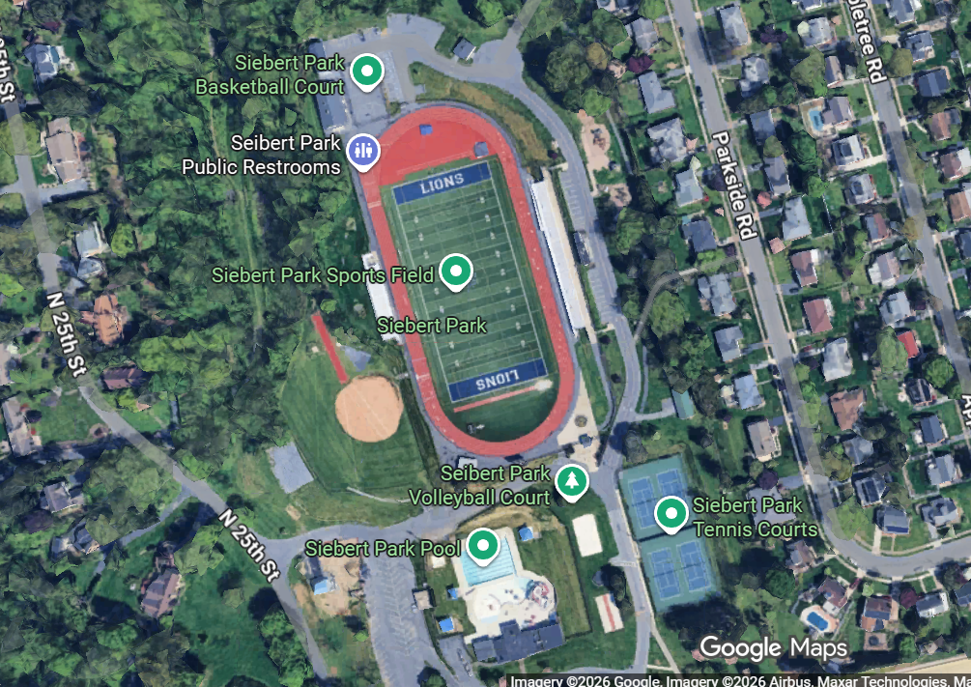

Green Arrows-Ambulance Access Points
Red Star-AED locations (Field House Athletic Training Room and Ticket Booth)
Yellow Lightning Bolt-Lightning Safe Structures
Events at this venue include but are not limited to:
Varsity and Middle School Football practices and games
Boys and Girls Soccer practices and games
High School Field Hockey practices and games
Cross Country practices and meets
Track practices and meets
Team conditioning
Entrance to field or stadium: Enter through gate at ticket booth or use backside of field as an alternate entrance
AED: AED 1 is located at the ticket booth near the entrance to the complex and AED 2 is located in the athletic training room at the back of the complex
Lightning safe structures: Bathrooms, locker rooms, and athletic training room

High School Cross Country Course Map (Siebert Park)
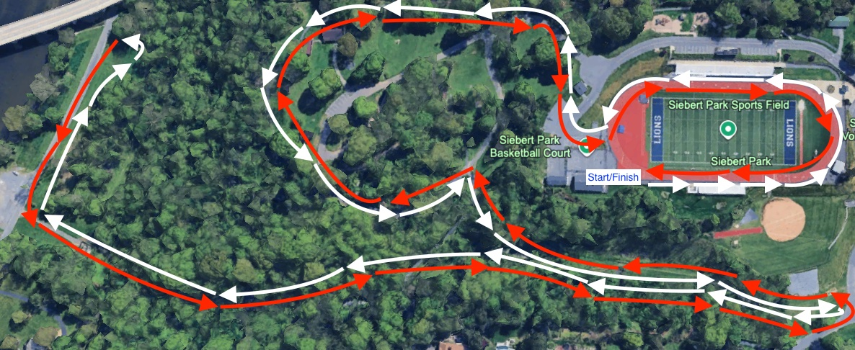

Middle School Cross Country Course Map (Siebert Park)
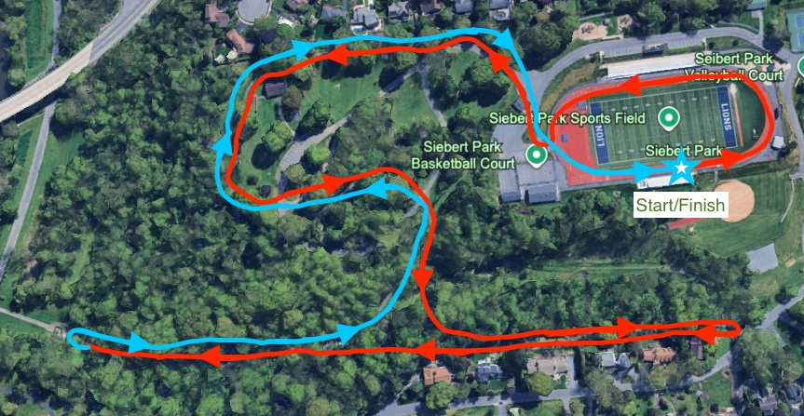

Camp Hill Athletics
Contact Tree

Coach or first responder at the scene

Life threatening condition Non-life threatening condition

Call 911 Call Athletic Trainer
Call Parent/Guardian

Note: This is a basic plan. Use your best judgement when a player is injured. Move down the chart if you are unable to reach the appropriate staff member.
Call AD & Principal

Policies and Procedures
Physician Visits
- All athletes that visit a physician for an injury/severe illness must be cleared in writing by that physician (MD or DO only), physician assistant (PAC), or nurse practitioners (CRNP) before returning to his/her sport. Notes from any other healthcare professionals will not be accepted per the PIAA.
- Head injury clearances must come from an MD or DO only. No other signatures will be accepted.
Head Injuries and Impact Testing
1. All athletes must have taken the SWAY concussion baseline test prior to starting official practice. Parental consent form must be signed on Rank One prior to baseline testing.
2. All head injuries or suspected head injuries will eventually be referred to a physician after being seen by the athletic trainer per school protocol.
3. The Camp Hill School District Head Injury Policy will be followed with no exceptions.
4. Please report ALL head injuries or suspected head injuries to the athletic trainer immediately! Coaches cannot clear an athlete to return to sport that is exhibiting signs of a head injury per Safety in Youth Sports Act law enacted in 2012. They must be assessed by a medical professional.
Athletic Trainer Care and Treatment
- Athletes will be cared for on a first come, first served basis.
- Athletes that need a new injury evaluation will be evaluated after everyone else has been taken care of.
- Middle school athletes will go after all high school athletes with the exception of game days.
- No athlete will have his/her ankle taped unless they are undergoing rehab for that injury. I do not do preventative ankle taping.
- Athletes should be in the athletic training room no later than 30 minutes prior to practices for taping and treatment. Lateness is not tolerated! After school practices do not apply to this rule, but student athletes are expected to arrive in my room by 3pm.
Athletic Training Room Rules
- Do not take anything without asking.
- No cleats or equipment are allowed in.
- You will be asked to leave the athletic training room if you are disrespectful or disruptive in any way.
- Backpacks, equipment bags, etc must be left upstairs and not in the athletic training room during taping or treatment.
- No loitering in the athletic training room
- No student athletes allowed in the athletic training room without a coach or athletic trainer supervision.
- Spatting football cleats will only be done when the athlete provides his/her tape and if time permits.
- The athletic training room must be locked at all times when not in use.
- The athletic training room supplies will be used for injuries/illnesses NOT EQUIPMENT. This includes but is not limited to: shin guards, shoulder pads, javelins, cleats, and wrestling shoes.
- Athletes that require inhalers or epi pens must have them present with them at all games and practices. Not having the inhaler or epi pen will result in missed practices and games. Do not let athletes share inhalers.
- All athletes must provide their own drinking containers. No cups are provided!
- Athletes that need to leave class or study hall early to see the athletic trainer, must have a pass from either the athletic director or athletic trainer. Passes from teachers or coaches will be not accepted
- Jewelry policies for practice and competitions will follow the specific sports competition guidelines. For example, no jewelry is permitted during a football game so none is permitted at practice. Tennis allows jewelry during competitions so it's allowed in practice.
Away Events
- Report injuries that occur at away events the same day as the actual event. It can be a simple email or phone call letting me know that a student athlete was injured.
- Travel rosters must be sent for all away contests. They should be sent to the athletic director and the athletic trainer both before you leave for your event and before you leave the away venue to come back to Camp Hill. Failure to send travel rosters will result in a meeting with the athletic director.
Wrestling Specific Items
- Wrestling weigh ins must conclude no later then 245pm
- No Junior High Wrestler may be reassessed for any reason. They will be certified at the documented weight on their first passing attempt at the hydration/weigh in process.
- High school wrestlers can be reassessed a max of 2 times. The second reassessment (3rd attempt total) will be their documented certified weight. This is strictly for those that pass hydration, weigh in, and simply don’t like the weight they were certified at.
- All wrestling weigh ins/hydration tests MUST be supervised by a member of the coaching staff or teacher/administrator.

Practice Schedules and Communication
- Coaches must provide a 24-hour notice when making a change to the practice schedule in order to get coverage.
- Please provide the athletic trainer with a practice schedule at the start of the season.
- Continue to keep the athletic trainer updated on practice schedule changes on a daily basis.
- If you use the remind app, game changer, or mass email list to notify athletes of practice changes, please include the athletic trainer and athletic director.
- No athletic training coverage will be provided on Sundays.
- August pre Season practice windows are as follows: 7am-11am and 3pm-730pm. All practices should start and finish within that window
- Practice windows during the school year are until 12pm on Saturdays and 730pm on weekdays.
- Practice windows on Labor Day, New Years Day, and Memorial Day are until 12pm.
- All in season practices have to be done with an athletic trainer present or on call. Practicing without medical professionals is not permitted.

Coaches Misc.
- Med kits, water, and ice must be present at all practices and competitions (home and away)with no exceptions. Coaches and athletes will be responsible for transporting water/ice to and from games/practices.
- Please take proper care of your athletic training equipment. Equipment and supplies damaged, lost, or ruined during the season will be replaced from your teams budget.
- No coaches are to be present in the athletic training room after school. I will update you on the statuses of your athletes when time allows.
- If an athlete is seeing me after school for an injury, I will enter their restrictions into Rank One. You will get a notification or an email. It is your responsibility to check those messages up until 345pm
- Due to privacy issues, I cannot text regarding injuries. You are still able to text me, but I can’t respond with anything more than a simple yes, no, or something similar.
- I cannot text students, so please do not give them my number. They can communicate with me via Remind or schoology.
- At least one coach per team must be CPR/AED certified. This coach should be at all competitions and practices. Online CPR classes are highly discouraged!
- If you are aware that an athlete is seeing a physician for an illness or an injury, please let me know. Don’t assume I know, especially if I haven’t communicated anything to you.
- A coach should never provide any medical advice, evaluation, stretching, taping, or rehab suggestions etc. That should be left to the athletic trainer. Providing medical advice without a medical license is illegal in the state of Pennsylvania.
- At the end of your season, please return cooler, injury ice chest, and med kit within 7 days of your last competition.
- You are responsible for being able to access Rank One emergency forms for your student athletes in case of an emergency. Please use the instructions I sent out via email.
- Coaches are responsible for making sure their team is properly equipped for all practices and competitions. This includes but is not limited to: shin guards, properly fitted helmets, chest protectors, mouth guards, proper footwear, catchers masks, wrestling headgear.
- Student managers must be approved by the athletic department. They will also need an emergency form on file as well as a liability waiver/permission form on file prior to participating in any team activities.

Coaches Instructions on how to fill out Rank One Paperwork

- Go to this link: Rank One
- Username: The email address we have on file for you
- Password (please change your password after your initial login): Camphill2023!
(This password is valid for your first time use (first year of coaching) and then should be changed)
- On the bottom left of your screen it should say coaches compliance. That is where you want to go. The picture below is an example. Click on the item you want to complete such as emergency form or coaches packet. That will take you to the proper screen and link.
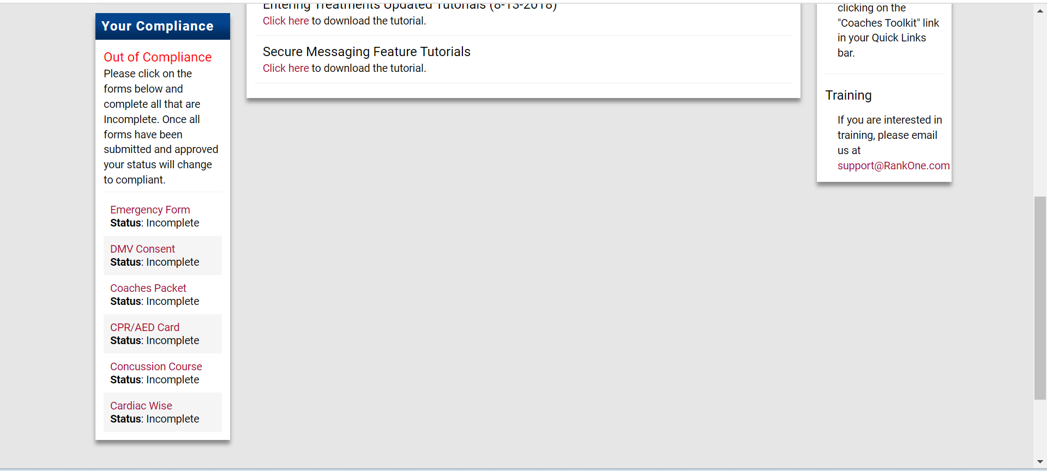
- You will need to complete several things prior to the first official practice with your team, and should be completed yearly.
  - sign the coaches packet acknowledgement form
  - complete the emergency form
  - either upload a current cpr card OR check the box stating you are not certified
  - complete cardiac compliance class and screenshot/upload the confirmation email you receive. You do not have to pay for a certificate!
  - complete the concussion compliance class and screenshot/upload the confirmation email you receive. You do not have to pay for a certificate!
  - Sign and check the box that states you have been approved by the CHSD HR and Athletic Departments to coach.
  - you are cleared to coach on the first official date once you are marked compliant

** Please note that what the athletic department needs in terms of coaches paperwork is totally different from what our district HR manager needs**
Below is an example of the completion certificate you will get after you complete the proper course.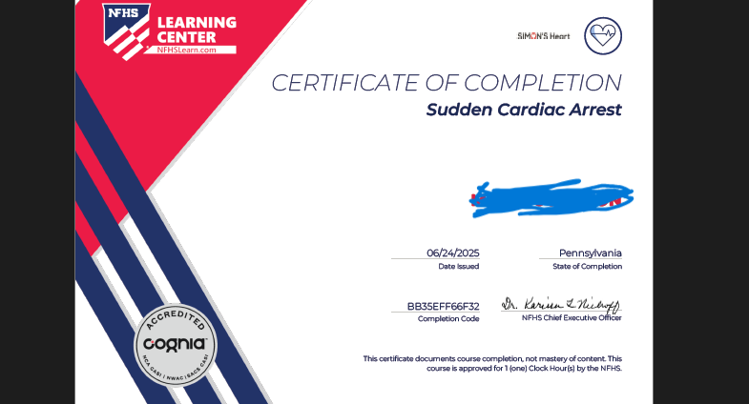

How to access team roster and athlete information on Rank One:
· Sign into rank one
· Click on athlete mgmt then manage rosters
· Make sure tab at the top right notes current school year
· Under school click on camp hill high school or camp hill middle school
· Under sport your only option should be the sport you are coaching
· Under level click varsity
· Under team click lions
· Then click view roster
· That should bring up your current roster of who signed up and/or turned in paperwork
· By clicking on the athletes name, you can see contact info
· If you click on files, you can access their emergency form
· You can also see what paperwork they are missing. Names in green have completed all paperwork.
The following titles are what you will see on Rank One for paperwork for student athletes. You will be able to tell what they have turned in and what they are missing.
PHY-section 6 of the PIAA physical packet that is filled out by doctor and submitted to athletic trainer via email. No paper copies accepted!!
The following items are filled out on Rank One:
PIAA- Pre Participation packet (section 1-4 PIAA physical packet)
S5-Health history (section 5 PIAA physical packet)
EMER-emergency form
SECTION 7-Recertification Form (not needed for fall sports)
SWY-Sway baseline test- This is entered manually by the athletic trainer after the student completes the baseline exam under the supervision of a coach or athletic trainer.
SPC-Sway parent consent form-Must be signed by a parent or guardian before the student athlete can take the baseline exam

Parent/Guardian Letter – Sway Medical Neurocognitive Testing

Dear Parent/Guardian,

Camp Hill Athletics’ new neurocognitive testing for baseline concussion evaluation will be Sway Medical. This program will assist the athletic trainer in evaluating and treating head injuries. It is an exam utilized in many professional, collegiate, and high school/middle school sports programs across the country to successfully diagnose and manage concussions. Sway Medical is an app that will be used to baseline test athletes before their sports season, to help determine the severity of a concussion in season, and then to evaluate athletes during recovery to make sure the head injury has healed prior to clearing the athlete’s return to competition.

The Camp Hill athletic trainer will be administering the test at the school prior to your child participating in a PIAA affiliated sport with the exception of Bocce and Golf. The test will not be taken at home as was the case with Impact Testing. This test is completed on your student’s phone (or a provided device if your student does not have a phone) and is a non-invasive assessment that takes about 20-25 minutes to complete. Essentially, the Sway Medical test is a preseason physical of the brain. It tracks information such as symptoms, balance, memory, reaction time, speed, and concentration.

If a concussion is suspected, the athlete will re-take the test usually within 72 hours after the concussive event or can also take a modified test during an event (on the sidelines) if the athletic trainer thinks it is warranted. Both the preseason and post-injury test data will be used to help evaluate the injury. The test data will also enable the athletic trainer and physician (when necessary) to determine when return-to-play is appropriate and safe for the injured athlete. Once the athlete is medically cleared by a physician, he/she must have returned to their baseline on the Sway Medical test and the Return to Play criteria will be followed.

The Sway Medical test is a free app that can be downloaded from the Apple or Google Play stores. There is no information stored on the device and the student can delete the app if they wish after the initial baseline test is completed. We will complete the baseline test in a group setting with each student using their own device. Please allow your student to download the app to their phone before baseline testing. If you do not own a smart mobile device or cannot download the Sway Medical app, we will provide a means of baseline testing for you. Please feel free to contact me if you have any questions about baseline testing or the Sway Medical app.

Sincerely,

Lisa Simpson
Camp Hill School District, Athletic Trainer
lsimpson@camphillsd.k12.pa.us


Camp Hill School District
Human Resources

Required Documents and Clearances for Employment

The following documents & clearances are required for employment with the Camp Hill School District. The Director of Human Resources will reach out to you to coordinate the completion of all required clearances and HR/payroll paperwork. All clearances and documents must be received in Human Resources before you are released to work with CHSD students. Failure to submit required paperwork by the start of the season could result in proration or loss of your stipend.

Act 151 Child Abuse History Clearance:

- Go to https://www.compass.state.pa.us/CWIS
- Click Individual Login or Create Individual Account to begin (your Keystone ID is a username that you create)
  - Under Application Purpose choose School Employee Governed by Public School Code
  - Please be sure to answer all questions as completely as possible.
  - Once you submit your application, the state can take up to 14 calendar days to process. You will receive an email once the clearance is ready. At that time, log back into your account to retrieve your clearance and send to Human Resources.
  - Clearances completed within the past five years will be accepted. This clearance must be renewed every five years.

Act 34 State Criminal History Check:

- Go to https://epatch.pa.gov/home
- Click Submit a New Record Check
- Complete the required fields with your personal information
  - Print the Certification Form to submit to the district (Please note, the Record Check Status Detail is NOT the actual clearance. Applicants must click on the Certification Form link in the middle of the screen in order to view and print the clearance certificate).
  - Clearances completed within the past five years will be accepted. This clearance must be renewed every five years.

Act 114 Federal Criminal History Check:

  - Go to https://uenroll.identogo.com
- Enter the service code for employment with a school district: 1KG6XN
- Click Schedule or Manage Appointment to begin the process
- Print the registration confirmation to take to the fingerprinting appointment. See IdentoGO website for locations.
  - When your fingerprinting is complete, you must provide the district with your UEID number (as shown on the receipt provided after fingerprint capture). The district needs this number to access the official clearance report.
  - Clearances completed within the past five years will be accepted. This clearance must be renewed every five years.

Act 126 Mandated Reporter Training:

  - Go to https://camphillsd.pa.safeschools.com/login
  - Your username is the initial of your first name plus your last name, i.e., jsmith.
  - You must complete Part 1 and Part 2 of the training.
  - When completed, print the certificates for both parts and submit copies with your clearances.
  - Mandated reporter training completed within the past five years will be accepted. This training must be renewed every five years.
ALICE Training
- You will receive an email from Navigate 360 with information about accessing your account and creating your own password.
- Go to https://learn.navigate360.com/learn/signin.
- On the left side of your welcome page will be the courses you are assigned.
- All new employees must complete the initial ALICE training within their first 30 days of employment. The Recertification must then be completed annually.

PDE 6004 – Arrests and Convictions

Act 168 - Must be filled out for each current place of employment and any previous employer where the employee had direct contact with children. This paperwork will be provided for you in the District’s online application process.

Health Record & TB

  - Health must be within a year, TB within 90 Days.

PIAA Required Trainings/Rank One Paperwork
  - Concussion Course (link on Rank One)
  - Cardiac Arrest (link on Rank One)
  - Emergency Form (Rank One)
  - Acknowledge and Sign Coaches’ Packet (Rank One)
  - First Aid (within first two years of coaching)
  - Fundamentals of Coaching (within first two years of coaching)

Signed Contract – Contract will be provided to you following Board approval.

Camp Hill School District
Human Resources

Required Documents and Clearances for Volunteer Coaches

The following documents & clearances are required for employment with the Camp Hill School District.

Act 151 Child Abuse History Clearance:

- Go to https://www.compass.state.pa.us/CWIS
- Click Individual Login or Create Individual Account to begin (your Keystone ID is a username that you create)
  - Under Application Purpose choose Volunteer having direct volunteer contact with children.
  - Please be sure to answer all questions as completely as possible.
  - Once you submit your application, the state can take up to 14 calendar days to process. You will receive an email once the clearance is ready. At that time, log back into your account to retrieve your clearance and send to Human Resources.
  - Clearances completed within the past five years will be accepted. This clearance must be renewed every five years.

Act 34 State Criminal History Check:

- Go to https://epatch.state.pa.us
- Click Submit a New Record Check
- Complete the required fields with your personal information
  - Print the Certification Form to submit to the district (Please note, the Record Check Status Detail is NOT the actual clearance. Applicants must click on the Certification Form link in the middle of the screen in order to view and print the clearance certificate).
  - Clearances completed within the past five years will be accepted. This clearance must be renewed every five years.

Act 114 Federal Criminal History Check:

  - Go to https://uenroll.identogo.com
- Enter the service code for employment with a school district: 1KG6XN
- Click Schedule or Manage Appointment to begin the process
- Print the registration confirmation to take to the fingerprinting appointment. See IdentoGO website for locations.
  - When your fingerprinting is complete, you must provide the district with your UEID number (as shown on the receipt provided after fingerprint capture). The district needs this number to access the official clearance report.
  - Clearances completed within the past five years will be accepted. This clearance must be renewed every five years.
  - Volunteers who have lived in the state of Pennsylvania for the past 10 years and who have not been arrested for or convicted of a reportable offense are eligible to submit a Volunteer Verification Form in lieu of the FBI Fingerprinting Clearance.
  - Clearances completed within the past five years will be accepted. This clearance must be renewed every five years.

Tuberculosis Test Results

  - The TB Test Results must be submitted to the District within 90 days after it is completed.

PIAA Required Trainings/Rank One Paperwork
  - Concussion Course (link on Rank One)
  - Cardiac Arrest (link on Rank One)
  - Emergency Form (Rank One)
  - Acknowledge and Sign Coaches’ Packet (Rank One)
  - First Aid (within first two years of coaching)
  - Fundamentals of Coaching (within first two years of coaching)

Camp Hill Sports Medicine Points of Emphasis

- Inhalers and EpiPens must be present for ALL PRACTICES AND GAMES. No inhaler and/or epi pen will result in the student athlete being unable to participate on that particular day. All inhalers/epi pens must be labeled with the student athletes name and be on the bench area during practices and games. Being in the student athletes equipment bag or in the locker room is not acceptable
- All athletes that visit a physician or medical facility for an injury or serious illness must be cleared in writing by that physician (MD or DO only) before returning to his/her sport. Notes from physician assistants (PA-C) and nurse practitioners (CRNP) will also be accepted in certain situations, but notes from nurses (RN), physical therapists (PT or PTA), chiropractors, etc. will never be accepted. Head injuries must always be cleared by an MD or DO. No other signatures will be accepted for head injuries.
- It is imperative to the student athletes safety that all head injuries or suspected head injuries be reported to myself or a coach immediately. Failure to do so puts the student athlete at risk of a much more severe injury.
- I cannot dispense any type of medication (Ibuprofen, Acetaminophen, etc)
- I communicate with coaches on a daily basis. During those communications the coaches get an injury report, treatment plans, and other information regarding injured athletes via our Rank One system
- I will communicate with parents and guardians via Rank One regarding injuries, updates, treatments, etc. Please check your Rank One account for messages if you know your child is seeing me for an injury. Significant injuries and other urgent matters will be taken care of via phone call. Please have your Rank One notifications on and accessible so you don’t miss anything.
- As a contracted employee of OSS Health, I have access to same day appointments with most of our physicians.

- If you have any questions or concerns throughout the season, please do not hesitate to contact me. I typically do not take calls, texts, or emails during off hours unless it is an actual medical emergency. I will return your call or email the following business day if you attempt to reach me during off hours.
Lisa Simpson LAT, ATC
Camp Hill High School
OSS Health
(717) 901-2500 X3031
lsimpson@camphillsd.k12.pa.us

How to join Lisa’s Remind Group or Group Me Group:

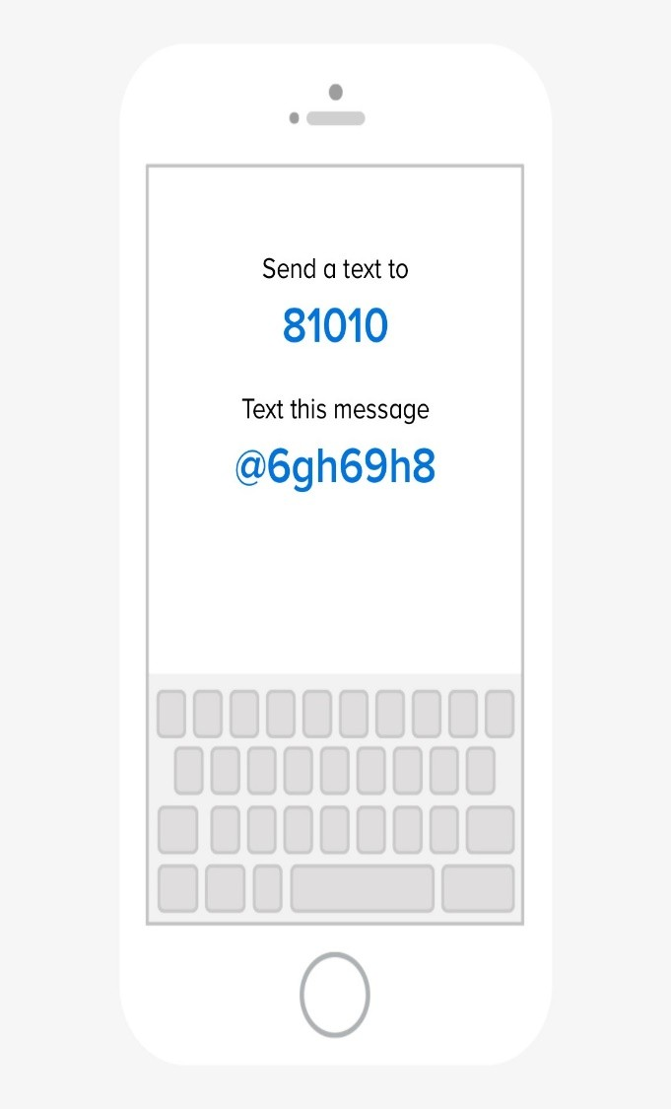
This group will be used for announcements for parents and students. Students can also text me using the group/app as I do not communicate with students via standard texting.

Group Me Link:
https://groupme.com/join_group/111470437/7FxiNcFR

PIAA Sports Physical Pre-Participation Information Packet & Instructions
1. Physical Examination Forms (CIPPE Section 6 to be scanned and emailed to lsimpson@camphillsd.k12.pa.us after completion by the physician) Please scan in PDF form. The physical must be performed/dated on or after May 1st each school year, which is a PIAA rule. These cannot be done online, so they will need to be printed out and taken to the doctor's appointment. No paper copies will be accepted upon completion. Section 6 is available for download on the Camp Hill Athletics website. Make sure everything is filled out completely. Section 6 must be signed and dated by the medical examiner in order to be accepted.
2. Completion of Rank One online registration. Select the link below to begin the registration process (PIAA CIPPE Sections 1-5 and additional forms will be completed through the online registration):
https://camphillschooldistrict.rankone.com/New/NewInstructionsPage.aspx

Please do not use auto fill for completion of the forms. Using autofill has been causing forms to be filled out incorrectly. Make sure the top of each form has a student name and not a parent or guardian name. Forms filled out incorrectly will be denied and need filled out and resubmitted again. Contact Rank One for tech support at support@rankone.com with any tech related questions.
3. SWAY baseline concussion screening -All students (except bocce and golf) must be baseline tested in the 2026-2027 school year This is different then in previous years. We have switched from Impact testing to SWAY testing for concussion baseline testing. The baseline test is taken at the school with your coach or athletic trainer and must be scheduled in advance. THIS CANNOT BE TAKEN AT HOME LIKE YOU HAVE DONE IN THE PAST. Contact your coach or athletic trainer to schedule a baseline test. You do not need to take the baseline more than once per school year. For example, if you’ve taken it for fall soccer in 9th grade you do not need to take it again for basketball in 9th grade.
For more information please go to the SWAY web site: SWAY
4. Paperwork Checklist
- Physical examination (section 6 of the PIAA CIPPE packet)-Send to the athletic trainer via email
- Online Health history (section 5 of the PIAA CIPPE packet)
- SWAY concussion baseline testing-This will be checked off manually by the athletic trainer after the student completes the baseline test.
- PIAA pre participation forms and Rank One account set up- (sections 1-4 of the PIAA CIPPE Packet and other forms). I will be communicating injuries/treatments through Rank One, so I recommend setting up an account and turning on your notifications so you don’t miss anything. Please use the link above to access messages on your computer without the app.
- Sway Parent Consent form-Must be signed prior to the student taking the baseline test
- Recertification Form (section 7 of the PIAA CIPEE form)-This form is not needed for fall sports. It may or may not be needed for winter and spring sports. It depends on the date of your physical exam. Please reach out to Lisa for clarification on this. This form will not be available until 6 weeks prior to the start of the season per PIAA regulations
- If you are completing the forms using an account, you can check the status of each form submitted by logging into your account. If you are completing the forms without an account (not recommended), you will receive a confirmation email once the document has been received by the athletic department.

2026-2027 Sign up/paperwork deadlines:

Sport | Paperwork Deadline | Practice Start Date
High School Football and Golf | 8/3/2026 by 12pm | 8/10/2026
All other fall sports except MS cross country and MS Field Hockey | 8/10/2026 by 12pm | 8/17/2026
Ms Cross Country and MS Field Hockey | 8/17/2026 by 12pm | 8/24/2026
Winter Sports | 11/18/2026 by 3pm | 11/20/2026
High School Spring Sports | 3/4/2027 | 3/8/2027
Middle School Spring Sports (soccer only) | 3/8/2027 | 3/10/2027
*Swimming and Lacrosse is through Trinity. All paperwork should be sent to them*
*Middle school track is a club sport and does not require paperwork*

This information is for parents/guardians of student athletes that are homeschooled, Co-op with another district, or enrolled through cyber school grades 7-12
Due to your child not having been issued a student ID number, you will need to contact Lisa Simpson lsimpson@camphillsd.k12.pa.us to set up your account.
After your account is set up by the athletic trainer, the athletic trainer will reach out to you with your designated account ID# in order for you to make an account through Rank One, with the following directions:
1. Physical Examination Forms (CIPPE Section 6 to be scanned and emailed to lsimpson@camphillsd.k12.pa.us after completion by the physician) Please scan in PDF form. The physical must be performed/dated on or after May 1st each school year, which is a PIAA rule. These cannot be done online, so they will need to be printed out and taken to the doctor's appointment. No paper copies will be accepted upon completion. Section 6 is available for download on the Camp Hill Athletics website. Make sure everything is filled out completely. Section 6 must be signed and dated by the medical examiner in order to be accepted.
2. Completion of Rank One online registration. Select the link below to begin the registration process (PIAA CIPPE Sections 1-4 and additional forms will be completed through the online registration):
https://camphillschooldistrict.rankone.com/New/NewInstructionsPage.aspx

Please do not use auto fill for completion of the forms. Using autofill has been causing forms to be filled out incorrectly. Make sure the top of each form has a student name and not a parent or guardian name. Forms filled out incorrectly will be denied and need filled out and resubmitted again. Contact Rank One for tech support at support@rankone.com with any tech related questions.
3. SWAY baseline concussion screening -All students (except bocce and golf) must be baseline tested in the 2026-2027 school year This is different then in previous years. We have switched from Impact testing to SWAY testing for concussion baseline testing. The baseline test is taken at the school with your coach or athletic trainer and must be scheduled in advance. THIS CANNOT BE TAKEN AT HOME LIKE YOU HAVE DONE IN THE PAST. Contact your coach or athletic trainer to schedule a baseline test. You do not need to take the baseline more than once per school year. For example, if you’ve taken it for fall soccer in 9th grade you do not need to take it again for basketball in 9th grade.
For more information please go to the SWAY web site: SWAY
4. Paperwork Checklist
- Physical examination (section 6 of the PIAA CIPPE packet)-Send to the athletic trainer via email
- Online Health history (section 5 of the PIAA CIPPE packet)
- SWAY concussion baseline testing-This will be checked off manually by the athletic trainer after the student completes the baseline test.
- PIAA pre participation forms and Rank One account set up- (sections 1-4 of the PIAA CIPPE Packet and other forms). I will be communicating injuries/treatments through Rank One, so I recommend setting up an account and turning on your notifications so you don’t miss anything. Please use the link above to access messages on your computer without the app.
- Sway Parent Consent form-Must be signed prior to the student taking the baseline test
- Recertification Form (section 7 of the PIAA CIPEE form)-This form is not needed for fall sports. It may or may not be needed for winter and spring sports. It depends on the date of your physical exam. Please reach out to Lisa for clarification on this. This form will not be available until 6 weeks prior to the start of the season per PIAA regulations
- If you are completing the forms using an account, you can check the status of each form submitted by logging into your account. If you are completing the forms without an account (not recommended), you will receive a confirmation email once the document has been received by the athletic department.

Camp Hill Middle School and High School Athletics
Manager Liability Waiver and Permission Form

Camp Hill Middle School and Camp Hill High School Sports Programs offer opportunities for students in grades 6 through 12 to join sports teams in the role of “Manager”. This role can vary from team-to-team based on the needs of the program, sport, and coaches. Managers are not PIAA eligible members of a sports program and will only require the completion of an Emergency Form prior to participation. However, in the role of Manager, there may be opportunities for the student to assist, or participate, in practices/activities. This form asks the parent/guardian to authorize their student’s participation in practices/activities, and to expressly assume all risks arising from the student’s participation in those activities as the team’s Manager.

Please Check the Box that Applies

Manager, Participant in Practice/Activity*

* I am the parent or legal guardian of the Manager. I have read this document, and I am signing it freely. I understand the legal consequences of signing this document, including (a) releasing the District, its officers, administrators and employees from all liability on my and the Manager’s behalf, (b) waiving my and the Manager’s right to sue the District, its officers, administrators and employees for any and all claims or causes of action for damages, injuries and death, (c) and assuming all risks of Manager’s participation in this Activity, including travel to and from the Activity or any events incidental to this Activity. I allow the Manager to participate in this Activity. I understand that I am responsible for the obligations and acts of the Manager as described in this document. I agree to be bound by the terms of this document.

Manger, Non-Participant in Practice/Activity

__________________________
Sports Team

_______________________________ _______________________________
Student’s Printed Name Student’s Grade

_______________________________ ___________________________________ ______________
Parent/Guardian’s Printed Name Parent/Guardian’s Signature Date

