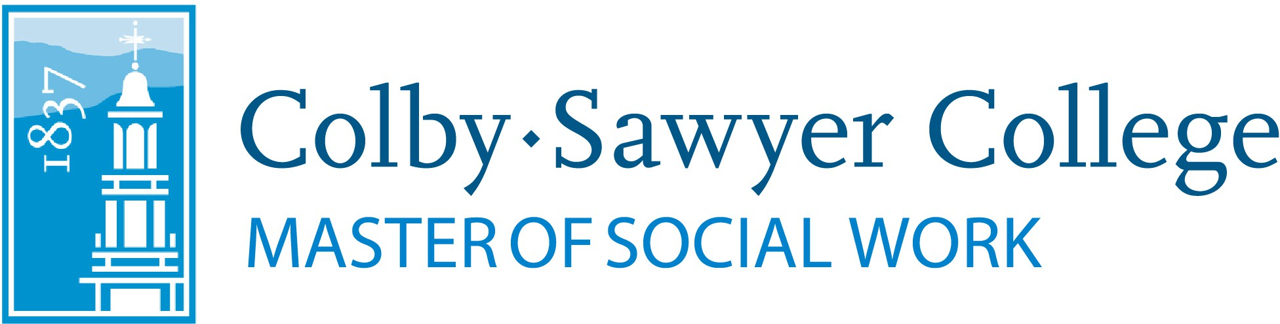

Emerging Social Work Leaders Master of Social Work (MSW) Scholarship

Thanks to the generosity of the Burkehaven Family Foundation, Master of Social Work program faculty are pleased to offer scholarships of $2,000 available for MSW students at Colby-Sawyer College.

The Emerging Social Work Leaders MSW Scholarship was designed by MSW faculty and the Burkehaven foundation to support graduate-level social work students who demonstrate strong academic performance, professional integrity, and a commitment to serving individuals, families, and communities with significant needs. The scholarships prioritize students whose work and/or professional goals align with practice in high-need areas and with marginalized populations, as well as underserved regions in New Hampshire. More than half of eligible MSW students are expected to receive scholarship awards, reflecting the Foundation's commitment to supporting the next generation of social work leaders.

A scholarship application may be submitted at the time of program application, admission, or enrollment.

Please submit your completed application via email to MSW Program Director Kate Turcotte.

Scholarship awards will be communicated to recipients via email at the time of admission or enrollment. Scholarship disbursements will be deposited directly into the recipient’s student financial account at Colby-Sawyer College.

Eligibility Criteria

Scholarship recipients must meet and maintain the following minimum requirements:

- Enrollment Status: Recipients must be deposited or enrolled in the Master of Social Work (MSW) program at Colby-Sawyer College. Applicants may be first year or advanced standing students.
- Academic Standing: Recipients must remain in good academic standing (not on academic probation or suspension).
- Professional Standing: Recipients should have no documented ethical or disciplinary violations in academic or professional settings associated with their enrollment in the MSW program.

Scholarship Selection

While all eligible students are encouraged to apply, prioritization of awards will be made for students who are working, plan to work, and/or plan complete their practicum placement(s) in a clinical capacity, and in the following regions and/or with the following populations:

- Geographic Priority
  - Currently working, plan to work, and/or plan complete practicum placement(s) in one of the following areas:
    - Sullivan County, NH
    - Grafton County, NH
    - Coös County, NH
    - Belknap County, NH
    - Cheshire County, NH
    - Merrimack County, NH
- Population Foci
  - Currently working, plan to work, and/or plan complete practicum placement(s) with historically and/or currently marginalized or oppressed populations, including but not limited to:
    - Low-resourced individuals, families, groups, communities, and organizations
    - Racial and ethnic minorities
    - Members of the LGBTQIA2S+ community
    - Individuals with disabilities
    - Immigrant or refugee populations
    - Veteran populations
- High-Need Practice Areas
  - Engaged in clinical practice areas with acute workforce or service needs, including:
    - Children and youth services
    - Aging and elder care
    - Substance use recovery
    - Community mental/behavioral health

Award Details

- Number of Awards Per Year: Varies
- Award Amount: $2,000. (If additional funding becomes available, students may submit one application per academic year during their MSW enrollment, for a maximum of two.)
- Disbursement: Funds will be deposited directly to the recipient’s account at Colby-Sawyer College. In the event that a student’s account is paid in full and they are completing the MSW program, the funds will be provided directly to the student as an account refund.

Selection Process

Applications will be reviewed by a scholarship committee consisting of MSW faculty and Graduate Admissions. Selections will be based on:
- Selection preferences outlined above
- Strength of written statement
- Most recent practicum site evaluation (completed by student’s site supervisor)
- Demonstrated financial need (as evidenced in college-held student FAFSA documents)
- Roughly equal disbursement between generalist and specialist year cohorts

Emerging Social Work Leaders Master of Social Work (MSW) Scholarship Application Requirements

Complete applications will consist of the following:

- Completed application form (see below)
- Current resume
- Personal statement (200-400 words)
  - Successful personal statements may include discussion of:
    - the applicant’s practicum and/or professional work (or desire to work) in outlined, preferred geographical areas
    - engagement with historically and/or currently marginalized or oppressed populations
    - clinical work and/or interest (including plans for clinical social work licensure)
    - practice (or plans to practice) in high need practice areas described above

Emerging Social Work Leaders Master of Social Work (MSW) Scholarship Application
(You may either attach this completed form or send the required information below in the body of an email.)

Your Name:

Employment / Practicum Placement

Current Employer:

Position/Role:

Location (City, County, State):

Population(s) Served:

If practicum: is your position compensated or uncompensated?

Brief Description of Responsibilities (you may include more detail in your personal statement):

If you have thoughts or plans for where you would like to complete your practicum placement(s), please provide them here:

Eligibility Confirmation

Please confirm the following (check all that apply):

- I have applied to the MSW program at Colby-Sawyer
- I have been accepted to the MSW program at Colby-Sawyer
- I have submitted a deposit for enrollment with the MSW program at Colby-Sawyer

Priority Areas of Focus
Please indicate any that apply:

- I live, work, or intern in the Upper Valley region of NH
- I live, work, or intern in Sullivan, Grafton, Bristol, or Merrimack County, NH
- I work or intern with historically or currently marginalized/oppressed populations
- I work or intern in a high-need practice area (children, elderly, recovery, etc.)

Be sure to include your resume and 200–400-word statement.

Please submit all application materials via email to Kate Turcotte.
Unfortunately, incomplete applications cannot be considered.

