

CPSD Kindergarten Handbook 2026-2027

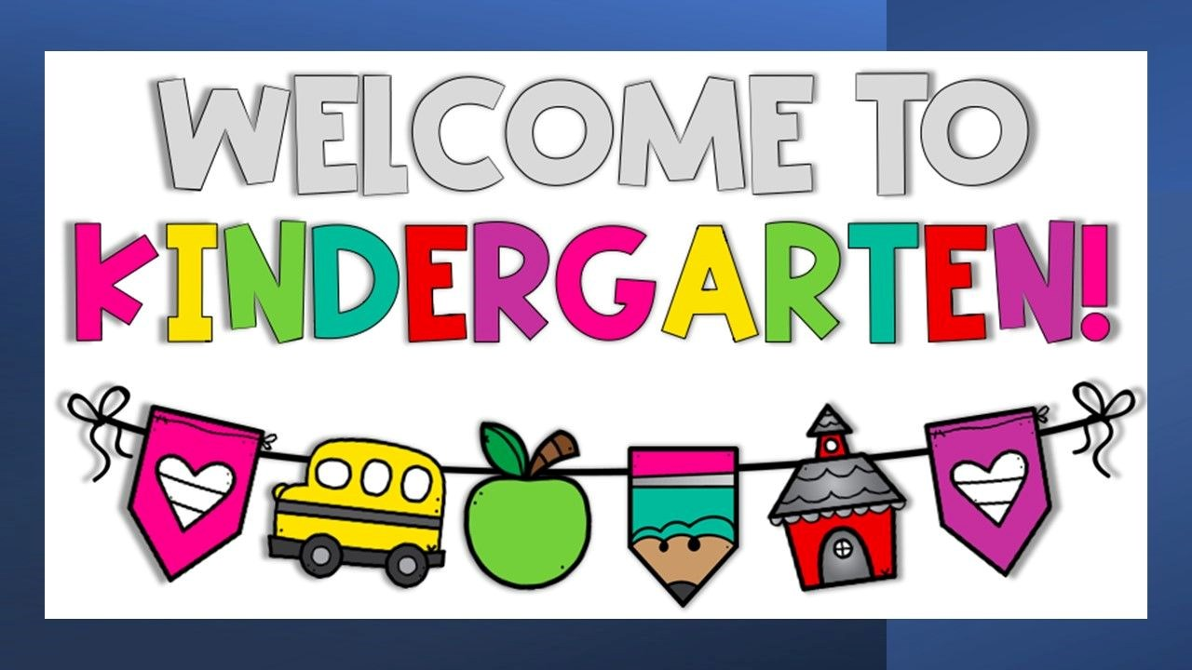

WELCOME TO KINDERGARTEN!

Dear Parents,

Welcome to what will be a fantastic kindergarten year! As we begin this new school year, we pledge to you, our students and parents, that this will be a wonderful year of engaging, meaningful and rigorous work in our classrooms, along with some fun and special times and events.
During the 2026-2027 school year, we will continue to build upon and refine our foundation of work, with none being more important than continuing to build upon our tradition of preparing students to become well-rounded by educating them both socially and academically. Our staff of highly qualified professional educators is committed to providing students many opportunities --- both inside and outside of the classroom --- for high caliber and quality learning, continual growth, leadership opportunities, and achieving at a high level of excellence! We pledge that this will be our focus daily, and we invite and encourage you, our students and parents, to work in partnership with us to seize these opportunities.
We know that it can be challenging as students transition from being at home to being in a school environment. This booklet is intended to help you and your child understand and prepare for this new adventure. With your partnership, I am confident that we will prevail in doing so! So, remember to stay on top of your ABC’s by checking on your child’s attendance, behavior, and course work. We look forward to working with you this year!

Your partner in education,

Dwight Luckett,
Superintendent

Director’s Message

Dear Early Childhood Family Member:
Thank you for enrolling your child in the Canton Public School District’s Early Childhood Education Program. By choosing to have your child participate in our program, you have made a commitment to invest in your child’s education.
The purpose of this handbook is to help you understand this unique educational program, to explain the goals and objectives and to offer suggestions that will help you and your child be successful in the Kindergarten Program and throughout his or her educational matriculation.
We also want you to know we value your support and input. Never hesitate to contact a member of our Early Childhood team who can assist you during your child’s Kindergarten experience. We are pleased to have you and your child as part of our school family.
On behalf of the entire Early Childhood team, we welcome your famiy to the program and we hope this first school year will be the beginning of a lifetime of learning. Thank you for sharing your child with us!

Shoney A. Harris, Ed.S
Director of Literacy & Early Childhood Education


WHAT IS KINDERGARTEN?

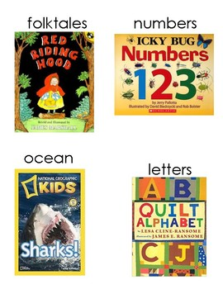

Kindergarten is a program designed to meet the needs of children ages 5 or 6. It offers the opportunity to build a solid foundation for academic, social, physical, emotional, and motor development. To build this foundation, children are prepared using the Mississippi College Career Readiness Standards for developmental readiness and academic readiness. Through whole class, small group, partner, and individual learning activities, kindergarteners will develop into successful, independent learners who are well-prepared for first grade and beyond.

KINDERGARTEN PROGRAM GOALS

SECTION 1
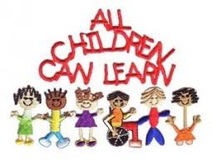

- One of the kindergarten program’s goals is to prepare students to be READY in four areas:

1. Academic Development
  - Develop thinking and learning strategies
  - Develop awareness of language and literacy
  - Develop listening, speaking, and reading abilities
  - Develop writing abilities
  - Develop number, spatial, and statistical sense
  - Develop sense of relationships and patterns
  - Develop an understanding of the world around them

- Social and Emotional Development
  - Develop a positive and realistic self-concept
  - Develop independence
  - Share, co-operate and learn from others

- Physical and Motor Development
  - Learn and practice safety
  - Take care of and respect his or her body
  - Develop movement and coordination of the body and movements
  - Participate in and enjoy movement

- Another kindergarten program goal is to prepare families to be READY in five areas:

- Safe and Consistent Environment
- Being able to reach you in the event of an emergency- contact numbers
- Consistent mode of transportation to and from school
- Notifying school of changes
- Authorized individuals having access to your child
- To check-out students, individual MUST have a valid photo ID and notification from parent and guardian

- Promote Good Health
  - Ensure your child gets enough sleep (10-12 hours)
  - Eat a balanced diet (especially breakfast)
  - Develop habits of cleanliness and independent hygiene
  - Have eyesight, hearing, teeth, and general health checked
  - Update immunizations as directed
  - Keep them home when they are ill (provide contact numbers to the school)
  - Call school to inform absences

- Steady and Supportive Relationships
  - Invest time and attention
  - Understanding of your child’s preferences and hobbies
  - Building a positive, loving home environment

- Home Responsibility
  - Making their bed and keeping room tidy
  - Dressing themselves and choosing their own clothes
  - Answering the telephone and dialing numbers
  - Assigning chores
  - Putting their shoes on independently
  - Cleaning up after eating

- Parent and School Collaboration
  - Attending Parent and Teacher Conferences
  - Visiting your child’s classroom
  - Volunteering in child’s classroom and school
  - Attending your child’s school PTO meetings
  - Volunteering your talents, skills, and profession

REQUIREMENTS FOR ENROLLMENT

SECTION 2

- Entrance Age

- Required Age
A child is eligible for a kindergarten program if they reach five years of age on or before September 1.

- Required Documentation
A birth certificate and current immunization record (Form 121) are required for all kindergarten students and shall be presented to the proper school authority.

- Requirements for enrollment of children in public school: MS Code § 37-15-9 (2013)
(1) Except as provided in subsection (2) and subject to the provisions of subsection (3) of this section, no child shall be enrolled or admitted to any kindergarten which is a part of the free public school system during any school year unless such child will reach his fifth birthday on or before September 1 of said school year, and no child shall be enrolled or admitted to the first grade in any school which is a part of the free public school system during any school year unless such child will reach his sixth birthday on or before September 1 of said school year. No pupil shall be permanently enrolled in a school in the State of Mississippi who formerly was enrolled in another public or private school within the state until the cumulative record of the pupil shall have been received from the school from which he transferred. Should such record have become lost or destroyed, then it shall be the duty of the superintendent or principal of the school where the pupil last attended school to initiate a new record.
(2) Subject to the provisions of subsection (3) of this section, any child who transfers from an out-of-state public or private school in which that state's law provides for a first-grade or kindergarten enrollment date subsequent to September 1, shall be allowed to enroll in the public schools of Mississippi, at the same grade level as their prior out-of-state enrollment, if:
(a) The parent, legal guardian or custodian of such child was a legal resident of the state from which the child is transferring;
(b) The out-of-state school from which the child is transferring is duly accredited by that state's appropriate accrediting authority;

(c) Such child was legally enrolled in a public or private school for a minimum of four (4) weeks in the previous state; and
(d) The superintendent of schools in the applicable Mississippi school district has determined that the child was making satisfactory educational progress in the previous state.

- Compulsory-School-Age and Withdrawal: Mississippi Code § 37-13-91
(f) “Compulsory-school-age child” means a child who has attained or will attain the age of six (6) years on or before September 1 of the calendar year and who has not attained the age of seventeen (17) years on or before September 1 of the calendar year; and shall include any child who has attained or will attain the age of five (5) years on or before September 1 and has enrolled in a full-day public school kindergarten program.



SECTION 3
CURRICULUM, MATERIALS, AND ASSESSMENTS

- Curriculum
The Canton Public School District’s kindergarten program uses research and evidence-based curriculum that is aligned with the Mississippi College and Career Readiness Standards that promotes reading, listening, thinking, speaking, writing, music, art, social studies, science, dramatic play, and physical activities.

- Learning Centers
The kindergarten program integrates learning centers in the language arts instructional period. Students are engaged in a minimum of four learning centers (three primary centers and one teacher-led small group) All centers are labeled, organized, and arranged so they can be accessible to students. Students are engaged in learning centers for a minimum of 120 minutes per day.
Learning Centers:
- Provide opportunities for students to engage in learning
- Integrate multiple subjects matters so that learning happens in a meaningful context
- Assess students’ understanding and knowledge through observation and authentic assessments practices
- Provide Hands-on opportunities to practice learning
- Foster a love of learning

- Educational Materials
Kindergarten teachers use instructional materials that are suited for students to meet their developmental needs. School Supply List vary by school; each school is expected to share its list with parents. At this time, we do not recommend parents buying mats for rest. Our kindergarten program requires quiet time. In addition, kindergarten students have access to technology on a daily basis.

- Assessment

SECTION 4
- Vision and Hearing Screening
Kindergarten students are given vision and hearing screenings within the first 45 days of school. Screening results are reviewed and the necessary education or developmental referrals are made within 45 days of the initial screening.
- Standardized Testing
All kindergarteners are administered the state-approved kindergarten readiness assessment. Students are tested at the beginning of the year and at the end of the year. All assessment data results are shared with parents. Students who show deficits are given interventions, which may be administered or documented by classroom teacher. Students will be given follow-up assessments to determine if interventions are successful. If the intervention is not successful, students will be given additional intervention; or the student may be referred for an evaluation for special educational service, if data collected support the suspicion of a disability. When making referral, district should follow their Child Find procedures.
- Individualized Testing
Kindergarteners are administered language arts, math, science, and social studies assessments to measure their learning outcomes from the required curriculum standards. All assessment data results are shared with parents.
- Portfolio of Student Work
Each kindergartner is required to have a compilation of their academic work and other documents of educational evidence to show whether students have met learning standards and an archive of their academic work products. This helps give an accurate picture of what the student has learned and able to do.
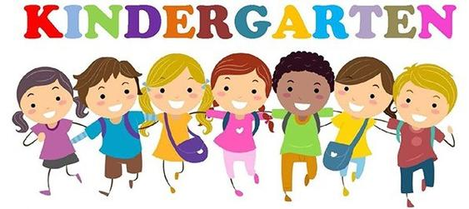

KINDERGARTEN ORGANIZATION AND STAFF
- Organization
- Requirements for Teacher-Child Ratio/ Length of School Day and Term
Kindergarten teacher-child ratio is 2:27 with a full-time teacher and assistant teacher. The length of the school day and school term is the same as that of the elementary school. Thus, the school day is 8:00 a.m. to 2:30 p.m.
- Requirements of the Instructional Day
Kindergarten’s instructional day consists of a minimum of 330 instructional minutes, to include 30 minutes of physical activities and 120 minutes of learning centers; 30 minutes of quiet time.
- Quiet Time
Kindergarten students are engaged in 30 minutes of quiet time daily. During this time, students are engaged in individual activities, looking at books/reading, listening to books on tape (audio books), and drawing, as appropriate for each individual student.
- Sample Full Day Kindergarten Schedule
Time | Instructional Activity | Minutes
8:00- 8:30 | Tiger Time: Phonemic Awareness | 30 minutes
8:30 – 9:00 | Daily Phonic Drill | 30 minutes
9:00 – 10:00 | - Shared Reading w/ Social Studies  - Shared/Interactive Writing  - Guided Group Reading w/ Centers | 120 minutes
11:00 -12:00 |  | 120 minutes
10:30 – 11:00 | Physical Education | 30 minutes
12:00-1:00 | Math | 60 minutes
1:00 – 1:30 | Science | 30 minutes
1:30 – 2:00 | Quiet Time | 30 minutes

- Certification of Kindergarten Teachers and Assistants
All kindergarten teachers are required to possess a 153, 116, 152, or a 120 license to teach a kindergarten classroom. All kindergarten teacher assistants must have an associate degree or higher, two-years or 48 college credits, or high school diploma and met Work-Keys requirements.

FAMILY ENGAGEMENT AND TRANSPORTATION

SECTION 5

- Family Engagement
- Kindergarten Handbook
Each school district must provide a handbook detailing the kindergarten philosophy, goals, and information unique to the kindergarten program.
- Requirement of Parent Communication
Each school shall follow the district’s policy and the school’s procedures for communicating with parents. Parent/teacher conferences are held twice a year during the kindergarten school year to inform parents or guardians of their child’s academic progress. Communication should be conducted on a regular basis between school and home.
- Parent Involvement
Each school shall follow the district’s policy and the school’s procedures for parent involvement. Regular parent involvement is highly recommended through such activities as Open House, Back-to-School night, Title I Night, teacher/parent conferences, Parent Fall/Spring Night, PTA, EL Night, and other school related activities to enhance the collaboration between parents and school. Parent or guardians are welcomed to volunteer at their child’s school. Parents are encouraged to share their ideas, skills, profession, or talents through varied activities. Volunteers that serve more than 120 hours per school year MUST sign a confidentiality agreement and consent to a background check conducted by the school district.

- Student Transportation
All transportation is optional except for students who have it listed as a service on their Individualized Education Programs (IEPs). Transportation requirements regarding children with IEPs are determined by the IEP Committee. Also, all kindergarten programs must abide by MS Code § 37-41-3 (2013) and National Highway Transportation Safety Association Guidelines. School bus drivers should promote a safe and positive environment through appropriate interaction with the students.

SECTION 6
REFERENCES

Mississippi Department of Education Kindergarten Guidelines, 2018
Mississippi Secretary of State, Mississippi Codes and Statutes, July 26, 2018

