Cadet Handbook

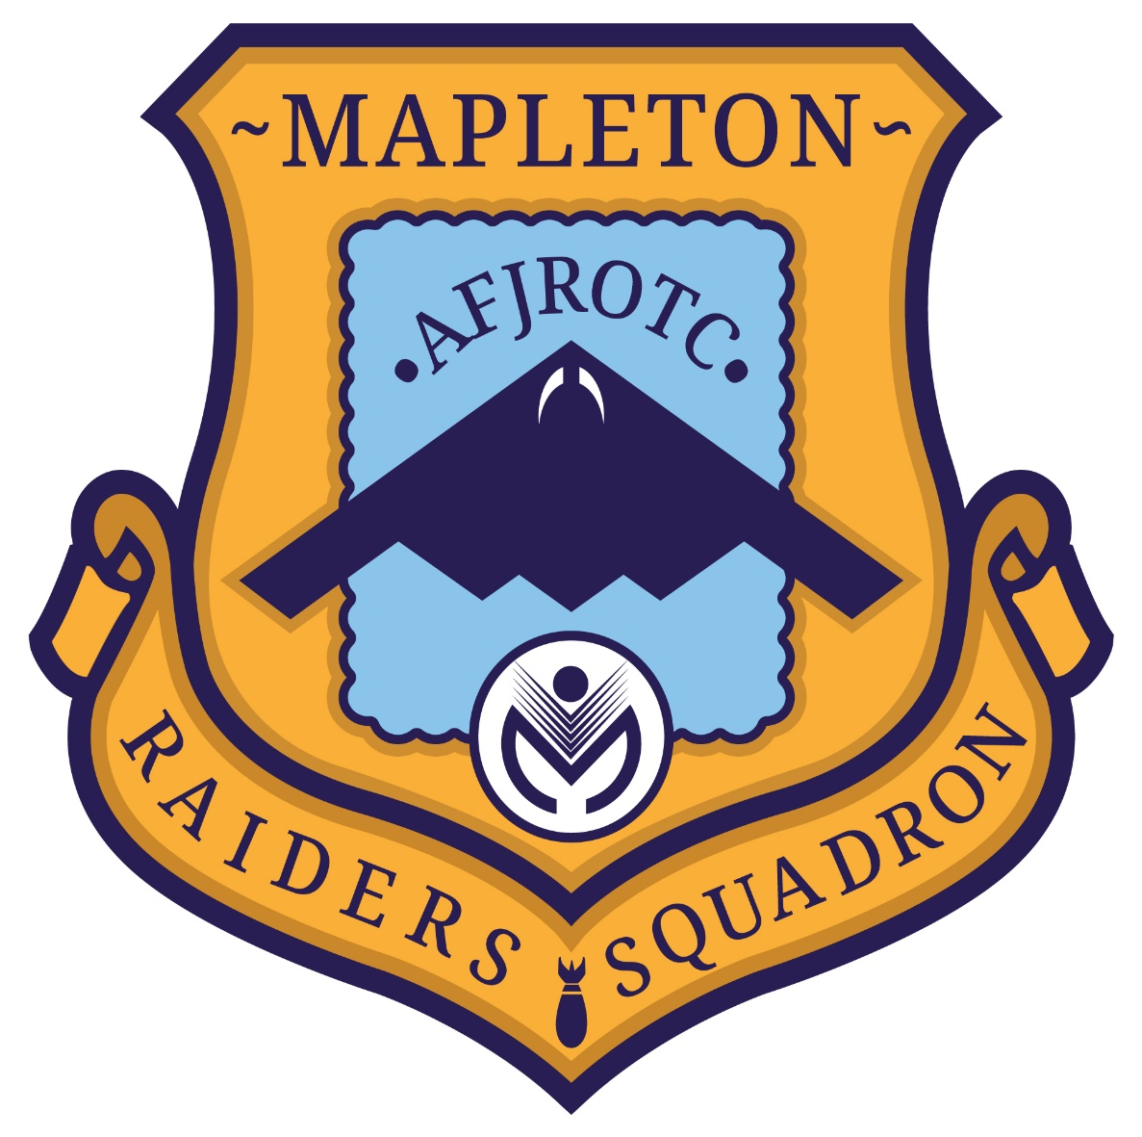

Mapleton Public Schools
[CO-20101]
2026-2027
Table of Contents

Air Force Song & AFJROTC Cadet Creed………………………………………………….. 3
Policy Statement, Mission Statement & USAF Core Values.....................................................4
Harassment, Bullying, Inappropriate Behavior, Hazing, & Discipline Policy……………….5
Mapleton Raiders Standards & Levels of Discipline...………………………………………...6
341 Form & Feedback System.………………………………………………………………….7
Mapleton Raiders Chain of Command...…………………………………………………….....8
Cadet Uniform Standards.………………………………………………………………………9
Cadet Grooming Standards……………………………………………………………………32
Cadet Leadership Responsibilities...…………………………………………………………..41
Cadet Recognition Program………………….………………………………………………...42
30-StepDrill Sequence……………………………………………………………………………………43
AFJROTC Ribbon Chart.……….……………………………………………………………..44

The Air Force Song
Wild Blue Yonder
By Robert Crawford

Off we go into the wild blue yonder
Climbing high into the sun.
Here they come zooming to meet our thunder.
At ‘em now, give ‘em the gun! (Give ‘em the gun!)
Down we dive, spouting our flame from under,
Off with one helluva roar!
We live in fame or go down in flame. Hey!
Nothing’ll stop the U.S. Air Force

AFJROTC Cadet Creed
I am an Air Force Junior ROTC Cadet.
I am connected and faithful to every Corps of Cadets who served their community and nation with patriotism.
I earn respect when I uphold the Core Values of Integrity First, Service Before Self, and Excellence in All We Do.
I will always conduct myself to bring credit to my family, school, Corps of Cadets, community, and to myself.
My character defines me. I will not lie, cheat, or steal. I am accountable for my actions and deeds.
I will hold others accountable for their actions as well.
I will honor those I serve with, those who have gone before me, and those who will come after me.
I am a Patriot, a Leader, and a Wingman devoted to those I follow, serve, and lead.
I am an Air Force Junior ROTC Cadet.

Policy Statement
Policy statement: The Cadet Handbook is designed to provide statements of policy, guidelines, and directions for operation of the Colorado 20101 Air Force Junior ROTC Cadet Squadron. This handbook provides standards by which AFJROTC cadets can work towards common goals of academic and military achievement. It assumes that cadets work toward the betterment of the group if they know the goals of the unit.
***All cadets are responsible for the information contained in this guide.
Handbook Responsibilities: The handbook is posted on Canvas. The handbook will be printed, and a copy given to each cadet for future use. It will be the cadet’s responsibility to bring this handbook to class everyday…no exceptions.
IMPORTANT: Cadets will have two weeks (10 class days) from the start of the academic year to drop the AFJROTC program. After that point, cadets will remain in the program until the academic year is complete. Extenuating circumstances will be looked at on a case-by-case basis. However, arbitrarily leaving the program WILL NOT be allowed. AFJROTC program was built on the premise of, “You finish what you start!”

Mission Statement
The mission of the AFJROTC program is to develop citizens of character.

Core Values
Integrity First: Integrity is the willingness to do what is right even when no one is looking. It is the ability to hold together and properly regulate all the elements of a personality. It also covers courage, responsibility, accountability, and self-respect.
Service before Self: Service before self tells us that professional duties take precedence over personal desires. At the very least it includes rule following, respect for others, discipline, self-control, and faith in the system.
Excellence in All We Do: Excellence in all we do directs us to develop a sustained passion for continuous improvement and innovation that will propel the Air Force into a long-term, upward spiral of accomplishment and performance. This applies to, but is not limited to, the following areas: Product/service excellence, personal excellence, community excellence, resources excellence, and operations excellence.
*More information on the Core Values can be found in “The Little Blue Book” – The United States Air Force Core Values book.

Harassment/Bullying/Inappropriate Behavior/Hazing/Physical Discipline

- Harassment/Bullying: Harassment or bullying of any of the cadets by anyone of any rank is strictly forbidden. Blatant misuse of authority will result in loss of position. Examples of harassment are improper or abusive language and physical abuse such as push-ups or having lower ranking cadets perform (non-offensive) duties for you.
- Inappropriate Behavior: Inappropriate behavior while in/out of uniform is prohibited. Such inappropriate behavior includes overly affectionate contact, horseplay, drug use, underage drinking, smoking e-cigarettes, and fighting. Verbal threat or physical aggression will be subject to additional school and legal consequences. All inappropriate behavior is considered “conduct unbecoming of an AFJROTC cadet.”

- Hazing: Hazing is defined as “the practice of directing someone of lesser rank to perform a humiliating action, which entails the surrender of dignity and self-respect, or a hazardous action which exposes one to physical bodily harm or injury.” HAZING IS STRICTLY FORBIDDEN IN AFJROTC AND IN THE MAPLETON SCHOOL DISTRICT.
4. Physical Discipline: Any use of physical discipline, such as, push-ups, wall-sits etc., is
strictly forbidden.

NOTE: Drug and alcohol use/abuse/possession will result in immediate removal/dismissal from AFJROTC.

Mapleton Raiders Standards
A cadet’s standards in the Raider Squadron are viewed in areas of attendance, preparation, performance, behavior, and uniform standards. If a cadet is having problems in one or more of these areas, then it will be noted and dealt with through the following policies:
NOTE: The following actions/behaviors will result in a cadet being disciplined by Cadet Leadership and/or the SASI/ASI :
*The severity of the discrepancy will be considered when deciding what Strike the cadet will be placed under. *
- An unexcused absence or tardy in any ROTC activity
- Failure to bring graphic organizer to class.
- Failure to turn in homework more than once without a valid excuse.
- Poor behavior in class or as indicated by a teacher.
- Failure to follow the room norms.
- Failure to wear the uniform correctly (includes P.T. and ABU)
- Disrespect towards authority (Element Leaders, Instructors, Top 10, etc.)
- A detention or suspension at school
- Violation of any of the three Core Values

Levels of Discipline

1. Verbal Warning: If a cadet IS NOT within standards, their Flight Commander or Sergeant will verbally warn them to address their behavior and correct any deficiencies.

2. Commander/Vice commander 341: If a cadet’s discrepancies continue, the cadet’s corresponding Corps commander/Vice Corps Commander will issue a 341 (Cadet Feedback Form) to the cadet.

3. SASI/ASI/Parent/Guardian Involvement: Further issues will result with a meeting between the SASI/ASI, parent/guardian to discuss cadet behavior and possible removal from the program.

341 Form
Example 341:


Feedback System
The feedback system includes two feedback sessions per school year. The first feedback session will be administered prior to the end of 1st semester and the final feedback will be given at the end of the school year.

Mapleton Raiders Chain of Command

Squadron Commander (C/Lt Col): ______________________________
Vice Commander (C/Maj): _____________________________________
Director of Operations (C/Maj): _________________________________
Squadron Administrative Officer (C/Capt): _______________________
Drill Team Commander (C/Capt): _______________________________
Squadron Chief (C/CMSgt): ____________________________________
First Sergeant (C/SMSgt): ______________________________________
Public Affairs Officer (C/1Lt): __________________________________
Logistics Officer (C/1Lt): ______________________________________
Chaplain (C/1Lt):_____________________________________________
Financial Manager (C/TSgt):___________________________________
Unit Fitness Program Monitor (C/TSgt): _________________________
Flight Commander (C/2Lt): ____________________________________
Flight Sergeant (C/MSgt): _____________________________________
Element Leader: _____________________________________________

Cadet Uniform Standards
Wearing the Uniform: The Academy AFJROTC requires each cadet to wear the Blue/OCP uniform for one full school day every other week (alternating). The uniform must be worn properly. The bi-weekly uniform wear day will be Thursday (unless directed by the SASI/ASI), as well as on days of AFJROTC field trips, flying activities, and exhibitions. Every cadet must wear their uniform for the entire day unless excused in advance by the SASI or the ASI.
Cadets are not allowed to wear the uniform if participating in demonstrations, hitchhiking, seeking employment, or other activities in which Stealth Squadron, AFJROTC, or the Air Force may be misrepresented. AS100 cadets will not wear a uniform prior to SASI/ASI approval. They earn the uniform by showing dedication and enthusiasm for the program through superior attendance.
Combination 1 (Class A): The Service Dress Uniform, which includes the Service coat, short sleeve light blue shirt/blouse, tie/tab, dark blue slacks/skirt, flight cap, belt, shoes (appropriately polished), and black socks.
Combination 2 (Class B): Lightweight Jacket (if appropriate due to weather), short sleeve light blue shirt/blouse, tie/tab, dark blue slacks/skirt, flight cap, belt, shoes (appropriately polished), and black socks.
Combination 3 (Class B): Lightweight Jacket (if appropriate due to weather), short sleeve light blue shirt/blouse, open collar, dark blue slacks/skirt, flight cap, belt, shoes (appropriately polished), and black socks.
Operational Camouflage Uniform (OCP): This uniform is only worn by select cadets at the discretion of the SASI/ASI and is worn on Thursdays replacing one blues day (2nd monthly uniform wear).
General Wear Rules:
- Keep your hands out of your pockets during formation.
- Do not wear civilian clothing with your uniform, except for a civilian winter coat during inclement weather.
- Keep all buttons buttoned, both the Service Coat and the shirt.
- Belts should be worn metal to metal on the left (only the metal tip should show past the buckle). Females wear belts metal to metal on the right.
- Shoes should be polished to a high gloss whenever worn.
- Do not engage in any public displays of affection while in uniform.

Badges
FLIGHT SOLO BADGE. Awarded to any cadet who has a solo flight endorsement by a certified flight instructor for either powered or unpowered aircraft.
FLIGHT CERTIFICATE BADGE. Awarded to any cadet who possesses a valid FAA pilot’s certificate for either powered or unpowered aircraft.
GROUND SCHOOL BADGE. Awarded for participation in the honors ground school curriculum option, or successful completion of another aviation ground school program prescribed by the FAA.
AWARENESS PRESENTATION TEAM BADGE. Awarded for participation in an awareness presentation team. Stealth Squadron Cadets must participate in at least three team presentations.
KITTY HAWK AIR SOCIETY BADGE. Awarded to those cadets who are members of the local chapter of the Kitty Hawk Air Society. Note: If membership lapses, this badge cannot be worn.
MODEL ROCKETRY BADGE. Awarded to cadets who have completed requirements for the award as part of the Aero Club.
DISTINGUISHED AFJROTC CADET BADGE. This annual award consists of a certificate and the Distinguished AFJROTC Cadet badge. The award recognizes one outstanding second- year cadet (third-year cadet in a 4-year program) selected at the end of each school year. This allows the recipient to wear the award their final year in the AFJROTC program. The recipient must be of high moral character, demonstrate positive personal attributes, display outstanding military potential, and maintain consistent academic and military excellence. The SASI, in coordination with the ASI and with the concurrence of the principal, selects the recipient of this award. The recipient will hold the following awards prior to selection:
a. Leadership Ribbon
b. Achievement Ribbon
c. Superior Performance Ribbon
d. Academic Ribbon
e. Leadership Development Requirement
f. Service Ribbon

ACADEMY OF MODELING AERONAUTICS WINGS. Awarded to cadets who are actively involved in the model airplane team as part of the Aero Club. Must be a member of local AMA club.
AEROSPACE EDUCATION FOUNDATION (AEF) ACADEMIC CADET BADGE. Awarded to rising junior and senior cadets for academic excellence as signified by attaining an overall 3.3 grade point average with no “C” grades on their transcript. These individuals must be recommended by the SASI. Note: If G.P.A. and grades are not maintained, this badge cannot be worn.
OTHER BADGES OR PINS.
CyberPatriot and Stellar Explorer pins/badges have been replaced with ribbons.

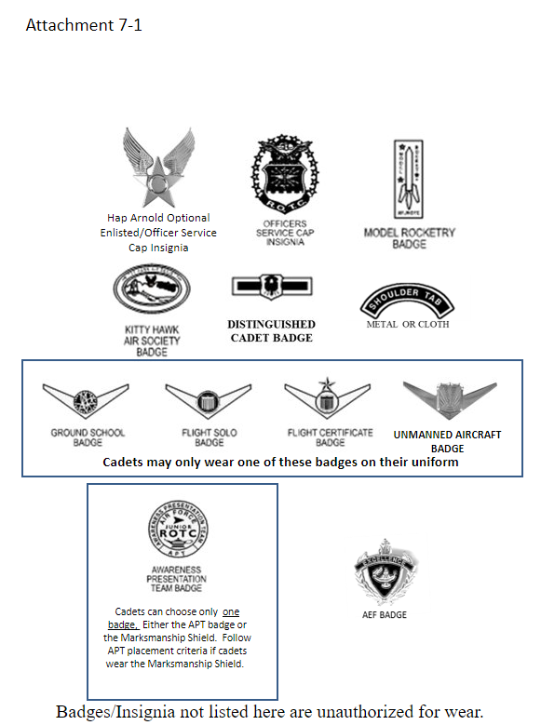

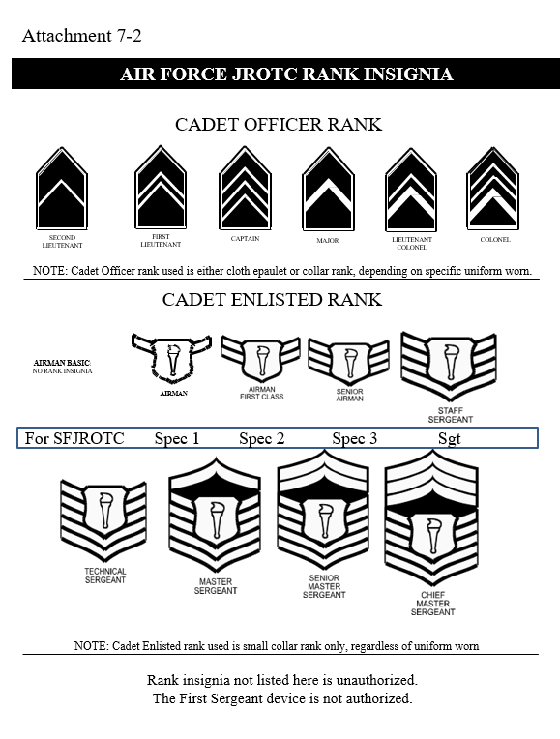
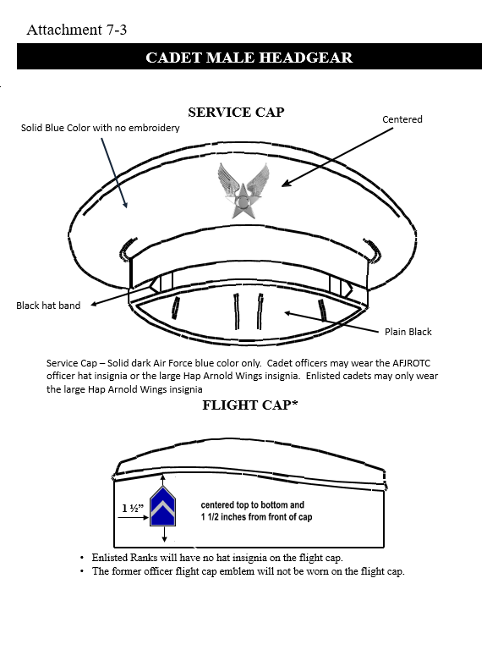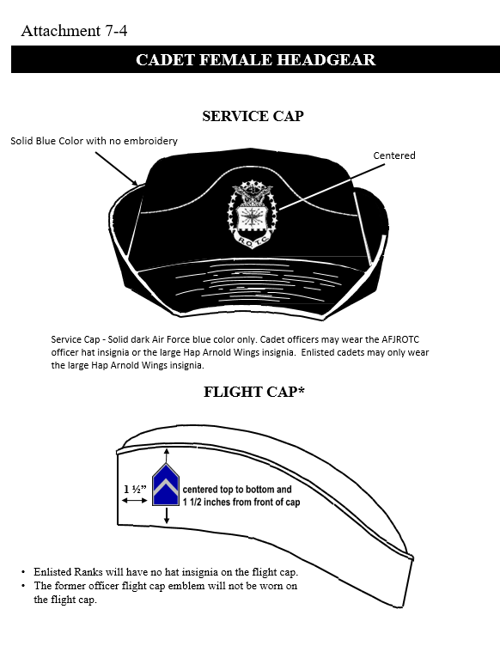
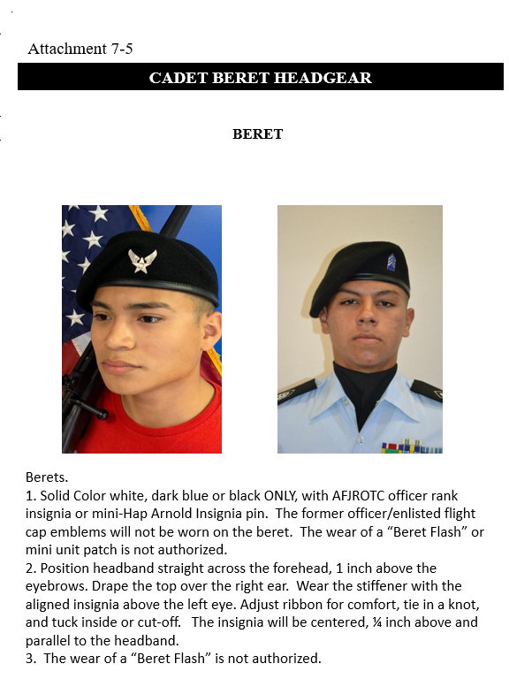

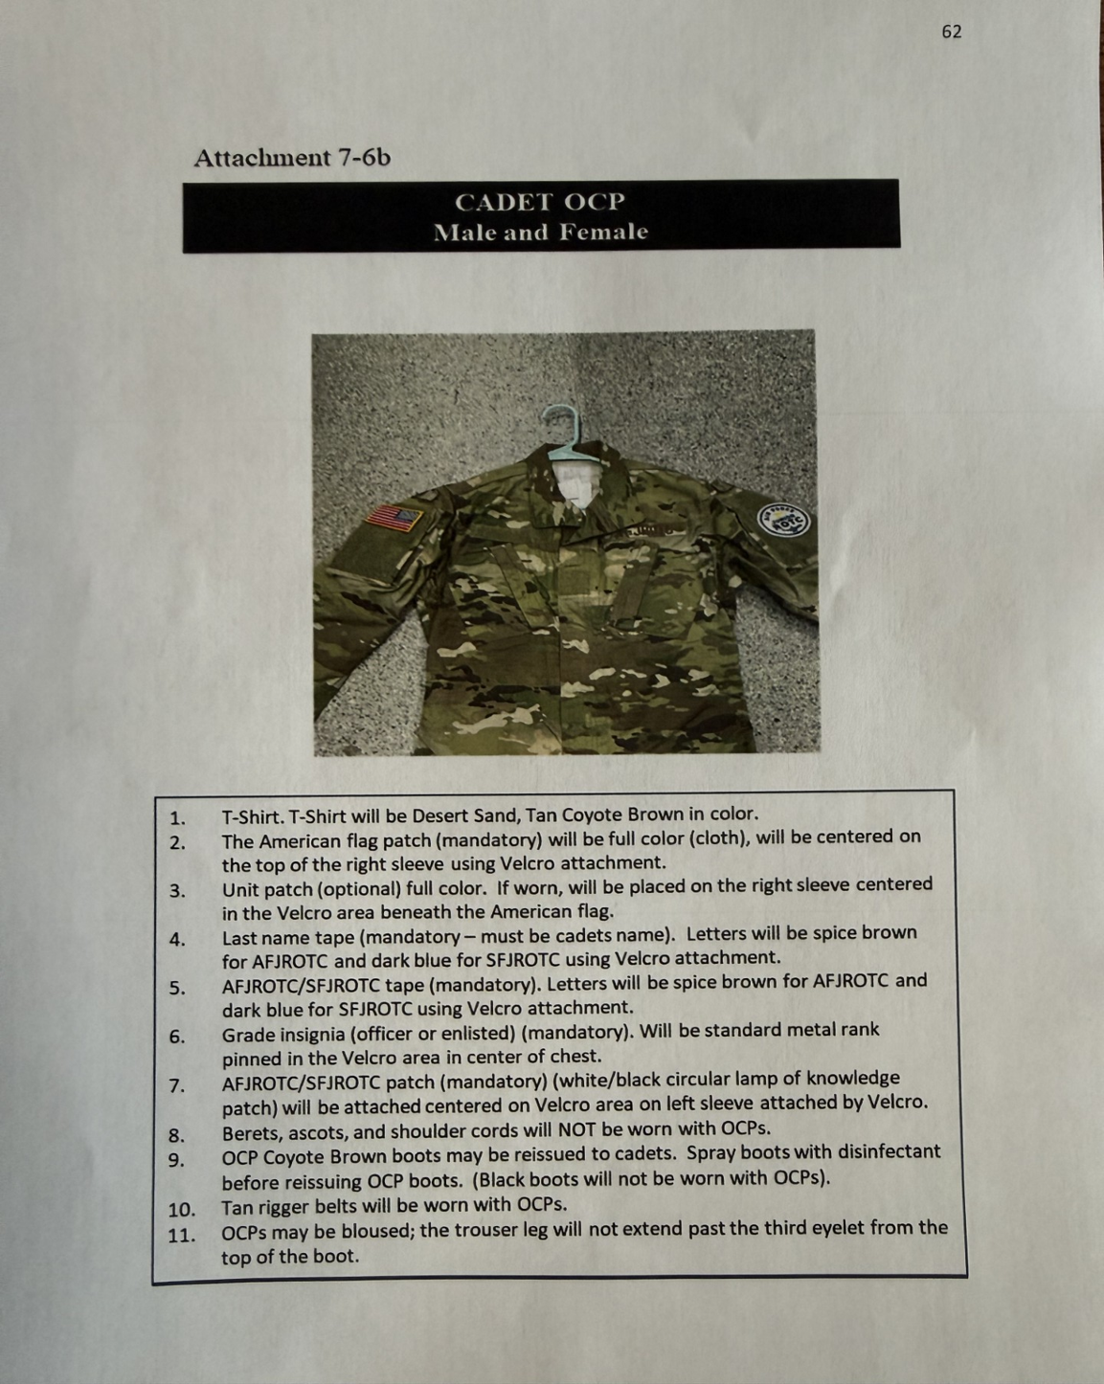
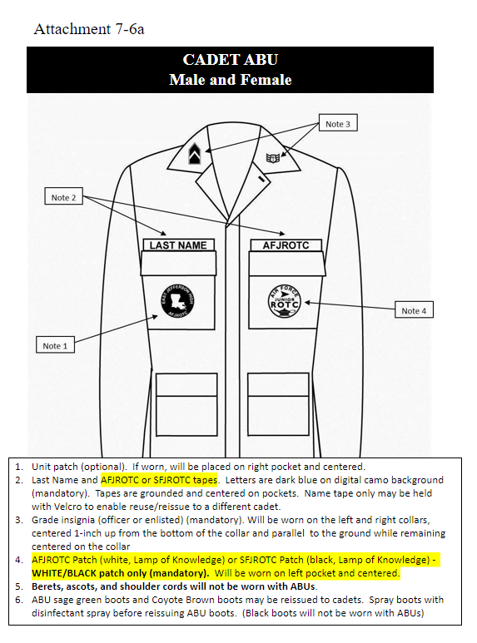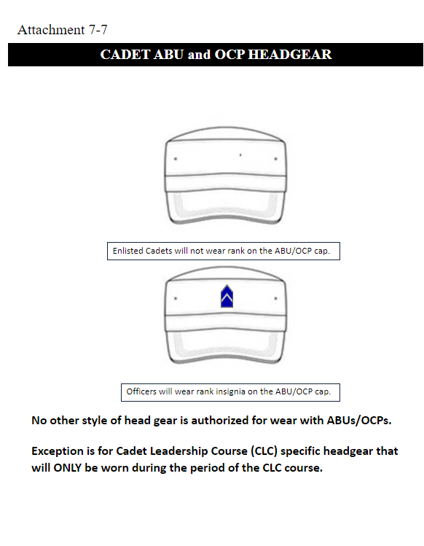
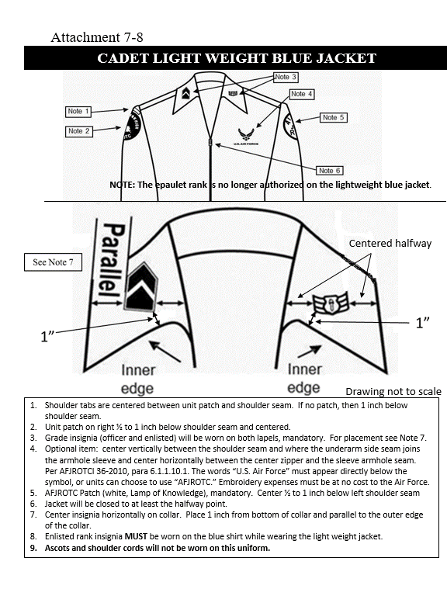
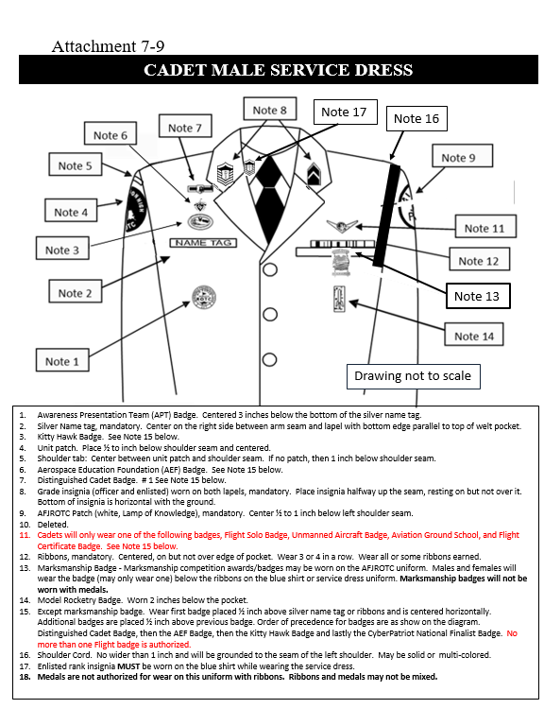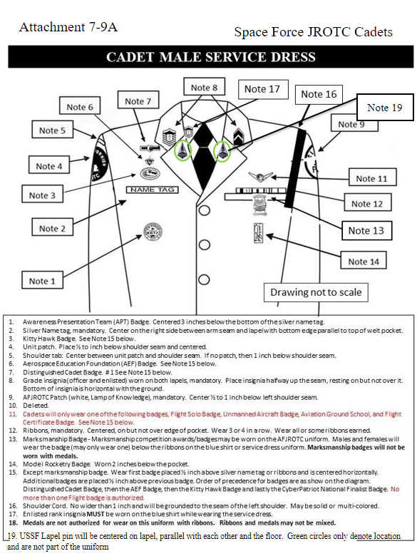
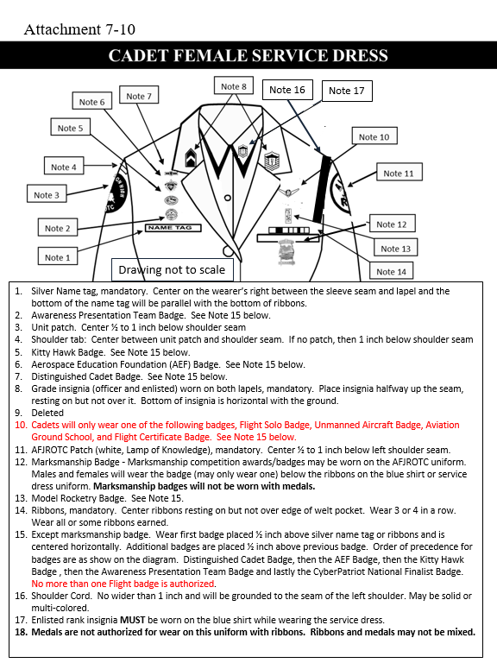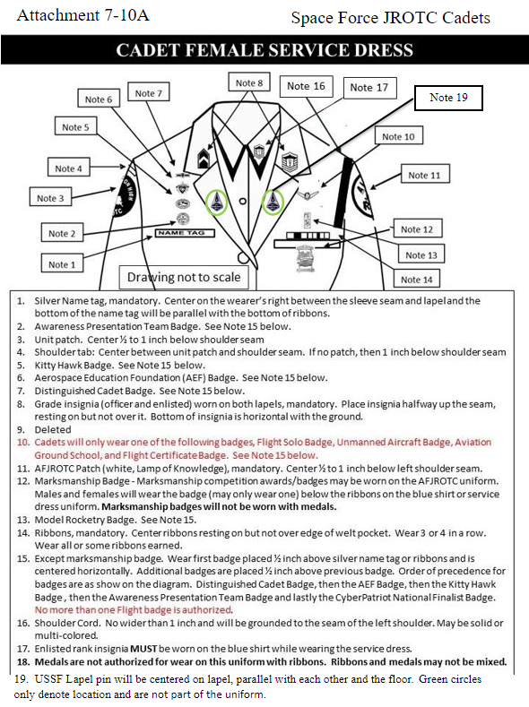
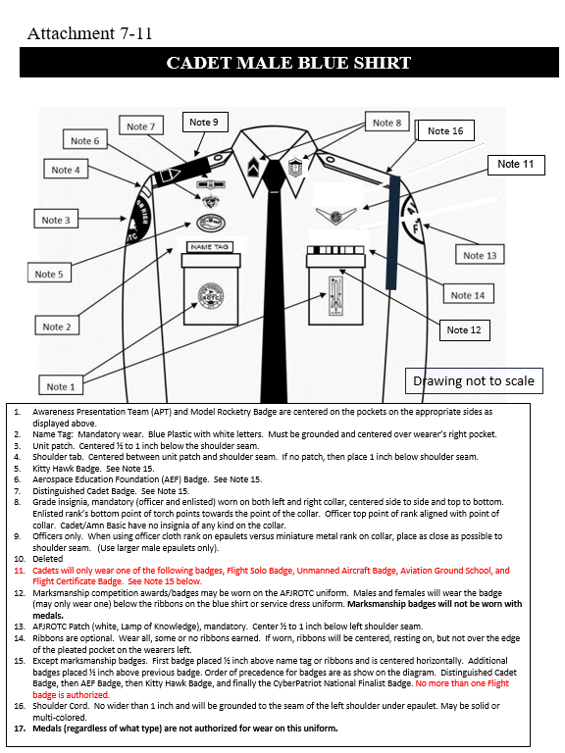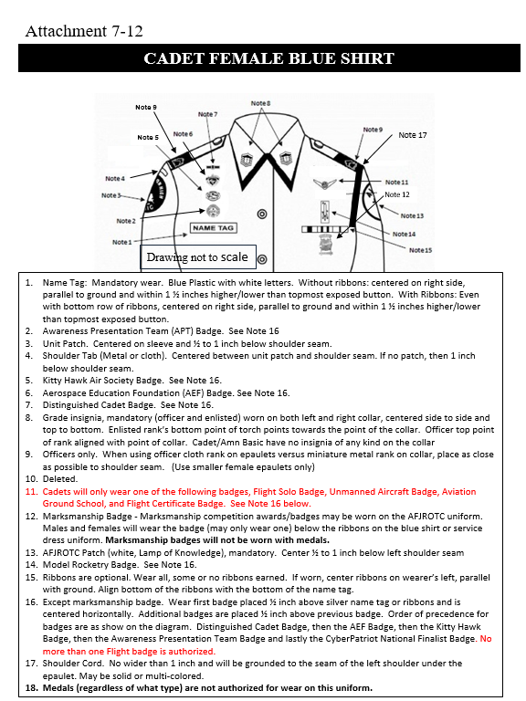
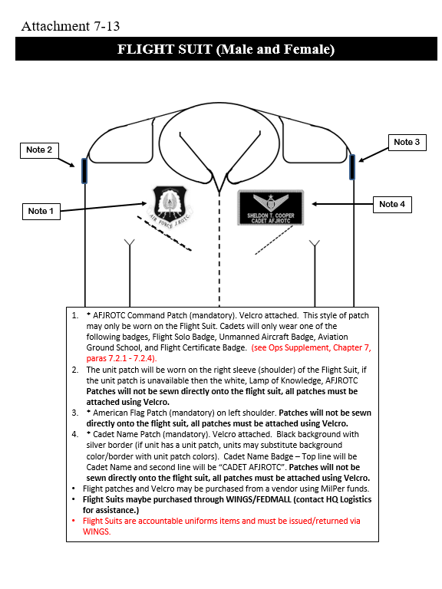
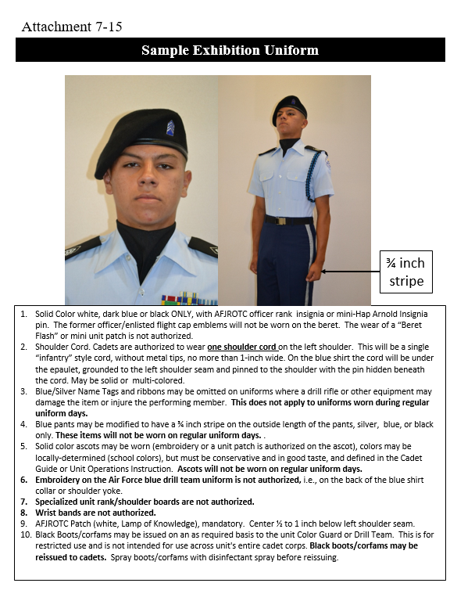
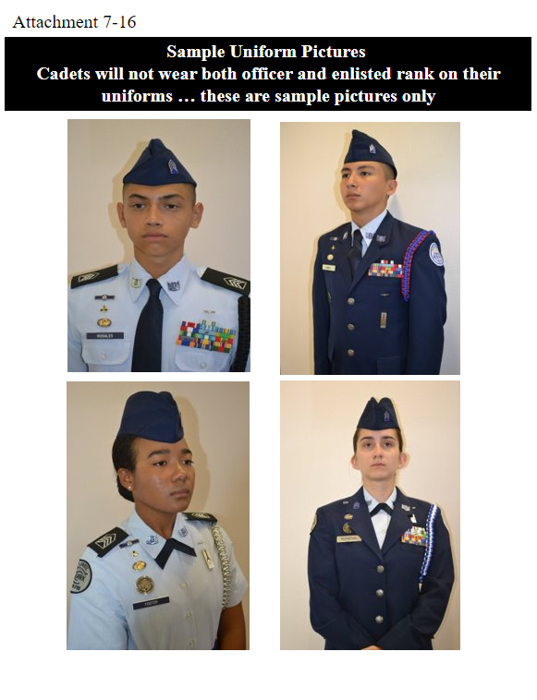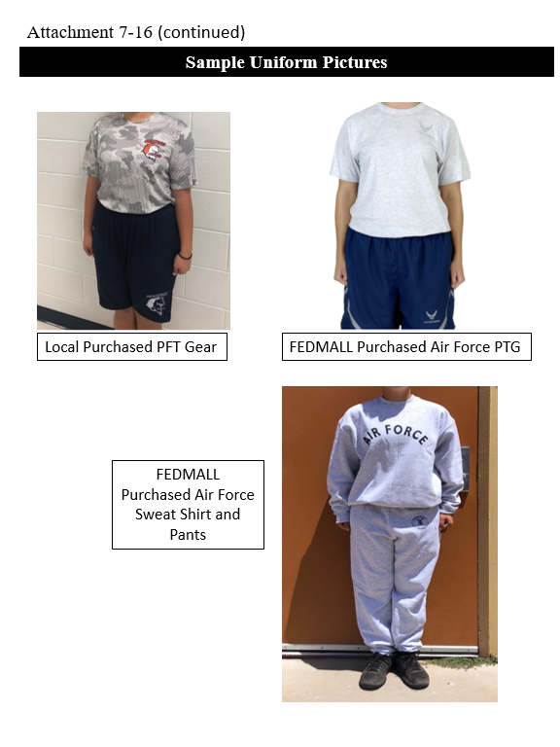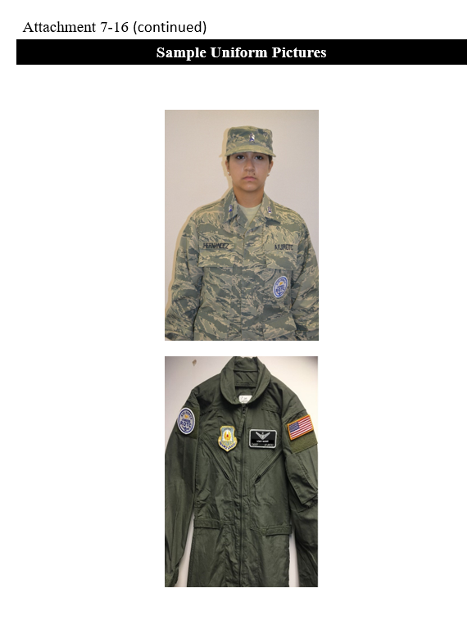

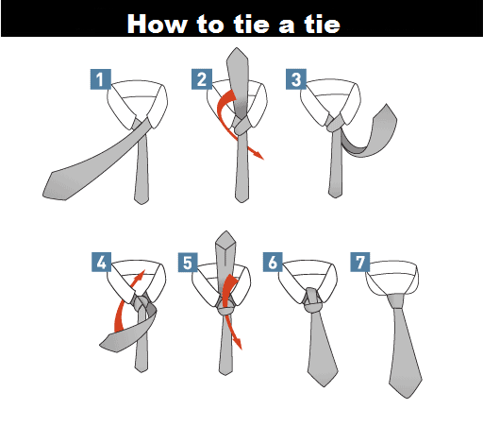
Physical Training Uniform
- PT shirts and PT shorts must be always worn. Raider shirt will be worn once course fee is paid and shirt is ordered/received.
- White or black socks with athletic shoes.
- PT sweatpants and sweatshirt worn in inclement weather or as directed by the SASI/ASI.
- Shirts long/short sleeves may be tucked or untucked.
- Drawstrings tucked in.
- Female hair must be put up with hair accessories of the same color of your hair.
- Men must abide by the same grooming standards as in the blue uniform.

Cadet Grooming Standards
Appearance and Grooming. When a cadet wears the uniform, he/she is responsible for presenting a neat, clean, and professional military image. Appearance and grooming standards help cadets present the image of disciplined cadets who can be relied upon to do the job they are called on to do. A professional military image has no room for the excessive or extreme. The standards for wearing the uniform consist of five elements: Neatness, cleanliness, safety, uniformity, and military image. The first four are absolute, objective criteria for the efficiency, health, and well- being of the force. The fifth standard, military image is also very important, military appearance is subjective, but necessary. People, both military and civilian, draw conclusions as to the military effectiveness of the Air Force by how they perceive those in uniform.
Jewelry. While in uniform will be plain and conservative (moderate, being within reasonable limits; not excessive or extreme) as determined by the SASI.
Rings. Cadets may wear a total of no more than three rings: wedding sets count as one ring when worn as a set. Rings will be worn at the base of the finger and can be worn on the thumb.
Necklaces. Will not be visible at any time. If worn, will be concealed under a collar or undershirt.
Bracelets. Ankle bracelets are not authorized. Cadets may wear one bracelet around their wrist. If worn, the bracelet will be conservative (moderate, being within reasonable limits; not excessive or extreme) in design, no wider than ½ inch, gold, or silver in color, and will not have any inappropriate pictures or writing. Medical alert/identification bracelets are authorized. If worn, medical alert/identification bracelets will be conservative and moderate. Bracelets will not be excessive or extreme, which is defined as plain, not drawing inappropriate attention. Gemstones/tennis bracelets may only be worn with the mess dress uniform. Bracelets espousing support for cause, philosophy, individual or group are not authorized (Exception: Traditional metal POW/MIA/KIA bracelets, which come in colors besides silver, bronze, or gold, remain authorized). No rubber or fabric type bracelets are allowed.
Eyeglasses/Sunglasses. Will be worn in the manner for which they are made. Eyeglasses and sunglasses will not be worn around the neck or on top/back of head or exposed hanging on the uniform. Eyeglasses and sunglasses may have conservative ornamentation on non-prescription sunglasses or eyeglasses, frames may be black or brown material or gold or silver wire. Brand name glasses may be worn with small logo on frames or lenses. Logo may contrast with frame color or lenses (conservative colors/small logos; black, brown, matte silver/gold). Conservative wrap-around sunglasses may be worn. Conservative, clear, slightly tinted, mirrored, or photosensitive lenses are authorized. Sunglasses (to include darkened photosensitive lenses) are not authorized in formation. [Exception: Sunglasses are not authorized in formation, unless for medical reasons, e.g., PRK/Lasik surgery and when authorized by a commander or commandant on the advice of a medical official.]
Hairnets. Worn as required for health and safety reasons. Must be made of natural/synthetic material and appear conservative in solid color similar to the wearer’s hair color. Has to be strong enough to support the hair and have no metal fasteners. Hairnets are authorized only when doing certain duties determined by the SASI.
Tattoos or Brands. Whether you are in or out of uniform, tattoos, or brands anywhere on the body are not allowed if they are obscene or if they advocate sexual, racial, ethnic, or religious discrimination. Tattoos or brands that might harm good order and discipline or bring discredit upon the Air Force are also barred, whether you are in or out of uniform. Tattoos, brands, and body markings WILL NOT be on the head, face, tongue, lips, eyes, and scalp.
NOTE: The SASI may exercise discretion if a new cadet arrives with a tattoo that may not be in full compliance with the above guidance.
Body Piercing. Cadets in uniform ARE NOT allowed to attach or display objects, articles, jewelry, or ornamentation to or through the ear (exception is transparent ear-piercing spacers that can only be used in the lower lobe), nose, tongue, or any exposed body part (including anything that might be visible through the uniform). Cadets may not cover any of these articles with make-up, band aids, or wearing clear post pins to hide body piercings.
Backpacks. Cadets may wear a backpack on the left shoulder or both shoulders (not to interfere with rendering the proper salute).
NOTE: Backpacks are to be carried when wearing COMBO 1…NO EXCEPTIONS!
Wear/use of an earpiece. Any Bluetooth technology, or headphones, while in uniform, indoors or outdoors, is prohibited, unless specifically authorized for the execution of official duties. Exception: Headphones and earphones [iPods, MP3-type players, etc.] are authorized during travel on public transportation i.e., bus, train, or air travel.
Dental Ornamentation. Teeth that are natural, capped, or veneered, will not be ornamented with designs, jewels, initials, etc. Permanent or temporary just for the use of decoration and not for medical/dental necessity is prohibited.
Specific Female Cadet Grooming Guidelines.
Hair-Female. No Minimum hair length, to a maximum bulk of 4 inches from scalp and allows proper wear of headgear. Also, one or two braids or a single ponytail may be worn with bulk not exceeding the width of the head and length not extending below a horizontal line running between the top of each sleeve inseam at the under arm through the shoulder blades. Bangs, or side-swiped hair may touch eyebrows but will not touch or cover eyes. See Figure 3.2. When in doubt, assess the correct length of hair with Airman standing in the position of attention.
Pinned-up hair should be styled in a manner that prevents loose ends from extending upward on the head. For example, when using a clip or hairpins, hair will not present the appearance of a rooster tail. When hair is in a bun, the bun must be a single bun; no wider than the width of the head and all loose ends must be tucked in and secured. When hair is in a ponytail, it must be a single ponytail that does not extend below a horizontal line running between the top of each sleeve inseam at the under arm through the shoulder blades.
Will be clean, well-groomed, present a professional appearance, allow proper wear of headgear, and conform to safety requirements. Will not contain excessive amounts of grooming aids (e.g., gel, mousse, pomade, or moisturizer), appear lopsided, touch either eyebrow, or end below an imaginary line across the forehead at the top of the eyebrows that is parallel to the ground. If applied, dyes, tints, bleaches, and frostings must result in natural hair colors. Examples of natural hair colors are brown, blonde, brunette, natural red, black, or grey. All cadets are authorized to wear hair in a natural color regardless of their natural born hair color. Prohibited hair color examples (not all inclusive) are blue, burgundy, purple, orange, fluorescent or neon colors. SASIs may temporarily authorize cancer patients to wear approved caps (black/tan) due to a temporary medical condition (i.e., radiation/chemotherapy).
Hair accessories. If worn, hair accessories (e.g., fabric scrunches, hairpins, combs, clips, headbands, elastic bands, barrettes, etc.) must match hair color. Black hair accessories are authorized regardless of hair color. Hair must still comply with bulk and appearance standards. Headgear must fit properly. Headbands or fabric scrunchies will not exceed two inch in width. Ornaments are not authorized (i.e., ribbons, beads, jeweled pins).

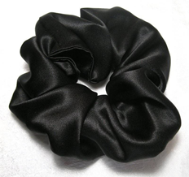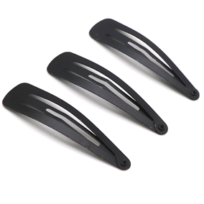
Scrunches Hair clips

Wigs/Hairpieces/Accessories. They are authorized as long as they are within standards of appearing natural, proper fitting, good quality, and comply with safety, functionality, and professionalism. They will not be used to cover unauthorized hairstyles. (Extensions unauthorized for males)
Locs, braids, twists, micro-braids, French braids, Dutch braids, and cornrows are authorized. Locs are defined as portions of hair that have been intentionally or unintentionally fused together to form a loc or locs. A braid or twist is two or more portions of interwoven hair. If adding additional hair, it must be a natural-looking color (like the individual's hair color) and conservative (moderate, being within reasonable limits; not excessive or extreme). Multiple locs, braids, twists or cornrows may come together down the back in one or two braids or a single ponytail. Hair must not exceed bulk standard (see figure 3.2). Headgear must fit properly.
All locs, braids and twists, when worn will be of uniform dimension, no wider than one inch, with natural spacing between the locs, braids, and twists and must be tightly interwoven to present a neat, professional, and well-groomed appearance. When worn, multiple locs, braids, or twists shall be of uniform dimension, small in diameter (approximately ¼ inches), show no more than ¼ inch of scalp between the locs, braids, or twists and must be tightly interwoven to present a neat, professional appearance.
A braid/twist must continue to the end of the hair without design and following the contour of the head and may be worn loose or in a secured style within hair standards in paragraph 7.10.1 above. Exception: Micro-braids or twists are not required to continue to the end of the hair.
Unauthorized: Mohawk, mullet, or etched design.
Fingernails. If worn by females, nail polish WILL BE clear or French or American manicure. French manicures include white tips with a base of clear and American manicures include ivory white or cream tips with a base of clear. Ombre manicure style is not authorized. DO NOT apply designs to nails!
NOTE: Fingernails must not exceed ¼ inch in length beyond the tip of the finger and must be clean and well groomed. Fingernails must not interfere with the performance of assigned duties. Fingernails must not hinder proper fit of prescribed safety equipment or uniform items.
Eyelash Extensions. The color of the eyelashes must be natural and not exceed 14 millimeters in length.
Skirts. The length of your skirt may not vary beyond the top and bottom of the kneecap. Your skirt will fit smoothly, hang naturally, and must not be excessively tight. You must wear hosiery with the skirt. Choose a sheer nylon in a neutral dark brown, black, off black, or dark blue shade that complements the uniform and your skin tone.
Earrings. Female cadets may wear small (not exceeding 6 mm in diameter) conservative (moderate, being within reasonable limits; not excessive or extreme) round or square white diamond, gold, white pearl, or silver earrings as a set with any uniform combination. If member has multiple holes, only one set of earrings are authorized to be worn in uniform and will be worn in the lower earlobes. Earrings will match and fit tightly without extending below the earlobe unless the piece extending is the connecting band on clip earrings.
Undergarments (Mandatory).
Females. Appropriate undergarments are required to be worn with all uniform combinations. Wear bra and underpants with all uniforms. Wear of the white V-neck style or athletic tank top undershirt when wearing opened collar service uniforms is authorized. Undershirt will be tucked into slacks or skirt. Undershirts will not have pockets.
Cosmetics. Male Cadets ARE NOT authorized to wear cosmetics. Female Cadets may wear cosmetics; however, if worn, they will be conservative shade that DOES NOT detract from the uniform (not excessive or extreme) and in good taste. Female Cadets WILL NOT wear shades of lipstick that detract from the uniform, or that are extreme colors. Some examples of extreme colors include but are not limited to, purple, gold, blue, black, bright (fire-engine) red, and fluorescent colors. Cosmetics WILL NOT be worn during field conditions.
Cosmetic tattooing. Tattooing for cosmetic purposes is authorized when directed by licensed, qualified medical personnel to correct a medical condition, illness or injury for both men and women. When not medically directed, cosmetic tattooing is permitted for women if done to apply permanent facial makeup (i.e., eyebrows, eye liner); the cosmetic tattooing must have a natural appearance and be conservative, moderate, within reasonable limits, not excessive or extreme, and in good taste.
Figure 3.2. Female Hair Style Examples
Ponytails
Female cadets may wear their hair in up to two braids or a single ponytail with bulk not exceeding the width of the head and length not extending below a horizontal line running between the top of each sleeve inseam at the under arm through the shoulder blades. In addition, women’s bangs may now touch their eyebrows, but not cover their eyes.

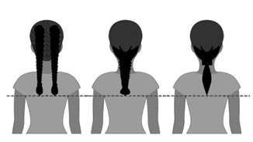
Figure 3.2. Female Hair Style Examples

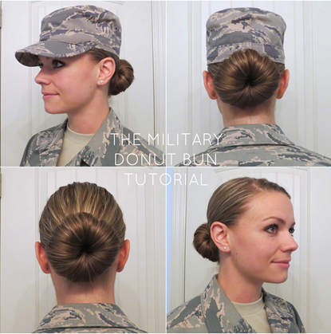

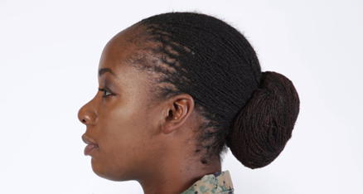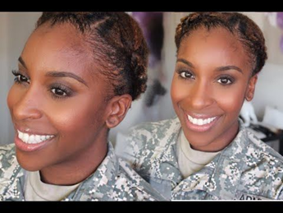
Braids Twists
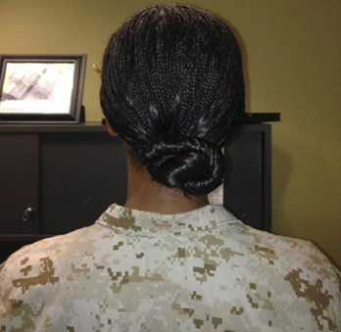
Locs
Specific Male Cadet Grooming Guidelines. (See Figure 3.1)
Men’s Hair. Will be clean, well-groomed, present a professional appearance, allow proper wear of headgear, and conform to safety requirements. Will not contain excessive amounts of grooming aids (e.g., gel, mousse, pomade, or moisturizer), appear lopsided, touch either eyebrow, or end below an imaginary line across the forehead at the top of the eyebrows that is parallel to the ground. If applied, dyes, tints, bleaches, and frostings must result in natural hair colors. Examples of natural hair colors are brown, blonde, brunette, natural red, black, or grey. All cadets are authorized to wear hair in a natural color regardless of their natural born hair color. Prohibited hair color examples (not all inclusive) are blue, burgundy, purple, orange, fluorescent or neon colors. SASIs may temporarily authorize cancer patients to wear approved caps (black/tan) due to a temporary medical condition (i.e., radiation/chemotherapy).
Hair-Male. Tapered appearance on both sides and the back of the head, both with and without headgear. A tapered appearance is one that when viewed from any angle outlines the member's hair so that it conforms to the shape of the head, curving inward to the natural termination point without eccentric directional flow, twists, or spiking. A block-cut is permitted with tapered appearance. Hair will not exceed 2.5 inches in bulk, regardless of length and ¼ inch at natural termination point; allowing only closely cut or shaved hair on the back of the neck to touch the collar. Hair will not touch the ears or protrude under the front band of headgear. Cleanly shaven heads, military high-and-tight or flat-top cuts are authorized. Prohibited examples (not all inclusive) are Mohawk, mullet, cornrows, dreadlocks, or etched shapes/design. Cadets may have one (cut, clipped or shaved) front to back, straight-line part, not slanted or curved, on either side of their head, above the temple. Part will not exceed 4 inches length or ¼ inch width. Men are not authorized hair extensions. See figure 3.1 for graphic examples of appropriate sideburns, mustache, and male hair standards.

Sideburns. If worn, sideburns will be straight and even width (not flared) and will not extend below the bottom of the orifice of the ear opening. Sideburns will end in a clean-Sideburns.
Mustaches. Male members may wear mustaches. No portion of the mustache shall extend below the upper lip line, and it must not go beyond the corners of the mouth. Mustaches must be neatly trimmed and should match the natural hair color of the Airman’s head. Handlebar styles, twists, curls, and goatees are strictly prohibited.
Beards. Beards ARE NOT authorized unless for medical reasons, when authorized by a SASI on the advice of a medical official. SASI will submit waiver request in WINGS for review by HQ AFJROTC Waiver Review board. Members will keep all facial hair trimmed not to exceed ¼ inch in length. Individuals granted a shaving waiver may shave or trim their facial hair to present a neat, clean, professional image but will not shave or trim in such a manner as to give a lined/shaped appearance.
Fingernails. Male cadets are not authorized to wear nail polish.
Earrings. Male cadets in uniform may not wear earrings or any other type of facial piercings.
Permanent Cosmetic. Can only be applied to the scalp
Undergarments (Mandatory)
Appropriate undergarments are required to be worn with all uniform combinations.
Wear undershirt and underpants with all uniforms. Wear the white V-neck or athletic style tank top undershirt when wearing opened collar service uniforms only. Undershirt will be tucked into trousers. Undershirts will not have pockets.
Figure 3.1. Male Hair Grooming Standards

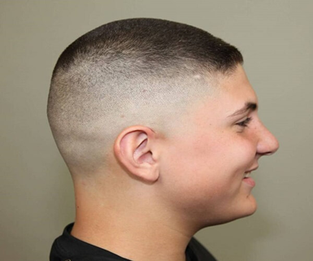
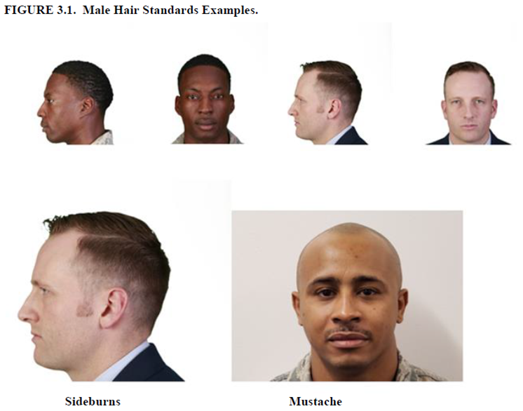

INTENTIONALLY LEFT BLANK

Cadet Leadership Responsibilities
Officer/Non-Commissioned Officer (NCO) Responsibilities: Napoleon said, “A good leader does not eat until his men have dined, and he doesn’t lie down until his men have a place to sleep.” Taking care of your people is the hallmark of a good leader. An officer/NCO takes on heavy responsibility.
- Keep your people informed: Officers in command and staff positions must brief their subordinate cadets on all activities affecting their positions and opportunities in the Corps. This is a leader’s responsibility, and it cannot be delegated to a subordinate.
- Job descriptions: Commanders and staff officers will ensure all subordinates are given written job descriptions to inform them of their specific duties. They must also ensure that everyone under their command is adequately informed about activities within his/her area of responsibility. This requires considerable effort on the part of the officers/NCOs. It will mean almost daily communication with subordinates.
- Set the example: All officers and NCOs must set the proper example and live up to the high standards, especially proper wear of the uniform. As in the Air Force, being a cadet officer/NCO is a 24/7 job. Officers/NCOs who do not properly wear the uniform will receive demerits and may face demotion.
- Proficiency: Officers and NCOs should constantly strive to do a better job. Know your subordinate’s responsibilities and learn more about AFJROTC policies and procedures by reviewing regulations. Officers/NCOs will ensure that subordinates remain proficient in their areas of responsibility.
- Supervise, advise, and lead: As subordinates depend on their senior officers and NCOs for guidance, officers and NCOs should constantly strive to be better supervisors, managers, leaders, cadets, and team players. In this way, everyone benefits from the strength of the group.

Cadet Recognition Program
STEP PROMOTIONS: Once per year (1st Semester), the SASI/ASI can promote 5% of the Unit’s first year cadets through STEP PROMOTION. Cadets MUST meet the following criteria: Corps accomplishments, uniform wear, class participation, community service hours, “B” or better in other classes, and an “A” in AFJROTC.
There will be one cadet chosen for Cadet of the Semester. To be eligible for this honor, cadets must complete certain requirements:
- The cadet’s grades must be “B” or better in all classes with an “A” in AFJROTC.
- The cadet must have eight (8) community service hours.
- Must have zero deductions (100%) on all Blue Uniform wears.
- The cadet must be nominated by their respective Flight Commander/Sergeant.
- Each Flight Commander gets one nomination. They must meet a board consisting of the Squadron CC/CV/DO (at least one as board president), Squadron Chief, First Sergeant, and the Flight/CCs (Sgts. If they cannot attend) promoting their chosen cadet, as well as compose a form 1206 on why they think this cadet should be eligible for this honor. Decisions will be made based on grades, leadership, attitude, and performance.
- Being chosen as Cadet of the Semester can help a cadet with promotion opportunities and with receiving the Outstanding Cadet of the Year Award.

30-Step Drill Sequence

- FALL IN
- Open ranks MARCH
- Ready FRONT
- Close ranks MARCH
- Present ARMS
- Order ARMS
- Parade REST
- ATTENTION
- Left FACE
- About FACE
- Forward MARCH
- Right flank MARCH
- Left flank MARCH
- Column right MARCH
- Forward MARCH
- To the rear MARCH
- To the rear MARCH
- Column right MARCH
- Forward MARCH
- Eyes RIGHT
- Ready FRONT
- Column right MARCH
- Forward MARCH
- Change step MARCH
- Column right MARCH
- Forward MARCH
- Flight HALT
- Left FACE
- Right step MARCH
- Flight HALT

