Power School Instructions for Nurses 2026 – 2027 Edition

GETTING INFORMATION FOR START OF YEAR

Getting Information to Give to EMS from Power School
Select a student > More > ACPS Stu Emerg Med Summary
Press Control P to print the screen

Pulling Health Alerts and Special Medical Considerations Option 1
PS Start Page > Data and Reporting > Reports > SQL Reports > Health > Students with Medical Alerts or Considerations
You can sort by the various columns, download as a CSV, then save as an Excel sheet.

How to Find Students with Health Alerts Entered Option 2
PS Start Page > PSCB Custom Reports > Misc > Student Alerts List > Select Medical from the drop-down menu
Note: Health Alerts and Special Medical Considerations may get you all the information you need for the Chronic Conditions Report, provided the information has been entered.
Note: You will only be able to pull information that someone entered such as health alerts, special medical consideration and screening results.

Pulling Information from ACPS Reg 9 – Medical (parent’s report of health history)
- Start page
- View Field List
- Go to box Filter and type in key word such as asthma
- Click the choice such as U_StuMedical.Asthma_Status
- Add =1 at the end of line
- You can then scroll through the students whose parents indicated they have asthma
- Clear fields before searching for the next condition such as allergies, seizure etc.

How to Find Health Alerts or Medical Conditions for One Student
- Search for student by entering last name
- Select correct student
- Click on the red caduceus on the lower right corner of the student’s picture, if there is one
- You can also select Emergency and Medical Contacts to see other health information
- For additional information, select More from the menu on the right
- Select ACPS Reg 9 Med, which will give you the parent’s report of health history
How to Find Parent Contact Information
- Choose Student Profile from menu on right
- Choose Contacts
- Click Contact Summary
- Select a parent or guardian unless the there is a No under Legal Custody or Can Pick Up

ENTERING INFORMATION
Enter Health Information In Power School
- Review health records and ACPS Reg 9 Med and note conditions
- Select Health from menu on left
- Go to Emergency and Medical Contacts
- Enter conditions into Alerts or Special Medical Considerations. Alerts are for conditions that all staff with supervisory authority should be aware of such as asthma, allergies, diabetes, seizure disorders etc. Key elements to include: Condition, medication provided and location, health plan on file. Please note, any conditions you enter as a health alert will be uploaded to the Dept of Transportation.
- Hit Submit

How to Enter Immunizations into Power School
- Select Student
- Go to Health
- Select Immunizations
- Enter dates of immunization from record
- You must enter something in the box titled Description of Change it can just be “entered”
- Click Submit

How to Enter Clinic Visits in Power School
- Start screen
- Search for student by entering last name
- Select correct student
- Select Health on left menu
- Select Office Visits on right
- Choose Visit Type category from pull-down menu
- Enter Time In and Time Out if different from current time
- Enter your name in Provider Name
- Put check mark in box next to Parent Contact, if appropriate
- Skip Visit Reason
- Add Reason Note
- Click and enter Vital Signs if appropriate
- Click Assessment and enter Assessment Note
- Click Outcomes & Actions
- Select from pull-down menu in Visit Outcome/ Action
- Select Procedure (medically ordered or nurse procedure)
- Select from pull-down menu under Treatment
- Enter Outcome/Action Note if appropriate
- Click Save

How to Enter Screening Results
Select student > Health > Screenings > Add Screening > Choose type of screening > Enter requested information > Save

REPORTS

How to Display All Clinic Visits for a Student Pull student up; Go to PS Start Page > PSCB Dev Reports > Health Office > Health Office Visits Logs > Student Selection > Current Selection > Enter start and end dates > Submit

Clinic Visit Reports (Monthly Data)
PS Start Page > Health > Summary of Clinic Visits by Date

How to Find Students Who are Pre-Registered You can use the search function on the PS Start page student search area: /enroll_status=-1

Pull Lists by Teacher You can use the search function on the PS Start page student search area Home_Room contains [name of teacher]

Vital Signs for One Student
Start Page > Data and Reporting > Reports > sqlReports > Health > Office Visits Vital Signs > Enter Start and End Date > Submit > Go up to top and select either First or Last Name (Quickly type first few letters of name)

How to find information from Field Lists
Additional information can be pulled via this pathway:
PS Start Page > Select All, Scroll to Custom Student List > Fill in the desired fields. The name of the doctor and dentist can be pulled so you can see if their parents report if they have one (Items 4 and 5 in example below).
For larger schools it may be easier to pull the information by grade so rather than All, you can request the information grade by grade.
PS Start Page > Select Grade, Scroll to Custom Student List > Fill in the desired fields.
The one that pulls anything in Special Medical Considerations (in the screen Emergency and Medical Contacts) is: StudentCoreFields.medical_considerations which I put in the 8th line in the example below.
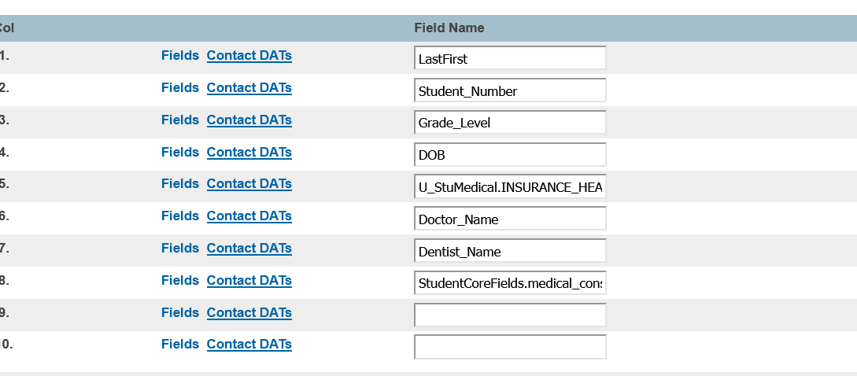
For the screening summary report:
- PS Start Screen
- Select grade –
- Go to Health on left menu
- Go to All Screenings
- Select Vision and Color
- In the column that reads Screening Outcome, select Show
- You can download this to a spreadsheet to count or you can manually count the passes and fails
- You can then check with the teacher to see if the child ended up getting glasses.
- You can do the same with hearing, but those results will only be there if someone entered them.

Select Grade ➔ Health➔ All Screenings Select Vision and Color and Show Results

They should be able to use the Health Management page for Screenings to determine students that have not had a particular screening entered into PowerSchool. They can go to the Screenings tab, adjust the Date Range Parameter, select the screening they want to view, and add any other filters such as Grade level to run the report.
The date range is simply the date that the screening was performed for the student so you have to be cognizant of that when running the report. If you select a narrow window, it doesn’t mean that a student hasn’t gotten the screening, it just means that the student didn’t receive a screening during the dates you selected.
Immunization Compliance Reports
Start Page ➔Health ➔All Immunizations ➔ Select Tiles for specific vaccines then choose Mode from pulldown menu in upper right corner (not recorded, compliant, exempt etc.)

Immunization Compliance Summaries
Start Page ➔ Data and Reporting ➔Reports ➔sqlRports➔Health➔Select from the 3 options
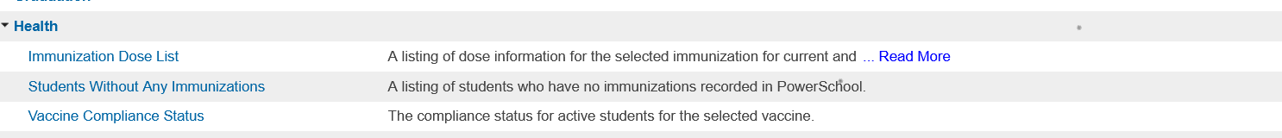

Other Reports
Start Page ➔ Data and Reporting ➔Reports ➔ReportWorks➔Select a Report
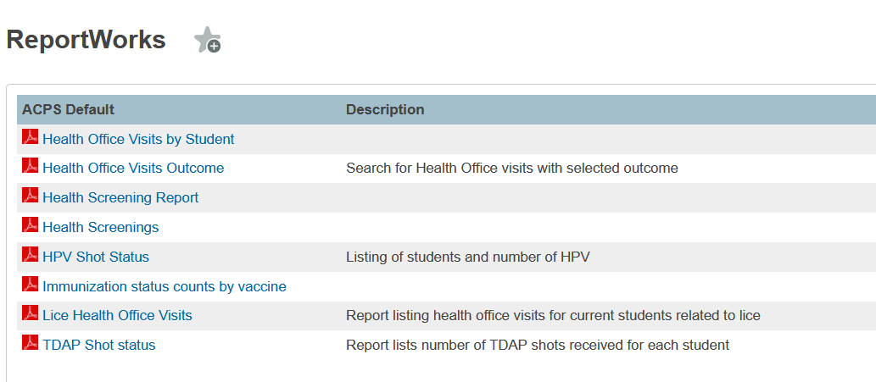
Finding New Students in Power School
EntryDate > 8/20/2024;Enroll_Status = 0 [Choose dates]
New students: sql reports ➔ enrollment ➔ Students not enrolled last year
Start Page ➔ Data and Reporting ➔Reports ➔sqlRports➔ enrollment ➔Students not enrolled at this school last year
When entered school: Home screen for student ➔ Student Enrollment ➔Enrollment History
Getting List of Students
Start Page ➔ Select Grade ➔List Students ➔ Report Title ➔ Grade_11 (or other) ➔
1. Last_Name
2. First_Name
3. Blank
4. DOB
Print

Emergency Health Information for EMS For a Group of Students
- Make the students your Current Selection
- Select the Group Functions Menu by clicking the downward triangle in the bottom right corner of the PS Home Screen
- Under Printing, Select Print Reports
- Select the Report ACPS Student Health/Contact Data from the drop down menu list
  - Do not change any other parameters on the page
- Click Submit to begin running the report
Once the report finishes running (may need to refresh the page), select View to view and/or print the report
Lists of Students with Various Fields
Select Grade➔Custom Student List ➔Select Variable from Field List ➔Submit

School Attendance Relative to School Division Attendance
Start Page ➔Data and Reporting ➔Reports➔ sqlReports ➔Attendance➔ Attendance Trend Data➔ Enter Date (report not available on the same day)

How to Use Medication Module
Use the Medication page to manage medication administration. For any medication that you are going to administer to a student, whether a scheduled medication or an on-demand medication, first add the medication and then add the inventory. The same units should be used across all medication records for a specific medication for a specific student. For example, when associating a medication with a student where the unit of tablet is used, then the inventory and doses should also be tracked using tablets.
This page is available with Enhanced Health Management.
Add Medication
- Navigate to the Medication page.
- Click Add.
- Enter information as needed.
If Time is populated, this is a medication that is given on a specific schedule. Scheduled dose records will be on the Daily Health To Do List with one row per scheduled time. If time is left blank, this will be an on-demand medication, and no future dose records will be created.
- Click Save.
Add Inventory
- Navigate to the Medication page.
- Click Inventory next to the medication you want to work with.
- Click Add.
- Enter information as needed.
- Dose refers to the quantity of medication. Use the same type of quantity measurement entered for Dispense a Dose to a Student.
- Staff refers to the school staff member administering the medication. District-only users do not appear in the list.
- Expiration Date can be changed once the record is saved. An alert message appears on the Medication page and the Medication Inventory screen 30 days before the expiration date.
- Click Save.

Dispense a Dose to a Student
- Navigate to the Medication page.
- Click Doses next to the medication you want to work with.
- Select a Scheduled Time.
- Click Add.
- Enter information as needed.
- Dose refers to the quantity of medication. Use the same type of quantity measurement entered for Add Inventory.
- Status refers to the result of the medication being given.
- Staff refers to the school staff member administering the medication. District-only users are not in the list.
- Click Save.

