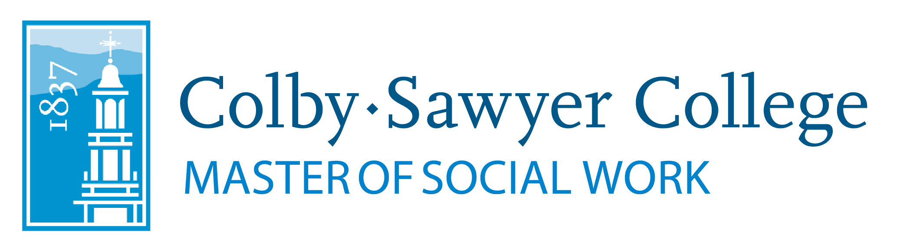

Title IV-E Child Welfare Partnership Program
Student Application

Student name:

Permanent address:

Colby-Sawyer College email:

Alternate (permanent) email:
____________________________________________________________________________________

I am applying for a DCYF Title IV-E partnership placement at the following level:

Generalist (first year) placement
Specialist-second year placement
Specialist-advanced standing placement

My practicum placement is scheduled to begin on (month/year):
____________________________________________________________________________________
Undergraduate GPA:
Current Colby-Sawyer MSW GPA:
Other GPA (from another graduate program):

Additional required materials:
I. Write a 3 to 4-page essay that describes your experiences in the area of child welfare,
including:
- Your, interests, motivation, experiences, strengths, and career plans relating to
working in the area of Child Welfare.
- Any paid work experience with children and families, dates of employment, and
description of responsibilities.
- Your volunteer experiences in the human services field.
- Your career goals.

II. Provide three letters of recommendation. These should include:
- How long and in what capacity the person has known you.
- Any observations they have made regarding your work with children and families.
- Why they feel you are well-suited for work in the child protective service field.
- The name, title, employer, and contact information of the person providing the reference.

Note: references from friends, family, and personal providers will not be accepted.

