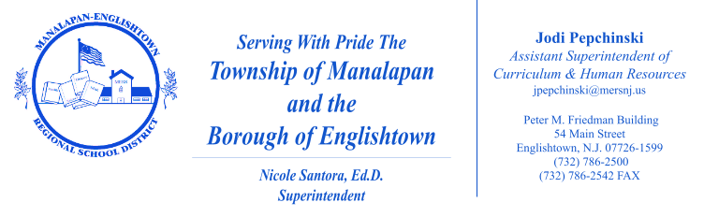

September 2026

Dear Parents/Guardians:

It is the goal of the Manalapan-Englishtown Regional School District to help our students develop the habits necessary to live healthy, productive lives that positively impact themselves, their families, schools, and communities. Through the MERS-developed health curriculum guides, we incorporate healthy practices and wellness skills, the New Jersey Student Learning Standards (NJSLS) in Comprehensive Health and Physical Education, and related State statutes in a manner appropriate to the age and grade level of our students. Within each unit of the health curriculum guide, specific lesson objectives, suggested resources, and suggested activities are listed to inform instruction. To view this information, click here to reach Atlas, our online database which stores our curriculum guides, and search for “Health.”

Family Life Education is part of the health curriculum. The course supports positive and responsible concepts. Our physical education teachers provide this instruction and collaborate as a department to ensure a consistent, age appropriate delivery of instruction. Furthermore, we recognize that the Family Life unit contains objectives related to State standards in which parents may like more specific information. Outlined in the chart below are the specific objectives included in the unit on Family Life.

Specific Objectives Addressed Within the Gr. 3-5 Family Life Unit
Students will be able to:

Grades 3, 4, and 5
- distinguish types of relationships (e.g., family, friend, romantic) experienced by adolescents and determine healthy characteristics (e.g., trust, communication, honesty) that may influence each relationship; and
- explain how qualities of a family (e.g., common values, love, emotional support) are fostered and may influence family members.

Grade 4 ONLY
- chart the stages of the life cycle and categorize by age.

Grade 5 ONLY
- create a list of gender-based stereotypes and cite counter examples;
- identify the difference between sexual orientation and gender identity;
- differentiate the physical, social, and emotional changes occurring during puberty for males and females and explain how these changes influence self-care;
- explain why puberty begins and ends at different ages for different people;
- identify different ways pregnancy can occur, including IVF and surrogacy;
- explain the process of fertilization and where their genetics come from;
- summarize the stages of pregnancy and reproduction from fertilization, cell division, embryonic and fetal development; and
- relate the health of the birth mother to the development of a healthy fetus.
Additional Information:
- In order to address the grade 5 objective “Identify the difference between sexual orientation and gender identity,” the following statement will be made: "Sexual orientation is who one is attracted to and gender identity is who one is." This will not be expanded upon. No additional resources will be used regarding that statement. This lesson occurs in the last trimester of the school year, typically in late May/June.
- In order to address the 5th grade objective “Identify different ways pregnancy can occur, including IVF and surrogacy,” IVF and surrogacy will be named as additional ways pregnancies can occur. No additional resources will be needed to support those examples.

In accordance with State statute (Section 18A:35-4.7 - Parent's statement of conflict with conscience), should you desire to have your child excused from any lesson or specific instructional portion of health, family life, or sex education as directly related to the Comprehensive Health and Physical Education standards because it is in conflict with your conscience, moral, or religious beliefs, please notify the teacher in writing by September 25, 2026.

Once the letter explaining how the content of the instruction is in conflict with your conscience, moral, or religious beliefs has been received by the school administration, a discussion will take place with you to clarify any misconceptions about the program. After such occurs, your child can then be excused without penalty or consequence from the identified content of the course found in conflict. Your child will complete an alternative instructional activity that supports achievement in other standards within the New Jersey Student Learning Standards for Comprehensive Health and Physical Education.

If any further clarification is necessary, please feel free to contact your child’s teacher.

Respectfully,
James Walsh
James Walsh
Supervisor of Health and Physical Education
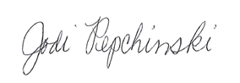

Jodi Pepchinski
Assistant Superintendent of Curriculum and Human Resources

