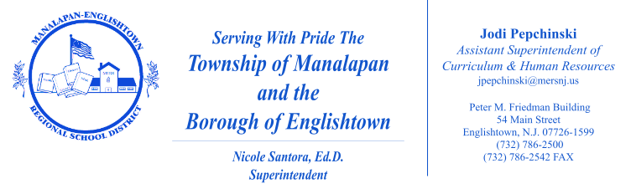

September 2026

Dear Parents/Guardians:

It is the goal of the Manalapan-Englishtown Regional School District to help our students develop the habits necessary to live healthy, productive lives that positively impact themselves, their families, schools, and communities. Through the MERS-developed health curriculum guides, we incorporate healthy practices and wellness skills, the New Jersey Student Learning Standards (NJSLS) in Comprehensive Health and Physical Education, and related State statutes in a manner appropriate to the age and grade level of our students. Within each unit of the health curriculum guide, specific lesson objectives, suggested resources, and suggested activities are listed to inform instruction. To view this information, click here to reach Atlas, our online database which stores our curriculum guides, and search for “Health.”

Family Life Education is part of the health curriculum. The course supports positive and responsible concepts. Our physical education teachers provide this instruction and collaborate as a department to ensure a consistent, age appropriate delivery of instruction. Furthermore, we recognize that the Family Life unit contains objectives related to State standards in which parents may like more specific information. Outlined in the chart below are the specific objectives included in the unit on Family Life.

Specific Objectives Addressed Within the Gr. K-2 Family Life Unit
Students will be able to:

Grades K, 1, 2
- identify different kinds of family units that exist;
- explain that family members have certain rights and responsibilities that contribute to the successful functioning of the family;
- explain ways that families can get help and support if they need it; and
- identify appropriate ways for children to be caring and show affection and discuss ways to develop healthy relationships.

Grade 2 ONLY
- explain the similarities and differences between boys and girls and discuss how boys and girls can have similar interests;
- define the word reproduction and discuss ways parents (e.g.,. animals, fish, people) care for their children; and
- explain that human babies develop inside their birth mother and must be cared for (e.g., fed and cleaned) and nurtured when they are born.

In accordance with State statute (Section 18A:35-4.7 - Parent's statement of conflict with conscience), should you desire to have your child excused from any lesson or specific instructional portion of health, family life, or sex education as directly related to the Comprehensive Health and Physical Education standards because it is in conflict with your conscience, moral, or religious beliefs, please notify the teacher in writing by September 25, 2026.

Once the letter explaining how the content of the instruction is in conflict with your conscience, moral, or religious beliefs has been received by the school administration, a discussion will take place with you to clarify any misconceptions about the program. After such occurs, your child can then be excused without penalty or consequence from the identified content of the course found in conflict. Your child will complete an alternative instructional activity that supports achievement in other standards within the New Jersey Student Learning Standards for Comprehensive Health and Physical Education.

If any further clarification is necessary, please feel free to contact your child’s teacher.

Respectfully,
James Walsh
James Walsh
Supervisor of Health and Physical Education
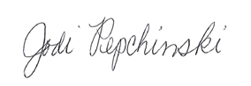

Jodi Pepchinski
Assistant Superintendent of Curriculum and Human Resources

