Wilson Creek Elementary School
Family & Student Handbook



Where Children Experience Success

Kimberly Cerasoli, Principal  Radhika Godbole & Ward Prather, Assistant Principals
6115 Wilson Road Johns Creek, Georgia 30097
Phone: 470-254-3811 Fax: 470-254-3819 Cafeteria: 470-254-3820
www.fultonschools.org/wilsoncreekes

TABLE OF CONTENTS

Mission, Vision, & Value Statements……………………………………………………………………………..4
Front office staff ...………………………………………………………………………………………………...4
Fulton County Board of Education………………………………………………………………………………..5
PTO Board………………………………………………………………………………………………………...5
Arrival & Dismissal Information………………………………………………………………………………..6-7
Transportation Changes…………………………………………………………………………………………...8
Absences & Tardies…………………………………………………………………………………………..…8-9
Remote Learning…………………………………………………………………………………………..9
Missed Schoolwork………………………………………………………………………………………..9
Conduct & Citizenship………………………………………………………………………………………....9-11
Cell Phones………………………………………………………………………………………………10
Dress Code……………………………………………………………………………………………….11
Clinic & Medication………………………………………………………………………………………………11
Emergency School Closings……………………………………………………………………………………...11
Communication…………………………………………………………………………………………………...12
Class Change Request……………………………………………………………………………………12
Instructional Programs…………………………………………………………………………………………....13
Homework………………………………………………………………………………………………..13
Standardized Assessments………………………………………………………………………………………..13
Grading……………………………………………………………………………………………………………14
Support Services…………………………………………………………………………………………….....15-16
Talented & Gifted………………………………………………………………………………………...17
Cafeteria………………………………………………………………………………………………………..17-18
Snacks………………………………………………………………………………………………………..........17
Parent & Community Involvement…………………………………………………………………………..........18
Visitors/Volunteers…………………………………………………………………………………….17-18
Activities………………………………………………………………………………………………………… ..19
Teacher Gifts………………………………………………………………………………………………20
Safety & Security……………………………………………………………………………………………….19-20
Recess……………………………………………………………………………………………………..20
Miscellaneous…………………………………………………………………………………………………........21
Forgotten Items……………………………………………………………………………………………20
Registration………………………………………………………………………………………………. 21
Withdrawal……………………………………………………………………………………………….. 22
Equal Opportunity Policy………………………………………………………………………………………….22
Appendices
Parent Guide to PBIS…………………………………………………………………………………….. 23
How to Sign Code of Conduct………………………………………………………………………….24-25
Carpool Contract………………………………………………………………………………………… 26

Wilson creek

Whole child  whole community

Mission Statement

The Wilson Creek community develops and nurtures the whole child.

Vision Statement

Wilson Creek inspires students to reach their unique potential through an innovative and encouraging learning environment.

Value Statement

Our Wilson Creek community values:

Well-roundedness
Integrity
Love of learning
Diversity
Creativity
Achievement
Teamwork
Students

Wilson Creek Elementary School

Kimberly Cerasoli
Principal

Radhika Godbole
Assistant Principal

Ward Prather
Assistant Principal

Marla Grosswald
Curriculum Support Teacher

Crystal Thompkins
Shereen Khedr
Counselors

Christine Grindle
Student Support Administrator

Sarah King
Instructional Support Teacher

Heather Haubenstock
Literacy Coach

Sandra Durham
Bookkeeper

Jacky Yin
Professional Assistant

Yesenia Sam Bradley
Data Clerk

Jean Reny
Bilingual Liaison

Ankita Doshi
Clinic Aides

Mascot – Wildcat

School Colors – Navy Blue/Red

Fulton County Board Members

Sara Gillespie | District 1 | gillespies1@fultonschools.org
Lillie Pozatek | District 2 | pozatekl@fultonschools.org
Katie Gregory | District 3 | GregoryK1@fultonschools.org
Franchesca Warren, Board Vice President | District 4 | Warrenf2@fultonschools.org
Kristin McCabe, Board President | District 5 | mccabek@fultonschools.org
Kimberly Dove | District 6 | dovek@fultonschools.org
Dr. Michelle Morancie | District 7 | moranciem1@fultonschools.org
Mike Looney | Superintendent | looneym@fultonschools.org
Brian Downey | Zone 6 Superintendent | downeyb@fultonschools.org

PTO Executive Board Members

Rashida Jaliwala | Co-President | walijir@gmail.com
Drashti Parikh | Co-President | drashti@gmail.com
Harmeet Kaur | Co-Treasurer | Vishnharry@gmail.com
Maoqiong (Michelle) Li | Co-Treasurer | limaoqiong@gmail.com
Mami Okamoto | Secretary | maokamoto1984@gmail.com
Renna Gupta | VP Education Enrichment | guptar1@fultonschools.org
Lakshmi Jayanthi | VP Communications | lbhargave@gmail.com
Renita Patel | VP Community Services | rjain7088@gmail.com
Jessica Park | VP Fundraising | jessicapark0428@gmail.com
Laura Reich | Co-VP Events | Laurareich1255@gmail.com
Mitzi Monzalo | Co- VP Events | mitzi.saldana@hotmail.com
Sangeetha Iyer | VP Volunteer Engagement | sangeetha.nathan@gmail.com
Gabrielle Homsy | Teacher Representative | homsyg@fultonschools.org
Kimberly Cerasoli | Administrative Representative | cerasolik@fultonschools.org

School Governance Council Members 2026-27
Ms. Reena Gupta | Parent | guptar1@fultonschools.org
Ms. Shaena Leuthe | Parent | leuthes@fultonschools.org
Ms. Katherine Bush | Parent | Bushk@fultonschools.org
Ms. Kimberly Cerasoli | Principal | cerasolik@fultonschools.org
Ms. Travis Hostetter | Community Member | hostetter@fultonschools.org
Ms. Juliana Berdis | Community Member | BerdisJ@fultonschools.org
Ms. Jennie Lane | Teacher | laneJ1@fultonschools.org
Madison Cliff | Teacher | cliffm@fultonschools.org
Ms. Elaina Forney | School Employee | forney@fultonschools.org
Mr. Thomas Rippy | School Employee | Rippy@fultonschools.org

ARRIVAL AND DISMISSAL INFORMATION
School Hours
School hours are 7:40 a.m. to 2:20 p.m. Please do not drop off children to school prior to 7:10 a.m. as no supervision is available.
Bus Riders
Parents are highly encouraged to use the bus to transport students to and from school. Bus riders will be dropped off and picked up at the side of the building next to the cafeteria.
Safe school transportation is considered an integral part of the total educational program. Riding a school bus is a privilege contingent upon proper and courteous conduct. The Fulton County Board of Education recognizes that safe school bus operation is only possible with the full cooperation of our parents, students, and school staff.
Students must get on and off the bus at their own stop. A student is not allowed to ride another student’s bus unless it is necessary for childcare purposes. In these cases, the parent must complete a Change of Dismissal Form and gain permission from the office. A Change of Dismissal Form is available on our school website at Home - Wilson Creek Elementary School scroll down to “Wilson Creek Features” and click on Change of Dismissal Form. This form must be submitted before 1:45 p.m. Emergency dismissal changes can be emailed to yinj@fultonschools.org AND the child’s homeroom teacher prior to 1:45 p.m. No changes will be accepted after 1:45 p.m.
Students who ride the bus are expected to stay in their seats facing forward, speak in a quiet voice and use appropriate language, keep hands, feet, and all belongings to themselves, cooperate with the bus driver and act in a respectful manner. Students may be subject to disciplinary action when bus safety rules are violated.
Please call North Transportation Department (470-254-2970) with questions or concerns regarding bus routes, times, and bus supervision. This information may also be found on the Fulton County School’s website at click on Student and Families tab, click on Transportation. Transportation - Fulton County School System
Day Care Riders
Students being transported by day care will be dismissed from the back B-Hall door. It is the responsibility of parents to notify the day care when their child will not be attending and/or riding day care transportation on any given day. Parents also need to notify the school when their child will not be attending and/or riding day care transportation by completing a Change of Dismissal Form.

Car Riders
Children can be dropped off and picked up at the front of the school in the designated area only. Children are not to cross through the parking lot unless an adult is walking with them. Parents are strongly encouraged not to park in the front parking lot from 7:10 a.m. - 7:45 a.m. unless you have an appointment with a staff member. At 7:40, the carpool staff will enter the building, and students will be considered tardy. A parent must sign their child in at the front desk in CheckMate.
To facilitate the loading and unloading of car riders, please follow the carpool rules listed below. Students are expected to be in the building by 7:40 a.m. Please adjust your departure time from home to account for the high volume of cars. If the bell has rung, a parent/guardian must sign the student in at the front office to receive a tardy slip to gain permission to go to the classroom.
Carpool Rules
Follow all signs and directions by school employees.
Only right turns into the school between 7:10 a.m. – 7:40 a.m.
Please slow down and do not pass other vehicles.
All parents should remain in the carpool line to drop-off/pick-up their children.
Parents need to stay inside their vehicle.
Children must enter and exit on the right side of the vehicle.
Always hang your carpool number on the rearview mirror for afternoon pickup.
At no time should you double park. Please be sure to always park in a marked parking spot.
Do not drive through the bus lane during the hours of 6:50 a.m. - 7:45 a.m. or 2:00 p.m. - 2:50 p.m. The only exception to this is if you see a staff member directing traffic this way.
Morning Arrival
Only use upper main driveway entrance by the marquee to enter campus. Right turns only into the school between 7:10 a.m. – 7:40 a.m.
Students are not to be dropped off prior to 7:10 a.m. There will be cones set-up across the carpool line in the morning. You may pull forward to start the carpool line. A staff member will move the cones to start the arrival process at 7:10 a.m.
Your child should be ready to exit your car as you approach the drop-off area.
All students in the drop off area should exit their vehicle. No one should stay in their car to wait until they get to the door to drop off.
No left turns are allowed between 7:10 a.m. - 7:40 a.m.
Afternoon Dismissal
Arrive at school no later than 2:30 p.m. When a student is late to be picked up 3 times, an administrator will contact you about alternative plans, such as bus or after school care.
Students are not allowed to re-enter the building once they are dismissed.
To ensure the safety of our students during afternoon carpool dismissal, we utilize a carpool card system. Each family will receive two cards per student. A replacement fee of $5.00 (cash only) will be charged for any lost cards. You may request additional cards for a fee of $5.00 each.
To pick up your child, the card needs to be visible to the carpool staff on the rearview mirror. Please be aware that if you misplace your carpool card, you must show identification to the carpool staff. If you have lost your carpool card, please come to the front office to get a new one and pay your replacement fee.
If your student is in the clinic at dismissal time, you will need to park your car and come into the front office to sign-out your child from the clinic. Please be sure to have your ID.

ARRANGEMENTS FOR TRANSPORTATION CHANGES
If it is necessary for a student to leave school early or change their dismissal from their normal transportation routine, please send a completed Change of Dismissal Form in advance to the student’s teacher. A Change of Dismissal Form is available on our school website at Home - Wilson Creek Elementary School scroll down to “Wilson Creek Features” and click on Change of Dismissal Form. Any student leaving before the regular dismissal time must be checked out in the front office no later than 1:45 p.m. by a parent, legal guardian or individual designated as an emergency contact in our system. Proof of identification is required.
Change of Dismissal
The Change of Dismissal Form on our school website or front office must be completed anytime a student is going home any way other than their normal, permanent transportation method. The signed form should be brought to the front office prior to noon.
Only in an emergency situation can an email request be emailed to yinj@fultonschools.org AND the homeroom teacher. Phone calls are not accepted. No requests will be accepted after 12:00 p.m.
If you need to pick up your child early, you must come into the front office by 1:45 p.m.
ABSENCE / TARDY PROCEDURE
The law requires each school system to clearly define student attendance and requirements, particularly tardies, absences, truancy, and notification to parents whose student(s)’ attendance is out of compliance. The law also addresses possible legal consequences facing parents whose children habitually miss school. The Fulton County School System is charged with enforcing this compulsory attendance law and school social workers must investigate, monitor, and follow-up with families experiencing student attendance problems.
In elementary school, attendance is taken prior to 8:30 a.m. Any student not present will have an automatic robo call made to the parent.
It is the responsibility of the student and/or parent/guardian to send in an absence note and/or doctor’s excuse to the homeroom teacher within five (5) days of returning to school from an absence in order for the absence(s) to be recorded as excused. The excuse must state the reason for the absence and be signed by the student’s parent or guardian. Excuses will be kept on file at the school at least until the beginning of the next school year.
In addition to attending school regularly, it is imperative that students arrive at school on time. School tardiness has a direct, negative effect on student success. Students arriving late miss morning announcements, instruction, academic assignments, and interrupt the instructional time for other students. Plan to arrive early enough that your child is in the classroom when the bell rings at 7:40 a.m.
The Fulton County policy defines late arrival/early checkout procedures as listed below:
If a student misses more than half of an instructional school day, they will be marked absent for the day.
A parent or guardian may be required to bring appropriate documentation for early checkout at the time the student is released from school or late arrival at the time the student arrives at school.
A student is tardy when he/she arrives to school after the beginning of the official school day or is not in the assigned class at the official beginning of the class period.
Fifteen (15) unexcused tardies result in a referral to the school social worker.
Please see District Policy JBD for all detailed information regarding absences and tardies by clicking View Board Policy JB: Student Attendance | Fulton County Schools and View Board Policy JBD: Absences and Excuses | Fulton County Schools
Planned Absence/Trips
Pre-approved absences will only be approved for once in a lifetime events, such as a wedding or graduation. These requests must be made five (5) school days in advance of the absence. To make this request, please complete a Pre-Approved Absence Request, found on our school website under Students & Families, Attendance. Submit the completed form to our attendance data clerk, Yesenia Sam Bradley at sambradleyy@fultonschools.org . *Note: Preapproval process typically takes 72 hours.
Remote Learning
Students can substitute up to 5 absences per semester (max of 10 per school year) with a remote learning day by meeting the remote learning participation benchmarks (see detailed policy online, link above). Remote learning days must be approved by the assistant principal using the Student Remote Learning Absence Request found on our school’s website under Students & Families, Attendance. These requests must be made five (5) school days in advance of the absence. Remote learning days may not be taken on a day that a major assessment is being given. All work must be turned in within 2 days of the student’s return in order to be counted as present during Remote Learning. Remote learning cannot be granted outside of the country.
Late Arrival Procedure
Students are tardy when they arrive in the building after 7:40 a.m. Students arriving after 7:40 a.m. must be accompanied by their parent/legal guardian to sign in their student at the front office area. The student will receive a tardy slip and proceed to the classroom. Please note, when a Fulton County school bus is late the students riding that bus, will not be counted tardy.
Missed Daily School Work
Should you need to pick up schoolwork for your child due to a one- or two-day absence, you are asked to email your child’s teacher before 10:00 a.m. in the morning. Teachers have 24 hours to provide the requested work. This gives the teacher adequate time outside of the instructional day to organize needed materials.
Students should make every effort to complete any missing work in a timely manner. It is the student/parent responsibility to ask the teacher for any missed assignments. Work should be returned with the number of days the student was absent (i.e., absent 2 days, work submitted within 2 days of returning).
Communication Protocols
After three (3) consecutive absences, late arrivals, or early checkouts, a doctor’s note will be required.
After seven (7) cumulative absences and/or 10 cumulative late arrivals or early checkouts, a doctor’s note will be required for any subsequent illness-related absences, late arrivals, or early checkouts.

CONDUCT AND CITIZENSHIP
Wilson Creek implements the Positive Behavioral Interventions and Support Program (PBIS). Through this program we reward positive behavior and choices to encourage students to be respectful, responsible, and ready to learn. The Wilson Creek staff supports all students’ right to learn. To do so, each student and teacher must be in a safe and nurturing environment in which to learn and work. Wilson Creek Elementary promotes the ideal of each student working toward self-management and taking ownership for his or her own actions.
The faculty and staff at Wilson Creek Elementary School implement a school-wide discipline plan designed to promote consistent expectations in an effort to improve the student-learning environment.
When students choose to misbehave, teachers may use interventions such as: verbal reprimands, action plans, time-outs, silent lunch, think sheets, behavioral contracts, school counselor referrals or office referrals. Administrators may use interventions such as, however, not limited to: restorative practices/strategies, office time-outs, counseling groups, and if necessary, as a last resort, in-school suspension or out-of-school suspension.
Promoting positive behavior requires a concerted effort of effective classroom management techniques and behavior management strategies reinforced by teachers and parents. Wilson Creek Elementary’s staff seeks to implement parental involvement processes designed to enable parents, teachers, and school administrators to work collaboratively to improve and enhance student behavior and academic performance.
Student Expectations
At the beginning of the school year the administrative team and each teacher will discuss with students the school-wide expectations as outlined on the Wilson Creek Behavior Expectations Matrix. Each teacher will establish classroom expectations and review procedures throughout the school year.
Code of Conduct and Discipline Handbook
The Fulton County School System takes seriously its responsibility to provide a safe learning and working environment for students and teachers. Part of that responsibility involves establishing clear, fair, and effective discipline procedures. The Fulton County Code of Conduct and Discipline Handbook and the *Wilson Creek Parent Guide to PBIS details our expectations for student behavior.
Fulton County Schools is making its Student Code of Conduct & Discipline Handbook available online in PDF format (click the link below). Once you have read the electronic version and have reviewed the contents with your student(s), please take a moment to complete the Acknowledgement of Receipt Form in Infinite Campus. The Code of Conduct for 2026-2027 can be found by using the provided Fulton County Schools 2026-27 Student Code of Conduct & Discipline Handbook. All parents and students (over 10 years old) MUST sign this form found within your INFINTE CAMPUS PARENT/STUDENT PORTAL ACCOUNT. This form will be available AFTER August 3, 2026. If you would like a paper copy of the Handbook, you or your student can pick one up in your school's front office.
Cell Phones/Other Electronic Devices
The use of Personal Communication Devices (PCDs) during the school day is not allowed in grades Pre-K through 5. In grades 6 through 12, the use of PCDs is not allowed during instructional time and will only be allowed when explicitly instructed to do so by a teacher or other school staff member. ***Please Note: If a student violates this rule which leads to the student’s personal communication device being confiscated by school personnel, it will only be released to the parent or guardian who must come to the school to personally retrieve the device. ***
The use of cell phones and other PCDs for non-educational purposes, including but not limited to, recording staff and/or students without permission or other inappropriate content is strictly prohibited. In addition, using a cell phone or other personal communication device to record a fight, battery or any other inappropriate content and either sharing with others (e.g., airdrop, nearby share, ShareIT, etc.) and/or uploading the video to any other type of social media/web-based media is also strictly prohibited. Consequences for doing so may result in up to a 10 Day suspension and a referral for a discipline hearing with a recommendation for long term suspension.
Toys, Cards, Non-Essential Instructional Items
Students should not bring personal items from home (such as Pokemon cards, toys, fidgets). These cause a distraction to the learning environment. If a student does bring these items, the school assumes no responsibility for personal items that are lost or stolen.
Dress Code
Students at Wilson Creek Elementary school are expected to dress and groom themselves in such a way as to reflect neatness, cleanliness, and safety. All students shall dress appropriately so as not to disrupt or interfere with the educational program or the orderly operation of the school. Examples of inappropriate dress and grooming include lack of cleanliness in person or dress; shoe lessness; "short-short" clothing; bare midriffs; "tank tops less than 2 fingers width"; "see-through" clothing, clothing that exposes undergarments, hats or hoodies pulled over the head and worn inside, or apparel which is offensive to others or any dress that is disruptive to the educational process. Designated dress involving school activities approved by the principal shall be acceptable. The principal or other duly authorized school official shall determine whether any particular mode of dress or grooming results in a violation of the spirit and/or the intent of this rule.
Students, in any grade level, arriving to school inappropriately dressed should be sent to the clinic and the parent may be contacted.
● 1st Violation – Note sent home.
● 2nd Violation – Call home to get appropriate clothing.

CLINIC, MEDICATION, STUDENT INFORMATION, ACCIDENTS
Wilson Creek Elementary has a staffed clinic. Parents may be contacted when students are injured or become ill during the school day. A parent or emergency contact must pick the student up from the clinic within ONE hour of being notified by the clinic (first attempt). Students who are ill must be kept at home. This is defined as symptomatic, a fever of 100.3 or higher, and/or vomiting. When your child is well enough to return to school (fever free for more than 24 hours without fever reducing medication, no vomiting for 24 hours), please send in an absence note following the guidelines on our website under Students & Families, Attendance, Regular Absences. Please notify the school office if your child has a contagious disease or an extended illness.
Students who must take prescribed or over-the-counter medicine during the school day should, upon entering the school, take the medication and a completed authorization form from the parents immediately to the clinic for storage until needed. If medication is necessary, a school employee must assist in administering the medication to the student. An authorization form must be completed and returned to the school before any medication can be administered to a student on a regular basis. If you grant permission for any over-the-counter medication including cough drops, etc., to be given, a non-prescription medication form must be signed and on file. Parents are responsible for providing all medicines.
In order to maintain accurate records, if a parent/guardian chooses to administer medicine to their child during school hours, the medication must be administered in the clinic so that the time, dosage and name of medication can be documented.
Change of Address and Telephone Number
Please notify the teacher and data clerk (Yesenia Sam Bradley, sambradleyy@fultonschools.org), of any change of address, telephone numbers and email addresses as soon as possible. Information can be checked and verified in Parent Portal. Accurate records are necessary to be able to notify parents in case of an emergency.
Insurance
Group accident insurance is available for students. Student insurance may be purchased through a private company approved each year by the Board of Education. Information on this insurance, its cost and other details of the plan are given to parents in the beginning of the year packet.

EMERGENCY SCHOOL CLOSINGS / PLAN
In the event that school must be closed due to inclement weather, the most up-to-date information will be provided on local radio and TV stations. School telephones and personnel will be utilized in order to follow emergency procedures to ensure the safety of the children. Closing information particular to Wilson Creek buses and carpool, will be communicated via email from the principal. Primetime and Day Care is not an option in the event of emergency early dismissal. Wilson Creek Elementary has developed a detailed emergency evacuation plan, which will be reviewed annually, updated, and practiced. This plan will be followed should any emergency occur during the school day. In case of an emergency requiring the evacuation of the building, students would be relocated to an off-site location. For the safety of all concerned, parents are discouraged from coming to school during any type of weather emergency unless otherwise communicated. Please make sure your child’s emergency contacts are correct in Parent Portal. Without permission, we are not permitted to release a child to anyone other than the parents and/or legal guardians or listed emergency contacts. Students will have a bright red tag on their book bag for their emergency transportation as indicated on the Wilson Creek 2024-2025 Parent Acknowledgement Form that was completed at the beginning of the school year by QR code.

COMMUNICATION BETWEEN HOME AND SCHOOL CONFERENCES
Open communication between parents and the school is crucial to support each student and is a priority for our Wilson Creek staff. For classroom and student concerns, parents/guardians should contact the teacher first. Teachers may be contacted via email. Teachers should respond within a 24-hour school-day period from the time they actually open the message.
Every Thursday parents are emailed the “Wildcat News” newsletter from the principal. This newsletter gives important dates, upcoming events, etc. Everyone is highly encouraged to read this newsletter for important information. Teachers will communicate classroom specific information with parents weekly. Teachers will also update their grade level website to keep parents informed of classroom activities.
Wilson Creek Elementary does not provide daycare services for conferences. Please be mindful of this fact when scheduling conferences. All parents will receive a parent-teacher conference prior to the end of October. We believe that the educational success of your child is a joint venture between the school and the home, and we want to keep communication lines open. Parent conferences may be initiated at any time throughout the school year by the parent, teacher or administrator and held at a mutually agreeable time.
At least twice a month graded work will be available through Teams or in a folder sent home with students.
Parents’ Right to Know
Parents may request information regarding the professional qualifications of their child’s teacher or paraprofessional including the following:
- whether the teacher has met the Georgia Professional Standards commission requirements for certification for the grade level and subject areas in which the teacher provides instruction;
- whether the teacher is teaching under an emergency or other provisional status through which Georgia qualifications or certification criteria have been waived;
- the college major and any graduate certification or degree held by the teacher;
- whether the student is provided services by paraprofessionals, and if so, their qualifications.
If you wish to request information concerning your child’s teacher’s qualification, please contact the principal at 470-254-3811.
Classroom Visitation
Parents may visit their student’s classroom by scheduling in advance, a thirty-minute observation time through the CST via email. This dedicated time is for observation only and not to be used for interaction with students.
Class Change Procedure
Much time and effort are put into placing children in the appropriate classroom. At times, parents may feel that the chosen classroom is not meeting the needs of their child. The following procedures will be implemented in determining a change in placement:
- The parent will meet and conference with the teacher.
- If the parent is still not satisfied, he or she will complete the Change of Classroom Placement Form. The form is available upon request from the CST.
- The parent will then present their reasoning to the Class Change Committee. This committee may consist of the curriculum support teacher, counselor, the principal, and/or assistant principal.
- The committee will make the final determination and communicate the decision to the parents.
*Please note: A class change request cannot be made until the 3rd week of school or 3rd week of child’s placement in the class.

INSTRUCTIONAL PROGRAMS
Organization
Wilson Creek Elementary is organized to include kindergarten through grade five. We follow the ELA, Mathematics, Social Studies and Science Georgia Standards and the Fulton County Continuous Achievement Guidelines. We differentiate instruction to help meet the needs of each student. Instruction may be presented whole group and/or small group within or outside of the general education setting to help meet students’ maximum potential.
The curriculum includes the following: reading, language arts (writing), mathematics, social studies, science, health, music, physical education, and art.
In addition to the classroom teacher, all Fulton County elementary schools have music, art, and physical education teachers as well as a METI, counselor, Talent and Gifted, Early Intervention Program, and English-Speaking Language teachers.
Instructional Materials and Supplies
Textbooks and other instructional materials and supplies are furnished free of charge to all elementary students. As textbooks and library books are the property of Fulton County schools, if a book is lost or damaged, a fee will be charged. Additional sets of textbooks are not provided for students until fees are paid. Chromebooks are provided to all 3rd through 5th graders. As with other materials, the laptop device is property of Fulton County Schools, and a fee will be charged for a broken or lost/stolen laptop. We encourage families to purchase the device protection plan offered through Fulton County Schools. Please refer to the Student and Device Handbook for information about the device protection plan and device replacement costs and fines FCS 26-27 Student Device One-to-One Handbook. Fees are due within 5 days of notice. If payment is not received within 5 days, the student’s replacement device will be held until payment or other arrangements are made.
Field Trips
Field trips are planned throughout the year to complement classroom curriculum. Typically, each grade level schedules 2 trips a year, one each semester. In order for students to participate, permission forms must be signed by parents. Siblings are not permitted to accompany chaperones on field trips.
Homework
Homework is a necessary part of each student’s educational program to practice skills learned throughout the school day. Each student may be expected to spend some time on homework in addition to scheduled class instruction. Homework reinforces skills taught in the classroom, increases the student’s success on achievement tests, provides opportunity for parent involvement and reinforces responsibility. Homework is for reinforcement only and will not be graded, either for accuracy or completion.

STANDARDIZED ASSESSMENTS
Testing is an integral part of our educational system. It helps us assess and meet students’ needs. Our testing program is aligned with the State of Georgia and Fulton County Schools. The following standardized tests are administered during the school year:
Grade K  Grades K-5 | GKIDS Assessment-On-going (August 2026 – May 2027)  AMIRA Testing  Fall, Winter, Spring
Grades K-5 | iReady Reading & Math
Grades K-5 | Fall, Winter, Spring
Grades K-5  Grade 3-5 | ACCESS (EL-Y)  January and February 2027
Grades K-5  Grade 3-5 | Writing Benchmark 1  October 5-9  Writing Benchmark 2  February 1-5
Grades 3 - 5 | Georgia Milestones End of Grade Assessment
Grades 3 - 5 | April 26 – May 7, 2027
GRADING PROCEDURES
Per FCS policy, grades should be based on the individual student’s mastery of standards, in the Georgia Performance Standards for the grade level in which the student is currently placed, subject to any Individualized Education Plan (IEP). Grading reports can be viewed in the Infinite Campus parent portal. Progress reports are available at each 4.5-week mark and Report Cards are available at the 9-week mark. Grades are cumulative for the semester.
Grading Scales
K-2:
EM Exceeding Mastery 90-100
M Mastering 80-89
AM Approaching Mastery 70-79
NYM Not Yet Demonstrating Mastery 69 and below

3-5:
A 90 and above
B 80-89
C 70-79
F below 70

Grading Categories

Majors: 45%
Minors: 40%
Practice: 15%

Non-Academic Skills

Self-Direction; Collaboration; Problem Solving; Work Habits
- Consistently demonstrates
- Often demonstrates
- Sometimes demonstrates
- Rarely demonstrates

Recovery
- Students in K-12 should be afforded the opportunity to recover all major assessments if they score below 75% on the assessment.
- Students are limited to one recovery attempt per major assessment that meets the threshold for recovery.
- Recovery of a major assessment should occur before the next major is given.
- Students are eligible to earn a replacement grade on a recovery that is no higher than 75%.
- If a student’s recovery is below the original score, the original score should stand in the grade book.
- The original score should be noted in the comment section of the grade book if a student recovers a major assessment.
Academic Dishonesty
One of the most important aspects of a student’s educational process is to learn honesty in all endeavors. This includes academic honesty. Academic dishonesty is defined as the giving or receiving of information among students when they are expected to be working on an individual basis, plagiarism (to take and use as one’s own writings or ideas of someone else), or related acts. This includes copying and pasting from websites and/or copying work from another student. In addition, Wilson Creek also follows Fulton County School’s guidelines on student use of AI when completing assignments. When academic dishonesty has been determined, students involved will receive a zero for work done. An alternate assessment will be given at the discretion of the teacher. Additionally, the teacher will contact the parents and complete an office referral. The student may receive disciplinary consequences based on the 2026-27 Student Code of Conduct.
Use of AI
Artificial intelligence (AI) can be a helpful learning tool when used appropriately and within teacher-directed guidelines. Students should always complete their own work and use AI only as specifically directed by their teacher. Unless explicitly permitted, using AI to create or complete this assignment and submitting it as the student's own work is a violation of the Fulton County Schools Code of Conduct. Please review guidelines for the use of AI outlined in the attached document. AI in Hands of K-5 Learners.pdf

SUPPORT SERVICES AND PERSONNEL
Curriculum Support Teacher (CST) – Marla Grosswald (grosswaldm@fultonschools.org)
The Curriculum Support Teacher is responsible for helping to implement the standards. The CST works with teachers in organizing classrooms and suggesting learning strategies, assesses students as needed and is an active participant of the Student Support Team. Parents with questions involving curriculum are encouraged to contact the Curriculum Support Teacher.
Literacy Coach (Lit Coach) – Heather Haubenstock (HaubenstockH@fultonschools.org)
The Literacy Coach is responsible for helping to implement literacy standards. The Literacy Coach works with teachers in organizing classrooms and suggesting learning strategies, assessing students as needed supports district assessment and data analysis. Parents with questions involving curriculum are encouraged to contact the Literacy Coach.
Instructional Support Teacher (IST) – Sarah King (kingsar@fultonschools.org)
The Instructional Support Teacher coordinates programs and services for special education students. The IST coordinates educational testing for students who are referred from the Student Support Team. Parents with questions about the special education process or those who have students with an Individualized Education Program (IEP) should contact the IST.
504 and MTSS Chair – Christine Grindle (millsm@fultonschools.org)
The Student Support Administrator is responsible for supporting Tier 2 and Tier 3 students as identified through the Multi-Tiered System of Supports (MTSS). The SSA coordinates with the school counselor on any Tier 2/3 behavioral interventions as well. Parents with questions or concerns about their student who is struggling academically or behaviorally should contact the SSA.
School Social Worker – Lisa Lewy (lewyl@fultonschools.org)
A school social worker is available to assist with situations that may involve the home (i.e. attendance, personal needs, and family concerns).
Counseling – Crystal Thompkins (ThompkinsCL@fultonschools.org)and Shereen Khedr (khedrs@fultonschools.org)
A school counselor is available to provide a comprehensive school counseling plan with a focus on academic, personal/social and career domains on a regular basis through individual, small group, and classroom guidance lessons. She works with school personnel to foster a positive learning environment for children. The counselor assists parents in understanding children and in developing positive attitudes, techniques and strategies essential for constructive child development.
Student Support Team (SST) – Christine Grindle (millsm@fultonschools.org)
The Student Support Team (SST) is an interdisciplinary group that uses a systematic problem-solving process to address learning and/or behavior problems of students, K-12, in a school. Per Georgia Board of Education Rule 160-4-2-.32, every Georgia School must have a support team in place. The Student Support Team (SST) is in Tier 3 of a Multi-Tiered System of Supports. Each school’s designated team participates in problem-solving and monitoring of students who are identified as having significant skill weaknesses and/or who do not respond to Tier 2 instruction and intervention. An educational screening may be recommended. The SST process precedes any referrals for further evaluation. The Student Support Administrator oversees the Student Support Team.
Section 504 – Ward Prather (pratherw@fultonschools.org) and Radhika Godbole (godboler@fultonschools.org)
Section 504 of the Rehabilitation Act of 1973/Public law 93-112 is a comprehensive law that addresses the rights of students with disabilities in schools, eliminating barriers to educational programs. A 504 plan may be provided for students with a physical or mental impairment who meet the eligibility requirements. Our counselor is our local 504 chair who oversees the coordination of the 504 process, including identification, eligibility, annual review meetings, providing educators with 504 Service and Accommodation Plans, and working with parents to address questions and concerns.
School Psychologist – Kaela Malka (malkak@fultonschools.org)
Wilson Creek Elementary has a part-time school psychologist. If the SST Committee determines the student needs in-depth educational testing, the school psychologist conducts some components of the testing and develops a report for the parents and SST Committee.
Early Intervention Program (EIP) – Christine Grindle (grindlec@fultonschools.org)
The Early Intervention Program is designed to serve students in kindergarten through fifth grade who are at risk of not reaching or maintaining grade level standards in reading and/or math, as defined in the state’s “Early Intervention Program Guidelines.” The purpose of EIP is to help students reach grade level/subject area performance. EIP is not always offered at every grade level/subject area.
Exceptional Children Services – Sarah King (kingsar@fultonschools.org)
Exceptional Children Services are provided for exceptional students who meet State criteria. All program placements are based on a referral process, individual evaluation, and parent consent. Services may be provided for behavior disorders, learning disabilities, speech, hearing and vision impairments.
Talented and Gifted (TAG) – Terri Maness (maness@fultonschools.org)
The Talented and Gifted Program is available for students who qualify. All students are screened for eligibility to be tested twice a year. A variety of assessments are used to determine a student’s eligibility. If eligible, a parent must sign a consent form for evaluation before any individual student testing is initiated. Results of testing will be given to the student’s parent(s). For additional information please refer to the Fulton County website www.fultonschools.org. Enter in the Search box “Curriculum Talented and Gifted.”
Media Center – Amanda Dennis (dennisa1@fultonschools.org)
The Media Center’s mission is to ensure that students and staff are effective users of ideas, information, and technology. The Media Center provides intellectual and physical access to materials in many formats, including print or online. The Media & Educational Technology Instructor (METI) offers collaborative, standards-based, technology-rich instruction to students and professional development opportunities to staff to foster competence and stimulate interest in reading, viewing, and using information, ideas, and technology.
Technology – Amanda Dennis (dennisa1@fultonschools.org)
Wilson Creek works diligently to ensure our students are advancing in their use of 21st century skills. Our goal is to integrate technology into the curriculum through regular use of interactive white boards, laptops, iPads and computers. Students are expected to use technology for education purposes. Misuse of technology could result in loss of privileges or other consequences in accordance the Fulton County School Code of Conduct.
CAFETERIA INFORMATION
Fulton County Schools offer a nutritional breakfast and lunch for all students. The cost of breakfast for students is $1.70 per day and the cost of lunch for students is $3.10 per day. Students may purchase extra milk for $0.75. The cost of breakfast for adults is $3.25 and the cost for lunch for adults is $5.25. All students are encouraged to participate in our school meal program. Wilson Creek’s menus can be found on the FCS website at Wilson Creek Elementary - MealViewer Schools.
Extra Food Sale Items
We offer a variety of items to students that can be purchased along with their lunch. Examples of available items include ice cream, chips, popcorn, fruit snacks and pretzels. A list of items and the prices will be provided at the beginning of the school year. We limit students to one dessert purchase per day. Please visit MySchoolBucks to sign up for a student lunch account for these purchases.
Outside Vendor Food
In support of our school nutrition program offered by Fulton County, we will not allow outside vendor food inside our cafeteria. Students can of course pack a lunch from home, and we will not be inspecting these, but we do not allow items from a restaurant, including fast food in our cafeteria. If students come to school with outside vendor food, or if it is dropped off, they will not be allowed to bring it into the cafeteria. Thank you for understanding.
Milk, Water and Juice
A choice of milk is served with each meal. Juice and water may be purchased at an extra cost instead of milk. If you would like your child to purchase milk or juice with their lunch from home, you may deposit money on their Meal Debit Card or send cash with them to purchase. Students should not bring carbonated drinks to school.
Parent/Visitor Dining with Your Child
After the first two weeks of school, parents and visitors are welcome to join their student for lunch in the cafeteria’s atrium during their student’s regularly scheduled lunchtime. The following guidelines should be observed:
Please sign-in at the front office and print a “Lunch Visitor” badge and then proceed to the atrium outside the cafeteria to meet your child. All strollers must be left in the reception area. Parents should not enter the cafeteria unless they are in line to purchase an adult lunch.
We ask that only your student be invited to the “special visitor” table to enjoy lunch with you. All other students should remain with their class at their designated lunch table. A designated table in the café atrium is reserved for all students who have special visitors for lunch. When the lunch period is over, say goodbye in the atrium and proceed to the front office to sign out. Please do not accompany your child to the classroom so instructional time can continue as soon as students return from lunch.
Due to safety concerns, parents/visitors should not walk around the cafeteria or sit at the class table. Please do not take pictures or videos of any children other than your own.
Visitors must adhere to the cafeteria rules and model respect towards the school personnel.
We have many students who have a variety of allergies, please do not share any food with anyone other than your own child.
Please do not buy any food or drinks for children other than your own.
We support our school nutrition program and would appreciate your help in minimizing all outside vendor food being brought in during lunchtime. We also encourage our families to enjoy a technology free lunch when parents come to visit with their children.
Please be mindful that lunchtime is not a time to talk with the teacher about your child’s progress. (Please refer to the “Communication/Conference” section of the appropriate handbook for this procedure.)
SNACKS
Students are encouraged to bring a small nutritious snack each day for break time (i.e. fresh fruit, granola bars, cheese and crackers). Snacks should not be shared with other students.

PARENT AND COMMUNITY INVOLVEMENT
Visitors/Volunteers
As we welcome visitors and value our volunteers, we also want to continue to provide a safe and nurturing environment for all students and staff. With safety being of utmost importance on our campus, Fulton County Board of Education has installed an electronic security system.
All first-time visitors are required to present our front desk receptionist with their valid driver’s license or another form of government photo identification and complete an initial registration process. You will then be entered into the check in system.
Each person who wants to volunteer at Wilson Creek and in the Fulton County School District must complete an online volunteer registration/application process. The details and the registration process can be found on the FCS District Website under Community or by clicking Register as a Contractor or Unsupervised Volunteer - Fulton County School System
Applicants should be prepared to spend about 10-15 minutes for the training and application process. In accordance with State Law, all volunteers must be current with the Child Abuse Reporting Protocol Training before being allowed to volunteer in our schools. It is very important that volunteers enter their full legal name as it appears on their government issued ID (please do not use nicknames or “goes by” names on the application). All applicants must wait 24 hours after applying for application processing and approval.
ALL volunteers must register PRIOR to your first volunteer commitment at Wilson Creek. It may take up to 48 hours to process.
School Governance Council
The purpose of the School Governance Council is to provide parents, school staff, and community members with a leadership role in the management of the school.
The School Governance Council is a governing body that is representative of the community and the school but operates under the control and management of the Board of Education. The Council is responsible for making decisions regarding the strategic direction of the school including:
Approve the school strategic plan and updates
Approve the annual budget and annual resource allocations
Manage the Request for Flexibility process
Participate in hiring the principal (in the case of a vacancy)
Provide annual feedback on the Principal’s performance.
Additional School Governance Council information is available on our school website SGC Overview - Wilson Creek Elementary School
Parent Teacher Organization (PTO)
The PTO is a strong team of volunteers that serves our students and school. The PTO is an active and integral part of Wilson Creek! All parents and staff are encouraged to become members. Yearly donations are requested from each family for the purpose of enhancing and enriching the total school program by fostering a sense of community with families, students, and teachers/staff, enriching the students’ academic experience, showing teacher appreciation, and providing additional activities, capital, and technologies not otherwise funded. Please contact the PTO president if you wish to volunteer your time, expertise and/or services to the school, or to learn more about our PTO please visit our school website www.fultonschools.org/wilsoncreekes and click under the Students & Families tab.

ACTIVITIES
School Parties
Two parties are planned for each class during the school year (winter holiday and end-of-year). These parties are organized by room parents. To comply with state-mandated instructional hours, no other parties, including individual birthdays, are to be held. Parties cannot interfere with the school lunch program. Siblings are not permitted to attend classroom parties or accompany chaperones on field trips.
Birthdays
This year birthday treats for students can only be purchased through our school cafeteria. We have increased the options that families can choose from if you would like to celebrate your child's birthday at school with a treat for the class. No birthday treats from outside the school will be allowed, this includes edible items as well as goody bags and balloons.

If you would like to celebrate your child's birthday at school, you can purchase items from the cafeteria. Complete the form linked below and send to Angela Bell, Cafeteria Manager (bella@fultonschools.org), to make arrangements. Helium balloons are not allowed in the cafeteria or in classrooms. Please do not have flowers, balloons, or other treats delivered to school for your student. Parents must notify the classroom teacher if they plan to purchase a birthday treat. This way the teacher can be aware for any student with food allergies and can also ensure that students do not receive multiple treats per day.

All students will be recognized on their birthday with a pencil and a sticker from the front office.
Teachers cannot send out a class email regarding birthday parties.
Spirit Days
The last Friday of each month is Spirit Day. Students are encouraged to wear Wilson Creek Elementary spirit wear.
Field Day
Field Day is held each year in the spring. Time is set aside for outdoor games and field activities for children in K through 5th grade. Parent volunteers assist with classes and help supervise the games. Good sportsmanship is always stressed.
After School Programs
We offer a variety of after-school programs for students at Wilson Creek Elementary. Please refer to our website at www.fultonschools.org/wilsoncreekes for a list of programs along with contact information. This information is also available in the front office. When your child’s after school program ends, he/she will return to the selected permanent transportation home unless a Change of Dismissal Form has been submitted.
Teacher Gifts
Wilson Creek adheres to the Fulton County Board of Education System Policy Number GAJB concerning teacher gifts as outlined below.
Giving gifts to teachers, coaches, club sponsors and other school employees at certain times of the year is traditional for many students and parents. The Board does not wish to prohibit teachers and employees from accepting gifts of nominal value on special occasions. However, no one should be pressured to give or contribute to an employee gift, and employees must never allow a gift from a student, parent, or anyone else to influence their treatment of others. Employees should not accept expensive or frequent gifts because this may create a conflict of interest or the appearance of a conflict.
As a general rule, gifts that meet the following guidelines will not be considered to create a conflict of interest: (1) an individual gift with a value of $50.00 or less; or (2) a group gift not exceeding a total value of $500.00. Gifts with a value of $200.00 or more must be reported to the employee’s principal or immediate supervisor.

SAFETY AND SECURITY
Entering Our School
All parents and visitors must enter the school through only the main front entrance. You must press the button to the right of the door and stand in front of the camera. Be prepared to share your name and purpose of your visit. When determined accepted, a front office staff member will buzz your entrance through the door. Please do not hold the door open for anyone else. Make sure the door closes behind you. If someone is attempting to come in with you, kindly ask them to wait their turn to press the button after the door closes.
Staff and students have been instructed to never open a door to anyone. Please do not knock on any doors or motion for a staff person/student to open the door for you.
Playground
Visiting your child on the playground is not permitted. Please do not park at the back gate during school hours as this is an unsafe practice and law enforcement will be called immediately.
Bus
During dismissal, please do not ask a bus driver or staff member to remove your student from the bus. You must complete a Change of Dismissal Form prior to 1:45 p.m. for a student’s permanent transportation to be changed. We do not allow students off the bus once they are on board unless a Change of Dismissal Form has been completed and verified.
Cafeteria
Visitors may meet their student in the cafeteria atrium located outside the cafeteria. There is also a visitors’ table in the café atrium where your student will join you for lunch.
After School Hours
Unless prior approval has been given by the principal or designee (i.e. teacher conference), no one is permitted in the building after 3:30 p.m. If you are picking up your student from Primetime or another after-school program, please meet your student at the designated check-out area.
Recess
Per Fulton County Board Policy, IEDA:
Students in Grades K-5 shall have, at a minimum, a scheduled 15-minute recess period of unstructured activity time each day, except for non-physical education days where a minimum of 30 minutes is required.
On non-physical education days, it is preferable that the unstructured activity time occur outside. This period is to be supervised by designated personnel. The time should be scheduled to serve as a break during academic learning and should not be used as a reward or incentive nor withheld for academic or disciplinary reasons.
At Wilson Creek, our students in Grades Kindergarten through 5 will receive 30-minutes of uninterrupted recess every day.
Address Verification
At any time during the school year, when a student’s residency is questioned, a letter from our administrative team will be mailed to the address on file. Parents/guardians will have 10 days from the date of the letter to provide updated proof of residency in the Wilson Creek school zone. If proper documentation is not provided in a timely manner, a referral will be made to the Fulton County Residency Verification Officer for further investigation. If within 10 days, proper documentation is still not submitted the student will be withdrawn from Wilson Creek Elementary.

MISCELLANEOUS
Student Telephone Use
Students may use the office telephone only after receiving a written note from their teacher. Telephone use by students is discouraged and will be limited to matters such as emergencies, transportation, or forgotten eyeglasses/medication. Students are not to use the telephone for matters such as forgotten homework or projects. We ask that parents help us by being sure students are prepared for school and understand after-school arrangements before leaving home.
Forgotten Items
Please help your child be prepared for school each day. At Wilson Creek, we teach our students to be respectful, responsible, and ready to learn. All homework, snacks, projects, lunches, jackets, forms, and other school related items should come in with your child each morning. After school has been dismissed for the day, students may not return to their classroom for any forgotten items. If you decide to bring a forgotten item to school for your child, please leave it on the “Forgotten Items” table in the reception area and write your child’s name on the easel in the atrium by the cafeteria. The student will then pick up their item during their lunch period. At Wilson Creek Elementary instructional time is a priority; therefore, our front office staff will not call into classrooms for students to pick up their item.
Backpacks
Students should only have a bookbag that they can carry on their shoulders. This means no rolling backpacks. Rolling backpacks pose a safety concern on the school bus and in the hallway. Students should not be carrying more than a few items in their backpacks each school day. This may include a homework folder, pencils, and a library book or two. Please help your students organize their backpack belongings in a way that ensures they are carrying a manageable amount of school related items.
Student Records
Parents or legal guardians have the right to examine their student’s records and to have them explained. Administrators, counselors, teachers, and other authorized personnel who work directly with a student shall have access to that student’s records.
Student School Registration Procedure
The required Student On-line Registration is now available through Infinite Campus: Go to Enrolling Your Student - Fulton County School System for registration details and process.
AFTER you have completed and submitted the online registration, please email your application number to our data clerk., Yesenia Sam Bradley (sambradleyy@fultonschools.org).
Withdrawal
Parents/guardians should notify the teacher and the data clerk at least one week prior to a student being withdrawn from school. In order to clear all records, all textbooks, library books, and devices are to be returned and any lunch fees paid before a student is withdrawn.
Parking
Parents and visitors are asked to park in designated areas only. Parking in the bus lanes or in the fire lanes is not permitted at any time. Vehicles parked in these areas may be towed at owner’s expense. For access to the building please refer to section Parent and Community Involvement of this handbook.
EQUAL OPPORTUNITY POLICY
It is the policy of the Fulton County School System not to discriminate on the basis of race, color, sex, religion, national origin, age, or disability in any employment practices, educational programs or activity or service. If you wish to make a complaint or request accommodation or modification due to discrimination in any program, activity, or service, contact Compliance Coordinator (Chief Human Resources Officer), 6201 Powers Ferry Road, Atlanta, Georgia 30339 or phone 470-254-3600.

Wilson Creek Parent Guide to PBIS

Philosophy: Whole Child ~ Whole Community
We teach expectations in a safe and nurturing environment, where motivators are both intrinsic and extrinsic. PBIS is a framework to help schools use data to drive decisions and implement social, emotional, and behavioral support to all types of learners. We also understand that at times, students will need boundaries to understand the impact of their choice. We take a restorative approach to discipline.

Reflection Log
Our students are overall an amazing group of kiddos but sometimes they have bad days. When a student makes a behavioral choice that does not meet expectations this can cause disruptions to the learning environment. We will follow the procedures below to document any issues. Whenever an incident occurs our staff work with those students to reteach behavioral expectations.
Teacher issues student a Reflection Sheet, which is recorded on the Reflection Log. After 2 Reflection Sheets are completed, the sheet will be sent home for parents to review with their student. If student receives 4 Reflection Sheets in a 9 week period, a referral to an administrator is made.
Note: Some behaviors will result in a DIRECT office referral with or without a Reflection report.

Targeted Support
Individualized support for the few students who display persistent challenges. The Student Support Teams works with these students to develop plans that focus on helping these students follow the daily expectations of our school.
School-wide Universal System
Proactive classroom management plans designed for all students to prevent behaviors that can cause a disruption to the learning environment. Positive reinforcement for students when they follow the school wide expectations.
Selected Interventions
Small groups of students get connected with extra resources in our school to help them if a pattern of poor choices becomes evident. This includes meeting with our Counselors and Administration.

Some examples of choices that might cause a student to complete the Reflection, include but are not limited to: horseplay, inappropriate language, technology misuse, not following directions, disrespectful of others, restroom misconduct, disruptive after warning, shouting out, putting hands or feet on other students, wandering, repeatedly off-task.

Parent & Student Code of Conduct Receipt Acknowledgement
Step 1: | Log into the Parent Portal – Click “Documents”
Step 2: | Select Needs Attention then scroll to the Signature Page
Step 3: | Select the red signature box to complete the form
Step 4: | Select with SIGN to agree or DECLINE to disagree
Step 5: | Select SUBMIT
What is the Code of Conduct?
The Fulton County Student Code of Conduct and Discipline Handbook contains some vital information that will help your child understand the expectations of the Fulton County School District.

Who Needs to Sign?
All students above 10 years of age and their parents, guardians, or other person having control or charge of the child is asked to sign acknowledging receipt of the Code of Conduct and Student Handbook.

Step 1: Log into the Parent Portal – Click “Documents” found in the left hand menu
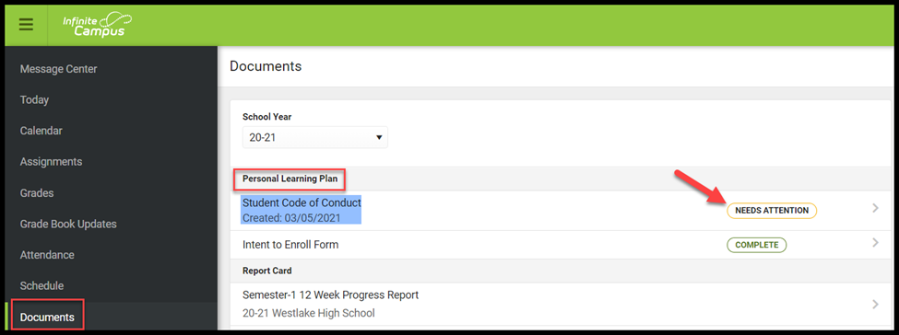

Step 2: Select Needs Attention then scroll to the Signature Page
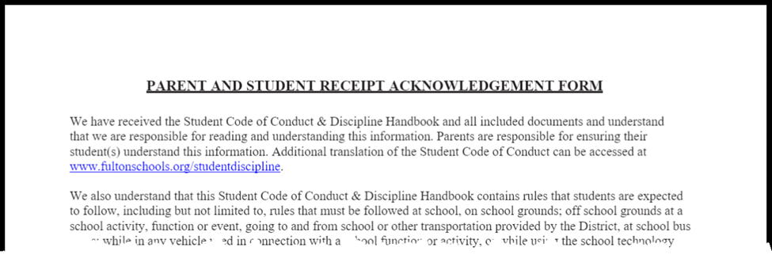
Step 3: Select the red signature box to complete the form
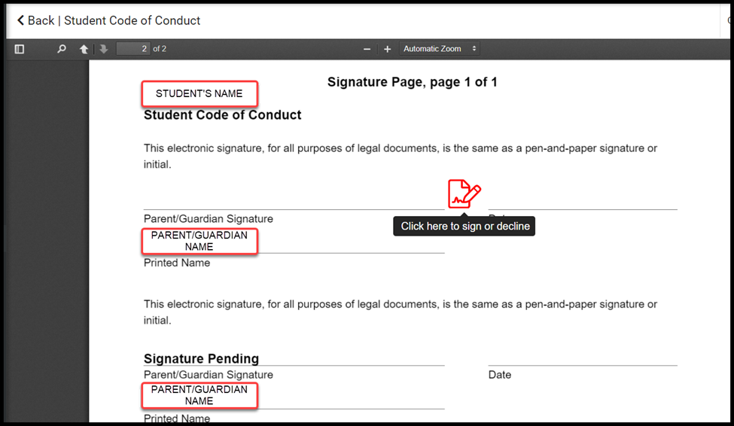

Step 4: Select with SIGN to agree or DECLINE to disagree
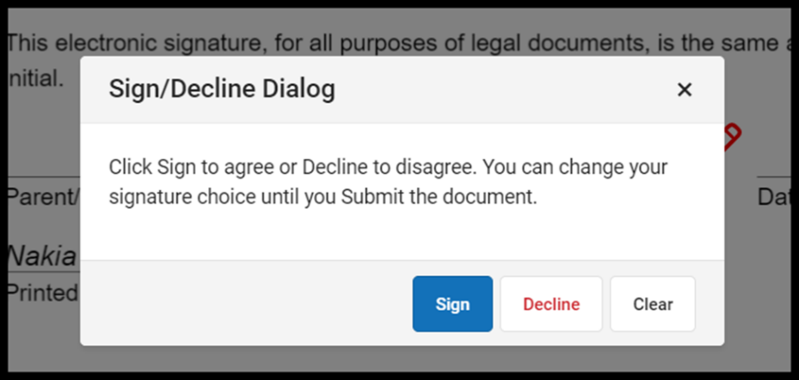

Step 5: Select SUBMIT
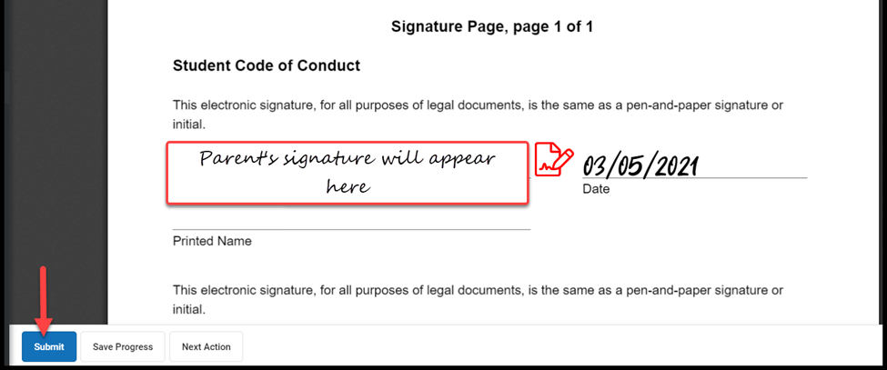

For the safety of all Wilson Creek students, staff, and visitors, I will abide by the following carpool guidelines.
Wilson Creek Elementary Carpool Contract
2026-27
- I will always enter the school’s main entrance (closest to Medlock Bridge Road with electronic school sign).
- I will make a right turn only into the entrance between the hours of 7:10 a.m. – 7:40 a.m.
- I will only drop-off/pick-up my student in the carpool line.
- I will not drop-off my student on the side parking lot to cross the bus lane.
- I will not park in the Exit only lanes or park on Wilson Road to avoid the carpool line.
- I will not drop-off my student at the top of the hill on Wilson Road to have him/her run down the hill.
- My student will enter through the front side doorway (A-hall) only.
- I understand the door is closed and locked at 7:40 a.m. After this time, I will park in a parking spot and escort my student(s) to the main front door to meet a school staff member to sign them in as tardy.
- I will not pass cars in the carpool lane.
- My child will enter/exit on the right passenger side of the vehicle. I will not have the child-lock system engaged.
- I will not drop-off my student prior to the 7:10 a.m. bell.
- In the afternoon, I will be in line no later than 2:30 p.m. If not, I will need to come to the front main entrance door where a staff member will meet me to pick-up my child. I understand that after three late pick-ups, an administrator will contact me.
- My carpool tag will be clearly visible in the front windshield. I understand that I will not be allowed to pick up my child in the line if I do not have a carpool tag.
- If my child is in the clinic at dismissal, or I do not have a carpool tag, I understand I must park in a parking spot, have my identification, and go inside to sign-out in the clinic/front desk.
- If I misplace my carpool hang tag, I will pay a $5.00 replacement fee for a new tag.
- I will always follow the directions of all carpool staff.
- I will be respectful of all staff.
I understand that in the mornings, the carpool line can be very long resulting in my child being tardy to school.

________________________________________________ _______________________
Parent/Guardian signature
Date
________________________________________________
Print Name
**Sign and return to the homeroom teacher before leaving sneak preview**

