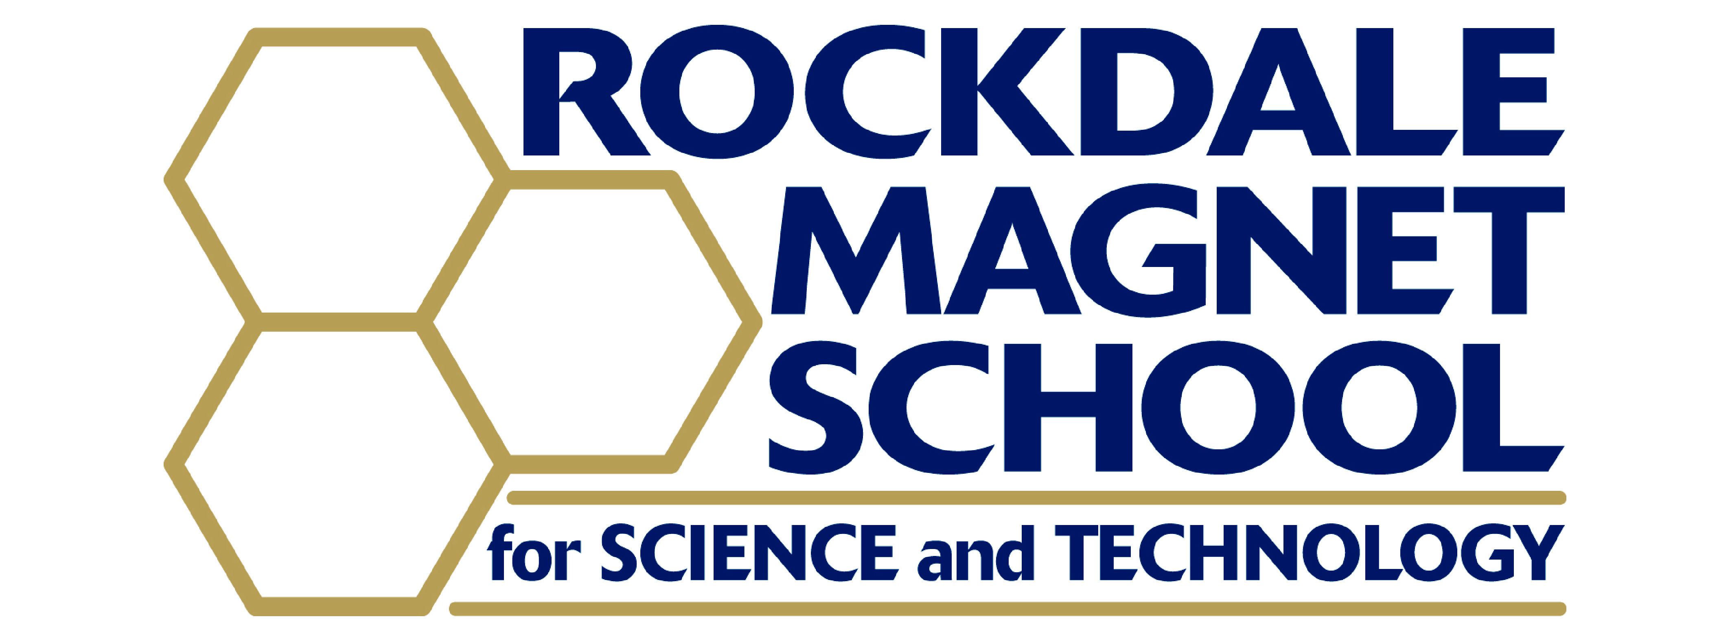

RMSST Student - Family Handbook

2026-2027

RMSST Student-Family Handbook
Table of Contents

RMSST Mission Statement…………………………………………………………………………….... 3
RCPS Vision and Mission Statement 3
RCPS 26-27 Calendar 4
A/B Period Schedule 5
2026-2027 Bell Schedule 6
Homeroom List 2026-2027 8
Magnet Parent-Student Workshops 9
Key Magnet Events………………………………………………………………..………………………10
General Policies and Procedures 14
Advanced Placement Exams 22
Academic Honor Code 23
Acceptable Conduct for School Functions 25
Magnet Graduation Requirements 26
Who Do I Contact When a Problem Arises? 29
Contact Information 30
Magnet Extracurricular Opportunities 32
Bulldog Scholars & RCHS Extracurriculars 36
Rockdale Magnet Fund, Inc. 37
Student Non-Discrimination Policy...………………………………………………………………….38
Handbook Signature Page 39

RMSST Mission Statement

The mission of Rockdale Magnet School for Science and Technology, a specialized research-focused learning community, is to foster and produce students who think ethically, critically, and independently while excelling in competitive academic environments and demonstrating high standards and expectations distinguished by:

  - Rigorous, accelerated curriculum with real-world and global experiences
  - Student-driven scientific research
  - Opportunities to evaluate and apply technology in a variety of settings
  - Instruction in professionalism, digital citizenship, and academic integrity
  - Personalized academic support and advisement
  - Collaboration with STEM-focused institutions and industries, including the College of Engineering at Georgia Institute of Technology and Middle Georgia State University
  - Extracurricular academic, leadership, and service opportunities on the state, national, and international level
  - Dedicated family and community involvement
  - Access to all programs and opportunities available at Rockdale County High School

RCPS is preparing students to thrive in a global society and at RMSST we are growing global STEM leaders of accelerated change!

RCPS VISION
The Vision for Rockdale County Public Schools is that all students will become productive and thriving members of our global society who can advocate for themselves and others.

RCPS MISSION
The Mission of Rockdale County Public Schools is to educate and empower all students by meeting their individual academic, behavioral, emotional, and social needs.

RCPS 26-27 Calendar

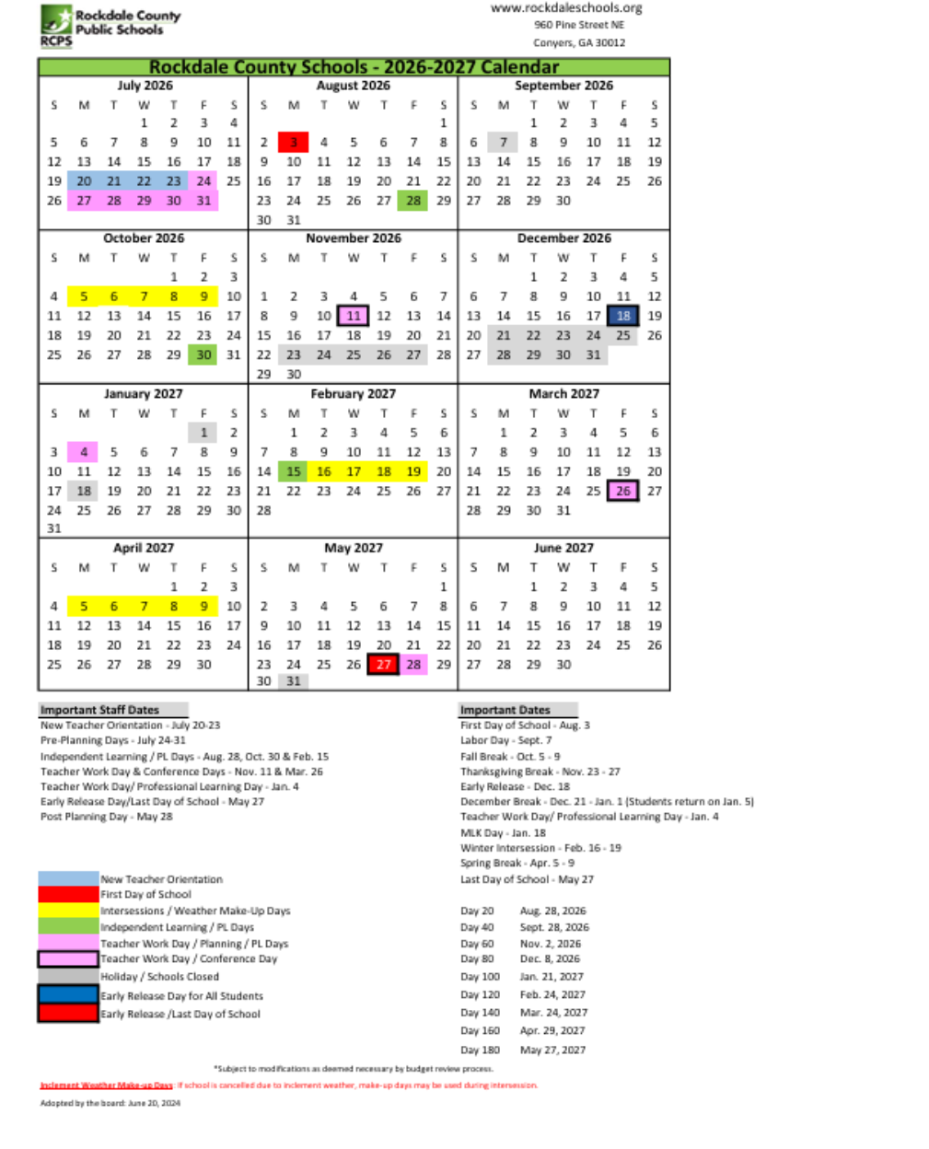

Rockdale County Public Schools A/B Period Schedule

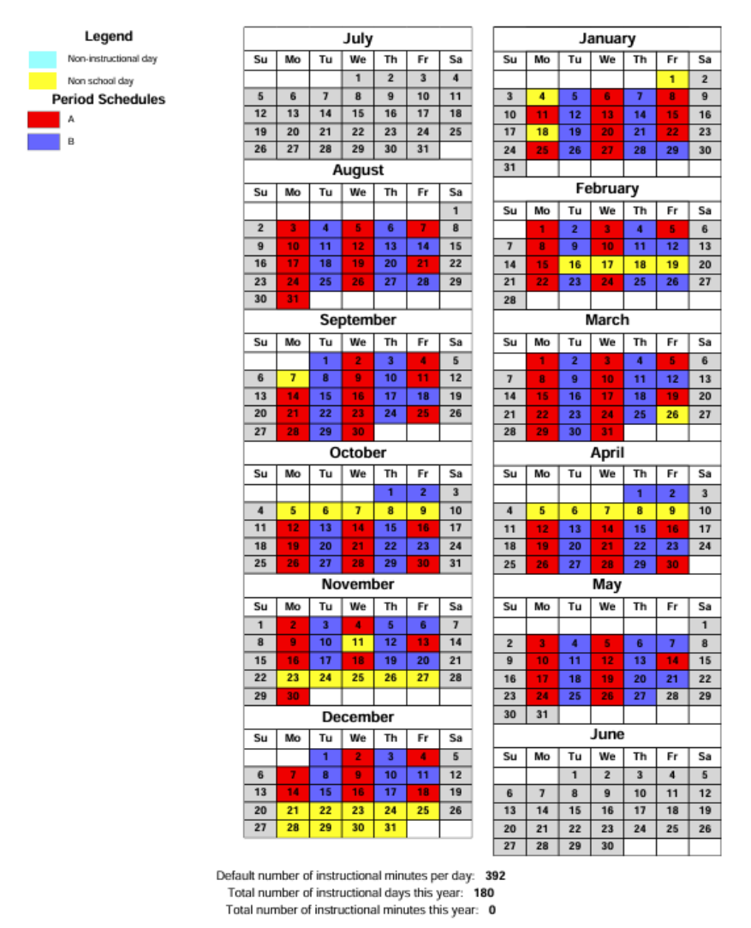

*Note: The final exam schedule is not finalized and A/B days will be adjusted during final exams.

2026-2027 Bell Schedule

1st Block 8:05am – 9:35am
9:35am-9:41am Transition
2nd Block 9:41am – 11:11am
11:11am-11:17am Transition
3rd Block 11:17am – 1:29pm
1st lunch 11:11am – 11:36am
2nd lunch 11:39am – 12:04pm
3rd lunch 12:07pm – 12:32pm
4th lunch 12:35pm – 1:00pm
5th lunch 1:03pm – 1:29pm (Magnet)

1:29pm-1:35pm Transition
4th Block 1:35pm – 3:05pm

*Monday and Wednesday = A day *Tuesday and Thursday = B day
*Friday = Rotating A/B day

RCA Bus Release Times
- 9:35am (Release at end of 1st period) [Bus leaves at 9:45am]
- 11:11am (Release at end of 2nd period) [Bus leaves at 11:20am]
- 12:40pm (Students who have 5th lunch @RCHS are released
to eat lunch @RCA) [Bus leaves at 12:45pm]
- 1:10pm (Release during 3rd period) [Bus leaves at 1:20pm]

Special Bell Schedules

For RMSST Events

Wellness Focus Day Schedule (as scheduled 1-2 times per month):
Wellness Lesson 12:40pm – 1:03pm
Lunch 1:03pm– 1:29pm

Friday FLEX Period Schedule (1 to 2 Fridays per month):
FLEX Period 12:15pm – 1:03pm
FLEX= Future Leadership Enrichment & eXtracurricular Period
Lunch 1:03pm– 1:29pm

For RCHS Events

RCHS Homeroom Bell Schedule:
*Students will start in homeroom for the first 5 days of school and as needed for testing and other school events.

Homeroom 8:05 am-8:30 am
1st Block 8:36 am – 9:50 am
2nd Block 9:56 am – 11:11 am
3rd Block 11:17 am – 1:29 pm
*regular schedule is followed after 3rd block starts; RCA students still leave at scheduled time

RCHS Pep Rally Bell Schedule

1st Block 8:05 am – 9:20 am
2nd Block 9:26 am – 10:41 am
3rd Block 10:47 am – 1:04 pm
1st lunch 10:47 am – 11:12 am
2nd lunch 11:15 am – 11:40 am
3rd lunch 11:43 am – 12:08 pm
4th lunch 12:11 pm – 12:36 pm
5th lunch 12:39 pm – 1:04 pm
4th Block 1:10 pm – 2:15 pm
Pep Rally 2:20 pm-3:05 pm

Homeroom List 2026-2027

Homeroom may be used occasionally throughout the year for grade-specific events.

9th Grade Homerooms: Organized alphabetically

Teacher Name Room # Students with last name
Anderson 816 A – J. Davis
Bolen 808 Domowicz - J
Carnes 823 K – Robinson
Jones 814 Rolle - Z

10th Grade Homerooms: Organized alphabetically

Teacher Name Room # Students with last name
Ruffin 803 A - D
Matthews 804 F- Lindsay
Sumperl 815 Lockhart – Romero Hernandez
Bare 812 Rowe - Z

11th Grade Homerooms: Organized alphabetically

Teacher Name Room # Students with last name
Coleman 830 A – Edgehill
Dufresne 829 Edwards - L
Ullo 828 M - R
Wisnewski 827 S - Y

12th Grade Homerooms: Organized alphabetically

Teacher Name Room # Students with last name starting
Williams 824 A – E
Mays 818 F - Ray
Seagraves 817 Reece- Y

Magnet Parent-Student Workshops
(format details and/or links will be announced at least 1 week prior to each event)

August 13 12th Grade: Senior Parent Meeting 6:00-7pm
(Virtual via Teams)
September 3 9th grade: Transition to High School 6:00-7:30pm
(In-person at Rockdale Magnet)
September 10 10th Grade: Advanced Academic Support 6:00-7:30pm
September 10 11th Grade: Support Strategies & College Prep 6:00-7:30pm
October 13 Eligible Student Night 5:00-8:00pm
(In-person at Rockdale Magnet)
November 19 11th Grade: Advisement 6:00-7:30pm
December 10 9th & 10th Grades: Advisement 6:00-7:30pm
February 25 Rising 9th Grade Meeting: Advisement 6:00-7:30pm
April 1 11th Grade: 12th grade & College prep 6:00-7:30pm

We request that all parents and students attend grade-level meetings on the specified dates above. These meetings will include a plethora of topics that will be designed to keep you informed and involved in magnet activities, decision-making, college planning, advisement, and course registration.

Families should read the weekly Magnet News sent via email and posted on the RMSST website, X, and Facebook for announcements, upcoming events, and more!

Key Magnet Events
*Details & any changes will be shared via weekly Magnet News sent via email, Facebook, and X

Fall Semester 2026

July:
- Open House- Tuesday, July 28th (3-6pm)

August:
- First Day of School- Monday, August 3rd
- Back to School Week- August 3rd- August 7th
- Back to School Flex hosted by StuCo - Friday, August 7th (12:15-1pm)
- Alumni Speakers Week - August 10-14
- Magnet Fund Meeting- Tuesday, August 11 (6-7:30pm via Teams)
- 9th grade & Peer Mentors only Flex (Alumni panel) - Thursday, August 13 (12:40-1pm)
- 12th Grade Family-Student College Kick-Off Meeting- Thursday, August 13 (6-7pm via Teams)
- 12th grade College Readiness Retreat - Friday, August 14 (9:40am-5pm)
- Find your Niche Club Fair Flex - Thursday, August 20 (12:15-1pm)
- Magnet Fund Fall Popcorn Sale- August 20-24
- Family Game Night & Potluck Social - Friday, August 21 (3:15-7pm)
- First Home Football Game vs. Alcovy High School (Senior Night)- Friday, August 21 (7:30pm start)
- 9th grade & Peer Mentors only Flex – Wednesday, August 26 (12:15-1pm)
- Curriculum Night at Rockdale County High School-TBD (Note that Magnet will review Curriculum at our grade level meetings in August – September)
- Independent Learning Day- Friday, August 28

September:
- Labor Day (no school for students and teachers)- Monday, September 7
- AP Scholars Breakfast - Wednesday, September 2 (7:45am-8:20am)
- 9th grade: Family-Student Meeting on Transition to High School & 9th grade Curriculum - Thursday, September 3 (6-7:30pm in-person)
- StuCo led Flex Assembly for Homecoming, Clubs, & Community Service Challenge - Friday, September 4 (12:15-1pm)
- Magnet Fund Meeting- Tuesday, September 8 (6-7:30pm)
- Homecoming Week- Starts Tuesday, September 8 (Monday is Labor Day)
- 10th & 11th grade Family-Student Meetings - Thursday, September 10 (6-7:30pm)
- 11 Acts of Kindness Day @ RMSST – Friday, September 11
- Homecoming Football Game vs. Central Gwinnett High School- Friday, September 11th (7:30pm start)
- Homecoming Dance- Saturday, September 12th
- School Service Project Social - Friday, September 18 (3:15-5pm)
- Fall AP Student & Parent Meeting- Thursday, September 17 (6-7pm)
- Probe College Fair- Thursday, September 17 (1-2:30pm)
- Ambassadors Working Retreat- Friday, September 18 (11:16am-3:05pm)
- Pre-ACT for 10th Graders - Wednesday, September 23
- 9th grade & Peer Mentors only Flex - Monday, September 28 (12:15-1pm)
October:
- Fall Break (no school for students and teachers)- October 5- October 9
- Student Council at SASC – October 10 through 12th
- Eligible Student Night – Tuesday, October 13 (5-8pm; staff report back by 4:30pm)
- Magnet Fund Meeting Tuesday, October 13 (6-7:30pm)
- Magnet Fund Monster Dash- Friday, October 16 (5:30-7:30pm)
- National Chemistry Week - October 19-23
- PSAT 9th-11th & SAT School Day for 12th grade - Wednesday, October 21 (8am-11:11am) (tentative pending district/College Board confirmation)
- Flex for Fall Ball, Chem Week, & Red Ribbon Week- Thursday, October 22 (12:15-1pm)
- 9th grade & Peer Mentors only Flex - Wednesday, October 28 (12:15-1pm)
- Cape Day Celebration for Children’s Healthcare - Friday, October 30 (tentative)
- Independent Learning Day – Friday, October 30
- Red Ribbon Week - October 23-30

November:
- Fall Semester Student Wellness Summit - Wednesday, November 4 (12:15-1pm)
- Teacher Workday/Conference Day- Wednesday, November 11
- 11th & 12th Grade Washington DC Trip - November 10 – November 15 (tentative)
- Career Day Flex - Friday, November 13 (12:15-1pm)
- Rockdale Mathematics Competition - Saturday, November 14 (tentative; note Fall Ball is also scheduled for this evening)
- Magnet Fall Ball Dance- Saturday, November 14th
- Zaxby’s Night supporting Rockdale Magnet Fund – Tuesday, November 17th
- Magnet Fund Meeting – November 17 6-7pm at Zaxby’s spirit night
- Pastries for Parents –Tuesday, November 17 7:30-8:30am
- 9th grade & Peer Mentors only Flex - Wednesday, November 18 (12:15-1pm)
- 11th Grade: Family-Student Advisement - Thursday, November 19 (6-7:30pm)
- Thanksgiving Wellness Flex - Friday, November 20 (2:40-3pm)
- Thanksgiving Break (no school for students and teachers) - November 23-27

December:
- EOC Algebra C&C Milestone tests- November 30-December 4 (tentative)
- Virtual Applicant Placement Testing – 5:30-7:30pm- Tuesday, December 1st
- 9th grade & Peer Mentors only Flex - Friday, December 4 (12:15-1pm)
- Magnet Fund Meeting – December 8 (6-7:30pm)
- 9th & 10th Grade Advisement Family-Student Meeting – Thursday, December 10 6-7:30pm
- RMSST School Science Fair - Thursday, December 10 (11:16am-1:03pm)
- -School Function Absence for all students not in Magnet classes
- -Transportation will be provided from RCA
- Final Exams Start- Wednesday, December 16th (tentative)
- Last Day of 1st semester & Early Release for HS- Friday, December 18
- December Break (no school for students and teachers)- December 21-January 1

Spring Semester 2027

January:
- 2nd Semester Preplanning Days (no school for students)- January 4
- First Day of 2nd Semester- Tuesday, January 5
- Magnet Fund Meeting – January 12 (6-7:30pm)
- MLK Day (no school for students and teachers)- Monday, January 18
- Regional Science Fair - Friday, January 22 (students miss 4th block)
- -School Function Absence for all students not in Magnet classes
- -Transportation will be provided from RCA

February:
- Honor Roll Celebration - Thursday, February 4 (8:30am-9:30am)
- Middle School Math Tournament - Saturday, February 6 (tentative)
- Heart Week - Feb 8-12
- Magnet Fund Meeting – Tuesday, February 9(6-7:30pm)
- Independent Learning Day- Monday, February 15
- February Break- February 16-19
- Flex hosted by BSSU- Wednesday, February 24
- Rising 9th Grade Parent/Student Advisement – Thursday, February 25 (6-7:30pm)

March:
- Magnet Fund Meeting – Tuesday, March 9 (6-7:30pm)
- 11th Grade: SAT School Day - Tuesday, March 16 (tentative pending district/College Board confirmation)
- Talent Show – Thursday, March 25
- Teacher Workday/Conference Day- Friday, March 26
- Georgia Science and Engineering Fair- March 26-27 (tentative)

April:
- 11th Grade Family-Student Meeting: Senior Year & College Prep – Thursday, April 1st
- Spring Break - April 5-9
- Magnet Fund Meeting – April 13 (6-7:30pm)
- Internship Interview Day – Thursday, April 15th (8-9:30am)
- Flex for National Student Leadership Week & AP prep Kick Off - Friday, April 16 (12:15-1pm)
- Teacher Appreciation Week – April 19-23 (celebrating before Spring testing starts)
- National Science League Tests- April 19-23 (tentative)
- TedX- Tuesday, April 20 (3:15-4:30pm)
- Magnet Family Picnic & Field Day Games with SME- Tuesday, April 20 (5-7pm)
- Green Team led Wellness Summit for Earth Day- Thursday April 22 (12:40-1:03pm)
- Prom- Saturday, April 24th
- Freshman Poster Session – Tuesday, April 27th(3:15-5pm)
- EOC Tests- April 26-May 7 (tentative)

May:
- Magnet Senior Awards Banquet - Friday, April 30th
- Magnet Calculus Competition - Saturday, May 1 (tentative)
- AP Exams - May 3-14 (tentative pending College Board confirmation)
- International Science & Engineering Fair- May 8-14 (tentative)
- Magnet Fund Meeting – May 11 (6-7:30pm)
- 9th-11th grade Awards – Tuesday, May 18 (6-7:30pm)
- 9th-11th Grade Exams Start- Monday, May 24th (tentative)
- Graduation – Week of May 24th (date TBD)
- Last Day of 2nd Semester- Thursday, May 27th

June:
- Rising 9th grade Summer Adventure- Tuesday, June 1
- Summer STEAM Camp- June 7-11

General Policies and Procedures

Campus Hours & Building Logistics

- The building officially opens at 7:30am and closes at 3:15pm. If you are in the building before or after these times, then you must be with a specific teacher or sponsor for a specific purpose.
  - All students staying after school for extracurricular activities, office hours, tutorial sessions, etc. must be picked up within 15 minutes of the ending time of the activity. All students will be asked to wait outside for their parents after 3:15pm or at the conclusion of after-school activities.
  - Getting extra help from teachers is important. If you are struggling academically, it is important to seek help before you get too far behind. Attending afterschool office hours and tutorial sessions is encouraged as well as asking questions during class.

- Students should report directly to the cafetorium if arriving before 7:55am. After 7:55am students should go directly to their first period classroom.

- Breakfast & Lunch:

  - Students wishing to purchase meals* must do so from the RCHS cafeteria. Please note that no food is served at Magnet. *School meals are available at no cost to students through the community eligibility program for the 25-26 school year.
  - Grab-n-Go Breakfast is served in the RCHS cafeteria and the RCHS front lobby until 8:00am.
  - Each teacher is assigned a 25-minute lunch period. Your 3rd block teachers will inform you of your assigned lunch period.
  - All students are expected to report to the RCHS Cafetorium for their assigned lunch period and remain there for the entire lunch period.
  - Students are not allowed to order or receive deliveries at school.
    - No meal delivery services (Uber, Door Dash, etc) are allowed for campus security (items will be confiscated and not returned at purchasers expense).
    - Family members are not allowed to drop off outside vendor food for lunch. A hot lunch is available to all students in the RCHS Cafeteria daily at no charge.
    - Students who go off campus for internship or RCA are expected to travel directly between campuses. No outside food purchased in transition will be allowed (items will be confiscated and not returned at purchaser’s expense).
  - Students are not allowed to leave campus to purchase lunch and return.

Code of Conduct and Behavior

- Students must sign and abide by the RCPS Student Code of Conduct. The RCHS Tardy Policy and Dress Code will be enforced. Students may be withdrawn from RMSST for disciplinary reasons. Violations of the following sections of the RCPS Student Code of Conduct may result in immediate long-term suspension from school and withdrawal from Magnet: Alcohol, Bullying, Drug, Sexual Misconduct, and Weapons.

- Students must sign and abide by the Magnet Honor Code. Students may be withdrawn from RMSST as a result of Honor Code violations.

- Students must sign and abide by the RCPS Technology Usage Agreement. Any student using the school computers for unauthorized purposes or using another student’s login may lose computer privileges.

Dress Code

- The Rockdale County School System has a district-wide dress code. The complete text of this code can be found in the Rockdale County Code of Student Conduct and Discipline. The purpose of the dress code is to restrict styles of dress which create a disruption or interference with classroom activities. The RCHS Dress code include these provisions:

- Obscene pictures, symbols, or depictions of illegal drugs, tobacco products, or alcoholic beverages shall not appear on clothing.
- Students are not allowed to wear hats or headgear inside the building.
- Students are not allowed to wear slides or flip flops to school.
- No short shorts/no mini-skirts (shorts or skirts must reach the finger tips)
- Leggings are only allowed if a shirt or dress is worn that reaches the fingertips.
- Extremely baggy pants and oversized shirts are not allowed.
- Low-cut blouses, low-cut dresses, or low-cut shirts are not allowed.
- Any shirt or blouse that is sleeveless must have a collar.
- Any shirt or blouse that does not have a collar must have sleeves.
- No tank tops.
- Bare midriffs are not allowed.
- Spandex pants/skirts are not allowed.
- No immodest or extreme fashion is permitted.
- Pants, skirts and shorts must be worn at the waist.
- No ripped jeans above fingertip length unless something is worn underneath that is not flesh covered to prevent skin from showing.
- Jeans must be free of holes above the knee or have small holes above the knee covered.
- Any clothing considered inappropriate by the administrators will not be allowed and will result in consequences.

- Students with an initial dress code violation in the first two weeks of school will be asked to call home for a change of clothing to be brought to the school. If someone is not available, the student can borrow an item from the professional dress closet or be sent to ISS for the rest of the day. Repeat offenders or those breaking dress code after the first 10 days of school receive consequences outlined in the RCPS Parent Handbook which includes in-school and potential out-of-school suspension.

Magnet Student Cell Phone Guidelines

- All personal electronic devices that are brought to school are the responsibility of the student. If a device is lost or stolen, administrators will not participate in a search for the device. A police report can be made with the School Resource Officer.
- Students may use their phones in the morning before classes, during class transitions, and during lunch. Use may not be a distraction to others or a safety concern.
- Students may NOT charge their cell phones in the classroom. Charging stations in the classroom are designated for laptop charging.
- Students may NOT use cell phones in the classroom unless approved specifically by a teacher during that lesson. Devices should remain stored away until the end of class.
- Unauthorized use of electronic devices will result in confiscation and electronic devices may be redeemed by student’s parent/guardian in the front office. RCPS is not liable for confiscated electronic devices. A student may not use a cell phone or any electronic device which may contribute to the disruption or interference with school operations.
Please note that cell phone policies and protocols will change during SY27 to comply with the 9-12 expansion of the Distraction-Free Education Act.
The consequences below will be followed for minor cell phone disruptions.

- 1st Offense – Teacher will ask the student to put away the cell phone and warn that it will be confiscated if seen again.
- 2nd Offense – Cellphone will be collected by the teacher and taken to the Front Office (between class periods). The school system accepts no liability for confiscated electronic devices.
- 3rd Offense - Cellphone will have to be picked up by a parent or guardian only. Discipline referral will be generated.
- 4th or more Offenses – Cellphone collected. Suspension assigned by administrator.

Notes on consequences:
- After a 1st offense in a classroom, cell phone offenses are tracked in the Magnet Front Office and apply to the entire semester across all classes.
- Once a teacher has warned a student to put their cell phone away, any future offenses in that class may be treated as a second offense.
- Cell phone use that is more disruptive to the learning environment may result in additional consequences.
- Students who refuse to turn a cellphone over to a school staff member when a phone is requested will receive additional disciplinary consequences.

- Students may wear headphones or earbuds in the hallway and during lunch as long as one ear is uncovered and the student is able to hear announcements/staff instructions.
- Students may NOT use headphones in the classroom unless they are plugged into the laptop or desktop and being used for educational purposes with teacher permission. Devices should remain stored away until the end of class.

Tardies & Attendance

- Tardies: Students must arrive in their assigned classroom no later than 8:05 am each morning. If a student is tardy to school, the student must check-in at the front office. The student will be marked tardy (excused or unexcused) by the office staff and will be given a pass to class.

- Tardies will be marked as unexcused unless the student has a written excuse note from a parent stating that the student was ill, at a doctor’s appointment, etc.

- Students are expected to arrive on time for each class. If a student who was already present for school arrives after the tardy bell, the teacher will record a tardy in Infinite Campus. See Check-in procedures for information on late arrivals to campus. If a student is more than 15 minutes late to class, the teacher will submit a discipline referral for skipping.

- Consequences will be assigned for overall cumulative tardies as follows. Administrative contracts will be issued at the 5th tardy outlining preventive steps and consequences for continued violations. Students failing to fulfill the assigned consequence will receive additional consequences as determined by the administrator. Transportation is the responsibility of the parent whose child is assigned to detention.

- Attendance: Students must be in their assigned class each period. If you must leave the classroom, a hall pass must be given by the teacher. If you are not in your assigned class and do not have teacher permission to be out of class, then you are considered skipping and being in an unauthorized location.

- Check In: If a student arrives to school any time after 8:05 AM they are currently marked absent in their class and need to be checked into school. The student will sign the check-in/check-out log in the front office and turn in any documentation (doctor’s excuses, court papers, written notes, etc.) to the Attendance folder. The front office will give the student a “check-in pass” that will allow them admission to class. If written documentation is provided it will be an excused check-in, if not, it will be an unexcused check-in. This information and the time of arrival will be entered in Infinite Campus.

- Check-Outs: Students who will be checking out during the day must bring a note to the Magnet Office before school starts stating the reason for check-out and listing the name and phone number of a parent or guardian who can be contacted. A copy of a guardian’s driver’s license or other government ID must be provided to the school when the note is verified for a student to check themselves out. Parents may also come into the Magnet office to check students out. Students will only be called from class once a parent is in the Magnet office. Students who follow the process above to check themselves out must still go through the Magnet office to officially check out before leaving campus. Students are not permitted to check out of school during lunch to go off campus for lunch. Checkouts will be counted as tardies; only reasons listed for excused absences can be counted as excused tardies. No check-outs are permitted after 2:45pm.

- Students cannot leave campus during the school day without following the check-out protocol. Students may not leave campus for lunch. The only exception to the check-out protocol are students going to a class at Rockdale Career Academy or for their internship off campus. Teachers will share instructions for leaving campus with these students.

- Students leaving and coming into the class are distractions to the learning process. Therefore, we discourage students from leaving school during the day, and we encourage parents to schedule appointments for students at times other than school hours.

- A student must bring an excused absence note to the magnet office within 3 school days of their return to school. Otherwise, it will automatically be recorded as an unexcused absence.

- Students will be allowed two excused absences for college visits. Please notify your counselor and teachers in advance of your planned absence. The student must provide documentation of the visit from the school upon return. Any visits beyond two are considered unexcused absences per RCPS Board Policy JB; however, you are permitted and encouraged to complete all Magnet make-up work. Arrangements for RCHS make-up work must be made with the teacher directly.

School Safety

- Fire drills will be held twice during the first two weeks of school and once each month for the remainder of the school year.
- Evacuation routes are posted in every classroom.
- When an alarm sounds, every student is expected to follow the instructions given by the teacher and to proceed in a calm, orderly manner to your designated area.
- An intruder drill will be conducted at least once per semester.
- If the school is placed on lockdown, all doors will be locked. Any students, faculty, or staff in the hallway should proceed to the nearest classroom or office for shelter. All persons will be required to stay in place until the lockdown has been lifted. Do not open the door for any reason.
- All RCPS guidelines for mitigation of infectious disease will be followed. Families will be informed of any changes in expectations should they occur. For the start of school, the following mitigation strategies are in place:
- Hand sanitizer is available and students are encouraged to use regularly
- Frequent hand washing should happen during breaks and in classrooms as available

Absences and Make-up Work

- A student must bring an excused absence note to the Magnet office, or email to magnetoffice@rockdale.k12.ga.us within 3 school days of their return to school. Otherwise, it will automatically be recorded as an unexcused absence.

- Work due during an unexcused absence will count as a zero unless a student completes the late work process as required for that class.

  - All late work submissions end five school days prior to the first exam day.
  - Long-term assignments (those worked on over two weeks or longer) are due as assigned (see number 13 below for more information).

- When student absences are excused, students will be allowed to make up their work during their absence. Students who have an excused absence should initiate arrangements for completion of missed assignments with teachers on the first day they return. The teacher will determine deadlines for completion of assignments at this time. All work should be made up within seven school days. Students, not teachers, are responsible for obtaining missed assignments. Students are encouraged to ask for work in advance if there is a planned absence. This also applies to absences due to a school-related function. See RCPS Attendance Protocol on the RCPS website www.rockdaleschools.org under the Parent tab for more information.

- Work assigned before an excused absence occurs must be turned in on the first day of your return to school (see below for long-term assignments). This also applies to absences due to a school-related function.

- Long-term assignments (those worked on over two weeks or longer) are due as assigned and not eligible for late work submission; a student is responsible for this due date even if absent. All long-term assignments will include progress checks during the work period for the project. If a student has not made progress at the check point, then teachers will notify parents.

Enrollment and Academic Expectations

- Students are committed to attending RMSST for four years unless the Magnet Director and RCPS Assistant Superintendent grant a transfer approval.

- Students may only withdraw from RMSST at the beginning or end of a semester if approved by the Magnet Director and RCPS Assistant Superintendent. Students who are not zoned for RCHS but wish to remain at RCHS must complete a waiver application with the Office of Teaching and Learning. A committee meets regularly to review these applications.

- Academic interventions are an important part of Magnet life. Magnet Teachers/Counselors /Administrators conduct meetings with students and parents. Students may be placed on academic support contract if one or more of their semester grades are less than 75%. A student may be removed from academic support contract if all grades are 80% or higher at midterm.

- Students will be withdrawn from RMSST if they fail one or more courses in a semester. This does include non-magnet classes. Students may appeal this policy if he/she has completed all support contract requirements or if there are substantial extenuating circumstances which have negatively impacted the student’s academic achievement. In this case, an Appeal Hearing is held, and a final decision is determined by the Appeal Board. Students may not appeal if they have failed more than two classes and/or have not completed academic support contract requirements. An appeal request is allowed only once per student throughout the four years.

- RMSST extracurricular clubs and teams may each have participation rules, and students are expected to maintain a 70% or higher in all classes throughout the semester to remain in good standing with their extracurricular organizations.

Final Exams

- Final exams are given at the end of the semester and count the percentage set in RCPS Board of Education policy. Students in Biology, Coordinate Algebra, US History, and American Literature are required to take the Georgia Milestone Assessment at the end of the course.
- Students will not be permitted to take final exams early. Students will only be permitted to take late exams if the absences are excused, and permission has been obtained from an administrator.
- Final Exam Exemption:
  - 10th –12th grade Students may exempt final exams only if all the conditions below have been met for an individual course.
- Students must be in grades 10-12
- Students must have a 90 or above
- A student may not be exempt from the first or second semester exam for courses that have an EOC exam
- Five or fewer unexcused tardies per course per semester
- Four or fewer absences per course per semester
- Three or fewer major referrals per semester for all classes combined
- Students earn eligibility to exempt each individual exam. An exemption in one course is not a guarantee of exemption in other courses.
- Students may not exempt state mandated milestone end of course exams under any circumstances. Courses with mandated end of course exams are: Biology, Coordinate Algebra, US History, and American Literature
- 9th graders are not eligible to exempt exams.

Parent Involvement

- All parents are requested to attend grade level meetings as scheduled, Magnet Banquet, and extracurricular activities in which your student participates throughout the year. Your presence and support make a difference in your child’s academic achievement.

- We request that all families participate in social and fundraising events coordinated by the Rockdale Magnet Fund, Inc. The Fund membership dues are collected at Open House.

Advanced Placement Exams

For the 2026-27 school year, students enrolled in an Advanced Placement course will take the Advanced Placement Exam in May 2027. If you complete the AP Exam registration during the standard registration period, RCPS will cover the standard AP Exam fee for students who take the exam on the regularly scheduled date as designated by the College Board. However, if you fail to register for the AP Exam during the standard registration period or fail to take the AP Exam on the regularly scheduled date, you will be responsible for the following fees that may be assessed by the College Board, if they apply to your situation:

· Late order fee (you sign up for the AP Exam after the standard registration period has ended and the College Board charges an additional fee).
· Late testing fee (you take the AP Exam on a date other than the regularly scheduled AP Exam date and the College Board charges an additional fee).
· Unused/canceled exam fee (you decide after the AP Exam ordering deadline not to take the exam that was ordered for you and the College Board charges an additional fee).
· Any other fee charged by the College Board based on your failure to register for the AP Exam during the standard registration period or your failure to take the AP Exam on the regularly scheduled date.

Your failure to pay the above-referenced fees, if issued by the College Board, may result in you not being able to take the AP Exam.

RCPS AP Exam Regulatory Parameters:
RCPS will follow the AP Exam Regulatory Parameters as outlined below when determining the number of exams that students will take. *For students taking four or more AP Courses, an advisement session will occur with the student, AP Coordinator, Counselor, parent/guardian to determine which AP Exams are in the best interest of the student.

# of AP Courses | # of AP Exams required
1 | 1
2 | 2
3 | 3
4 | 3
5 | 3
6-8 | 4

Academic Honor Code
Rockdale Magnet School for Science and Technology

Part I: Purpose of the Honor Code
The members of the Rockdale Magnet School Community believe that the fundamental objective of the Institution is to provide the students with a high-quality education while developing in them a sense of ethics and social responsibility. We believe that trust is an integral part of the learning process, and that self-discipline is necessary in this pursuit. We also believe that any instance of dishonesty hurts the entire community. It is with this in mind that we have set forth a Student Honor Code at the Rockdale Magnet School for Science and Technology.

Part II: The Honor Pledge
As a member of the Rockdale Magnet School for Science and Technology, I understand the objective of the institution is to provide high school students with a high-quality education which fosters academic integrity, scientific ethics, and social responsibility. I pledge and accept my responsibility as a member of the Rockdale Magnet School Community to rigorously uphold and to abide unconditionally by the Honor Code at all times. I promise that I will not participate in any form of academic misconduct. In addition, I understand it is my responsibility to hold others to these same standards and it is my duty to report honor code violations as defined in the code.

Part III: Definitions
Academic dishonesty is a critical offense at the Rockdale Magnet School for Science and Technology. Without regard to motive, conduct that is academically dishonest consists of:
- Cheating – intentionally using, attempting to use, or possessing unauthorized materials, information, technology, or study aids in any academic exercise including, but not limited to artificial intelligence aids.
- Plagiarism – unintentionally or knowingly representing the words or ideas of someone else without properly acknowledging the source; unintentionally or knowingly helping or attempting to help another to violate any provision of this Code.
- Fabrication and Falsification – includes but not limited to inventing experimental data or changing experimental data of any information or citation in an academic exercise.
- Recycling Fraud- The reuse of significant, identical, or nearly identical portions of one's own work without acknowledging that one is doing so or citing the original work is a form of “self-plagiarism”. This includes submitting an assignment for credit in multiple classes without informing the teachers.

Part IV: Outline of Protocol for Misconduct
A collection of evidence is used in academic misconduct cases at Rockdale Magnet School for Science and Technology. Each case must be proven by a preponderance of evidence, more commonly known as the “more likely than not” standard of proof.
- In the event that a violation is observed or suspected, the teacher/student will make a written statement at the request of the Assistant Director.
- The Assistant Director will speak with the accused student to gather information and notify parents.
- The Assistant Director will lead the investigation and present evidence to the Honor Code Council.
- If after investigating the Assistant Director determines the situation could be a violation then the Honor Code Council will schedule a hearing. The hearing will be held within five school days.
  - If the student confesses and the Assistant Director agrees with the student assessment that the student violated honor code, then at the Assistant Director’s discretion a consequence may be issued for first violations without a full Honor Code Council. First time violations, even with an admission of violation, can go to the Honor Code Council if deemed necessary.
- The Honor Code Council shall review the evidence, interpret the Honor Code, and administer consequences for Honor Code violations. The Honor Code Council will be composed of at least 3 of the following members:
  - Magnet administrator
  - Magnet staff (other than current teachers of the accused student)
  - RCHS administrators
  - Magnet student representatives
  - Magnet alumni

Part V: Consequences
Penalties that may be imposed include, but are not limited to, the following:
- Zero on assignment/quizzes/test/project/lab
- Re-do assignment/quizzes/test/project/lab
- Academic Integrity Paper
- Administrative Detention
- Community Service Hours
- In School Suspension (ISS)
- Notation on permanent record
- A second violation will automatically result in notification of academic dishonesty to colleges and universities during the application process.
- A third violation will result in the student’s removal from the Rockdale Magnet School and transfer to zoned high school at the end of the semester.

Adapted from the Honor Codes of Agnes Scott, Georgia College, Georgia Tech, Rice University, Southern Polytechnic State University, Thomas Jefferson High School, University of Georgia, and Young Harris College (2012)

Acceptable Conduct for School Functions

The Rockdale Magnet School for Science and Technology is committed to creating and maintaining an environment in which all persons who participate in off-campus school functions feel safe and comfortable. All participants are expected to conduct themselves professionally and exhibit exemplary behavior during school functions as they are representing our school, district, and community. Please review the following expectations:

- All RCPS, RCHS, and RMSST rules apply during off-campus school functions.
- Possession or consumption of any form of alcohol, tobacco, or illegal substance (by Georgia law) will not be tolerated. Any student found to have abused this rule will be sent home immediately at their parent’s expense and suspended from school with possible recommendation for expulsion.
- When students are divided into specific groups, you are to stay with that group without exception! At no time are you to be out by yourself. Always use the “buddy system”.
- You are responsible for keeping up with your own money and belongings. Do not leave your items lying around anywhere, including in your room.
- All students are expected to attend all events, whether you are participating or not. Keep a copy of your itinerary and rules and regulations with you at all times. Please follow your itinerary closely, being early for all departures.
- Chaperones reserve the right to enter and search any student’s room or belongings at any time without warning.
- Always wear appropriate attire and display behavior that is representative of any RMSST student. Jeans, shorts, and/or flip flops should never be worn unless prior approval has been granted. Controversial clothing such as spaghetti straps, tank tops, frayed clothing, and clothing advertising alcohol, drugs, profanity, and sexual pictures is unacceptable. Students will be asked to change if this problem occurs.
- There shall be no public display of affection (PDA) at any time.
- Cell phones and other devices should not be used during activities or after curfew.
- Females and males should never be in the same hotel room, dorm room, etc. If this occurs, the student(s) will be dismissed from the event. All expenses for the student to return home will be the responsibility of the child’s family.
- All students must remain in their assigned area (hotel room, dorm, host family’s home, etc.) after curfew. If students are found outside of their rooms after curfew, they will be excused from the event. All expenses for the student to return home will be the responsibility of the child’s family.

Magnet Graduation Requirements

All students must successfully complete, at a minimum, the following courses in order to receive a Magnet Diploma:

- AP Environmental Science
- Magnet Biology
- Magnet Chemistry
- AP Physics C
- Four magnet mathematics units with a minimum of one unit of Magnet Calculus
- Three units of Magnet Research
- Four English/Language Arts credits to include 2 units of Magnet English
- One senior specialized elective credit: Microbiology, Botany, AP Computer Science, History of Mathematics, or Oceanography (other courses may be added to this list at the discretion of the Magnet Director)
- Four units of Social Studies- American Government, World History, US History, and Economics
- Half unit of Health and half unit of Personal Fitness
- Two units of the same World Language
- One unit of senior capstone credit: Scientific Internship or Research IV
- One unit Magnet Technology Course

Class Rank is determined by each student’s weighted GPA.
Honor Graduates will be defined as Cum Laude (3.5-3.69), Magna Cum Laude (3.7-3.89), and Summa Cum Laude (3.9+). Weighted GPA is used to determine these honors.

Magnet Valedictorian and Salutatorian:
Valedictorian and Salutatorian will be decided based upon the RCPS Board Policy IHD-R.
- Each school and Magnet program will have a Valedictorian and Salutatorian at graduation.
- The Valedictorian and Salutatorian will be determined as follows:
  - Be identified as a Board Scholar.
  - Have been enrolled in the awarding high school for a minimum of two years, which is defined as four full, consecutive semesters. Students must be enrolled prior to the 10th day of Fall semester for the semester to be included in the 4 semester requirement.
  - Be identified based on the highest and second highest weighted GPA.
  - Designees shall be determined at the end of first semester after grades have been posted.
  - In the event of a tie (a matching GPA):
    - For the first tie-breaker, the students will be identified based on the highest and second highest numeric average.
    - For the second tie-breaker, the students will be identified based on the highest and second highest total SAT score.
- The principal reserves the final decision as to whether there shall be speakers at graduation ceremonies and, if any, who they shall be. This honor does not go automatically to the Valedictorian and/or Salutatorian.
- Valedictorians and Salutatorians shall be recognized and shall have the opportunity to have an active part in graduation ceremonies.

To remain in good standing, students must:
- Follow all rules and regulations of RMSST & RCHS. Abide by the Magnet Honor Code.
- All grades must be 70% or above in all classes.
- If a student has a grade below 70% at the end of a semester in any class, then they will be withdrawn from RMSST. At this time, any student who is not zoned for RCHS will return to the school for which they are zoned. (An appeal process allows students with a final grade of 65-69% one opportunity throughout their high school career to appeal the transfer to remain enrolled at RMSST.)

RCPS Grading Scale

The RCPS grading scale is reflected below:

- A= 90-100 (4 quality points)
- B= 80-89 (3 quality points)
- C= 70-79 (2 quality points)
- F= 69 and below (0 quality points)
How to Calculate Your GPA

Un-weighted GPA:
- Assign a value to each grade on your transcript
  - A = 4
  - B = 3
  - C = 2
  - F = 0
- Calculate the total of these points
- Divide this sum by the number of courses on the transcript

Weighted GPA:
- Assign a value to each grade associated with a course on your transcript that is NOT weighted
  - A = 4
  - B = 3
  - C = 2
  - F = 0
- Assign a value to each grade associated with a weighted course on your transcript
  - A = 5.2
  - B = 4.2
  - C = 3.2
  - F = 0
- Calculate the total of these points
- Divide this sum by the number of courses on the transcript

HOPE GPA:
- Your HOPE GPA is calculated based on grades earned in the core subject areas only. Everything is on the un-weighted scale except for AP courses which count an A=4.5, B=3.5, etc.
- Not all courses on your transcript are used to calculate your HOPE GPA
- Set up an account at www.gacollege411.org to view your estimated HOPE GPA

Class Rank is determined by your weighted GPA

Who Do I Contact When a Problem Arises?

- The first point of contact for any issues that are related to grades or teacher-student conflicts should be the classroom teacher. If the issue is not resolved, contact the Assistant Director, Dr. Lynette Clark. If she cannot solve the problem or answer your questions, then the situation will be referred to the Director, Dr. Eldridge Powell.

- Contact your student’s counselor if you have questions or concerns related to social and emotional learning, college and career preparation, scheduling, and/or advisement.

  - Ms. Brianna Lockhart - all students with last name A through J
  - Ms. Jennifer Harris - all students with last name K through Z

- Contact the Assistant Director, Dr. Lynette Clark with any issues that are related to classroom discipline. If the Assistant Director cannot solve the problem or answer your questions, then she will refer the situation to the Director, Dr. Eldridge Powell, and/or a RCHS administrator.

- Contact the Assistant Director, Dr. Lynette Clark, with any issues that are related to the Magnet curriculum. If the Assistant Director cannot answer your questions, then she will refer the situation to the Director, Dr. Eldridge Powell, and/or a RCHS School administrator.

- Contact Mrs. Stephanie Bradford, Magnet Admissions Secretary, with any issues that are related to various Magnet events such as the Magnet College Trips, Magnet Selection Process, Family Picnic, Awards Banquet, and Summer Adventure.

- Contact Mr. Scott Bolen with questions about science fairs, research, or internship class.

- Contact , Magnet Intel, Technology Support, if you have any problems with or questions about your Dell laptops. The Technology office is located in the Innovation Hive.

- Contact Mr. Josh Dyer, Digital Learning Specialists, if you have any problems accessing Infinite Campus, Canvas, or the school website.

- Contact Mrs. Teja Ray, President of Magnet Fund, Inc or Mrs. Stephanie Bradford with any questions related to the Rockdale Magnet Fund, Inc.

We ask that you contact these individuals first before contacting central office staff, school board members, or Rockdale County High School administrators so that we are made aware of the problems and are given a chance to solve them.

Contact Information

Rockdale Magnet School for Science and Technology
Phone: (770) 483-8737
Fax: (770) 483-7379
Address: 930 Rowland Road Conyers, GA 30012
Website: http://www.magnet.rockdaleschools.org/
Twitter: https://twitter.com/rockdalemagnet @RockdaleMagnet
Facebook: https://www.facebook.com/RockdaleMagnet

Administration and Staff:

Dr. Eldridge Powell, Director
epowell@rockdale.k12.ga.us

Dr. Lynette Clark, Assistant Director
lclark@rockdale.k12.ga.us

Jennifer Harris, Magnet Counselor
jharris1@rockdale.k12.ga.us

Brianna Lockhart, Magnet Counselor

Beth Dire, Bookkeeper
bdire@rockdale.k12.ga.us

Stephanie Bradford, Admissions Secretary
sbradford@rockdale.k12.ga.us

Ashley Jackson, Registrar
ajackson@rockdale.k12.ga.us

blockhart26@rockdale.k12.ga.us

Faculty:

Blaire Anderson
banderson27@rockdale.k12.ga.us

Stephen Bare
sbare@rockdale.k12.ga.us

Scott Bolen
sbolen@rockdale.k12.ga.us

Yasmeen Carnese
ycarnes27@rockdale.k12.ga.us

Brandon Coleman
bcoleman23@rockdale.k12.ga.us

Billy DuFresne
bdufresne@rockdale.k12.ga.us
Dr. Chuck Garner
cgarner@rockdale.k12.ga.us

Tiffany Jones
tjones1@rockdale.k12.ga.us

Diana Kennen
dkennen@rockdale.k12.ga.us

Julie Matthews
jmatthews@rockdale.k12.ga.us

Zakiria Mays
zmays26@rockdale.k12.ga.us

Walter Ruffin
wruffin26@rockdale.k12.ga.us
Shelley Seagraves
sseagraves@rockdale.k12.ga.us

Joshua Sumperl
Jsumperl25@rockdale.k12.ga.us

Cherie Ullo
cullo@rockdale.k12.ga.us
Dametria Williams
dwilliams@rockdale.k12.ga.us

Kimberly Wisnewski
kwisnewski@rockdale.k12.ga.us

Magnet Extracurricular Opportunities

- Colleges and universities want to see that you have been actively involved in extra-curricular activities. This means that you should choose a few activities and stick with them for several years. Show that you are an involved member!
- It is also important to hold leadership positions (officer, chairperson, etc.) within these organizations.
- The clubs and teams at Magnet are organized into four broad categories: Academic, Enrichment, Service and Advocacy, and Leadership.
- Students are encouraged to work toward becoming a Bulldog Scholar by their senior year through two or more years of dedicated involvement in both a Magnet and RCHS extracurricular activity.
- Students in the Rockdale County Schools must meet certain requirements in order to participate in extracurricular activities. These requirements are determined by the Rockdale Board of Education, the Georgia Department of Education and the Georgia High School Association. A student must meet the requirements of ALL these agencies to be eligible for participation in ANY extra-curricular activity that includes interscholastic competition.

ACADEMIC TEAMS & CLUBS

Magnet Academic Decathlon – Mrs. Wisnewski
This club is a competitive team where students of all GPA levels prepare for multi-subject events including math, literature, science, and speech. Teams compete at regional and state levels, showcasing collaboration, critical thinking, and academic excellence.
Tome Society (formerly the Magnet Book Club & Reading Bowl) - Mrs. Wisnewski
Tome Society meetings to discuss popular books of interest and compete in reading competitions. Any student that enjoys reading is encouraged to participate.

Magnet Green Team –Ms. Seagraves
The Magnet Green team allows students to apply environmental science knowledge. The team focuses on sustainability, gardening, and other projects to support protecting the environment.

Magnet, Inc. – Mr. Sumperl
This is a group for inspiring entrepreneurs that meet to develop business ideas and innovate in their respective fields.

Rockdale Magnet Math Team – Mr. Dufresne
Students in grades 9-12 are invited to participate on the Math Team. Students enrolled in Math I and Math II can join the Junior Varsity Team; all other students are eligible for the Varsity Team. There is no special selection process. Students are simply required to attend one practice per week. The Math Team participates in contests and tournaments throughout the fall and spring semesters. The contests are done in-house; that is, the Math Team Sponsor (or designee) proctors the students and then mails in the results. The tournaments take place off-campus at various high schools and universities. Each participant’s performance on each contest and tournament is ranked and converted to points. The sum of all points earned is the factor by which Math Team performance is judged. Math Team students have the potential to earn an athletic letter.

Robotics, Engineering, & Computers Science (RECS) Team – Mrs. Williams
This team will participate in robotics, engineering, and computer science competitions with opportunities to use the engineering design process to address real problems.

Rockdale Magnet Science Team – Mrs. Jones
The Magnet Science Team participates in numerous competitions such as Science Bowl, USA Biology Olympiad, Envirothon, and US National Chemistry Olympiad. Students are able to apply and build their science skills in a fun, collaborative setting.

Magnet Speech and Debate Team – Mrs. Ullo
The Speech and Debate Team is a speech and debate oriented team. Members compete in everything from debates on government policy to writing speeches in short periods of time. We compete at many tournaments throughout the state each year. There is an event available for you if you like public speaking.

ENRICHMENT CLUBS & TEAMS

Magnet Camera Club – Ms. Mays
This club works to document Magnet events and develop the annual Memory Book. Students practice their photography and digital layout skills in a social environment. Magnet Newsroom is also part of Camera Club.
Magnet The Gathering – Mr. Bare
Magnet the Gathering is a club for students who enjoy strategy gaming. Students and sponsors bring in various board and card games every week that help students with memory, logic, and forward thinking.

Magnet Newsroom – Mr. Bolen
Magnet Newsroom empowers students to report on, write, and produce engaging content that highlights school events, student voices, and community stories through a variety of media platforms.

LEADERSHIP (leadership opportunities also exist within each club/team)

Magnet Ambassador Program – Dr. Powell & Mrs. Bradford
The Ambassador Program was established in 2009 to provide an opportunity for students to serve as leaders in our school community. Students with excellent communication skills and the ability to interact with both students and adults are encouraged to get involved. Ambassadors are responsible for serving as tour guides during school visits, making presentations at elementary and middle schools across the district, and participating in outreach events. Applications are available in December.

Magnet Peer Mentoring Program – Ms. Harris
The Peer Mentoring Program was established in 2004 as a means of creating a support system for 9th grade students entering the Magnet School. Rising 10th, 11th and 12th grade students apply for the mentoring positions and are selected based on their grades and leadership characteristics. The mentors are responsible for planning and executing activities for Summer Adventure as well as scheduling other social events and meetings with their peer group. At the meetings, the mentors speak to the students about getting acclimated to high school and magnet school life. They check on their lockers, school supplies, organizational habits, time management skills, and social adjustment as well as their academic progress. Applications are typically available in December each year.

Magnet Peer 2 Peer– Ms. Lockhart
Peer 2 Peer is a leadership opportunity that includes tutoring and academic support for fellow students. Applications to be a peer tutor are distributed in August each year to current 10th, 11th, and 12th grade students. One or more peer tutors will be selected for mathematics and AP Sciences and will work closely with the teacher to determine tutoring needs, activities, and so forth. Students who work well with others and have strong content knowledge and the ability to explain information clearly are encouraged to apply.

Magnet Student Council – Mr. Ruffin
Student Council is a student organization that seeks to unify and recognize the efforts of RMSST’s leadership, academic, and service communities. Student council organizes Back to School Week, Heart Week, and National Student Leadership Week. They are responsible for planning whole school recognition Flex assemblies and also put on an annual Fall Ball.

SERVICE & ADVOCACY CLUBS

Magnet Black STEM Student Union (BSSU) - Dr. Clark
BSSU is open to all students and focuses on exploring and embracing Black culture, developing life skills, and empowering students for future success in STEM careers.

Magnet Project X – Dr. Powell
Project X is a cultural awareness and empowerment group that is open to all students who celebrate and want to learn about Latin American and Asian cultures while promoting leadership, service, and academic success.

Unity and Respect Peer Alliance – Mrs. Wisnewski
The Unity and Respect Peer Alliance is open to all students, and it works to create a welcoming space for students with different identities so they can build mutual understanding, foster peer mentoring, personal excellence and collaborative growth

Helping Atlanta’s Little Ones (HALO) - Mrs. Jones
HALO is a community service group focused on supporting children through collaboration with non-profit organizations across the Metro Atlanta area.

Magnet Idea Incubator Club – Mr. Bare
Magnet Idea Incubator Club allows students to pitch their non-profit, business, or extracurricular ideas for the chance to earn a quarter-long table space in The Innovation Hive to develop their concept, with the opportunity to extend based on participation and meeting proposal benchmarks.

Sophisticated Men of Excellence – Mr. Coleman
Sophisticated Men of Excellence is open to all students and is a leadership/community service group focused on improving the community.

Beta Lambda Tau –Ms. Matthews
Freshman Honor Society

Bulldog Scholars & RCHS Extracurriculars
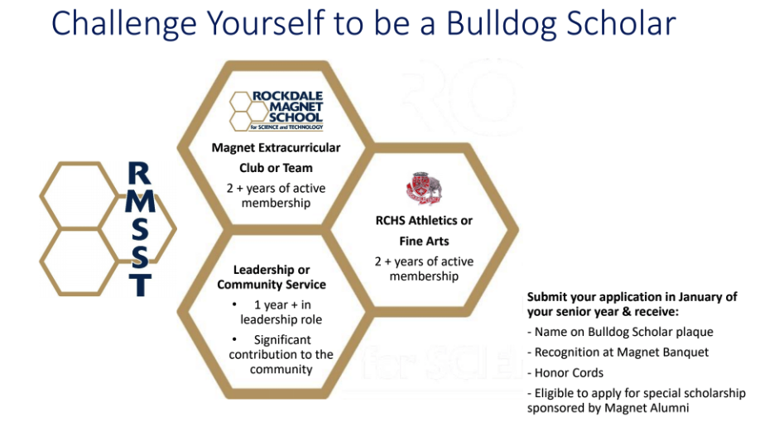

Rockdale Magnet Fund, Inc.

The Official RMSST Academic Booster Club
www.rockdalemagnetfund.com

Meetings:
August 11 6:00 pm-7:30 pm  September 8 6:00 pm-7:30 pm  October 13 6:00 pm-7:30 pm  November 17 6:00 pm-7:30 pm  December 8 6:00 pm-7:30 pm | January 12 6:00 pm-7:30 pm  February 9 6:00 pm-7:30 pm  March 9 6:00 pm-7:30 pm  April 13 6:00pm-7:30 pm  May 11 6:00 pm-7:30 pm

If there are any changes to the schedule above, it will be shared in a Magnet News email. Meetings are generally held via Teams from 6-7:30pm.

Dues:
All magnet families are requested to pay their annual dues of $220 to gain membership and benefits of fund-sponsored activities. (Among other things, annual dues support all Magnet extracurricular Clubs & Teams. Fund dues are also used to fund the Fall Ball, materials for research projects, field trips, travel to various competitions, etc.)

Examples of Social & Celebration Events Sponsored by the Fund:

Game Night
Magnet Fall Ball Dance
Honor Roll Celebration
Magnet Talent Show
Pastries for Parents
Family Picnic
Award Nights - Senior Banquet
Movie Nights & more!

Fundraising Events: Families are requested to participate in at least 2 fundraisers
- Monster Dash Fun Run
- Restaurant Spirit Nights
- Popcorn Sales (Fall & Spring options planned)
- Science Fair Sponsorship Drive
- Math Competition Sponsorship Drive
- Golf Tournament

Committees: Magnet families are asked to participate in at least one committee
- Fundraising Committee
- Hospitality and Teacher Appreciation Committee
- Scholarship Committee
- Finance Committee

Fund Email: rockdalemagnetfund2017@gmail.com
2026-27 President: Mrs. Teja Ray

STUDENT NON-DISCRIMINATION POLICY

The Rockdale County Board of Education (“Board”) prohibits unlawful discrimination against students because of race, color, national origin, sex, religion, age, disability, or other protected group status or activity (e.g. opposition to prohibited discrimination or participation in the statutory complaint process) in its programs and activities or employment in its programs or activities. In keeping with this commitment, the Board will not tolerate harassment, discrimination, or other unlawful treatment of its students. It is the policy of the Board to comply fully with the requirements of Title VI, Title IX, Section 504 of the Rehabilitation Act of 1973, the Americans with Disabilities Act and all accompanying regulations.

Please see Rockdale County Public School’s “Student Non-Discriminatory Policy and Complaints Procedure” (JAA) section or see the Board policy at
www.rockdaleschools.org

For any questions regarding Title IX, or to submit a formal complaint, please contact the school-based deputy Title IX Coordinator for students in person, or by mail, email, or phone: Dr. Lynette Clark, Assistant Director, 930 Rowland Road, Conyers, Georgia 30012, Phone: (770) 483-8737, Email: lclark@rockdale.k12.ga.us.



Handbook Signature Page

Please read the RMSST Student-Family Handbook
(www.magnet.rockdaleschools.org)
then sign and return this signature page to the
Magnet Front Office by Friday, August 7th

- I have read and understand the contents of the 2026-2027 Rockdale Magnet School for Science and Technology Parent-Student Handbook which is posted on our school website and agree to adhere to the policies and procedures as stated.

- I have read and understand the contents of the 2026-2027 Rockdale Magnet School for Science and Technology Academic Honor Code of the RMSST Parent-Student Handbook.

- I have read and agree to adhere to the guidelines set forth by the Rockdale Magnet School Acceptable Conduct for School Functions of the RMSST Parent-Student Handbook.

STUDENT NAME _________________________________________

X_______________________________________ __________________
Guardian Signature Date

X_______________________________________ __________________
Student Signature Date

