2026-2027 8th Grade Supply List
Students are REQUIRED to carry a backpack and CHROMEBOOK with charger every day to class. Other elective teachers may have their own supply list for their class.
English | Science |  | Math
(1) Composition Notebook  (1 pack) markers  (2 packs) pencils  (1 box) tissues  (1 pack) copy paper  (2 packs) glue sticks  (3 pack) sticky notes | (10) glue sticks  (1 pack) copy paper  (1 pack) pencils  (1 pack) colored pencils  (1 pack) fine tip dry erase markers  (1) simple calculator  (1 box) tissues  (2 rolls) paper towels  (1 pack) Clorox wipes |  | (2) Notebooks  (2 packs) pencils  (3 pack) sticky notes  (1 box) tissues  (1 pack) copy paper  (1 pack) Clorox wipes  (1 pack) dry erase markers  (4 pack) highlighters
Literacy Enrichment  Note: Not all students will have a reading class. Please consult the student’s schedule. | Art 1 or Art 2 | Band | Social Studies
(1) Composition Notebook  (1 pack) markers  (2 packs) pencils  (1 box) tissues  (1 pack) copy paper  (1 pack) notebook paper  (2 packs) glue sticks  (3 pack) sticky notes | $20 art fee per semester  (1 roll) paper towels  (2 pkgs) of wet wipes or baby wipes  (1 box) tissues | (1 pack) copy paper | (1) composition notebook  (1) 2 pocket folder  (2 pack) glue sticks (3 per pack)  (1 pack 24 count) colored pencils  (1 pack) sticky notes  (1 pack) pencils  (1 pack) copy paper  (1 box) tissues  (1 roll) paper towels

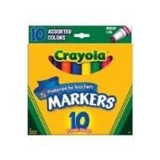 | 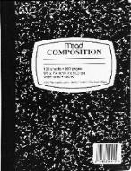 | 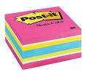 | 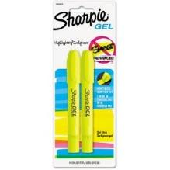 | 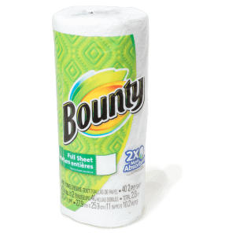 | 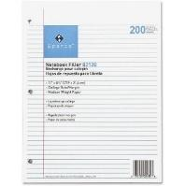
Markers | Comp. notebook | Sticky notes | Highlighters | Paper towels | Notebook paper
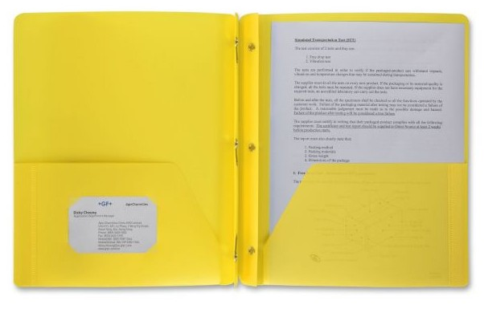 | 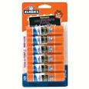 | 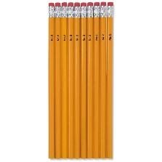 | 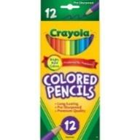 | 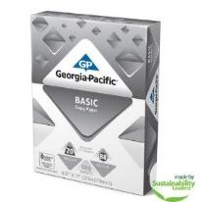 | 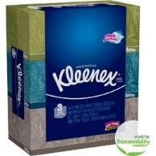 | 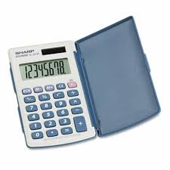
two pocket folder | Glue sticks | Pencils | Colored Pencils | Copy paper | Tissues | calculator
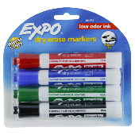 | 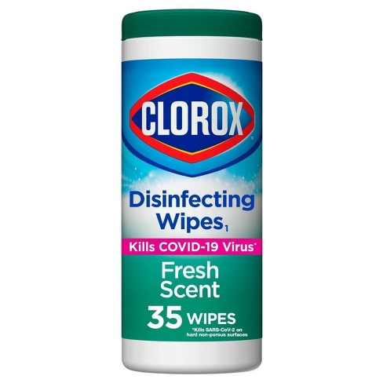 | 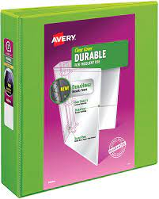 | 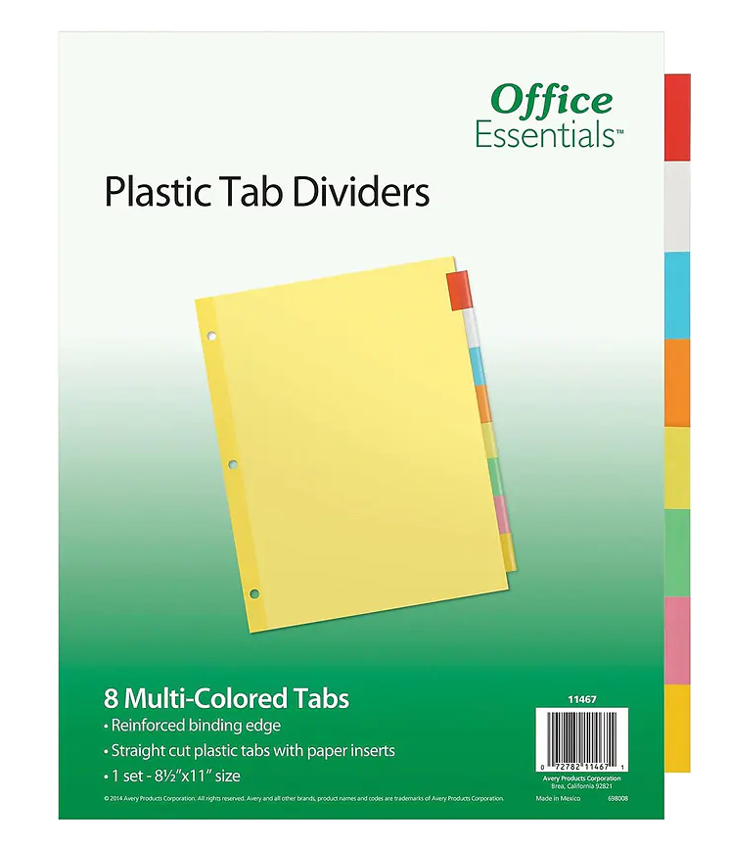 | 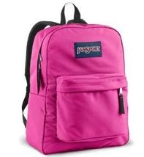 | 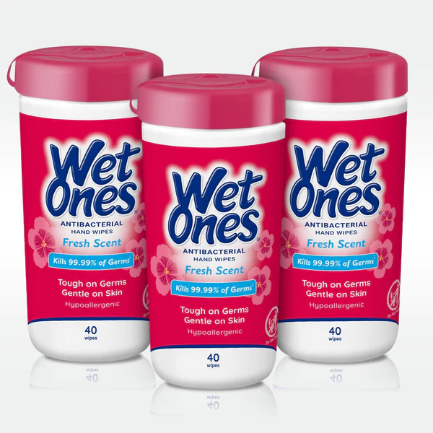 | 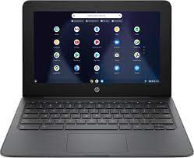
Dry erase markers | Clorox wipes | 2 inch binder | dividers | Backpack | wet wipes | Chromebook
2022-2023 Lista de Materiales del Grado Ocho
Se REQUIERE que los estudiantes lleven una mochila y un CHROMEBOOK con cargador todos los días a clase. Otros maestros electivos pueden tener su propia lista de útiles para la clase.
ĺngles | Ciencia | Matemáticas
(1) Libro de composición  (1 paquete) marcadores  (2 paquetes) lápices  (1 caja) tejidos  (1 paquete) papel de copia  (1 paquete) Post-It Notes  (2 paquetes) barras de pegadores | (2) Libros de composición  (10) barras de pegadores  (1 paquete) papel de copia  (1 paquete) lápices  (1 paquete) lápices de colores  (2) toallas de papel  (1 caja) tejidos | (2) cuadernos  (2 paquetes) lápices  (3 paquetes) Post-It Notes  (4 paquetes) resaltadores  (1 caja) tejidos  (1 paquete) papel de copia  (1 pack) toallitas Clorox  (1 paquete) marcadores no permamente
Lectura  Nota: No todos los estudiantes tendrán una clase de lectura. Por favor consulte el horario del estudiante. | Arte 1 o Arte 2 | Historia
(1) Libro de composición  (1 paquete) marcadores  (2 paquetes) lápices  (1 caja) tejidos  (1 paquete) papel de copia  (1 paquete) Post-It Notes  (2 paquetes) barras de pegadores | Una tarifa de $20 por semester  (1 rollo) toallas de papel  (1 paquete) toallitas húmedas or toallitas para bebé  (1 caja) tejidos | (1) Libro de composición  (1) carpeta de dos bolsillos  (2 paquete) barras de pegadores  (1 pack 24 count) lápices de colores  (1 paquete) Post-It Notes  (1 paquete) lápices  (1 paquete) papel de copia  (1 caja) tejidos  (1 roll) toallas de papel

marcadores | Libro de composición | Sticky notes | resaltadores | toallas de papel | papel de libro
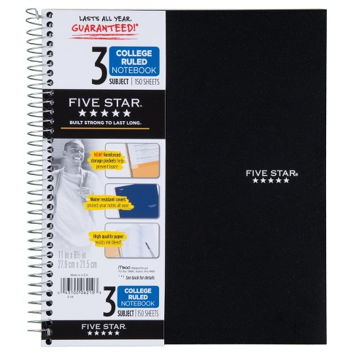
3 subject spiral | pegador | Pencils | Colored Pencils | Copy paper | Tissues
 |  | 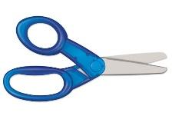 | 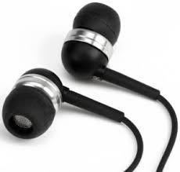
marcadores no permamente | toallitas Clorox | Scissors | Earbuds | mochila | Chromebook

