2026-2027 7th Grade Supply List
Students are REQUIRED to carry a backpack, CHROMEBOOK with charger, and headphones or earbuds every day to class. Other elective teachers may have their own supply list for class.
English | Science | Math
(2) Composition Notebook  (1 pack) colored pencils  (2 packs) pencils  (1 box) tissues  (1 pack) copy paper  (1 pack) notebook paper  (2 packs) glue sticks  (3 pack) sticky notes | (2) composition notebooks  (2 packs) glue sticks  (1 pack) copy paper  (1 pack) pencils  (1 pack) colored pencils  (1 box) tissues  (2 rolls) paper towels  (1 pack) markers | (2) Notebooks  (1 pack) graph paper  (1 box) tissues  (1 pack) copy paper  (1 pack) Clorox wipes  (1 pack) dry erase markers  (1 pack) pencil
Reading  Note: Not all students will have a reading class. Please consult the student’s schedule. | Electives | Social Studies
(1) Composition Notebook  (1 pack) colored pencils  (1 box) tissues  (1 pack) copy paper  (1 pack) notebook paper  (2 packs) glue sticks  (3 pack) sticky notes  (1 pack) highlighters | Art 1 or 2  $15 art fee per semester  (1 roll) paper towels  (1 pkg) of wet wipes or baby wipes  (1 box) tissues  Band  (1 pack) copy paper | (1) 3 subject spiral notebook  (2 pack) glue sticks (3 per pack)  (1 pack) sticky notes  (1 pack) pencils  (1 pack) copy paper  (1 box) tissues  (1 pair) snub-nosed scissors  (1 roll) paper towels

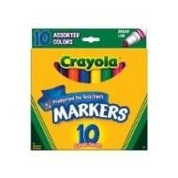 | 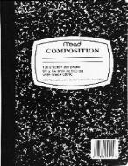 | 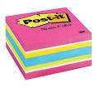 | 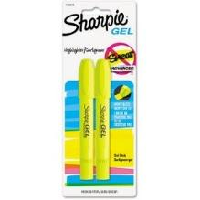 | 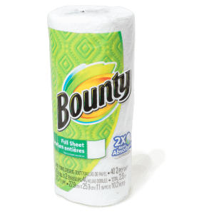 | 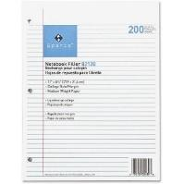
Markers | Comp. notebook | Sticky notes | Highlighters | Paper towels | Notebook paper
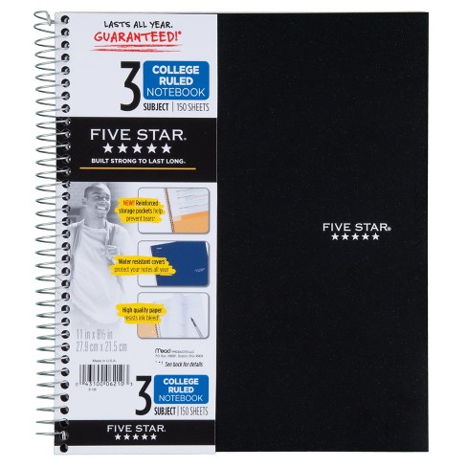 | 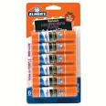 | 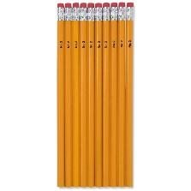 | 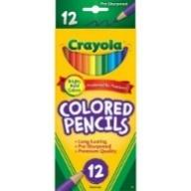 | 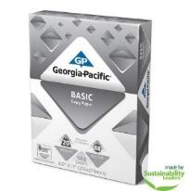 | 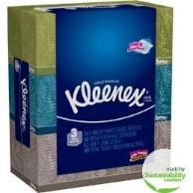
3 subject spiral | Glue sticks | Pencils | Colored Pencils | Copy paper | Tissues
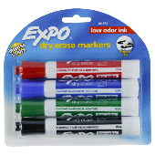 | 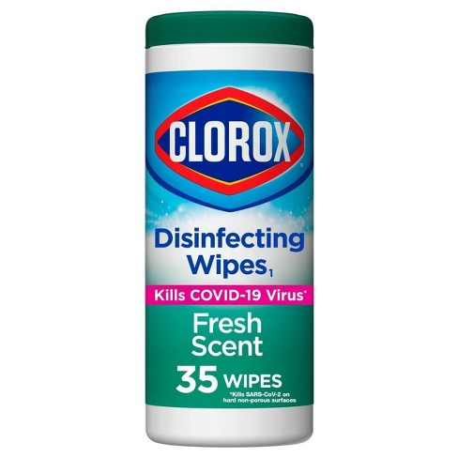 | 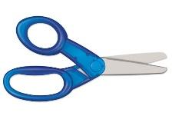 | 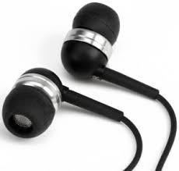 | 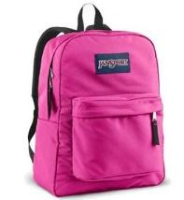 | 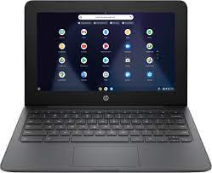
Dry erase markers | Clorox wipes | Scissors | Earbuds | Backpack | Chromebook

