First Grade Supply List 2026-2027
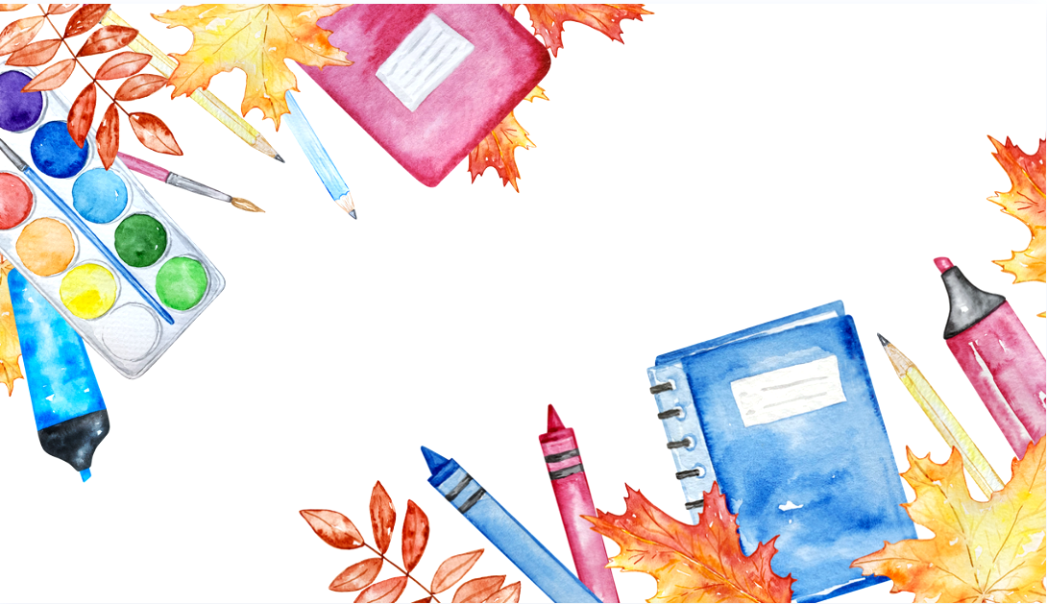
*only label headphones, pencil box, 3 ring pencil pouch, and scissors with your child’s name*
- 1 Book Bag (no wheels)
- 1 Pair of Fiskars Scissors
- Pencil Box (1)
- 3 Ring Pencil Pouch with clear front (to be placed inside Road Runner Notebook)
- Headphones (no earbuds) in a ziploc baggie with your child’s name
- #2 Pencils (ticonderoga pre-sharpened)
- Colored Pencils (12 pack)
- 4 boxes Crayola Crayons (24 pack)
- Black Expo Markers (4 pack)
- Glue Sticks (8 pack)
- Pink Block Erasers (1-2)
- Watercolor Paints (1 pack)
- Playdoh (1)
- Composition Book without picture (1 per student)
- Primary Journal Composition Notebook (with picture) (1 per student)
- Tissues (2 boxes)
- Clorox or Lysol Wipes (1-2 containers)
- GermX or Purell Hand Sanitizer
Extras to donate:
- Copy Paper
- Prizes (playdoh, bubbles, fun pens/pencils, hotwheel cars, slime, character erasers, tattoos, etc)
- Thick Crayola Markers
- Ziplock (gallon sized)
- White and Colored Cardstock
- Baby Wipes
- Paper Towels
- Extra glue sticks and crayons are always appreciated, we use a lot of these throughout the year.

