 | Week 5 |   Skills Assessed
Unit 3 Week 5 | Comprehension / Genre / Author’s Craft | Language Development
Essential Question: How do you express yourself? | Cite relevant evidence from text  Make inferences to support understanding Identify the main idea and key details  Ask and answer questions  Evaluate the use of graphic features Identify and use text features. | Oral Vocabulary Acquisition:  carved glide sphere suddenly surface  Vocabulary Acquisition:  Acquire and use academic vocabulary cheered concert instrument movements music rhythm sounds understand Vocabulary Strategy:  Recognize and understand prefixes
Grammar:
Understand and use the verb have
Text(s):  Teach and Model | Writing | Speaking and Listening
Text(s):  Teach and Model | Writing process:  Plan and draft an expository essay  Analytical writing:  Write responses the demonstrate understanding
Interactive Read Aloud: Why People Drum Shared Read: They’ve Got the Beat  Practice and Apply |  | Engage in collaborative discussions Retell “Why People Drum”  Present information about a patriotic song
 | Foundational Skills | Research and Inquiry
Anchor Text: Many Ways to Enjoy Music, A Musical Museum  Leveled Readers  A: The Sounds of Trash O: The Sounds of Trash ELL: The Sounds of Trash B: The Sounds of Trash  Genre Passages  A: Talking Underwater O: Talking Underwater ELL: Talking Underwater B: Talking Underwater  Optional Classroom Library Trade Books  Fire Fighter!, One Plastic Bag | Foundational Skills | Research and Inquiry
 | Word Work:  Phonological Awareness: Identify and Generat4e Alliteration  Phonemic Awareness: Addition, Deletion, Blending  Phonics: Long u, u_e, ue, u, ew  Structural Analysis: Comparative Endings -er, -est Use High Frequency Words  Handwriting: Review Lowercase Letters  Spelling Words:  huge, cube, fumes, music, unit, menu, few, pew, fuel, cues, pony, queen, began, come, give  Fluency:  Intonation | Research and identify patriotic songs

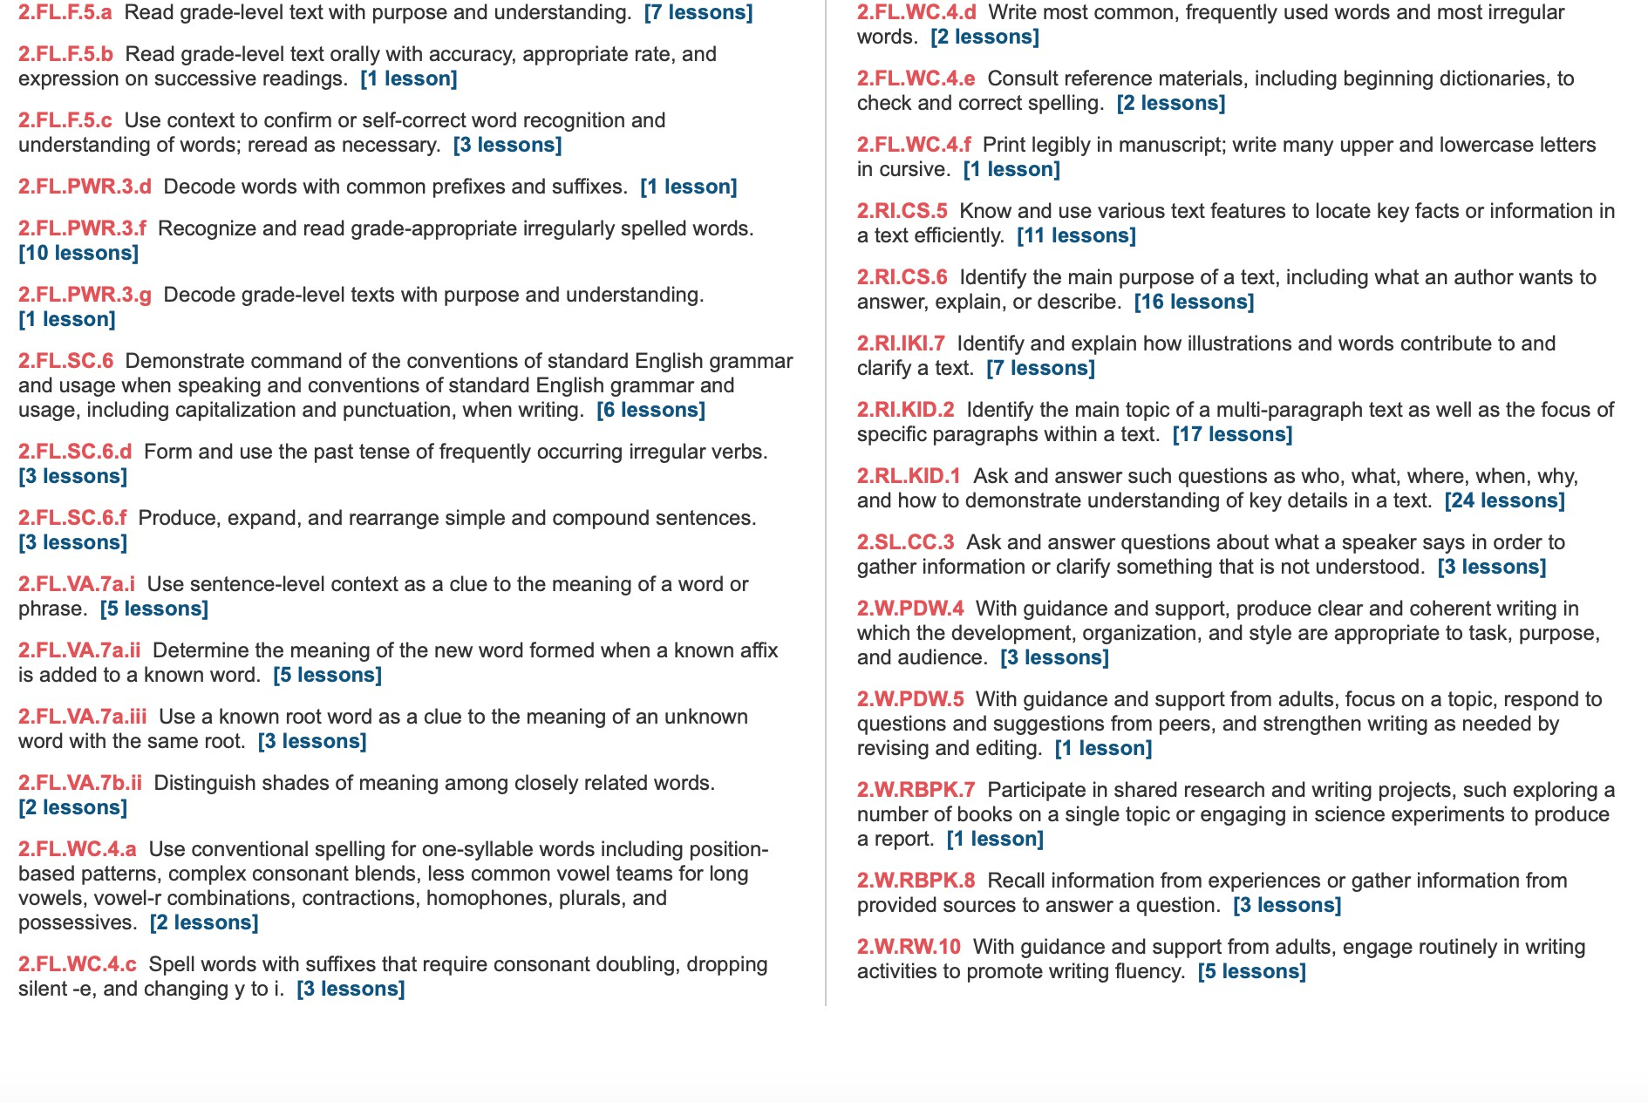
Weekly Standards:

Monday Day 1 | Instructional Plan
Student Learning Targets:
2.RI.KID.2, 2.RI.IKI.7, 2.FL.SC.6, 2.FL.SC.6.f, 2.FL.SC.6.d, 2.FL.WC.4.e, 2.FL.WC.4.a, 2.FL.VA.7a.i, 2.FL.VA.7a.ii, 2.FL.VA.7a.iii, 2.FL.WC.4.c, 2.FL.PWR.3.f, 2.FL.WC.4.d, 2.FL.F.5.a
Introduce the Concept  Oral Vocabulary Words (Reading / Writing Companion) Talk About It | Students will: T334-336  - Discuss the essential question: How do you express yourself?  - Share with a partner how they can express themselves through music.  - Reading/Writing Companion p. 62-63 work in small groups to complete the graphic organizer.  - Learn Oral Vocabulary Words through define/example/ask routine.
Listening Comprehension  Interactive Read Aloud | Students will: T337  - Identify components of expository text.
Word Work Phonemic Awareness Phonics  High Frequency Words Handwriting | Students will: T378-385  - Add and delete sounds in words.  - Connect the long u sound to the letters u_e, ue.  - Identify HFWs in text.  - Practice all cursive lowercase letters.
Read the Shared Read (Reading / Writing Companion) Teach / Model Close Reading  Summarize Quick Write | Students will: T338-341  - Read They’ve got the Beat!.  - Reading/Writing Companion p. 64-65 Take notes, interesting words, key details in Cats and Kittens.  - Ask and answer questions.
Vocabulary  Reading / Writing Companion | Students will: T342-343  - Reading/Writing Companion p. 68-69 Work with a partner to complete work on vocabulary.
Spelling  Reading / Writing Companion | Students will: T372  - Take the spelling pretest Practice Book p. 247.
Tuesday Day 2 | Instructional Plan
Student Learning Targets:
2.RI.CS.5, 2.RI.IKI.7, 2.RI.KID.2, 2.RI.CS.6, 2.SL.CC.3, 2.FL.PWR.3.f, 2.FL.PWR.3.g, 2.FL.F.5.a, 2.FL.F.5.b, 2.FL.SC.6, 2.FL.SC.6.f, 2.FL.SC.6.d, 2.FL.WC.4.e, 2.FL.WC.4.c, 2.FL.WC.4.a,
2.FL.VA.7a.i, 2.FL.VA.7a.iii, 2.FL.F.5.a, 2.W.RW.10, 2.W.RBPK.7
Strategy  Text Structure Skill | Students will: T344-349  - Ask and answer questions.  - Explain how the author uses bar graphs.  - Reading/Writing Companion p. 72-73 Identify main idea and key details.
Word Work  Phonics | Students will: T388-390  - Blend and build words with long u: u_e, ue..

Reread the Shared Read (Reading / Writing Companion) Guided Practice of Close Reading  Text Features / Literary Elements Comprehension Skill Comprehension: Craft & Structure | Students will: T350-351  - Reread They’ve Got the Beat!.  - Work with a partner to identify lines of poems that rhyme and name the rhyming words.  - Reading/Writing Companion p. 65-66  - Express how the author uses color phrases.
Respond to Reading  Reading / Writing Companion | Students will: T352-353  - Reading/Writing Companion p. 74 Respond to the prompt How does the author help you understand what being in the chorus is like for the students? by using text evidence.
Study Skill / Research & Inquiry  Reading / Writing Companion | Students will: T356-357  - Reading/Writing Companion p. 75 Brainstorm questions about their chosen song.
Grammar  Practice Book | Students will: T370  - Use two present tense forms for the verb have.
Fluency | Students will: T354-355  - Read orally with accuracy, fluency, appropriate rate and expression.

Wednesday Day 3 | Instructional Plan
Student Learning Targets:
2.RL.KID.1, 2.RI.KID.2, 2.RI.CS.6, 2.RI.IKI.7, 2.FL.SC.6, 2.FL.SC.6.f, 2.FL.SC.6.d, 2.FL.WC.4.e, 2.FL.WC.4.a, 2.FL.WC.4.d, 2.FL.WC.4.c, 2.FL.VA.7a.i, 2.FL.VA.7b.ii, 2.FL.VA.7a.iii, 2.FL.PWR.3.f,
2.FL.F.5.a
Word Work Phonemic Awareness Phonics  High-Frequency Words | Students will: T392-399  - Use Response Boards to blend words with the long u sound.  - Connect the long u sound to the letters ew,u  - Identify HFWs in text.
Read and Reread the Anchor Text (Literature Anthology)  Practice / Apply Close Reading Take Notes About Text | Students will: T357A-357C  - Use the Graphic Organizer to take notes of words they don’t understand and questions they may have.  - Reading/Writing Companion p. 76 Respond to prompt What words and phrases does the author use to help you sense the excitement of a concert?
Writing: Analyze Expert Model | Students will: T362-363  - Identify features of expository text. Reading/Writing Companion p. 84
Grammar / Mechanics  Practice Book | Students will: T371  - Write sentences correctly using capital letters and punctuation.
Expand Vocabulary | Students will: T375

Practice Book | - Orally complete cloze sentences to review words.
Thursday Day 4 | Instructional Plan
Student Learning Targets:
2.RL.KID.1, 2.RI.KID.2, 2.RI.CS.6, 2.RI.KID.3, 2.RI.IKI.7, 2.RI.CS.5, 2.FL.VA.7b.ii, 2.FL.SC.6, 2.FL.SC.6.f, 2.FL.SC.6.d, 2.FL.WC.4.e, 2.FL.WC.4.a, 2.FL.VA.7a.i, 2.FL.VA.7a.iii, 2.FL.PWR.3.f,
2.FL.F.5.a, 2.W.RBPK.8, 2.W.PDW.5, 2.W.PDW.4, 2.W.RW.10
Word Work  Phonics | Students will: T401-402  - Blend and build words with long u: :u_e, ue, ew, u
Read and Reread the Paired Text (Literature Anthology) Author’s Craft  Respond to Text | Students will: T359A-361  - Thinking about the essential question, compare how “A Musical Museum” and “Many Ways to Enjoy Music” are similar and different.  - Explain how diagrams contribute to and clarify a text.  - Identify the main idea and key details.
Writing Process: Plan  Reading / Writing Companion | Students will: T364-367  - Reading/Writing Companion p. 85-86  - Brainstorm ideas for writing an expository essay about their favorite kind of music or instrument.  - Complete sentences to begin writing expository essay.
Friday Day 5 | Instructional Plan
Student Learning Targets:
2.RL.KID.1, 2.RI.CS.5, 2.RI.IKI.7, 2.FL.SC.6, 2.FL.SC.6.f, 2.FL.SC.6.d, 2.FL.WC.4.e, 2.FL.WC.4.a, 2.FL.WC.4.d, 2.FL.WC.4.c, 2.FL.VA.7a.i, 2.FL.VA.7a.iii, 2.FL.PWR.3.f, 2.W.PDW.4, 2.W.RW.10,
2.FL.F.5.b
Word Work  Phonics | Students will: T404  - Blend and build words with long u: u_e, ue, ew, u
Writing Process: Draft  Reading / Writing Companion | Students will: T368-369  - Use a paragraph model to begin writing a draft of an expository essay.
Spelling  Practice Book | Students will: T373  - Take the spelling posttest.
Integrate | Students will: T376  - Reading/Writing Companion p. 82 Cite text evidence to tell how the author uses a Japanese print.

Week 6
Week 6 | Comprehension / Genre / Author’s Craft | Language Development
Review, Extend, and Assess | Review strategies and skills Track progress  Cite relevant evidence from text Summarize the text  Interpret information presented visually | Vocabulary Acquisition:  Use context to determine the meaning of unfamiliar words  Use prefixes to determine word meaning
Text(s):  Reading Digitally: Antarctica Bound  Reader’s Theater: I’ll Be the Dragon  Passage 1: Landing the Eagle Passage 2: A Shower in the Sky | Writing | Speaking and Listening
 | Writing process:  Complete an expository text  Share writing and choose a portfolio piece  Analytical writing: Write an opinion Write a summary | Paraphrase information presented digitally Engage in collaborative discussions
 | Foundational Skills | Research and Inquiry
 | Fluency: Read grade-level text fluently with appropriate prosody, accuracy, and rate | Conduct and present research Use Internet Browser tools  Gather relevant information from digital sources Navigate links

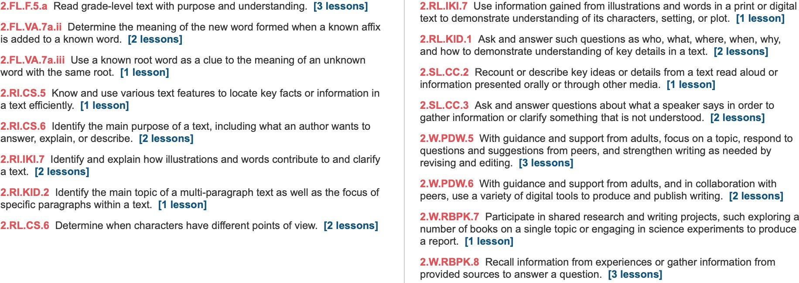
Weekly Standards:

Monday Day 1 | Instructional Plan
Student Learning Targets:
2.RI.KID.2, 2.RL.KID.1, 2.RI.CS.6, 2.RI.CS.5, 2.SL.CC.2, 2.FL.F.5.c, 2.FL.F.5.a, 2.FL.F.5.b, 2.FL.VA.7a.ii, 2.W.PDW.5, 2.W.RBPK.8, 2.W.RBPK.7
Reading Digitally OR  Reader’s Theater | Students will: T444-445 Reading Digitally  - Learn how to use the interactive features and hyperlinks for the online article “Antarctica-Bound!”.  - After rereading the article aloud, discuss how the author helps readers understand the purpose of the article.  - Answer questions about the article.  - Discuss what they learned from previous texts about other surprising places.  - Respond through discussion: What are the animals that live in Antarctica like?  Students will: T446 Reader’s Theater  - Listen as the teacher models the reading of the play.  - Practice the play with intonation and expression.  - Perform the play.
Show What You Learned  Reading / Writing Companion | Students will: TT448-449  - Use Reading/Writing Companion p. 94-95 and read “Landing the Eagle”  - Visualize as they read the story forming mental pictures of the events.  - Recall facts as to why this is an expository text.  - Identify main idea and key details.  - Answer comprehension questions Reading/Writing Companion p. 96.
Writing Process: Revise  Reading / Writing Companion | Students will: T458-459  - Practice revising a draft - Reading/Writing Companion p. 89
Tuesday Day 2 | Instructional Plan
Student Learning Targets:
2.RI.KID.2, 2.RI.CS.5, 2.RL.CS.6, 2.FL.F.5.c, 2.FL.F.5.a, 2.FL.F.5.b, 2.SL.CC.2, 2.W.PDW.5, 2.W.RBPK.8, 2.W.RBPK.7
Reading Digitally OR  Reader’s Theater | Students will: T444-445 Reading Digitally, T446-447 Reader’s Theater  - Perform the play.
Show What You Learned  Reading / Writing Companion | Students will: T450-451  - Use Reading/Writing Companion p. 97-98 and read “A Shower in the Sky”  - Recall facts as to why this is fiction.  - Answer comprehension questions Reading/Writing Companion p. 99.
Writing Process: Peer Review | Students will:

Reading / Writing Companion | - Continue revising their draft.

Wednesday Day 3 | Instructional Plan
Student Learning Targets:
2.RL.CS.6, 2.RL.IKI.7, 2.FL.F.5.c, 2.FL.F.5.a, 2.FL.F.5.b, 2.W.PDW.5
Extend Your Learning | Students will: T452-454  - Use Reading/Writing Companion p. 100 to discuss what a personal narrative is.  - Complete a graphic organizer Reading/Writing Companion p. 101  - Use Reading/Writing Companion p. 102 with a partner to identify the meaning of prefixes.
Writing Process: Edit and Proofread  Reading / Writing Companion | Students will: T462-463  - As a class, practice proofreading and editing sentences.  - Edit draft and list two mistakes found. Reading/Writing Companion p. 91  - With a partner, edit and proofread drafts using the editing checklist as a guide.
Thursday Day 4 | Instructional Plan
Student Learning Targets:
2.FL.F.5.c, 2.FL.F.5.a, 2.FL.F.5.b, 2.FL.VA.7a.ii, 2.FL.VA.7a.iii, 2.SL.CC.3, 2.W.RBPK.8, 2.W.PDW.6
Extend Your Learning | Students will: T455-457  - Use Reading/Writing Companion p. 103 to write a personal narrative  - Listen to “The Hidden Sun”. I identify the beginning, middle and end of the main events. Reading/Writing Companion p.104.  - Write a community helpers ad.
Writing Process: Publish, Present, and Evaluate  Reading / Writing Companion | Students will: T464-465  - Publish draft with illustrations.  - Present published work.  - Reading/Writing Companion p. 92-93 Reflect on their progress as writers.  - Set writing goals for future work.
Friday Day 5 | Instructional Plan
Student Learning Targets:
2.SL.CC.3, 2.W.PDW.6, 2.W.RW.10, 2.W.RBPK.8
Writing Process: Publish, Present, and Evaluate | Students will: T464-465

Reading / Writing Companion | - Publish draft with illustrations.  - Present published work.  - Reading/Writing Companion p. 92-93 Reflect on their progress as writers.  - Set writing goals for future work.
Track Your Progress | Students will: T466  - Use Reading/Writing Companion p. 106 to decide on how happy they are with the skills they have learned.  - Write about something they want to get better at.
Wrap Up the Unit | Students will: T467  - Collaborate in small groups to discuss what they have learned about the world that surprises them.
Summative Assessment | Students will:  - Complete assessments.

BCS Literacy Vision
Unit 4
Genre Study 1:
Essential Question: How are kids around the world different?
Text Sets:
Read Aloud: My New School Shared Read: Happy New Year!
Anchor Text: Dear Primo: A Letter to My Cousin, Games Around the World
Genre Study 2:
Essential Question: How does the Earth change?
Text Sets:
Read Aloud: Earth Changes Shared Read: Into the Sea
Anchor Text: Volcanoes, To The Rescue
Genre Study 3:
Essential Question: What excites us about nature?
Text Sets:
Read Aloud: Redwood National Forest, The Amazing Meadow, The Sahara Desert Shared Read: Snow Shape, Nature Walk, In the Sky
Anchor Text: April Rain Song, Rain Poem, Helicopters, Windy Tree

 | Weeks 1-2 | Skills Assessed
Unit 4 Weeks 1-2 | Comprehension / Genre / Author’s Craft | Language Development
Essential Question: How are kids around the world different? | Cite relevant evidence from text Make inferences  Evaluate author’s use of character, setting, plot: Compare and Contrast  Visualize the story  Evaluate Maps  Identify and use literary elements | Oral Vocabulary Acquisition:  accompanies assigns crowded locker usual  Vocabulary Acquisition:  common costume customs favorite parade surrounded travels wonder  Vocabulary Strategy:  Recognize and understands similes  Grammar:  Understand and use linking verbs Understand and use helping verbs
Text(s): | Writing | Speaking and Listening
Text(s): | Writing process:  Plan and draft a realistic fiction story  Analytical writing:  Write responses that demonstrate understanding
Teach and Model  Interactive Read Aloud: My New School Shared Read: Happy New Year! |  | Engage in collaborative discussions Retell “My New School”  Present information about a celebrations from a different country
 | Foundational Skills | Research and Inquiry
Practice and Apply | Foundational Skills | Research and Inquiry
Anchor Text: Dear Primo: A Letter to My Cousin, Games Around the World  Leveled Readers  A: Sharing Cultures O: A New Life in India  ELL: A New Life in India B: Akita and Carlo  Genre Passages  A: Music Around the World O: Dress Around the World ELL: Dress Around the World B: Food Around the World  Optional Classroom Library Trade Books  Hot, Hot, Roti, Mama Panya’s Pancakes | Word Work:  Phonemic Awareness: Identify, Categorization, Blending, Substitution, Addition  Phonics: Silent Letters, r-controlled vowels Structural Analysis: Prefixes, Suffixes  High-Frequency Words  Handwriting: Strokes for Cursive, Size and Shape, Cursive A, O, C, E  Spelling Words:  Week 1: comb crumb scene scent gnat sign knife know wrist writing cube music  Week 2: clerk herd first skirt stir churn hurt burst work worse know wrist  Fluency:  Read fluency with intonation and expression | Evaluate primary and secondary sources  Make a Celebration Chart about a celebration from a different country.

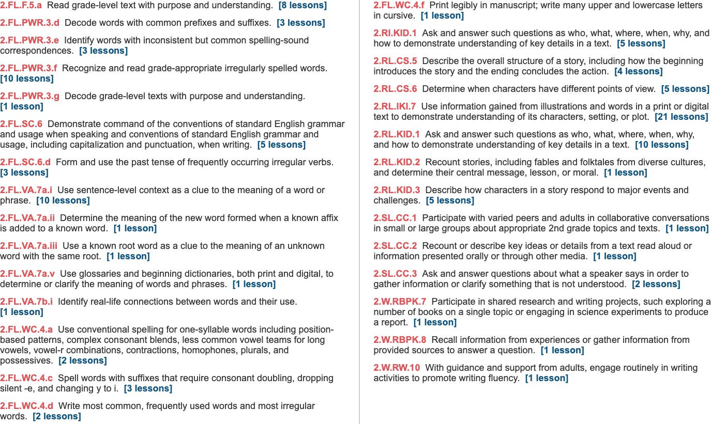
Weekly Standards

Monday Day 1 | Instructional Plan
Student Learning Targets:
2.RL.KID.2, 2.RL.KID.1, 2.RL.IKI.7, 2.FL.VA.7a.i, 2.FL.SC.6, 2.FL.SC.6.d, 2.FL.PWR.3.e, 2.FL.WC.4.a, 2.FL.PWR.3.f, 2.FL.PWR.3.g, 2.FL.WC.4.d, 2.FL.WC.4.c, 2.FL.F.5.a, 2.SL.CC.1, 2.SL.CC.2,
2.SL.CC.3
Introduce the Concept (Reading / Writing Companion) Talk About It | Students will: T24-25  - Discuss the essential question: How are kids around the world different?  - Share with a partner some games or sports that are common to our culture.  - Reading/Writing Companion p. vi-1 Work as a class to complete the graphic organizer.
Listening Comprehension  Oral Vocabulary Interactive Read Aloud | Students will: T26-27  - Learn Oral Vocabulary Words through define/example/ask routine.  - Identify components of realistic fiction.
Word Work Phonemic Awareness Phonics  High-Frequency Words Decodable Reader Handwriting | Students will: T74-77, 79-81  - Connect the letters wr, kn, gn, mb, sc to the sounds r, n, m, s  - Blend and read words with silent letters wr, kn, gn, mb, sc.  - Identify HFWs in text.  - Decodable Reader: The Thumb’s-Up Rain Forest, read and check for comprehension.  - Read The Thumb’s-Up Rain Forest to a partner focusing on fluency.  - Identify correct size and shape of uppercase cursive letters.
Read the Shared Read (Reading / Writing Companion) Teach / Model Close Reading  Summarize Quick Write | Students will: T28-31  - Reading/Writing Companion p. 2 Take notes, interesting words and key details in Happy New Year.  - Answer questions p. 3-5.
Vocabulary  Reading / Writing Companion | Students will: T32-33  - Reading/Writing Companion p. 6-7Work with a partner to complete work on vocabulary.  - Using text evidence, find similes.
Grammar  Practice Book | Students will: T62  - Identify linking verbs in sentences.
Spelling  Practice Book | Students will: T66  - Take the spelling pretest Practice Book p. 264.
Tuesday Day 2 | Instructional Plan
Student Learning Target:
2.RL.CS.5, 2.RL.CS.6, 2.RL.IKI.7, 2.RI.KID.1, 2.W.RW.10, 2.W.RBPK.8, 2.W.RBPK.7, 2.FL.SC.6, 2.FL.SC.6.d, 2.FL.PWR.3.d, 2.FL.WC.4.c

Reread the Shared Read (Reading / Writing Companion) Guided Practice of Close Reading  Text Features / Literary Elements Comprehension Skill Comprehension: Craft & Structure | Students will: T34-41  - Reading/Writing Companion p. 8 Reread Happy New Year. Use visualize strategy.  - Identify point of view in Happy New Year.  - Compare and contrast by using a graphic organizer. Reading/Writing Companion p. 10-11)  - Express how the author crafts the story to help you understand what the fireworks sound like, explain why the author includes a description of the family’s dinner on New Year’s, and how the author shows the girl’s excitement during the Chinese lion dance.
Word Work  Phonics  Structural Analysis | Students will: T84-87  - Blend and build words with silent letters wr, kn, gn, mb, sc  - Identify the meaning of prefixes and suffixes.  - Using Word Building Cards, identify vowels sounds in words.
Respond to Reading  Reading / Writing Companion | Students will: T42-43  - Reading/Writing Companion p. 12 Respond to prompt How does he author show that people in China and the United States celebrate the New Year differently? by using text evidence.
Study Skill / Research & Inquiry  Reading / Writing Companion | Students will: T46-47  - Reading/Writing Companion p. 13 Identify what primary and secondary sources.
Grammar  Practice Book | Students will: T62  - Identify linking verbs in sentences.

Wednesday Day 3 | Instructional Plan
Student Learning Target:
2.RL.KID.3, 2.RL.CS.5, 2.RL.IKI.7, 2.FL.SC.6, 2.FL.SC.6.d, 2.FL.VA.7a.i, 2.FL.VA.7a.ii, 2.FL.VA.7a.v, 2.FL.VA.7a.iii, 2.FL.PWR.3.f, 2.FL.WC.4.d, 2.FL.WC.4.c, 2.FL.F.5.a
Word Work  Phonics  High-Frequency Words Decodable Reader | Students will: T88-89, 93-95  - Use Word-Building Cards to identify short and long vowel sounds.  - Identify HFWs in text.  - Read Decodable Reader Acadia Scenes fluently to help with comprehension.
Read the Anchor Text (Literature Anthology) Practice / Apply Close Reading  Take Notes About Text | Students will: T47A-47O  - (after teacher tells them they will read two cousins who live in different places but keep in touch by sending letters), predict how the story will answer the essential question.  - Identify words that show that the story is in the first person.  - Ask and answer comprehension questions.  - Identify main topic and key details.

Grammar/Mechanics  Practice Book | Students will: T63  - Use correct punctuation when writing a letter.
Expand Vocabulary  Practice Book | Students will: T71  - Orally complete cloze sentences to review words.
Thursday Day 4 | Instructional Plan
Student Learning Target:
2.RL.KID.3, 2.RL.CS.5, 2.RL.IKI.7
Word Work  Phonics | Students will: T97-99  - Blend and build words with silent letters wr, kn, gn, mb, sc.
Read the Anchor Text (Literature Anthology) Practice/Apply Close Reading  Take Notes About the Text Respond to Text | Students will: T47A-47O  - Ask and answer comprehension questions.  - Identify key details.  - Build vocabulary.  - Use illustrations to understand how the games the cousins play are the same and different.  - Identify how labels help understand the text.  - Write about the text Reading/Writing Companion
Friday Day 5 | Instructional Plan
Student Learning Target:
2.RL.KID.3, 2.RL.CS.5, 2.RL.IKI.7, 2.FL.F.5.a, 2.FL.SC.6, 2.FL.PWR.3.e, 2.FL.WC.4.a, 2.FL.PWR.3.f
Reread the Anchor Text (Literature Anthology) Practice / Apply Close Reading | Students will: T47A-47O  - Identify author/illustrator’s craft Reading/Writing Companion p. 15  - Make inferences.  - Explain why the author spreads the words “I have an idea!” over two pages Reading/Writing Companion p. 16
Writing Process: Expert Model  Reading / Writing Companion | Students will: T54-55  - Identify features of realistic fiction Reading/Writing Companion p. 24.
Spelling  Practice Book | Students will: T67  - Take the spelling posttest.

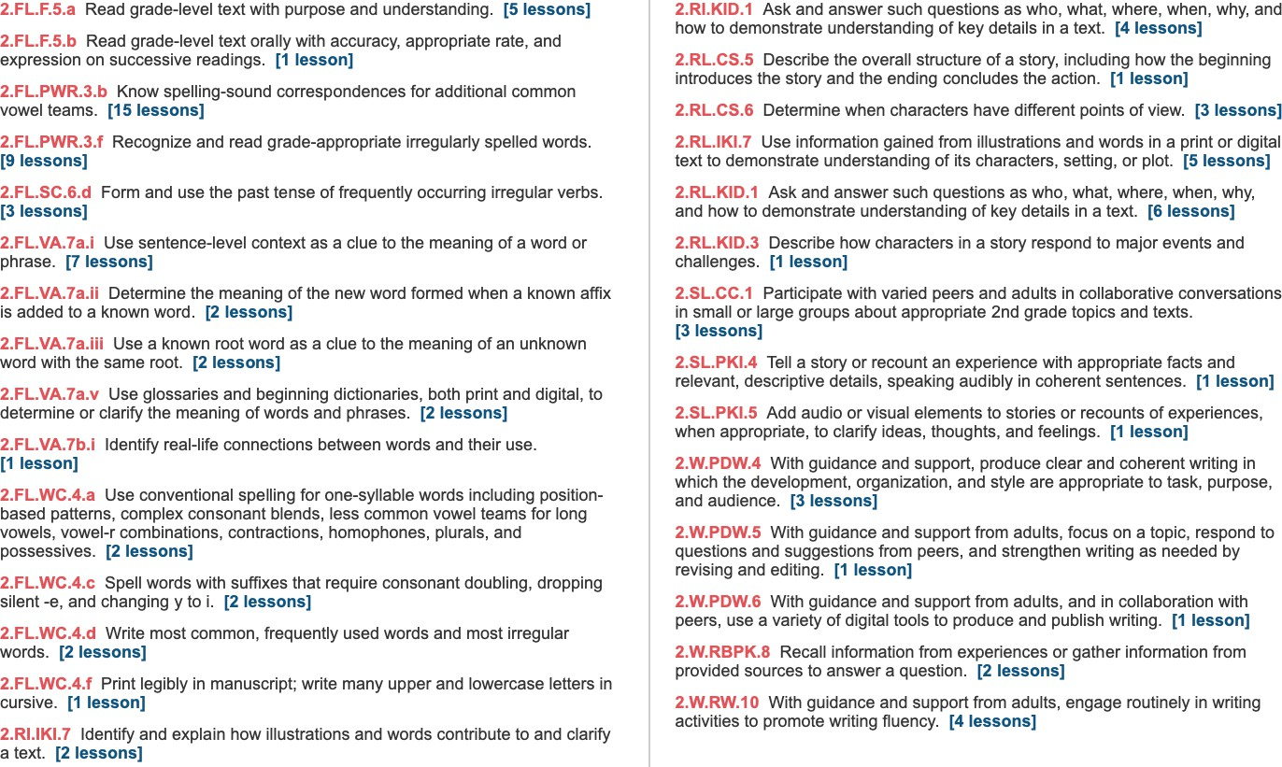
Weekly Standards

Monday Day 6 | Instructional Plan
Student Learning Targets:
2.RL.KID.3, 2.RL.CS.5, 2.RL.IKI.7, 2.RL.KID.1, 2.W.RW.10, 2.W.PDW.5, 2.W.PDW.4, 2.FL.SC.6.d, 2.SL.CC.1, 2.FL.PWR.3.b, 2.FL.PWR.3.f, 2.FL.F.5.a, 2.FL.WC.4.a, 2.FL.WC.4.d, 2.FL.WC.4.c,
2.FL.WC.4.f
Word Work Phonological Awareness Phonics  High-Frequency Words Decodable Reader Handwriting | Students will: T102, 104-105, 107-109  - Substitute sounds in words to create new words.  - Connect the letters er, ir, ur, or to the sound /ûr/  - Read HFWs in connected text.  - Read Decodable Reader Shirl and Her Tern focusing on fluency and comprehension.  - Practice cursive uppercase letters A, O, C, E
Reread the Anchor Text (Literature Anthology) Practice / Apply Close Reading | Students will: T47A-47O  - Explain why the author spreads the words “I have an idea!” over two pages Reading/Writing Companion p. 16  - Explain why the author wrote about one cousin in Mexico and one in the United States.
Respond to the Text  Reading / Writing Companion | Students will: T48-49  - Reading/Writing Companion p. 17 Respond to prompt How does the author show the cousins are similar even though they live in different countries.
Writing Process: Plan  Reading / Writing Companion | Students will: T56-57  - Brainstorm ideas for writing realistic fiction about a character who has visited two places\.  - Complete sentences to begin writing realistic fiction.
Grammar  Practice Book | Students will: T64  - Identify helping verbs in sentences.
Spelling  Practice Book | Students will: T68  - Take the spelling pretest Practice Book p. 281.
Tuesday Day 7 | Instructional Plan
Student Learning Targets:
2.RL.KID.1, 2.RI.IKI.7, 2.W.PDW.4, 2.W.RW.10, 2.FL.SC.6.d, 2.SL.CC.1, 2.FL.VA.7a.i, 2.FL.VA.7a.ii, 2.FL.VA.7a.v, 2.FL.VA.7a.iii, 2.FL.PWR.3.b
Word Work  Phonics  Structural Analysis | Students will: T112-115  - Blend and build words with the sound /ûr/ er, ir, ur, or  - Practice inflectional endings -s, -es, -ed, -ing
Read Paired Selection (Literature Anthology) | Students will: T49A-49D

Practice / Apply Close Reading | - Thinking about the essential question, compare how Dear Primo: A Letter to My Cousin and “Games Around the World” are similar and different.  - Ask and answer questions.
Writing Process: Plan  Reading / Writing Companion | Students will: T58-59  - Reading/Writing Companion p. 27 Identify the importance of using settings when writing realistic fiction.
Grammar  Practice Book | Students will: T64  - Identify present and past tense helping verbs in sentences.
Expand Vocabulary  Practice Book | Students will: T70  - Add -er and -est to adjectives to compare two nouns Practice Book p. 291.

Wednesday Day 8 | Instructional Plan
Student Learning Targets:
2.RL.KID.1, 2.RI.IKI.7, 2.W.PDW.4, 2.W.RW.10, 2.FL.SC.6.d, 2.SL.CC.1, 2.FL.VA.7a.i, 2.FL.VA.7a.ii, 2.FL.VA.7a.v, 2.FL.VA.7a.iii, 2.FL.PWR.3.b, 2.FL.PWR.3.f, 2.FL.WC.4.d, 2.FL.WC.4.c
Word Work Phonemic Awareness Phonics  High-Frequency Words Decodable Reader | Students will: T116-117  - Substitute sounds in words to create new words.  - Use Word-Building Cards to identify short and long vowels, as well as for er, ir, ur, and or in words.  - Read HFWs in connected text.  - Read Decodable Dogs Work! sounding out decodable words and reading HFWs fluently in order to answer comprehension questions.
Reread Paired Selection (Literature Anthology) Practice / Apply Close Reading | Students will: T49A-49O  - Reread “Games Around the World”  - Use text features maps and captions to better understand text. .
Author’s Craft  Reading / Writing Companion | Students will: T50-51  - Reading/Writing Companion p. 21 Work with a partner to use maps to locate information in a text.
Writing Process: Draft  Reading / Writing Companion | Students will: T60-61  - Use compare and contrast when writing a realistic fiction draft.
Grammar  Practice Book | Students will: T65  - Write book titles correctly.

Expand Vocabulary  Practice Book | Students will: T71  - Partner with another student to identify similes and figure out meanings.
Thursday Day 9 | Instructional Plan
Student Learning Targets:
2.W.RBPK.8, 2.FL.F.5.b, 2.W.PDW.4, 2.W.RW.10, 2.FL.PWR.3.b
Word Work  Phonics | Students will: T125-127  - Blend and build words with the sound /ûr/ er, ir, ur, or
Fluency  Practice Book | Students will: T44-45  - Use intonation to help reading sound smooth and natural.
Writing Process: Draft  Reading / Writing Companion | Students will: T60-61  - Use compare and contrast to continue writing a realistic fiction draft.
Make Connections  Reading / Writing Companion | Students will: T72  - Reading/Writing Companion p. 22 Use text evidence to make connections between a photo and selections they have read.
Friday Day 10 | Instructional Plan
Student Learning Targets:
2.W.RBPK.8, 2.SL.PKI.5, 2.W.PDW.6, 2.SL.PKI.4, 2.W.PDW.4, 2.W.RW.10, 2.FL.WC.4.a, 2.FL.PWR.3.f
Word Work  Phonics | Students will: T128  - Blend and build words with the sound /ûr/ er, ir, ur, or
Writing Process: Draft  Reading / Writing Companion | Students will: T60-61  - Use compare and contrast to continue writing a realistic fiction draft.
Spelling  Practice Book | Students will: T69  - Take the spelling posttest.
Research and Inquiry  Reading / Writing Companion | Students will: T73  - Use the Presenting Checklist to prepare presentations to show and explain their Celebration Chart to the class.
Progress Monitoring | Students will: T162-163  - Complete Assessments.

 | Weeks 3-4 | Skills Assessed
Unit 4 Weeks 3-4 | Comprehension / Genre / Author’s Craft | Language Development
Essential Question: How does the Earth change? | Cite relevant evidence from text  Make inferences to support understanding  Understand the author’s use of Cause and Effect Reread to monitor comprehension  Evaluate text structure  Identify and use text features | Oral Vocabulary Acquisition:  carved glide sphere suddenly surface  Vocabulary Acquisition:  active Earth explode island local properties solid steep  Vocabulary Strategy:  Use context clues to determine meanings  Grammar:  Understand and use irregular verbs Understand and use contractions with not
Text(s):  Teach and Model  Interactive Read Aloud: Earth Changes Shared Read: Into the Sea  Practice and Apply  Anchor Text: Volcanoes, To the Rescue  Leveled Readers A: Earthquakes O: Earthquakes ELL: Earthquakes B: Earthquakes  Genre Passages  A: Glaciers O: Glaciers ELL: Glaciers B: Glaciers  Optional Classroom Library Trade Books  How Mountains are Made, Investigating Landforms | Writing | Speaking and Listening
 | Writing process:  Revise, edit, and publish a realistic fiction story  Analytical writing:  Write responses that demonstrate understanding | Engage in collaborative discussions Retell “Earth Changes”  Present information about how Earth changes
 | Foundational Skills | Research and Inquiry
Word Work
Phonological Awareness: Identify and Generate Rhyme; Identify Syllables
Phonemic Awareness: Substitution, Blending
Phonics: r-controlled vowels /or/, /ar/; r-controlled vowels
/ir/
Structural Analysis: Plurals (irregular); Abbreviations Use High-Frequency Words
Handwriting: Cursive L, D, B, R, T, F, S, G
Spelling Words:
Week 1: port north more store oar roar board part start park first hurt ago carry people Week 2: deer cheers steer here jeer near ear
dear clear spear store north again house inside
Fluency:
Read with phrasing and intonation

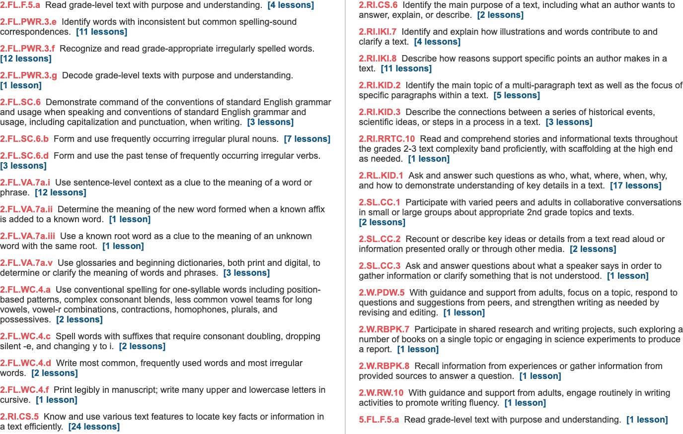
Weekly Standards:

Monday Day 1 | Instructional Plan
Student Learning Targets:
2.SL.CC.3, 2.SL.CC.2, 2.RI.CS.52.FL.PWR.3.g, 2.FL.F.5.a, 2.RI.RRTC.10, 2.FL.VA.7a.i, 2.FL.SC.6, 2.FL.SC.6.d, 2.FL.WC.4.a, 2.FL.PWR.3.e, 2.FL.PWR.3.f, 2.FL.WC.4.d, 2.FL.WC.4.c, 2.FL.WC.4.f
Introduce the Concept (Reading / Writing Companion) Talk About It | Students will: T178-179  - Discuss the essential question: How does the Earth change?  - Reading/Writing Companion p. 34-35 Share with a partner how a river changes Earth’s surface.
Listening Comprehension  Interactive Read Aloud | Students will: T180-181  - Learn Oral Vocabulary Words through define/example/ask routine.  - Identify components of expository text.
Word Work Phonemic Awareness Phonics  High-Frequency Words Decodable Reader Handwriting | Students will: T228-231, 233-235  - Identify and generate rhyme.  - Connect the letters or, ore, oar to the sound /ôr/ and letters ar to the sound /är/.  - Identify HFWs in text.  - Decodable Reader: More Fun Than a Hat!, read and check for comprehension  - Practice cursive uppercase letters L, D, B, R
Read the Shared Read (Reading / Writing Companion) Teach / Model Close Reading  Summarize Quick Write | Students will: T182-185  - Reading/Writing Companion p. 36 Take notes, interesting words, and key details in Into the Sea.  - Answer text evidence questions p. 37-39.  - Use context clues to find the meaning of a word.
Vocabulary  Reading / Writing Companion | Students will: T186-187  - Reading/Writing Companion p. 40-41 Work with a partner to complete work on vocabulary.  - Use text evidence to find context clues.
Grammar  Practice Book | Students will: T216  - Identify and use the past tense of irregular verbs go and do in sentences.
Spelling  Practice Book | Students will: T220  - Take the spelling pretest Practice Book p. 298.
Tuesday Day 2 | Instructional Plan
Student Learning Targets:
5.FL.F.5.a, 2.RI.KID.3, 2.RI.KID.2, 2.RI.CS.5, 2.RI.CS.6, 2.RI.IKI.8, 2.W.RW.10, 2.W.RBPK.8, 2.W.RBPK.7, 2.FL.SC.6, 2.FL.SC.6.d, 2.FL.PWR.3.e, 2.FL.SC.6.b

Reread the Shared Read (Reading / Writing Companion) Guided Practice of Close Reading  Text Features / Literary Elements Comprehension Skill Comprehension: Craft & Structure | Students will: T188-193  - Reread Into the Sea.  - Reading/Writing Companion p. 42 Explain when erosion becomes a problem for people.  - Identify and use subheads and bold print. Reading/Writing Companion p. 43  - Work with a partner to complete the graphic organizer for “Into the Sea”.  - Express how the author uses subheadings to organize information.
Word Work  Phonics  Structural Analysis | Students will: T238-240  - Blend and build words with or, ore, oar, ar.  - Practice irregular plurals.
Respond to Reading  Reading / Writing Companion | Students will: T196-197  - Reading/Writing Companion p. 46 Respond to the prompt How does the author explain that erosion can be a problem? How can people help solve the problem? by using text evidence.
Study Skill / Research & Inquiry  Reading / Writing Companion | Students will: T200-201  - Reading/Writing Companion p. 47 Use sequencing to plan their Earth Changes Drawings.
Grammar  Practice Book | Students will: T216  - Identify and use the past tense of irregular verbs say, tell, see, make.

Wednesday Day 3 | Instructional Plan
Student Learning Targets:
2.RI.KID.3, 2.FL.SC.6, 2.FL.SC.6.d, 2.FL.VA.7a.i, 2.FL.VA.7a.ii, 2.FL.VA.7a.v, 2.FL.VA.7a.iii, 2.FL.PWR.3.f, 2.FL.WC.4.d, 2.FL.WC.4.c, 2.FL.PWR.3.f, 2.FL.F.5.a
Word Work Phonemic Awareness Phonics  High-Frequency Words Decodable Reader | Students will: T242-243, 247-249  - Use Response Boards to identify vowel sounds in words.  - Use Word-Building Cards to identify vowels sounds in words.  - Identify HFWs in text.  - Read Decodable Reader Just for Fun! fluently to help with comprehension.
Read the Anchor Text (Literature Anthology) Practice / Apply Close Reading  Take Notes About Text | Students will: T201A-201F  - (after teacher tells them they will read about how volcanoes change the Earth), predict how the story will help answer the essential question.  - Use the graphic organizer to take notes.  - Identify cause and effect.
Grammar / Mechanics  Practice Book | Students will: T217  - Write proper nouns correctly.

Expand Vocabulary  Practice Book | Students will: T225  - Orally complete cloze sentences to review words.
Thursday Day 4 | Instructional Plan
Student Learning Targets:
2.FL.VA.7a.i, 2.RI.KID.3, 2.FL.PWR.3.e
Word Work  Phonics | Students will: T251-252  - Blend words with or, ore, oar, ar.
Read the Anchor Text (Literature Anthology) Practice/Apply Close Reading  Take Notes About the Text Respond to Text | Students will: T201A-201H  - Reread Volcanoes.  - Reading/Writing Companion p. 49 Explain how the author uses descriptive language to help understand a volcanic eruption.  - Use context clues.
Friday Day 5 | Instructional Plan
Student Learning Targets:
2.FL.VA.7a.i, 2.RI.KID.3, 2.W.PDW.5, 2.FL.PWR.3.f, 2.FL.WC.4.a, 2.FL.PWR.3.f, 2.FL.SC.6.b
Word Work  Phonics | Students will: T254  - Blend and build words with or, ore, oar, ar.
Reread the Anchor Text (Literature Anthology) Practice / Apply Close Reading | Students will: T201A-201F  - Identify main idea and key details.  - Use text features to help understand the effects of a volcanic eruption.
Writing Process: Revise  Reading / Writing Companion | Students will: T208-209  - Practice revising a draft Reading/Writing Companion p. 29.  - Revise their drafts by focusing on voice, story structure and descriptive language.
Spelling  Practice Book | Students will: T221  - Take the spelling posttest.

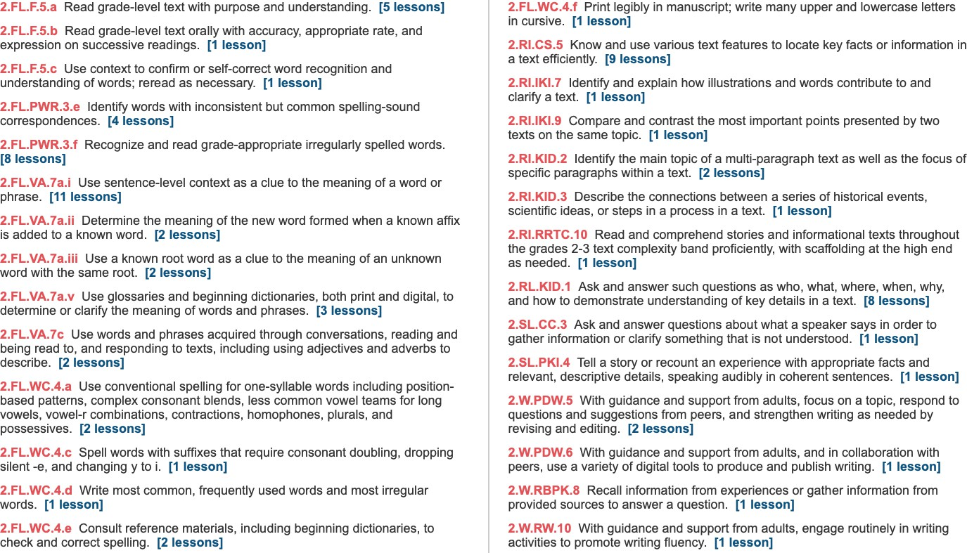
Weekly Standards

Monday Day 6 | Instructional Plan
Student Learning Targets:
2.FL.VA.7a.i, 2.RI.KID.3, 2.RL.KID.1, 2.W.RW.10, 2.W.PDW.5, 2.FL.PWR.3.f, 2.FL.WC.4.d, 2.FL.WC.4.c, 2.FL.WC.4.e, 2.FL.WC.4.a, 2.FL.WC.4.f, 2.FL.F.5.a
Word Work Phonological Awareness Phonics  High-Frequency Words Decodable Reader Handwriting | Students will: T256-259, 261-263  - Clap syllables and identify the number of syllables.  - Connect the /îr/ sound to the letters eer.  - Blend words with eer.  - Identify HFWs in text.  - Decodable Reader: “Cheer Up, Dot!!” Read and check for comprehension.
Reread the Anchor Text (Literature Anthology) Practice / Apply Close Reading | Students will: T201A-201F  - Reread Vocanoes.  - Reading/Writing Companion p. 50 Identify the Author’s Craft
Respond to the Text  Reading / Writing Companion | Students will: T202-203  - Reading/Writing Companion p. 51 Respond to the prompt How does the author help you understand the power of a volcano’s eruption?
Writing Process: Revise  Reading / Writing Companion | Students will: T208-209  - Continue revising their drafts.
Grammar  Practice Book | Students will: T218  - Write contractions using “t.
Spelling  Practice Book | Students will: T222  - Take the spelling pretest Practice Book p. 315.
Tuesday Day 7 | Instructional Plan
Student Learning Targets:
2.RL.KID.1, 2.RI.CS.5, 2.W.PDW.5, 2.FL.VA.7a.i, 2.FL.VA.7a.ii, 2.FL.VA.7a.v, 2.FL.VA.7a.iii
Word Work  Phonics  Structural Analysis | Students will: T266-269  - Blend and build words with eer.  - Identify and write abbreviations.
Read Paired Selection (Literature Anthology) Practice / Apply Close Reading | Students will: T203A-203B  - Thinking about the essential question, compare how Volcanoes and “To the Rescue” are similar and different.  - Ask and answer questions.

Writing Process: Peer Conferencing  Reading / Writing Companion | Students will: T210-211  - Practice peer conferencing with a partner – Reading/Writing Companion p. 30.  - Give feedback to others on their drafts.
Grammar  Practice Book | Students will: T218  - Write contractions hasn’t, haven’t, can’t, couldn’t.
Expand Vocabulary  Practice Book | Students will: T224  - Identify homographs.

Wednesday Day 8 | Instructional Plan
Student Learning Targets:
2.RL.KID.1, 2.RI.CS.5, 2.W.PDW.6, 2.FL.VA.7a.i, 2.FL.VA.7a.ii, 2.FL.VA.7a.v, 2.FL.VA.7a.iii, 2.FL.PWR.3.e, 2.FL.PWR.3.f, 2.FL.F.5.a
Word Work Phonemic Awareness Phonics  High-Frequency Words Decodable Reader | Students will: T270-271, 275-277  - Identify syllables.  - Connect the /îr/ sound to the letters ere, ear.  - Identify HFWs in text.  - Read Decodable Reader Watching and Hearing Animals fluently to help with comprehension.
Reread Paired Selection (Literature Anthology) Practice / Apply Close Reading | Students will: T203A-203B  - Reread “To the Rescue”.  - Identify author’s purpose and craft.
Author’s Craft  Reading / Writing Companion | Students will: T204-205  - Reading/Writing Companion p. 55 Identify categorical text structure in text.
Writing Process: Edit and Proofread  Reading / Writing Companion | Students will: T212-213  - As a class, practice proofreading and editing a paragraph.  - Edit draft and list two mistakes found. Reading/Writing Companion p. 31.  - With a partner, edit and proofread drafts using the editing checklist as a guide.
Grammar  Practice Book | Students will: T219  - Use apostrophes in contractions.
Expand Vocabulary  Practice Book | Students will: T225  - Use context clues to determine the meaning of unknown words.

Thursday Day 9 | Instructional Plan
Student Learning Targets:
2.W.RBPK.8, 2.RI.IKI.9, 2.RI.RRTC.10, 2.RI.CS.5, 2.FL.F.5.b, 2.W.PDW.6
Word Work  Phonics | Students will: T279-281  - Blend and build words with eer, ere, ear.
Fluency  Practice Book | Students will: T206-207  - Read orally with accuracy, fluency, appropriate rate and expression.
Writing Process: Edit and Proofread  Reading / Writing Companion | Students will: T212-213  - Continue to edit and proofread their realistic fiction drafts.
Make Connections  Reading / Writing Companion | Students will: T226  - Reading/Writing Companion p. 57 Use text evidence to make connections between a photo and caption.
Friday Day 10 | Instructional Plan
Student Learning Targets:
2.SL.PKI.4, 2.SL.CC.3, 2.W.PDW.6, 2.FL.WC.4.e, 2.FL.WC.4.a, 2.FL.PWR.3.f
Word Work  Phonics | Students will: T282  - Blend and build words with eer, ere, ear.
Writing Process: Publish, Present, and Evaluate  Reading / Writing Companion | Students will: T214-215  - Publish draft with illustrations.  - Present published work.  - Reading/Writing Companion p. 32-33 Reflect on their progress as writers.  - Set writing goals for future work.
Spelling  Practice Book | Students will: T223  - Take the spelling posttest.
Research and Inquiry  Reading / Writing Companion | Students will: T227  - Use the Presenting Checklist to prepare presentations to present their Earth Changes Drawings to the class.
Progress Monitoring | Students will: T316-317  - Complete assessments.

 | Week 5 | Skills Assessed
Unit 4 Week 5 (combine with Week 6) | Comprehension / Genre / Author’s Craft | Language Development
Essential Question: What excites us about nature? | Cite relevant evidence from text  Make inferences to support understanding Identify the author’s use of theme Visualize events  Evaluate figurative language Identify and use literary elements | Oral Vocabulary Acquisition:  broad dunes plump swaying twirling  Vocabulary Acquisition:  drops excite outdoors pale  Vocabulary Strategy:  Recognize and understand antonyms  Grammar:  Combine sentences with conjunctions
Text(s): | Writing | Speaking and Listening
Teach and Model  Interactive Read Aloud: Redwood National Forest, The Amazing Meadow, The Sahara Desert | Writing process:  Plan and draft a free verse poem  Analytical writing:  Write responses that demonstrate understanding | Engage in collaborative discussions Retell “The Amazing Meadow”  Present information about the water cycle
Shared Read: Snow Shape, Nature Walk, In the Sky | Foundational Skills | Research and Inquiry
Practice and Apply
Anchor Text: April Rain Song, Rain Poem, Helicopters, Windy Tree  Leveled Readers  A: A Hike in the Woods O: A Little World  ELL: A Little World B: Star Party  Genre Passages  A: The Woods O: See a Star ELL: By the Sea B: Moon  Optional Classroom Library Trade Books  Hot, Hot Roti, Mama Panya’s Pancakes | Word Work  Phonological Awareness: Identify syllables Phonemic Awareness: Categorization, Blending Phonics: r-controlled vowel /ar/: are, air, ear, ere Structural Analysis: r-controlled vowel syllables Use high frequency words  Handwriting: Cursive I, J; Cursive Review, Punctuation Marks  Spelling Words:  dare stare fare hair pair chair bear pear where there dear cheers knew never talk Fluency:  Read with phrasing | Develop and follow a research plan Create a diagram showing the water cycle

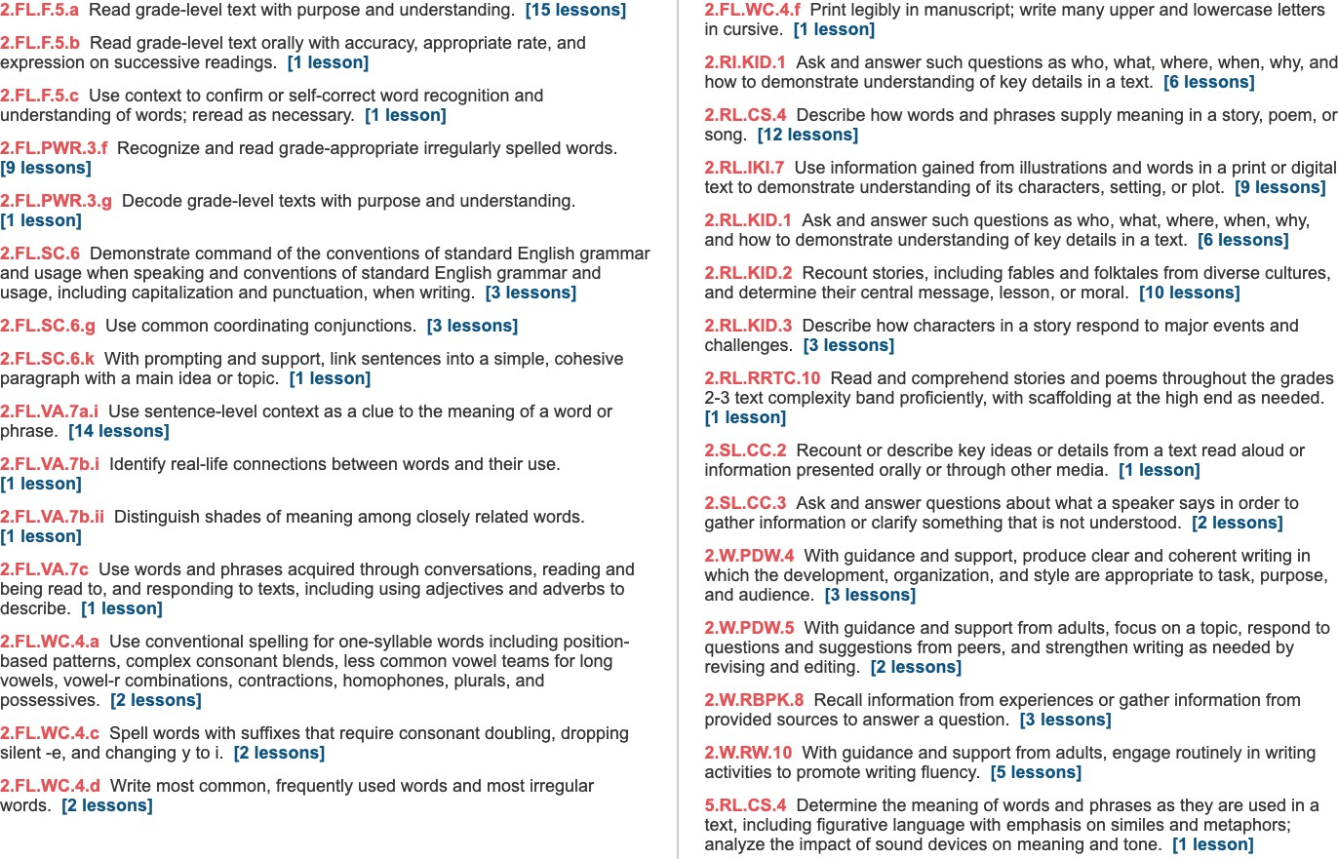
Weekly Standards:

Monday Day 1 | Instructional Plan
Student Learning Targets:
2.RL.CS.4, 2.FL.VA.7a.i, 2.FL.PWR.3.g, 2.FL.VA.7a.i, 2.FL.SC.6, 2.FL.SC.6.g, 2.FL.WC.4.a, 2.FL.PWR.3.f, 2.FL.WC.4.d, 2.FL.WC.4.c, 2.FL.F.5.a, 2.FL.WC.4.f
Introduce the Concept  Oral Vocabulary Words (Reading / Writing Companion) Talk About It | Students will: T330-331  - Discuss the essential question: What excites us about nature?  - Share with a partner things in nature that they have experienced or read about.  - Reading/Writing Companion p. 58-59 work in small groups to complete the graphic organizer.  - Learn Oral Vocabulary Words through define/example/ask routine.
Listening Comprehension  Interactive Read Aloud | Students will: T332-333  - Identify components of poetry.
Word Work Phonemic Awareness Phonics  High Frequency Words Handwriting | Students will: T374-377, 379-381  - Clap syllables and identify the number of syllables.  - Connect the /âr/ sound to the letters are, air, ear, ere.  - Identify HFWs in text.  - Practice cursive uppercase letters I, J and punctuation marks ?, !
Read the Shared Read (Reading / Writing Companion) Teach / Model Close Reading  Summarize Quick Write | Students will: T334-337  - Read Snow Shape, Nature Walk, and In the Sky.  - Reading/Writing Companion p. 60 Take notes, interesting words, key details.  - Make inferences.
Vocabulary  Reading / Writing Companion | Students will: T338-339  - Reading/Writing Companion p. 64-65 Work with a partner to complete work on vocabulary
Spelling  Reading / Writing Companion | Students will: T368  - Take the spelling pretest Practice Book p. 332.
Tuesday Day 2 | Instructional Plan
Student Learning Targets:
2.RI.KID.15, 2.RL.CS.4, 2.RL.RRTC.10, 2.RL.KID.2, 2.RL.IKI.7, 2.FL.SC.6.k, 2.FL.F.5.c, 2.W.RW.10, 2.FL.SC.6, 2.FL.SC.6.g
Strategy  Text Structure Skill | Students will: T342-345  - Identify components of free verse in poetry.  - Reading/Writing Companion p. 68-69 Identify key details to figure out the theme of a text.
Word Work | Students will: T384-386

Phonics | - Blend and build words with are, air, ear, ere.
Reread the Shared Read (Reading / Writing Companion) Guided Practice of Close Reading  Text Features / Literary Elements Comprehension Skill Comprehension: Craft & Structure | Students will: T346-347  - Reread Snow Shape, Nature Walk, and In the Sky.  - Reading/Writing Companion p. 61-63  - Express how the author uses point of view and sensory words.
Respond to Reading  Reading / Writing Companion | Students will: T348-349  - Reading/Writing Companion p. 70 Respond to the prompt How does the poet help you understand the theme of the poem? by using text evidence.
Study Skill / Research & Inquiry  Reading / Writing Companion | Students will: T352-353  - Reading/Writing Companion p. 71 Develop and follow a research plan.
Grammar  Practice Book | Students will: T366  - Identify and use compound subjects and predicates in sentences.
Fluency | Students will: T350-351  - Read orally with accuracy, fluency, appropriate rate and expression.

Wednesday Day 3 | Instructional Plan
Student Learning Targets:
2.RL.KID.2, 2.FL.SC.6, 2.FL.SC.6.g, 2.FL.VA.7a.i, 2.FL.PWR.3.f, 2.FL.WC.4.d, 2.FL.WC.4.c, 2.FL.PWR.3.f, 2.FL.F.5.a
Word Work Phonemic Awareness Phonics  High-Frequency Words | Students will: T388-389, 393-395  - Use Response Boards to blend words with the /âr/ sound.  - Use Word Building cards to identify short and long vowels and r-controlled vowels in words.
Read and Reread the Anchor Text (Literature Anthology)  Practice / Apply Close Reading Take Notes About Text | Students will: T353A-353D  - Use the Graphic Organizer to take notes of words they don’t understand and questions they may have.  - Reading/Writing Companion p. 72 Explain how the author uses repetition.
Writing: Analyze Expert Model | Students will: T358-359  - Identify features of poetry. Reading/Writing Companion p. 80.
Grammar / Mechanics | Students will: T367

Practice Book | - Use sentence punctuation correctly when writing sentences.
Expand Vocabulary  Practice Book | Students will: T371  - Orally complete cloze sentences to review words.
Thursday Day 4 | Instructional Plan
Student Learning Targets:
2.RL.KID.2, 2.RL.CS.4, 2.RL.IKI.7, 2.FL.F.5.a, 2.W.PDW.5, 2.FL.VA.7b.i, 2.W.PDW.4, 2.W.RBPK.8, 2.W.RW.10, 2.FL.VA.7b.ii
Word Work  Phonics | Students will: T397-399  - Blend and build words with are, air, ear, ere.
Read and Reread the Paired Text (Literature Anthology) Author’s Craft  Respond to Text | Students will: T355A-355B, 356-357  - Thinking about the essential question, compare how “Helicopters” and “Windy Tree” are similar to and different from other poems they have read this week.  - Explain why poet uses repetition.  - Work with a partner to find examples of figurative language.
Writing Process: Plan  Reading / Writing Companion | Students will: T360-363  - Reading/Writing Companion p. 81-82.  - Brainstorm ideas for writing a poem about a type of weather or a season.  - Complete sentences to begin writing poetry.
Friday Day 5 | Instructional Plan
Student Learning Targets:
2.FL.F.5.b, 2.RL.CS.4, 2.RL.IKI.7, 2.W.PDW.5, 2.W.PDW.4, 2.W.RBPK.8, 2.W.RW.10, 2.FL.WC.4.a, 2.FL.PWR.3.f
Word Work  Phonics | Students will: T400  - Blend and build words with are, air, ear, ere.
Writing Process: Draft  Reading / Writing Companion | Students will: T364-365  - Use visual patterns to write a draft of a free verse poem about weather or a season.
Spelling  Practice Book | Students will: T369  - Take the spelling posttest.
Integrate | Students will: T372  - Reading/Writing Companion p. 78 Cite text evidence to tell how the author uses images in poems.

Week 6
Week 6 (combined with Week 5 | Comprehension / Genre / Author’s Craft | Language Development
Review, Extend, and Assess | Review strategies and skills Track progress  Cite relevant evidence from text Summarize the text  Interpret information presented visually | Vocabulary Acquisition:  Explain the meaning of antonyms in context Discuss the use of figurative language
Text(s):  Reading Digitally: Hope for the Everglades Reader’s Theater: A Whale of a Story  Passage 1: Rivers of Ice  Passage 2 How to Wait, Against the Wind | Writing | Speaking and Listening
 | Complete a poem  Share writing and choose a portfolio piece  Analytical writing:  Write responses that demonstrate understanding | Paraphrase information presented digitally Engage in collaborative discussions
 | Foundational Skills | Research and Inquiry
 | Fluency: Read grade-level text fluently with appropriate prosody, accuracy, and rate | Conduct and present research  Use online images as part of research  Gather relevant information from digital sources Navigate links

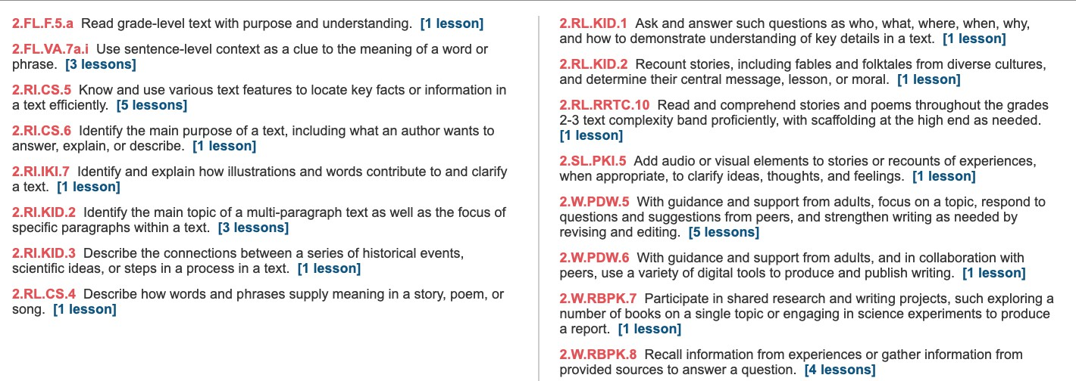
Weekly Standards:

Monday Day 1 | Instructional Plan
Student Learning Targets:
2.RI.KID.2, 2.RI.CS.5, 2.W.RBPK.8, 2.W.RBPK.7, 2.FL.VA.7a.i, 2.W.PDW.5
Reading Digitally OR  Reader’s Theater | Students will: T440-441 Reading Digitally  - Learn how to use the interactive features and hyperlinks for the online article “Hope for the Everglades!”.  - After rereading the article aloud, discuss how the author helps readers understand the purpose of the article.  - Answer questions about the article.  - Discuss what they learned from previous texts about nature.  - Respond through discussion: How are people working to help the Everglades?  Students will: T442 Reader’s Theater  - Listen as the teacher models the reading of the play.  - Practice the play with intonation and expression.  - Perform the play.
Show What You Learned  Reading / Writing Companion | Students will: TT444-445  - Use Reading/Writing Companion p. 90-91 and read “Landing the Eagle”  - Identify cause and effect.  - Use subheadings and sentence clues.  - Answer comprehension questions Reading/Writing Companion p. 92.
Writing Process: Revise  Reading / Writing Companion | Students will: T454-455  - Practice revising a draft - Reading/Writing Companion p. 85
Tuesday Day 2 | Instructional Plan
Student Learning Targets:
2.RI.KID.2, 2.RI.CS.5, 2.RL.RRTC.10, 2.W.RBPK.8, 2.W.RBPK.7, 2.FL.VA.7a.i, 2.W.PDW.5
Reading Digitally OR  Reader’s Theater | Students will: T440-441 Reading Digitally, T442-443 Reader’s Theater  - Perform the play.
Show What You Learned  Reading / Writing Companion | Students will: T446-447  - Use Reading/Writing Companion p. 93-94 and read “How to Wait” and “Against the Wind”.  - Recall facts as to why this is free verse poetry.  - Answer comprehension questions Reading/Writing Companion p. 95.
Writing Process: Peer Review  Reading / Writing Companion | Students will: T454-455  - Continue revising their draft.

Wednesday Day 3 | Instructional Plan
Student Learning Targets:
2.RL.CS.4, 2.RI.CS.6, 2.W.PDW.5
Extend Your Learning | Students will: T448-450  - Use Reading/Writing Companion p. 96 to compare genres.  - Complete a graphic organizer Reading/Writing Companion p. 97  - Use Reading/Writing Companion p. 98 with a partner to identify antonyms.
Writing Process: Peer Conferencing  Reading / Writing Companion | Students will: T456-457  - As a class, practice proofreading and editing sentences.  - Edit draft and list two suggestions. Reading/Writing Companion p. 86  - With a partner, edit and proofread drafts using the editing checklist as a guide.
Thursday Day 4 | Instructional Plan
Student Learning Targets:
2.RI.KID.2, 2.RI.CS.5, 2.FL.VA.7a.i, 2.W.RBPK.8, 2.W.PDW.5, 2.SL.PKI.5, 2.W.PDW.6
Extend Your Learning | Students will: T451-453  - Use Reading/Writing Companion p. 99 to write a thank you letter.  - With a partner, create a game guide that explains how to play one of their favorite games Reading/Writing Companion p.104.
Writing Process: Edit and Proofread  Reading / Writing Companion | Students will: T458-459  - Continue editing their draft.
Friday Day 5 | Instructional Plan
Student Learning Targets:
2.SL.PKI.5, 2.W.PDW.6, 2.W.RBPK.8
Writing Process: Publish, Present, and Evaluate  Reading / Writing Companion | Students will: T460-461  - Publish draft with illustrations.  - Present published work.  - Reading/Writing Companion p. 88-89 Reflect on their progress as writers.  - Set writing goals for future work.
Track Your Progress | Students will: T462  - Use Reading/Writing Companion p. 102 to decide on how happy they are with the skills they have learned.  - Write about something they want to get better at.

Wrap Up the Unit | Students will: T463  - Collaborate in small groups to discuss how different environments make the world an interesting place.
Summative Assessment | Students will: T474-475  - Complete assessments.

BCS Literacy Vision
Unit 5
Genre Study 1:
Essential Question What do heroes do? Text Sets:
Read Aloud: A Hero On and Off Skis Shared Read: Cesar Chevez
Anchor Text: Brave Bessie, The Princess Frog
Genre Study 2:
Essential Question: What do good citizens do? Text Sets:
Read Aloud: A Colorful Problem Shared Read: A Difficult Decision
Anchor Text: Grace for President, Helping to Make Smiles
Genre Study 3:
Essential Question: Why are rules important Text Sets:
Read Aloud: Towns Need Rules
Shared Read: The Problem with Plastic Bags Anchor Text: A Call to Compost, American Symbols

 | Weeks 1-2 | Skills Assessed
Unit 5 Weeks 1-2 | Comprehension / Genre / Author’s Craft | Language Development
Essential Question: What do heroes do? | Cite relevant evidence from text  Make inferences to support understanding Identify sequence of events  Summarize the text  Identify and use text features. | Oral Vocabulary Acquisition:  competing inspired limited overcome refused  Vocabulary Acquisition:  Agree challenging discover heroes interest perform study succeed  Vocabulary Strategy:  Recognize and use synonyms  Grammar:  Identify and use pronouns  Use subjective and objective pronouns
Text(s):  Teach and Model  Interactive Read Aloud: A Hero On and Off Skis  No shared read  Practice and Apply  Anchor Text: Brave Bessie, The Princess Frog  Leveled Readers  A: Rudy Garcia-Tolson O: Rudy Garcia-Tolson ELL: Rudy Garcia-Tolson B: Rudy Garcia-Tolson  Genre Passages  A: The Unsinkable Molly Brown O: The Unsinkable Molly Brown ELL: The Unsinkable Molly Brown B: The Unsinkable Molly Brown  Optional Classroom Library Trade Books  I am Helen Keller, The Story of Ruby Bridges | Writing | Speaking and Listening
 | Writing process:  Plan and draft a biography  Analytical writing:  Write responses that demonstrate understanding | Engage in collaborative discussions Retell “A Hero On and Off Skis”  Present information about an American hero
 | Foundational Skills | Research and Inquiry
Word Work:
Phonemic Awareness: Phoneme Reversal, Substitution, Blending, Segmentation, Deletion
Phonics: diphthongs ou, ow; oy, oi
Structural Analysis: Plurals, Consonant +le syllables Use high-frequency words
Initial and final sound substitution Handwriting: Cursive N, M, H, K, P, Q, V, u Spelling Words:
Week 1:
mound cloud shout pound clown brown crown howl growl chair where been myself pushed Week 2:
Soil broil moist point toil oil toy joy coin noise crown mound I’ll laugh maybe
Fluency: Read fluently with phrasing, intonation

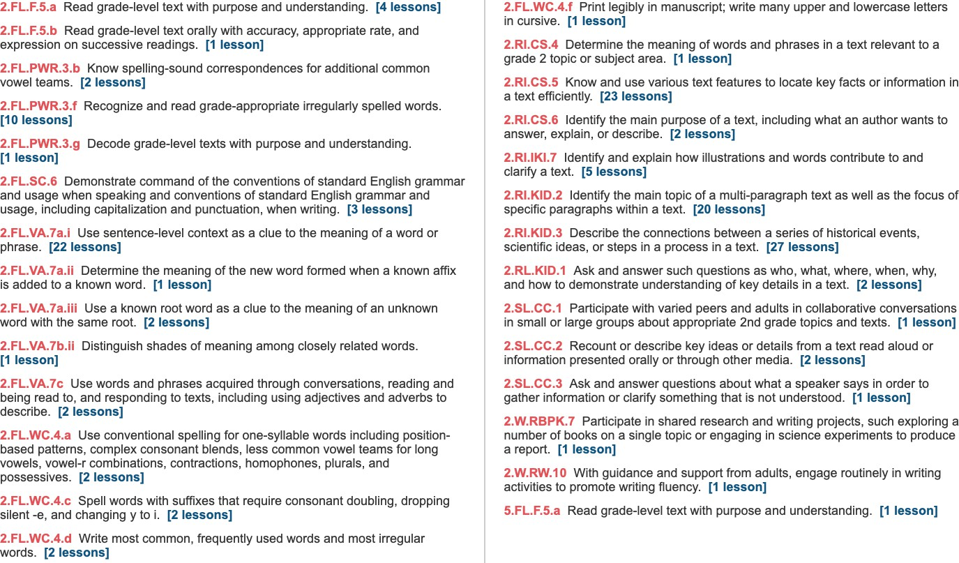
Weekly Standards

Monday Day 1 | Instructional Plan
Student Learning Targets:
2.RI.KID.3, 2.SL.CC.3, 2.SL.CC.1, 2.SL.CC.2, 2.RI.CS.5, 2.FL.VA.7a.i, 2.FL.VA.7a.i, 2.FL.SC.6, 2.FL.PWR.3.b, 2.FL.PWR.3.g, 2.FL.PWR.3.f, 2.FL.WC.4.a, 2.FL.WC.4.d, 2.FL.WC.4.c, 2.FL.WC.4.f,
2.FL.F.5.a
Introduce the Concept (Reading / Writing Companion) Talk About It | Students will: T24-25  - Discuss the essential question: What do heroes do?  - Share with a partner what makes rescue workers heroes.  - Reading/Writing Companion p. vi-1 Work with a partner to complete the graphic organizer.
Listening Comprehension  Oral Vocabulary Interactive Read Aloud | Students will: T26-27  - Learn Oral Vocabulary Words through define/example/ask routine.  - Identify components of a biography.
Word Work Phonemic Awareness Phonics  High-Frequency Words Decodable Reader Handwriting | Students will: T74-81  - Reverse sounds in words to create new words.  - Connect the letters ou and ow to the /ou/ sound.  - Blend words with ou, ow  - Identify HFWs in text.  - Decodable Reader: Out of String Beans! Read and check for comprehension.  - Practice cursive uppercase letters N, M, H, K.
Read the Shared Read (Reading / Writing Companion) Teach / Model Close Reading  Summarize Quick Write | No Shared read this week
Vocabulary  Reading / Writing Companion | Students will: T32-33  - Reading/Writing Comparison p. 6-7 Work with a partner to complete work on vocabulary.  - Using text evidence, find synonyms.
Grammar  Practice Book | Students will: T62  - Practice Book p. 353 Identify and use singular pronouns.
Spelling  Practice Book | Students will: T66  - Take the spelling pretest Practice Book p. 349

Tuesday Day 2 | Instructional Plan
Student Learning Target:
2.RI.KID.3, 2.RI.CS.5, 2.RI.IKI.7, 2.RI.CS.6, 2.RI.KID.2, 2.W.RW.10, 2.RI.IKI.7, 2.W.RBPK.7, 2.FL.SC.6
Reread the Shared Read (Reading / Writing Companion) Guided Practice of Close Reading  Text Features / Literary Elements Comprehension Skill Comprehension: Craft & Structure | Students will:  No shared Read this week
Word Work  Phonics  Structural Analysis | Students will: T82-87  - Blend and build words with ou, ow.  - Use singular nouns and irregular plural nouns correctly.
Respond to Reading  Reading / Writing Companion | Students will: T42-43  - Reading/Writing Companion p. 12 Respond to prompt Explain about your hero. What text features helped you understand more about his/her life?
Study Skill / Research & Inquiry  Reading / Writing Companion | Students will: T46-47  - Reading/Writing Companion p. 13 With a partner, paraphrase information from a text.
Grammar  Practice Book | Students will: T62  - Identify and use plural pronouns.

Wednesday Day 3 | Instructional Plan
Student Learning Target:
2.RI.KID.3, 2.RI.CS.5, 2.RI.IKI.7, 2.FL.SC.6, 2.FL.VA.7a.i, 2.FL.VA.7a.ii, 2.FL.VA.7a.iii, 2.FL.PWR.3.f, 2.FL.WC.4.d, 2.FL.WC.4.c, 2.FL.F.5.a
Word Work Phonemic Awareness Phonics  High-Frequency Words Decodable Reader | Students will: T88-95  - Use Response Boards to blend sounds to say a word.  - Use Word-Building Cards to identify vowel sounds in words.  - Identify HFWs in text.  - Read Decodable Reader Let’s Help Out! fluently to help with comprehension.
Read the Anchor Text (Literature Anthology) Practice / Apply Close Reading  Take Notes About Text | Students will: T47A-47H  - (after teacher tells them they will read about a young woman who works hard to achieve her goals in spite of many obstacles), predict how the story will help them answer the essential question.

- Use a graphic organizer to take notes and record the order of events in the story.
- Work with a partner to find sequence words in text.
Grammar/Mechanics  Practice Book | Students will: T63  - Write the pronoun I correctly.
Expand Vocabulary  Practice Book | Students will: T71  - Orally complete cloze sentences to review.
Thursday Day 4 | Instructional Plan
Student Learning Target:
2.FL.VA.7a.i, 2.RI.KID.3, 2.RI.CS.5, 2.RI.IKI.7
Word Work  Phonics | Students will: T96-99  - Blend and build words with ou, ow
Read the Anchor Text (Literature Anthology) Practice/Apply Close Reading  Take Notes About the Text Respond to Text | Students will: T47A-47G  - Reread anchor text.  - Use story structure to better understand the story. Reading/Writing Companion p. 14.
Friday Day 5 | Instructional Plan
Student Learning Target:
2.FL.VA.7a.i, 2.RI.KID.3, 2.RI.CS.5, 2.RI.IKI.7, 2.FL.F.5.a, 2.RI.CS.6, 2.FL.PWR.3.b, 2.FL.WC.4.a, 2.FL.PWR.3.f
Reread the Anchor Text (Literature Anthology) Practice / Apply Close Reading | Students will: T47A-47H  - Reread the anchor text.  - Use story structure to better understand the story. Reading/Writing Companion p. 15.
Writing Process: Expert Model  Reading / Writing Companion | Students will: T54-55  - Identify features of a biography Reading/Writing Companion p. 24
Spelling  Practice Book | Students will: T67  - Take the spelling posttest.

Monday Day 6 | Instructional Plan
Student Learning Targets:
2.RI.KID.3, 2.RI.CS.5, 2.RI.IKI.7, 2.W.RBPK.8, 2.W.RBPK.8, 2.W.PDW.4, 2.W.RW.10, 2.FL.SC.6, 2.FL.PWR.3.b, 2.FL.WC.4.a, 2.FL.WC.4.d, 2.FL.WC.4.c, 2.FL.WC.4.f, 2.FL.PWR.3.f, 2.FL.F.5.a,
2.FL.VA.7a.i
Word Work Phonological Awareness Phonics  High-Frequency Words Decodable Reader Handwriting | Students will: T102-109  - Orally blend sounds to say words.  - Connect the /oi/ sound to the letters oy, oi.  - Identify HFWs in text.  - Decodable Reader: Let’s Join Joy’s Show!, read and check for comprehension.
Reread the Anchor Text (Literature Anthology) Practice / Apply Close Reading | Students will: T47A-47H  - Reread the anchor text.  - Use timelines to help understand details of the text. Reading/Writing Companion p. 16.
Respond to the Text  Reading / Writing Companion | Students will: T48-49  - Reading/Writing Companion p. 17 Respond to the prompt How does the author use Bessie’s story to show what it means to be a hero? by using text evidence.
Writing Process: Plan  Reading / Writing Companion | Students will: T56-57  - Brainstorm ideas for writing a biography about how a hero.  - Complete sentences to begin writing a biography.
Grammar  Practice Book | Students will: T64  - Identify subjective and objective pronouns.
Spelling  Practice Book | Students will: T68  - Take the spelling pretest Practice Book p. 366.
Tuesday Day 7 | Instructional Plan
Student Learning Targets:
2.FL.VA.7a.i, 2.RI.KID.3, 2.RI.CS.5, 2.RI.IKI.7, 2.W.RBPK.8, 2.W.PDW.4, 2.W.RW.10, 2.FL.SC.6, 2.FL.VA.7a.ii, 2.FL.VA.7a.iii
Word Work  Phonics  Structural Analysis | Students will: T110-115  - Blend and build words with oy, oi.  - Practice final stable syllables.
Read Paired Selection (Literature Anthology) | Students will: T49A-49D

Practice / Apply Close Reading | - Thinking about the essential question, compare how Brave Bessie and “The Prince’s Frog” are similar and different.  - Identify character, setting, events.
Writing Process: Plan  Reading / Writing Companion | Students will: T58-59  - Identify primary and secondary sources for writing a biography Reading/Writing Companion p. 27
Grammar  Practice Book | Students will: T64  - Identify and use possessive pronouns correctly in sentences.
Expand Vocabulary  Practice Book | Students will: T70  - Use an online dictionary to check the pronunciation of an unknown word

Wednesday Day 8 | Instructional Plan
Student Learning Targets:
2.RI.KID.3, 2.RI.CS.5, 2.RI.IKI.7, 2.FL.SC.6.g, 2.W.PDW.4, 2.W.RW.10, 2.FL.SC.6, 2.FL.VA.7a.i, 2.FL.VA.7a.ii, 2.FL.VA.7a.iii, 2.FL.PWR.3.f, 2.FL.WC.4.d, 2.FL.WC.4.c, 2.FL.PWR.3.f, 2.FL.F.5.a
Word Work Phonemic Awareness Phonics  High-Frequency Words Decodable Reader | Students will: T116-123  - Use Response Boards to segment words into phonemes.  - Use Word-Building Cards to identify vowel sounds in words.  - Identify HFWs in text.  - Read Decodable Reader Join a Team! fluently to help with comprehension.
Reread Paired Selection (Literature Anthology) Practice / Apply Close Reading | Students will: T49A-49D  - Reread the paired selection  - Identify the author’s craft using text evidence. Reading/Writing Companion p. 19
Author’s Craft  Reading / Writing Companion | Students will: T50-51  - Reading/Writing Companion p. 21 With a partner, identify words that tell the point of view of a text.
Writing Process: Draft  Reading / Writing Companion | Students will: T60-61  - Use a sequencing to show the order of events when writing a draft of a biography.
Grammar  Practice Book | Students will: T65  - Write commas in dates correctly.
Expand Vocabulary  Practice Book | Students will: T71  - Identify the correct meaning & usage of synonyms.

Thursday Day 9 | Instructional Plan
Student Learning Targets:
2.RL.CS.6, 2.RL.KID.3, 2.RL.KID.1, 2.FL.F.5.b, 2.FL.SC.6.g, 2.W.PDW.4, 2.W.RW.10
Word Work  Phonics | Students will: T124-127  - Blend and build words with oy, oi.
Fluency  Practice Book | Students will: T52  - Use inotnation to help reading sound smooth and natural.
Writing Process: Draft  Reading / Writing Companion | Students will: T60-61  - Use sequencing to continue writing a draft of a biography.
Make Connections  Reading / Writing Companion | Students will: T72  - Reading/Writing Companion p. 22 Use a photograph to make connections between it and previous text selections.
Friday Day 10 | Instructional Plan
Student Learning Targets:
2.W.RBPK.8, 2.SL.CC.3, 2.FL.SC.6.g, 2.W.PDW.4, 2.W.RW.10, 2.FL.PWR.3.b, 2.FL.WC.4.a, 2.FL.PWR.3.f
Word Work  Phonics | Students will: T128  - Blend and build words with oy, oi
Writing Process: Draft  Reading / Writing Companion | Students will: T60-61  - Use sequencing to continue writing a draft of a biography.
Spelling  Practice Book | Students will: T69  - Take the spelling posttest.
Research and Inquiry  Reading / Writing Companion | Students will: T73  - Reading/Writing Companion p. 23 With a partner, plan how they will present their American Hero Poster to the class.
Progress Monitoring | Students will: T162-163  - Complete assessments.

 | Weeks 3-4 | Skills Assessed
Weeks 3-4 (Week 4 in Q4) | Comprehension / Genre / Author’s Craft | Language Development
Essential Question: What do good citizens do? | Cite relevant evidence from text  Make inferences to support understanding Evaluate the author’s use of point of view Make and confirm predictions  Evaluate graphic features/callouts  Identify and use literary elements: first person point of view | Oral Vocabulary Acquisition:  calm concern exhausted offered treat  Vocabulary Acquisition:  champion determined issues promises responsibility right volunteered votes  Vocabulary Strategy:  Recognize and understand suffixes -ful, -less  Grammar:  Understand and use pronoun-verb agreement
 |  | Understand and use possessive pronouns
Text(s): | Writing | Speaking and Listening
Teach and Model  Interactive Read Aloud: A Colorful Problem Shared Read: A Difficult Decision | Writing process:  Revise, edit and publish a realistic fiction story  Analytical writing:  Write responses that demonstrate understanding | Engage in collaborative discussions Retell “A Colorful Problem”  Present information about the roles of mayor, governor, or president
 | Foundational Skills | Research and Inquiry
Practice and Apply | Foundational Skills | Research and Inquiry
Anchor Text: Grace for President, Helping to Make Smiles  Leveled Readers  A: Fixing the Playground O: The Food Crew  ELL: The Food Crew B: How Many Greats  Genre Passages  A: Hero  O: A School Feeds Others ELL: A School Feeds Others B: Freedom Walk  Optional Classroom Library Trade Books  Judy Moody Saves the World! I Pledge Allegiance | Word Work  Phonological Awareness: identify syllables  Phonemic Awareness: categorization, blending, deletion, addition  Phonics: Variant vowels /u/: oo, u_e, ew, -ue, ui, and /u/: oo, ou, u; /o/: aw, au, augh, al, ough  Structural Analysis: contractions, vowel team syllables Use High-frequency words  Handwriting: Cursive W, X, Y, Z; spacing letters and words  Spelling Words:  Week 1: room flu June new glue fruit crook could full push point coin along ever strong Week 2: ball small paw jaw pause sauce taught chalk walk sought new fruit city own read Fluency:  Read fluently with phrasing and expression | Ask and answer questions comparing the roles of a mayor, governor, and president  Research and write a pamphlet telling why you would be a good leader and what you would do

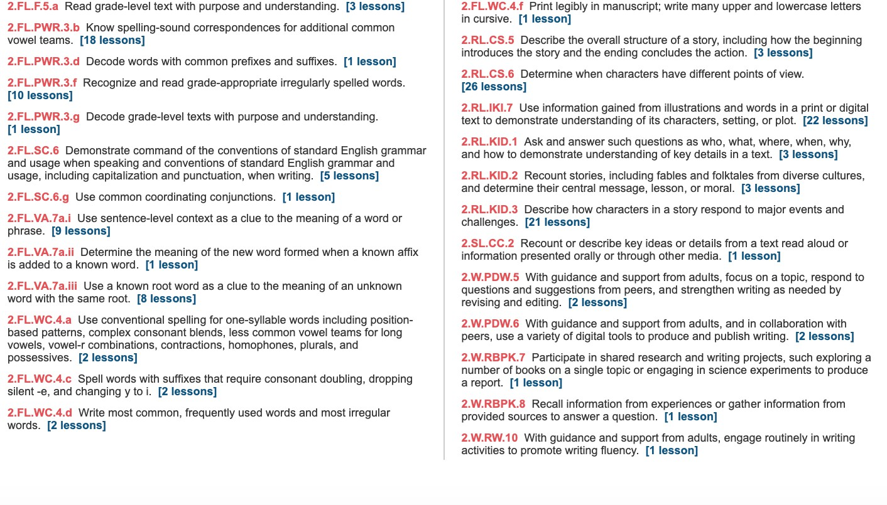
Weekly Standards:

Monday Day 1 | Instructional Plan
Student Learning Targets:
2.RL.KID.1, 2.SL.CC.2, 2.RL.KID.3, 2.FL.PWR.3.g, 2.RL.KID.1, 2.FL.VA.7a.i, 2.FL.VA.7a.iii, 2.FL.VA.7a.i, 2.FL.VA.7a.iii, 2.FL.SC.6, 2.FL.WC.4.a, 2.FL.WC.4.f, 2.FL.PWR.3.b, 2.FL.PWR.3.f,
2.FL.WC.4.d, 2.FL.WC.4.c, 2.FL.F.5.a
Introduce the Concept (Reading / Writing Companion) Talk About It | Students will: T178-179  - Discuss the essential question: What do good citizens do?  - In small groups, discuss some of the rights and responsibilities they have as citizens of their school/community/country.  - Reading/Writing Companion p. 34-35 Work with a partner to complete the graphic organizer.
Listening Comprehension  Interactive Read Aloud | Students will: T180-181  - Learn Oral Vocabulary Words through define/example/ask routine.  - Identify components of realistic fiction.
Word Work Phonemic Awareness Phonics  High-Frequency Words Decodable Reader Handwriting | Students will: T228-231, 233-235  - Clap syllables and identify the number of syllables.  - Connect letters for variant vowel sounds /ü/ and /ù/  - Identify HFWs in text.  - Decodable Reader: Soon the North Wind Blew, read and check for comprehension.  - Practice cursive uppercase letters W, X, Y, Z.
Read the Shared Read (Reading / Writing Companion) Teach / Model Close Reading  Summarize Quick Write | Students will: T182-185  - Reading/Writing Companion p. 36 Take notes, interesting words and key details in A Difficult Decision.  - Make, Confirm and Revise predictions.  - Identify point of view.
Vocabulary  Reading / Writing Companion | Students will: T186-187  - Reading/Writing Companion p. 40-41 Work with a partner to complete work on vocabulary.  - Use text evidence to find suffixes.
Grammar  Practice Book | Students will: T216  - Identify verbs that agree with subject pronouns.
Spelling  Practice Book | Students will: T220  - Take the pretest Practice Book 383.
Tuesday Day 2 | Instructional Plan
Student Learning Targets:
2.RL.KID.2, 2.RL.KID.1, 2.RL.CS.6, 2.RL.KID.3, 2.RL.IKI.7, 2.W.RW.10, 2.W.RBPK.8, 2.W.RBPK.7, 2.FL.SC.6, 2.FL.PWR.3.b

Reread the Shared Read (Reading / Writing Companion) Guided Practice of Close Reading  Text Features / Literary Elements Comprehension Skill Comprehension: Craft & Structure | Students will: T188-195  - Reading/Writing Companion p. 42 Make and confirm predictions.  - Identify the point of view in The Boy Who Cried Wolf.
Word Work  Phonics  Structural Analysis | Students will: T238-240  - Use Word-Building Cards to blend and build words with /ü/ and /ù/  - Write contractions with not.
Respond to Reading  Reading / Writing Companion | Students will: T196-197  - Reading/Writing Companion p. 46 Respond to the prompt What does Wyatt learn about being a good citizen? by using text evidence
Study Skill / Research & Inquiry  Reading / Writing Companion | Students will: T200-201  - Reading/Writing Comparison p. 47 Ask and answer questions.
Grammar  Practice Book | Students will: T216  - Identify verbs that agree with subject pronouns.

Wednesday Day 3 | Instructional Plan
Student Learning Targets:
2.RL.CS.6, 2.RL.KID.2, 2.FL.VA.7a.iii, 2.FL.SC.6, 2.FL.VA.7a.i, 2.FL.VA.7a.ii, 2.FL.VA.7a.iii, 2.FL.PWR.3.b, 2.FL.PWR.3.f, 2.FL.WC.4.d, 2.FL.WC.4.c, 2.FL.F.5.a
Word Work Phonemic Awareness Phonics  High-Frequency Words Decodable Reader | Students will: T242-243, 247-249  - Orally blend phonemes  - Use Word-Building Cards to identify vowel sounds in words  - Identify HFWs in text.  - Read Decodable Reader It Couldn’t Be Done! fluently to help with comprehension.
Read the Anchor Text (Literature Anthology) Practice / Apply Close Reading  Take Notes About Text | Students will: T201A-201K  - Predict what the story might be about and how it might answer the essential question.  - Use a graphic organizer to note unfamiliar words or questions they may have.  - Identify the point of view of the text.  - Confirm predictions
Grammar / Mechanics  Practice Book | Students will: T217  - Write proper nouns correctly.

Expand Vocabulary  Practice Book | Students will: T225  - Orally complete cloze sentences to review words.
Thursday Day 4 | Instructional Plan
Student Learning Targets:
2.RL.CS.6, 2.RL.KID.2, 2.FL.VA.7a.iii, 2.FL.PWR.3.b
Word Work  Phonics | Students will: T251-252  - Use Word-Building Cards to blend and build words with /ü/ and /ù/
Read the Anchor Text (Literature Anthology) Practice/Apply Close Reading  Take Notes About the Text Respond to Text | Students will: T201A-201L  - Reread the anchor text.  - Use important details about the characters, setting and plot to summarize the story.  - Identify the author’s craft. Reading/Writing Companion p. 48
Friday Day 5 | Instructional Plan
Student Learning Targets:
2.RL.CS.6, 2.RL.KID.2, 2.FL.VA.7a.iii, 2.FL.SC.6.g, 2.W.PDW.5, 2.FL.SC.6, 2.FL.WC.4.a, 2.FL.PWR.3.f, 2.FL.PWR.3.b
Word Work  Phonics | Students will: T254  - Use Word-Building Cards to blend and build words with /ü/ and /ù/
Reread the Anchor Text (Literature Anthology) Practice / Apply Close Reading | Students will: T201A-201K  - Reread the anchor text.  - Identify suffixes.  - Identify the illustrator’s craft. Reading/Writing Companion p. 49
Writing Process: Revise  Reading / Writing Companion | Students will: T208-209  - Practice revising a draft - Reading/Writing Companion p. 29  - Revise their drafts by adding strong conclusions.
Spelling  Practice Book | Students will: T221  - Take the posttest.

