Dear Students and Families,

My name is Miss Montana and I will be your third grade teacher this school year! I am so excited to continue in my career as a Butler Bear. Fun fact - I was once a student at Butler and three teachers who still work here were my teachers! Since graduating from West Chester University, I have spent my time in the Central Bucks School District community working with students of all grade levels and abilities. In the general education setting, I have taught fifth, sixth, and third grade! I am eager to get to know you, help you grow as learners, and witness your “pawsitivity”!

Third grade is such an exciting time! You will build independence, strengthen your problem-solving skills, and explore the world around you in deeper ways. We’ll also focus on kindness, teamwork, and becoming a supportive classroom community through the Butler Pillars. As for our schoolwork, the Math in Focus program will help us master multiplication and division while solving real-world problems. We’ll grow as readers using our reading comprehension skills in new texts and sharpen our writing skills with personal narratives, opinion, historical fiction pieces, and letter writing. You’ll even get to learn cursive! Much of this work will involve the use of your new laptop, so get ready to build your technology skills throughout the year!

I look forward to developing strong relationships with you to support your journey through third grade. During the first few days in class, we will spend time getting to know one another, participating in community building activities, establishing classroom goals, and modeling appropriate routines and procedures. On the first day of school, please bring in a picture of your family or loved ones and an independent reading book.

I value an open line of communication between myself, the students, and their families, so please do not hesitate to reach out with any questions, concerns, or updates. My goal is to work together to ensure a successful and enjoyable school year for all. Please stay tuned for upcoming events, important dates, and opportunities to get involved. Much of this will be communicated through my weekly newsletter that I email out every Monday. I look forward to an amazing school year and cannot wait to meet you on the first day of school, and your families at Back to School Night!

Sincerely,

Miss Montana
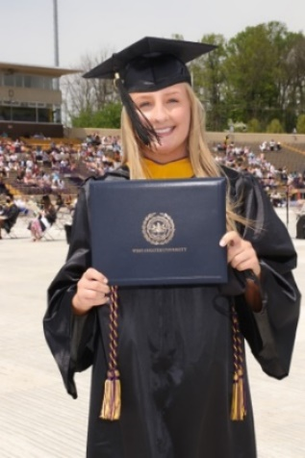
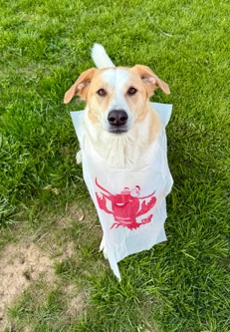
hmontana@cbsd.org
