Building Partnerships
There are opportunities at our school for parents to volunteer and play a role in their child’s education. Please consider joining the faculty, staff, and fellow parents though the following event:
- Meet the Teacher: Aug. 11th
- Early Childhood Sessions for Parents HeadStart
- STEM Night: Oct. 30th
- Volunteering Days – First Wednesday of each month throughout the school year
- Winter Carnival: Dec. 13th from 9:00-12:00
- Winter Program: Dec. 16th 9:00 – 11:00
- Career Day: May 15th 8:30 – 11:00
- Parent-Teacher Conferences: Fall & Spring *Scheduled Time
**All other events or trainings will be announced through social media and class group chats via ClassDojo.
Communication About Student Learning
RYSS Academy at Pasadena is committed to two-way communication with families about their student’s learning. Expect us to reach you by:
- Parent-Teacher Conference in Fall & Spring
- Progress / Report Card every 3 weeks
(K-6th grade)
- Progress Reports 3 times a year (PK only)
- Weekly Conduct Folder
- Weekly Homework Folder
- Weekly Family Raptor Newsletter
- ClassDojo, Social Media, Email, Phone
Parental Involvement
Parent opportunities at our school for parents to volunteer and play a role in their child’s education include:
- PTO
- Volunteer Opportunities
- Early Literacy Sessions for Parents
- Community Events

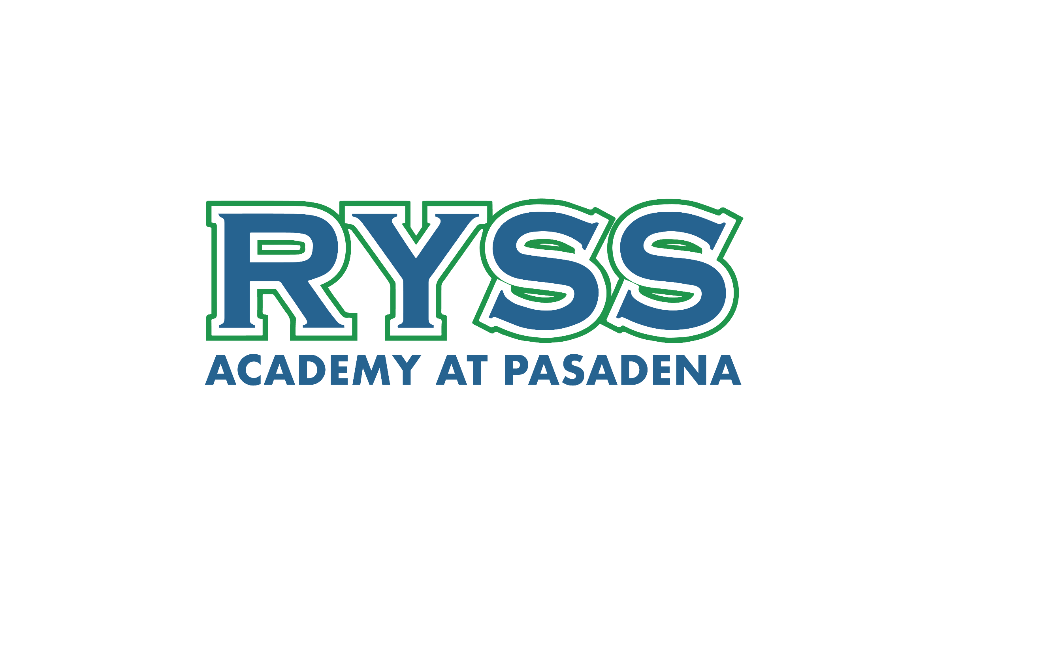2025-2026
School-Parent
Compact

Learn, Grow, SUCCEED!

Yesenia Cervantes, Principal
____________________________
1062 Fairmont Pkwy.
Pasadena, Texas, 77504
(832) 482-9583
Para traducer llame al: 832-482-9583
What is a School-Parent Compact?
A school-parent compact serves as a conduit for conveying shared goals, expectations, responsibilities, visions, and best practices between teachers and families. By establishing a binding agreement between the school and home, the compact fosters a collaborative environment to work harmoniously towards the betterment of your child.
Jointly Developed
The parents, students, and staff of RYSS Academy at Pasadena worked together and shared ideas to develop the School-Parent Compact. A meeting is held every year to review and revise our goals based on the school’s academic achievement goals. As a result, a compact is created incorporating the feedback provided.
Parents are welcome to provide feedback at any time. All feedback will be collected and reviewed during annual revision meeting with the Campus Leadership Committee.
Our Raptor Promise is to:
P – Be Present (Attend school regularly & be mentally present in class.)
R – Be Respectful (Show respect toward students, self, faculty & staff)
I – Be Innovative (preparedness, grow through learning, participate)
D – Exhibit Proper Discipline (Follow school & class rules, procedures, self-discipline)
E – Show Excellence (Ready to learn, complete assignments, seek support when needed)

Please call 832-482-9583 or visit our website at: https://pasadena.ryss.org/
for more information on the school-parent compact.

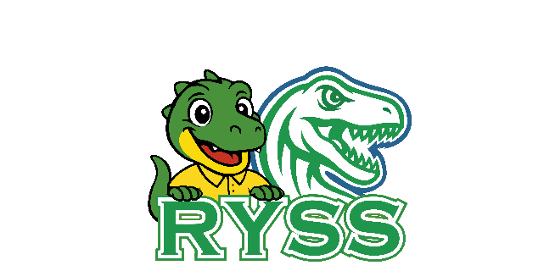

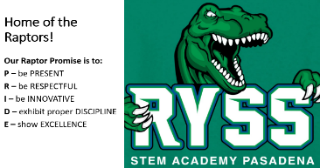

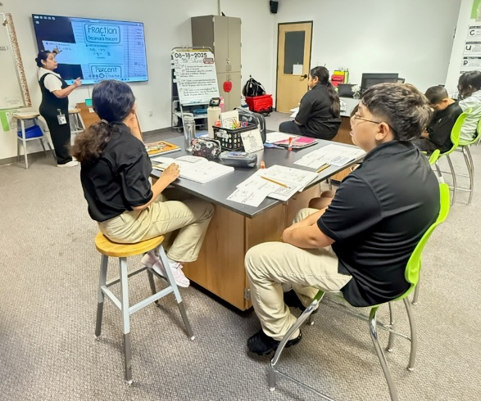
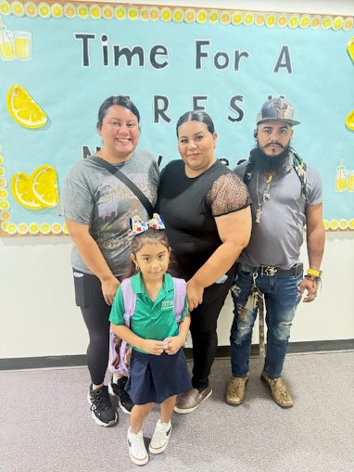
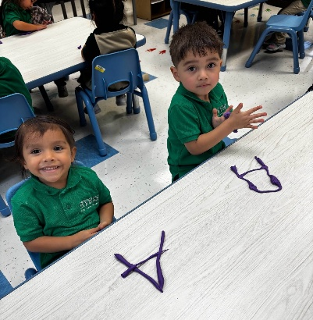
Our Goal for Student Achievement
Campus Goals
- All students will receive high-quality instructional material designed to significantly improve their academic performance, with a goal of increasing reading achievement by 75% and math achievement by 70%.
- Students at RYSS STEM Academy Pasadena will improve their daily attendance of 92% to 94% that meets or exceeds the Texas Education Agency's (TEA) standards for satisfactory attendance.
- RYSS will increase Parent and family community engagement opportunities to increase opportunities that support students’ achievement outcomes.
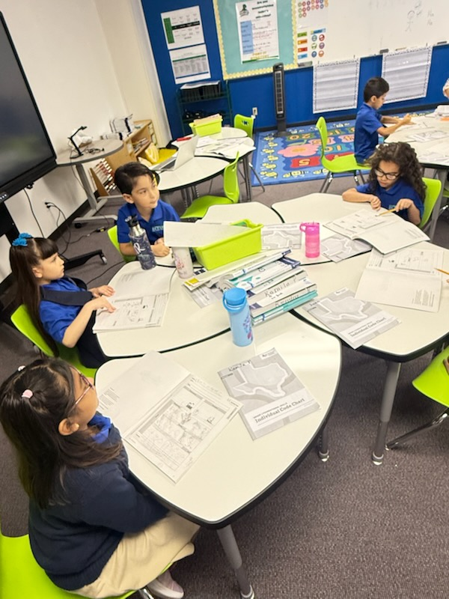
Focus Areas
- preK 3 – Social-Emotional Development
- preK 4 – Early Literacy & Numeracy
- Kinder – 2nd Grade – Literacy & Math
- 3rd - 6th Grade – Reading Comprehension, Writing, Number Sense, Scientific Inquiry
- K – 6th Grade – Science with Inquiry

MY GOALS
As students we will . . .
aim to improve our academic achievement, complete assignments, ask for help when needed, share all notices and information that I receive from my school with my family/guardian every day, and attend school regularly.

My goal for MATH is:
______________________________________
My goal for READING is:
______________________________________
My FAMILY can help me reach my goal by:
______________________________________
My TEACHER can help me reach my goal by:

_______________________________________

As a school, our . . .
focus is to empower our diverse student population to excel by providing high-quality curriculum and instruction in a nurturing and effective learning environment. We actively partner with families, offering opportunities for involvement and maintaining clear communication about student academic achievement.
At Home we will . . .
support our student’s learning by ensuring my student(s) attend school regularly and staying informed about my student’s education by promptly addressing all notices from the school or the school district and responding, as appropriate.

