Private School Administrator:
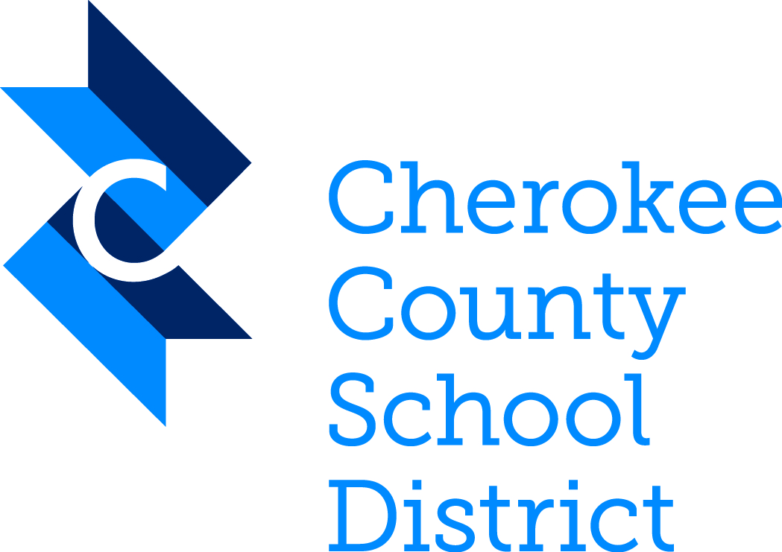
Janet Read Welch
School Board Chair

Patsy Jordan
Vice-Chair, District 2

Kelly Poole
District 1

Chance Beam
District 3

Robert Rechsteiner
District 4

Erin Ragsdale
District 5

Dr. Susan Padgett-Harrison
District 6

Mary Elizabeth Davis, PhD
Superintendent of Schools
1205 Bluffs Parkway
Canton, Georgia 30114
770.479.1871
www.cherokeek12.net

Georgia Law (§ 20-2-690) requires private schools to report students enrolled in grades K-12 to the Superintendent of the public school district in which the student resides. The report must be submitted within 30 days after the beginning of the school year and contain the name, age (not birth date), grade and residence, to include the zip code, of each student. (P.O. Box numbers will NOT be accepted.) Please also include the name of the person preparing the report for your school and a contact number.

The report is based upon the location of the student’s residence. Accordingly, if you have students residing in several different public school districts, a separate report must be made to each of the districts involved detailing those students that reside within the given public school district. If you do not have any students from Cherokee County, please write “no students” on the form and return it to our office.

Georgia Department of Education Form 1111 (DE Form 1111) outlining the information to be reported is located at www.cherokeek12.net on the Federal Programs webpage.

The instructions for completing DE Form 1111 are listed below:

- Complete the school name, total enrollment and grades.
- Enter the student information alphabetically by grade level.
- Enter all the student information into the requested fields. (Depending on your database, you may be able to import the student information into the spreadsheet.)
- E-mail your completed Excel spreadsheet to privateschools@cherokeek12.net.

Thank you for your assistance. If you have questions or concerns, please contact our office at 770.704.4287.

