Pre-K 3 supply list
- Cot or crib sheet and blanket
- Change of clothes- uniform top & bottom, underwear and socks (In labeled Ziplock bag)
- Pull ups/wipes (unscented) Please send pull ups with side tabs, if possible, it makes the changing process much easier (if your child requires them)
- Package of Glue sticks
- 1 pack Crayons (Large Crayola)
- 1. Normal school size Backpack (not on wheels) must be large enough to hold folders and nap items.
- 1 Black 1” 3ring binder with clear view cover
- Lunch box with ice pack if not eating school lunch
- 1 pair of blunt tip scissors
- 1 box of Crayola washable markers
- Water bottle with covered straw and labeled
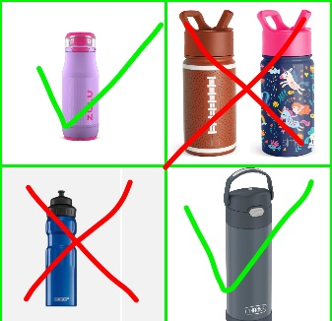
- Please label all of your child's personal items with their first and last name.
- Please make sure lunch items are easy for your child to open, and that food that may be a choking hazard is cut into small pieces. For example (Grapes, hot dogs, and carrots) please do not send items that need to be heated up because we will not have access to a microwave if food needs to stay warm, please send it in a thermos or hot food container.

Donations
Lysol/Clorox wipes
Hand Sanitizer
Healthy Snacks (goldfish, veggie straws, pretzels, cereal, granola bars, animal crackers, graham crackers, cheez its)
Kleenex
Paper Towels
Classroom Amazon Wishlist Below

