Taking Attendance Using PowerTeacher for Guest Teachers
PowerTeacher offers a web-based portal for guest teachers to take attendance for the class they are assigned to. Here are the steps needed to take attendance in PowerTeacher:
Log onto the local faculty computer using the guest teacher logon credentials

Username: teacher
Password: guest
Open the web browser of your choice (Firefox, Internet Explorer, Chrome, Safari) and navigate to the following page:


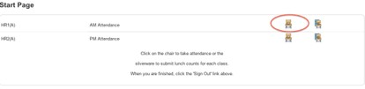
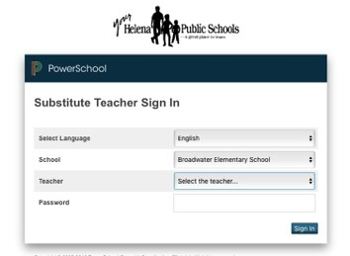
https://hsd.powerschool.com/subs

Select the appropriate school and teacher and enter the password. The password changes daily and is calculated based on the date followed by guest. For example, if you are teaching on September 15th, the daily password would be 15guest.
Once you have logged in successfully, you will see all classes available for the teacher you selected. Click on the chair icon to take attendance for a particular class.
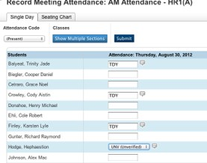
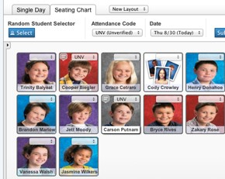
You will see a list of students assigned to that particular class. Click the drop-down menu to select the attendance code to assign. You will only need to select Tardy, Absent, or Unverified. Students that are present will not have an entry. Click on field next to the student name to assign a code to that student.
If the teacher has setup a seating chart, you can also take attendance directly on the chart. Select the code you want to assign and click on the students picture to assign that code.
Once you have taken attendance, click the Submit button.
For security purposes, click the Logout button on the top-right of the window. Closing the PowerTeacher window without logging out will result in the guest teacher account for that teacher being locked for 20 minutes!!

