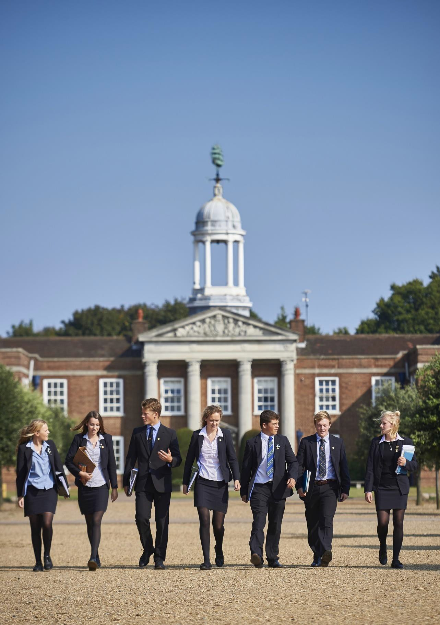




CHANGES FOR THE NEW TERM (SEPTEMBER 2025)

Please note the uniform changes from September 2025 are as follows:

- Blazers: Year 7 will now be required to wear Blazers from September 2025.
- School Coats: Pupils allowed to wear their own dark blue or black coat over their blazer – please have minimal branding.
- Scarves, hats & gloves: No restrictions.
- Belts: Can include the school belt.
- Sixth form pupils: Are allowed to wear dark blue or black V-neck jumpers or quarter zips of their own choosing provided any branding is minimal and ties (if worn) are visible.

BUYING ITEMS
We have an excellent top up service of second-hand uniform available for sale from our RHS Shop on site and our online used uniform shop.

All items are as currently listed by the school’s official uniform provider, Schoolblazer and are of excellent quality ensuring the smartness of our pupils whether they are wearing brand new or previously used uniform.

OPENING TIMES
- Term Time: pupils only, the pupils may visit the school uniform shop in their breaks with permission from their house matron.
- Half term and School holidays: 9.30am-12noon Tue, Wed & Thu by appointment only.
Please contact cfitzpatrick@royalhospitalschool.org at the beginning of each half term/school holidays to make an appointment.

The shop may be open on other key events such as Divisions and the last and first day of term, these will be advertised on RHS Post.
Additional items of merchandise are available to buy in the shop and other services include washing, ironing, repairs, during or alternations.
The second-hand uniform price list provides an indication of the cost of items. On purchase, this will amount be added to your end of term bill.

SELLING ITEMS
If you have items of outgrown uniform you wish to sell, please bring them to the shop at the opening times or leave them with your house/matron. Please attach a label (example on the back) giving us all the relevant information. These can be found at the houses or at the shop.
What we can accept:
- Items must be currently listed by the school’s official uniform supplier, Schoolblazer.
- Items must be laundered, ironed and in excellent condition.
- There is no need to remove name labels.
- We reserve the right to refuse any items that are not in saleable condition
- All items to be sold must come with parental knowledge and permission

If we are unable to accept your items, they will be donated to the clothes bank, on the sale of an item, 40% of the price will be credited to your end of term bill. Alternatively, this a good opportunity to support the school by donating the proceeds in one of the following ways:
- House Fund
- The Annual Fund which supports projects benefiting pupils in the school today A Capital Project
- The Bursary Fund which helps support children with financial and charitable need

If your child is leaving RHS, we would advise you bring items for sale to the shop as close to the end of term/start of the holidays as you are able. We will keep your ‘bill' open for a further 6-8 weeks. If, after this time, the items have not been sold, the proceeds will be donated to the Annual Fund.

ITEM COST
Blazer | £45.00
6th Form Suit Jacket | £45.00
6th Form Suit Trousers/Skirt | £25.00
6th Form Overcoat | £75.00
6th Form shirt/blouse | £10.00
6th Form Jumper | £15.00
6th Form Crested Tie | £7.00
Shirt/blouse | £6.50
V Neck jumper | £13.00
Trousers | £13.00
School Skirt | £22.50
Tie | £6.50
Storm-proof Coat | £25.00
Scarf | £13.00
Training Pant | £17.50
Tracksuit Top | £22.00
Hockey Shirt | £12.50
PE Shirt | £12.50
Fitness T Shirt | £12.00

SECONDHAND UNIFORM PRICE LIST
ITEM COST
Hoody | £14.50
Half Zip Fleece | £15.50
Base Layer Top | £10.00
Base Layer bottoms | £10.00
Match rugby shirt | £22.00
Athletics Singlet | £12.00
Cricket Shirt | £12.50
Cricket Trousers | £12.50
Cricket Jumper | £20.00
Rugby Training Top | £15.00
Beanie Hat | £7.00
Shorts | £12.50
Skort | £12.00
Running Shorts | £14.00
Sports Bag | £22.00

WHERE TO FIND US
We can be found within the laundry building which is located at the back of the Estates offices. This is signposted to the left from Chapel Road just before the Music School and Health Centre. There is plenty of parking available.
If you have any queries regarding the Second-hand Uniform Shop, please email cfitzpatrick@royalhospitalschool.org or telephone (within the opening hours) on 01473 326170.












□
□
□
□
□
□
□
□
□
□
To be attached to your item or bag of items

