Uploading documents to your student’s Final Forms Account
Please use the instructions below to upload your student’s sports physical and float test (if applicable) directly to their FinalForms account.

Step 1
From your “My Students” page in FinalForms, click on the file folder icon to the right of your student’s name. This folder can also be found in the upper right corner of your student’s profile page.
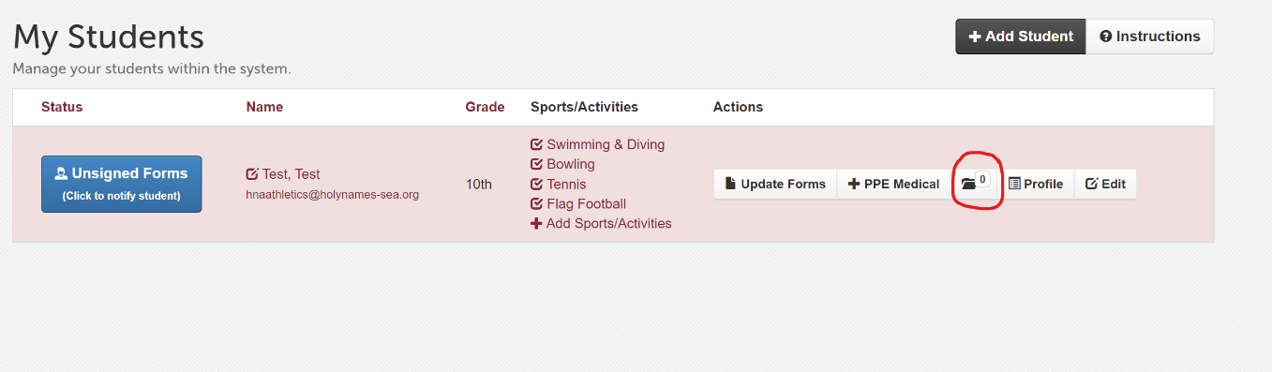
Step 2
Click the drop-down menu and select Physical or Other Document (for crew float tests).
Follow the instructions for uploading a file from your computer or a phone from your phone/tablet.

