How to Buy and Access Tickets and Passes in the Bound App
Purchasing and accessing tickets and passes for District 11 athletic events is quick and easy through the Bound App.
Purchasing Tickets or Passes
- Open the Bound App and locate the event you would like to attend.
- Tap the Buy Tickets button.
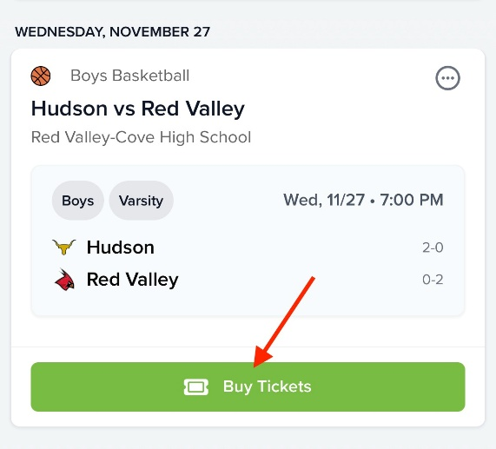
- Use the + or – buttons to select the number of tickets you would like to purchase.
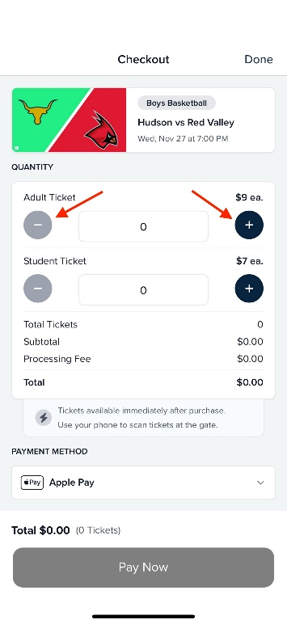
- Under Payment Method, choose your preferred payment option:
  - Credit Card
  - Apple Pay
  - Google Pay
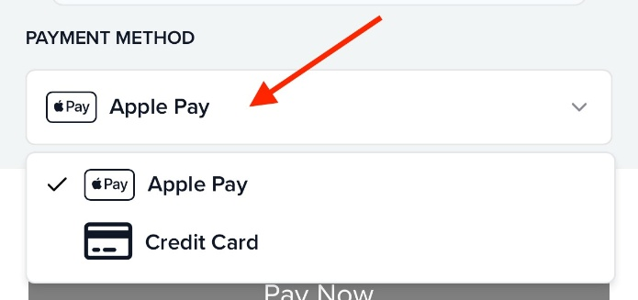
- Tap Pay Now and enter your payment information.
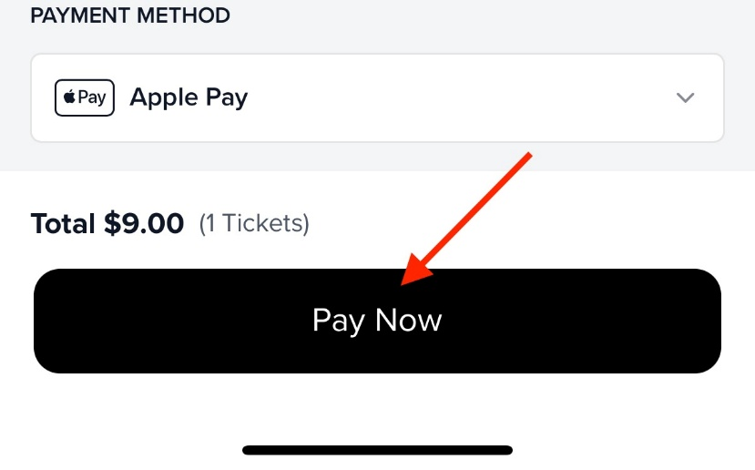
- Once your payment is successfully processed, you will receive:
  - An in-app notification
  - A confirmation email
  - Immediate access to your tickets within the app
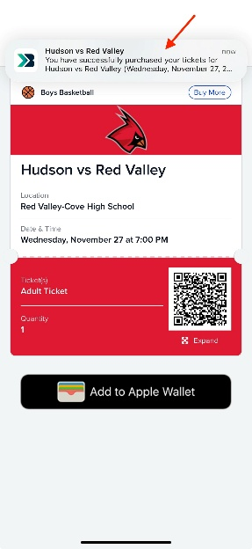
Accessing Your Tickets or Passes
There are several ways to view your purchased tickets and passes:
Option 1: Tickets Tab
- Tap the Tickets tab in the main navigation menu.
- This screen will display all tickets you currently own.
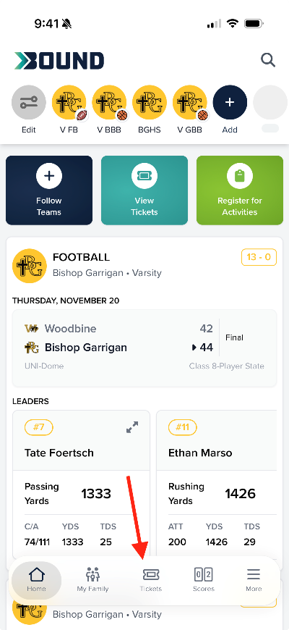
Option 2: Home Page Quick Access
- From the app’s Home Page, tap the blue View Tickets button located in the quick action section.
- Your purchased tickets will be displayed immediately.
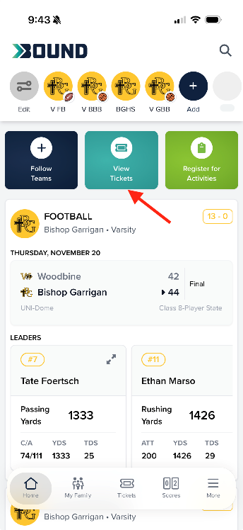
Viewing Passes
- Open the Tickets section.
- Select the My Passes tab.
- Tap the pass you would like to view.
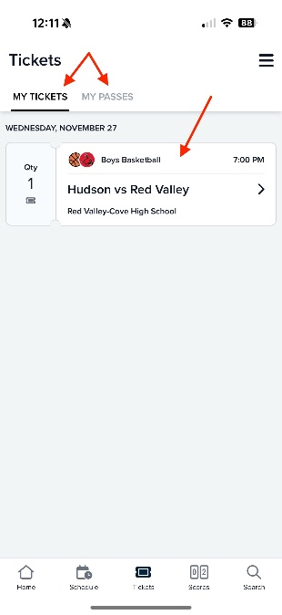
Adding Tickets to Your Mobile Wallet
For quick and convenient entry, tickets can be added directly to your mobile wallet.
- Open your ticket within the Bound App.
- Tap Add to Apple Wallet or Add to Google Wallet.
- Your ticket will be saved to your device's wallet for easy access on event day.
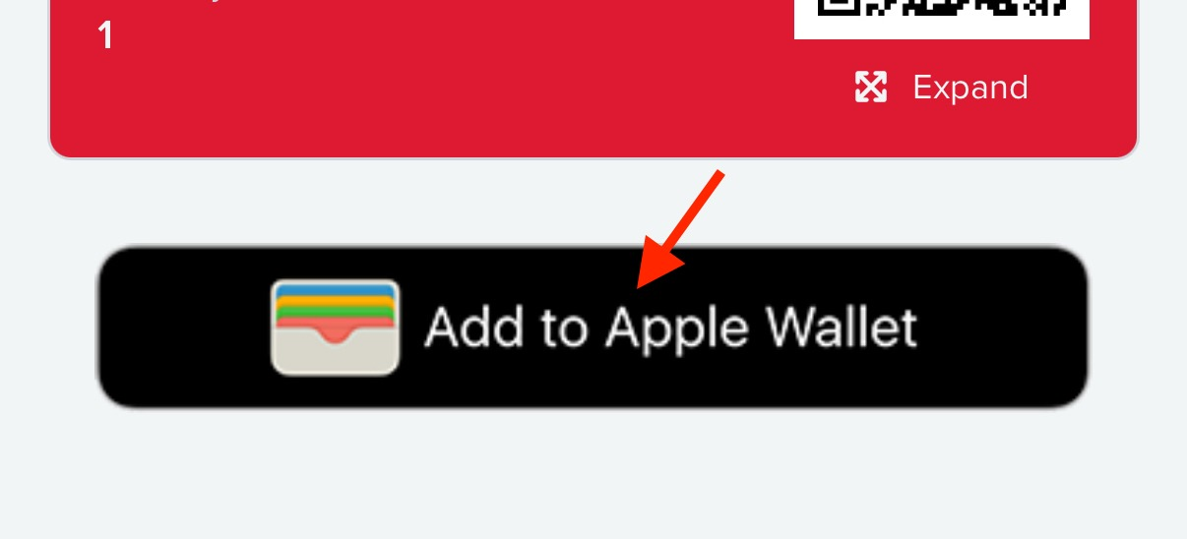
Accessing Tickets from an Event Page
Events for which you have already purchased tickets will display an indicator showing that you own tickets for that event.
- Open the event in the Bound App.
- Tap the ticket indicator or access button.
- Your purchased tickets will be displayed and ready for use.
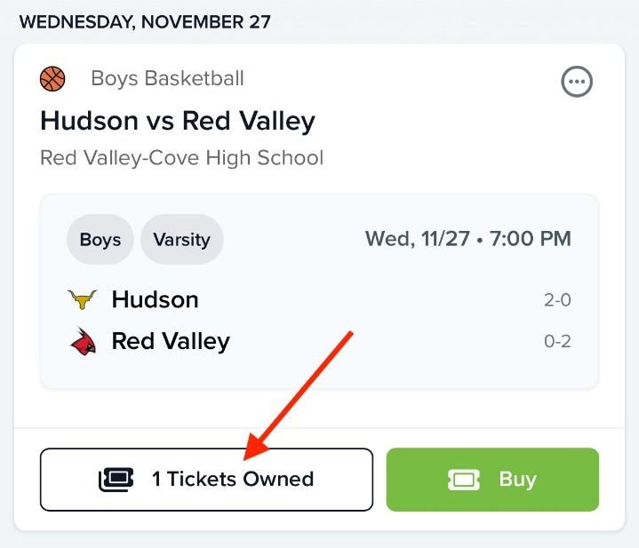
If you experience any issues purchasing or accessing tickets, please contact your school's Athletic Department for assistance.

